Green Business Practices for Environmental Sustainability in Banking Sector

Ms. Prerna Malhotra, Assistant Professor,
Maharaja Agrasen School of Management, Maharaja Agrasen University
Atal Shiksha Kunj, Village Kalujhanda,
Baddi, Himachal Pradesh 174103
Email id – pmalhotra260592@gmail.com

Abstract
The days have gone when the only motive of all the organizations all over the world was earning profit. Nowadays, in the 21st century that we are living we are becoming more and more aware and concerned about our natural environment. As a result of this organisations have started modifying and are making changes in their work environment to achieve sustainability to the maximum extent possible. They have realised why is it important to protect and preserve the environment and the natural resource. In order to achieve sustainability, researches have been done at a global level so that we can find different ways to achieve the goal of sustainability. Green finance is defined as the monetary help that is given for those projects that pact with protection of environment, that minimises the effects of change in climate, that invests in renewable sources of energy, increases the green cover, and all other projects related to sustainable development. The concept is different from traditional method as it focuses on the benefits that comes from environment protection by considering the risk management plans and sustainability of the plans. This research paper considers the concepts of Sustainability, Green Banking and Green Business Practices and Role of green banking products and technology used for environmental sustainability. Green banks are those institutions that work to achieve a mission and use financing methods that are innovative to fight climate change. The main focus has been placed on the environmentally friendly practices and innovations used by banks that help in environmental sustainability as a part of Green Financing. Green Banking entails merging latest technologies and evolving consumer behaviour in banking industry. It also evaluates the benefits of using technology for promoting environmental sustainability.

Keywords- Green Banking, Green Environment, Environmental Sustainability, Risk Management, Green Business Practices
I. Introduction

The world has been facing the problem of degradation of environment and balancing the economy. There has been a lot of debates in question so as to protect the environment and achieve sustainability all over the world. The organizations and consumers have nowadays much awareness on how the environment is becoming important for the subsistence of human beings. People have started paying attention to the green movement that helps in sustainability of the environment specially when talked in reference to banking sector. The green movement has gained popularity and is growing quickly in industrialised nations, but as time goes on, people on the Indian subcontinent are also becoming more open to the idea of being green (Biswas, M.N.,2011) With a recent concentration on the banking industry, green or environmental marketing is now a strategic marketing technique. Due to political and social constraints, profit-driven companies are now adopting green marketing tactics, and in order to have an edge in the market, they have started using eco-concerns for the same since a longer period of time (BS. K,2013) Green and clean technologies strive to interact with functional areas of daily business operations of many organisations, including the banking sector, in order to identify this competitive advantage. One of the key financial industries that supports and is essential to a country's economic development are banks. As banks provide funds for the economy, they may significantly contribute to the promotion of environmental sustainability by contributing money to investment projects that are socially and environmentally beneficial. For the sustainability of the environment, banks are embracing green practices. The idea of "Green Banking" will be advantageous to the banking sector, the economy, and the environment. It will not only ensure that industries are greener in the future, but it will also make it easier to improve asset quality (Dipika,2015) As the banks are aware of the benefits attached with the green banking approach, they have started adopting it from the last few years and for making the environment responsible, green initiatives have been taken. Various green banking products have been taken into consideration and looked upon for sustainability for example green securities, green investments, green insurance, green credit, green infrastructural bonds etc. The latest technology in the banking sector have been useful in developing these green banking products which in turn is in some way or the other promoting environmental sustainability. But it can be seen that the different strategies of green banking are different from each other because they are at different stages of green marketing.
Since it has become the need of hour in the current scenario to protect and preserve the environment and its natural resources the stakeholders are much aware of this issue because of the problems that are on increase and prevalent in the environment like depletion of ozone layer, global warming, increase in the pollution levels, and other environmental issues. Green finance intends to create a balance between nature and economics in this paper, an attempt has been made to evaluate the role of technology in promoting green banking products that subsequently leads to environmental sustainability.

1.1 Sustainable Business
Sustainable business refers to a business model that aims to create long-term value by considering and minimizing its impact on the environment, society, and economy. It involves integrating sustainable practices into all aspects of a business operations, including its supply chain, production processes, and product/service offerings. It requires asking the question, “How can you, as an entrepreneur, use your influence to help society in being more sustainable?”
The entire concept revolves around ‘doing more with less.'
Fig-1 (Sustainable Business)

1.2 Environment sustainability
An act named as The National Environmental Policy Act (NEPA) came into existence in 2014 in the United States whose aim was promotion of welfare of the people and society and maintain harmony and coordination amongst man and natural surroundings. The major objective for existence of this act was to achieve economic and social welfare of present and future generations. Before the existence of NEPA The concept of environmental sustainability came up in 1969. Environmental Sustainability is defined as ‘the ability to conserve the elements of physical environment that includes both natural and biological habitats. According to some people and some authors , it is ‘a state of equilibrium , resilience and interconnectedness that allows human society to satisfy its needs .The aim and objective of Environmental system is to maintain and preserve global life support system all over the globe .In the developing country of the world like India and if we talk about the industrialized sector of this country the problems of the environment have been serious and crucial and their dependence on natural resources for the growth and development emphasize the need of implementing policy and plans for sustainable resource use. Environmental difficulties in India have gotten worse as a result of the country's poor environmental management system, increasing effects of industry, urbanisation, and population growth. Therefore, it is imperative that we use natural resources in a sustainable manner, i.e., by addressing current requirements in a way that also considers those of the next generation. 'Living well within the environment' is a clear definition of it.
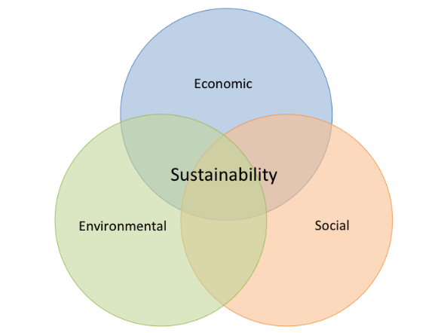
Figure-2 (Concepts of Environmental Sustainability)
Source-Sustainability Social Economic Environmental - Bing images
1.3 Green Banking
The notion and term “green banking” came into existence in the year 2009 in Florida. And subsequently SBI one was the first bank amongst all the banks that upheld greater environmental requirements and took the first step towards the "green banking" concept. Green banking is a sort of banking practice in which banks are ahead in maintaining the sustainability of environment. It takes into account every ecological and social component with the intention of protecting the environment and preserving natural resources. It is also called as ethical banking or sustainable banking. A "green bank" is one that promotes green technology in all aspects of its operations, whether they are internal to the bank or external to the environment. (Bose et al, 2017). It is a form of banking that promotes the nation's economy's overall development and expansion (Jeucken & Bouma, 1999; UNEP FI, 2016). In order to advance towards sustainable practises, green banks incorporate social and economic considerations into their initiatives. (UNEP FI, 2011, 2017). Green banking is a standard banking system that considers all social and environmental factors in order to promote ecological sustainability and the optimal use of natural resources, according to the Indian Banks Association. (Scholtens, 2009; Lympero Poulos et al., 2012; Kumar & Prakash, 2018; Sahi & Pahuja, 2020). Hermes et al. (2005) said that Banks are incorporating social, governance, and environmental aspects into their fundamental strategy as they transition from conventional to sustainable practises. The concept of social responsibility of green corporate in banking has been explained by Scholtens (2009), who also stressed on the notion that a green bank offers savings accounts to stakeholders and guarantees that the deposits will help in financing the projects that are sustainable to the environment. Development of green products such as green financial products, loans for renewable energies, greener technology, green lending, and environmental management techniques are considered part of bank green marketing, according to (Evangelions et al.,2009).
So, it can be said that Green Banking is a type of banking facility or banking strategy that looks upon internal and external environmental aspects and make use of environmentally friendly practice in the banking organisations along with funding and investing in commercial projects.

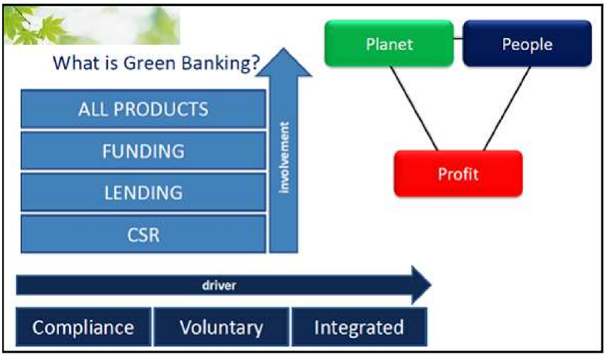
Figure -3 (Concept of Green Banking)
Source https://www.bing.com/images/search?q=green+banking+&form=HDRSC3&first=1

  - Sustainable Business Practices/Green Business Practices
Green business practices in the banking sector refer to strategies and initiatives implemented by banks to promote environmentally sustainable practices. These practices aim to reduce the bank's ecological footprint and minimize adverse environmental impacts,
Here are some key green business practices often observed in the banking sector:
1.Sustainable Financing: Banks offer sustainable financing options, such as green loans or green mortgages. These projects include renewable energy installations, energy-efficient buildings, sustainable agriculture, and eco-friendly technologies.
2. Responsible Investment: Banks integrate environmental, social, and governance (ESG) factors into their investment decisions. By screening investments for sustainability criteria and supporting companies with strong ESG performance, banks contribute to a greener economy while managing risks and generating returns for their clients.
3. Green Product Development: Banks develop innovative financial products that encourage environmentally responsible behavior. For example, offering incentives for using electronic banking services, promoting paperless transactions, or launching green savings accounts that reward customers for supporting sustainable projects.
4. Stakeholder Engagement: Banks engage with customers, employees, and communities to raise awareness about environmental issues and promote sustainable practices. This is done through educational campaigns, partnerships with environmental organizations, or sponsoring initiatives aimed at combating climate change and protecting natural resources
5. Energy Efficiency Measures: Banks adopt energy-efficient practices within their own operations by optimizing energy consumption, implementing sustainable office spaces, and promoting renewable energy procurement. This help reduce the bank's environmental footprint and set an example for its stakeholders.

II. Review of Literature
A review of literature is a review of books, journals, and theses, that are essential for the research and is related to a certain topic that aids in comprehending earlier research on the subject. It provides the framework for formulating and analysing the research problem, identifies the range and constraints of prior research, and provides information on areas that earlier researchers did not address.
Dipika (2015) in her study researched how and in what ways Indian banks set their strategies on green banking. The difficulties in executing of green banking in India and its proper implementation and steps to be taken was studied. Exploratory research methodology was applied. Secondary data was used to collect data. According to the findings, "Green Banking" helped banks to improve their quality of asset and helped in greening of the sectors.
Rambala Y et al. (2013) examined several Green Banking strategies used by India's commercial and public sector banks to promote environmental sustainability. The sample consisted of the top performing banks of the public sector and the private sector banks. Case study approach was used. Data was collected using secondary method. The findings showed that more focus on technology and innovations strive for a better future and enhance environmental sustainability. Apart from this, amongst the public and private sector banks public sector banks had taken a step further in taking and implementing green banking initiatives.
Khairunnessa, F et al. (2021) in their study emphasized the part that regulators and financial regulations play in helping to green the financial industry. Additionally, it investigated how banks and other financial institutions helped in making the economy a green economy The study was descriptive in nature and was founded on the analysis of secondary data. The study's findings showed that through enacting different green policies and regulatory measures, Bangladesh's central bank significantly contributed to the country's financial sector being more environmentally friendly.
Mir A et al. (2022) in their study on ‘Green banking and sustainability – a review” studied the importance of practicing green banking. The role and contribution of banks in environmental sustainability was also focused upon. The study was conceptual in nature. Findings showed that banks played a major and essential role in the environment by helping in the development of a healthy and successful economy with low carbon emission.
Sushma, B (2021) in the study on “Green Finance – An Effective Tool to Sustainability” studied the various prospects of green finance that helped in achieving of the goals of sustainability. The different types of green financing products were also identified. The benefits and limitations of green finance was also looked upon. The study was conceptual one. Secondary sources like reports, journals, research articles and websites were considered for collection of data. The findings to the study indicated that green financing helped in maintaining a balance and harmony amongst environment and finance by providing funds to the projects and maintained environment sustainability.
Kala N et al. (2020) in their study analysed the demographic profile of the bankers working in public and private sector banks . The data was collected using simple random sampling technique. Correlation and regression analysis was used to find out the results of the study. According to the study, environmental training, energy-saving techniques, and green projects significantly affect banks' environmental performance.
Sharma, D (2022) in his highlighted the importance of technology in green banking in India. The study was conducted using survey method and random sampling technique was used to collect the data that was a primary one. For getting the final results, factor analysis was used. From the findings of the study, it was concluded that green banking had helped to boost the environment and led to economic progress. In private sector banks, technology had also been a key and crucial part of green banking.
Sharma, M & Choubey, A (2020) in their study proposed a theoretical model showing the initiatives taken under banking initiatives and its impact on the environment. The study was qualitative in nature having in-depth interviews. The results demonstrated that the banking industry was vital to the development of the green banking system by increasing the availability of financing and meeting the needs of the green economy.
III. Objectives of Study
- To understand the perception of Inclusive and Sustainable Green Business
- To identify Key Green Business Practices often observed in the banking sector for environmental sustainability.

IV. Research methodology

The present study has used exploratory research method. An in-depth literature review on Green Banking, Sustainable Green Business and Green Business Practices in the banking sector was done and future steps were taken to ensure environmental sustainability. The reports on green banking were examined from the bank sites and other internet sites and websites. Secondary data was collected through journals, articles, annual reports and online websites.

V. Findings
- There is reduction in the use of paper by adopting e-transactions. Advices to corporate customers are given and they are asked to refer to electronic statements.
- Various eco-friendly green banking efforts are being deployed, including solar-powered biometric ATMs, online banking, telebanking, and mobile banking.
- Banks have started making use of paperless banking and has become the largest financer for solar energy related projects.
- The bank is not providing any loan facilities to those industries that are involved in depletion of ozone layers.
- E-lounges for high-tech banking facilities like ATM, cash/cheque acceptor, passbook printing kiosk, internet banking, online trading and tele banking have been set up.
- The bank implemented e-governance for human resource management function and several other administrative areas to reduce the paperwork
- Green Home Loan Scheme: The new green home loan scheme, introduced by SBI, for instance, will support environmentally-friendly residential projects and offer various concessions
- State Bank of India has taken a major step towards paperless banking “green banking” by opening “Green Channel Counter” which allows deposits and remittance transactions to be made by using debit cards only without the use of paper by customers.
- Solar power ATM’s have been installed across different areas.
- The use of solar-powered ATMs, check-deposit machines, CFL lamps, rainwater harvesting, printing on both sides of the paper, immediate repair of any water leaks, purchase of multiple functional composite fax machines, use of master sensor/master switches for lights, fans, etc. are just a few of the actions that the banks have taken as part of their green initiatives.
• At a few ATM locations where power outages are frequent, the banks have additionally installed solar UPS.

VI. Conclusion

With the use of latest technology and innovations in the market, green banking has helped in maintaining the progress of the economy along with enhancing the sustainability of the environment. There were a large number of banks who were reluctant in practicing and using green banking strategies and were unwilling to venture new possibilities in those industries that were ecologically sustainable and amongst these banks were the Indian Private Sector Banks. In order to attain sustainability and have access to the markets at the global level the banks must realize the obligations and duties that are ecological and ethical and in light of this, the techniques and latest innovations have become a common feature in recent times amongst both small avenues and across varied financial service providers, corporate finance organisations, as well as insurance firms. Apart from this, those industries and organisations that have been going green or are making efforts to go green should be given a priority in bank funding process. The study concludes with the notion that technology plays a transformational role for both public and private sector banks green banking process as it helps the banks to provide online and digital services, helps the bank being paperless and also increases the efficiency and effectiveness of banking sector. It is also found that technology play a significant and important role in green banking.
VII. References

- Biswas, M. N. (2011, January). Sustainable Green Banking Approach: The Need of the Hour. Business Spectrum, 1(1).
- B S, K. (2013, February). A study on Emerging Green Finance in India: Its Challenges anf Opportunities. International Journal of Management and Social Sciences Research (IJMSSR), 2(2).
- BS, S. (2021). " Green Finance " An Effective Tool To Sustainability. International Journal Of Creative Research Thoughts, 9(1).
- Dipika. (2015). Green Banking in India: A Study of Various Strategies Adopted By Banks For Sustainable Development. International Journal of Engineering Research & Technology (IJERT), 3(10).
- Evangelions K, et al.2009, “An Analysis of Corporate Social Responsibility (CSR) and Sustainability Reporting Assessment in the Greek Banking Sector”
- Khairunnessa, F., Vazquez-Brust, D., & Yakovleva, N. (2021). A Review of the Recent Developments of Green Banking in Bangladesh. Sustainability, 13(4), 1904.
- Kala, N. (2020). A Study on The Impact of Green Banking Practices on Bank’s Environmental Performance With Special Reference To Coimbatore. African Journal of Business and Economic Research, 15(3), 1750-4562.
- Mir, A. A., & Bhat, A. A. (2022). Green banking and sustainability – a review. Arab Gulf Journal of Scientific Research, 40(3), 247–263.
- National Environment Policy Act. (2014, 03 06). EPA Home: http: National Environment Policy Act. Retrieved from NEPA: http://www.epa.gov/compliance/basics/nepa.html#oversight
- Pathak, Y. a. (2013, January). Environmental Sustainability Through Green Banking : A Study on Public and Private Sector Banks in India. OIDA International Journal of Sustainable Development, 6(8).
- Scholtens, B. (2009). Corporate social responsibility in the international banking industry. Journal of Business Ethics, 86, 159–175. https://doi.org/10.1007/s10551-008-9841-x
- Sharma1, D. V. (2022). Role Of Technology In Green Banking In India: An Emperical Study of Private Sector Banks. Journal of Positive School Psychology, 6(6).
- Sharma, M., & Choubey, A. (2022). Green banking initiatives: a qualitative study on Indian banking sector. Environment, Development and Sustainability, 24(1), 293–319. https://doi.org/10.1007/s10668-021-01426-9
- Vijai, M. S. (2020, October-December). Green Banking Initiatives in the Indian Banking Sector. Sambodhi Journal, 45(3).

