Braking Framework Investigate Utilizing All-Electric Braking Framework

Dr. Hredeya Mishra1 Dr. Pradnya Prakash More2

Lecturer in MED Lecturer in MED

MVPS’s RSM Polytechnic Nashik MVPS’s RSM Polytechnic Nashik

[1002mishrahk@gmail.com](mailto:1002mishrahk@gmail.com) [pradnya.more@rsmpoly.org](mailto:pradnya.more@rsmpoly.org)

***Abstract*—** **The braking system manages a combination of pneumatic braking and electric braking. This system is the main cause of train noise and friction of the disc brake shoe when braking. causes environmental pollution. Therefore, this article presents a method for using the all-electric braking system as a zero-speed braking system to remove dust and other contaminants.**

***Keywords—Braking system; fully electric brake system***

1. INTRODUCTION

Electric trains have become an important means of public transport in recent years. With the improvement of passenger comfort and the development of electronic equipment, the performance, performance and operation of the car should be improved. The

braking system manages a combination of pneumatic and electric brakes. This system is the main cause of train noise and friction of the disc brake shoe when braking. It causes environmental pollution.

Therefore, this article presents a method for using the all-electric braking system as a zero-speed braking system to remove dust and other contaminants.

1. ELECTRIC BRAKE Framework

The starting and stopping of the electric train is controlled by the inverter drive controller. The electric brake operates at a speed of approximately 5 km/h. The air brake operates at a speed of about 5 km/h. The system uses an encoder to detect the motor acting as a vector controller. Precise vector control is not possible due to the characteristic output of about 60 to 100 pulses per revolution of the encoder system.

For this reason, a hybrid electric and pneumatic braking system is used. This system is the main cause of train noise and friction of the disc brake shoe when braking. It causes environmental pollution. When the train speed drops below 5 km/h, the compressor will make noise, it will not be easy to maintain and the air brake will run the risk of air aging.

The completely electric brake framework is primarily utilized by the electric braking to play down the chance of pneumatic brake. Impacts gotten utilizing the completely electric brake framework are as follows:

1. Reduce the wear of the brake shoe by minimizing the utilize of the pneumatic brake

2. Can decrease braking commotion and clean due to mechanical wear

3. Brake upkeep taken a toll savings

4. Maximizing the utilize of vitality to the development of the regenerative braking.

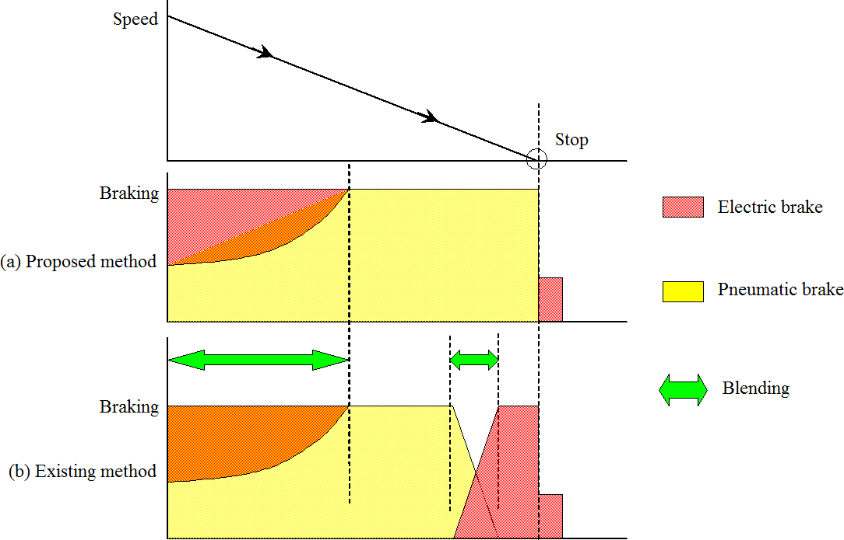

Figure 1. Electric brake framework

1. COMPOSITION OF FULLY ELECTRIC BRAKE SYSTEM

The braking framework comprises of the inverter, the Pulse-width tweak (PWM) control unit, the vector control unit, the drive control unit, the speed location unit. The inverter control the speed of the engine by changing over the DC voltage to AC voltage input through a pantograph.

The PWM control unit makes the door beat of the inverter. The PWM control unit alter the footing motor's input circuits voltage and recurrence. The vector control unit gets the engine speed and current signals.

The vector control unit decides the inverter voltage inverter recurrence. The drive control unit performs the operation command for speeding up, recovery and braking.

The brake controller controls the stopping brake. The speed discovery unit recognizes the rotor speed for the engine control. The inverter for engine control performs work from the begin to the halt and the stopping brake when the prepare stops.

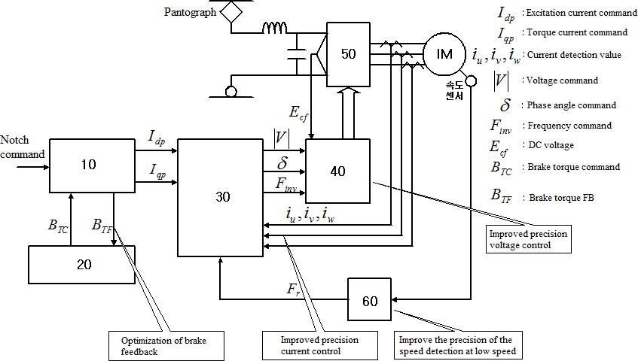

Figure 2. Vector control configuration

The vector control unit gets the engine current discovery esteem and the speed in arrange to criticism footing control and the speed from the footing engine. And it alters the yield of the beat width balance control unit.

The vector control unit performs criticism control of current and recurrence as the vector control in arrange to reply the reference esteem of the drive control unit.

In this consider, the resolver is utilized in arrange to move forward the speed discovery and the exact control within the low-speed range.

Figure 3 speaks to the brake control at moo speed amid deceleration. When the halt flag is recognized, the torque current command(Iqp) is accomplished to yield the braking power.

When the speed of the prepare comes to the low-speed extend (5km / h or less), the electrical braking constrain is diminished and the torque current command esteem is decreased steadily. When the prepare is halted, the pneumatic brake is done.

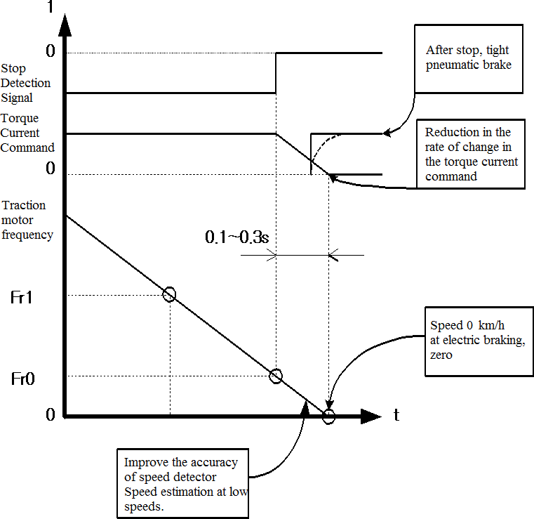

Figure 3. Brake control at moo speed amid deceleration

1. TEST

There are the taking after conditions to halt the motor.

4.1 Avoid revolution after stop.

1. Pneumatic brake operation, When the braking torque is 0

2. The braking torque is created within the slope. The

braking constrains with pneumatic brake work of stops the prepare.

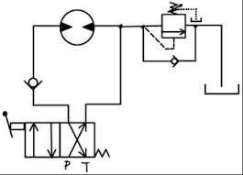

Figure4: Braking Sequence

The electric motor is the driver for propulsion and regenerative braking. Figure 5 shows that the starting speed of the characteristic drive is 360 [rpm] and the torque is 0 at 800 [rpm]. The braking torque is proportional to the stopping speed.

In Figure 5 and 6, the torque setting is a step change. Slow driving was observed when stopped

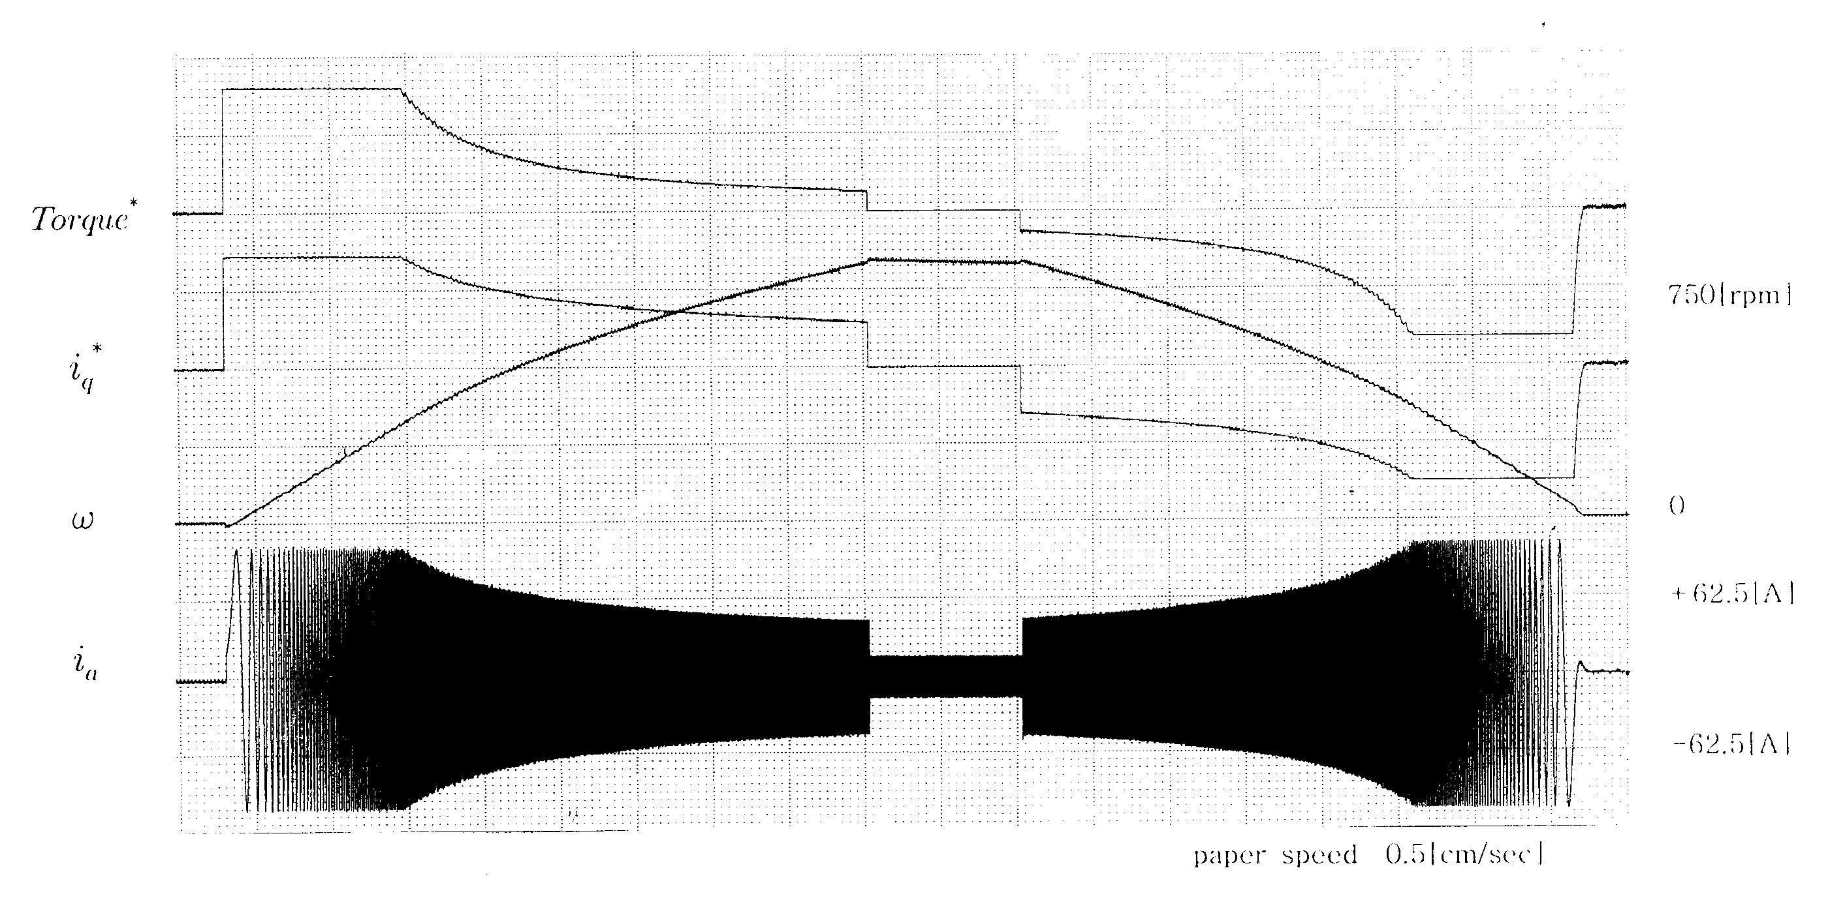

Figure 5. Drive tests on Inertial load

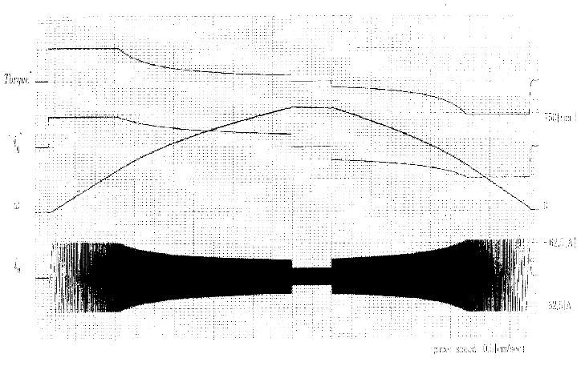

Figure 6. Drive tests on Inertial load (Torque Variable)

1. CONCLUSION

The braking system manages a combination of pneumatic braking and electric braking. Section

The main cause of train noise and disc brake shoe friction when braking is the system. causes environmental pollution. Therefore, this article presents a method for using the all-electric braking system as a zero-speed braking system to remove dust and other contaminants.

The benefits of using an all-electric machine are:

1.Reduce the use of pneumatic brakes and reduce shoes to

2. Can reduce noise and dust from machine use

3. Save on brake cost

4. Use the greatest strength to attach additional flexibility

REFERENCES

1. Hanmin lee, Gildong Kim, Changmu Lee, Euijin Joung, “A study on Braking Control for Pure electric Brake of Electric Train”, The Korean Institute of Electrical Engineers conference, 2012
2. Hanmin lee, Gildong Kim, “A Study on Electric Braking System to 0km/h”, The Korean Society for Railway conference,pp.178, 2007
3. Sone, Ashiya, "Pure electrical brake of the railway electric vehicles",Railway cybernetics, vol.34,No.513, pp.194~197, 1997
4. Ogasa, Nagai, Watanabe, "Plant-test Result of All Electrical Braking (Report 1)", National convention Record I.E.E.Japan, 1260,pp.5- 389~390, 1998
5. Ogasa, Nagai, Watanabe, Toda, "Plant-test of Electrical Breaking to Zero Speed for Railway Vehicle", National Convention Record I.E.E.Japan-Industry Application Society-, No.77,pp.257~262, 1998
6. Sato, Iida, Hisatomi, "Pure electric braking system test using stsrt", National Convention Record I.E.E.Japan-Industry Application Society-, No.78,pp.253~2666, 1998