A NEVER-ENDING CONTEMPORANEOUS: EPICS AND TALES

Author  Shanmugapriy. K  Research Scholar  Department of English,  School of Social Science and Languages, Vellore Institute of Technology, Vellore,  Email: shanmugapriya.k@vit.com  Contact: 9677914220 | Co-author  Dr. G. Christopher,  Assistant Professor Senior,  Department of English,  School of Social Science and Languages, Vellore Institute of Technology, Vellore,  Email: christopher.g@vit.ac.in  Contact: 98949 11000

Abstract
Many of us grew up hearing stories that have been told numerous times through various mediums such as oral narration, books, TV, and films, in addition to the oral, written, and visual formats of Indian classical epics and fables. On the other hand, various other creative approaches, such as dancing, painting, clay artworks, textiles, theme parks, and so on, play an essential role in story narrations. To liven things up, inventive art and techniques will assist those antique literary works become everlastingly modern. The growth and evolutions of Indian ancient literature is never ending process. From cave to the recent creative evolution, helps both adult children have to keep on learn rich moral values. The aspects the only change but content remains the same. The purpose of this study is to highlight the principles of originality in the storytelling of ancient Indian classical works such as Panchatantra stories, Jataka Tales, Ramayana, and Mahabharata.
Keywords: Creativity, Epics, Fables, Classical literature, never-ending
Introduction
“Art, in its many forms, is practiced by almost all human cultures and can be regarded as one of the defining characteristics of the human species” (Morriss-Kay, 2010, p. 158). Many of us grew up hearing stories, which have been recounted multiple times through various mediums like – oral narration, books, TV, and movies, however, apart from the oral, written, and visual formats of Indian classical epics and fables. On a spit of that several other creative methods also play an important role in story narrations like dance, painting, clay artworks, textiles, theme parks, etc. To spice things up creative art and techniques will help those ancient literary works into never-ending contemporary.
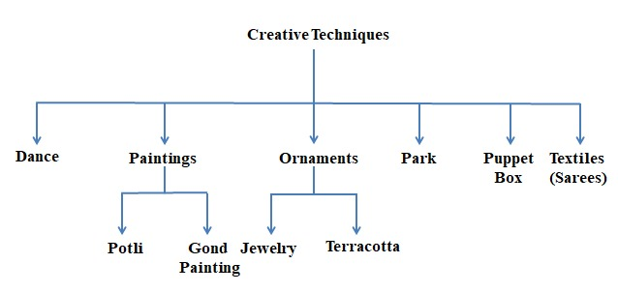
Source: The authors
Dance: A Creative Tool for Young People
Dance is a creative process through which human movement is used to sense, comprehend, and convey ideas, emotions, and feelings. To be skillful in the art of dance, one must understand and apply its content, words, capabilities, and techniques. Dance elements are the basic aspects and vocabulary for creating movement skills and comprehending choreography as an art form. All of these elements can be found in a dance (Kogon, 2013). “We do not learn from experience...we learn from reflecting on the experience,” says American philosopher, psychologist, and educational reformer John Dewey. Reflecting on experience is best accomplished by visual elements capturing events as they occur. But when a story is conveyed through dance, the learner is left with an even stronger impression.
Pavithra Srinivasan, a Bharatanatyam dancer, was invited to teach students about Panchatantra stories as a component of the cultural event. When stories are told through a visual medium such as dance, it encourages thought reflection, resulting in a profound knowledge of the topic, and encouraging critical thinking skills in the viewer. It is extremely easy for the audience to visualize and learn the story. “Anything we visualize stays in our minds for a longer period. This tends to make storytelling a successful learning tool,” explains psychologist Dr.NappinaiSeran (Narasiah, n.d.). The Ramayana Ballet, also known as a dance drama, is a stylized dance art form that visualizes and represents the epic Ramayana plot line. RamayanaBallet performances combine music, dance, and drama and are typically performed without dialogue, it is a source of creative inspiration, particularly in Southeast Asia (Suharti et al., 2020, p. 1).
Paintings
Painting is the transfer of pigment, colour, or another substance to such a solid surface; it is the medium that is often applied to the surface with a brush or softeners. Religious art has dominated a segment of the development of painting in both Eastern and Western art. The majority of the artwork depicts legendary figures on pottery, as well as Biblical events and scenes from Buddha’s life. Different types of painting include allegory, figure painting, illustration painting, landscape painting, portrait painting, still life, and veduta.
“POTLI” is a wonderful bag, and a great present for children to build extended remembrances. The Rogan painting technique has been handed down from father to son for more than 300 years. Only in Jabbar’s village in Gujarat’s Kutch region, Nirona is this task still performed. Even though it is a unique and lovely craft, it has not been able to be supported by common people. The majority of families have given up the art to pursue other sources of income. The last remaining Rogan Art family is the Khatris. Together with the Khatri family, Potli has worked to promote this art globally and prevent its extinction, 2014 received a State Award; 2019: International Craft Designer Award. With these special DIY craft kits that combine fun and learning a valuable lesson, you can encourage your kids to become involved in the Panchatantra stories. Children are taught to draw stories in various creative Indian traditions, Potli art is also roughly similar to Gond painting, Warli, Madhubani, Kalighat, and Saura.Learn the value of hands-on craft while engaging with intricately carved wooden blocks to build their creations; once the narrative is finished, the blocks may be utilized to make more artwork, improving the child’s creative thinking. It’s also a wonderful chance to share a loving experience with your children and make memories that will last a lifetime (Our Artisans – Potli, n.d.).
Jewelry Making
“The jewellery is based on shadow leather puppetry, an art form for telling stories that have been around for 600 years in Andhra Pradesh. Tholubommalata is a style of folk theater from Nimmalakunta in Andhra Pradesh”. The puppeteer here tells mythical tales with the help of transparent leather puppets. Tholubommalata, the stories, music, and vibrant puppets are all intertwined and dependent upon one another. The jewelry and all the artwork for the stories were meticulously made by Divya N and SindeSriramulu as a collaborative project. This project began as a research experiment and will be displayed as a durational exhibition during New York City Jewellery Week in 2021, the author continues. The project includes tales from the Mahabharata, Jataka, and Ramayana” (DTNext, n.d., p. 8).
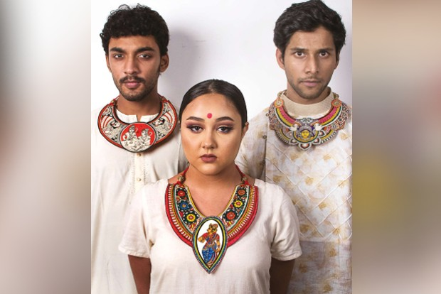
Source: DTNext Newspaper, dated on 22 Nov, 2021
Terracotta called Baked Earth in Italian language, it’s a type of item fashioned from rather coarse, porous clay that, when burned, takes on a colour varying from dull ochre to deep red. The temples of Bengal in India are well known for their intricate terracotta work and carvings. Among them, the Hindu epics, Ramayana, and Mahabharata are also seen in many places. Scenes and characters from the epics are sculpted (West Bengal’s Unique Terracotta Temples: Devotion Moulded in Clay | The Financial Express, n.d.).
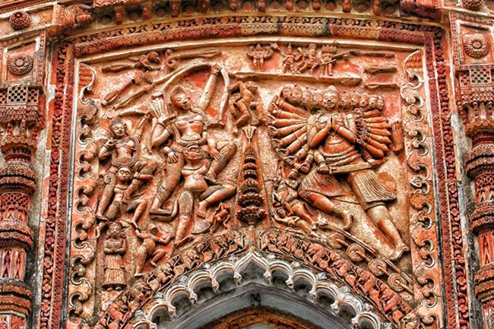
Source: Guest, Financial Express Newspaper, dated on September 5, 2019
Puppet Box
Generally, Puppet shows are theatrical performances featuring puppets and puppeteer-provided speech or music. Puppets are moving models controlled by hands or strings. Puppets are human, fantastical, or animal-shaped. Puppets provide interaction, conversation, and surprise to play-and-learn activities. Puppets help early childhood development.Different puppets include Puppets Dolls, Glove-puppets, Phantoms Puppet, Arms Marionettes, Dolls Puppet, and ventriloquist Dolls (Different Types Of Puppet | Different Kinds Of Puppet | Wiki, n.d.). But nowadaysPuppet boxes are used to convey stories creatively, and also, they can be used to pull children away from the television screen. This creative craft is appropriate for children aged between 3 to 6. The Ramayana Story is a paper hand puppet kit. This kit is primarily created to artistically stimulate the imagination and attention of a child aged 3-6 years and to foster respect for Indian culture through painting. A fun activity set for a kind surprise for a cherished one.
Textile
In the recent textile trend, they were using a creative technique to advertise their products under the name “sarees that tell a story.” Pieces of fabric are not only garments but also works of art. A closer examination of each saree reveals scenes and characters from the Indian epics Ramayana, Mahabharata, and Panchatantra. Designers, through their creative ideas and modern techniques, rejuvenated the classical text into Sarees and Dupattas. The lengthy painted banners from ML Pawinee’s collection tell the tale of Vessantara Jataka. Since 1985, she has been gathering textiles, and to date, she has more than 1,000 items from various nations, which include Laos and Cambodia; it is such a unique event, organized in cooperation with the Thai Textile Society. The banners, which are between 30 and 50 meters long, depict 13 well-known scenes from the Vessantara Jataka, which recounts the story of Gautama Buddha's last incarnation as Prince Vessantara. (Limited, n.d., p. 2). Vishwanatha Reddy is a pen Kalamkari artist who earned a National Award in 2008 for his work. His parents have been practicing for over two generations, and he was one from boyhood. He says, “Initially, our family just manufactured wall hangings, but over the past 10 years they have established a variety of saris, dupattas, running cloth, and stoles as well” (Classic Expressions of Indigenous Narratives, n.d.). Kantha is a beautiful kind of Indian embroidery that is mostly done in Bengal. It’s a simple running stitch type that’s utilized to make the most gorgeous, detailed designs (Mahabharat Embroidered Exotic Fabric Tapestry Handmade Indian - Etsy India, n.d.). The below figure is the significant event while Krishna declaims the Bhagavat Gita to Krishna in order to teach duty and truth. With Kantha stitching, this fabric recreates that moment.
Source: web page, Etsy India
Fables Theme Park:
People will learn Panchatantra lessons through self-explanatory murals, sculptures, and frescos. To re-imagining ancient Indian literature ‘The Lucknow Raj Bhawan’ will now create a “Panchatantra van,” in which people, particularly children, the garden will be built on 2.5 hectares of land and will include a nature trail, a fountain, and animal models. The theme was chosen, according to the Forest Department official, “because it provides an ideal vantage point for understanding conflicts involving individuals, philosophies, organizations, or consciousness. Panchatantrastories can be used to provide useful clues for resolving all types of conflicts.” (“Panchatantra Van” to come up in UP Raj Bhawan, 2022, p. 2). The below figure is a story of crocodile and monkey from Panchatantra Tales.
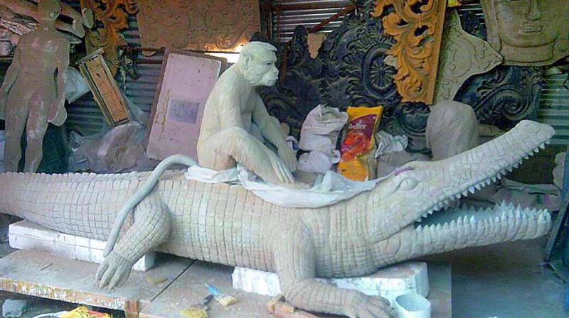

Source: ShashidharAdivi, Desi- Disneyland coming soon, Deccan Chronicle,

Jun 6, 2018 (Adivi, 2018).
Children and tourists may learn the values of Panchatantra through interactive displays such as sculptures and storyboards that recite stories via audio speakers when a button is pressed. Similarly, the Pail text Jataka also reform in the form of the park called “Buddhist Heritage Theme Park” which is located in the Nalgonda district and is situated across 274 acres on the riverbanks of the Krishna River. According to Mallepally Laxmaiah, the project’s officer, the total number of 547 stories from Jataka is represented through creative artworks scattered across the park. The Jataka tales, as demonstrated by the life and experience of the Bodhisattva (Jataka Tales, Stupas to Meditation Haven, 2022).
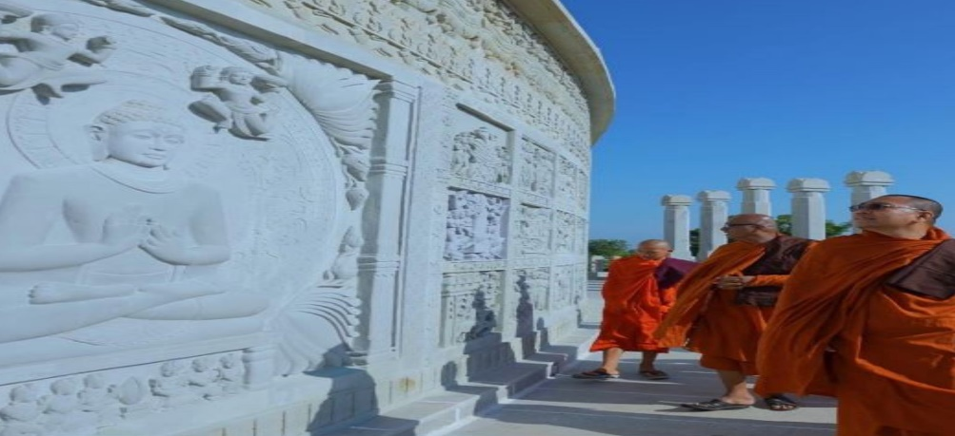
Source: Kakoli Mukherjee, News18, July 20, 2022
Conclusion
“Storytelling techniques can be implemented to support and enable the creative process” (Catala et al., 2017, p. 237). People, particularly youngsters, had simply stopped reading books due to digitations, but creative art had taken their place, and every individual was may familiar with the tales again. So, it is a great initiative to recreate classical literature, which has been lost; therefore, bringing them back in creative form. “All cultures place a premium on stories, narratives, and storytelling. To be effective, storytelling must engage both the self and the other person and provide a storyline that is not only cognitively but also emotionally compelling” (corissajoy, 2016).
Reference
Adivi, S. (2018, June 6). Desi-Disneyland coming soon. Deccan Chronicle. https://www.deccanchronicle.com/lifestyle/pets-and-environment/060618/desi-disneyland-coming-soon.html
Catala, A., Theune, M., Gijlers, H., & Heylen, D. (2017). Storytelling as a Creative Activity in the Classroom. Proceedings of the 2017 ACM SIGCHI Conference on Creativity and Cognition, 237–242. https://doi.org/10.1145/3059454.3078857
Classic expressions of indigenous narratives. (n.d.). The New Indian Express. Retrieved September 7, 2022, from https://www.newindianexpress.com/cities/delhi/2022/apr/09/classic-expressions-of-indigenous-narratives-2439929.html
corissajoy. (2016, July 6). Narratives and Story-Telling [Text]. Beyond Intractability. https://www.beyondintractability.org/essay/narratives
Different Types Of Puppet | Different Kinds Of Puppet | Wiki. (n.d.). Twinkl. Retrieved September 9, 2022, from https://www.twinkl.co.in/teaching-wiki/puppet
DTNext. (n.d.). Narrating mythical, folklore, moral stories through jewellery. DT Next. Retrieved August 25, 2022, from https://www.dtnext.in/city/2021/11/22/narrating-mythical-folklore-moral-stories-through-jewellery
Jataka Tales, Stupas to Meditation Haven: Telangana Gets New Buddhist Theme Park. Details Here. (2022, July 20). News18. https://www.news18.com/news/india/from-jataka-tales-stupas-to-meditation-haven-all-about-telanganas-new-buddhist-theme-park-5591899.html
Kogon, C. (2013, November). Dance as a tool for creativity with young people | Educational Tools Portal. Tool for Learning. https://educationaltoolsportal.eu/educationaltoolsportal/en/tools-for-learning/dance-tool-creativity-young-people
Limited, B. P. P. C. (n.d.). A chance to see rare textiles. Bangkok Post. Retrieved August 25, 2022, from https://www.bangkokpost.com/life/social-and-lifestyle/2079999/a-chance-to-see-rare-textiles
Mahabharat Embroidered Exotic Fabric Tapestry Handmade Indian—Etsy India. (n.d.). Retrieved September 7, 2022, from https://www.etsy.com/in-en/listing/885741010/mahabharat-embroidered-exotic-fabric?utm_source=OpenGraph&utm_medium=PageTools&utm_campaign=Share
Narasiah, K. R. A. (n.d.). Dancing to stories of Panchatantra to teach vital lessons of life. The Times of India. Retrieved August 25, 2022, from https://timesofindia.indiatimes.com/blogs/tracking-indian-communities/dancing-to-stories-of-panchatantra-to-teach-vital-lessons-of-life/
Our Artisans – Potli. (n.d.). Retrieved September 5, 2022, from https://potli.org/our-artisans/
“Panchatantra Van” to come up in UP Raj Bhawan. (2022, April 30). Newsd.In. https://newsd.in/panchatantra-van-to-come-up-in-up-raj-bhawan/
Suharti, M., Sari, C. T., & Sulihanto, S. (2020). MOTIVATION MODEL DISTORTION OF RAMAYANA BALLET PERFORMERS. International Journal of Economics, Business and Accounting Research (IJEBAR), 4(02), Article 02. https://jurnal.stie-aas.ac.id/index.php/IJEBAR/article/view/963
West Bengal’s unique terracotta temples: Devotion moulded in clay | The Financial Express. (n.d.). Retrieved October 20, 2022, from https://www.financialexpress.com/lifestyle/travel-tourism/west-bengals-unique-terracotta-temples-devotion-moulded-in-clay/1696326/

