Food Microstructure Analysis Techniques: Unraveling the Hidden World of Food
Soumya C Meti, Udaykumar Nidoni, Sharanagouda Hiregoudar and Pramod Katti
Corresponding author: Soumya C Meti; Email: soumyacm97@gmail.com
Abstarct

This book chapter delves into the intricacies of food microstructure, defined as the spatial arrangement of cells, intercellular spaces, and the interaction of food constituents within the matrix. This all-encompassing concept extends to diverse food items, encompassing bakery products, fruits, vegetables, and meat, exerting profound influence on their quality, texture, and nutritional attributes. Although imperceptible to the unaided eye, microstructure plays an indispensable role in shaping characteristics such as sponginess, crispness, firmness, and emulsion stability. An enlightened comprehension of food microstructure and its dynamic metamorphosis during processing is indispensable in crafting superlative foodstuffs with optimized nutritional availability. Employing an array of microscopic analysis techniques such as optical microscopy, fluorescence microscopy, scanning electron microscopy, and others, researchers gain invaluable insights into food composition, quality control, and the discernment of unwelcome substances. As discerning consumers demand augmented nutritional excellence, heightened sensory properties, and utmost safety, the unexplored realm of microstructural engineering emerges as a captivating avenue to tailor food microstructure for targeted functional efficacy. This chapter accentuates the significance of food microstructure analysis techniques and underscores their boundless potential for pioneering food applications and transformative innovations.
Keywords: Food microstructure, imaging, microscopy

Food Microstructure Analysis Techniques: Unraveling the Hidden World of Food

Introduction
Food microstructure can be defined as the intricate arrangement and interplay of food constituents, leading to distinct and observable spatial divisions of different material phases at the microscopic level. Moreover, food microstructure may encompass not only the physical and chemical organization of constituents but also the interactions of individual molecules within the microstructural matrix (1).
The primary role of food is to offer pleasure through its delightful flavors, enticing aromas, and pleasing textures, while also providing essential nutrition and energy. Additionally, consumers seek food with other functionalities, such as extended shelf life, enhanced health benefits, and transparent labeling. An emerging trend in food research is the aspiration to create and manufacture food products with tailored functionalities to meet specific consumer demands. Achieving this goal involves diverse approaches pursued by researchers and food manufacturers, with a prominent focus on comprehending and controlling food structures, particularly at the microscopic level. The study of food microstructures encompasses three essential aspects: visualization, identification, and quantification, each necessitating distinct tools and techniques to gain valuable insights into the intricate nature of food compositions (41).
Food is a complex and heterogeneous system, encompassing both fresh products characterized by cellular structures and processed items with microscopic domains formed by a blend of ingredients. These structures are often beyond the direct observation of the naked eye. While human vision can perceive objects down to approximately 1 μm with adequate lighting, many biological cells and food components fall within this scale but remain imperceptible due to lighting limitations. Nevertheless, they become distinctly visible and clear under the magnification of a regular light microscope. For instance, some salad dressing emulsions contain oil or water droplets well below 1 μm in diameter, while elemental plant fibers possess a diameter in the range of a few nanometers, necessitating the use of higher-resolution microscopes such as scanning electron microscopes to investigate and discern their intricate characteristics (11).
Microscopes help determine food morphology, but a complete understanding of microstructure requires chemical imaging tools (Fourier transform infrared, Raman, fluorescence, or confocal laser scanning microscope) for ingredient distribution and physical structural tools (x-ray diffractometer) for molecular arrangement and crystallinity analysis. Combining these techniques enables researchers to unravel the complexity of food microstructures, aiding in product development and consumer appeal.
Modern microscopy and chemical imaging tools have revolutionized the study of food microstructure, enabling researchers to not only determine food morphology and ingredient distribution but also quantify crucial parameters like dimension, concentrations, fractions, and kinetic constants. With the advent of x-ray computed tomography, quantification can now be performed in three dimensions through non-destructive imaging, offering invaluable insights into food structures. Furthermore, these advanced techniques allow for the probing of microscale interactions and forces among food ingredients, facilitated by instruments such as the atomic force microscope. This enhanced understanding of food microstructure and interactions paves the way for more precise food product development and optimization, addressing consumer demands and enhancing the overall quality and appeal of food products (11).
Quantitative measurements serve as the conclusive element in deciphering food microstructures. Though initially not intended for food applications, diverse microstructure techniques have been adopted by food researchers to establish correlations between structure and functionality. A wide range of unexplored methods for analyzing food microstructure hold promise. Targeted microstructure imaging facilitates the identification of specific molecules within the food matrix, providing valuable insights. Understanding and modeling microstructure present opportunities for pioneering microstructural engineering, enabling purposeful manipulation to achieve targeted material properties. Continuous exploration of microstructure analysis propels advancements in food science and engineering, paving the way for novel and superior food products that precisely align with consumer preferences.2. Milestones in microscopic techniques (11).
2. Milestones in microscopic techniques
The milestones in food microscopic techniques have unfolded over centuries, driven by the groundbreaking work of visionary scientists. It all began with the invention of the light microscope by Antonie van Leeuwenhoek in the late 16th to early 17th century, paving the way for the observation of cellular structures in foods. In 1931, Ernst Ruska and Max Knoll introduced electron microscopy, granting researchers the ability to visualize nanoscale food microstructures. The 1950s witnessed two key advancements: the introduction of Fourier Transform Infrared (FTIR) spectroscopy by Peter Fellgett and Rudolf Kompfner for chemical analysis of food components, and the development of confocal laser scanning microscopy by Marvin Minsky and Kohei Shimada, allowing three-dimensional imaging. Sir C. V. Raman's discovery of Raman scattering in 1928 led to the application of Raman spectroscopy in food microstructure analysis. In 1972, Godfrey Hounsfield and Allan M. Cormack's work resulted in X-ray computed tomography, revolutionizing non-destructive 3D imaging of food samples. The 1986 invention of atomic force microscopy by Gerd Binnig and Heinrich Rohrer enabled nanoscale surface characterization of food materials, while Cryogenic Electron Microscopy (Cryo-EM) provided insights into near-atomic level structures. In the early 2000s, super-resolution microscopy techniques pioneered by Eric Betzig, Stefan W. Hell, and William E. Moerner, surpassed diffraction limits, offering subcellular insights. In 2021, continued advancements in all microscopy techniques, including 3D imaging, high-speed imaging, label-free imaging, and correlative microscopy, have further deepened our knowledge of food microstructures and their significance in food science and technology.

3. Magnification and resolution
The concept of magnification in microscopy is the ability of the microscope to generate an image of a sample or object at a larger scale than its actual size. It is simply a measure of how much the image is enlarged. Two methods to increase the magnifying power of a microscope are (i) using lenses with smaller focal lengths and (ii) decreasing the object distance from the objective lens. An illustration of this can be seen in Fig. 1, which shows scanning electron microscopy images of lipid nanoparticles at magnifications of ×20,000 and ×50,000 (19). These techniques in magnification enable scientists to explore minute details and structures, leading to advancements in various scientific domains.
Resolution is the ability to distinguish or resolve two small points, which are very close together, as two separate entities as it can be seen in the Fig. 2. Radiolarian under (C) light microscope and (D) scanning electron microscope. Surface texture of Radiolarian can be seen clearly in scanning electron microscope which has a higher resolution than light microscope (19).
Factors that affect a microscope’s resolution include the properties of the imaging agent (wavelength of the light) and the focusing power of the instrument (numerical aperture of the objective for light microscope). These are considered with a simple equation to calculate the theoretical resolution limit for a given microscope’s primary or objective lens (11):
R = λ/2NA
Where,
R = resolution (theoretical resolution limit, minimum distance of the two adjacent objects)
λ = wavelength of the visualizing agent
NA = numerical aperture of the lens

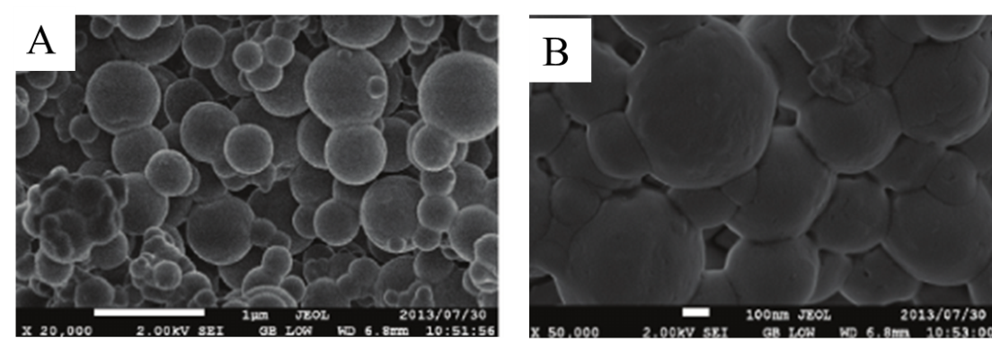

Fig. 1. Scanning electron microscopy images of lipid nanoparticles at (A) ×20,000 and (B) ×50,000 magnification
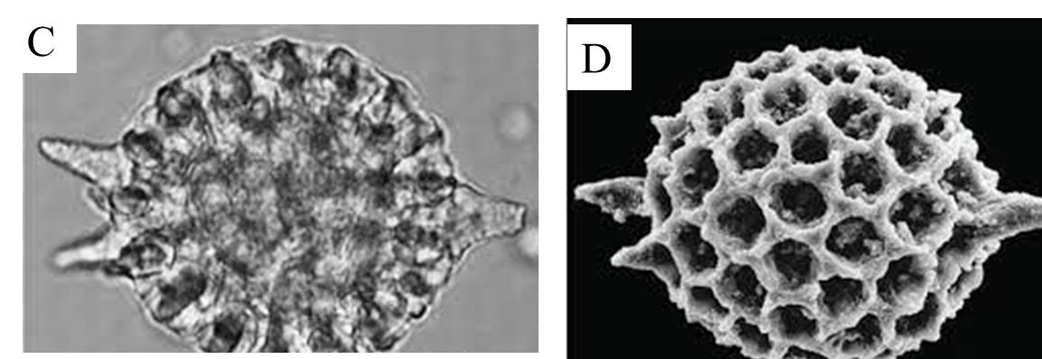

Fig. 2. Radiolarian under (C) light microscope and (D) scanning electron microscope

4. Food microstructure analysis techniques
Imaging has emerged as a preeminent and indispensable family of instrumental techniques for the analysis of foods and food microstructures. Traditionally known as microscopy, imaging has transcended its prior confines, encompassing a broader and more diverse domain. Microscopy, encompassing both an artistic and scientific pursuit, has experienced remarkable advancements, resulting in an enhanced ability to achieve higher magnification and improved feature contrast. Various imaging agents, such as photons (light), high-energy photons (x-rays), and electrons, play distinctive roles in this multifaceted field. For food analysis, a myriad of imaging tools is harnessed, including optical microscopy, fluorescence microscopy, Raman microscopy, transmission electron microscopy, scanning electron microscopy, X-ray computed tomography, atomic force microscopy, nuclear magnetic resonance imaging, field emission scanning electron microscope, confocal laser scanning microscopy, cryo-electron microscopy (Dong and Joer, 2017) and super-resolution stimulated emission depletion microscopy (5). These sophisticated techniques bestow valuable insights into the intricate microstructure of food, enhancing comprehension of food properties and overall quality.

4.1. Optical microscopy
Optical or light microscopy, since the development in the 17th century by pioneers such as Antonie van Leeuwenhoek, has become a standard technique for visualization of microstructure. The method makes use of lenses to render a magnified view of a specimen. In the simplest form of bright field light microscopy, transmitted white light through the specimen is observed resulting in a 2D contrast image of differences in transmitted light due to differences in absorbance by the microstructural phases. This specimen usually needs to be carefully prepared for imaging. The sample must fit the stage of the microscope, must be sufficiently transparent and contrast may need to be enhanced by special treatments. Therefore, the specimen is taken mostly by destructive sampling of thin slices of the object and may involve staining and fixation steps. This may introduce artifacts. To circumvent the problems of sample pretreatment, advanced optical techniques have been developed, including dark field and phase contrast microscopy, which can enhance contrast if elements in the microstructure have similar light absorbance but differences in scattering behavior or refractive index (3).
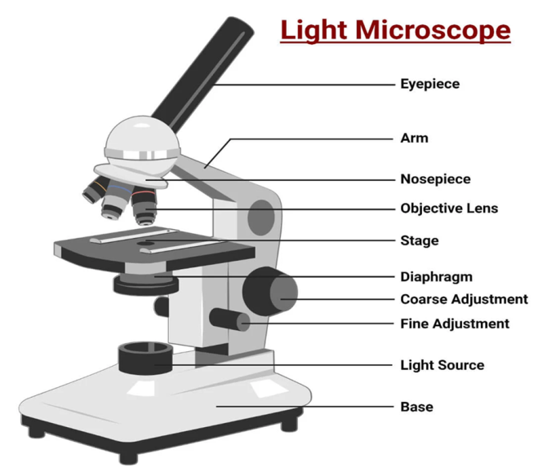

Fig. 3. Schematic diagram of an optical microscope
The optical microscope offers a magnification range of 10 to 1000× and a resolution of 0.2 μm or 200 nm, facilitating the visualization of size, shape, and internal structure of individual particles and cells. Specific stains are utilized to color distinct components in food, aiding in the identification of protein, fat, starch, and sugar. Starch is revealed using iodine, fats with osmium tetroxide, proteins with hematoxylin, and carbohydrates with periodic acid-schiff staining (34).
Blaszczak and Lewandowicz (2020) observed that at room temperature, potato starch granules remained unchanged and appeared as black spots in the micrographs (Fig. 4A). In LM images, the swollen granules exhibited red-blue-mazarine ovals (Figure 1B). The red color indicated the presence of amylopectin-iodine complexes, while the blue color represented amylose complexes, with darker regions denoting non-gelatinized areas. The transparency of these shapes depended on the extent of gelatinization among different granules. Additionally, the micrographs unveiled the presence of the hydrated amylose phase, which leaked out from the starch granules, contributing to the paste milieu (Fig. 4B). Upon heating the potato starch granules at 90°C, a more advanced gelatinization stage was observed (Fig. 4C). A substantial portion of the released amylose formed droplets, and in conjunction with solubilized amylopectin, constituted a bicontinous network to some extent.
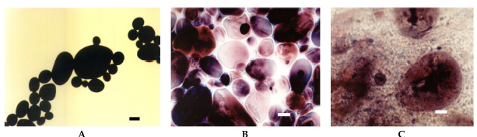

Fig. 4. LM micrographs (20×) of native potato starch dispersions incubated at different temperatures for 15 min: (A) 25°C, (B) 68°C, (C) 90°C, (Bar-20 µm). LM: light microscopy.
Borem et al. (2008) examined the structural changes in coffee seeds exposed to different drying temperatures (40, 50, and 60°C) in a tray dryer until they reached a final moisture content of 11% w.b. Sudan IV staining was employed to visualize the oil globules in the coffee seeds. Drying at 40°C resulted in oil globules exhibiting a globular shape within the cells, owing to the preserved integrity of the plasma membrane (Fig. 5). At 50°C, the oil was located at the extremities of the endosperm tissue. However, at 60°C, the oil spread throughout the cellular surface, forming large droplets in the intercellular spaces. The rupture of membranes exposed the oils to oxidation, leading to the formation of undesirable compounds that significantly altered the coffee's aroma and flavor.

Fig. 5. LM of coffee seeds dried at (a) 40°C (b) 50°C and (c) 60°C

Phothiset and Charoenrein (2014) studied the effect of freezing and thawing on microstructure changes in papaya tissues. Toluidine blue was used to visualize substructures of cell. Papaya cubes were frozen at -40°C until product reaches to -25°C and thawed at 4°C for 4 h. The freeze–thawing processes caused an increase in pectic and hemicellulosic depolymerization in cell walls and loss of vacuoles (Fig. 6.) resulted in cell shrinkage that was associated with a decrease in firmness and an increase in drip volume.
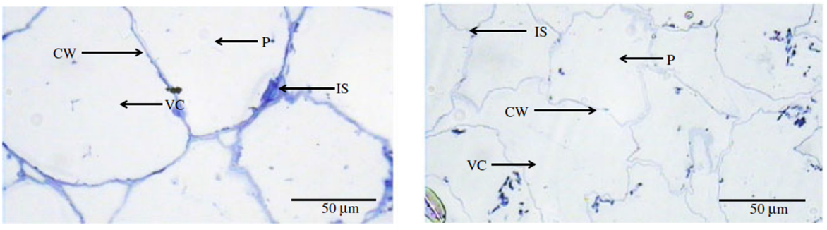

Fig. 6. LM images of (a) fresh papaya tissue; (b) freeze–thaw cycle. CW, cell wall; IS, intercellular spaces; VC, vacuoles; P, protoplast
The advantages of an optical microscope include being inexpensive, relatively compact and easy to set up and use, whereas its disadvantages include (i) only has 1,000 times magnification (ii) Specimens may become deformed while being prepared for microscopy (iii) only has a 0.2 m resolution (iv) Working with various stains is challenging (18).

4.2. Fluorescence microscopy
A fluorescence microscope is an optical microscope that uses fluorescence instead of, or in addition to, scattering, reflection and attenuation or absorption, to study the properties of organic or inorganic substances. "Fluorescence microscope" refers to any microscope that uses fluorescence to generate an image, whether it is a simple set up like an epifluorescence microscope or a more complicated design such as a confocal microscope, which uses optical sectioning to get better resolution of the fluorescence image (Fig. 7.). It has a magnification of 120- 14400× with the resolution of 177 nm (43).
Fluorescence is the light emitted from an atom, a molecule, or a material excited to the electronically active state. The wavelength or energy of the excitation light is characteristic to the chemical bonds within a molecular or to the chemical/ physical state of a material. Optical filters are added to a bright light source to select target wavelength for excitation, or excitation spectrum and fluorescence filters are added after the sample to capture emission spectrum. Fluorescent stains, which contain functional groups that fluoresce upon excitation (called fluorochrome), also can be added to a sample to contrast components that they have strong affinity with. Staining can be done positively (staining the target structure) or negatively (staining nontarget structures). Many food materials contain natural fluorochrome. When a proper excitation wavelength is selected, bright color from fluorescence emission can be easily visualized under the light microscope.
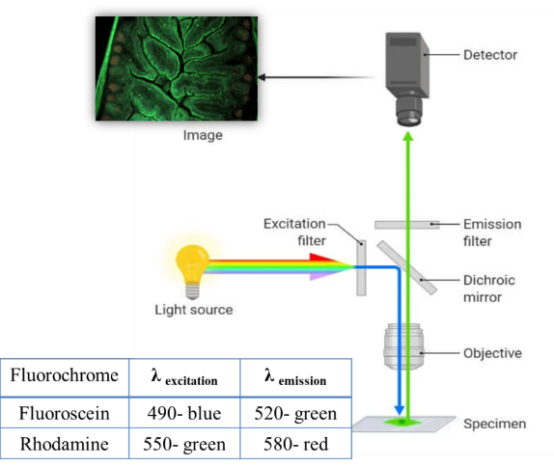

Fig. 7. Schematic view of fluorescence microscope
Fig. 8. shows the aleurone layer within a wheat kernel that auto-fluoresces bright blue, making that particular layer of cells become obvious to the viewer, over any other cell types within the wheat kernel (5).

Fig. 8. Particles of wheat fiber demonstrating various colors of auto-fluorescence
Tsai et al. (2010) evaluated the contribution of phenol-pectin crosslink in strengthening the texture of guava slices during thermal processing. Guava slice (2 cm) was treated with ferulic acid (0.5 g/kg) and dehydrated at 30°C for 36 h with air convectional drier. Excitation wavelength of 488 nm was used. Ferulic acid treated guava slice exhibited higher hardness (4.2 kg) than control (2.5 kg) which strengthened the texture of guava. Autofluorescence was observed at the borders of the cell wall (Fig. 10.). Evident that the accumulated phenolic compounds around the cell wall might link with pectin and prevent the detachment of cells during processing.
Fig. 10. Fluorescence photograph of ferulic acid treated guava slices

4.3. Confocal laser scanning microscopy
Confocal microscopy, most frequently confocal laser scanning microscopy (CLSM) or laser confocal scanning microscopy (LCSM), is an optical imaging technique for increasing optical resolution and contrast of a micrograph by means of using a spatial pinhole to block out-of-focus light in image formation. Capturing multiple two-dimensional images at different depths in a sample enables the reconstruction of three-dimensional structures within an object. This technique is used extensively in the scientific and industrial communities and typical applications are in life sciences, semiconductor inspection and materials science (31).
Light travels through the sample under a conventional microscope as far into the specimen as it can penetrate, while a confocal microscope only focuses a smaller beam of light at one narrow depth level at a time (Fig. 11.). The CLSM achieves a controlled and highly limited depth of field.
The principle of confocal imaging was patented in 1957 by Marvin Minsky and aims to overcome some limitations of traditional wide-field fluorescence microscopes. In a conventional fluorescence microscope, the entire specimen is flooded evenly in light from a light source. All parts of the sample can be excited at the same time and the resulting fluorescence is detected by the microscope's photodetector or camera including a large unfocused background part. In contrast, a confocal microscope uses point illumination and a pinhole in an optically conjugate plane in front of the detector to eliminate out-of-focus signal – the name "confocal" stems from this configuration. As only light produced by fluorescence very close to the focal plane can be detected, the image's optical resolution, particularly in the sample depth direction, is much better than that of wide-field microscopes. However, as much of the light from sample fluorescence is blocked at the pinhole, this increased resolution is at the cost of decreased signal intensity – so long exposures are often required. To offset this drop-in signal after the pinhole, the light intensity is detected by a sensitive detector, usually a photomultiplier tube (PMT) or avalanche photodiode, transforming the light signal into an electrical one (30).
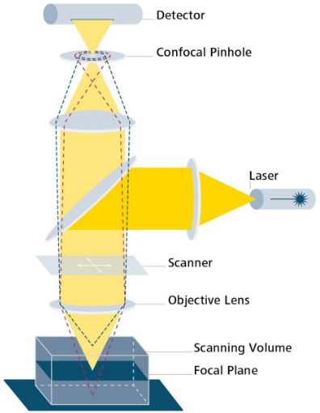
Fig. 11. Schematic view of a confocal laser scanning microscope
As only one point in the sample is illuminated at a time, 2D or 3D imaging requires scanning over a regular raster (a rectangular pattern of parallel scanning lines) in the specimen. The beam is scanned across the sample in the horizontal plane by using one or more (servo controlled) oscillating mirrors. This scanning method usually has a low reaction latency and the scan speed can be varied. Slower scans provide a better signal-to-noise ratio, resulting in better contrast.
The achievable thickness of the focal plane is defined mostly by the wavelength of the used light divided by the numerical aperture of the objective lens, but also by the optical properties of the specimen. The thin optical sectioning possibly makes these types of microscopes particularly good at 3D imaging and surface profiling of samples. Successive slices make up a 'z-stack', which can either be processed to create a 3D image, or it is merged into a 2D stack (predominately the maximum pixel intensity is taken, other common methods include using the standard deviation or summing the pixels) (30).
Krebs et al. (2022) studied the effect of UHP homogenization on the microstructure of buttermilk. 1% Fast Green (proteins) and 1% Nile Red (fat) were used as flurochromes. The sample was excited with 488- and 638-nm lasers and collected at 590 nm and 755 nm, respectively. Results found that with increasing pressure from 0 to 300 MPa, the particles became much smaller, more homogeneous protein distribution in aggregates associated together into a filamentous manner which gave stable structure to buttermilk (Fig. 12.).
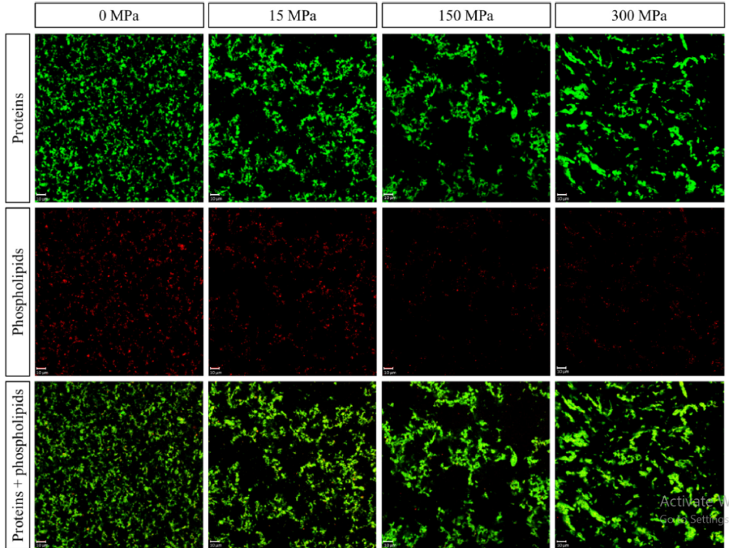
Fig. 12. Confocal laser scanning microscopy images at 40× magnification of buttermilk at various pressure levels of 0, 15, 150 and 300 MPa
Limitations of fluroscence microscope are as follows (i) It has a lower resolution than SEM and TEM, (ii) Fluorophores lose their capacity to fluorescence due to photobleaching when a short wavelength is used, (iii) Low light sensitivity and (iv) High complexity and cost (24).

4.4. Stimulated emission depletion microscopy
Stimulated emission depletion (STED) microscopy is one of the techniques that make up super-resolution microscopy. It creates super-resolution images by the selective deactivation of fluorophores, minimizing the area of illumination at the focal point and thus enhancing the achievable resolution for a given system as shown in Fig. 12 (4).
STED microscopy is one of several types of super resolution microscopy techniques that have recently been developed to bypass the diffraction limit of light microscopy to increase resolution. STED is a deterministic functional technique that exploits the non-linear response of fluorophores commonly used to label biological samples in order to achieve an improvement in resolution, that is to say STED allows for images to be taken at resolutions below the diffraction limit (12).
STED functions by depleting fluorescence in specific regions of the sample while leaving a center focal spot active to emit fluorescence. This focal area can be engineered by altering the properties of the pupil plane of the objective lens. The most common early example of these diffractive optical elements, or DOEs, is a torus shape used in two-dimensional lateral confinement shown below. The red zone is depleted, while the green spot is left active. This DOE is generated by a circular polarization of the depletion laser, combined with an optical vortex. The lateral resolution of this DOE is typically between 30 and 80 nm. However, values down to 2.4 nm have been reported (38).
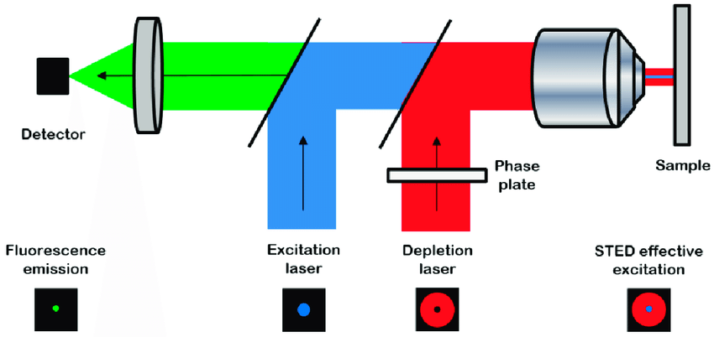

Fig. 12. Stimulated emission depletion microscopy principle
Jose et al. (2022) compared super-resolution microscopy technique and conventional confocal microscopy for visualizing protein microstructural organization in egg white protein and its relation to rheology. STED microscopy was able to resolve protein microstructures with a 5-fold increase in resolution compared to the confocal system. This gain in resolution allowed a more precise quantification of the structure, with quantification of 7–13 times more particles in the solid area of the materials compared to confocal images. The increase of particle count and particle density measured in the STED images showed a correlation with the logarithmic increase of the elastic modulus of the egg-white cooked at the three different temperatures (Fig. 13.).

Fig. 13. (A) Image of cooked egg albumen in confocal and STED at three different cooking temperatures. (B) Quantitative data extracted from the egg microstructure images captured with both confocal and STED systems simultaneously

4.5. Raman microscopy
In Raman imaging, a confocal microscope is combined with a spectrometer and a Raman spectrum is recorded at every point of the sample. Optical microscope objective lenses are used to observe the sample and pass the Raman scatter to the spectrograph. Mapping of constituents of interest in complex food matrices like chemical distribution, quantity and structural arrangement. The main limitations of Raman spectroscopy involve signal detectability. Low detection could be because a material is not Raman active, because it emits a poor Raman signal (9).
Fig. 14. Raman microscopy images of milk (Pink = calcium; Green = protein; Red = fat and Orange = carotenoids) (9)
Lohumi et al. (2018) studied detection of adulterants (Sudan-I and Congo Red dyes) in paprika powder using excitation wavelength of 785 nm and Raman shifts of 763 to 2837 cm⁻¹. Results found that adulterants could be detected at the level of 0.1, 0.25 and 0.5% (Fig. 15.).
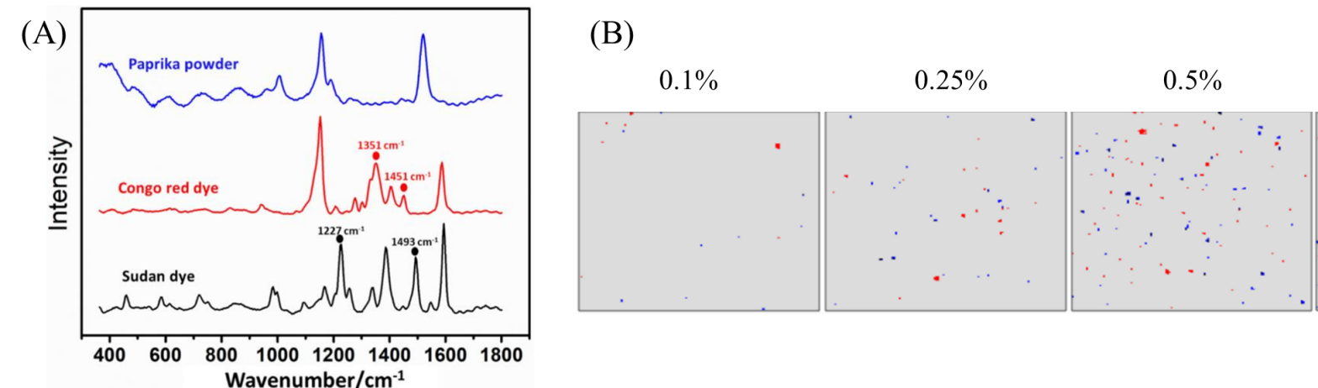

Fig. 15. Raman spectra of paprika powder and adulterants and (B) combined color-coded Raman chemical images for each adulterant at different concentrations (0.1, 0.25, 0.5%).

4.6. Transmission electron microscopy
Transmission electron microscopy (TEM) is a microscopy technique in which a beam of electrons is transmitted through a specimen to form an image. The specimen is most often an ultrathin section less than 100 nm thick or a suspension on a grid. An image is formed from the interaction of the electrons with the sample as the beam is transmitted through the specimen. The image is then magnified and focused onto an imaging device, such as a fluorescent screen, a layer of photographic film, or a sensor such as a scintillator attached to a charge-coupled device (20).
Transmission electron microscopes are capable of imaging at a significantly higher resolution than light microscopes, owing to the smaller de Broglie wavelength of electrons. This enables the instrument to capture fine detail-even as small as a single column of atoms, which is thousands of times smaller than a resolvable object seen in a light microscope.
TEM instruments have multiple operating modes including conventional imaging, scanning TEM imaging (STEM), diffraction, spectroscopy and combinations of these. TEM is capable of returning an extraordinary variety of nanometer- and atomic-resolution information, in ideal cases revealing not only where all the atoms are but what kinds of atoms they are and how they are bonded to each other. For this reason, TEM is regarded as an essential tool for nanoscience in both biological and materials fields (20).
From the top down, the TEM consists of an emission source or cathode, which may be a tungsten filament, a lanthanum hexaboride (LaB6) single crystal or a field emission gun. The gun is connected to a high voltage source (typically ~100–300 kV) and emits electrons either by thermionic or field electron emission into the vacuum. In the case of a thermionic source, the electron source is mounted in a Wehnelt cylinder to provide preliminary focus of the emitted electrons into a beam while also stabilizing the current using a passive feedback circuit. A field emission source uses instead electrostatic electrodes called an extractor, a suppressor and a gun lens, with different voltages on each, to control the electric field shape and intensity near the sharp tip. The combination of the cathode and these first electrostatic lens elements is collectively called the "electron gun". After it leaves the gun, the beam is typically accelerated until it reaches its final voltage and enters the next part of the microscope: the condenser lens system. These upper lenses of the TEM then further focus the electron beam to the desired size and location on the sample (Fig. 17).

Fig. 17. Schematic view of a transmission electron microscope

4.7. Scanning electron microscopy
A scanning electron microscope (SEM) is a type of electron microscope that produces images of a sample by scanning the surface with a focused beam of electrons. The electrons interact with atoms in the sample, producing various signals that contain information about the surface topography and composition of the sample. The electron beam is scanned in a raster scan pattern and the position of the beam is combined with the intensity of the detected signal to produce an image. In the most common SEM mode, secondary electrons emitted by atoms excited by the electron beam are detected using a secondary electron detector. The number of secondary electrons that can be detected and thus the signal intensity, depends, among other things, on specimen topography. Some SEMs can achieve resolutions better than 1 nanometer.
Specimens are observed in high vacuum in a conventional SEM, or in low vacuum or wet conditions in a variable pressure or environmental SEM and at a wide range of cryogenic or elevated temperatures with specialized instruments (23).
The signals used by a SEM to produce an image result from interactions of the electron beam with atoms at various depths within the sample. Various types of signals are produced including secondary electrons (SE), reflected or back-scattered electrons (BSE), characteristic X-rays and light (cathodoluminescence) (CL), absorbed current (specimen current) and transmitted electrons. Secondary electron detectors are standard equipment in all SEMs, but it is rare for a single machine to have detectors for all other possible signals.
Secondary electrons have very low energies on the order of 50 eV, which limits their mean free path in solid matter. Consequently, SEs can only escape from the top few nanometers of the surface of a sample. The signal from secondary electrons tends to be highly localized at the point of impact of the primary electron beam, making it possible to collect images of the sample surface with a resolution of below 1 nm. Back-scattered electrons (BSE) are beam electrons that are reflected from the sample by elastic scattering. Since they have much higher energy than SEs, they emerge from deeper locations within the specimen and, consequently, the resolution of BSE images is less than SE images. However, BSE are often used in analytical SEM, along with the spectra made from the characteristic X-rays, because the intensity of the BSE signal is strongly related to the atomic number (Z) of the specimen. BSE images can provide information about the distribution, but not the identity, of different elements in the sample. In samples predominantly composed of light elements, such as biological specimens, BSE imaging can image colloidal gold immuno-labels of 5 or 10 nm diameter, which would otherwise be difficult or impossible to detect in secondary electron images. Characteristic X-rays are emitted when the electron beam removes an inner shell electron from the sample, causing a higher-energy electron to fill the shell and release energy. The energy or wavelength of these characteristic X-rays can be measured by Energy-dispersive X-ray spectroscopy or Wavelength-dispersive X-ray spectroscopy and used to identify and measure the abundance of elements in the sample and map their distribution.
Due to the very narrow electron beam, SEM micrographs have a large depth of field yielding a characteristic three-dimensional appearance useful for understanding the surface structure of a sample. This is exemplified by the micrograph of pollen shown above. A wide range of magnifications is possible, from about 10 times (about equivalent to that of a powerful hand-lens) to more than 500,000 times, about 250 times the magnification limit of the best light microscopes.
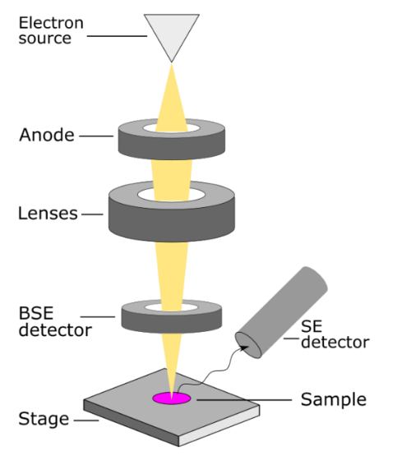
Fig. 18. Schematic view of a scanning electron microscope
Sharma et al. (2017) investigated the emulsifying ability of sodium caseinate in combination with pectin to encapsulate the clove oil in the form of nanoemulsions. Mixed clove oil, NaCas (5%) and pectin (1%) by using high speed magnetic stirrer at 25°C for 20 min at 15,000 to 24,000 rpm and stored at 25°C for one month. Used SEM at 15 kV and TEM at 70 kV for analysis.

Fig. 19. SEM of stable clove oil nanoemulsion showed spherical nanoparticles with slight aggregation

Fig. 20. TEM (a) shows spherical nanoemulsion droplets; (b) shows the core material having size ~36 nm and encapsulated within coating material i.e having size ~54 nm
The formulation remained stable against phase separation for a period of 20 days (storage period). Morphological studies (SEM and TEM) affirmed the core material i.e. clove oil, is completely condensed in the coat material (Fig. 19. and Fig. 20).
Borem et al. (2008) evaluated the changes in the structure of coffee seed subjected to different temperatures of 40, 50 and 60°C in tray dryer at until it reaches final moisture (11% w.b.) Sudan IV was used to stain oil globules of coffee seed. Drying of coffee at 40°C, oil is in globular shape inside the cells due to preserved integrity of the plasma membrane (Fig. 21.). At 50°C, oil is in the extremity of the endosperm tissue. At 60°C, oil is spread throughout the cellular surface forming large droplets in the intercellular spaces. Rupture of the membranes exposed the oils to oxidation, which in turn leads to the formation of undesirable compounds that alter the coffee’s aroma and flavor.

Limitations of electron microscope are as follows (a) Images are black and white, (b) Instruments are very large and expensive, (c) EMs require special housing and maintenance because they are sensitive to mechanical vibration, fluctuation of electromagnetic fields, (d) Sample preparations from bulk materials are normally very time-consuming, (e) Potential artifacts can be generated by sample preparation, (f) Special training is needed for tool operation and data analysis, (g) Samples are limited to those that tolerate the vacuum chamber and are small and solid enough to fit in the chamber and (h) Maximum size in horizontal dimensions is usually on the order of 10 cm, vertical dimensions are generally much more limited and rarely exceed 40 mm.

4.8. Cryo-electron microscopy
Cryogenic electron microscopy (cryo-EM) is a cryomicroscopy technique applied on samples cooled to cryogenic temperatures. For biological specimens, the structure is preserved by embedding in an environment of vitreous ice. An aqueous sample solution is applied to a grid-mesh and plunge-frozen in liquid ethane or a mixture of liquid ethane and propane. While development of the technique began in the 1970s, recent advances in detector technology and software algorithms have allowed for the determination of biomolecular structures at near-atomic resolution.
Cryogenic electron microscopy involves the imaging the radiation-sensitive samples by a under low temperature conditions and enables the biomolecules structure determination within cellular conditions. It helps to study thin, frozen slices of suspensions, allowing for morphology studies of particles in their dispersed state. The reduction of sample heating by the electron beam and thus the reduction of potential beam damage of sensitive materials. It has magnification of 50-500 lakhs× and resolution of 1.22 Å.
Trejo et al. (2021) examined the interior of the native casein micelle from bovine milk. Milk was frozen at –182°C and Cryo-EM was operated at 200 kV with magnification of 38,000×. The tomograms demonstrated the presence of water-filled cavities and channels within the interior of the native micelle structure and the absence of any spherical protein substructures. These inner cavities, which are interconnected by wide channels, explain the dynamic nature of the native casein micelle and its ability to release and retain β-casein macromolecules (Fig. 21.).
Fig. 21. Electron tomogram of the native casein micelle, highlighting in blue the protein nanoclusters and in magenta, the positions of the higher density colloidal calcium phosphate

4.9. X-ray computed tomography
A computed tomography scan (usually abbreviated to CT scan; formerly called computed axial tomography scan or CAT scan) is a medical imaging technique used to obtain detailed internal images of the body. The personnel that perform CT scans are called radiographers or radiology technologists. CT scanners use a rotating X-ray tube and a row of detectors placed in a gantry to measure X-ray attenuations by different tissues inside the body. The multiple X-ray measurements taken from different angles are then processed on a computer using tomographic reconstruction algorithms to produce tomographic (cross-sectional) images (virtual "slices") of a body. CT scan can be used in patients with metallic implants or pacemakers, for whom magnetic resonance imaging (MRI) is contraindicated. Since its development in the 1970s, CT scanning has proven to be a versatile imaging technique. While CT is most prominently used in medical diagnosis, it can also be used to form images of non-living objects. The 1979 Nobel Prize in Physiology or Medicine was awarded jointly to South African-American physicist Allan MacLeod Cormack and British electrical engineer Godfrey Hounsfield "for the development of computer-assisted tomography”.
X-ray computed tomography (Fig. 22) is a technique that exploits differences in attenuation of X-ray radiation by materials to generate transmission images (radiographs) of samples. From multiple radiographs taken from different angles to the sample, a 3D image (a tomograph) is computed. Internal content or microstructures of food products, such as fat and protein distribution and air bubble distribution (Fig. 23 and 24). The white region shows higher absorption of X-Rays, i.e., high-density region by material and the black region shows lower absorption, i.e., air voids and gas phase. It has a Resolution of 1 μm and magnification of 1000-2000× (42).
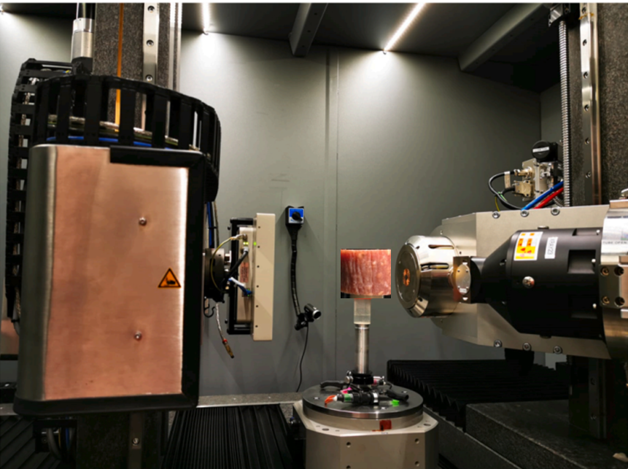
Fig. 22. Experimental setup for X- ray CT for Salami
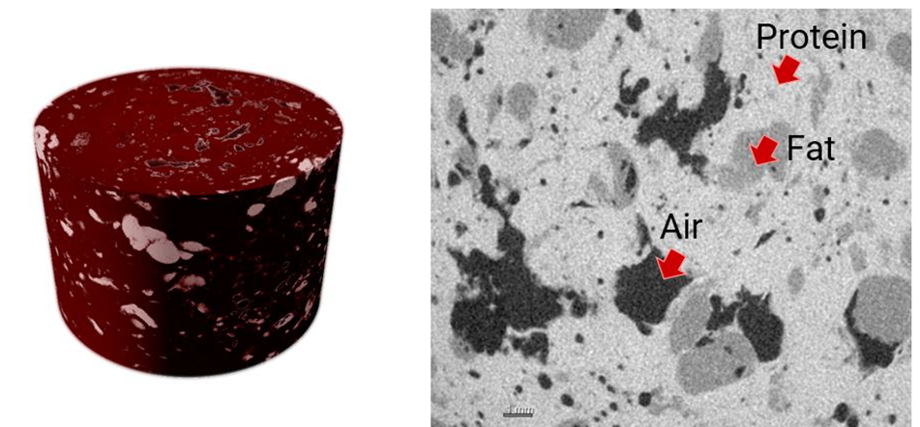
Fig. 23. 3D rendered scan is shown on the left and a cross-section is shown on the right
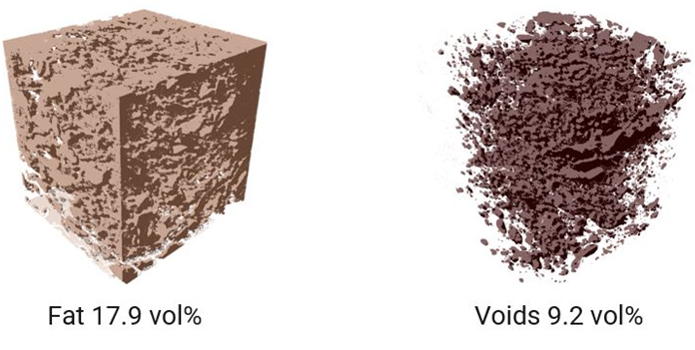
Fig. 24. Distribution and volume fraction analysis
Limitations of X-ray CT scnning includes finite resolution that causes some blurring of material boundaries and not all features have sufficiently large attenuation contrasts for useful imaging. Image artifacts can complicate data acquisition and interpretation. Large data volumes can require considerable computer resources for visualization and analysis. X-ray imaging is limited to detection of macro-size particles and it cannot detect the presence of nano materials (42).

4.10. Nuclear magnetic resonance imaging
A nondestructive technique that can be used to acquire two-dimensional and even three-dimensional images of biological products. Measures the physical properties of the sample such as proton density and relaxation times. NMR relaxation time is used as a parameter for the quantification of water or fat content or for the extraction of information related to changes in microstructure. Nuclear magnetic resonance (NMR) studies magnetic nuclei such as protons by aligning them with an applied constant magnetic field (Fig. 25.) and perturbing this alignment using an alternating magnetic field (21).
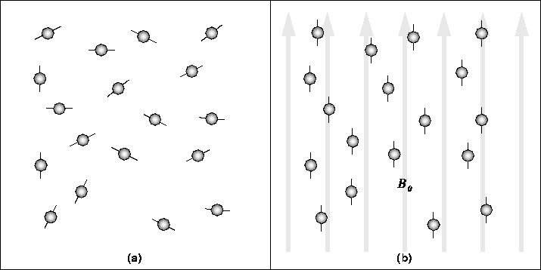

Fig. 25. Basic principle of MRI
NMR relaxation measures the changes of the NMR signal, which result from the nuclear magnetization or alignment, as a function of time. This signal generally becomes weaker after an excitation as the nuclei lose their aligned orientation. As a result, different time constants can be computed for the population of nuclei in the sample to return to their thermodynamic rest state after an electromagnetic pulse is applied. The time constants are related to, among others, concentrations of the magnetic nuclei but also their mobility. 2D NMR relaxometry has been made possible with the development of appropriate algorithms for data analysis in early 2000. Since that time, it has been revolutionizing our approach to complex microstructured systems by providing detailed “relaxation spectra,” giving separate peaks for water in different pores and compartments in microstructured systems. Each peak in the 2D spectrum is characterized by a particular proton longitudinal and transverse relaxation time (T1 and T2, respectively), which differ according to the local water content and size/nature of the pore or compartment. Peaks from solutes and biopolymers may also arise in the spectrum and their relaxation times give additional information on their dynamic state such that the composition of the sample can be explored in detail. Other types of 2D relaxation and diffusion experiments are possible and these give information on localized water transport through the microstructure of fleshy food products such as tomato (28; 29) or mango as affected by processing (22). However, NMR does not provide spatial images. Progress has been made, however, with spatially resolved multiexponential relaxation using special sequences in magnetic resonance imaging (MRI). MRI greatly broadens the range of applications devoted to the inspection of food products. MRI provides a picture that contains combined spectroscopy and relaxometry information both spatially resolved. The studies performed to date are a demonstration of the potential of these techniques for the internal quality monitoring even under inline conditions: maturity in avocados, pit detection in cherries and olives, internal browning in apples, internal breakdown in pears, freeze injury and seed in citrus (2).
The amount and distribution of intramuscular fat in beef and pork are some of the most important quality characteristics because they highly influence the nutritional value and eating quality of the meat. Magnetic resonance imaging (MRI) is a suitable non–invasive alternative method that can provide both qualitative and quantitative information on beef meats with high spatial information. The results from image analysis were compared with the chemical reference result for the percentage of intramuscular fat. The results show a strong correlation (R² = 0.98) between the MRI detected and chemically measured values. The distribution uniformity of intramuscular fat within the beef meats was evaluated by calculating their distribution and pixel size in the MRI according to four levels of beef quality grade (Fig. 26 and 27.) (25).
Fig. 26. Main steps involved in extraction of fat pixels from the MRI image and application of ImageJ image processing. (a) Original MRI image of beef meat, (b) Selected total beef slice image, (c) Selected fat region image, (d) Extracted total beef slice image from background and (e) Extracted fat region image from muscle and background
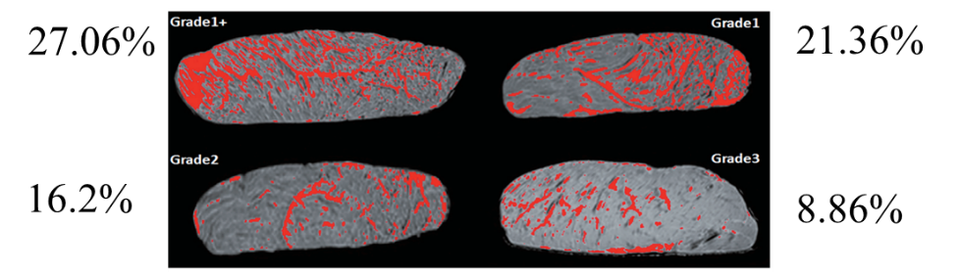
Fig. 27. MRI images of different grades of beef samples. Fat is in red

4.11. Atomic force microscopy
Atomic force microscopy (AFM) or scanning force microscopy (SFM) is a very-high-resolution type of scanning probe microscopy (SPM), with demonstrated resolution on the order of fractions of a nanometer, more than 1000 times better than the optical diffraction limit.
Atomic force microscopy (AFM) is a type of scanning probe microscopy (SPM), with demonstrated resolution on the order of fractions of a nanometer, more than 1000 times better than the optical diffraction limit. The information is gathered by "feeling" or "touching" the surface with a mechanical probe. Piezoelectric elements that facilitate tiny but accurate and precise movements on (electronic) command enable precise scanning. For imaging, the reaction of the probe to the forces that the sample imposes on it can be used to form an image of the three-dimensional shape (topography) of a sample surface at a high resolution. This is achieved by raster scanning the position of the sample with respect to the tip and recording the height of the probe that corresponds to a constant probe-sample interaction. In manipulation, the forces between tip and sample can also be used to change the properties of the sample in a controlled way. Examples of this include atomic manipulation, scanning probe lithography and local stimulation of cells. Simultaneous with the acquisition of topographical images, other properties of the sample can be measured locally and displayed as an image, often with similarly high resolution. Examples of such properties are mechanical properties like stiffness or adhesion strength and electrical properties such as conductivity or surface potential. In fact, the majority of SPM techniques are extensions of AFM that use this modality (37).
Tiwari et al. (2018) studied microwave-assisted alkali pretreatment for the production of sugars from banana fruit peel waste. AFM Showed a roughness and unevenness in pretreated samples, possibly due to disruption of structures of cell wall which might have resulted into a significant reduction of hemicelluloses and lignin content and led to a high amount of sugar production (Fig. 28) (0.561 g/ g of dry biomass waste).
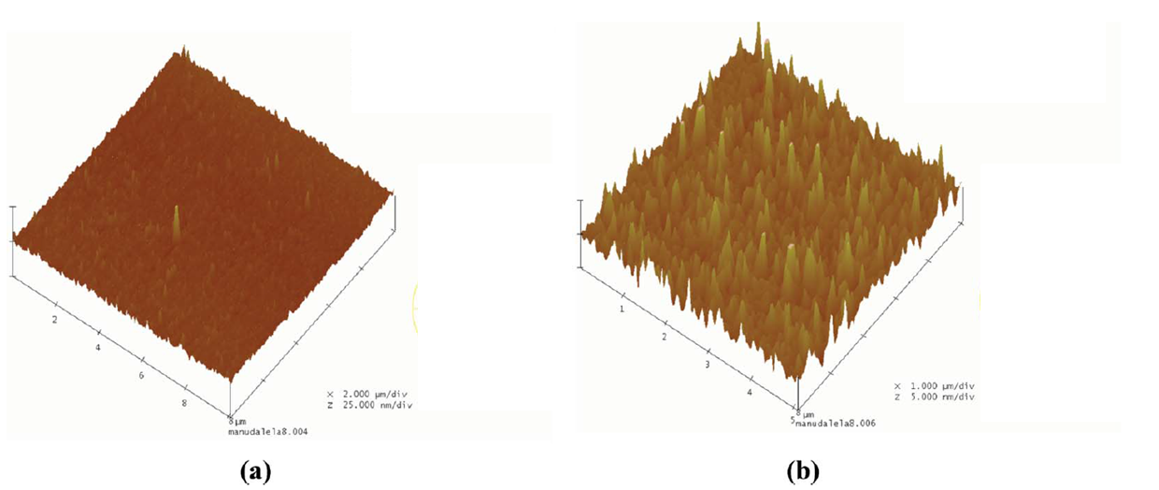
Fig. 28. Atomic force microscopy (AFM) images of (a) raw banana peel waste and (b) banana peel waste pretreated at 600 W for 2 min
Liu et al. (2017) evaluated the changes in structure of Escherichia coli subjected to electrolysed water. Untreated E. coli cells had relatively smooth surfaces (average deviation of the sample surface height from its mean height = 10 ± 1.5 nm) with small spherical structures. When treated with EW at 4 mg/L free available chlorine, wrinkled bundles were observed and an increased RMS of 23 ± 4.4 nm was noticed. This rough surface and deformed cellular structure demonstrate that EW causes morphological changes in E. coli (Fig. 29).
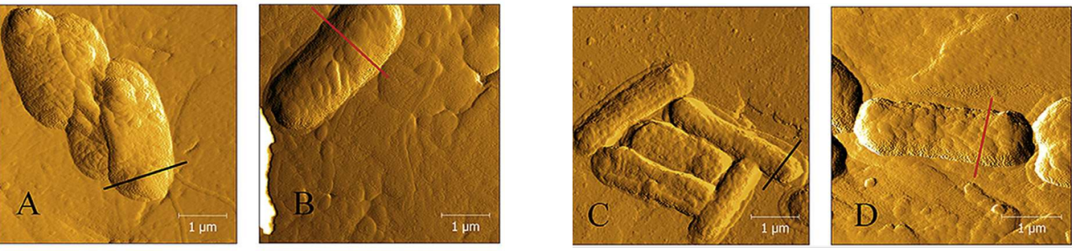

Fig. 29. AFM Morphology of fresh and treated E. coli by EW: untreated (a-b), EW treated (c-d).

5. Microscopic techniques followed by FSSAI and CODEX for food analysis
- Determination of light filth in whole wheat flour- The method is applicable to whole wheat flour (atta), refined flour. A test portion is digested by boiling in a 3% HCl solution and the mixture is sieved. The residue is defatted by boiling in isopropanol and the mixture is sieved again. The filth is trapped with mineral oil in a mixture of Tween 80 and Na₄EDTA in 40% isopropanol. The oil phase is trapped off, filtered and examined microscopically for filth elements. No filth should be visible under microscope. Light Filth must be absent in wheat flour (14).
- Test for the presence of animal body fat in vegetable fat- Animal body fats such as beef tallow and lard have been shown to contain trisaturated glycerides. On crystallization these glycerides exhibit a characteristic crystalline appearance when viewed under microscope. Examine the crystals under x 160 and finally x 400 magnifications. The typical appearance of beef tallow crystallized into characteristic fan like tufts, the ends of which are more or less pointed can be seen. Lard crystals are of chisel shaped. Hydrogenated fats deposit smaller size crystals. The size and shape of the crystals depend upon the strength of solution, amount of fat taken and the time allowed for crystallization. (16).
- Microscopic examination of spices- The spice is boiled with Chloral hydrate to make them transparent. Chloral hydrate has two-fold action: (1) it removes starch thereby concentrating other tissues and (2) it removes coloring matter from the tissues so that the outlines of the can be seen much more clearly. Phloroglucinol is used to stain Sclerenchymatous matter (13).
- Test for chicory in coffee- Boil about 1 g of sample with 50 ml of 2% sodium hydroxide for about 2 - 3 minutes. Dilute and filter and wash the residue with water till the filtrate is free of alkali. Repeat till the residue gives no colour with water (treatment with calcium chloride solution and then washing with water may be done in case the decant still shows some colouring matter. Place a drop of residue material in glycerine on a clear microscopic slide. Coffee is characterized by longitudinal and transverse schlerenchymatous fibres (from pericarp) Chicory has large vessels upto 115 microns across which have short pits. Roasted cereals such as barley, oats and wheat and soya may be mixed with coffee and coffee and chicory as coffee substitutes. Careful microscopic examination will reveal their presence (15).
- Method for distinguishing type of peas- This method is based on differentiation between starch granules of the wrinkled-seeded types and starch granules of the smooth-seeded types. Starch granules of the smooth-seeded types (round, early, Continental) show up as an amorphous mass with no well-defined geometric shape. Starch granules of the wrinkled-seeded types (garden peas, sweet) show up as clear cut, well defined, generally spherical particles (10).

6. Key characteristics of tools to examine food microstructure

Table 1. Key characteristics of tools to examine food microstructure (11)
Tool | Imaging agent | Resolution | Information
Optical microscopy | Visible light | ̴200 nm | Morphology, composition with staining
Fluorescence microscopy | Visible light | 177 nm | Composition
Confocal laser scanning microscopy | Laser | 120 nm | Ingredient localisation, 3D information
Raman microscopy | Laser | 0.2 μm | Chemical distribution and its quantitative assessment
Stimulated emission depletion microscopy | Laser | 20 nm | To visualize and quantify protein, fat, starch microstructural organization
Transmission electron microscopy | Electron | 0.1 nm | Fine structural detail, macromolecular interactions
Scanning electron microscopy | Electron | 0.5 nm | Surface topography and composition of the sample
Electron tomography | Electron | 1.22 Å | Surface topography and composition of the sample in their native state
X-ray computed tomography | X- rays | 1 μm | Non-destructive 3D structure based on atomic contrast
Nuclear magnetic resonance imaging | Protons | 1 μm | Quantification of water or fat
Atomic force microscopy | Electron | 0.1 nm | Surface topology

7. Limitations of food microstructure analysis techniques
While Food Microstructure Analysis Techniques offer valuable insights into the hidden world of food, they also come with certain limitations that researchers and food scientists should be aware of. Some of the limitations include:
- Sample preparation complexity: Many microscopy techniques require meticulous sample preparation, which can be time-consuming and labor-intensive. Preparing samples for analysis may involve delicate cutting, staining, and fixation procedures, which can introduce artifacts and alter the original microstructure.
- Destructive analysis: Some microscopy methods, such as transmission electron microscopy and scanning electron microscopy, often require the destruction of the sample or its portion during the preparation process. This limitation restricts the ability to analyze the same sample multiple times or perform additional tests on it.
- Limited depth of field: Traditional microscopy techniques often have a limited depth of field, which means that only a thin slice of the sample is in focus at a time. This may hinder the complete visualization and understanding of the three-dimensional microstructure of complex food systems.
- Resolution limitations: The resolution of light microscopy, although significantly improved over the years, is still limited when compared to advanced imaging techniques like super-resolution microscopy or electron microscopy. This limitation may affect the ability to visualize nanoscale structures and interactions within the food matrix.
- Accessibility: Sophisticated microscopy equipment, such as transmission electron microscopes and confocal laser scanning microscopes, can be expensive to acquire and maintain. This cost may restrict the accessibility of these techniques to certain research facilities and limit their wider application.
- Sample size requirements: Some microstructure analysis techniques require a certain minimum sample size for accurate analysis. This could be challenging when dealing with limited or precious food samples, especially in research involving rare or valuable food materials.
- Data analysis complexity: Microscopy generates large volumes of image data that need to be meticulously analyzed and interpreted. The complexity of data analysis and the need for specialized software and expertise can be a challenge for researchers, especially in multidimensional imaging studies.
Despite these drawbacks, Food Microstructure Analysis Techniques remain indispensable tools for understanding the intricate composition and functionality of food materials. Being cognizant of these limitations allows researchers to employ these techniques judiciously and seek complementary methods to obtain comprehensive insights into food microstructures.

8. Conclusion
In conclusion, Food Microstructure Analysis Techniques present numerous opportunities for advancing our understanding of food materials. These techniques, ranging from traditional microscopy to advanced imaging and spectroscopy, have allowed us to visualize and analyze the intricate microstructures of food, leading to valuable insights into their composition, organization, and functionality. By harnessing this knowledge, researchers and food manufacturers can design and produce food products with tailored properties to meet specific consumer demands. These techniques also hold great potential for improving food safety by enabling the identification and characterization of additives, contaminants, and undesirable substances, ensuring the production of safer and high-quality food.
However, alongside these opportunities, there are certain drawbacks to consider. The complexity and diversity of food materials pose challenges in selecting the most appropriate microstructure analysis technique for each specific application. Some techniques may require extensive sample preparation, which could alter the natural microstructure, leading to potential artifacts. Additionally, the high cost and specialized expertise needed to operate certain advanced imaging equipment may limit accessibility for smaller food businesses and research laboratories.
Despite these drawbacks, the continual advancements in Food Microstructure Analysis Techniques offer a promising future for the food industry. As researchers continue to explore and refine these methods, addressing current limitations and improving efficiency, the potential benefits for food product development, quality control, and safety are expected to significantly outweigh the challenges. By leveraging these powerful tools, we can uncover the hidden world of food, leading to innovative and sustainable solutions that enhance the overall food experience for consumers worldwide.

9. References
- Aguilera, J. M., 2005, Why food microstructure?. Journal of Food Engineering, 67(2): 3-11.
- Adriaensen, H., Musse, M., Quellec, S., Vignaud, A., Cambert, M. and Mariette, F., 2013, MSEMRI sequence optimisation for measurement of bi- and tri-exponential T2 relaxation in a phantom and fruit. Magnetic Resonance Imaging, 31(2): 1677-1689.
- Błaszczak, W. and Lewandowicz, G., 2020, Light microscopy as a tool to evaluate the functionality of starch in food. Foods, 9(5): 670-676.
- Blom, H. and Brismar, H., 2014, STED microscopy: Increased resolution for medical research?. Journal of Internal Medicine, 276(6): 560–578.
- Bonilla, J. C. and Clausen, M. P., 2022, Super-resolution microscopy to visualize and quantify protein microstructural organization in food materials and its relation to rheology: Egg white proteins. Food Hydrocolloids, 124(3): 107281-107290.
- Borém, F. M., Marques, E. R. and Alves, E., 2008, Ultrastructural analysis of drying damage in parchment Arabica coffee endosperm cells. Biosystems Engineering, 99(1):62-66.
- Chaple, S., Sarangapani, C., Dickson, S. and Bourke, P., 2023, Product development and X-Ray microtomography of a traditional white pan bread from plasma functionalized flour. LWT-Food Science and Technology, 174(1): 114326-114337.
- Chargot, M., Chylińska, M., Pieczywek, P.M., Rösch, P., Schmitt, M., Popp, J. and Zdunek, A., 2016, Raman imaging of changes in the polysaccharides distribution in the cell wall during apple fruit development and senescence. Planta, 243(2): 935-945.
- Chawanji, A., Holroyd, S.E. and Nickless, E., 2022, Raman confocal microscopy to assess changes in cheddar cheese during maturation. International Journal of Dairy Technology, 75(4): 882-891.
- CODEX STAN 297-2009, Codex Standards in the WHO South-East Asia Region.
- Dong, J. and St. Jeor, V. L., 2017, Food microstructure techniques. Food Analysis, pp. 557-570.
- Dyba, M. and Hell, S. W., 2003, Photostability of a Fluorescent Marker Under Pulsed Excited-State Depletion through Stimulated Emission. Applied Optics, 42(25): 5123–5129.
- FSSAI, 2021. Manual For Analysis of Spices, Herbs and Condiments. Pp. 92.
- FSSAI, 2015. Manual of Methods of Analysis of Foods: Cereals and Cereal Products. Pp. 14-17.
- FSSAI, 2015. Manual of Methods of Analysis of Foods: Beverages (Coffee, Tea, Cocoa, Chicory) Sugar and Sugar Products & Confectionery Products. Pp. 16-19.
- FSSAI, 2015. Manual of Methods of Analysis of Foods: Oils and Fats. Pp. 50-52.
- Garud, S. R., Lamdande, A. G., Tavanandi, H. A., Mohite, N. K. and Nidoni, U., 2022, Effect of physicochemical properties on popping characteristics of selected pearl millet varieties. Journal of the Science of Food and Agriculture, 102(15): 7370-7378.
- Gunning, P. A., 2013, Light microscopy: principles and applications to food microstructures. Food Microstructures, 62–95. doi:10.1533/9780857098894.1.62 .
- Heintzmann, R. and Ficz, G., 2007, Breaking the resolution limit in light microscopy. Methods in cell biology, 81(1): 561-580.
- Jonge, N. and Ross, F. M., 2011, Electron microscopy of specimens in liquid. Nature Nanotechnology, 6(8): 695–704.
- Kirtil, E. and Oztop, M.H., 2016, 1 H nuclear magnetic resonance relaxometry and magnetic resonance imaging and applications in food science and processing. Food Engineering Reviews, 8(1): 1-22.
- Kirtil, E., Oztop, M.H., Sirijariyawat, A., Ngamchuachit, P., Barrett, D.M. and McCarthy, M.J., 2014. Effect of pectin methyl esterase (PME) and CaCl2 infusion on the cell integrity of fresh-cut and frozen-thawed mangoes: An NMR relaxometry study. Food research international, 66(1): 409-416.
- Klein, T., Buhr, E. and Frase, C. G., 2012, TSEM: A review of scanning electron microscopy in transmission mode and its applications. Advances in imaging and electron physics, 171(1): 297-356.
- Krebs, L., Pouliot, Y., Doyen, A., Venema, K. and Brisson, G., 2023. Effect of reverse osmosis and ultra-high-pressure homogenization on the composition and microstructure of sweet buttermilk. Journal of Dairy Science, 106(3): 1596-1610.
- Lee, S., Lohumi, S., Lim, H.S., Gotoh, T., Goto, T., Cho, B.K. and Jung, S., 2015, Determination of intramuscular fat content in beef using magnetic resonance imaging. Applied Magnetic Resonance, 60(1): 157–162.
- Liu, Q., Wu, J., Lim, Z. Y., Aggarwal, A., Yang, H., & Wang, S. (2017b). Evaluation of the metabolic response of Escherichia coli to electrolysed water by 1H NMR spectroscopy. LWT-Food Science and Technology, 79(4): 428–436.
- Lohumi, S., Lee, H., Kim, M.S., Qin, J. and Cho, B.K., 2018, Through-packaging analysis of butter adulteration using line-scan spatially offset Raman spectroscopy. Analytical and bioanalytical chemistry, 410(2): 5663-5673.
- Marigheto, N. A., Moates, G. K., Furfaro, M. E., Waldron, K. W. and Hills, B. P., 2009, Characterisation of ripening and pressure-induced changes in tomato pericarp using NMR relaxometry. Applied Magnetic Resonance, 36(9): 35-47.
- Musse, M., Cambert, M. and Mariette, F., 2010, NMR study of water distribution inside tomato cells: effects of water stress. Applied Magnetic Resonance, 38(2): 455-469.
- Patel, D. V. and McGhee, C. N., 2007, Contemporary in vivo confocal microscopy of the living human cornea using white light and laser scanning techniques: a major review. Clinical and Experimental Ophthalmology, 35(1): 71-88.
- Pawley, J. B., ed. 2006, Handbook of Biological Confocal Microscopy (3rd ed.). Berlin: Springer. ISBN 0-387-25921-X.
- Phothiset, S. and Charoenrein, S., 2014, Effects of freezing and thawing on texture, microstructure and cell wall composition changes in papaya tissues. Journal of the Science of Food and Agriculture, 94(2): 189-196.
- Sharma, M., Mann, B., Sharma, R., Bajaj, R., Athira, S., Sarkar, P. and Pothuraju, R., 2017. Sodium caseinate stabilized clove oil nanoemulsion: physicochemical properties. Journal of food engineering, 212(2): 38-46.
- Stephens, D. J. and Allan, V. J., 2003, Light microscopy techniques for live cell imaging. Science, 300(5616): 82-86.
- Sugumar, S., Nirmala, J., Ghosh, V., Anjali, H., Mukherjee, A. and Chandrasekaran, N., 2013. Bio‐based nanoemulsion formulation, characterization and antibacterial activity against food‐borne pathogens. Journal of basic microbiology, 53(8): 677-685.
- Sunil, C. K., Chidanand, D. V., Manoj, D., Choudhary, P. and Rawson, A., 2019, Effect of ultrasound treatment on dehulling efficiency of blackgram. Journal of Food Science and Technology, 55(7): 2504–2513.
- Tiwari, G., Sharma, A., Kumar, A. and Sharma, S., 2019. Assessment of microwave-assisted alkali pretreatment for the production of sugars from banana fruit peel waste. Biofuels, 10(1): 3-10.
- Torok, P. and Munro, P. R. T., 2004, The use of Gauss-Laguerre vector beams in STED microscopy. Optics Express, 12(15): 3605–3617.
- Trejo, R., Dokland, T., Jurat-Fuentes, J. and Harte, F., 2011, Cryo-transmission electron tomography of native casein micelles from bovine milk. Journal of dairy science, 94(12): 5770-5775.
- Tsai, P.J., Sun, Y.F. and Hsiao, S.M., 2010. Strengthening the texture of dried guava slice by infiltration of phenolic compounds. Food research international, 43(3): 825-830.
- Verboven, P., Defraeye, T. and Nicolai, B., 2018, Measurement and visualization of food microstructure: Fundamentals and recent advances. Food Microstructure and its Relationship with Quality and Stability, 2(3): 3-28.
- Vidhya, M., Varadharaju, N., John Kennedy, Z., Amirtham, D. and Manohar Jesudas, D., 2017, Applications of X-Ray Computed Tomography in Food Processing. Food research international, 2(8): 673-679.
- White, N.S. and Errington, R.J., 2005. Fluorescence techniques for drug delivery research: theory and practice. Advanced drug delivery reviews, 57(1): 17-42.

