Need of skill development program to empowering women: an initiative of Skill India Mission

Nandini Barman
Department of Education
Sikkim University
Nagaon, India

ABSTRACT

It is often said that, “when women move forward, the family moves, the village moves, and the nation moves” (Pandit Jawaharlal Nehru).The present paper intent to analyze the programs and initiatives taken by the Skill India Mission under Ministry of Skill Development and Entrepreneurship to promote self-employment among women. Indian women seems always indulged them with domestic activities and they give priority to look after their child to give best life. Thus keep the women isolated from workplace and unable to lead them independent life. In order to increase the women workforce in the mainstream, govt has taken many initiatives to encourage women employability in the workplace. Further a great number of women are involved in conventional and unorganized sector, which give them no security of wages or tenure, it keep them away to improve their social status and remain them in lower status . Hence it is necessary to remove the inadequacy between male and female, the gap has to be filled earlier to improve socio-economic status of the country. Therefore Skill India Mission comes with their special program to promote women employability by engaging them into training to develop skill among them. These training really cater the needs of women, by proving them all facilities like safe transport, flexible schedule, free accommodation and childcare support at the training center. It has transformed over 35.56 lakh women through various schemes viz. PMKVY, NAPS, JSS, CTS and CITS under MSDE to improve their social security, economy option and limit their opportunities to gain from newer, non-traditional professions.

Key words: Skill India Mission, self employment, women empowerment

- INTRODUCTION

Unemployment is a burning issue in our India. Govt take many initiatives to removing unemployment among youths. The Skill India Mission not only focus on Male employability but also taken steps to involve all women in this program, so that will ultimately befitted to our economy and gender equality. Involvement of both male and female together in the workforce can lead financial stability and economic growth of the country. Trainings given under this program really cater the all needs of women. For mothers they have special facilities to take care their children, females have free transportation and accommodation. This support system motivates our Indian women to lead a life of social independency through their active participation in the skill development training. In 2001, therefore declare as a “Women Empowerment Year” by the Govt of India under National policy for empowerment of women.
Earlier in our society women got ignorance in every aspect of social development on the basis of gender biasness. Later on with changing time period women also got opportunity to participate in social-economic development. We can only consider our country as developed country if every individual equally contribute in the developmental process. Women always not suppose to be a house maker, more than they should be a skilled person, confident spirit and empowered women. The progress is still slow and limited in certain areas. As there is prevailing imbalanced position in mainstream, empowering women is now necessary for their betterment. Women can be empowered if they aware about their right and responsibility towards their country as a concern citizen.
Skill India initiates training program for increase our economic growth by enhancing different skills and crafts among all. It full flegedly involved the women who always busy their self in house making, they also take training to develop themselves as skilled person to earn for their self in non-traditional way under Skill India Mission. We can see increasing number of active participation of women in new age job roles such as artificial intelligence, 3d printing, data analytics etc that are linked with revolutionary technology of 21st century and also across in skills like welding, automobile mechanics etc. which was earlier called as male dominated work. Under this program as they provide proper support which encourage their inclusion rapidly in workforce. They also provide online webinar, online learning portals and online skill competition to boost their knowledge by developing skill by sitting at their home only.

- OBJECTIVES OF THE STUDY

- To study the importance of skill development among women.
- The study how women got empowered through skill development program.
- To study the various skill development program focus on women empowerment.

- METHODOLOGY

This paper is based on purely secondary based data. For the study researcher gathered data from different sources such as books, websites, journal articles, e-books reports, virtual observation of various organizations and commissions, articles published in local papers, national and international, etc. This paper is conducted to aim at knowing how Skill India Initiatives help in empowering the rural women for their self employability and progressiveness of our socio-economic growth.

- WHAT IS SKILL DEVELOPMENT

Skill is action of doing something in a very proficient manner. It denote having ability to perform activity in an expertise way through acquisition of proper training or practice over a period. A skilled person always been appreciated by others and they always try to create something new through their skill. People use their skill to earn money which gives them a livelihood.
In India people can learn or acquire skill through various skill development program initiated by GOI. Our govt provide Skill development program to engage our youth in workforce to develop our economic status by reducing the unemployment. Ministry of Skill Development and Entrepreneurship aims at establish skill development efforts over the country to facilitate the manpower by reducing the distance between demand and supply. The Ministry aims to make skillful India on big scale and higher speed in order to achieve its vision of “Skilled India”. MSDE’s Vision 2025 is to convert India to Atma Nirvar Bharat by creating counterbalance in gender equality, and lead towards high skilling opportunity to create positive outcomes of enterprises and the economy among the citizens.

The Mission has also incorporate skill based learning in school curriculum to create opportunities for both long term and short term training and employment. Being named as “Young” country, India’s 75% population under working age, and among half of the population covering by women without having employability .So skilled workforce will play crucial role in development of overall economic system of the country. According to the data from Centre for Monitoring Indian Economy (CMIE), employment rate increase to 37.95 in January 2021 from 36.9% in December 2020. MSDE’s flagship scheme -Pradhan Mantri Kaushal Vikas Yojna, has achieved 17.72 lakh women trainer. This scheme implemented by National Skill Development Corporation, with the aim of women empowerment and improving employment opportunities via short term training programs, special project and recognition of prior learning.

- SKILL DEVELOPMENT FOR WOMEN EMPOWERMENT

Empowerment as a concept was introduced at the International Women’s Conference at Nairobi in 1985 where ‘empowerment’ defined as a redistribution of social, power and control of resource in favour of women (Marloes A. Huis, 2017). Empower mean when the person know their rights and take decision by themselves independently. A woman called empowered if she has power and control of her over her life. No one can’t make others empowered, empowerment comes within to stand up by own, may be the other person can support or encourage them to do this by themselves. Empowerment does not mean allow or give permission someone to do something, if a woman has to take permission about any decision of her life that refers someone taking the authorship of her. Women empowerment can consider as foster awareness of self-regard, ability to choose for their own, right to contribute for their social change and economic development to lead independency.
GOI initiates Skill India Mission, comes forward to make sure women empowerment by developing skills in them so that they can economically, socially, physically and mentally independent to lead their lives.
The Ministry provides schemes which aims at developing skill among all section of people including women, such as- Pradhan Manti Kaushal Vikas Yojna, National Apprenticeship Promotion Scheme, Jana Shikshan Santhan, Craftmanship Training Scheme, Craft Instructor Training Schemes. The details are given below of various schemes under MSDE :
Table 1: Data of candidates taking skill training

S.No | Name of schemes | Year | No of Male candidate trained | No of Female candidate trained
1 | PMKVY | 2016-21 | 64,37,213 | 48,30,646
2 | JSS | 2018-22 | 1,54,359 | 8,00,269
3 | NAPS | 2018-22 | 3,01,556 | 61,842
4 | CTS | 2018-21 | 39,37,114 | 5,30,406
5 | CITS | 2020-21 | 3,394 | 6,111

MSDE avail several initiates to achieve women empowerment by skill development program. They announces the initiatives by keeping special focus on women’s need, which provide them opportunity to engage their selves in the work and lead them financial independency are followed here-.

- 15,402 no of Industrial Training Institutes (ITIs) are providing long term skill development training through its wide network over the country. Total 22.82 lakh candidates have been enrolled till now in this program and their duration of training is more than one year through its long term goal. To develop women employment in industry it offers programs for women such as industrial skill training under Craftsmen Training Schemes(CTS), instructor skill training under Crafts Instructors Training Schemes(CITS), tailor-made courses as per industry demand, special programs for training the instructors of it is. National Skill Training Institutes for Women provide both long term and short term training in the areas such as office management, electronics, secretarial practice , architecture, computer, dress making, desk top publishing, surface ornamentation techniques, fashion design and technology, computer aided embroidery and designing, draughtsman civil and interior decoration and designing etc. through its CTS and CITS courses under vocational training program. Compared to 2014 there is 97% rise in enrolment in 2018 to reach 173,105 women trainees from 87,799. As a result we can see a large no of women actively participated in the non-traditional sector of work, which is connected to Industry 4.0 like those in Artificial Intelligence, 3D printing, Data Analytics etc.

- The flagship program of the Ministry, Pradhan Mantri Kaushal Vikas Yojan attempt to make greater involvement of women through its free short term training, which is for 2-6 months course among the workforce by providing proper skill and addressing the gender equality in skill development. Further than the total 56 lakh candidates half of them were women candidates enrolled and trained under PMKVY to get benefited from the scheme. However in women dominated work such as; Apparel, Beauty & Wellness and Healthcare, there is made major changes in women’s role with non-traditional role in the field of technician-computing and peripherals duty in this zone by allowing them monetary pursuance for skill certification. The candidates got placement consultant after completing their course.

- Candidates who have great learning experience or skills from previously are gets certified under Recognition of Prior Learning. RPL along with National Skill Qualification Framework provide recognization to their existing skill among unregulated candidates through its 12-80 hour orientation. More than 4 lakh women under the Recognition of Prior Learning (RPL) align with various job roles as per their skill and lead them a better livelihood.

- Under National Apprenticeship Promotion Scheme India try to promote apprenticeship among individuals to avail them monetary support maximum 1500 per month per apprentice with the employers. Along with UNDP and Society of Development Alternatives (DA), Skill India through NSDC, aims at running small scale program helps to organize large scale project, within a range of 15 months it give advantage to over than 50k women in 7 states/UTs . Directorate General of Training under MSDE plan to assist Apprenticeship training among women by undertake gender based study to analyse the restrictions of women engagement in the field of ITI and Apprenticeship Program.

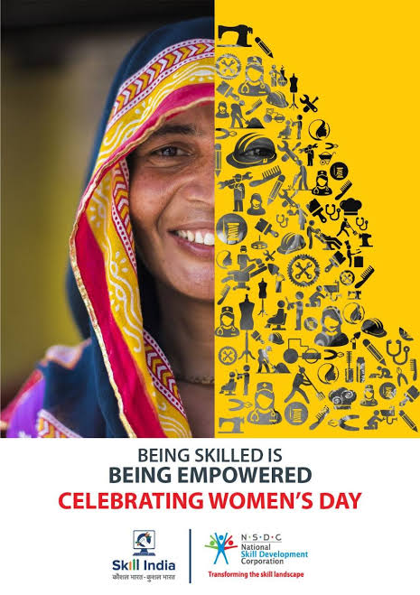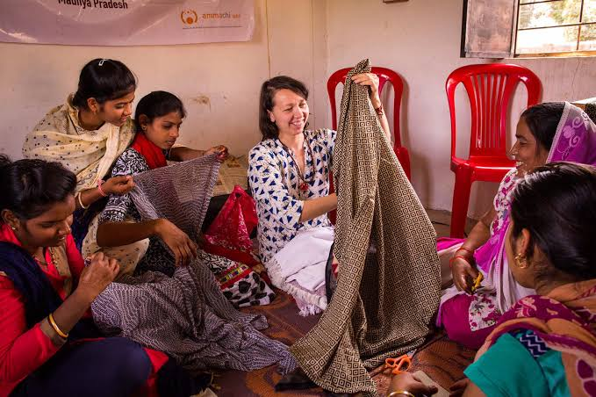

Figure 1: Women participation in skill development

- To creating larger participation of women in both training and apprenticeship by building infrastructure accordingly for their economic growth The National Skill Development and Policy laid focus on women involvement. Training delivery mechanisms provide training at afternoon; to accommodate women based on their local need along with they make sure safety of women participants, show sensitivity towards gender equality at the training center and they rectify the grievances put up by women.
Apart from these, according to Common Norms of Minister, they pay incentives for accommodation as well as meal, pay travelling allowance for outside training programs and give stipends after placement to settle them in new place. Through these ways they give special support for women candidates. These programs initiate digital accounting and entrepreneurial skill among women so that in future they can run their own business.

- Mann Deshi Foundation, Shri Mahila Sewa Sahkari Bank Limited and Sri Sarada Math Rasik Bhita etc special women-centric projects working on skill development of rural areas under National Skill Development Corporation. To incentivize women participation in Swachh Bharat Mission, NSDC along with the Ministry of Drinking Water and Sanitation encourage them into job roles such as builder training for making twin pit toilets and gobar gas. These projects are helps to provide ideas and entrepreneur skill to set up their new business after training.

- Under Pradhan Mantri Kaushal Vikas Yojna project, Amrita Vishwa Vidyapeetham is intend to establish women empowerment in under privileged areas which include women of marginalize group and tribal population, by availing training and opportunities in skill development at their place. The project has seeks around half population of women participant in Odisha, Jharkhand, Kerala, Tamil Nadu and Chhattisgarh. Humara Bachpan Trust in Odisha give employability to 1500 women from economically deprived areas, Industree Crafts Foundation helps in training around 1500 women from Karnataka and Youthnet Home Stay Project in North East (Nagaland and Arunachal Pradesh) provide homestays and income source to occupy a better life style.

- Very frequently to train women more than 6k trainings have been given under Pradhan Mantri Mahila Kaushal Kendra (PMMKK) project. They initiated trainings under this project for customer care executive, hair stylist, yoga trainer, self employed tailor, beauty therapist etc. with the availability of crèche facility in the centers so that the mothers of new born can take participate in skill training without any obstacles.

- Skill India supporting women to engage in 21st century technological advancement job roles such as artificial intelligence, IT architect, algorithm developer, 3d printing, data scientist etc. to transform India as developed country. They have witnessed increased participation of women in hard skills like welding, automobile mechanics etc. These programs grab attention of young girls to train themselves in skills for job roles in unconventional and new-age areas like CNC mechanics, artificial intelligence, cyber security, that are in line with the future trend of jobs. In its consequence we can witnessed as many as 892 females were trained as automation specialists while about 500 were trained as CNC Operators in this past two years.

- Ministry of Skill Development and Entrepreneurship has promised to develop the number of women entrepreneurs over the country. NIESBUD along with MSDE has conducted programs for the rural women with the aim as inclusion of entrepreneurial skill, attitude and motivation among the socially disadvanced women to start up their new project by standing against the risks in new field.
National Entrepreneurship Awards are provided acknowledgement to the entrepreneurial journey of women for their valuable input into the entrepreneurship development.
The government in this way tries to balance gender equality through employing both male and female in the economic growth of the country. Skill-building initiatives and New Education Policy emphasis on assure more women participation in the developmental process by providing supportive facilities to encourage them into the unconventional workplace, which helps them be empowered women.

Conclusions
India has come long way, Indian women have come long way. Literacy growth of women rise, gender gap has been reduced, women contribution in workforce has increase rapidly. Skill India Mission empowered lot of women by sifting their existing skill into professional and formal. It helps to make their own identity in front of the society through contributing their service to the country and make them self independent by self employability. India has relized very earlier that the gender biasness should reduce to become a “developed country” from a “developing country”. It has working continuously through various ways, Skill India Mission is one of them lunched in 2015 under MSDE through NSDP has achieved greater success in bridge up space between male-female by providing special provision towards women. Which let women participate actively in the training program, later they involved in high paid job to lead their life without depending on others to mark them as empowered women..

REFERENCES

- Aluoch, J. R. (2014). Women Empowerment and Skilled Attendance/Facility Delivery. IOSR Journal of Nursing and Health Science (IOSR-JNHS) , 48-53.
- Rani, D. R. (2020). Women Empowerment through Skill India. In D. R. Bansal, SKILL INDIA: A Catalyst to Nation Building (pp. 126-131). Empyreal Publishing House .
- Saikia, K. (2020). Economic Empowerment Of Women: A Brief Overview In. European Journal of Molecular & Clinical Medicine, ISSN 2515-8260 Volume 7, Issue 08 .
- Supriya.R, D. (2020). Women Empowerment through Skill India. In D. R. Bansal, SKILL INDIA: A Catalyst to Nation Building (pp. 95-102). Empyreal Publishing House .
- Tauffiqu Ahamad, A. S. (2016). Women Empowerment through Skills Development & Vocational Education. SMS Journal of Entrepreneurship & Innovation .
- https://www.nationalskillsnetwork.in/#
- https://www.nationalskillsnetwork.in/launch-of-guidelines-for-implementation-of-10-baglessdays-in-schools/
- https://www.nationalskillsnetwork.in/skill-india-women-initiatives/
- https://www.investindia.gov.in/team-india-blogs/skill-development-prerequisite-womenempowerment
- https://pib.gov.in/PressReleasePage.aspx?PRID=1778477

