Assessment of Thermal Conductivity of M25 Grade Cement Concrete with Wax and Resin based Curing Compounds

Rashmita Srinivasan
Department of Civil Engineering
Maharashtra Institute of Technology
Aurangabad-431010, (MH) India
srinivasan.rashmita@gmail.com

Siraj Sayyed
Department of Mechanical Engineering
Maharashtra Institute of Technology
Aurangabad-431010, (MH) India
lucky.sartaj@gmail.com

ABSTRACT
The current research looks at the thermal conductivity of M25 grade cement concrete with wax and resin curing compounds. For the experiment, an M25 grade mixture comprised of cement, sand, and aggregates in a 1:1:2 ratio is used, with the curing chemical purchased locally. The cement concrete specimen is created utilizing the standard thermal conductivity set-up specifications of 25 mm diameter and 28 mm depth. Curing chemicals spread soon after casting and the removal of water from the specimen surface. Upon the successful completion of the experimentation, it has been observed that the wax and resin based curing compound outperformed compared to the standard water curing procedures. Long-term research would yield greater outcomes in treating chemicals.

Keywords— Cement; Concrete; RCC; Curing Compound; Thermal conductivity

INTRODUCTION and LITERATURE REVIEW

Cement mortar and concrete is a composite material has several applications [1]. While working with cement-concrete combinations, the researchers encountered a variety of issues owing to a lack of water and rising temperatures. Higher temperatures frequently degrade the quality of cement-concrete combinations [2], [3]. To address such issues, researchers are constantly developing alternate solutions. In many cases, the mixtures of cement-concrete used as an insulating materials and the thermal insulating mortar has a thermal conductivity < 0.2 W/m.K [3]. Numerous research work is being carried out on this research area to overcome such type of problems. Iman et al. [1] have evaluated the efficacy of heat conductivity of cement mortar using x-ray scanning in 2023. The study discovered that there were minor differences in the thermal conductivity of samples obtained from various places and x-ray scanning was the most effective method of determining the thermal conductivity of cement mixtures. Similarly, Rathish et al. [2], [3] were studied the paraffin was as an self-curing agent for self-compacting concretes, Ghodele and Kulkarni [4] studied the rapid curing compounds and its effects on cement-concrete, Raychel [5] were studied the effect of age and thermal conductivity when concrete specimen coated with curing compounds. The studies showed that curing compounds were significantly enhances the age of the cement-concretes and effectiveness of the thermal conductivity. Furthermore authors also studied the effect of curing compounds using different proportions in cement-concrete [6], wax and water emulsion as an curing compound [7], phase change materials for building components [8], strength variation in concrete-cement using different curing compounds [9], [10], paraffin was as an curing agent in ordinary cement-concrete [11]. As stated earlier, similar kind of results were observed these studies. Some of the studies also focused on multiphase model in predicting the thermal conductivity of cement paste [12], FTIR spectroscopy and SEM techniques [13], blending of curing compounds [14], characteristics of thermal insulation cements [15]. The present study focused on M25 grade cement-concrete coated with both the wax based and resin based curing compounds. The study followed all the standard test procedures of ASTM and specimens are prepared by using M25 grade cement-concrete. The experimentation has been performed to assess the thermal conductivity of the prepared specimens and effectiveness of curing compounds on the specimens under consideration. The results and conclusions are provided on the basis of experimentation.

EXPERIMENTAL PROGRAM

The experimentation has been performed on reinforced cement concrete components using wax based and resin based curing compounds.

Preparation of Specimen
The specimen is prepared by using M25 grade cement concrete with cement, sand, and aggregates in a proportion of 1:1:2. The test specimens are produced by utilizing the standard dimensions of the experimental set-up of thermal conductivity. The specimen consist of diameter and length of 25 mm and 28 mm respectively. Figure 1 illustrates the actual photograph of the specimen. The wax based and resin based curing compounds are procured from the local market to paste on the specimen. While preparing the specimen the curing compound is spread soon after casting and the removal of water from the specimen surface. The common features such as drying time, density, and curing efficiency are observed for both the wax based and resin based compound within the range of 110-120 min., 1010-1020 kg/m3 and 90-91% respectively. Table 1 provides the technical specifications of curing compounds.

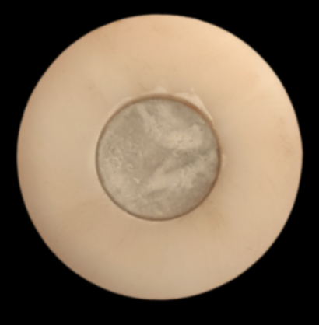
Figure 1: Photograph of specimen
Table 1: Technical specification of curing compounds
Sr.  No. | Terms | Wax based CC | Resin based CC
1 | Physical state | White liquid | Aluminium liquid
2 | Composition | Wax based | Aluminized reflective
3 | Density | 1016 | 1017
4 | pH value | >6.0 | 8.5
5 | Drying time | 120 min. | 110 min.
6 | Curing efficiency | 90.5% | 90.7%

Measurement of Thermal Conductivity (K)
The thermal conductivity play an important role where the temperature is considered as gradient. The experimentation has been performed on JP-techno make thermal conductivity meter. In this set-up the standard test procedure has been adopted during the experimentation. A dimmer stat kept constant to get the constant output of voltage and current. Total 9 thermocouples are utilized to measure the temperatures of the source, specimen, and sink of the experimentation. The readings of the temperatures are recorded within the time interval of 10 min. and total 10 readings are recorded. To test the accuracy and reproducibility of the experimental set-up, the experimentation has been performed thrice by considering each curing compound specimens. Figure 2 illustrates the actual photograph of experimental set-up of thermal conductivity.

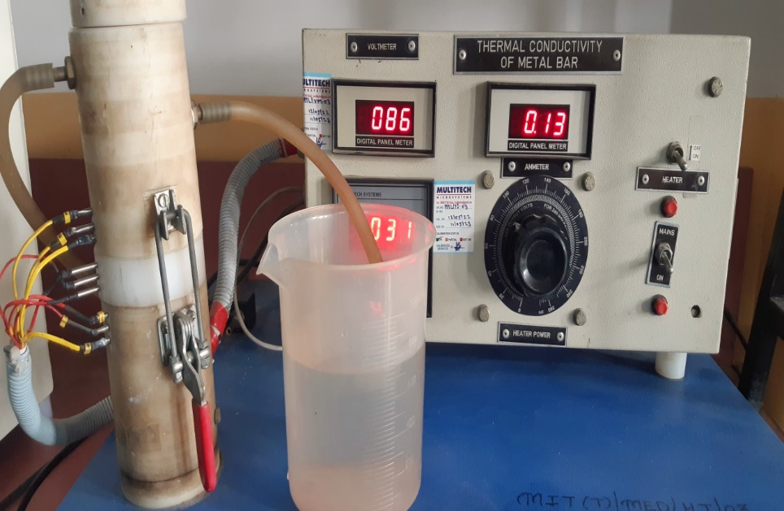

Figure 2: Photograph of Thermal conductivity set-up

RESULTS and DISCUSSION

The experimentation has been performed on the specimen prepared by using M25 grade cement-concrete with cement, sand, and aggregates in proportion of 1:1:2. The curing compound has been coated on the specimen within four hours of time span. Further experimentation has been performed for measuring the thermal conductivity of the specimen and availability of moisture content. During experimentation an aluminized reflective layer has been observed as resin based curing compound coated on the specimen compare to wax based curing compound. Figure 3 illustrates the photograph of wax and resin based coated specimen after the experimentation. Marginal variations in thermal conductivities are observed in wax based and resin based curing compound. The thermal conductivity observed within the range of 1.40-1.60 W/m.K for wax based whereas 0.70-1.87 W/m.K for resin based curing compound. A sufficient amount of moisture content is still present in the cement-concrete at the complete hydration stage. Figure 4 illustrates the thermal conductivity for both the curing compounds.

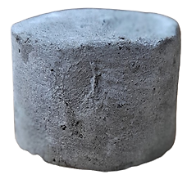  (a) | 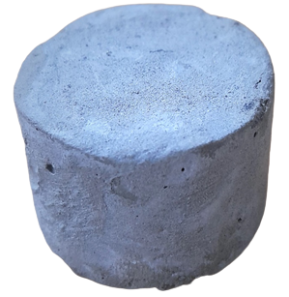  (b)

Figure 3: Wax and Resin coated specimen after experimentation
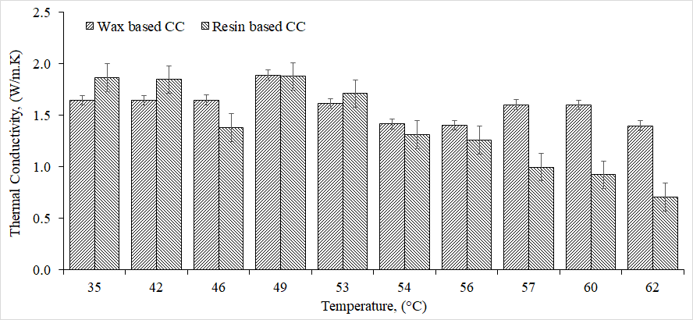
Figure 4: Comparison of thermal conductivity for both curing compounds (CC)

CONCLUSIONS and FUTURE SCOPE

The present study focused on wax based and resin based curing compound on specimen prepared from M25 grade cement-concrete. From the experimental study it has been concluded that both wax based and resin based curing compound showed greater bonding with M25 grade cement-concrete. Following conclusions are drawn on the basis of experimentation,
- When casted specimens of M25 grade cement-concrete are treated with wax-based and resin-based curing agents, their physical appearance changes.
- An aluminized reflective layer is noticed when a resin-based curing compound is applied to the specimen.
- A sufficient amount of moisture content is still present in the cement-concrete at the complete hydration stage.
- A long-term test need to be required to study the detailed results along with the FTIR analysis.

REFERENCES
[1] I. Asadi, G. Ji, and M. H. Baghban, “Evaluating the effective thermal conductivity of cement mortar through x-ray scanning,” Case Stud. Therm. Eng., vol. 41, no. December 2022, p. 102686, 2023, doi: 10.1016/j.csite.2022.102686.
[2] M. Sri Rama Chand, P. Rathish Kumar, P. Swamy Naga Ratna Giri, G. Rajesh Kumar, and M. V. Krishna Rao, “Influence of paraffin wax as a self-curing compound in self-compacting concretes,” Adv. Cem. Res., no. April 2016, pp. 1–11, 2015, doi: 10.1680/adcr.15.00062.
[3] P. R. Kumar, M. Sri, R. Chand, P. S. N. R. Giri, G. Rajesh Kumar, and R. Scholar, “Effect of Paraffin Wax As Self Curing Agent in Recycled Aggregate Based Self Compacting Concretes (Scc),” Int. J. Adv. Mech. Civ. Eng., no. 5, pp. 2394–2827, 2018, [Online]. Available: http://iraj.in.
[4] A. P. G. S. K. Kulkarni, “Use of Rapid Curing Concrete to Optimize Project Schedule,” Int. J. Sci. Res., vol. 7, no. 6, pp. 157–161, 2018, doi: 10.21275/ART20183056.
[5] R. Bahnick, M. Joshaghani, O. Ghasemi-Fare, and Z. Sun, “Exploring the curing condition and age effect on thermal conductivity of concrete,” E3S Web Conf., vol. 205, pp. 1–6, 2020, doi: 10.1051/e3sconf/202020506012.
[6] Y. Nahata, N. Kholia, and T. G. Tank, “Effect of Curing Methods on Efficiency of Curing of Cement Mortar,” APCBEE Procedia, vol. 9, no. Icbee 2013, pp. 222–229, 2014, doi: 10.1016/j.apcbee.2014.01.040.
[7] W. S. Management, “Effectiveness of wax / water emulsions of curing compounds for mortar Título Original en Español : Efectividad de emulsiones aceite / agua en el curado del concreto,” no. February, 2023.
[8] E. Dhanalakshmi, A. M. B. D. V, and D. Vimal, “An Experimental Study on Building Components using Phase Change Material,” 2020.
[9] N. V. Babu, “Experimental Study on Strength Variation in Concrete by Using Different Curing Techniques,” vol. 7, no. 8, pp. 639–646, 2020.
[10] Princy K P and Dr. Elson John, “Study on the Effectiveness of Various Curing Methods on the Properties of Concrete,” Int. J. Eng. Res., vol. V4, no. 11, pp. 213–216, 2015, doi: 10.17577/ijertv4is110263.
[11] M. S. R. Chand, P. S. N. R. Giri, G. R. Kumar, and P. R. Kumar, “Paraffin wax as an internal curing agent in ordinary concrete,” Mag. Concr. Res., vol. 67, no. 2, pp. 82–88, 2015, doi: 10.1680/macr.14.00192.
[12] Y. Du and Y. Ge, “Multiphase model for predicting the thermal conductivity of cement paste and its applications,” Materials (Basel)., vol. 14, no. 16, 2021, doi: 10.3390/ma14164525.
[13] F. Chyliński, A. Michalik, and M. Kozicki, “Effectiveness of Curing Compounds for Concrete,” Materials (Basel)., vol. 15, no. 7, 2022, doi: 10.3390/ma15072699.
[14] T. V. Rao, M. V Seshagiri Rao, and P. J. Rao, “Strength properties of double blend and triple blend self-compacting concrete subjected to different curing methods,” IOP Conf. Ser. Mater. Sci. Eng., vol. 1126, no. 1, p. 012085, 2021, doi: 10.1088/1757-899x/1126/1/012085.
[15] W. Zhou, C. Wang, R. Meng, Z. Chen, H. Lu, and J. Chi, “Study on thermal insulation cement and its thermal insulation characteristics for geothermal wells,” Sci. Rep., vol. 13, no. 1, pp. 1–12, 2023, doi: 10.1038/s41598-023-30614-y.
Nomenclature
Abbreviations | Full-form
% | Percentage
°C | Degree Celcius
CC | Curing Compound
I | Current
K | Thermal conductivity
min. | Minute
mm | Millimeter
RCC | Reinforced cement concrete
V | Voltage

