Artificial Intelligence: A Game Changer for Physics Education

Mrs Nidhi Maan
Government Public School
Emirates School Establishment
Abu Dhabi, United Arab Emirates
nidhimaan2000@gmail.com

ABSTRACT

Physics often seems abstract and uninteresting to students, leading to a decline in motivation. Educators, too, may feel discouraged. However, Artificial Intelligence (AI)holds promise in revitalizing both student and educator engagement. Implementing AI in Physics education comes with challenges, such as the need for training of educators and resources available to them. Overcoming these obstacles is crucial to effectively leverage AI’s potential and restore motivation in the study of Physics.

Keywords—motivation; artificial intelligence, physics educators

INTRODUCTION

Physics remains a vital field that will continue to shape the future, even after a century. Unfortunately, many students and teachers currently struggle with its perceived difficulty and find it irrelevant to their lives. Disturbingly, statistics indicate a widespread lack of motivation in both groups. To address this issue, cultivating self-regulation skills emerges as a potent solution for boosting motivation. By empowering students to take charge of their learning and enabling teachers to establish meaningful connections to real-world contexts, we can reignite enthusiasm and relevance in the study of physics. Competence is a key factor that strongly predicts self-determined motivation in students. Teaching practices that support students' competence, such as providing high-quality feedback and creating an environment that encourages growth and mastery, have a positive impact on students' intrinsic motivation and drive to engage in learning activities. By fostering a sense of competence, teachers can significantly enhance students' self-determined motivation and overall learning outcomes. Artificial Intelligence (AI) indeed has a significant role to play in supporting both teacher autonomy and competence. AI technologies can help provide personalized feedback, adaptive learning experiences, and resources tailored to individual students' needs. By automating certain tasks, AI can free up teachers' time, allowing them to focus more on individualized instruction, guiding students' learning journeys, and providing targeted support. Additionally, AI can enhance teachers' competence by offering data-driven insights and recommendations, assisting in instructional planning, and keeping them informed about the latest educational practices and research. Overall, AI has the potential to augment teacher autonomy and competence, leading to improved student learning and motivation.

METHOD OF DATA ANALYSIS

The author conducted research over various published studies with more than 1 lakh students across multiple cultural contexts, age groups, and grade levels. Data analysis is carried out on high school students and their teachers, specifically those in grades 9 to 12, who were enrolled in physics courses across multiple schools.

OBJECTIVE OF STUDY

The proposed study has two key objectives:
- To explore the impact of Artificial Intelligence on enhancing student self-determined motivation in Physics learning leading to competence.
- Examine how Artificial Intelligence can improve teacher effectiveness in implementing differentiation and individualized instruction.

KEY OBSERVATIONS

- Factors affecting Student Motivation Towards Learning Physics
- When a student embarks on a new topic in physics and attempts to solve a problem, encountering a wrong answer can be a critical juncture in their learning process. If, at that moment, someone is available to guide the student and explain their error, it can have a profound impact on the student's confidence and learning trajectory. With proper guidance, the student is likely to feel more assured and motivated to persist in solving the problem. However, when no one is available to offer guidance and support, the student may experience a loss of confidence and become discouraged. This lack of assistance can lead the student to abandon the topic altogether, missing out on valuable learning opportunities. The presence of a supportive mentor or teacher who can provide timely feedback and constructive explanations can make a significant difference in the student's academic journey. This guidance not only helps the student correct their mistakes but also fosters a sense of encouragement and empowerment to tackle challenging topics and continue their exploration of physics. In turn, this positive learning experience can contribute to the student's overall confidence and enthusiasm for the subject.
- Many physics concepts and problems can be abstract and difficult to visualize, making it challenging for some students to grasp them easily. Additionally, hands-on experiments might intimidate shy or less confident students, hindering their understanding of the underlying concepts. Virtual learning platforms can play a crucial role in addressing these issues and promoting a more inclusive and effective learning environment. Virtual simulations and interactive visualizations can help students better understand abstract concepts by providing a more tangible representation of phenomena that might be difficult to visualize otherwise. Virtual platforms allow students to learn at their own pace, ensuring they have sufficient time to comprehend each topic fully. This flexibility is especially valuable for students who need more time to grasp certain concepts. Virtual platforms enable students to repeat experiments and simulations as many times as needed. This repetition reinforces their understanding and allows them to correct their mistakes in a non-threatening environment. Virtual platforms often offer interactive quizzes, exercises, and feedback mechanisms, encouraging active engagement and enhancing the learning experience. Virtual platforms often offer interactive quizzes, exercises, and feedback mechanisms, encouraging active engagement and enhancing the learning experience.
- Continuous poor assessment marks significantly demotivate students and hinder their interest in studying physics. To counteract this, incorporating small self-study topics, daily self-testing, personalized feedback, and practice questions can be highly effective in keeping students engaged and motivated. Breaking down complex physics topics into smaller, more manageable sections can make learning less overwhelming for students. It allows them to focus on one concept at a time, master it, and gradually build their understanding. Regular self-testing helps students reinforce their learning and identify areas where they might be struggling. Short quizzes or review sessions at the end of each study day can aid retention and provide a sense of accomplishment. Offering individualized feedback helps students understand their strengths and weaknesses. Constructive feedback can guide them in areas that need improvement, providing a clear path for progress. Providing specific improvement suggestions and study tips can help students refine their study techniques and learning strategies. This empowers them to take ownership of their learning and see tangible progress. Encouraging collaboration and peer support can create a supportive learning community. Students can discuss concepts, solve problems together, and learn from each other's perspectives.

- Factors affecting Teacher effectiveness in Implementing differentiation and Individualized Instruction
- With limited time, it is challenging for teachers to give personalized attention to each student. Individualized instruction requires more time to understand and address students' specific needs. Conducting thorough pre-assessments and ongoing assessments to gauge students' abilities and progress takes time. In a short class period, it may not be feasible to gather sufficient data for effective differentiation. Deciding which students should be grouped together based on their needs and abilities requires careful consideration. Designing and preparing differentiated materials and resources tailored to various learning levels and styles demands extra time and effort. Teachers may feel pressure to cover a specific curriculum or content within the limited class time, making it challenging to dedicate extra time to differentiated activities. Tracking the progress of each student and providing timely feedback requires continuous monitoring, which can be challenging with limited time.
- Lack of knowledge about laboratory equipment among teachers is a common challenge that can result in ineffective demonstrations during class, hindering students' understanding of scientific concepts. Teachers may not be fully aware of the proper handling and usage of certain laboratory equipment, leading to safety hazards for themselves and students. Lack of confidence in using laboratory equipment can reduce teachers' enthusiasm for conducting experiments, impacting student engagement and interest in science. Different teachers may have varying levels of knowledge about laboratory equipment, leading to inconsistent teaching practices across classrooms.
- Limited knowledge of Student Evaluation and Assessment tools may hinder teachers' ability to provide meaningful and constructive feedback to students, limiting their ability to address individual learning needs. Inadequate knowledge of assessment tools can hinder teachers' ability to differentiate instruction effectively, as they may struggle to identify individual strengths and areas for improvement. Teachers may face challenges in aligning assessments with specific learning objectives, which can impact the effectiveness of instruction and hinder students' academic growth. Limited knowledge of assessment tools may prevent teachers from using data effectively to inform instructional strategies and improve learning outcomes. Teachers may be unable to identify learning gaps in students' understanding, which can lead to missed opportunities for targeted intervention and support.

Recommendation

- Enhancing Student Motivation

- AI-powered learning platforms and virtual assistants can offer personalized support and guidance to students, enhancing their learning experience. AI can offer immediate feedback on practice questions and problem-solving attempts. This real-time feedback helps students correct their mistakes promptly and reinforces their understanding of concepts. For example, Plaito AI offers practice questions tailored to a student's performance and proficiency level which creates a more personalized learning journey. Adaptive learning systems ensure that students are appropriately challenged and receive questions that match their current understanding of the subject.AI bots and virtual assistants are available round-the-clock, enabling students to seek help and guidance at any time, irrespective of their location. AI with natural language processing capabilities can understand and respond to students' questions in a conversational manner, making the learning process feel more interactive and human-like. Students may feel more comfortable making mistakes or admitting areas of difficulty to an AI mentor without fear of embarrassment or judgment. AI mentors can deliver consistent responses and patiently explain concepts as many times as necessary, helping students grasp challenging topics at their own pace.

- AI-powered learning platforms can offer interactive simulations that allow students to manipulate variables, observe outcomes, and understand real-world phenomena in a controlled virtual environment. For instance, students can experiment with physics simulations to understand the motion of objects, electrical circuits, or fluid dynamics. Virtual AI physics experiments can simulate extreme conditions (e.g., microgravity, high pressure, or extreme temperatures) that are challenging or impossible to recreate in traditional labs. AI can create dynamic visualizations that help students understand complex physics principles, such as gravitational forces, electromagnetic fields, or wave behaviors. In the absence of physical laboratory access, AI-powered platforms can provide virtual experiments that replicate real-world scenarios. Students can perform experiments virtually, collect data, and draw conclusions, like what they would do in a physical laboratory setting. Virtual experiments can be paused, rewound, or repeated, giving students the freedom to explore concepts at their own pace. They can observe phenomena from various angles and perspectives, promoting a deeper understanding. Virtual AI experiments can simulate high-tech and expensive laboratory equipment that might not be available in all educational settings. This enables students to access cutting-edge technology and perform experiments beyond the limitations of their physical learning environment. Virtual experiments eliminate potential safety risks associated with real-world lab experiments. Students can explore hazardous or complex phenomena without the need for expensive equipment or the fear of accidents.

- AI can analyze student's strengths and weaknesses, learning pace, and previous performance to create personalized quiz questions that match their current understanding of the subject. The AI-powered quiz platform can adjust the difficulty level of questions based on the student's responses. If a student is answering correctly, the platform can gradually increase the complexity of the questions to challenge them appropriately. AI can provide instant feedback on quiz results, pointing out correct answers and explaining incorrect ones. This real-time feedback helps students understand their mistakes and learn from them immediately, which results in grades improvement. The below figure ‘1’ depicts on how artificial intelligence has a profound impact on students in terms of their competency, collaboration and autonomous behavior.
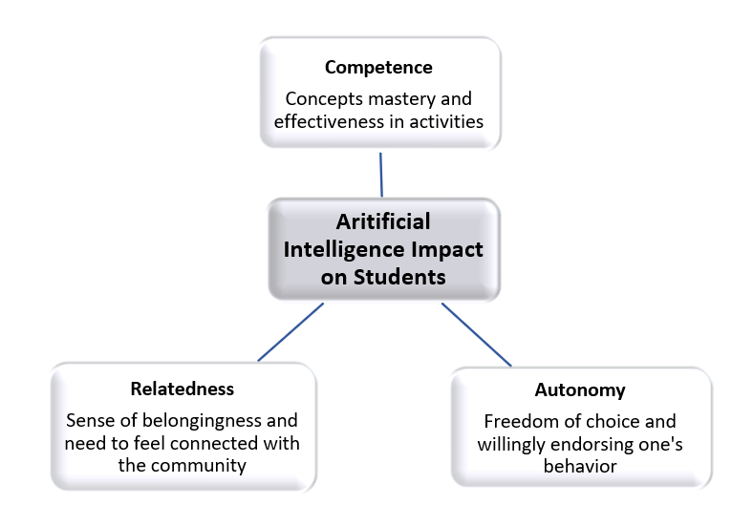
Figure 1: Artificial Intelligence Impact on Student Motivation

- Enhancing Teacher effectiveness

- Artificial intelligence (AI) can play a significant role in helping teachers manage classroom time more efficiently. By automating certain tasks and providing valuable insights and support, AI can free up teachers' time, allowing them to focus on individualized instruction and fostering a more engaging and productive learning environment. AI-driven adaptive learning platforms can analyze students' performance and learning patterns to create personalized learning paths. This individualized approach ensures that each student receives targeted content and activities aligned with their learning needs and pace. AI-powered tools can automate the grading of multiple-choice quizzes, tests, and assignments, reducing the time teachers spend on manual grading. This allows teachers to provide timely feedback to students without being burdened by the administrative workload. AI can process and analyze large amounts of data, providing teachers with valuable insights into student progress, strengths, and areas for improvement. Teachers can use this information to make data-driven decisions and adjust their instructional strategies accordingly. AI tools can help teachers generate lesson plans and curate relevant educational resources based on learning objectives and student needs. This streamlines the planning process and ensures that lessons are well-organized and aligned with curriculum standards. AI systems can streamline attendance tracking, reducing administrative tasks for teachers and providing accurate records of student attendance. AI-powered translation tools can assist teachers in communicating with students who speak different languages, facilitating better understanding and inclusivity in the classroom.

- AI can assist in designing experiments, suggesting appropriate materials, and planning setups, saving teachers time and effort in preparing lab activities. AI-powered platforms can offer teachers ongoing professional development opportunities in lab work methodologies and best practices. AI can assess each teacher's current knowledge and skills related to lab activities through pre-assessments. Based on the results, AI can generate personalized training programs that target specific areas for improvement. AI mentors can provide real-time feedback to teachers as they engage with training activities. This feedback helps them understand their strengths and areas for improvement. AI-powered platforms can curate multimedia resources, such as instructional videos, infographics, and interactive modules, to support teachers' learning and understanding of lab activities. AI can facilitate collaborative learning environments, allowing teachers to engage in discussions and knowledge-sharing with peers and experts.

The below diagram shows how artificial intelligence impacts on teachers in terms of their efficiency, personalization and informed decision making.

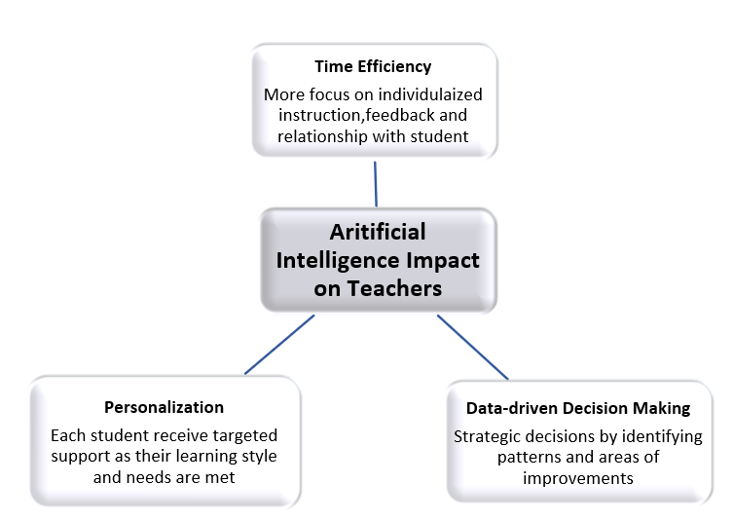

Figure2: Artificial Intelligence Impact on teacher Effectivity

CONLUSION

Artificial Intelligence can indeed play a crucial role in increasing student motivation in learning science and supporting teachers in providing better instruction. AI can be available 24/7, allowing students to access resources, practice questions, and receive assistance whenever they need it, enhancing their self-directed learning and motivation. AI can provide personalized learning experiences by adapting content, activities, and pacing based on each student's abilities and interests, keeping them engaged and motivated. However, human intervention remains essential for effective and meaningful educational experiences. Human teachers can establish a personal connection with students, understanding their individual needs, and providing emotional support and encouragement.
AI and human involvement together create a powerful synergy in the educational process. AI can handle routine tasks, provide data-driven insights, and create engaging learning experiences, while human teachers bring their empathy, creativity, and expertise to foster meaningful connections and cater to the holistic development of students. By combining AI's capabilities with the strengths of human educators, we can create a more effective, student-centric, and motivating learning environment.

REFERENCES

- Pathways to Student Motivation: A Meta-Analysis of Antecedents of Autonomous and Controlled Motivations: Julien S. Bureau, Joshua L. Howard, Jane X. Y. Chong and Frédéric Guay: Review of Educational Research Volume 92, Issue 1, February 2022, Sage Journals
- Investigating Relationships Between Learning Environment Perceptions, Motivation and Self-Regulation for Female Science Students in Abu Dhabi, United Arab Emirates: Jill M Aldridge & Kate Rowntree: Research in Science Education volume 52, (2022) Springer
- AI Adoption for Teaching and Learning of Physics Edidiong Enyeneokpon Ukoh, Jude Nicholas Science and Technology Education Department University of Ibadan, Nigeria, International Journal for Infonomics (IJI), Volume 15, Issue 1, 2022
- Tuomi, I. The Impact of Artificial Intelligence on Learning, Teaching, and Education. Policies for the future, Eds. Cabrera, M., Vuorikari, R & Punie, Y., EUR 29442 EN, Publications Office of the European Union, Luxembourg, 2018, ISBN 978-92-79-97257-7, doi:10.2760/12297, JRC113226
- Zawacki-Richter, O., Marín, V.I., Bond, M. et al. Systematic review of research on artificial intelligence applications in higher education – where are the educators? Int J Educ Technol High Educ 16, 39 (2019). https://doi.org/10.1186/s41239-019-0171-0
- Educational applications of artificial intelligence in simulation-based learning: A systematic mapping review, Author Chih-Pu Dai, Fengfeng Ke, Computers and Education: Artificial Intelligence Volume 3, 2022, 100087

