Fenton Oxidation process for treatment of waste water containing dyes

Seema Shrivastava Sumita N. Rao
Department of Applied Chemistry Department of Applied Chemistry
Priyadarshini College of Engineering, Priyadarshini College of Engineering,
Nagpur, India Nagpur, India
seemashrivastava@rediffmail. sumita2000@rediffmail.com

I INTRODUCTION
Dyeing is the process that imparts colour to the fabric, making it attractive. It is one of the primary processes in the textile industry. Since ancient times, natural fabric dyes were used all over the world. Several plants and animals were used to produce various natural dyes for the fabrics. In 1070 BC the Tai Kang of the Xia Dynasty used purple dye, which was obtained from the tropical Murex Snails. Large amount of snails was needed to produce an ounce of dye. Mauveine, the first synthetic dye, was discovered by William Henry Perkin in 1856. Since then many acid, basic, reactive, mordant, vat, azoic, sulfur dyes were synthesized and found numerous applications in dyeing industries.
Synthetic dyes are primarily categorized according to their uses and structural makeup. They are referred to as chromophores and are made up of various functional groups that produce colors. Complex amide groups, including substituents such halogen, alkyl, hydroxyl nitro, sulfonic acid, and inorganic sodium salts, make up these synthetic dyes (1). Iindustrial dyes contain anthraquinone, triphenylmethyl, azo, sulfur, and phatalocianine groups in their structure which are generally toxic and carcinogenic.
Textile industries are known for their high water consumption as well as the quantity and variety of chemicals used throughout the different operations. The common textile processing technology consists of desizing, scouring, bleaching, mercerizing and dyeing processes ((2), which consumes a large volume of water at every step. Estimation shows that approximately 100 L of wastewater / kilogram of textile product are generated (3). In dyeing process, several other chemicals along with dyes are also used to improve the affinity between dye and the fabric. The unfixed reactive dyes are highly soluble in water and contain a significant non bio-degradable colour causing residues.
The effluents of dye houses are characterized by high organic matter, colour, COD, different breakdown products and byproducts. Worldwide growth of textile industries is responsible for large volumes of liquid dye waste discharge. This causes a serious adverse impact on all forms of life and severely affecting the aquatic environments, especially their aesthetic properties. This is the reason for the legislative binding on dye houses to treat their discharges at the source prior to release into nearby water bodies. Various treatment methods viz., chemical, physical and biological processes (4) were explored to waste water discharged from textile industry but due to its complex nature it is difficult to treat using a single treatment method, hence these treatment methods are generally used in combinations.
Each treatment process has its own advantages and disadvantages, which makes their application limited. Advanced Oxidation Processes (AOPs) and traditional chemical treatments have been shown to be the most successful technological options for the treatment of such resistant wastes. Oxidation by ozone of various organic compounds has been reported by different investigators (5, 6]. Ozone has proved to be a suitable reagent for effective color removal. Waste waters containing several types of reactive dyes were pretreated or treated using ozone oxidation to increase the biodegradability of colour imparting toxic wastes (7-8). Serdar Dogruel, at., el. (9) reported complete colour removal from cotton finishing textile effluent containing dyes using ozone oxidation technique. Oxidation with Ozone is proven to be more efficient in reduction of colour as compared to reduction in Chemical oxygen demand (COD) (10). The major advantage of ozonolysis is that there is no generation of sludge but it is very expensive when applied to large volumes of waste water.
Since past 30 years, lot of research is being done to explore the efficacy of AOPs in treatment of wastewaters containing refractory and toxic pollutants (11Balcıoğlu et al. 2003). N. Azbar at el conducted a comparative study of various AOPs (O3, O3/UV, H2O2/UV, O3/H2O2/UV, Fe2+/H2O2) and chemical treatment methods using Al2(SO4)3 · 18H2O, FeCl3 and FeSO4 for the degradation and decolorisation of polyester and acetate fiber dyeing effluent. The process was found to be better with 98% decolorisation and 99% degradation, which is 50% and 60% respectively in case of other chemical treatment processes (12). The study showed that Fe2+/H2O2 was more economical choice for the acetate and polyester fiber dyeing effluent in the removal of color and reduction in COD.
Fenton process completely degrades the contaminants and converts them into harmless compounds (13). An effective destruction of Azo dyes’ chromophoric structure and its degradation by this process is subject to upon on the nature and structure of auxiliary groups linked with the aromatic nuclei of the dyes. The limitations of Fenton’s process include high chemical consumption of iron ions, its acidic environment (effective in the range of pH 2–4), use of expensive H₂O₂, post-treatment requirement due to generation of sludge, and the need for neutralization of the treated sample pre-disposal (14-16).
Continuous research is in progress to modify the conventional Fenton method for enhancing the oxidation efficiency and reduction in operative costs. It is widely reported that use of homogeneous Photo-Fenton and pseudo Photo-Fenton methods include treating colored effluents, due to the generation of strong OH to destroy organic pollutants considerably (17-19), still the sludge processing cost and the narrow pH range of the treatment system remain the limiting factors. To some extent the photo Fenton with heterogeneous catalyst (20- 21) is found capable to achieve the reduction in consumption of Fe ions and avoid generation of metal containing sludge, which require costly post treatment of treated effluent (22-25).
A broad range of recalcitrant toxic organic contaminants is treated using Electrochemical AOPs, which is emerging, as a promising field of dye waste treatment (26). Advantages of this process includes its compactness, simplicity, easy operation, energy efficient, versatility, cost effectiveness, amenability to automation, and environment friendly nature (27-30).
Based upon the extensive research work carried on AOPs, they are found to be better options for the pre and advanced treatments for the mineralization and decolorisation of broad spectrum of textile wastewaters. Reagents used in the process are easily available, safe to handle, convenient to store, and harmless to the environment. The process doesn’t require a complex system. It can be performed at ambient pressure and temperature.
A case study of synthetic dye bath waste treated using Fenton method is discussed here. The experiments were conducted to study the feasibility of use of pickling waste as Fe catalyst source. The present case is not only exploring the alternative source of costly FeSO4, but also offers a treatment solution of effluent produced by two major industries, which are textile and steel mills (31).

Case study: Use of waste pickle liquor as an inexpensive source of iron for Fenton oxidation of synthetic dye bath waste
In this case study, leftover pickle liquor is used as the iron catalyst source in the traditional Fenton's oxidation method. Typically, pickling waste is viewed as an alternative to traditional coagulants in the treatment of wastewater [32]. The study reported its usage as a source of catalyst for the first time.

II Materials and methods:
Pickle liquor produced from the pickling processes at a steel factory, Reactive Blue 4 (RB4, Color Index No. 61205) and Reactive Orange 16 (RO16, Color Index No. 17757) used for the investigation. From E. Merck India Pvt. Ltd., analytical grade H₂O₂ (30% w/v), Na₂CO₃, NaCl, Urea, NaOH, Ferrous sulphate, and sulphuric acid (98%) were purchased.

The method for producing the synthetic dye bath effluent was the same as that utilized in the factory-standard process for dying cotton fibres [9]. The composition of the dye bath wastewater was as follows: NaOH 2 g/l, NaCl 50 g/l, RO16 25 mg/l, RB4 100 mg/l, Na₂CO₃ 5 g/l, urea 1.5 g/l. Separately, the dyes were first dissolved in hot water (65 ⁰C), and then the correct proportions of NaCl, NaOH, Na₂CO₃, and urea were combined. The synthetic dye bath waste was found to have an initial chemical oxygen demand (COD) of 420 +/- 10 mg/L. Prior to use, the pickle liquor's total Fe level was found to be between 79 and 81 g/L. Fe2+ (64 0.05 g/L) and Fe3+ (16 0.03 g/L) were both detected. Using pickle liquor as a source of Fe catalyst, Fenton's oxidation experiments were carried out in a 4-beaker (1 L) Jar Testing apparatus (KI-89 Flocculator). A pH range of 3.5 to 4.0 was maintained while stirring test solutions at 100 rpm. Different sets of tests were carried out to optimize the contact time and the dosages of Fe²⁺ and H₂O₂. After the experiment, the collected test samples were adjusted to a pH >7.0 to separate the soluble iron catalyst sludge, and several metrics, such as COD and concentrations of RB4 and RO16, were utilized to examine the supernatants. By conducting many sets of tests, contact time and the dosages of Fe²⁺ and H₂O₂ were optimized.

III Analysis of samples
By measuring absorbance at maximum wavelengths of 599 and 493 nm, respectively, the concentrations of RO16 and RB4 were found using a Systronics 166 UV-VIS spectrophotometer. The COD of the samples was determined using Standard Methods [32]. The stated COD findings have a batch-to-batch error of less than 5%.

IV Results and discussion
A. Contact time optimization:
In an experiment utilising pickle liquor, as Fe catalyst, reactive dyes RO16 and RB4 were present in synthetic dye wastewater, degradation and decolorization of these dyes were recorded at various time durations, including 30, 60, 90, and 120 min, while maintaining Fe2⁺ and H₂O₂ doses, 1.79 mM and 26.4 mM respectively. Table 1 displays the COD and dye residual concentrations at various contact times together with the related percentage elimination.
Although decrease in colour is noticed at each stage, at 120 min, the maximum decrease is noted. RB4 shows a decrease in concentration by 23.2% whereas RO16, decreases by 16% with 40% of decrease in COD values. A graph is plotted between −log [(C₀ − C_{t})/C₀] versus time (Fig. 1) and the rate constant [k] values are obtained which is found to be 8.6 x10⁻³ and 2.4 x 10 ⁻³min⁻¹for RO16 and RB4, respectively for their decolorization. It can be seen from the outcomes that the decolorization of RO16 is four times faster than that of RB4. Further, the concentration of COD is decreased by roughly 40%. According to Figure 2 the equivalent k value obtained from the plot of −log [(COD₀−COD_{t})/COD₀] versus time is 5.7 x 10⁻³ min⁻¹.

Table 1: Optimization of contact time
Time  (min) | RB4 C₀= 100 ppm |  |  |  | RO16 C₀ = 25 ppm |  |  |  | COD₀ = 420 ppm
 | (Ct)  (ppm) | Cª | -log C | %R^{b} | (Ct)  (ppm) | C | -log C | %R | C_{t} (ppm) | X | -log X | %R
30 | 87.9 | 0.12 | 0.91 | 12.1 | 24.29 | 0.028 | 1.54 | 02.84 | 368 | 0.124 | 0.906 | 12.4
60 | 81.0 | 0.19 | 0.72 | 19.0 | 22.11 | 0.115 | 0.93 | 11.86 | 352 | 0.162 | 0.79 | 16.2
90 | 80.0 | 0.20 | 0.69 | 20.0 | 22.00 | 0.120 | 0.92 | 12.00 | 320 | 0.238 | 0.623 | 23.8
120 | 76.8 | 0.23 | 0.63 | 23.2 | 21.65 | 0.160 | 0.79 | 16.00 | 250 | 0.40 | 0.392 | 40.0

a) C= C₀−C_{t}/C₀,
b) %R = percent removal, X = COD₀ −COD_{t} / COD₀, Fe dose: 1.79 mM; H2O2 dose: 26.4 mM.

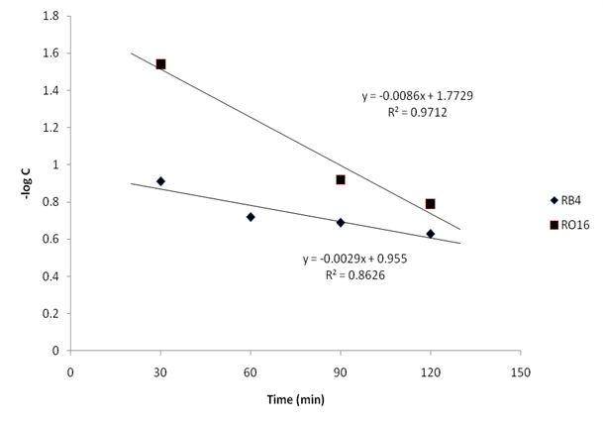

Figure 1: Effect of time on de-colorization of RO16 and RB4

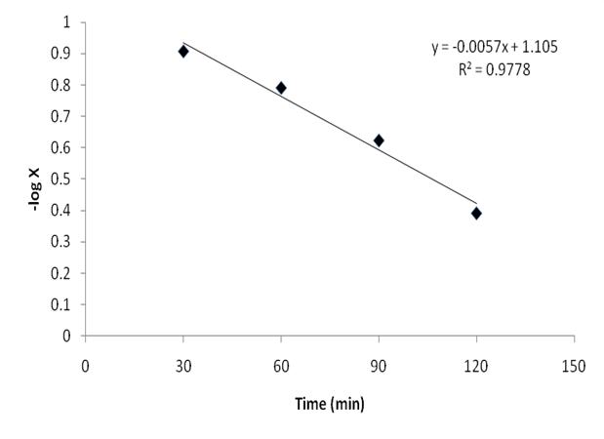

Figure 2: Effect of time on degradation of RO16 and RB4

B. Fe dose optimization:
Presence of Fe²⁺ plays a major role in de-colorization and degradation of dyes present in wastewater. Within this case study the dose of H₂O₂ was fixed at 26.4 mM and the runtime was fixed at 2 hours while the Fe ²⁺ dose varied from 1.79 to 8.95 mM. Table 2 shows the observed values of de-colorization and degradation. The plot of [(C₀ − C_{t})/C₀] versus Fe dose shows the maximum colour removal, at 8.95mM of Fe²⁺ dose, which are 86% (RB4) and 92.5%(RO16). Plotting COD₀ − COD/COD₀ versus Fe dose reveals that at an early stage, there was little change in COD values as Fe dose increased, but at 8.95 mM of Fe²⁺, around 56% of COD is eliminated (Fig. 4)

Table2: Optimization of Fe dose

Fe (ppm) | SVª (ml/l) | RB4 C₀= 100 ppm |  |  | RO16 C₀ = 25 ppm |  |  | COD₀ = 420 ppm
 |  | C_{t}(ppm) | C^{b} | %R^{c} | C_{t} (ppm) | C | %R | COD_{t}(ppm) | X | %R
100 | 60 | 76.8 | 0.232 | 23.2 | 21.65 | 0.16 | 16.0 | 250 | 0.404 | 40.4
200 | 150 | 34.7 | 0.653 | 65.3 | 13.8 | 0.448 | 44.8 | 260 | 0.38 | 38.0
300 | 190 | 27.7 | 0.723 | 72.3 | 13.8 | 0.448 | 44.8 | 247 | 0.411 | 41.10
400 | 250 | 19.4 | 0.81 | 80.6 | 1.87 | 0.925 | 92.5 | 238 | 0.433 | 43.30
500 | 260 | 13.8 | 0.862 | 86.2 | 1.87 | 0.925 | 92.5 | 184 | 0.562 | 56.2

a) SV = Sludge volume. b) C = C₀ −􏰂C_{t} / C0., c) %R = percent removal, X = COD₀ −COD_{t} / COD₀ (mL/L), Time: 2 h; H2O2: 26.4 mM

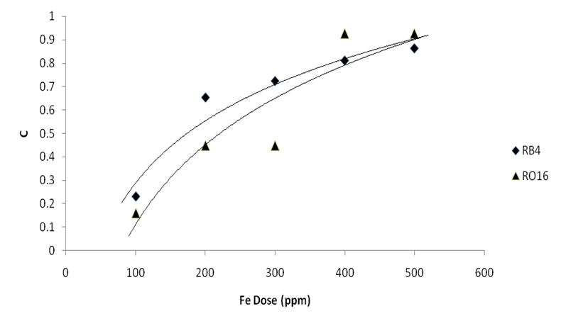

Figure 3: Effect of Fe dose on de-colorization of RO16 and RB4

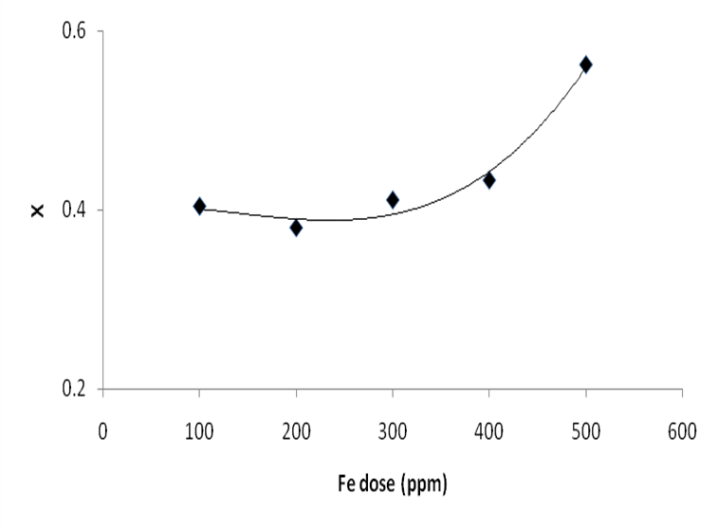

Figure 4: Effect of Fe dose on degradation of RO16 and RB4

C. H₂O₂ dose optimization:
Various H₂O₂ dosages (3 to 11 mL/L), with fixed concentration of Fe²⁺ (8.95 mM), and contact times of 2 hours were used in the experiments. It is clearly observed from the experimental values that the highest percentage reduction in RB4 and RO16 concentration is 90 and 98%. In the graph of [(C₀ − C_{t})/C₀] versus H₂O₂ dose (Fig. 5) and COD₀ – COD_{t} /COD₀ versus H₂O₂ dose (Fig. 6), an increase in the decolorization and degradation of dyes with increased dose of H₂O₂ dose is observed initially. However, there was not much change at higher H₂O₂ doses. A maximum of 62% reduction in COD is observed at an optimum dose of H₂O₂ which is 7 mL/L (61.8 mM).

Table 3: Optimization of H₂O₂ dose; Time: 2 h; Fe dose: 8.95 mM.

H₂O₂  (mM) | RB4 C₀= 100 ppm |  |  | RO16 C₀ = 25 ppm |  |  | COD₀ = 420 ppm
 | C_{t} ppm | Cª | %R^{b} | C_{t} ppm | C | %R | (C_{t}) ppm | X | %R
26.4 | 13.8 | 0.862 | 86.2 | 1.87 | 0.925 | 92.5 | 184 | 0.562 | 56.2
44.1 | 12.5 | 0.88 | 88.0 | 1.35 | 0.946 | 94.6 | 172 | 0.59 | 59.0
61.8 | 10.4 | 0.90 | 90.0 | 1.0 | 0.96 | 96.0 | 160 | 0.62 | 62.0
79.4 | 8.02 | 0.91 | 91.0 | 0.85 | 0.97 | 97.0 | 180 | 0.57 | 57.0
97.0 | 7.05 | 0.92 | 92.0 | 0.50 | 0.98 | 98.0 | 185 | 0.56 | 56.0

ªC = C₀-Ct/C₀, ^{b} %R = percent removal, X = COD₀-COD_{t}/COD₀

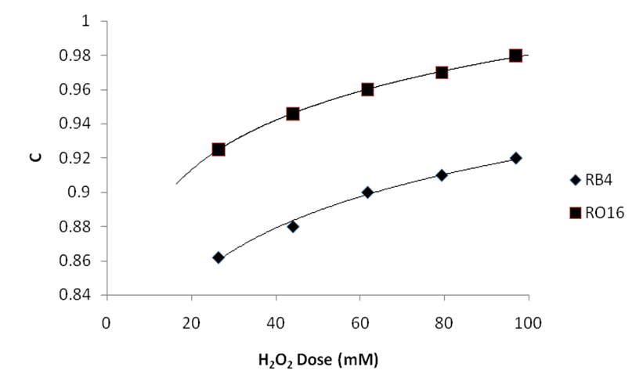

Figure 3: Effect of H₂O₂ dose on de-colorization of RO16 and RB4

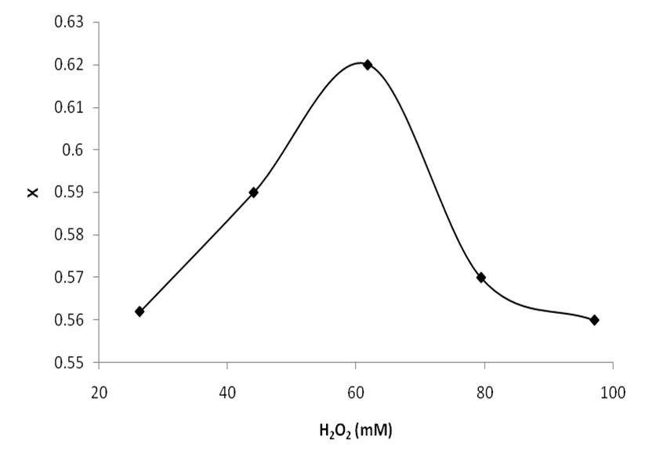

.

Figure 4: Effect of H₂O₂ dose on degradation of RO16 and RB4

V Pickling waste v/s FeSO₄ – A Comparison
Comparable results are obtained by performing the experiment by replacing pickle liquor with FeSO₄, using optimized doses of time (2 h.), Fe²⁺ (8.95 mM) and H₂O₂ (61.8 mM). Observed values of degradation and de-colorization are given in Table 4. In comparison to FeSO4, a somewhat greater volume of sludge was seen at the same dosages of Fe²⁺ and H₂O₂. However, the residual iron percentage in treated wastewater was slightly lower when pickling liquor was employed. The comparative study clearly exhibits that in conventional Fenton’s oxidation for dye waste treatment, pickling liquor can serve as a reliable source of iron catalyst.

It is significant from the linearity of plot of –log [(COD0 −CODt)/COD0] versus time (Fig. 2), with R2 > 0.97 that the oxidation reaction follows first order reaction kinetics [34].
H₂O + Fe²⁺ →∙OH + OH⁻ + Fe³⁺ (1)
Ferric ions produced in Eq. (1) react with hydrogen peroxide to produce hydroperoxyl radicals (∙OOH) and ferrous ions:
H₂O₂ + Fe³⁺ →∙OOH + H⁺ + Fe²⁺ (2)

Table 4: Comparison of pickling waste with FeSO₄

Fe²⁺ | Time  (min) | RB4 C₀= 100 ppm |  | RO16 C₀ = 25 ppm |  | COD₀= 420ppm
 |  | C_{t}(ppm) | %R | (C_{t})(ppm) | %R | COD_{t}(ppm) | %R
Pickling waste | 120 | 10.4 | 90 | 1.0 | 96.0 | 160 | 62
FeSO₄ |  | 10.4 | 90 | 0.9 | 96.4 | 200 | 52

(Fe2⁺dose: 8.95 mM; H2O2 dose: 61.8 mM)
According to case study, the percentage decolorization and degradation of RO16 and RB4 dyes, it rises with increasing concentrations of both iron and hydrogen peroxide., however, it is noted that the optimum Fe²⁺/H₂O₂ ratio results in the greatest de-colorization and COD decrease in 2 hours. Initially, with increase in H₂O₂ doses there is an increase in percent de-colorization and percent COD removal till a maximum dose of 61.8 mM. But as illustrated in Fig 6, concentrations higher than 61.8 mM H₂O₂ hinders the degradation of dyes. Higher quantities of H₂O₂ have been shown to wastefully react with available hydroxyl radicals to produce water and oxygen [35]. The breakdown rate of organic compounds slows down when a concentration greater than the critical concentration is employed as a result of the scavenging reactions (3), (4), and (5) shown below.
H₂O₂ + ∙OH → H₂O + HO₂ ∙ (3)
HO₂ ∙ + OH → H₂O + O₂ (4)
∙OH + ∙OH → H₂O₂ (5)
VI Conclusions
According to the data, it is evident that the decolorization and degradation of RO16 and RB4 by Fenton’s oxidation with pickle liquor as iron catalyst source is feasible. The optimized doses of Fe²⁺/ and H₂O₂ in a 1:7 ratio resulted in about 90 and 97% decolorization of RB4 and RO16, and simultaneously, there was also observed to be a 62% reduction in COD. The experimental investigations clearly demonstrate that utilization of pickling liquor (steel industry waste) can provide an inexpensive alternative to FeSO₄ and a waste of one industry can be utilized to treat the waste of other industry.

References

[1] Technology of Synthetic Dyes, Pigments and Intermediates. New Delhi, Delhi: Engineers India Research Institute, 2005
[2] D. Rajkumar, Kim J, “Oxidation of various reactive dyes with in situ electro-generated active chlorine for textile dyeing industry wastewater treatment,” J Hazard Mater. ,136 (2), 2006, pp 203–212.
[3] FM Amaral, MT Kato, L Florêncio, S Gavazza. “Color, organic matter and sulfate removal from textile effluents by anaerobic and aerobic processes,” Bioresour Technol; 163, 2014, pp364–369.
[4] Y Anjaneyulu, N.S. Chary, and D.S.S. Raj, “Decolorisation of industrial effluents–available methods and emerging technologies–a review,” Reviews in Environmental Science and Bio/Technology, 4(4): 2005, pp 245-273.
[5] Jan Pertowski, lech Kos and Stanisaw Ledakowicz, “Application of Ozone in textile wastewater treatment; Ozone: Science and .engineering,: the journal of the international ozone association, 2008, pp73-85.
[6] R Hoda. Guendy, “Ozone treatment of textile waste water relevant to toxic effect elimination in marine environment,” Egyptian journal of Aquatic research, 33(1), 2007, pp98-115.
[7] S. Liakou ; S. Pavlou ; G. Lyberatos “Ozonation of azo dyes,” Water Sci. Technol. 35(4), pp 279–286.
[8] G. Ciardelli, G. Capanelli, and A. Bottino, “Ozone treatment of textile wastewaters for reuse,” Water Science and Technology, ,44 (5) 2001, pp 61–67.
[9] Serdar Dog ˇ ruel, Fatos¸ Germirli-Babuna, Is¸ık Kabdas¸lı, Gu¨clu¨Insel and Derin Orhon journal of chemical technology and biotechnology, 78, 2002, pp6–14.
[10] J. I Torregrasa, L. F. Navarro, P. Lopez, S. C. Cardona, A. Abad, and L. Capablanca, “Study of the ozonation of a dye using kinetic information reconstruction,” Ozone: Science and Engineering, 30, 2008, pp344-355.
[11] IA Balcioglu, I. Arslan, “Treatment of textile waste water by heterogeneous photocatalytic oxidation processes,” Environ Technol., 18, 1997, pp1053–1059.
[12] N. Azbar, T. Yonar, K. Kestioglu, Chemosphere, vol. 55, issue 1, April2004, pp35-43
[13] FJ Rivas, F Beltrán, O Gimeno, F Carvalho. “Fenton-like oxidation of landfill leachate,” J Environ Sci Health Pt A, 38, 2003, pp371–379.
[14] B Iurascu, I Siminiceanu, D Vione, MA Vicente, A Gil. “Phenol degradation in water through a heterogeneous photo-Fenton process catalyzed by Fe-treated laponite,” Water Res, 43, 2009, pp1313–1322.
[15] A Babuponnusami, K. Muthukumar, “Removal of phenol by heterogeneous photo electro Fenton-like process using nano-zero valent iron,” Separ Purif Technol., 98, 2012, pp130–135.
[16] Ali MEM, TA. Gad-Allah, MI. Badawy, “Heterogeneous Fenton process using steel industry wastes for methyl orange degradation,” Appl. Water Sci. 3, 2013, pp263–270.
[17] K. Wu, Y. Xie, J. Zhao, H. Hidaka, “Photo-Fenton degradation of a dye under visible light irradiation,” J Mol. Catal. A 144, 1999, pp77–84.
[18] TM Elmorsi, YM Riyad, ZH Mohamed, El Abd, HM. Bary, “Decolorization of Mordant Red 73 azo dye in water using H2O2/UV and photo-Fenton treatment,” J Hazard Mater, 174, 2010, pp352–358.
[19] B Archina, AR Abdul Aziz, WD Wan, Mohd Ashri, “Degradation performance and cost implication of UV-integrated advanced oxidation processes for wastewater treatments,” Rev Chem. Eng., 31, 2015, pp263–302.
[20] JJ Pignatello, E Oliveros, A MacKay, “Advanced oxidation processes for organic contaminant destruction based on the Fenton reaction and related chemistry,” Crit. Rev Environ Sci. Technol., 36, 2006, pp1–84.
[21] De la Cruz N, Gimenez J, Esplugas S, Grandjean D, de Alencastro L F, Pulgarin C. “Degradation of 32 emergent contaminants by UV and neutral photo-Fenton in domestic wastewater effluent previously treated by activated sludge,” Water Res, 46, 2012, pp1947–1957.
[22] Y Zhang, X Dou, J Liu, M Yang, L Zhang, Y Kamagata, “Decolorization of Reactive Brilliant Red X-3B by heterogeneous photo-Fenton reaction using an Fe-Ce bimetal catalyst,” Catal Today b, 126, 2007, pp387–393.
[23] M Tekbaş, HC Yatmaz, N Bektaş, “Heterogeneous photo-Fenton oxidation of reactive azo dye solutions using iron exchanged zeolite as a catalyst,” Microporous Mesoporous Mater, 115, 2008, pp594–602.
[24] Q Chen, P Wu, Y Li, N Zhu, Z Dang, “Heterogeneous Photo-Fenton photo degradation of Reactive Brilliant Orange X-GN over iron-pillared montmorillonite under visible irradiation,” J Hazard Mater, 168, 2009a, pp901–908.
[25] J An, L Zhu, Y Zhang, H. Tang, “Efficient visible light photo-Fenton-like degradation of organic pollutants using in situ surface-modified BiFeO3 as a catalyst,” J Environ Sci. (China), 25, 2013, pp1213–1225.
[26] Pipi ARF, I Sirés, AR De Andrade, E Brillas, “Application of electrochemical advanced oxidation processes to the mineralization of the herbicide diuron,” Chemosphere, 109, 2014, pp49–55.
[27] MC Gutiérrez, M. Crespi, “A review of electrochemical treatments for colour elimination,” J Soc Dyers Colour, 115, 1999, pp342–345.
[28] CA Martínez-Huitle, E Brillas, “Decontamination of wastewaters containing synthetic organic dyes by electrochemical methods: a general review,” Appl Catal B, 87, 2009, pp105–145.
[29] E Brillas, CA. Martínez-Huitle, “Decontamination of wastewaters containing synthetic organic dyes by electrochemical methods. An updated review,” Appl Catal B, 166–167, 2015, pp603–643.
[30] A Fernandes, MJ Pacheco, L Ciriaco, A Lopes, “Review on the electrochemical processes for the treatment of sanitary landfill leachates: present and future,” Appl. Catal. B, 176: 2015, pp183–200.
[31] F. A. Steward, W. J. McLay, “Waste Minimization and Alternate Recovery Technologies,” Alcoa Separations Technology, Inc., Warren dale, PA 1985.
[32] APHA, “Standard Methods for the Examination of Water and Wastewater,” 21st ed., APHA, Washington, DC 2005.
[34] N. P. Tantak, S. Chaudhari, “Degradation of Azo Dyes by Sequential Fenton’s Oxidation and Aerobic Biological Treatment,” J. Hazard. Mater., B136, 2006, pp698.
[35] C. G. Namboodri, W. K. Walsh, “Ultraviolet Light/Hydrogen Peroxide System for Decolorizing Spent Reactive Dye Bath Waste Water,” Am. Dyestuff Reporter, 85, 1996, pp15-25.

