Gum Hypertrophy: An Oral Manifestation
Of Hypertension Therapy
Chiranjita mane¹
chiranjitamane05@gmail.com
7387034380
Yogita dental college and Hospital
Narangi river side dapoli road
Khed 415709

ABSTRACT

Now a days nearly 48.1% people suffer from hypertension. As a result these people are on antihypertensive therapy that involves a long group of drugs with each one having it's own peculiarities. One of the classes of antihypertensive drugs are the Calcium channel Blockers. These include Amlodipine, Diltiazem, Felodipine, Isradipine, Nicardipine, Nefidipine & Nisoldipine[1]. Among which Amlodipine is the most frequently used drug[4]. But as the coin has two sides this drug also has it's adverse effects. The most important adverse effect of the Calcium Blockers is the gum hypertrophy. How the decrease of intracellular Calcium storages leads to development of enlarged gum that is Gum hypertrophy. The most recently used class of drugs for hypertension is the ACE inhibitors Listopril. In this article brings about the mechanism of action of these Calcium Channel Blockers that further causes gum hypertrophy. Gingival hyperplasia is an overgrowth of gum issue and around the teeth[7]
Key words : Angiotensin Converase Enzme Inhibiors (ACEI ) , Angiotensin Recepor Blockers (ARB), Calcium Channel Blockers (CCB)
I . INTRODUCTION
More than 95% Cases, specific underlying cause of hypertension cannot be found. Such patients are said to be essential hypertension patients[2]. Different investigations have proposed that the kidney, peripheral resistance vessels and the sympathetic nervous system are the seat of the sympathetic outflow of the primarily abnormality[2]. These are various methods to diagnose hypertension especially Sphygmomanometer is used to check the hypertension. The article will give you an overview on different types of hypertension and the various antihypertensive drugs that cause oral manifestation. especially the Gum hypertrophy. The exact mechanism of action of calcium channel blocker which leads to Gum hypertrophy. The Investigation done to check the blood pressure for hypertension.Drug induced gingival hyperplasia can be serious concern for both patients and clinicians[4].
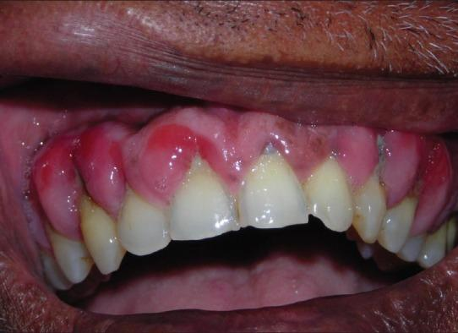

Figure 1 : Gum hypertrophy in oral lesion an abnormal overgrowth of gingival tissues.

II . HYPERTENSION

High blood pressure is a common condition that affects the body's arteries. It's pressure is also called hypertension[8]. If you have high blood pressure, the force of blood pushing against the artery wall is consistently too high[8]. The Heart has to work harder to pump blood. Normal BP- 120/180 mm of hg or lower. Elevated blood pressure: The top number ranges from 120 to 129 mm of hg or the bottom number is below, not above 80 mm Hg[8]. Fig1 Shows abnormal growth in the gingival tissue area due to hypertension.
Stage I hypertension: The top number ranges from 130 to 139 mm Hg or the bottom number is. between 80 and 89 mm Hg[8].
Stage II hypertension: The top number is 140 mm Hg or higher or the bottom number is 90 mm of Hg or higher. Untreated high Blood pressure increases the risk of heart attack, stroke and other serious health problems[ 8].
III. DRUGS USED TO TREAT HYPERTENSION

The first line antihypertensive drugs are thiazide ,diuretics, B blockers, ACE inhibitors/ ARBs and CCBs[1]. The Group called Calcium channel blockers are used to treat hypertension. It contains three groups.(1)Phenylalkylamine-Verapamil (2)Benzothiazepine-Diltiazem (3)Dihydroxypyridines- Nifedipine, felodipine, Amlodiping, Clinidipine, and Lacidipine. Among which most of the drugs like verapamil,amlodipine cause oral manifestation like Gum Hypertrophy[3].

IV.THE MECHANISM OF ACTION OF CALCIUM CHANNEL BLOCKERS

The Calcium Channel blockers they act on (1) Smooth Muscle : Smooth muscles depolarise primarily by inward Ca2+ movements through a voltage sensitive L-type channel. The CCBs cause relaxation by decreasing intracellular, avaibility of Ca2+ .They markedly relax arterioles, but have mild effect on veins (2) Heart : In the working atrial and ventricular fibers, Ca2+ moves in during the plateau phase of AP, and elicits contraction through binding to troponin. The Calcium Channel Blockers would thus have negative inotropic action by reducing Ca2+ Amlodipine cause Gum hypertrophy. As amlodipine is a calcium channel blocker it reduces the influx of Ca2+ inside the cell. Depolarization will not be achieved, cell activity will be less. As a result the uptake of folic acid in the cell will be reduced. Folic acid is required for inhibition of collagen enzyme. The collagenase enzyme required for degradation of collagen fibers giving space for new collagen fibers. As the collagenase enzyme is degraded the collagen fibers will not be degraded instead they will keep growing and accumulating giving rise to hypertrophy.

V. INVESTIGATIONS FOR BLOOD PRESSURE

S.no | Test for Examination BP
1 | Urine analysis for blood, proteins and glucose.
2 | Chest radiograph for cardiomegaly and heart failure.
3 | ECG for left ventricular hypertrophy & ischemia
4 | Plasma electrolytes
5 | Blood glucose level and lipids.

Table 1: Tabulate the test Sample to invesigate for Hypertension

VI .CONCLUSION

Gum hypertrophy may be an indication that the patient might be on an hypertensives. Accordingly the treatment planning of the patient should be done by dentist. As the antihypertensive may have an Orthostatic hypertension where the patient must avoid sudden changes with patient chair and when treatment is finished return the chair slowly to upright position.Better drugs are always available for the treatment of hypertension.A patient undergoing dental treatment should always give proper history so that the dentist can properly plan the tretament according to patients condition . Mostly the angiotensin receptor blockers must be used to treat hypertension.

VII .REFERENCE

- KD Tripathi. (2020, November). Essentials of Pharmacology for dentistry.
- Sir Sanleyndavidson.(2019). Davidsons Medicine,1440.
- KD Tripathi. (2020). Essentials of Medical Pharmacology, 1142.
- P.S uzanne.portnoy,Shin u lee,Ashley Mcmullen.(2022) .Amoldipine induced massive gingival hypertrophy.
- Wolters Kulwer ,JFE Mann (2022).Choice of drug therapy in primary hypertension.
- Angela L wang cosa .New generations of dihydropyridines for treatment of hypertension
- Christine frank DDS. Kiara Anthony (2018) .Gingival hyperplasia causes , symptoms and treament
- Leslie thomas ,M.D (2023) . High blood pressure symptoms and causes.

