Environmental Impact Assessment - Processes & Attributes

Introduction:
EIA is an activity designed to identify and predict the impact of a project on bio geo physico-chemical Environment and on human health so as to recommend appropriate legislative measures, programs, and operational procedures to minimize the impact. EIA is an exercise to be carried out before any project or major activity is undertaken to ensure that it will not in any away harm the environment on a short-term or long-term basis. Any developmental activity requires not only the analysis, the monetary costs and benefits involved and of the need of such a project but also most important, it requires a consideration and detailed assessment of the effect of a proposed development on the environment.

Need for EIA:
EIA links environment with development for environmentally safe and sustainable development. EIA provides a cost effective method to eliminate or minimize the adverse impact of developmental projects. EIA enables the decision makers to analyse the effect of developmental activities on the environment well before the developmental project is implemented. EIA encourages the adaptation of mitigation strategies in the developmental plan. EIA makes sure that the developmental plan is environmentally sound and within the limits of the Capacity of assimilation and regeneration of the ecosystem.

Indian Policies:
- Environment Impact Assessment in India is statutorily backed by the Environment Protection Act, 1986 which contains various provisions on EIA methodology and process.
- The Indian experience with Environmental Impact Assessment began over 20 years back. It started
- in 1976-77 when the Planning Commission asked the Department of Science and Technology to examine the river-valley projects from an environmental angle.
- Till 1994, environmental clearance from the Central Government was an administrative decision and lacked legislative support.
- On 27 January 1994, the then Union Ministry of Environment and Forests, under the Environmental (Protection) Act 1986, promulgated an EIA notification making Environmental Clearance (EC) mandatory for expansion or modernisation of any activity or for setting up new projects listed in Schedule 1 of the notification.
- The Ministry of Environment, Forests and Climate Change (MoEFCC) notified new EIA legislation in September 2006.
- The notification makes it mandatory for various projects such as mining, thermal power plants, river valley, infrastructure (road, highway, ports, harbours and airports) and industries including very small electroplating or foundry units to get environment clearance.
- However, unlike the EIA Notification of 1994, the new legislation has put the onus of clearing projects on the state government depending on the size/capacity of the project.

EIA Processes:
The EIA process in India is made up of the following phases:
- Screening
- Scoping and consideration of alternatives
- Baseline data collection
- Impact prediction
- Assessment of alternatives, delineation of mitigation measures and environmental impact statement
- Public hearing
- Decision making
- Monitoring the clearance conditions

Screening:
Screening is done to see whether a project requires environmental clearance as per the statutory notifications. Screening Criteria are based upon:
- Scales of investment;
- Type of development; and,
- Location of development.
A Project requires statutory environmental clearance only if the provisions of EIA notification and/or one or more statutory notification mentioned or cover it.
Scoping:
Scoping is a process of detailing the terms of reference of EIA. It has to be done by the consultant in consultation with the project proponent and guidance, if need be, from Impact Assessment Agency. The Ministry of Environment and Forests has published guidelines for different sectors, which outline the significant issues to be addressed in the EIA studies. Quantifiable impacts are to be assessed on the basis of magnitude, prevalence, frequency and duration and non-quantifiable impacts (such as aesthetic or recreational value), significance is commonly determined through the socio-economic criteria.

Baseline Data:
Baseline data describes the existing environmental status of the identified study area. The site- specific primary data should be monitored for the identified parameters and supplemented by secondary data if available.
Impact prediction:
Impact prediction is a way of ‘mapping’ the environmental consequences of the significant aspects of the project and its alternatives. Environmental impact can never be predicted with absolute certainty and this is all the more reason to consider all possible factors and take all possible precautions for reducing the degree of uncertainty.
The following impacts of the project should be assessed:

Air.
  - changes in ambient levels and ground level concentrations due to total emissions from point, line and area sources.
  - effects on soils, materials, vegetation, and human health.

Noise.
  - changes in ambient levels due to noise generated from equipment and movement of vehicles.
  - effect on fauna and human health.

Water.

Land.

- availability to competing users.
- changes in quality.
- sediment transport.
- ingress of saline water.

- changes in land use and drainage pattern
- changes in land use and drainage pattern

Biological.
  - deforestation/tree-cutting and shrinkage of animal habitat.
  - impact on fauna and flora (including aquatic species if any) due to contaminants/pollutants
  - impact on rare and endangered species, endemic species, and migratory path/route of animals.
  - Impact on breeding and nesting grounds.

Socio-Economic.
  - impact on the local community including demographic changes.
  - Impact on economic status
  - impact on human health.
  - impact of increased traffic.

Assessment of alternatives, delineation of mitigation measures and environmental impact statement:-
  - For every project, possible alternatives should be identified and environmental attributes compared. Alternatives should cover both project location and process technologies.
Alternatives should consider ‘no project’ option also. Alternatives should then be ranked for selection of the best environmental option for optimum economic benefits to the community at large.
  - Once alternatives have been reviewed, a mitigation plan should be drawn up for the selected option and is supplemented with an Environmental Management Plan (EMP) to guide the proponent towards environmental improvements. The EMP is a crucial input to monitoring the clearance conditions and therefore details of monitoring should be included in the EMP.
  - An EIA report should provide clear information to the decision-maker on the different environmental scenarios without the project, with the project and with project alternatives. Uncertainties should be clearly reflected in the EIA report.

Public hearing:-
  - Law requires that the public must be informed and consulted on a proposed development after the completion of EIA report.
  - Any one likely to be affected by the proposed project is entitled to have access to the Executive Summary of the EIA.
The affected persons may include:
  - bonafide local residents;
  - local associations;
  - environmental groups: active in the area
  - any other person located at the project site / sites of displacement
  - They are to be given an opportunity to make oral/written suggestions to the State Pollution Control Board as per Schedule IV of Annex I.

Decision making:-
  - Impact Assessment Authority along with the experts consults the project-incharge along with consultant to take the final decision, keeping in mind EIA and EMP (Environment Management Plan).

Monitoring the clearance conditions:-
  - The various phases of implementation of the project are monitored.

Components of EIA:-
  - The difference between Comprehensive EIA and Rapid EIA is in the time-scale of the data supplied. Rapid EIA is for speedier appraisal process. While both types of EIA require inclusion/ coverage of all significant environmental impacts and their mitigation, Rapid EIA achieves this through the collection of ‘one season’ (other than monsoon) data only to reduce the time required. This is acceptable if it does not compromise on the quality of decision-making. The review of Rapid EIA submissions will show whether a comprehensive EIA is warranted or not.
  - It is, therefore, clear that the submission of a professionally prepared Comprehensive EIA in the first instance would generally be the more efficient approach. Depending on nature, location and scale of the project EIA report should contain all or some of the following components.

Air Environment.
- Determination of impact zone (through a screening model) and developing a monitoring network.
- Monitoring the existing status of ambient air quality within the impacted region (7-10 km from the periphery) of the proposed project site.
- Monitoring the site-specific meteorological data, viz. wind speed and direction, humidity, ambient temperature and environmental lapse rate.
- Identification, quantification and evaluation of other potential emissions (including those of vehicular traffic) within the impact zone and estimation of cumulative of all the emissions/impacts.
- Evaluation of the adequacy of the proposed pollution control devices to meet gaseous emission and ambient air quality standards.
- Delineation of mitigation measures at source, path ways and receptor.

Noise Environment.
- Monitoring the present status of noise levels within the impact zone, and prediction of future noise levels resulting from the proposed project and related activities including increase in vehicular movement.
- Identification of impacts due to any anticipated rise in noise levels on the surrounding environment.
- Recommendations on mitigation measures for noise pollution.

Water Environment.
- Study of existing ground and surface water resources with respect to quantity and quality within the impact zone of the proposed project.
- Prediction of impacts on water resources due to the proposed water use/pumping on account of the project
- Quantification and characterisation of waste water including toxic organic, from the proposed activity
- Evaluation of the proposed pollution prevention and wastewater treatment system and suggestions on modification, if required
- Assessment of the feasibility of water recycling and reuse and delineation of detailed plan in this regard.

Land Environment.

- Studies on soil characteristics, existing land use and topography, landscape and drainage patterns within the impact zone
- Estimation of impacts of project on land use, landscape, topography, drainage and hydrology
- Estimation and Characterisation of solid wastes and delineation of management options for minimisation of waste and environmentally compatible disposal.

Roles in the EIA Process:-
EIA involves many parties, grouped by their role definition within the process. The following section outlines the basic responsibilities of various bodies:
The Project Proponent
The Environmental Consultants
The State Pollution Control Board / Pollution Control Committees (PCCs) The Public
The Impact Assessment Agency

The Role of the Project Proponent.
The project proponent during the project planning stage decides the type of projects i.e. new establishment, expansion or modernisation. Later the project proponent needs to prepare the Detailed Project Report/Feasibility Report and submits the Executive Summary, which shall incorporate the project details, and findings of EIA study, which is to be made available to concerned public.
The proponent has to approach the concerned SPCB for NOC and holding the public hearing. After the public hearing the proponent submits application to IAA for environmental clearance.

Role of Environment Consultant.
Environmental consultant should be conversant with the existing legal and procedural requirements of obtaining environmental clearance for proposed project. The consultant should guide the proponent through initial screening of the project and establish whether EIA studies are required to be conducted and if so finalise the scope of such study. The consultant should also be fully equipped with required instruments and infrastructure for conducting EIA studies. The environmental consultant is responsible for supplying all the environment-related information required by the SPCB and IAA through the proponent. The consultant is also required to justify the findings in the EIA and EMP during the meeting with the expert groups at IAA.

The Role of the State Pollution Control Board (PCB) /Pollution Control Committee (PCC).
The State PCBs/PCCs are responsible for assessing the compatibility of a proposed development with current operational and prescribed standards. If the development is in compliance, the PCB will then issue its NOC. They shall also hold the public hearing as per the provisions of EIA notification. The details of public hearing shall be forwarded to IAA.

The Role of the Public.
The public also has an important role to play in EIA. The concerned persons will be invited through press advertisement to review information and provide their views on the proposed development requiring environmental clearance.

The Role of the Impact Assessment Agency (IAA).
Where a proponent is required to obtain environmental clearance, the IAA will evaluate and assess the EIA report. In this process the project proponent will be given a chance to present his proposal. If a project is accepted the IAA will also prepare a set of recommendations and conditions for its implementation based on this assessment.

Government of India Ministry of Environment and Forest Notification (2000),
Whereas a notification under clause (a) of sub-rule (3) of rule 5 of the Environment (Protection) Rules, 1986 inviting objections from the public within sixty days from the date of publication of the said notification, against the intention of the Central Government to impose restrictions and prohibitions on the expansion and modernization of any activity or new projects being undertaken in any part of India unless environmental clearance has been accorded by the Central Government or the State Government in accordance with the procedure specified in that notification was published as SO No.
80(E) dated 28th January, 1993;
And whereas all objections received have been duly considered;
Now, therefore, in exercise of the powers conferred by sub-section (1) and clause (v) of sub-section (2) of section 3 of the Environment (Protection) Act, 1986 (29 of 1986) read with clause (d) of sub-rule (3) of rule 5 of the Environment (Protection) Rules, 1986, the Central Government hereby directs that on and from the date of publication of this notification in the Official Gazette, expansion or modernization of any activity (if pollution load is to exceed the existing one, or new project listed in Schedule I to this notification, shall not be undertaken in any part of India unless it has been accorded environmental clearance by the Central Government in accordance with the procedure hereinafter specified in this notification.

List of projects requiring Environmental clearance
- Nuclear Power and related projects such as Heavy Water Plants, nuclear fuel complex, Rare Earths.
- River Valley projects including hydel power, major Irrigation and their combination including flood control.
- Ports, Harbours, Airports (except minor ports and harbours).
- Petroleum Refineries including crude and product pipelines.
- Chemical Fertilizers (Nitrogenous and Phosphatic other than single superphosphate).
- Pesticides (Technical).
- Petrochemical complexes (Both Olefinic and Aromatic) and Petrochemical intermediates such as DMT, Caprolactam, LAB etc. And production of basic plastics such as LLDPE, HDPE, PP, PVC.
- Bulk drugs and pharmaceuticals.
- Exploration for oil and gas and their production, transportation and storage. 10.Synthetic Rubber.
11.Asbestos and Asbestos products. 12.Hydrocyanic acid and its derivatives.
13 (a) Primary metallurgical industries (such as production of Iron and Steel, Aluminium, Copper, Zinc, Lead and Ferro Alloys). (b) Electric arc furnaces (Mini Steel Plants).
- Chlor alkali industry.
- Integrated paint complex including manufacture of resins and basic raw materials required in the manufacture of paints.
- Viscose Staple fibre and filament yarn.
- Storage batteries integrated with manufacture of oxides of lead and lead antimony alloys.
- All tourism projects between 200m—500 metres of High Water Line and at locations with an elevation of more than 1000 metres with investment of more than Rs.5 crores.
- Thermal Power Plants.
- Mining projects (major minerals) with leases more than 5 hectares.
- Highway Projects except projects relating to improvement work including widening and strengthening of roads with marginal land acquisition along the existing alignments provided it does not pass through ecologically sensitive areas such as National Parks, Sanctuaries, Tiger Reserves,
Reserve Forests
- Tarred Roads in the Himalayas and or Forest areas. 23.Distilleries.
24.Raw Skins and Hides 25.Pulp, paper and newsprint. 26.Dyes.
27.Cement. 28.Foundries (individual) 29.Electroplating 30.Meta amino phenol

Application form
- (a) Name and Address of the project proposed :
  - Location of the project: Name of the Place:
District, Tehsil:
Latitude/Longitude:
Nearest Airport/Railway Station :
  - Alternate sites examined and the reasons for selecting the proposed site:
  - Does the site conform to stipulated land use as per local land use plan:
- Objectives of the project:
- (a) Land Requirement:
Agriculture Land:
Forest land and Density of vegetation. Other (specify):
- (i) Land use in the Catchment within 10 kms radius of the proposed site:
- Topography of the area indicating gradient, aspects and altitude:
- Erodibility classification of the proposed land:
- Pollution sources existing in 10 km radius and their impact on quality of air, water and land:
- Distance of the nearest National Park/Sanctuary/Biosphere Reserve/Monuments/heritage site/Reserve Forest:
- Rehabilitation plan for quarries/borrow areas:
- Green belt plan:
- Compensatory afforestation plan:
- Climate and Air Quality:
- Windrose at site:
- Max/Min/Mean annual temperature:
- Frequency of inversion:
- Frequency of cyclones/tornadoes/cloud burst:
- Ambient air quality data:
- Nature & concentration of emission of SPM, Gas (CO, CO2, NOx, CHn etc.) from the project:
- Water balance:
- Water balance at site:
- Lean season water availability; Water Requirement:
- Source to be tapped with competing users (River, Lake, Ground, Public supply):
- Water quality:

- Changes observed in quality and quantity of groundwater in the last years and present charging and extraction details:
- (i) Quantum of waste water to be released with treatment details:
- Quantum of quality of water in the receiving body before and after disposal of solid wastes:
- Quantum of waste water to be released on land and type of land:
- (i) Details of reservoir water quality with necessary Catchment Treatment Plan:
(ii) Command Area Development Plan:
- Solid wastes:
- Nature and quantity of solid wastes generated
- Solid waste disposal method:
- Noise and Vibrations:
- Sources of Noise and Vibrations:
- Ambient noise level:
- Noise and Vibration control measures proposed:
- Subsidence problem, if any, with control measures:
- Power requirement indicating source of supply: Complete environmental details to be furnished separately, if captive power unit proposed:
- Peak labour force to be deployed giving details of:
Endemic health problems in the area due to waste water/air/soil borne diseases: Health care system existing and proposed:
- (a) Number of villages and population to be displaced:
(b) Rehabilitation Master Plan:
- Risk Assessment Report and Disaster Management Plan:
- (a) Environmental Impact Assessment
- Environment Management Plan:
- Detailed Feasibility Report:
- Duly filled in questionnaire
Report prepared as per guidelines issued by the Central Government of India.
- Details of Environmental Management Cell:

Composition of Expert Committee
- The Committees will consist of experts in the following disciplines:
  - Eco-system Management
  - Air/Water Pollution Control
  - Water Resource Management
  - Flora/Fauna conservation and management
  - Land Use Planning
  - Social Sciences/Rehabilitation
  - Project Appraisal
  - Ecology
  - Environmental Health
  - Subject Area Specialists
  - Representatives of NGOs/persons concerned with environmental issues.

- The Chairman will be an outstanding and experienced ecologist or environmentalist or technical professional with wide managerial experience in the relevant development sector.
- The representative of Impact Assessment Agency will act as a Member- Secretary.
- Chairman and Members will serve in their individual capacities except those specifically nominated as representatives. 5. The Membership of a Committee shall not exceed 15.

Ecological sensitive places
- Eco-Sensitive Zones or Ecologically Fragile Areas are areas within 10 kms around Protected Areas, National Parks and Wildlife Sanctuaries.
- ESZs (Eco-Sensitive Zones) are notified by MoEFCC,( The Ministry of Environment, Forests and Climate Change) Government of India under Environment Protection Act 1986.
- In case of places with sensitive corridors, connectivity and ecologically important patches, crucial for landscape linkage, even area beyond 10 km width can also be included in the eco-sensitive zone.
- The basic aim is to regulate certain activities around National Parks and Wildlife Sanctuaries so as to minimise the negative impacts of such activities on the fragile ecosystem encompassing the protected areas.

International agreements
- With the introduction of forward-thinking concepts such as sustainable development along with a growing global awareness to protect the environment in recent decades, nation states feel an increasing need to participate in international treaties for environmental regulation. There is a particular concern with safeguarding steadily diminishing reserves of natural resources, which can be attained through cooperation among the countries. India is party to many such international agreements concerning the management of the environment. Some of the important agreements are as follows:
- The Antarctic Treaty (Washington, 1959)
The Antarctic Treaty was framed with the objective that the Antarctic shall continue to be a zone that shall be used for peaceful purposes only and shall not become an object of international discord. The treaty covers the area south of 60oS latitude and is known as the Antarctic Treaty Area (ATA) and imbibes the suspension of territorial claims, prohibition of all military activities in the region, freedom of scientific inquiry, and international co-operation in scientific activities.
India signed into the Antarctic Treaty system in 1983 as a Consultative Party Member (CEL, undated).
- Convention on International Trade in Endangered Species of wild fauna and flora (CITES), 1973 CITES was signed in March 1973 for the regulation of international trade in endangered species of wild flora and fauna. India had signed the agreement in July 1976 and the Director, Wild Life Preservation is India designated CITES Management Authority (MoEF, 2018). Although CITES seeks to prevent and control trade in endangered species, it should not be interpreted as overall conservation of endangered species of flora and fauna.

Montreal Protocol on Substances that deplete the Ozone Layer (to the Vienna Convention for the Protection of the Ozone Layer), 1987
Also known popularly as the Montreal Protocol, the protocol set targets aimed at a reduction in the production and consumption of ozone depleting substances (ODS) and came into force in 1989. The protocol also recognizes the obligations of nations in reducing emissions of ODS in terms of financial and technological abilities and identifies countries that are larger contributors than others. The Montreal protocol was adopted by India in September 1992. In order to supplement the protocol, the Ministry of Environment & Forests (MoEF), GoI has formed an Ozone Cell as well as constituted a steering committee on the Montral Protocol in order to implement the India Country Program (World Bank, undated).

Basel Convention on Transboundary Movement of Hazardous Wastes, 1989
Known popularly as the Basel Convention, the convention aims for a reduction in the transboundary movement of hazardous wastes. The Convention sees to it that creation of hazardous wastes is minimized. It also prohibits shipment of hazardous waste to countries unable to dispose of the hazardous waste in an environment-friendly manner. India ratified to the treaty in 1992 and included some provisions of the Basel Convention in The Indian Hazardous Waste Management Rules Act, 1989 (World Bank, undated).

UN Framework Convention on Climate Change (UNFCCC), 1992
The UNFCCC aims to regulate greenhouse gas emissions through international co-operation and agreement to bring emissions to a level that that can offset the effects of global warming and climate change. India became a member of the convention in 1992 and went on to ratify it in 1993. As a developing nation (as per the UNFCCC at the time), India was not bound to commitments for mitigation of greenhouse gas emissions. This changed, however, with the Paris Agreement of 2015 whereby India has a commitment to participate in multilateral negotiations under the UNFCCC. In this India has shown leadership in moving ahead with policy frameworks that includes the National Environment Policy (NEP) and the National Action Plan on Climate Change (NAPCC).

Convention on Biological Diversity, 1992
The Convention on Biological Diversity (CBD) provides a legally binding framework for the conservation of biodiversity, sustainability in use of biological resources and the equitable sharing of benefits and knowledge that arise in the case of the usage of biological resources. The convention was enforced in 1993 and a complex set of requirements was introduced for nations to ensure the preservation of biodiversity and natural habitats along with their sustainable us.
The Nagoya Protocol was adopted in 2010 to propagate the continued development of the access and benefit sharing framework in the Convention. The Article 6 of the CBD instructs parties to the convention to form national programs and strategies sustainable use and conservation of biodiversity. It also integrates them into national developmental plans and policies (MoEF, 2018). India passed the Biological Diversity Act, 2002 providing a legal framework for addressing biodiversity in the count. India has taken numerous other policy actions following the convention such as participating in the International Treaty on Plant Genetic Resources for Food and Agriculture (ITPGRFA) and the Trade Related Intellectual Property Rights (TRIPS), 1995 including biodiversity conservation in various national legislations.

Agenda 21
Agenda 21 is a product of the Earth Summit organized by the United Nations (UN) that took place in Rio de Janerio, Brazil in 1992 to include stakeholders in a non-binding action plan for achieving sustainable development. The stakeholders included local and national governments, business, international organizations, citizen groups and non-governmental organizations. The international community met again ten years later at the World Summit on Sustainable Development and reviewed developments to forge global partnerships for the implementation of Agenda 21 (World Bank, undated). India is signatory to Agenda 21 and has sought to align various parts of its development infrastructure such as energy, transport, industry, water facilities, climate change policy, forests, biodiversity, ecosystems, marine and coastal management, land policy, agriculture, urban governance and human resource development.

UN Convention on Desertification, 1994
The UN Convention on desertification was formulated in 1994 and seeks a bottom-up approach to build international co-operation in combating desertification or addressing policy in regions prone to droughts. The participation of local users of land and non-governmental organization is sought in this convention within policy activities concerned with the regulations for and alleviation of desertification in terms of its related effects. South Asia has a Regional Action Program with
seven countries signatory to the convention including India. Cartagena Protocol on Biosafety
The Cartagena Protocol on Biosafety is a supplement to the Convention on Biological Diversity and provides an international regulatory framework for the safe use, transfer and handling of Living Modified Organisms (LMOs) i.e. genetically modified organisms resulting from biotechnology. The protocol came into force in January 2000 and was the first such protocol of its kind (MoEF, 2018). The protocol was negotiated under the Convention for Biological Diversity and aims to provide protection against the exploits of modern biotechnology. As a part of the Convention on Biological Diversity, India is party to what is also called the Cartagena Protocol on Biosafety as well.
Prior Informed Consent, Rotterdam Convention Also known as the Rotterdam Convention, the treaty looks to promote shared responsibility in the trade of hazardous chemicals. It came into force in February 2004. The convention also looks to promote the environmentally safe use of the hazardous chemicals by supporting a national decision making process on their export and import by facilitating information exchange. India ratified the treaty in 2005 (MoEF, undated).

Environmental Attributes.
Many times an EIA analyst or the person charged with the preparation of an EIA report, is faced with a vast quantity of raw and usually unorganized data. Hence, each technique and method for the evaluation of impacts should have the following qualities and characteristics (I):
- It should be systematic in approach;
- It should be able to organize a large mass of heterogeneous data;
- It should be able to quantify the impacts;
- It should be capable of summarizing the data;
- It should be able to aggregate the data into sets with the least loss of information because of the aggregations;
- It should have a good predictive capability;
- It should extract the salient features, and
- It should finally be able to display the raw data and the derived information in a meaningful fashion

Criteria for the selection of EIA methodology.
- Simplicity: The methodology should be simple so that the available manpower with limited background knowledge can grasp and adopt it without much difficulty.
- Manpower time and budget constraints: The methodology should be applied by a small group with a limited budget and under time constraints.
- Flexibility: The methodology should be flexible enough to allow for necessary Modifications and changes through the course of the study.

Impact identification
  - Comprehensiveness : The methodology should be sufficiently comprehensive to contain all possible options and alternatives and should give enough information on them to facilitate proper decision-making.
  - Specificity: The methodology should identify specific parameters on which there would be significant impacts.
  - Isolation of project impacts: The methodology should suggest procedures for Identifying project impacts as distinguished from future environmental changes produced by other causes.
  - Time and duration:The methodology should be able to identify accurately the location and extent of the impacts on a temporal scale.

Impact measurement
- Commensurate units: The methodology should have a commensurate set of units so that comparison can be made between alternatives and criteria.
- Explicit indicators : The methodology should suggest specific and measurable indicators to be used to qualify impacts on the relevant environmental parameters.
- Magnitude: The methodology should provide for the measurement of impact magnitude, defined as the degree of extensiveness of scale of the impact, as distinct
from impact importance, defined as the weighting of the degree of significance of the impact.
- Objective criteria: It should be based on objective criteria and the criteria should be stated explicitly.

Impact interpretation & Evaluation
- Significance: The methodology should be able to assess the significance of measured impacts on a local, regional and national scale.
- Explicit criteria : The criteria and assumptions employed to determine impact Significance should be explicitly stated.
- Portrayal of "with" and without ‘situation: The methodology should be able to Aggregate the vast amounts of information and raw input data.
- Uncertainty: Uncertainty of possible impacts is a very real problem in environmental impact assessment. The methodology should be able to take this aspect into account.
- Risk: The methodology should identify impacts that have low probability of occurrence but a high potential for damage and loss.
- Depth of analysis: The conclusions derived from the methodology should be able to provide sufficient depth of analysis and in still confidence in the users, including the general public.
- Alterative comparison: It should provide a sufficiently detailed and complete Comparison of the various alternatives readily available for the project under study.
- Public involvement: The methodology should suggest a mechanism for public involvement in the interpretation of the impacts and their significance.

Impact Communication
- Affected parties: The methodology should provide a mechanism for linking impacts to specific effected geographical or social groups.
- Setting description: It should provide a description of the project setting to aid the users in developing an adequately comprehensive overall perspective.
- Summary format: It should provide the results of the impact analysis summarized in a format that will give the users, who range from the lay public to the decision makers, sufficient details to understand it and have confidence in its assessment.
- Key issue : It should provide a format for highlighting the key issues and impacts identified in the analysis.
- Compliance: One of the most important factors in choosing a methodology is whether it is able to comply with the terms of referel1Ce established by the controlling agency.

Adhoc Method
Ad hoc methods indicate broad areas of possible impacts by listing composite environmental parameters (Ex: flora and fauna) likely to be affected by the proposed activity. These methods involve assembling a team of specialists who identify impacts in their area of expertise. Here, each parameter is considered separately and the natures of impacts (long term or short term, reversible or irreversible) are considered. These methods give a rough assessment of total impact while giving the broad areas and the general nature of possible impacts. In this method, the assessor relies on an intuitive approach and makes a broad-based qualitative assessment. This method serves as a preliminary assessment and helps in identification of important areas like: Wildlife
- Endangered species
- Natural vegetation
- Exotic vegetation
- Grazing
- Social characteristics
- Natural drainage
- Groundwater
- Noise
- Air quality
- Visual description and services
- Open space
- Recreation
- Health and safety
- Economic values and
- Public facilities

Types of Ad hoc method are:
  - Opinion poll
  - Expert opinion and
  - Delphi methods
This method is very simple and can be performed without any training. It does not involve any relative weighting or any cause-effect relationship. It provides minimal guidance for impact analysis while suggesting broad areas for possible impacts. Moreover, it does not even state the actual impacts on specific parameters that will be affected.
The drawbacks of this method are listed below:
- It gives no assurance that a comprehensive set of all relevant impacts have been studied.
- Analysis using this method lacks consistency as it different criteria are selectively evaluated by different groups.
It is blatantly inefficient as it requires a considerable effort to identify and assemble a panel for each assessment

Matrices Method
This methodology provides a framework of interaction of different activities of a project with potential environmental impacts caused by them. A simple interaction matrix is formed when project actions are listed on one axis (usually vertical) and environmental impacts are listed along the other axis. This technique was pioneered by Leopold et al in 1971. It lists about 100 project actions and about 88 environmental characteristics and conditions. An example of this matrix is shown below:

Importance of Matrices
  - Matrices are two dimensional tables.
  - These facilitate the identification of impacts arising from the interaction between project activities and specific environmental components.
  - The entries of the cell of the matrix can be either qualitative or quantitative estimates of impact.

Simple Matrix
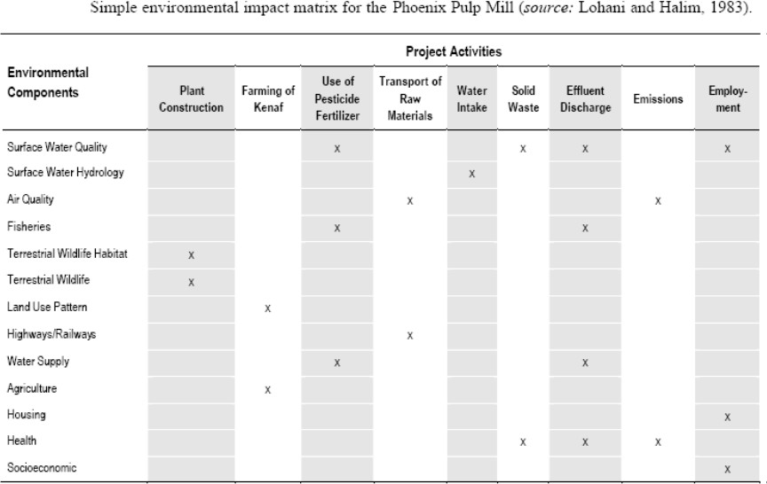

Leopold Matrices
- Identify all actions that are part of the proposed project
- Under the each of the proposed actions, place a slash at the inter-section with each item on the side of the matrix if an impact is possible.
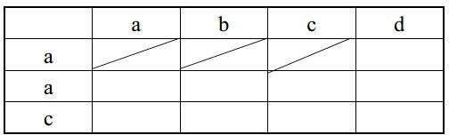
- In the upper left hand corner of each box with a slash, place a number from 1 to 10 which indicates the MAGNITUDE of the possible impact.
- 10 represent the greatest magnitude of impact.
- 1 is the least magnitude of impact (no zeroes).
- Before each number place + (if the impact would be beneficial).
- In the lower right hand corner of the box place a number from 1 to 10 which indicates the IMPORT ANCE of the possible impact (Eg. Regional vs. Local).
- 10 represents the greatest importance and 1 the least (no zeroes).
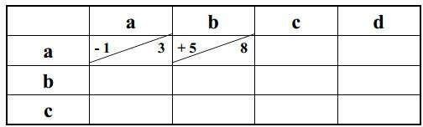

Advantages:
The matrix method is that it links action to impact This is a very good method for displaying EIA result.

Disadvantages:
It is difficult to distinguish between direct and indirect impacts using this method. There is potential for double-counting of impacts.
It is qualitative in nature and does not refer to quantity of impact.

Network Method
- This method uses the matrix approach and extends it to include both the primary as well as the secondary impacts.
- It is shown in the form of a tree called impact tree. This diagram is also called as reference or sequence diagram.
- Identification of direct, indirect along with short, long term impact is a crucial and basic step of making an impact tree.
- The impact tree is used to identify cause-effect linkages.
- The impact tree is a visual description of linkages.

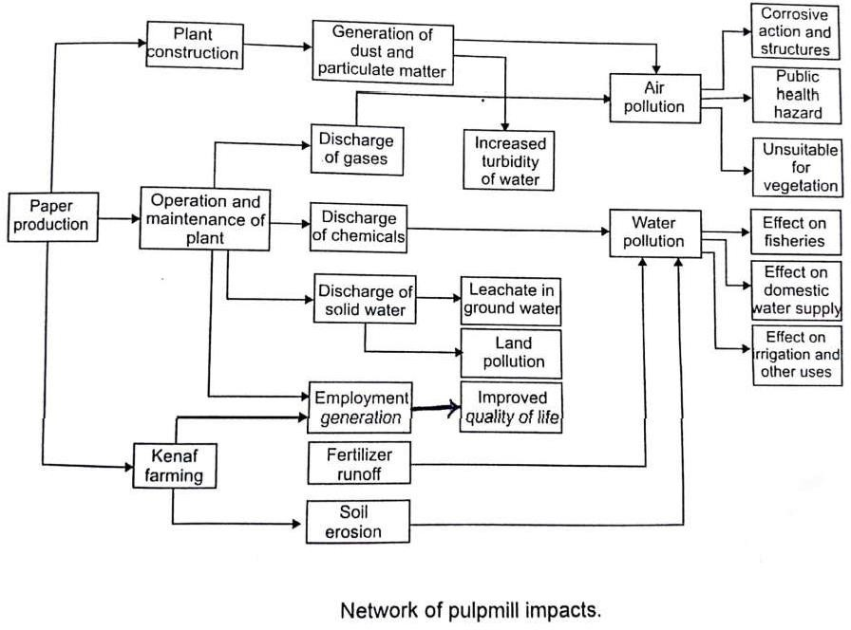

Advantages:
- It links action to impact.
- It is useful to check second order impacts in a simplified form.
- It handles direct and indirect impacts.

Disadvantages:
- It becomes overly complex if used beyond simplified version.
- It is completely qualitative in nature.

Overlays Method
  - Overlay methods involve preparation of a set of transparent maps, which represent the spatial distribution of environmental characteristics (e.g., Extent of dense forest area).
  - Information on wide range of variables will be collected for standard geographical units within the study area which will be recorded on series of maps typically one for each variable.
  - These maps will be overlaid to produce a composite.
  - The resulting composite maps characterize the area's physical, social, ecological, land use and other relevant characteristics relative to the location of the proposed development.
  - To evaluate the degree of associated impacts many project alternatives can be located on the final map and validity of the assessment will be related to the type and number of parameters chosen.
  - Normally to have some clarity the number of parameters that can be over layed in atransparency map is limited to 10.
  - These methods are widely used for assessing visually the changes in the landscapebefore and after the activity.
  - Secondly it can be used for preparing combined mapping with an analysis of sensitiveareas or ecological carrying capacity.
  - As these methods are spatially oriented they can very clearly show the spatial aspects of cumulative impacts.
  - These maps are overlaid to produce a composite characterization of the regional environment.
  - Impacts are identified by noting the impacted environmental characteristics lying within the project boundaries.
  - The approach seems most useful as a method of screening alternative project sites or routes, before detailed impact analysis.
  - Overlays can be useful for industrial EIA of any project for comparing land capabilities existing and projected land uses, road route alternatives and other under parameters, and alternative levels of air quality conditions along with pollution control.
Advantages:
  - It s easy to understand and use
  - It has a good display
  - It is good for setting site selection
Disadvantages
- The overlay method can accommodate both qualitative and quantitative data.
- The weakness of the overlay method is that it is only moderate comprehensive, because there is no mechanism that requires consideration of all potential impacts.
- There is no provision for quantification and measurement of the impacts nor is it assured that all impacts will be covered.
- The overlay approach is generally effective for selecting alternatives and identifying certain types of impacts; however, it cannot be used to quantify impacts to identify secondary and tertiary interrelationships.

Checklists methods:
Checklists are standard lists of the types of impacts associated with a particular type of project. Checklists methods are primarily for organizing information or ensuring that no potential impact is overlooked. They are a more formalized version of adhoc approaches in that specific areas of impact are listed and instructions are supplied for impact identification and evaluation. Sophisticated checklists include: 1) scaling checklists in which the listed impacts are ranked in order of magnitude or severity, and 2) weighting-scaling checklists, in which numerous environmental parameters are weighted (using expert judgment), and an index is then calculated to serve as a measure for comparing project alternatives.
There are four general types of checklists:
- Simple Checklist: a list of environmental parameters with no guidelines on how they are to be measured and interpreted.
- Descriptive Checklist: includes an identification of environmental parameters and guidelines on how tomeasure data on particular parameters.
- Scaling Checklist: similar to a descriptive checklist, but with additional information on subjective scaling of the parameters.
- Scaling Weighting Checklist: similar to a scaling checklist, with additional information for the subjective evaluation of each parameter with respect to all the other parameters.
Varying levels of information and expertise are required to prepare checklists. Simple checklists may require only a generalized knowledge of the environmental parameters likely to be affected, and access to an information base. Alternatively, simple checklist methods can be used to summarize the results of an EIA. Scaling weighted checklists are likely to require more expertise to prepare.
There are several major reasons for using checklists:
  - they are useful in summarizing information to make it accessible to specialists from other fields, or to decision makers who may have a limited amount of technical knowledge;
  - scaling checklists provide a preliminary level of analysis; and
  - Weighting is a mechanism for incorporating information about ecosystem functions.

EIA review
The quality of environmental impact statements (EIS) is a subject of increasing concern. Review of EISs provides an important mechanism for checking the quality of documentation and, by extension, the effectiveness of the approach taken in the impact. Topic 1 introduced the concept of the full EIA review process. This Topic looks in detail at the EIA review process, and the tools and steps to achieve an unbiased review of an EIS.

Baseline Conditions
A description of the environment as it is currently and as it could be expected to develop if the project were not to proceed is very important. Some baseline data can be gathered from existing data sources, but some will need gathering and the methods used to obtain the information should be clearly identified. Baseline data should be gathered in such a way that the importance of the particular area to be affected can be placed into the context of the region or surroundings and that the effect of the proposed changes can be predicted.

Construction Stage Impacts & post project impacts.
The methodology used to define the project specifications should be clearly outlined, including details of consultation with expert bodies and the public, and reference to panels of experts, guidelines, checklists, matrices, previous best practice examples of environmental assessments on similar projects.
Consideration should be given to impacts which may be positive or negative, cumulative, short or long term, permanent or temporary, direct or indirect. The logic used to identify the key impacts for investigation and for the rejection of others should be clearly explained. The impacts of the development on human beings, flora and fauna, soil, water, air, climate, landscape, material assets, cultural heritage, or their interaction, should be considered.

