ROBOTICS IN SURGERY AND HEALTH CARE
Dr Fatima Khatoon^{1*}, Summaiya Banu¹, Dr Syed Mohammed Kazim², Dr M A Aleem², Dr Nabeela Fatima²
¹Department of Pharmacy, Nizam Institute of Pharmacy, Deshmukhi, Telangana, India-508284
²Department of Pharmacy Practice, Nizam Institute of Pharmacy, Deshmukhi, Telangana, India-508284
Corresponding Author:
Dr Fatima Khatoon
Department of Pharmacy Practice,
Nizam Institute of Pharmacy, Deshmukhi.
Email: fak89867@gmail.com
Phone: +91-9505547994

ABSTRACT:
The use of robots in surgery and healthcare has brought about a paradigm change that is revolutionizing how patients are treated and medical operations are carried out. Simple tele manipulators gave way to complex, autonomous platforms as robotic technologies in surgery advanced. They provide unmatched dexterity, precision, and the capacity to carry out minimally invasive treatments with improved visualization. Now, difficult surgeries may be carried out by surgeons with fewer incisions, less blood loss, and quicker patient recoveries. Robotic surgery is used in a variety of surgical specialties, including general surgery, urology, gynecology, and orthopedics. Robots are being used in the healthcare industry for patient care, rehabilitation, and medical logistics in addition to surgery. Robots used in telemedicine make it possible to monitor and consult on patients from a distance, enhancing access to healthcare services, particularly in underdeveloped regions. Robotic exoskeletons and other assistive technology improve the quality of life for those with mobility limitations by helping with physical therapy and rehabilitation. Autonomous delivery robots also streamline the supply chain, guaranteeing prompt distribution of medical goods and lightening the load on medical staff. Robotics use in healthcare is not without difficulties, though. Regulation barriers, high start-up costs, and worries about employment displacement must all be addressed. Additionally, it is important to carefully address the ethical implications of robots in healthcare, including responsibility and data privacy. In conclusion, the use of robots in healthcare and surgery is a revolutionary development. Although there are still issues, the advantages in terms of better patient outcomes, increased effectiveness, and more access to healthcare services are indisputable. Robotics integration is positioned to become more and more important in determining the future of patient care and healthcare delivery as technology develops.
Keywords: Robotics, Robotic Surgery, Patient recovery, Rehabilitation, Healthcare.
- INTRODUCTION:
One of the most cutting-edge types of minimally invasive surgery is robotic surgery. Even though surgical robotics has been using robotic technology for around 20 years, robotics and automation have been around since 400 BC. We owe it to these thinkers and scientists that we are able to provide the advantage of minimal invasion in surgery. A few of the early pioneers include Archytas of Arentum, Leonardo da Vinci, Gianello Toriano, and Pierre Jaquet-Droz. A cutting-edge field that combines cutting-edge technology and medical know-how to revolutionize patient care is robotics in surgery and healthcare. In this cutting-edge method, robotic systems are used to support surgeons and medical staff in carrying out difficult operations, making diagnoses, and providing patient care.
Robotic arms are frequently used in surgery under the supervision of competent surgeons to increase dexterity and precision. This minimally invasive method frequently leads to smaller incisions, less pain, quicker recoveries, and better patient outcomes.
Robotics not only revolutionizes surgery but also telemedicine, rehabilitation, and diagnostics in the healthcare industry. While robotic exoskeletons support physical therapy and rehabilitation, telemedicine robots allow clinicians to consult with patients from a distance. The gathering of specimens is one duty that diagnostic robots may help with.
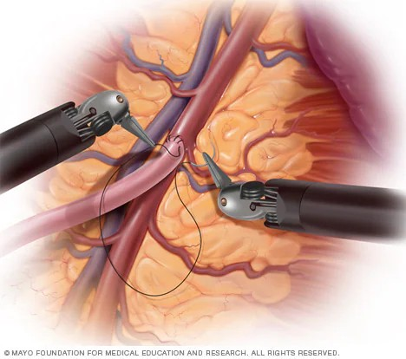
Fig-1: Use of robots in surgeries [Adapted from Mayo Clinic]

- CLASSIFICATION OF ROBOTIC SYSTEM:
Surgical robots vary in quality. Robotic surgery systems come in three varieties: shared-control systems, tele surgical systems, and supervisory-controlled systems. How involved a human physician needs be when executing a surgical procedure is the primary distinction between each system. On one end of the spectrum, robots perform surgical techniques without the direct intervention of a surgeon. On the other end, doctors perform surgery with the assistance of a robot, but the doctor is doing most of the work.
  - SUPERVISORY CONTROLLED ROBOTIC SYSTEM:
When using a supervisory controlled robotic surgery system, the surgeon still has full control over the surgical procedure, but the robot helps and improves their abilities. Surgical systems are the most automatic of the three types of robotic surgery are supervisory-controlled systems. But that does not imply that these machines can operate without human supervision. In fact, before the robot can operate, surgeons must perform considerable preparation with surgery patients. That's because when doing surgery, supervisory-controlled systems adhere to a set of rules. The robot has to receive data from the human surgeon, which it then starts a series of regulated movements, then finishes the operation. There is no space for error because these robots cannot correct errors in real time. The robot's activities must be closely monitored, and surgeons must be prepared to step in if things doesn't go according to plan. The rationale for which surgeons may employ such a system.
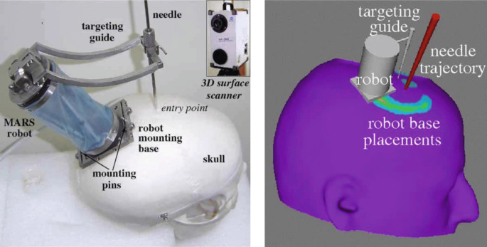
Fig-2: Supervisory Control Robots
  - TELESURGICAL SYSTEM:
A tele-surgical system, sometimes referred to as tele-operated or remote robotic surgery, is a kind of robotic surgery system that enables a surgeon to use robotic technology to perform surgical procedures on a patient from a distance. When a highly experienced surgeon is required but not nearby or when being physically close to the patient is not possible, this technology is especially helpful. With the use of robotic technology and wireless networking, telesurgery, also known as remote surgery, connects patients and surgeons who are separated by distance. The term "telesurgery," which derives from the Greek words "tele," "cheir," and "ergein," means "remote," "hand," and "to work," is used to describe a type of network-mediated robotic control. The primary benefit of telesurgery is its capacity to get beyond some of the drawbacks of traditional surgery, including the geographical impossibility of quick and high-quality surgical care, the lack of surgeons and logistical issues with surgeon scheduling, expense, and long-distance travel. Both patients and surgeons gain from this technology, which increases operation safety and provides technical correctness.
  - SHARED CONTROL ROBOTIC SURGERY SYSTEM:
A type of robotic surgical technology called a shared control robotic surgery system combines the skill of a surgeon with the accuracy and stability of a robotic device. In this system, the surgeon and the robot collaborate to improve the overall quality and safety of the surgical procedure while sharing control and decision-making duties. During surgery, shared-control robotic devices assist the surgeon, but they are not a replacement for them. The surgeons must control the surgical instruments themselves, unlike other robotic systems. Through active constraint, the robotic system offers stability and support while monitoring the surgeon's performance. The idea of active constraint is based on classifying patient regions as either safe, close, boundary, or banned. Safe areas are referred to be a surgery's primary focus by surgeons. In orthopedic surgery, for instance, the safe area can be a certain location on the patient's hip. Soft tissues do not border safe areas. A near area in orthopedic surgery is one that borders soft tissue. The region that the surgeon can work in is limited by the robot since orthopedic surgical equipment can cause significant harm to soft tissue. It accomplishes this by giving force feedback, or reactions.
- ROBOTIC SYSTEMS USED:
  - ARTEMIS:
The Advanced Robotics and TElemanipulator System for Minimally Invasive Surgery, or ARTEMIS, is intended to be an integrated teleoperation and telepresence system for organizing, practicing, and carrying out various minimally invasive surgical operations. The real prototype was created as an experimental tool for investigating and evaluating the required technologies, as well as their suitability and quality for use in surgery. The two master-slave units guiding the surgical tools and the endoscope guiding system are the major parts. Each master-slave device comprises of a slave or work unit and a master or control unit that are connected by a control system that is computer based.
  - AESOP:
Robotic surgery has undergone a revolution thanks to the invention and application of robotic technology in medicine, which has several advantages and improves patient outcomes. AESOP (Automatic Endoscopic System for Optimal Positioning), a robotic arm, was one of the first and most important breakthroughs in this field. This innovative technology, created in the 1990s, allowed surgeons to direct the direction of a conventional laparoscope using a voice command at first and a foot pedal subsequently. AESOP Systems became the first voice-controlled robot to get FDA certification, marking a significant advancement in medical robotics. The development and use of robotic technology in medicine has revolutionized robotic surgery. This technology has several benefits and enhances patient outcomes. One of the first and most significant developments in this area was the robotic arm known as AESOP (Automatic Endoscopic System for Optimal Positioning). This ground-breaking invention from the 1990s allowed surgeons to initially control a standard laparoscope using voice commands and then with a foot pedal. AESOP Systems received FDA clearance as the first voice-controlled robot, a significant development in the field of medical robotics.
  - DA VINCI:
Physician has access to a sophisticated collection of tools using the da Vinci surgical system to perform robotic-assisted, minimally invasive surgery. Many times, the word "robotic" misleads people. Surgery is not performed by robots. Utilizing equipment that are guided by a console, your surgeon performs surgery utilizing da Vinci. While completing the surgery, the da Vinci system interprets your surgeon's hand gestures at the console in real time, bending and twisting the tools. The small wristed devices have a wider range of motion than a human hand. The da Vinci vision system also provides 3D high-definition pictures of the surgical region that are greatly enlarged. Because of the device size, surgeons may perform their procedures with just one or a few small incisions.
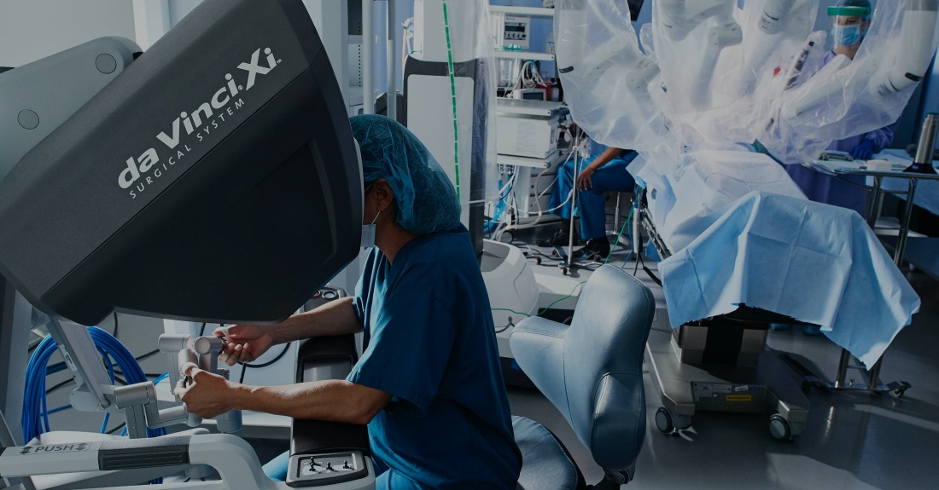
Fig-3: Da Vinci Robot [Adapted from Da Vinci Robotic-Assessted Surgery]
  - ZEUS:
Four years after launching the AESOP robotic system, Computer Motion unveiled the ZEUS robotic system. A second-generation robotic surgical device called ZEUS was created to provide even more control and accuracy during operation. Three robotic arms were added into the ZEUS system, increasing operational agility and range of motion. The laparoscope was operated with one arm, while the other two arms were used to perform various surgical procedures such as cutting and suturing. Computer Motion debuted the ZEUS robotic system four years after introducing the AESOP robotic system. For even greater control and accuracy during surgery, ZEUS, a second-generation robotic surgical tool, was developed. The ZEUS system's operating flexibility and range of motion were increased with the addition of three robotic arms. One arm was used to operate the laparoscope, while the other two arms were employed for various surgical tasks including cutting and suturing.
- ADVANTAGES AND DISADVANTAGES:
  - Advantages: Robotics in medicine and surgery have a number of benefits, including:
- Precision and Accuracy: Because robotic devices can make extremely exact movements, the chance of human mistake during surgical operations is reduced.
- Minimum Invasion: Smaller incisions are needed for many robotic operations, which are less invasive. As a result, patients frequently experience less discomfort, quicker recuperation times, and less scars.
- Enhanced Visualisation: Surgeons who employ robotic systems frequently have access to high-definition, three-dimensional visualisation of the operating region, which gives them a sharper picture of the anatomy.
- Steady Hands: Robots don't get hand tremors or become tired, so they may move steadily and consistently during lengthy operations.
- Remote Surgery: Teleoperated robotic platforms let surgeons carry out operations from a distance. When a professional is not physically there, this is very helpful.
- Reduced Blood Loss: Robotic surgery can result in reduced blood loss due to its precise cutting and cauterization.
  - Disadvantages: Despite the benefits of robotic surgery and healthcare, there are a number of drawbacks and difficulties to take into account:
- Cost: The high expense of purchasing and maintaining robotic devices can increase healthcare expenditures. Some healthcare institutions and patients may find this expense to be a barrier to access.
- Training Requirements: To use robotic systems efficiently, surgeons and medical personnel need specialized training. This training may take a lot of time and money.
- Lack of Haptic Feedback: Human surgeons have a tactile sense (haptic feedback), which robotic systems lack. The evaluation of tissue texture, which is important in several operations, may be difficult as a result.
- Technical Issues: Just like any other piece of technology, robotic surgical equipment is susceptible to glitches or faults that might delay or complicate the procedure.
- Limited Accessibility: Only a select group of patients may use robotic surgical systems since not all hospitals or healthcare institutions have access to them.
- Procedure Suitability: Not all procedures are appropriate for robotic surgery. Due to the intricacy of the condition, some procedures may necessitate an open approach.
- ROBOTICS IN CARDIOTHORACIC SURGERY:
  - CARDIAC REVASCULARIZATION:
Your chest receives three little incisions from the surgeon, each measuring less than a third of an inch. As a result, it is no longer necessary to cut through the breastbone to reach the heart. The left internal mammary artery (LIMA) is detachable from the chest wall thanks to a cutting-edge imaging robot used by the surgeon. Robotic harvesting of the LIMA enables utmost accuracy. The LIMA graft is then sewn to the front side of the heart via the left anterior descending (LAD) artery by the surgeon using direct view of the heart. Because the bypass is done while the patient's heart is still beating, there is a reduced chance of problems. The surgeon makes three tiny incisions on your chest, each less than a third of an inch long. As a consequence, accessing the heart no longer requires cutting through the breastbone. Thanks to a state-of-the-art imaging robot employed by the surgeon, the left internal mammary artery (LIMA) is capable of being separated from the chest wall. The LIMA may be harvested robotically for maximum precision. The surgeon next uses direct vision of the heart to stitch the LIMA graft to the front side of the heart via the left anterior descending (LAD) artery. There is a lower risk of complications since the bypass is performed while the patient's heart is still beating.
  - MITRAL VALVE REPAIR:
Both mitral valve replacement and repair are surgical procedures used to treat or replace a heart's leaky or stiff mitral valve. The left atrium and left ventricle of the heart are separated by the mitral valve.
Open heart surgery or minimally invasive heart surgery can be used to do mitral valve repair and replacement. Sometimes a catheter-based technique may be used to correct a mitral valve issue. Your mitral valve disease's severity and whether or not it's worsening determine the precise method that will be employed.
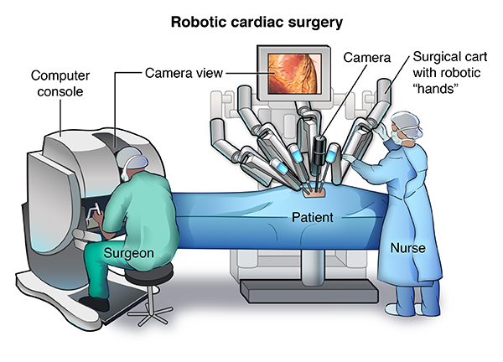
Fig-4: Robotics in Cardiac surgery. [Adapted from Stanford Medicine Children Health]
  - THYMECTOMY:
The most common surgical procedure involving the mediastinum is a thymectomy, which is used to treat thymic tumours as well as to treat myasthenia gravis (MG) in a multidisciplinary manner. Various surgical techniques, including minimally invasive and standard open techniques, have been reported. The development of minimally invasive surgery has advanced with the introduction of robotic thymectomy. With good long-term outcomes in myasthenic patients and promising results in patients with early stage thymoma, both in terms of surgical and oncological outcomes, the data available suggest that robotic thymectomy may be deemed a safe and practicable procedure. We describe the robotic thymectomy surgical approach that we use for patients with early-stage thymoma with myasthenia gravis.
  - LOBECTOMY:
The gold standard for the treatment of lung cancer remains lobectomy. Robotic lobectomy has been shown to be an operation that is safe and can be completed quickly, similar to video-assisted thoracoscopic surgery (VATS), thanks to the remarkable progress of robotic surgery. Furthermore, findings indicate that the long-term oncologic results of robotic lobectomy are comparable to those of VATS and open lobectomy. The same criteria are used to choose patients as for VATS. Surgery can benefit subjectively from improved vision, more dexterous equipment, and better ergonomics.
- ROBOTICS IN GENERAL SURGERY:
  - ROUX-EN-Y GASTRIC BYPASS:
The most popular weight-loss treatment in the US is called a Roux-en-Y Gastric Bypass, or RYGB (pronounced "roo-en-why"). It offers a great combination of weight reduction and controllable side effects and has been used for more than 30 years. The technique can be carried out laparoscopically (via tiny abdominal incisions) or robotically (with the assistance of computers during surgery). Weight Loss Is Encouraged By RYGB In Two Ways Restriction: The stomach's top and lower halves are divided by the surgeon. The top section (also known as the "pouch") is subsequently joined to the "Rouxlimb," a tiny intestinal limb. You may eat less because of the new stomach pouch, which causes you to feel full after only a modest amount of food. Mal-Absorption: The surgeon reroutes your digestive system to avoid the bigger portion of your stomach and part of your small intestine after the smaller pouch is constructed. The bypass causes you to absorb less energy and nutrients from your diet (mal-absorption).
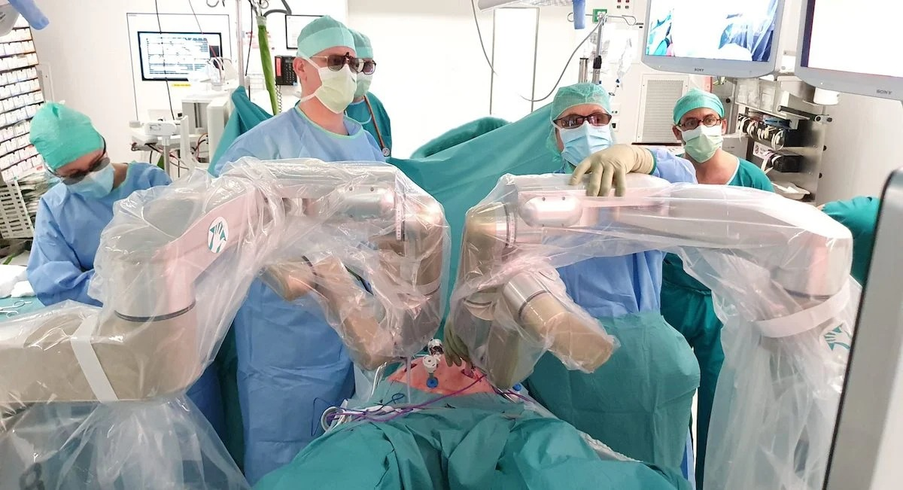
Fig-5: Robotics in General Surgery [Adapted from Robotics in Genaral Surgery]
  - THYROIDECTOMY:
Doctors in South Korea invented the robotic thyroidectomy, a minimally invasive procedure to remove all or part of the thyroid. Robot-assisted endoscopic surgery or robot-assisted thyroid surgery are other names for it. Eren Berber, M.D., an endocrine surgeon at the Cleveland Clinic and one of the first doctors in America to employ this method, thinks that it makes logical that robotic thyroidectomy would be the next step in thyroid surgery, especially for individuals who don't want a neck scar. Prior to its creation, endoscopic surgery or traditional open surgery were the two primary alternatives for thyroid surgery. Traditional open surgery leaves a scar on the neck; endoscopic procedures may or may not leave a scar on the neck.
  - MEDIAN ARCUATE LIGAMENT:
The median arcuate ligament of the diaphragmatic crura compresses the proximal celiac artery (CA) and celiac ganglion, causing medial arcuate ligament syndrome. The symptoms of median arcuate ligament syndrome (MALS) include postprandial epigastric discomfort, nausea, vomiting, and weight loss. Due to its rarity, MALS is often identified by ruling out other, more prevalent illnesses. Mesenteric duplex ultrasonography, computed tomography angiography, magnetic resonance angiography, stomach tonometry, and mesenteric arteriography can all be used to confirm the diagnosis. For the release of the median arcuate ligament (MALR), a number of procedures have been suggested, including open surgery, laparoscopic surgery, vascular repair, and endovascular angioplasty. Although many patients have reported improved symptoms after using most of these approaches, the long-term results have indicated varying degrees of symptom recurrence.
- ROBITICS IN NECK AND HEAD SURGERY:
Robotic head and neck surgery uses minimally invasive techniques on distinct anatomical structures and built-in access points. Surgical robotics have revolutionized head and neck surgery, building on the history of minimally invasive endoscopic otolaryngology techniques. Anatomical restrictions limit surgical techniques and make it difficult for surgeons to see what they are doing. The development of transoral robotic surgery (TORS) during the past ten years has shown positive oncologic and functional results, transforming the way head and neck surgeons handle both malignant and benign disorders. Access will keep becoming better and push the limits of least invasive methods as new robotic platforms are developed.
  - TRANSORAL ROBOTIC SURGERY:
Robotic transoral surgery, with the use of the cutting-edge da Vinci® Surgical System and transoral robotic surgery (TORS), head and neck surgeons at Penn can enter throat regions that are challenging to access with conventional surgery. A minimally invasive surgical technique called TORS can be used to remove both cancerous and benign tumors. With better access to the throat, patients recover more quickly and easily, experience fewer swallowing adverse effects, and have better cancer outcomes. TORS treats several disorders with a minimally invasive surgical technique:
- Carcinoma at the tongue base
- Throat and head cancer
- Carcinoma of the hypopharynx
- Throat cancer
- Benign tumors of the larynx
- Carcinoid tumors in the larynx
- Squamous cell cancer of the larynx
- Obstructive snoring
- Tumors oropharynx cancer
- Mucoepidermoid carcinoma of the oropharynx
- Squamous cell carcinoma of the oropharynx
- Tumors in the parapharyngeal cavity.
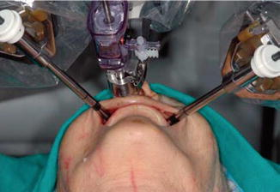
Fig-6: Robotics in Head and Neck Surgery [Adapted from Robotics in Neck and Head Surgery]
  - TONSILLECTOMY:
Tonsillectomy is the medical term for the surgical removal of your tonsils (pronounce it "tahn-suh-LEK-tuh-me"). The fleshy, rounded masses in the back of your throat are your tonsils. You have two, one on each side, unless you have had them removed.
The majority of the time, during this treatment, the surgeons will remove your entire tonsils. However, some patients may just require a partial tonsillectomy.
There are two primary reasons why doctors advise tonsillectomy to treat sleep disorders that are connected to breathing, like sleep apnea to lower the risk of infection in those who frequently or persistently suffer from tonsillitis. Although tonsillectomies are typically performed on youngsters, they can also be beneficial for adults. Nowadays, tonsillectomies are less frequent than they were a few decades ago. However, more than 500,000 tonsillectomies are routinely performed by surgeons each year. your tonsil has been released by your surgeon, this device will be wrapped around it to clamp it off. Bleeding is lessened as a result. Scalpel harmonics: This technique makes use of ultrasonic vibrations.Your tonsils can be removed while stopping the bleeding using a vibrato. Other procedures include the use of carbon dioxide lasers, radiofrequency ablation techniques, and/or microdebriders (which combine suction and cutting).
Stages of post-tonsillectomy recovery;
Here is a basic timeline of what to anticipate during tonsillectomy recovery, though everyone's healing will appear a little different:
- 1-2 days following tonsillectomy.
- Sore throat.
- Low-grade fever.
- Fatigue.
- Poor breathe.
- Hoarseness or difficulty speaking.
- Feeling of swelling in your throat, which makes it feel full.
Following a tonsillectomy, three to five days
- Persistent sore throat, which can get worse after three to four days.
- Fatigue.
- 5–10 days following tonsillectomy
- Scabbing.
- When the scabs gradually come off, there is some minor bleeding.
The surgery is done by surgeons to treat chronic tonsillitis or breathing-related sleep disturbances. Tonsillectomies are still performed by surgeons in the US every year, despite the fact that they are somewhat less frequent now.
  - TRANSORAL LASER MICROSURGERY:
Laser Microsurgery Transoral Larynx, pharynx, and oropharynx are only a few of the anatomic subsites in the head and neck that have undergone considerable evaluation with transoral laser microsurgery. TLM has been investigated at various sites for the management of advanced T3/T4 BOT malignancy and has been demonstrated to be a successful surgical technique with outstanding oncologic and functional results in selected patients. Patients with T4 lesions have poor swallowing performance, and these lesions are linked to a higher conversion to open approach. T3 lesions addressed with TLM do pretty well from a functional standpoint. Additionally, as is the case with the majority of surgical techniques, more advanced cancers necessitate multimodality therapy, making case selection for primary surgery in the context of T3/T4 base of tongue crucial. At our institution, we have more experience with TORS and do not routinely employ TLM for advanced BOT cancer, however, the principles are similar despite the differences in technique. Whereas TLM surgery has some advantages in terms of visualization of tumors with more inferior location when compared with current robotic technology, TORS has several advantages over TLM, most notably avoidance of line-of-sight issues and wristed instrumentation. Although transoral laser microsurgery (TLM) is primarily used for early-stage laryngeal cancers, some surgeons perform endoscopic partial laryngectomy for the treatment of locally advanced glottic and supraglottic tumors. Frequently the patient can be spared a tracheotomy after the procedure, and the swallowing rehabilitation can ideally be shorter than with similar open procedures. Removal of a large tumor requires excising the tumor in a piecewise fashion, although it does not appear to affect locoregional control rates. A retrospective review of TLM for advanced laryngeal cancer was performed by Hinni and colleagues; this review included 117 patients with stage III or IV SCC of the glottic or supraglottic larynx treated with TLM at multiple institutions.16 The researchers examined laryngeal preservation, overall survival, disease-free survival, locoregional control, and distant metastases. The percentage of patients with an intact larynx 2 years after treatment was 92%. The 5-year Kaplan-Meier estimates were local control, 74%; locoregional control, 68%; disease-free survival, 58%; overall survival, 55%; and distant metastases, 14%. The conclusion of Hinni and colleagues was that in the right patients, TLM offers acceptable rates of organ preservation and locoregional control with low morbidity. Although TLM for advanced BOT cancer is not frequently used at our institution because we have greater expertise with TORS, the fundamentals are the same. TORS provides various advantages over TLM, chief among them the avoidance of line-of-sight problems and wristed instrumentation. TLM surgery has certain advantages over current robotic technology in terms of imaging of tumors with more inferior position. Although endoscopic partial laryngectomy is sometimes used to treat locally progressed glottic and supraglottic tumors, transoral laser microsurgery (TLM) is most frequently utilized to treat early-stage laryngeal malignancies. With the aid of a CO2 laser and a microscope, this kind of surgery preserves the cartilaginous support structure while removing a piece of the endolarynx.
- ROBITICS IN UROLOGY AND GYNAECOLOGY:
  - Robotic urology surgery:
Robotic surgery is a kind of minimally invasive surgery that uses tiny surgical instruments that are directed by cutting-edge robots. It is a highly sophisticated method that enables the surgeon to carry out surgical procedures with extreme precision. Typically, general anesthesia is used for this kind of operation. Due to the smaller, more precise incisions used during robotic surgery as opposed to open surgery, patients recover more quickly and experience less discomfort. Furthermore, because robotic surgery is more precise than traditional surgical methods, it is less likely to affect erectile and urine continence. Due to the benefits it offers for the patient, robotic surgery is being used for an increasing number of surgical procedures. Robotic surgery in urology is used in the treatment of prostate cancer (prostatectomy), kidney cancer (nephrectomy), bladder cancer, genital prolapse, urethral stenosis, and other pathologies.
Robotic surgery entails a sizeable investment in equipment and in specific training for surgeons. For these reasons, it is not available at all medical centres. As alternatives, urological surgical procedures may be performed using conventional open surgery or ideally using minimally invasive techniques such as endoscopy or urological laparoscopy.
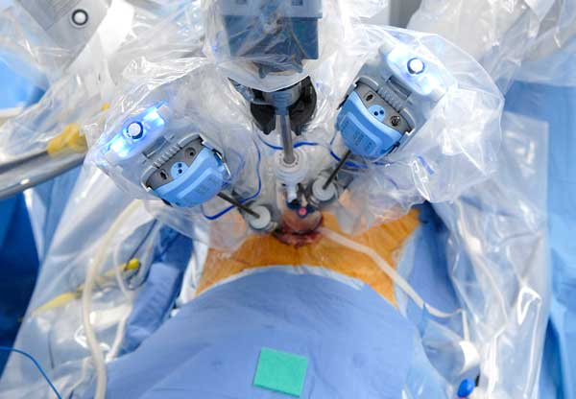
Fig-7: Robotics in Urology [Adapted from Robotics in Urology]
  - Gynecological robotic surgery:
The first gynecologic procedures with the Hugo robotic-assisted surgery (RAS) system were performed in Panama in July 2021, providing patients with a new minimally invasive treatment. The modular, multiquadrant platform from Medtronic plc is designed for a broad range of soft tissue procedures, including hysterectomies and myomectomies. “As an ob-gyn [obstetrician-gynecologist], I am especially passionate about the positive impact that the Hugo system can have on women’s health,” said Carla Peron, MD, chief medical officer of surgical robotics at Medtronic. “The technology is also unique and thoughtfully designed, based on surgeon and hospital leader input to meaningfully address the greatest barriers to robotic adoption and use the patient and the doctor. Prostate cancer, kidney cancer, bladder cancer, genital prolapse, urethral stenosis, and other pathologies are all treated with robotic surgery in urology. Costly equipment and specialized training for surgeons are required for robotic surgery. Due of these factors, not all medical facilities offer it. Alternative methods for doing urological surgical treatments include traditional open surgery or, ideally, minimally invasive methods like endoscopy or urological laparoscopy. Hugo robotic-assisted surgery (RAS) was used for the first time for gynecologic surgeries in Panama in July 2021, offering patients a novel, minimally invasive approach.1 The Medtronic Plc's modular, multiquadrant platform is intended for a variety of soft tissue treatments, includingboth myomectomies and hysterectomies. Carla Peron, MD, chief medical officer of surgical robotics at Medtronic, stated: "As an ob-gyn [obstetrician-gynecologist], I am very excited about the great influence that the Hugo system may have on women's health. The technology is also special and well-thought-out, based on input from surgeons and hospital leaders to truly address the biggest obstacles to robotic acceptance and use.
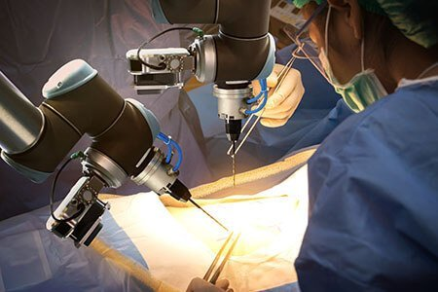
Fig-8: Robotics in Gynecology [Adapted from Robotics in Gynecology]
  - Robotics in nephrotomy:
For locally contained kidney cancer (cancer that has not spread), surgery is typically the first line of treatment. Larger open incisions or minimally invasive techniques like laparoscopic or robotic surgery can both be used to remove kidney tumors. These minimally invasive techniques provide comparable cancer control to open surgery and provide a quicker recovery. At BIDMC, almost all kidney cancer surgeries can be carried out laparoscopically or robotically because to our significant training and experience in these procedures. In 2014, we performed more robotic partial nephrectomies than the majority of other institutions—more than 95% of them. Additionally, in 2014, more than 95% of our radical nephrectomies were carried out using laparoscopy, saving our patients from a more unpleasant procedure. Rib-length incision and possible weeks or months of healing. Part of the kidney is removed during a partial nephrectomy in order to protect the remaining kidney from harm or removal, usually due to a tumor. If the patient has only one kidney or the renal tumor is smaller than 7 cm, it is routinely performed. The patient's rib must be removed in order to conduct this technique traditionally, which calls for an 8–12 inch incision in the flank. Robotic partial nephrectomy is a minimally invasive approach that requires the surgeon to not put his or her hand inside the belly and is carried out using thin, specialized devices inserted through small incisions. This yields a cancer cure rate comparable to open surgery. Similar to surgery, but with significantly less discomfort and a faster recovery.
  - Robotic assisted prostatectomy:
Robotic prostatectomy or Robotic prostatic surgery is the innovative surgical equipment enables the surgeon to precisely remove the prostate and surrounding tissues by inserting miniature robotic instruments through a number of tiny keyhole incisions in the patient's abdomen. Compared to a traditional radical retropubic prostatectomy, which requires an abdominal incision that reaches from the belly button to the pubic bone, this procedure is significantly less invasive. A three-dimensional endoscope and image processing tools are utilized during robotic-assisted radical prostatectomy to provide a magnified view of the delicate structures surrounding the prostate gland (such as nerves, blood arteries, and muscles), allowing for the best preservation of these important structures. One of the keyhole incisions is subsequently used to remove the prostate. The physician does the majority of the procedure while sat at a computer panel, manipulating tools that fit around the wrist and have a much wider range of motion than a human wrist. The procedure is carried out without the doctor's hands touching the patient's internal organs.
  - Hysterectomy:
The surgical removal of the uterus and, most likely, the cervix is known as a hysterectomy. A hysterectomy may involve the removal of nearby organs and tissues, including the ovaries and fallopian tubes, depending on the purpose for the operation. During pregnancy, a fetus develops in the uterus. The blood lost during your menstrual cycle makes up its lining. After a hysterectomy, the women won't be able to become pregnant or start period. There are various hysterectomies. Depending on circumstances, healthcare professional will talk about the sort of hysterectomy that is required. Fallopian tubes and/or ovaries may need to be removed depending on the results of this. A total hysterectomy involves the removal of the uterus, cervix, but not the ovaries. Having a supracervical hysterectomy involves only removing the upper portion of cervix, uterus. Removing uterus, cervix, fallopian tubes (salpingectomy), and ovaries (oophorectomy) is done during a total hysterectomy with bilateral salpingo-oophorectomy. Removing ovaries will cause menopausal symptoms if a person have never gone through it. The removal of uterus, cervix, fallopian tubes, ovaries, upper region of vagina, some surrounding tissue, and lymph nodes. Radical hysterectomy with bilateral salpingo-oophorectomy. When malignancy is present, this kind of hysterectomy is done.
- Vasectomy hysterectomy: An incision is made at the top of vagina to remove uterus. No external incision is present
- In vagina, dissolvable sutures are inserted.
- Uterine prolapse and other benign (or noncancerous) diseases are the most frequent uses.
- Fastest recovery (up to four weeks) and least number of issues make this method the best choice.
- A lot of times, people return home the same day as surgery.
- The procedure is laparoscopic.
Through a tiny incision in belly button, a laparoscope (a thin tube with a video camera on the end) is put in lower abdomen. Several further tiny incisions are used to implant surgical instruments. Uterus can be cut up and removed. Either through the incisions made in abdomen or vagina. Some patients leave the hospital the same day or the following morning. Compared to an abdominal hysterectomy, the full recovery is quicker and less painful.
Body-part hysterectomy: An abdominal incision between six and eight inches long is used to remove your uterus. Your pubic bone or your belly button is where the incision is done.To close the wound, the surgeon will use stitches or staples. Most frequently applied in cases of malignancy, uterine enlargement, or disease spreading to other pelvic regions. Typically, it necessitates a lengthier hospital stay (two or three days) as well as a longer recuperation period.

- ROBOTICS IN ORTHOPEDICS:
Robotics applied to orthopedics has become an interesting topic both from the surgical point of view and the engineering one at Mayo Clinic locations in Arizona, Florida, and Rochester, Minnesota, Mako robotic-arm assisted orthopedic surgery is used for partial and total knee replacements as well as total hip replacements. A physician replaces injured bone and cartilage with artificial parts composed of metal alloys, premium plastics, and polymers during joint replacement treatments. Replacement knee. The whole knee joint is replaced in a total knee replacement. However, surgeons can only replace the damaged piece of the knee joint if only a small amount of the knee is injured. A partial knee replacement is what this is total replacement of the hip. The hip is a ball-and-socket joint, and during a total hip replacement, both parts of the joint are taken out and replaced.
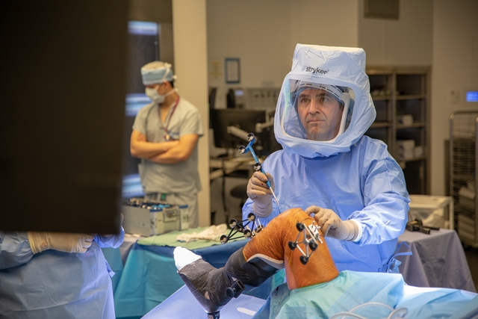
Fig-9: Robotic is Orthopedics [Adapted from Robotics in Orthopedics]
  - TOTAL KNEE ARTHROPLASTY:
The femoral condyles and tibial plateau of the knee joint are replaced with smooth metal and highly cross-linked polyethylene plastic during a total knee arthroplasty (TKA) or total knee replacement (TKR), a standard orthopedic procedure. TKA was discovered to increase patients' sports and physical activity. Its goal is to improve the quality of life of people with end-stage osteoarthritis by lowering pain and boosting function. In affluent nations, the number of TKA procedures has increased with younger patients undergoing the procedure.
After surgery:
As a shock absorber, at least one piece of polyethylene is positioned between the tibia and the femur. The prostheses are often strengthened with cement, although in cases where bone development is relied upon for reinforcement, they may not be. It is possible to replace or resurface the patella. The extensor mechanism is intended to be restored by patella repair. It is possible to use a quadriceps-splitting or quadriceps-sparing technique. The cruciate ligaments can be removed or left in place.
- CONCLUSION:
In conclusion, robotics has had a transformative impact on surgery and healthcare. It has enabled greater precision, minimally invasive procedures, and improved patient outcomes. Robotics in surgery has reduced human error, enhanced the capabilities of surgeons, and expanded access to specialized care. However, challenges remain in terms of cost, training, and ensuring ethical and safe use of these technologies. As technology continues to advance, the future of robotics in healthcare holds promise for further innovation and improved patient care.
REFERENCES:
- Satava RM. Surgical robotics: the early chronicles: a personal historical perspective. Surgical Laparoscopy Endoscopy & Percutaneous Techniques. 2002 Feb 1;12(1):6-16.
- Felger JE, Nifong LW, Chitwood Jr WR. The evolution of and early experience with robot-assisted mitral valve surgery. Surgical Laparoscopy Endoscopy & Percutaneous Techniques. 2002 Feb 1;12(1):58-63.
- Marescaux J, Rubino F. Transcontinental robot-assisted remote telesurgery, feasibility and potential applications. Teleophthalmology. 2006:261-5.
- Cheah WK, Lee B, Lenzi JE, Goh PM. Telesurgical laparoscopic cholecystectomy between two countries. Surgical endoscopy. 2000 Aug 9;14(11):1085-.
- Das S, Vyas S. The Utilization of AR/VR in Robotic Surgery: A Study. InProceedings of the 4th International Conference on Information Management & Machine Intelligence 2022 Dec 23 (pp. 1-8).
- Kim VB, Chapman Iii WH, Albrecht RJ, Bailey BM, Young JA, Nifong LW, Chitwood Jr WR. Early experience with telemanipulative robot-assisted laparoscopic cholecystectomy using da Vinci. Surgical Laparoscopy Endoscopy & Percutaneous Techniques. 2002 Feb 1;12(1):33-40.
- Fuchs KH. Minimally invasive surgery. Endoscopy. 2002 Mar;34(02):154-9.
- Allendorf JD, Bessler M, Whelan RL, Trokel M, Laird DA, Terry MB, Treat MR. Postoperative immune function varies inversely with the degree of surgical trauma in a murine model. Surgical endoscopy. 1997 May;11:427-30.
- Al-Rubaey RF. Robotic surgery and tele-surgery: A review article. Medical Journal of Babylon. 2014;11(3):XVI-XIV.
- Prasad SM, Ducko CT, Stephenson ER, Chambers CE, Damiano Jr RJ. Prospective clinical trial of robotically assisted endoscopic coronary grafting with 1-year follow-up. Annals of surgery. 2001 Jun;233(6):725.
- Kwoh YS, Hou J, Jonckheere EA, Hayati S. A robot with improved absolute positioning accuracy for CT guided stereotactic brain surgery. IEEE transactions on biomedical engineering. 1988 Feb;35(2):153-60.
- Davies B. A review of robotics in surgery. Proceedings of the Institution of Mechanical Engineers, Part H: Journal of Engineering in Medicine. 2000 Jan 1;214(1):129-40.
- Schurr MO, Buess G, Neisius B, Voges U. Robotics and telemanipulation technologies for endoscopic surgery: a review of the ARTEMIS project. Surgical endoscopy. 2000 Apr;14:375-81.
- Dario P, Carrozza MC, Pietrabissa A. Development and in vitro testing of a miniature robotic system for computer-assisted colonoscopy. Computer Aided Surgery. 1999 Jan 1;4(1):1-4.
- Tholey G, Chanthasopeephan T, Hu T, Desai JP, Lau A. Measuring grasping and cutting forces for reality-based haptic modeling. InInternational Congress Series 2003 Jun 1 (Vol. 1256, pp. 794-800). Elsevier.
- Hu T, Castellanos AE, Tholey G, Desai JP. Real-time haptic feedback in laparoscopic tools for use in gastro-intestinal surgery. InInternational Conference on Medical Image Computing and Computer-Assisted Intervention 2002 Sep 25 (pp. 66-74). Berlin, Heidelberg: Springer Berlin Heidelberg.
- Kennedy CW, Hu T, Desai JP, Wechsler AS, Kresh JY. A novel approach to robotic cardiac surgery using haptics and vision. Cardiovascular Engineering: An International Journal. 2002 Mar;2:15-22.
- Kennedy CW, Hu T, Desai JP. Combining haptic and visual servoing for cardiothoracic surgery. InProceedings 2002 IEEE International Conference on Robotics and Automation (Cat. No. 02CH37292) 2002 May 11 (Vol. 2, pp. 2106-2111). IEEE.
- Kennedy CW, Desai JP. Force feedback using vision. InThe 11th International Conference on Advanced Robotics 2003 Jun 30 (pp. 2106-2111).
- Cadière, MD, Ph. D GB, Himpens, MD J, Germay O, Izizaw R, Degueldre, MD M, Vandromme, MD J, Capelluto, MD E, Bruyns, MD J. Feasibility of robotic laparoscopic surgery: 146 cases. World journal of surgery. 2001 Nov;25:1467-77.
- Falcone T, Goldberg JM, Margossian H, Stevens L. Robotic-assisted laparoscopic microsurgical tubal anastomosis: a human pilot study. Fertility and sterility. 2000 May 1;73(5):1040-2.
- Margossian H, Falcone T. Robotically assisted laparoscopic hysterectomy and adnexal surgery. Journal of Laparoendoscopic & Advanced Surgical Techniques. 2001 Jun 1;11(3):161-5.
- Marescaux J, Smith MK, Fölscher D, Jamali F, Malassagne B, Leroy J. Telerobotic laparoscopic cholecystectomy: initial clinical experience with 25 patients. Annals of surgery. 2001 Jul;234(1):1.
- Abbou CC, Hoznek A, Salomon L, Olsson LE, Lobontiu A, Saint F, Cicco A, Antiphon P, Chopin D. Laparoscopic radical prostatectomy with a remote controlled robot. The Journal of urology. 2001 Jun;165(6 Part 1):1964-6.
- Damiano Jr RJ, Tabaie HA, Mack MJ, Edgerton JR, Mullangi C, Graper WP, Prasad SM. Initial prospective multicenter clinical trial of robotically-assisted coronary artery bypass grafting. The Annals of thoracic surgery. 2001 Oct 1;72(4):1263-9.
- Mohr FW, Falk V, Diegeler A, Walther T, Gummert JF, Bucerius J, Jacobs S, Autschbach R. EVOLVING TECHNOLOGY. J Thorac Cardiovasc Surg. 2001;121:842-53.
- Kappert U, Cichon R, Schneider J, Gulielmos V, Ahmadzade T, Nicolai J, Tugtekin SM, Schueler S. Technique of closed chest coronary artery surgery on the beating heart. European journal of cardio-thoracic surgery. 2001 Oct 1;20(4):765-9.
- Boehm DH, Reichenspurner H, Gulbins H, Detter C, Meiser B, Brenner P, Habazettl H, Reichart B. Early experience with robotic technology for coronary artery surgery. The Annals of thoracic surgery. 1999 Oct 1;68(4):1542-6.
- Cisowski M, Drzewiecki J, Drzewiecka-Gerber A, Jaklik A, Kruczak W, Szczeklik M, Bochenek A. Primary stenting versus MIDCAB: preliminary report–comparision of two methods of revascularization in single left anterior descending coronary artery stenosis. The Annals of thoracic surgery. 2002 Oct 1;74(4):1334-9.
- Hollands CM, Dixey LN, Torma MJ. Technical assessment of porcine enteroenterostomy performed with ZEUS™ robotic technology. Journal of pediatric surgery. 2001 Aug 1;36(8):1231-3.
- Hollands CM, Dixey LN. Robotic-assisted esophagoesophagostomy. Journal of pediatric surgery. 2002 Jul 1;37(7):983-5.
- Morimoto AK, Foral RD, Kuhlman JL, Zucker KA, Curet MJ, Bocklage T, MacFarlane TI, Kory L. Force sensor for laparoscopic Babcock. InMedicine Meets Virtual Reality 1997 (pp. 354-361). IOS Press.

