DOMESTIC ENERGY EFFICIENCY: THE ROLE OF INTELLIGENT DEMAND RESPONSE IN SMART GRIDS

V.Umayal Muthu
Assistant Professor
Department of EEE
Velammal College of Engineering and Technology Madurai, India
uma@vcet.ac.in
Dr.A.Shunmugalatha
Dean (Academics)
Department of EEE
Velammal College of Engineering and Technology Madurai, India
asl@vcet.ac.in

M.Devaki R.Saranya
Assistant Professor Assistant Professor
Department of EEE Department of EEE
Velammal College of Engineering and Technology Velammal College of Engineering and Technology
Madurai, India Madurai, India
mde@vcet.ac.in rsy@vcet.ac.in

ABSTRACT

The need for electrical energy has greatly increased, posing difficulties not just for its generation but also for its distribution. As a result, the complexity of power networks is developing due to the increased demand for more responsibility, efficiency, security, and environmental and energy sustainability issues. These characteristics contribute to a power grid becoming smarter, which is eventually known as the "Smart Grid" concept of today. This is an abstract method in which all beneficial characteristics are enforced in order to expand the electricity distribution network. Smart Grids," with their alternatives and many perspectives on the power distribution industry, have been introduced. Additionally, it is noted that although these technologies change, they have a great deal of potential to advance and strengthen the distribution system.

Keywords— Power supply, demand response for smart grid and peak

INTRODUCTION

Smart Grid has been characterized as associate integrated system which will increase the potency, dependableness and suppleness of the electricity network through a two-way flow of electricity and knowledge. the most purpose is to resolve the height downside by sanctionative period of time communications between the client and also the utility, and to extend power network resilience through the combination of renewable energy sources. Because, the customers favors to tailor their energy consumptions in responding to cost or environmental issues, the height load burden are reduced, and therefore sensible Grid will meet enlarged client demand while not adding dearly-won infrastructure

METHODOLOGY:

In this project, we have built a system that alerts the customer to busy and slow periods and nudges him to move hundreds to off-peak times. This gradually lowers the cost due to high capability installations and lessens overloading problems. This project also provides the option of adding small 21eneration power units as and when necessary. If the height hour consumption is high in our project, the system may verify it and turn off the lowest amount with the highest priority.

BLOCK DIAGRAM:
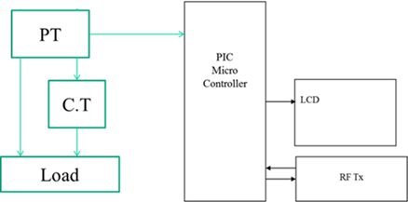
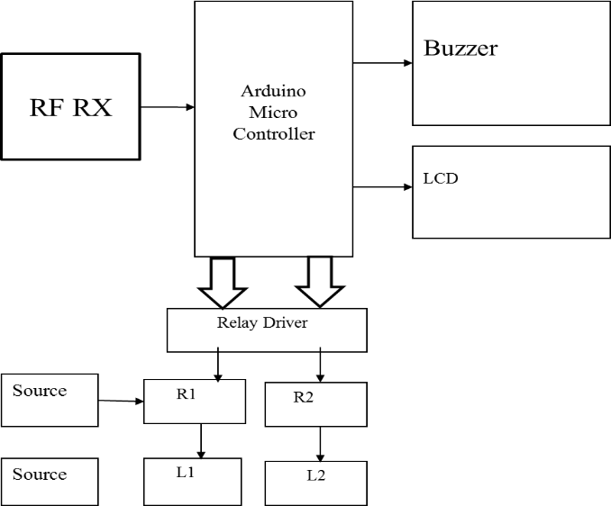

HARDWARE REQUIREMENTS:

- PIC16F877A
Devices of the PIC16F series are Complementary Metal Compound Semiconductors (CMOS). Over other technologies, CMOS technology has a number of advantages. For instance, CMOS circuits are extremely tolerant of hazardous designs and electrical noise, work over a broad range of voltages, and waste little power. PIC stands for "Peripheral Interface Controller" and was initially noticed.
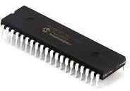

ARDUINO NANO:

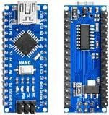
It is a little, low-size board that is also adaptable and has a wide range of uses. Additionally, it can be powered by batteries using either the Mini-B USB connector, a 6-20V unregulated external power supply (pin 30), or a 5V regulated external power supply (pin 27). The best voltage supply is mechanically selected for the facility supply.

RF TRANSMITTER AND RF RECEIVER

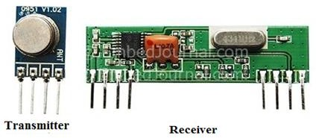
The combined transmitter and receiver (Tx/Rx) works at a 433MHz frequency. The antenna of an RF transmitter attached to pin 4 accepts serial data and broadcasts it wirelessly using RF. The speed of the transmission is between 1Kbps and 10Kbps. Associate in Nursing RF receiver operating at a frequency similar to the transmitter picks up the broadcast information.

RELAY

Relays are controls that open and close in response to the state of another circuit. The switch in the original design is activated by a magnet to open or close one or more sets of contacts. Henry did, in fact, create it in 1835. A relay is frequently referred to, in an extremely wide sense, as a type of electrical electronic equipment since it can control an output circuit that is more powerful than the input circuit. Frequently, these contacts are change-over contacts or normally open (NO) or closed (NC) contacts. When the relay is turned on, normally-open contacts connect the circuit; when the relay is turned off, the circuit is detached.

BUZZER
A buzzer or pager is an audio device that uses electricity or a mechanical mechanism. Buzzers and beepers are frequently used as timers, alarm clocks, and confirmation of human input such a click or typing. Early gadgets did not support the metal gong but rather a mechanical device system that was similar to an electrical bell. The contacts buzz as a result of a relay that is also attached to interrupt its own activation current. In order to use a wall or ceiling as a sounding board, these units were fixed to them. The rasping sound that mechanical device buzzers produced is where the word "buzzer" originates.
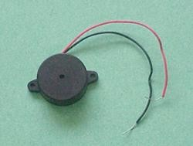

LCD DISPLAY

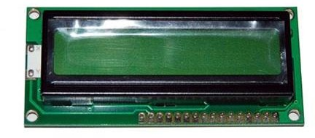
LEDs and liquid cell displays (LCDs) are employed in applications that are comparable to each other. These applications demonstrate segmental and matrix displays of numeric and alphabetic characters.

POWER SUPPLY

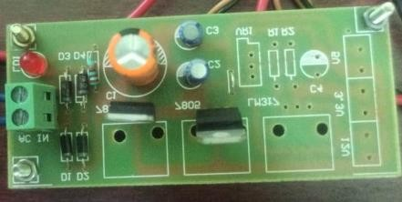
Selected voltage and freight current ratings are produced by this source. The influence offer's circuit diagram may then follow.Since the microcontroller, RS232, LM311 and liquid crystal display require input voltages, we need a consistent low voltage regulated power supply of +5V. Alphanumeric LCD displays that require five volts are available.

STEP DOWN TRANSFOMER

The secondary winding of a step-down transformer is smaller than the primary winding.To match the voltage of our device, we used a 220 vac stepdown transformer in this project to change the electrical output of a power supply.
. 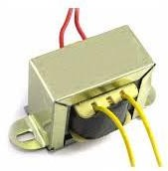

CURRENT TRANSFOMER

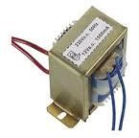
It is employed to generate a secondary alternating current that is inversely proportional to the primary alternating current. When a current or voltage is too high to monitor directly, this is typically utilized.

POTENTIAL TRANSFORMER

It is a voltage transformer that lowers a high voltage circuit’s voltage to a lower level for measurement purposes. These are interconnected with or situated across from the road that has to be watched.
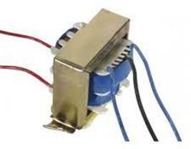

SOFTWARE REQUIRED:

1.SKETCH IDE – ARDUINO & NODE MCU MODULE PROGRAMMING SOFTWARE:
This moniker suggests that an Arduino program is used. The hardware and software created by the project are made available as open source and are distributed under the General Public License (GPL), which enables anybody to produce Arduino boards and distribute software. Typically, a dialect of elements from the programming languages C and C++ are used to program the microcontrollers.
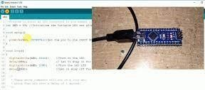

2 MPLAB ICD4
For the fastest debugging and programming tool for the peripheral interface controller, we chose a circuit debugger/programmer (picture).
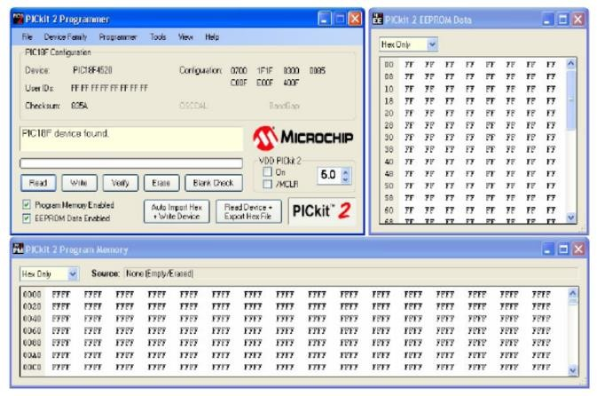

RESULT AND CONCLUSION:
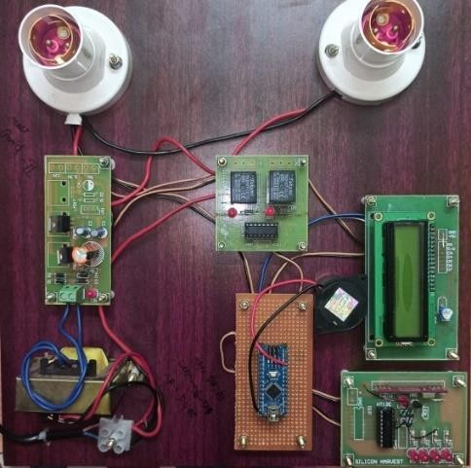
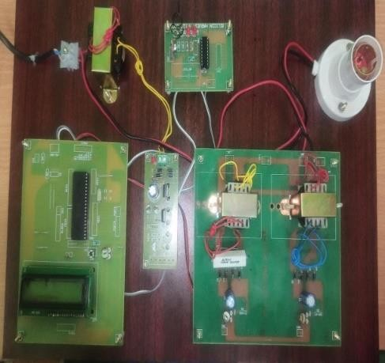
The project's success and its grid-based primary focus on home load management have been established. The outcomes are in line with what was anticipated. With every software package and hardware testing tool, the project has been examined. The choice of RF transmitters and receivers, relay interfaces, current and voltage sensors, and other components was made with the intended use in mind. The project has enough potential for development in the future. The project can be a prototype that satisfies all logical requirements. The project that needs the fewest improvements can be used for real-time applications. The project makes a significant contribution to the field of power grid automation and prepares the way for faster advancements in the same area. The project is accommodating of ongoing performance and ancillary upgrades. This work is utilized in industrial settings and applications.

REFERENCES

[1]D. Gavrila, P. Marchal, and M.-M. Meinecke, "SAVE-U, Deliverable 1-A: Vulnerable Road User Scenario Analysis," technical report, Information Soc. Technology Programme of the EU, 2020.
[2]W. Jones, "Building Safer Cars," IEEE Spectrum, vol. 39, no. 1, pp. 82-85, Jan. 2019.
[3] United Nations—Economic Commission for Europe "Statistics of Road Traffic Accidents in Europe and North America," 2018.
[4] R. Bishop, Intelligent Vehicle Technologies and Trends. Artech House, Inc., 2019.
[5] L. Vlacic, M. Parent, and F. Harashima, Intelligent Vehicle Technologies. Butterworth-Heinemann, 2018.6. T. Heinrich, "Bewertung Von Technischen Maßnahmen zum Fußgängerschutz am Kraftfahrzeug," technical report, Technische Univ. Berlin, 2019.

