SOME COMMON HEALTH PROBLEMS-DIATARY MANGANESE SUPPLEMENTS PRESENT IN SELECTED EDIBLE VEGETABLES, IMPHAL, MANIPUR, INDIA.

M. Aken Singh,

Department of Chemistry, G.P Women’s College, D.M University, Imphal -795001, Manipur.

* Corresponding author, E-mail: akenmaibam569@gmail.com , Phone: 09862125442.

ABTRACT: Energy Dispersive X-ray Fluorescence (EDXRF) technique was used for the determination of trace elements in some selected vegetables available in Manipur. Manganese and Zinc present in some selected vegetables as medicinal value, improves some common health problems.
Key words: EDXRF, Manganese some selected edible vegetables, Tardive Dyskinesia, Goiter, Osteoporosis, Sprains-Strains and Diabetes Type 1, 2.
INTRODUCTION
Manipur referred to as the “Jewel of India” stretches from 23⁰83/ N - 25⁰86/N to 93⁰03/E - 94⁰78/E in the northeastern corner of the country. It is surrounded on the north by Nagaland on the east by upper Myanmar, on the south by Chin- hills of Myanmar and Lusai Hills ( Mizoram) and on the west by Cachar district of Assam.
The state has an area of 22.356 sq Km. with an oval shape fertile valley in the centre. The forest area is 15,154 sq. km. is reserved, 4171 Sq. Km is protected and 9.520 Sq. Km. is unclassed forest areas (Statistical Bulletin, Manipur Forest, 1990). The flora and fauna of the state is similar and related to those of the neighboring regions. However has its own endemic species too. Untouched and undiscovered Manipur promises to be the great tourist discovery of the 21st century. An oval shaped valley surrounded by blue green hills, rich in art and traditions has inspired description as the “Switzerland of East” with its cascading rapids, tripping river, carpet of flowers, exotic blooms. Plants have been used from the time of immortal at different countries as foods to get energy. Human body needs different trace elements for normal physiological function. So such trace elements generally obtained from our food we consumed. The deficiency and excess of trace elements in our body lead to some complications and metabolic disorder. Hence the investigation of trace elements in the edible food items is very important. Here some selected edible plants were analyzed for their elemental concentrations.
Manganese is a trace mineral and one the most abundant metals in the tissues of mammals and has been shown to function in many key biological processes, serving as a catalyst, enzyme cofactor, a gene modulator. Mn is required for a variety of body functions including the metabolism of amino-acids, cholesterol, glucose, and carbohydrates¹. Mn in other physiological processes including brain and skeletal development, blood clotting, reproductions, neuronal function, antioxidantdefense, maintaining immune integrity and in anti-viral innate immunity^{2, 3, 4}. Mn is found in soil, water, food legumes and has eleven (11) oxidation states, but it is predominantly in biological tissues as Mn²⁺ & Mn³⁺ ions^{5, 6}. Mn deficiency has been associated with increased susceptibility to seizures, birth and skeletal defects^{6, 7, 8}. Normal Mn concentration varies depending on the biological tissues evaluated. Generally the estimated value of Mn in the body is about 4-12micro gm per lite whole body, 1-8 micro gm per lite in urine, and 0.4-0.85 micro gm per litre in serum^{9, 10}.
Manganese is an essential trace mineral needed for healthy skin, bone, and cartilage formation, as well as glucose tolerance. It also helps activate superoxide dismutase (SOD)—an important antioxidant¹¹.
Tardive dyskinesia is caused by long-term use of neuroleptic drugs, which are used to treat psychiatric conditions. Tardive dyskinesia is a side effect of antipsychotic medications. One doctor has found that administering the trace mineral manganese (15 mg per day) can prevent the development of TD and that higher amounts (up to 60 mg per day) can reverse TD that has already developed. Other researchers have reported similar improvements with manganese¹².
A goiter is an abnormal enlargement of our thyroid gland. Our thyroid is a butterfly-shaped gland located at the base of our neck just below our Adam's apple. Although goiters are usually painless, a large goiter can cause a cough and make it difficult forus to swallow or breathe. The most common cause of goiters worldwide is a lack of iodine in the diet. In the United States, where the use of iodized salt is common, a goiter is more often due to the over- or underproduction of thyroid hormones or to nodules in the gland itself. Deficiencies of manganese can contribute to iodine-deficiency goiter. Supplementing with manganese may help. When iodine deficiency is present, other nutrient levels become important in the development of goiter. Deficiencies of zinc and manganese can both contribute to iodine-deficiency goiter¹². There are other factors for goiter.
Hypoglycemia is the condition when our blood glucose (sugar, the body's main source of energy) levels are too low. It happens to people with diabetes when they have a mismatch of medicine, food, and/or exercise. Non-diabetic hypoglycemia, a rare condition, is low blood glucose in people who do not have diabetes¹². Manganese helps control blood sugar levels in people with diabetes, and since there are similarities in the way the body regulates high and low blood sugar levels, it might be helpful for hypoglycemia as well. Research has shown that supplementing with chromium (200mcg per day or Manganese (340 mg per day) can prevent blood sugar levels from falling excessively in people with hypoglycemia. Niacinamide (vitamin B3) has also been found to be helpful for hypoglycemic people¹³. Other nutrients, including vitamin C, Vitamin E, Zinc, Cu, Mn and Vitamin B6 may help control blood sugar levels in diabetes¹⁴.
Osgood-Schlatter disease (Knee Pain) is a common cause of knee pain in growing adolescents. It is an inflammation of the area just below the knee where the tendon from the kneecap (patellar tendon) attaches to the shinbone (tibia). Some doctors have reported good results using a combination of zinc, manganese, and vitamin B6 for people with Osgood-Schlatter disease. Another group of doctors has reported good results using a combination of Zinc, manganese, and Vitamin B6 for people with Osgood-Schlatter disease; however, the amounts of these supplements were not mentioned in the report. Most physicians would consider reasonable daily amounts of these nutrients for adolescents to be 15 mg of zinc, 5 to 10 mg of manganese, and 25 mg of vitamin B6. Larger amounts might be used with medical supervision^{15, 16}.
Osteoporosis, or thinning bones, can result in painful fractures. Risk factors for osteoporosis include aging, being female, low body weight, low sex hormones or menopause, smoking, and some medications. Prevention and treatment include calcium and vitamin D, exercise, and osteoporosis medications¹⁷. A combination of minerals including manganese was reported to halt bone loss in one study. Some doctors recommend manganese to people concerned with bone mass maintenance. Interest in the effect of manganese and bone health began when famed basketball player Bill Walton's repeated fractures were halted with manganese supplementation. A subsequent, unpublished study reported manganese deficiency in a small group of osteoporotic women. Since then, a combination of minerals including manganese was reported to halt bone loss. However, no human trial has investigated the effect of manganese supplementation alone on bone mass. Nonetheless, some doctors recommend 10 to 20 mg of manganese per day to people concerned with maintenance of bone mass. One trial studying postmenopausal women combined hormone replacement therapy with magnesium (600 mg per day), calcium (500 mg per day), Vitamin C, B, D Zinc, Cu, Mn, Boron and other nutrients for an eight- to nine-month period. In addition, participants were told to avoid processed foods, limit protein intake, emphasize vegetable over animal protein, and limit consumption of salt, sugar, alcohol, coffee, tea, chocolate, and tobacco. Bone density increased a remarkable 11%, compared to only 0.7% in women receiving hormone replacement alone^{18, 19, 20}.
Type 1 diabetes(a chronic disease) is a condition in which our immune system destroys insulin in our pancreas. These are called beta cells. The condition is usually diagnosed in children and young people, so it also known as Juvenile diabetes. People with type 1 diabetes is unable to make insulin, a hormone that helps our body’s cells use glucose for energy. Our body gets glucose from the food we eat. Insulin allows the glucose to pass from our blood into our body’s cells. Supplementing with manganese may increase antioxidant defenses and improve blood sugar control in those with type 1 diabetes.
Manganese is involved in the activity of an important antioxidant enzyme system in the body. A genetic variant linked to reduced activity of this enzymes system has been implicated as a factor in the development of type-1diabetes and its complications. Low blood levels of manganese have been reported in people with type 1 and type 2 diabetes. Animal research suggests that manganese supplementation can improve the functioning of this enzyme system, increase insulin secretion, and improve glucose metabolism. One team of researchers reported on a case of a young adult with insulin-dependent diabetes who received oral manganese (3 to 5 mg per day as manganese chloride) and experienced a significant fall in blood glucose, sometimes to dangerously low levels; however, three other people with type 1 diabetes they treated with manganese supplementation had no change in blood glucose levels. People with type 1 diabetes wishing to supplement with manganese should do so only with a doctor's close supervision²².
Type 2 diabetes, is a lifelong disease that keeps our body from using insulin. People with type-2 diabetes are said to have insulin resistance ie stopped responding well to insulin. The body struggles to move glucose from the blood into the cells, adequate levels of the hormone. In fact, a person with ype-2 diabetes may not know they have it until they have a complication. People who are middle aged or older are most likely to get this type of diabetes, so also known as adult onset diabetes. This type also affects kids and teens, mainly because of childhood obesity. Manganese is important as an antioxidant and metabolic regulator. Supplementation to prevent deficiency may be helpful for people with type 2 diabetes. Manganese is an important nutrient for the activation of antioxidant and metabolic enzyme systems. Both high and low manganese levels can contribute to increased oxidative stress and the development and progression of type 2 diabetes. Animal and laboratory research suggest manganese supplementation might improve insulin sensitivity and protect blood vessels from damage due to high glucose levels in people with type 2 diabetes. Although clinical trials are lacking, taking a multivitamin/mineral supplement to ensure adequate manganese intake is a reasonable precautionary measure for people with type 2 diabetes²³.

Materials and methods:
Samples Preparation
The edible vegetable samples along with wild edible species were purchased from different vegetable venders at Imphal city and some wild plants from hilly areas of Manipur, India. A total of 8 samples were washed one by one with distilled water 2-3 times to remove contaminated particles, soil/sand and dried in the oven at 65⁰C for 24 hours. The analyzed samples were given in Table-1. One should take care that concentration of K can be changed if the drying temperature is higher than 70⁰C and subsequently ground by an agate mortar. The powdered samples were passed through sieve to have homogeneity in three dimensions. 150 mg of each sample were weighed and pelletized into thin pellets of uniform thickness having 13 mm diameters using a table-top K-Br press under a pressure of 150-200 kg/cm² for 5 minutes.
EDXRF Analysis:
The pellets of the samples were analyzed in three replications by the Jordan Valley ED-3600 Energy Dispersive X-Ray fluorescence spectrometer, which works with liquid-nitrogen-cooled system. The NIST standard apple leaf (SRM-1515) was used as reference material for the analysis work. The data acquisition time was 10 minutes for each sample. Ti and Fe filters were used for 14 kV (e2) and 23 kV (e3) respectively. The spectra were analysed by using EXwin²⁵.

List of the samples analyzed.
Sl.No | Samples analysed | Code Names
1 | Local Name –Maroi napakpi(Leaves)  Bot Name- Allium hookerii Thw | MN
2 | Local Name-Laphu tharo  Bot Name- Musa paradisiacal L | LT
3 | Local Name- Thambou(white type)  Bot Name-Nelumbo nucifera Gaertn | TW
4 | Local Name- Thambou(Red type)  Bot Name-Nelumbo nucifera Gaertn | TR
5 | Local Name-Tokningkok(Rhizome)  Bot Name-Houttuynia cordat | TO
6 | Local Name-Heiba  Bot Name-Ficus palmate Forsk | HE
7 | Local Name- Karot akhabi  Bot Name- Momordica Charantia | KB
8 | Local Name- Kengoi  Bot Name- Lysimachia Obovata | KE
9 | Local Name-Loklei(Stem)  Bot Name-Hedycium coronarium | LS
10 | Local Name-Monsoubi  Bot Name-Chenopodium album | MO
11 | Local Name-Phakpai  Bot Name-Persicaria odorata | PH
12 | Local Name-Kolamani  Bot Name-Ipomoea aquatic | KL
13 | Local Name- Komprek  Bot Name-Oenanthe javanica | KO
14 | Local Name-Loklei(Rhizome)  Bot Name-Hedycium coronarium | LR
15 | Local Name- Kangouman  Bot Name- Elsholtzia blanda (Benth.) Benth | KG
Contd…
Sl.No | Samples analysed | Code Names
16 | Local Name-Yaipal  Bot Name-Cucurma angustifolia | YL
17 | Local Name-Peruk  Bot Name-Centella asiatica | PE
18 | Local Name-Awa phadigom  Bot Name-Eryngium foetidum L | AP
19 | Local Name- Tukuma(Seed)  Bot Name-Hyptis suaveolens | TU
20 | Local Name-Kuthab ukabi  Bot Name-Clerodendrum viscosum Vent | KU
21 | Local Name-Khumon  Bot Name- Nymphoides aquatica | KH

The photographs of Vegetables selected with their code names are shown below.
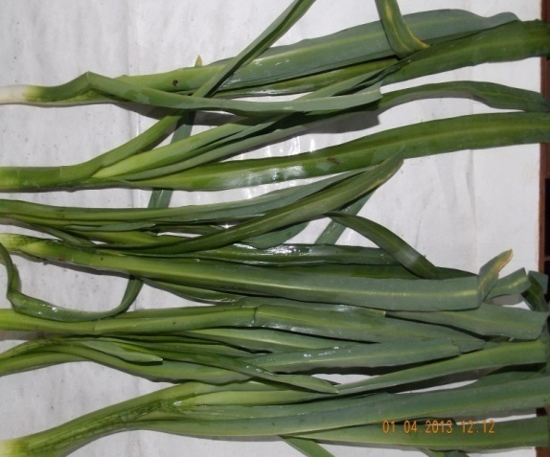  Plate-1. Local Name –Maroi napakpi(Leaves)  Bot Name- Allium hookerii Thw |  |  | 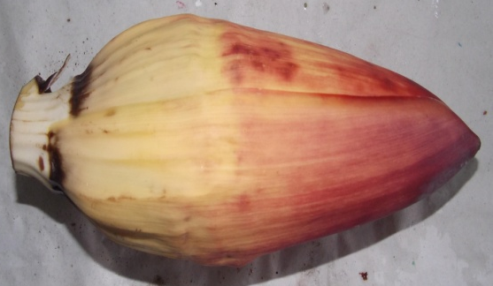  Plate-2-Local Name-Laphu tharo  Bot Name- Musa paradisiacal L
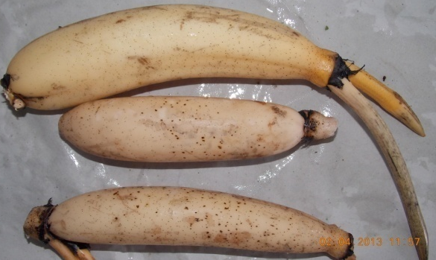  Plate-3.Local Name- Thambou(white type)  Bot.name- Nelumbo nucifera Gaertn |  |  | 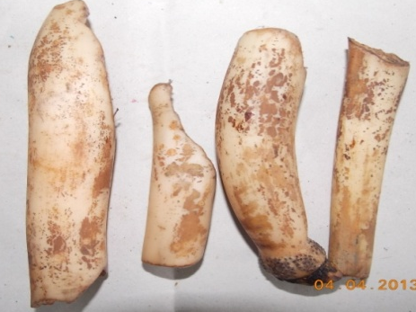  Plate-4.Local Name-Thambou(Red type)  Bot. name- Nelumbo nucifera Gaertn
 | 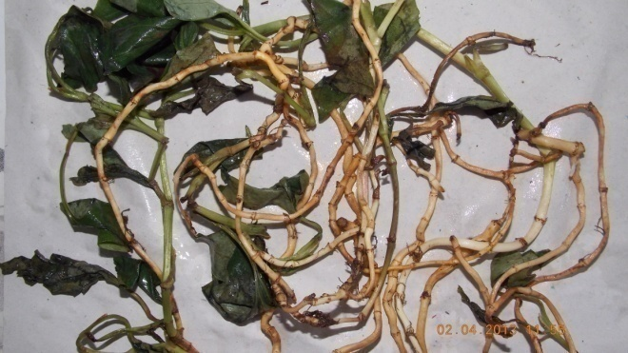  Plate-5.LocalName-Tokningkok(Rhizome)  Bot Name-Houttuynia cordat |  | 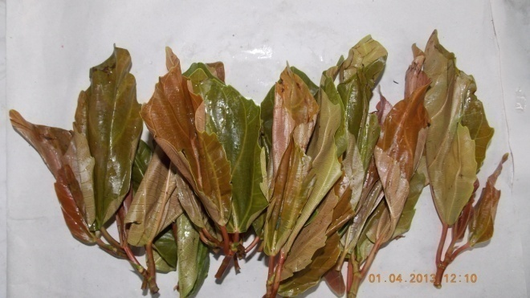  Plate-6. Local Name-Heiba  Bot Name-Ficus palmate Forsk
 | 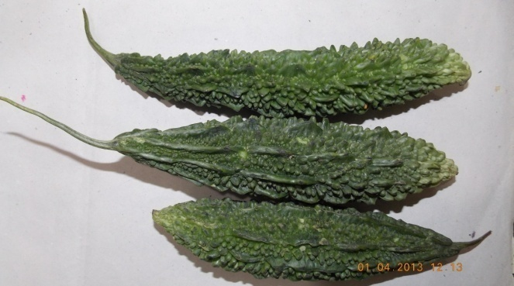  Plate-7. Local Name- Karot akhabi.  Bot Name-Momordica Charantia. |  | 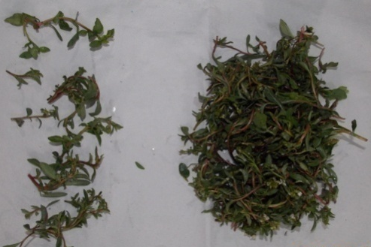  Plate-8.Local Name- Kengoi.  Bot Name-Lysimachia Obovata.
 | Plate-9.Local Name-Loklei(Stem)  Bot Name-Hedycium coronarium |  | 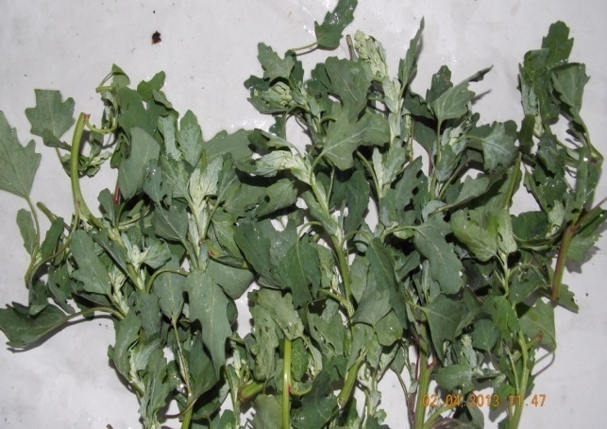  Plate-10.Local Name-Monsoubi  Bot Name-Chenopodium album
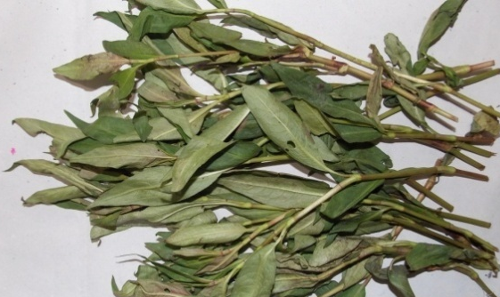  Plate-11.Local Name-Monsoubi  Bot Name-Chenopodium album |  | 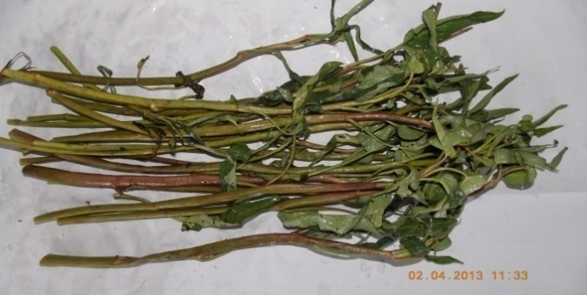  Local Name-Kolamani  Bot Name-Ipomoea aquatic
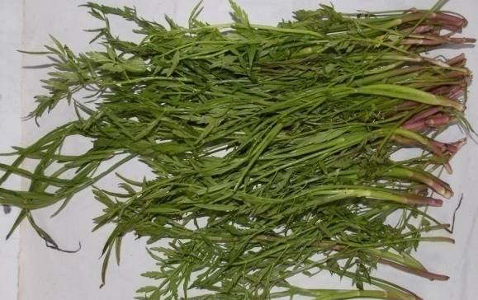Plate-13. Local Name- Komprek  Bot Name-Oenanthe javanica |  | Plate14.Local Name-Loklei(Rhizome)  Bot Name-Hedycium coronarium
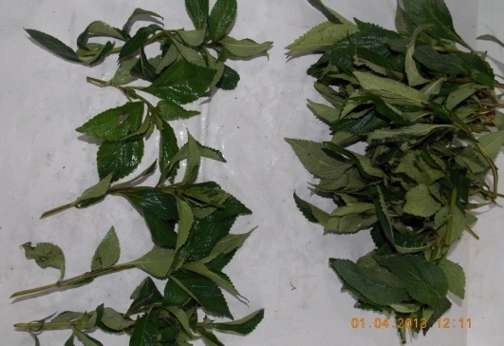  Plate-15. Local Name- Kangouman  Bot Name- Elsholtzia blanda (Benth.) Benth |  | 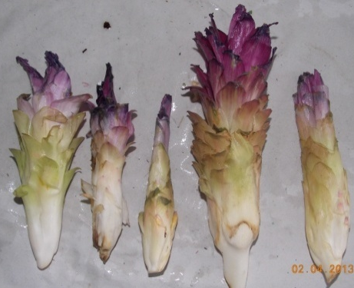  Plate-16.Local Name-Yaipal  Bot Name-Cucurma angustifolia
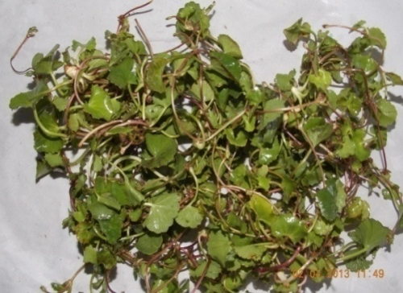  Plate-17. Local Name-Peruk  Bot Name-Centella asiatica |  | 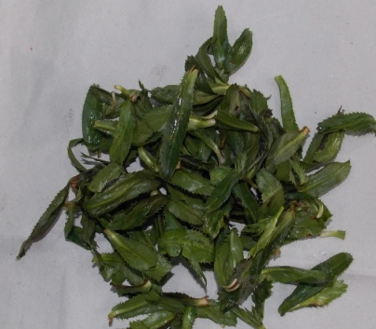  Plate-18. Local Name-Awa phadigom  Bot Name-Eryngium foetidum L
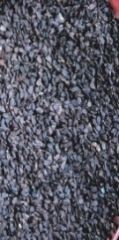
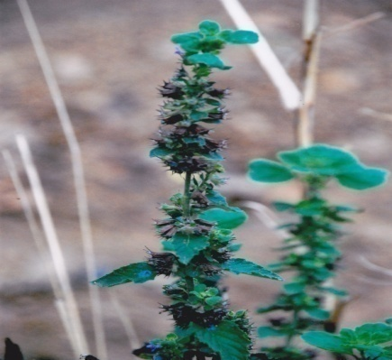
Plate-19.LocalName- Tukuma(Seed)
Bot Name-Hyptis suaveolens
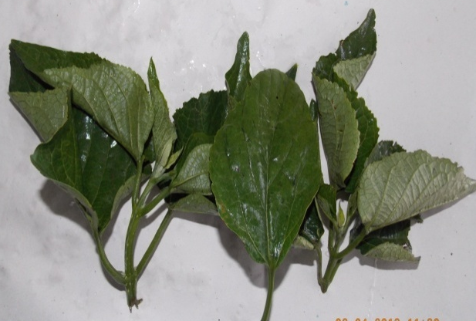  Plate-20. Local Name-Kuthab ukabi  Bot Name-Clerodendrum viscosum Vent |  | 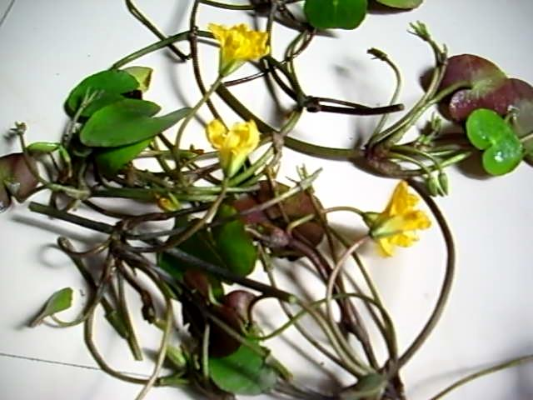  Plate-21. Local Name-Khumon  Bot Name-Nymphoides aquatica

ED-XRF Data
Procedure: biopellet_e2
Tables below showing Manganese present in ppm in 21 selected samples, concentration 50% above

Samples with codes
1-MN |  | Mean | 2-LT |  | Mean | 3-TW |  | Mean | 4-TR |  | Mean | 5-TO |  | Mean | 6-HE |  | Mean | 7-KB |  | Mean
R₁  R₂  R₃ | 47.69  52.84  50.57 | 50.36 | R₁  R₂  R₃ | 51.17  49.64  56.82 | 52.54 | R₁  R₂  R₃ | 62.65  68.91  52.23 | 61.26 | R₁  R₂  R₃ | 147.95  149.81  146.41 | 148.06 | R₁  R₂  R₃ | 170.83  189.19  181.19 | 180.41 | R₁  R₂  R₃ | 64.72  64.93  65.51 | 65.06 | R₁  R₂  R₃ | 52.18  52.83  48.49 | 51.17

Samples with codes
8-KE |  | Mean | 9-LS |  | Mean | 10-MO |  | Mean | 11-PH |  | Mean | 12-KL |  | Mean | 13-KO |  | Mean | 14-LR |  | Mean
R₁  R₂  R₃ | 57.87  58.75  59.43 | 58.69 | R₁  R₂  R₃ | 127.46  128.46  123.41 | 126.45 | R₁  R₂  R₃ | 233.95  220.10  219.92 | 224.66 | R₁  R₂  R₃ | 278.48  275.83  276.01 | 276.78 | R₁  R₂  R₃ | 229.39  220.31  224.76 | 224.82 | R₁  R₂  R₃ | 123.80  127.58  127.53 | 126.31 | R₁  R₂  R₃ | 343.08  324.83  340.20 | 336.04

Samples with codes
15-KG |  | Mean | 16-YL |  | Mean | 17-PE |  | Mean | 18-AP |  | Mean | 19-TU |  | Mean | 20-KU |  | Mean | 21-KH |  | Mean
R₁  R₂  R₃ | 53.54  52.26  54.59 | 53.47 | R₁  R₂  R₃ | 526.00  509.72  525.81 | 520.51 | R₁  R₂  R₃ | 382.33  389.54  387.04 | 386.31 | R₁  R₂  R₃ | 85.23  85.80  89.13 | 86.72 | R₁  R₂  R₃ | 112.45  114.85  115.11 | 114.14 | R₁  R₂  R₃ | 651.94  716.60  655.09 | 674.55 | R₁  R₂  R₃ | 1943.43  2011.80  1924.11 | 1959.78

Mean Values of 21 samples
Sl  No | Code  name | Mn in ppm
1 | MN | 50.36
2 | LT | 52.54
3 | TW | 61.26
4 | TR | 148.06
5 | TO | 180.41
6 | HE | 65.06
7 | KB | 51.17
8 | KE | 58.69
9 | LS | 126.45
10 | MO | 224.66
11 | PH | 276.78
12 | KL | 224.82
13 | KO | 126.31
14 | LR | 336.04
15 | KG | 53.47
16 | YL | 520.51
17 | PE | 386.31
18 | AP | 86.72
19 | TU | 114.14
20 | KU | 674.55
21 | KH | 1959.78

Results and Discussion
The human body cannot produce Manganese, but it can store it in the liver, pancrease, bones, kidneys and brain. A person usually obtain Mn from their diet.
The mean values of three replicates were given in tables… manganese present in 21 selected samples were detected. The element plays important physiological functions in our body providing Manganese superoxide dismutase (SOD), antioxidants shield the body from free radicals, which are molecules that destroy or damage cells in the body. SOD helps break down one of the more dangerous free redicals called superoxide (O₂⁻) into smaller components that are not harmful²⁴. Mn helps promote strong, dense bones when combined with other nutrients such as calcium and vitamin-D²⁵. It reduces blood sugar, people with diabetes, Mn helps lower blood sugar level^{26, 27}. It can heal wounds, along with Vitamin-K, Mn aids the formation of blood clots. Blood clotting which keeps the bloodin a damaged blood vessel, is the first stage of healing²⁸.
Daily requirement of Manganese, Mn is 2.5-5.0 mg per day²⁹. The concentration of Mn found in the eight samples ranges from 50.36-1959.78 ppm and the intake capacity is within the permissible quantity. So these are not harmful to our health only improve the nutritive value. We consume 25-200gm per day these vegetables in different forms, deficiency of Mn will be neutralized.

Adequate Intakes (AIs) for Manganese³⁰
Age | Male | Female | Pregnancy | Lactation
Birth to 6 months* | 0.003 mg | 0.003 mg
7–12 months | 0.6 mg | 0.6 mg
1–3 years | 1.2 mg | 1.2 mg
4–8 years | 1.5 mg | 1.5 mg
9–13 years | 1.9 mg | 1.6 mg
14–18 years | 2.2 mg | 1.6 mg | 2.0 mg | 2.6 mg
19–50 years | 2.3 mg | 1.8 mg | 2.0 mg | 2.6 mg
51+ years | 2.3 mg | 1.8 mg

CONCLUSION
The trace elements in the twenty one different edible plants were detected by ED-XRF technique. The element plays definite and specific roles in the physiological function of our body. So it will be useful if we can find speciation of the elements present.
Excess of Mn give some help effects. The author need further study to impact more benefits to human society.

ACKNOWLEDGEMENT
The authors are thankful to UGC-DAE Consortium for Scientific Research, Kolkata Centre for extending the facility for the research work.

References;
- https://www.medicalnewstodays.com/articles/325636.
- Fitsanakis V.A., Au C., Erikson K.M., Aschner M. The effects of manganese on glutamate, dopamine and gamma-aminobutyric acid regulation. Neurochem. Int. 2006;48:426–433.doi:10.1016/j.neuint.2005.10.012. [PubMed] [CrossRef] [Google Scholar]
- Chen Y., Shen Y., Wang W., Wei D. Mn²⁺ modulates the expression of cellulase genes in Trichodermareesei Rut-C30 via calcium signaling. Biotechnol. Biofuels. 2018;11:54. doi: 10.1186/s13068-018-1055-6.[PMC free article] [PubMed] [CrossRef] [Google Scholar]
- Wang C., Guan Y., Lv M., Zhang R., Guo Z., Wei X., Du X., Yang J., Li T., Wan Y., et al. Manganese Increases the Sensitivity of the cGAS-STING Pathway for Double-Stranded DNA and Is Required for the Host Defense against DNA Viruses. Immunity. 2018;48:675–687. doi: 10.1016/j.immuni.2018.03.017. [PubMed] [CrossRef] [Google Scholar]
- Chen P., Chakraborty S., Mukhopadhyay S., Lee E., Paoliello M.M., Bowman A.B., Aschner M. Manganese homeostasis in the nervous system. J. Neurochem. 2015;134:601–610. doi: 10.1111/jnc.13170.[PMC free article] [PubMed] [CrossRef] [Google Scholar]
- Kwakye G.F., Paoliello M.M., Mukhopadhyay S., Bowman A.B., Aschner M. Manganese-Induced Parkinsonism and Parkinson’s Disease: Shared and Distinguishable Features. Int. J. Environ. Res. Public Health. 2015;12:7519–7540. doi: 10.3390/ijerph120707519. [PMC free article][PubMed] [CrossRef] [Google Scholar]
- Gonzalez-Reyes R.E., Gutierrez-Alvarez A.M., Moreno C.B. Manganese and epilepsy: A systematic review of the literature. Brain Res. Rev. 2007;53:332–336. doi: 10.1016/j.brainresrev.2006.10.002. [PubMed] [CrossRef] [Google Scholar]
- Zhaojun W., Lin W., Zhenyong W., Jian W., Ran L. Effects of manganese deficiency on serum hormones and biochemical markers of bone metabolism in chicks. J. Bone Miner Metab. 2013;31:285–292. doi: 10.1007/s00774-012-0417-6. [PubMed] [CrossRef] [Google Scholar]
- Da Silva A.L.C., Urbano M.R., Almeida Lopes A.C.B., Carvalho M.F.H., Buzzo M.L., Peixe T.S., Aschner M., Mesas A.E., Paoliello M.M.B. Blood manganese levels and associated factors in a population-based study in Southern Brazil. J. Toxicol. Environ.HealthA. 2017;80:1064–1077.doi: 10.1080/15287394.2017.1357354. [PubMed] [CrossRef] [Google Scholar]
- O’Neal S.L., Zheng W. Manganese Toxicity Upon Overexposure: A Decade in Review. Curr. Environ. Health Rep. 2015;2:315–328. doi: 10.1007/s40572-015-0056-x. [PMC free article] [PubMed] [CrossRef] [Google Scholar]
- https://www.peacehealth.org/medical-topics/id/hn-2881000
- https://www.peacehealth.org/medical-topics/id/hn-2881000
- chromium.
- antioxidant enzyme.
- zinc,
- vitamin B6.
- https://www.webmd.com/osteoporosis/default.htm.
- vitamin C.
- B vitamins.
- boron.
- https://medlineplus.gov/sprainsandstrains.html.
- https://www.webmd.com/diabetes/type-1-diabetes.
- https://www.webmd.com/diabetes/type-2-diabetes.
- https://www.ncbi.nlh.gov/pmc/articles/PMC 3185262/.
- https://www.medicalnewstodays.com/articles/248958 and 161618.
- https://www.medicalnewstodays.com/articles/248958.
- https://www.ncbi.nlh.gov/pmc/articles/PMC3973834.
- https://ods.od.nih.gov/factsheets/Manganese-HealthProfessional/#en5.
- A. K. Bhagi and G. R. Chatwal, Bioinorganic and Supra molecular Chemistry, Himalaya Publishing House, First Edn, 2003, 46(50), 55-56.
- https://ods.od.nih.gov/factsheets/Manganese-HealthProfessional/.
- Jordan Valley Next Series Operation Manual, Jordan Valley AR, Inc., Austin, 2000.
- M. Aken Singh, PhD, Studies of pesticides contamination and heavy metals in selected food items etc Manipur,India.
- E. Blaurock-Busch, PhD, The Clinical Effects of Manganese (Mn), 29-04-2013.

