An Overview of Nuclear Nuclear medicine with emphasis on Applications
Ruchi Poria¹, Mohini Kalra¹, Marwaha Kumar Rakesh²
¹Amity Institute of Pharmacy, Amity university, Gurgaon.
²Department of Pharmaceutical Sciences, Maharshi Dayanand Univerity, Rohtak,

Abstract
Molecular imaging and targeted therapy are combined in the fast-developing field of nuclear medicine to offer effective diagnostic and therapeutic options for a variety of medical problems. Nuclear medicine enables the imaging and quantification of physiological processes within the human body at the molecular and cellular level by using small quantities of radioactive substances, or radiopharmaceuticals. The foundational concepts, methods, and applications of nuclear medicine are examined in this abstract. It starts by describing the fundamentals of nuclear medicine, such as how radiopharmaceuticals are made and what makes them unique, how detection and imaging systems work, and the rules of radiation safety. It also emphasizes how anatomical and functional information can be obtained using positron emission tomography (PET), single-photon emission computed tomography (SPECT), and hybrid imaging modalities like PET/CT and SPECT/CT. The extensive spectrum of clinical uses of nuclear medicine is further explored in the abstract. It talks about how nuclear imaging is used to diagnose, stage, and track a variety of illnesses, including as cancer, cardiovascular problems, neurological issues, and musculoskeletal abnormalities. It also looks at the recently developed area of theranostics, which uses nuclear medicine techniques to administer targeted radiation directly to tumour cells in order to both diagnose and treat some tumours. The abstract also emphasizes recent developments in nuclear medicine research and technology. It discusses contemporary breakthroughs in imaging instrumentation and data analysis methods that improve the sensitivity, resolution, and accuracy of nuclear imaging processes, as well as recent developments in radiopharmaceutical design, including the use of novel tracers and targeted agents. In conclusion, by offering non-invasive imaging methods and tailored treatments, nuclear medicine continues to play a crucial role in contemporary healthcare. Nuclear medicine gives vital insights into diagnosis, therapy planning, and therapeutic response assessment due to its capacity to investigate the molecular pathways underlying diseases, improving patient care and results. Future developments in this area show considerable promise for improving the accuracy and efficiency of therapeutic imaging and imaging-guided procedures.
Keywords: Nuclear medicine, Molecular imaging, Radiopharmaceuticals, Diagnostic imaging, Therapeutic imaging, Positron emission tomography (PET), Single-photon emission computed tomography (SPECT), Hybrid imaging (PET/CT, SPECT/CT), Radiation safety, Radiotracer localization, Clinical applications

Table of contents:
- Introduction to Nuclear Medicine
  - Definition and Scope
  - Historical Overview
  - Basic Principles of Nuclear Medicine
  - Radiopharmaceuticals: Production and Characteristics

- Imaging Systems in Nuclear Medicine

2.1 Gamma Cameras and Single-Photon Emission Computed Tomography (SPECT)
2.2 Positron Emission Tomography (PET)
2.3 Hybrid Imaging: PET/CT and SPECT/CT
2.4 Radiotracer Localization and Detection Techniques

- Clinical Applications of Nuclear Medicine

3.1 Oncology
3.1.1 Diagnosis and Staging of Cancer
3.1.2 Treatment Response Assessment
3.1.3 Radioimmunotherapy and Targeted Radionuclide Therapy

- Recent Advances in Nuclear Medicine
4.1 Novel Radiopharmaceuticals and Tracers
4.2 Image Reconstruction and Data Analysis Techniques

- Future Perspectives and Challenges
5.1 Potential Applications and Innovations

- Conclusion

- Introduction to Nuclear Medicine
Nuclear medicine is a subfield of medical imaging that combines molecular imaging with radiopharmaceutical-targeted therapy (1). A radioactive isotope and a biological substance that specifically targets particular organs, tissues, or physiological processes in the body are called radiopharmaceuticals (2). By enabling the viewing and quantification of molecular and cellular processes, radiopharmaceuticals offer crucial diagnostic data (3).
Definition and Scope
Physics, chemistry, biology, and medicine are just a few of the disciplines that are combined in the multidisciplinary field of nuclear medicine. Its main emphasis is on the utilization of radioactive substances and imaging methods for disease diagnosis and treatment (4). Nuclear medicine's main goal is to offer molecular and functional data that support the anatomical imaging offered by other modalities like MRI, ultrasound, and X-rays (5). Numerous applications are included in the area of nuclear medicine. Nuclear medicine diagnostic imaging uses radiopharmaceuticals to measure receptor expression, blood flow, and organ function (6). Nuclear medicine assists in the early identification, precise staging, and monitoring of numerous diseases, such as cancer, cardiovascular issues, and neurological conditions, by detecting anomalies at the molecular level (7, 8).

Targeted therapy is included in nuclear medicine in addition to diagnostic imaging. In this method, radiopharmaceuticals having therapeutic qualities are administered in order to deliver radiation selectively to sick cells or tissues (9). Certain forms of cancer may be treated with this targeted radiation therapy, which offers a focused and accurate therapeutic alternative (10). In nuclear medicine, radiation safety is of the utmost importance. To reduce radiation exposure to patients, healthcare professionals, and the general public, strict adherence to radiation safety norms and regulations is required (11). Nuclear medicine procedures must be used safely and effectively, which requires adherence to radiation safety standards, adequate shielding techniques, and the correct handling and administration of radiopharmaceuticals (12).
Historical Overview
A look at the growth and development of nuclear medicine from its inception to the present is given by its historical overview. It emphasizes significant turning points, discoveries, and developments that have influenced nuclear medical practice.

Nuclear medicine has its origins in the early 20th century, when researchers first started looking into using radioactive materials for therapeutic purposes. Wilhelm Roentgen's invention of X-rays in 1896 laid the groundwork for medical imaging, but it wasn't until the 1930s that the idea of using radioactive isotopes for both diagnosis and treatment started to take hold (13). Pioneering scientists like George de Hevesy and George von Hevesy studied the metabolism of elements within the human body in the 1930s and 1940s using radioactive tracers. They established the potential of radioisotopes as diagnostic tools and provided the foundation for the profession of nuclear medicine (14).

Nuclear medicine was significantly advanced by the development of nuclear reactors and the discovery of synthetic radioisotopes during World War II. Iodine-131 was the first radiopharmaceutical to be made commercially available for the treatment and diagnosis of thyroid conditions (15). This was a crucial turning point in the field since it showed how radioactive materials may be used in actual medical practice. With the advent of gamma cameras and scintillation detectors, nuclear medicine experienced rapid expansion in the 1960s and 1970s. These developments made it possible to image different organs and physiological processes without intrusive procedures (16). The capabilities of nuclear medicine imaging were further expanded with the development of computerized data processing and image reconstruction techniques, which resulted in better picture quality and diagnostic precision.

Positron emission tomography (PET) became a potent imaging technique in nuclear medicine in the 1980s and 1990s. The development of hybrid imaging systems, which offer both anatomical and functional information, was facilitated by the integration of PET with computed tomography (CT) and later with magnetic resonance imaging (MRI) (17). This fusion of imaging modalities created new opportunities for the investigation of disease mechanisms and the advancement of personalized medicine. Nuclear medicine has developed and broadened its applications over time. The development of new technologies has enhanced the design of radiopharmaceuticals, imaging equipment, and data analysis methods. Theranostics, which uses nuclear medicine techniques for both diagnosis and therapy, has also emerged in this area, particularly in oncology (18).

The development of nuclear medicine has been fuelled by the important contributions of researchers, doctors, and technologists, which are highlighted in the field's historical overview. It illustrates how imaging and therapeutic advances have come about from the early discovery of radioactive substances. Nuclear medicine has developed continuously, which has improved patient care, increased diagnostics, and focused therapies.

Basic Principles of Nuclear Medicine
The creation and application of radioactive materials, radiation detection and measurement, image reconstruction, and quantitative analysis are all included in the fundamentals of nuclear medicine. The diagnostic and therapeutic uses of nuclear medicine are based on these principles.

- Radiation Emission from Radioactive Decay: Radioactive isotopes utilized in nuclear medicine experience spontaneous decay and release a range of radiation. Understanding radioactive decay and half-life is essential to comprehending radioisotope behaviour and properties (19).
- Radiopharmaceuticals: Radiopharmaceuticals are mixtures of a physiologically active chemical with a radioactive isotope. They are intended to target particular bodily organs, tissues, or functions. Determining the best radiopharmaceutical depends on a number of variables, including the half-life, decay parameters, and the desired diagnostic or therapeutic application (20).
- Radiation Detection: Nuclear medicine uses a variety of radiation detection technologies. The radiation emitted by the radioisotopes is typically detected and measured using gamma cameras, SPECT, and PET scanners (21, 22). Radiation is transformed into electrical signals by these detectors, which are then processed and examined.
- Reconstruction of the image: To produce images that depict the distribution of radiopharmaceuticals within the body, the data collected from radiation detectors is processed and reconstructed. To account for elements including attenuation, scatter, and resolution constraints, sophisticated algorithms and reconstruction techniques are used (23). Nuclear medicine-based functional information from PET/CT and SPECT/CT hybrid imaging is combined with anatomical data from CT images.
- Quantification and analysis: Data concerning physiological and functional parameters are extracted from nuclear medicine pictures by quantitative analysis. To measure tracer uptake, clearance rates, and other pertinent parameters, regions of interest (ROIs) are established (24). Evaluation of therapy outcomes and illness diagnosis, staging, and monitoring are all made easier with the help of quantitative analysis.
- Radiation Safety: Since ionizing radiation is used in nuclear medicine, radiation safety is crucial. It entails adhering to radiation safety recommendations, making sure that shielding is adequate, maximizing radiation doses, and putting in place sensible handling, storage, and disposal practices for radioactive materials (25).
For nuclear medicine to be practiced safely and effectively, it is imperative to comprehend these fundamental concepts.

Radiopharmaceuticals: Production and Characteristics
Radiopharmaceuticals are substances that combine a biologically active chemical with a radioactive isotope to enable precise targeting and the viewing of physiological processes. To assure the safety and effectiveness of radiopharmaceuticals, a variety of methods and factors are used in the synthesis and characterisation of these substances.

Production of radiopharmaceuticals:

a. Cyclotron Production: Short-lived isotopes, such carbon-11 (C-11) and fluorine-18 (F-18), which are frequently utilized in PET imaging, are created in cyclotrons. In order to create the appropriate radioisotope, stable isotopes can be bombarded with high-energy particles (26).

b. Generator Systems: Technetium-99m (Tc-99m) generator systems are used to produce radioisotopes with extended half-lives that are appropriate for SPECT imaging. The most widely used radioisotope in nuclear medicine, Tc-99m, comes from a generator system that uses both molybdenum-99 (Mo-99) and Tc-99m (27).

c. Radiosynthesis: To generate a radiopharmaceutical, radiosynthesis entails joining a radioisotope with a physiologically active chemical. This procedure involves applying the proper chemical methods, such as ligand exchange or radioiodination, to mark the target molecule with the radioisotope (28).

2. Radiopharmaceutical characteristics:

- Radioisotope selection: The choice of radioisotope depends on a number of variables, including the desired imaging or therapeutic application, decay parameters, and radiation energy. Examples are iodine-131 (I-131) for targeted radionuclide therapy, Tc-99m for SPECT imaging, and F-18 for PET imaging (29).

b. Biological Targeting: Radiopharmaceuticals are created to specifically target organs, organ systems, or biological processes. By coupling a physiologically active molecule, such as a peptide or an antibody, to the radioisotope, this targeting is made possible. The exact disease or condition under investigation will determine which targeted molecule is used (30).

c. Pharmacokinetics: The distribution, metabolism, and clearance rates of radiopharmaceuticals within the body are influenced by their pharmacokinetic features. These characteristics affect the radiopharmaceutical's absorption, retention, and clearance from non-target tissues or organs (31).

3. Quality Assurance and Rules:

a. Quality Control: Strict quality control procedures are used to guarantee the uniformity, effectiveness, and safety of radiopharmaceuticals. Assessments of radiochemical purity, radionuclides purity, specific activity, and sterility are all included in quality control tests (32).

b. Regulatory recommendations: For the manufacture, quality assurance, and distribution of radiopharmaceuticals, regulatory organizations like the European Medicines Agency (EMA) and the U.S. Food and Drug Administration (FDA) issue recommendations and rules. These recommendations must be followed to maintain safety and efficacy levels (33, 34).
For radiopharmaceuticals to be used safely and effectively in nuclear medicine imaging and therapy, it is essential to understand how they are made and what makes them tick.
- Imaging Systems in Nuclear Medicine
Nuclear medicine imaging devices are crucial for catching and spotting the radiation given off by radiopharmaceuticals inside the body. These technologies make it possible to produce images that depict the movement and activity of radiopharmaceuticals, offering crucial diagnostic data.
2.1 Gamma Cameras and Single-Photon Emission Computed Tomography (SPECT)
Planar imaging, which offers two-dimensional views of the radioisotope distribution within the body, is a common application of gamma cameras in nuclear medicine. They are made consisting of a sizable crystal scintillator, like cadmium zinc telluride (CZT) or sodium iodide (NaI), connected to a group of photomultiplier tubes (PMTs). The PMTs detect and transform the flashes of light that are created when gamma rays interact with the scintillator crystal into electrical impulses. Images illustrating the spatial distribution of radioactivity are produced once these signals have been analysed (35, 36). Nuclear medicine uses the three-dimensional imaging method known as SPECT to provide tomographic pictures that are more precise. A gamma camera is rotated around the subject to collect several projections from various perspectives. Following data acquisition, intricate algorithms are used to reassemble the data in order to produce cross-sectional views akin to computed tomography (CT) scans. The distribution of radiopharmaceuticals is revealed in three dimensions by SPECT, which also enables the viewing of deeper structures (37, 38).
- Collimators: A crucial part of SPECT imaging is the use of collimators. They are plates made of lead or tungsten with different sized and shaped holes. Only photons that are emitted in a certain direction are allowed to reach the detector thanks to the collimator, which is positioned in between the patient and the gamma camera. Depending on the desired resolution, sensitivity, and energy of the emitted gamma radiation, several collimators can be utilized (39).
- Reconstruction: To produce cross-sectional images, reconstruction methods are applied to SPECT data collected from various angles. These algorithms use mathematical approaches to recreate the distribution of radioactivity in three dimensions, such as filtered back-projection or iterative reconstruction techniques. Detailed anatomical and functional information is provided by the generated images (40).
Nuclear medicine uses gamma cameras and SPECT systems, which enable non-invasive imaging of physiological processes and the molecular identification of disease-related alterations. The diagnosis, staging, and monitoring of numerous ailments, including cancer, cardiovascular disease, and neurological problems, have benefited greatly from the use of these imaging systems.
2.2 Positron Emission Tomography (PET)
Positron Emission Tomography (PET), a potent imaging method used in nuclear medicine, offers useful details about the body's physiological and metabolic processes. With the aid of radiopharmaceuticals tagged with positron-emitting radioisotopes, molecular and cellular processes can be visualized and measured using PET imaging.

The fundamentals of PET imaging

- Radioisotopes: PET uses radioisotopes that undergo positron decay and release positrons, which are positively charged particles. The radioisotopes fluorine-18 (F-18), carbon-11 (C-11), and oxygen-15 (O-15) are frequently used positron emitters. To monitor metabolic activities, these radioisotopes are often integrated into biologically active compounds, such as glucose analogs (FDG) (41, 42).
- Administration of Radiotracers: A radiotracer is injected into the patient's bloodstream, such as FDG. Depending on the metabolic activity of the tissues, the radiotracer builds up there. For instance, cells absorb FDG in proportion to how they use glucose. The radioisotope releases positrons, which annihilate with body electrons to create two gamma photons that are 180 degrees apart and go in opposing directions (43).
- Gamma photon detection: Around the patient, detectors are often positioned in a ring or multiple rings to detect annihilation photons. These detectors are made up of silicon photomultipliers (SiPMs) or photomultiplier tubes (PMTs) connected to scintillation crystals, such as lutetium oxyorthosilicate (LSO) or lutetium yttrium oxyorthosilicate (LYSO), as well as scintillation crystals. The gamma rays are detected and transformed into electrical impulses by the detectors (44, 45).
- Coincidence Detection: PET scanners use coincidence detection to spot gamma photon pairs that are detected almost simultaneously and in opposition to one another. These two photon pairs came from the exact same annihilation process. The radioactive source can be located and the body's activity distribution can be reconstructed using coincidence detection (46).
- Image reconstruction: Iterative reconstruction techniques are used to process PET data, which is made up of coincident events that have been discovered, in order to reconstruct three-dimensional images. During the reconstruction phase, corrections for variables including attenuation, scatter, and random coincidences are used to enhance image quality and quantitative accuracy (47, 48).
2.3 Hybrid Imaging: PET/CT and SPECT/CT
In hybrid imaging, anatomical detail from computed tomography (CT) is combined with the functional data offered by molecular imaging techniques like positron emission tomography (PET) or single-photon emission computed tomography (SPECT). Nuclear medicine's diagnostic powers are enhanced by the combination of functional and anatomical imaging, which enables more precise localization and characterisation of disorders.

- PET/CT Imaging: PET/CT allows for the simultaneous gathering of functional PET data and anatomical CT images by combining PET and CT technologies in a single imaging device. The anatomical location of functional impairments discovered by PET is precise thanks to this integration (49, 50).
- Workflow: A radiotracer is supplied to the patient during a single imaging session for PET imaging. The radiotracer's gamma rays are detected by the PET scanner, which records functional data. High-resolution anatomical images are simultaneously captured by the CT scanner, giving precise structural data.
- Image Fusion: Next, using specialized software, PET and CT images are aligned and combined. The combined pictures make it possible to evaluate the radiotracer's activity and distribution in respect to the anatomical structures seen on CT in great detail. The precision of lesion localization and characterisation is increased by this fusion.
- Clinical Applications: Oncology, cardiology, and neurology are just a few of the many clinical fields where PET/CT has applications. It assists in the diagnosis, staging, planning, and monitoring of cancer treatments in oncology. Functional PET data and accurate anatomical information from CT are combined to improve tumour detection, delineation, and treatment effectiveness evaluation.

- SPECT/CT imaging: Similar to PET/CT, SPECT/CT imaging combines SPECT and CT technologies to concurrently offer functional and anatomical information. While CT offers anatomical context, SPECT uses gamma cameras to detect radiotracer-emitted gamma rays (51, 52, 53).
- Workflow: For SPECT imaging, the patient is given a radiotracer, and the gamma camera records the emitted gamma rays to collect functional information. Anatomical CT pictures are also captured simultaneously by the CT scanner.
- Image Fusion: With the use of specialized software, the SPECT and CT images are co-registered and fused, enabling precise localisation and association of functional anomalies with anatomical structures. The combined images aid in treatment planning and improve diagnostic interpretation.
- Clinical Applications: Thyroid imaging, bone scintigraphy, and cardiovascular imaging are just a few of the clinical uses for SPECT/CT. In cardiology, SPECT/CT aids in the detection and treatment of coronary artery disease by evaluating myocardial viability and perfusion. It enhances the localisation and characterization of bone lesions in bone imaging, improving the ability to detect metastases and assess skeletal conditions.
By combining functional and anatomical data, hybrid imaging with PET/CT and SPECT/CT offers a thorough evaluation. Combining various imaging modalities improves abnormality localisation, characterisation, and diagnostic accuracy, resulting in better patient management and individualized treatment plans.

2.4 Radiotracer Localization and Detection Techniques

Nuclear medicine employs radiotracer localization and detection methods to monitor the distribution and buildup of radiopharmaceuticals inside the body. These methods enable the visualization and quantification of biological processes and can yield important information for both diagnosis and treatment as depicted in figure 1.

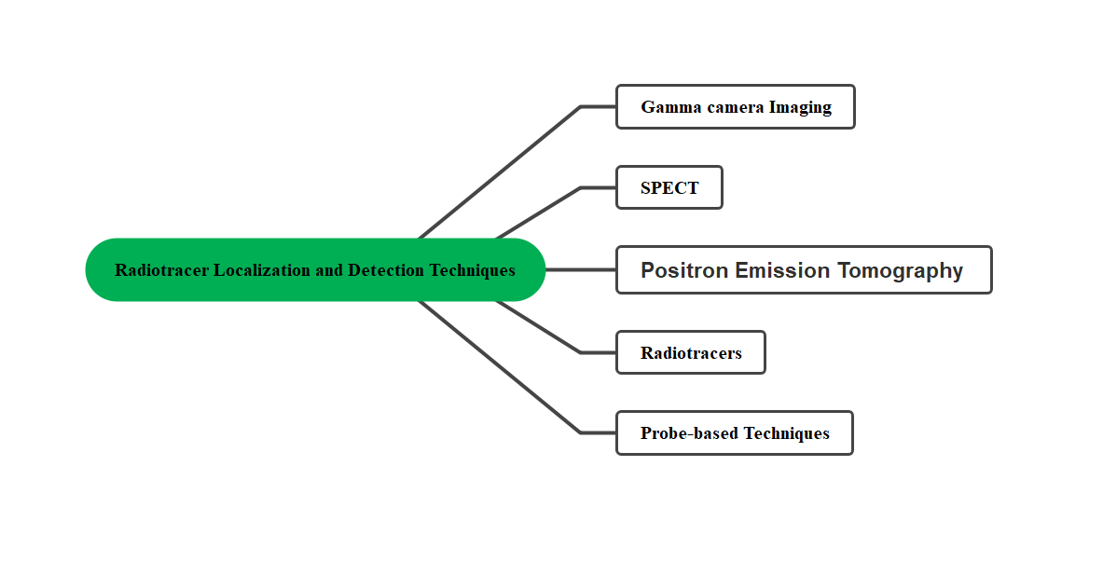
Figure 1: Depicts the Radiotracer Localization and Detection Techniques

- Gamma camera Imaging: Planar imaging is a common use of gamma camera imaging, sometimes referred to as scintigraphy in nuclear medicine. It makes use of gamma cameras, which are made up of scintillation crystals connected to either older technologies like silicon photomultipliers (SiPMs) or photomultiplier tubes (PMTs). Gamma rays released by the radiotracer interact with the scintillation crystal to create brief light bursts. These light flashes are picked up by the PMTs or SiPMs and converted into electrical signals. These signals are then processed to produce two-dimensional pictures showing the distribution of radioactivity within the body (54, 55).
- Single-Photon Emission Computed Tomography (SPECT): SPECT is a three-dimensional imaging method that produces tomographic images that are more detailed than those produced by a planar gamma camera. A gamma camera is rotated around the subject during SPECT imaging in order to collect several projections from various positions. To create cross-sectional photographs, sophisticated algorithms are then used to reconstruct the obtained data. Using SPECT, the distribution of radiotracers within certain organs or tissues can be localized and quantified, providing functional data (56, 57).
- Positron Emission Tomography (PET): PET is a molecular imaging method that makes use of radiotracers that release positrons. The patient is given a radiotracer that has been marked with a radioisotope that emits positrons, such as carbon-11 (C-11) or fluorine-18 (F-18). Pairs of gamma photons flying in opposite directions are created when the positrons released by the radioisotope annihilate with internal electrons. PET scanners use specialized detectors set in a ring or series of rings around the subject to find these annihilation photons. The distribution and concentration of the radiotracer are reflected in three-dimensional pictures that are constructed using the coinciding photons that have been detected (58, 59).
- Radiotracers: Radiotracers can be seen and located on tissue slices using the autoradiography technique. It entails exposing a tissue portion to radiographic film or a digital imaging system, usually following a biopsy or post-mortem. A picture that depicts the distribution of the radiotracer within the tissue is produced when the radioactivity released by the radiotracer exposes the film or activates the imaging device. To identify and characterize particular cellular or molecular targets, autoradiography gives precise spatial information about radiotracer accumulation (60).
- Probe-based Techniques: During surgical or interventional operations, radiotracer uptake is localized using handheld radiation detecting instruments, sometimes known as probes or gamma probes. These gamma radiation-sensitive probes offer real-time data on the distribution and intensity of radiotracers. During operations like sentinel lymph node mapping, tumour localization, or radio-guided surgery, surgeons use these approaches to assist them, improving surgical precision and minimizing the amount of tissue removal (61, 62).

Nuclear medicine relies on radiotracer localization and detection methods to visualize and measure molecular and functional processes occurring within the body. These methods make it possible to identify different diseases, stage them, keep track of them, and direct therapeutic interventions.

- Clinical Applications of Nuclear Medicine
Cancer detection, staging, and management are significantly aided by nuclear medicine. It provides distinctive functional and molecular details on the biology of tumours and makes it easier to assess how well a treatment is working.
3.1 Oncology
3.1.1 Diagnosis and Staging of Cancer
Some of the most significant clinical uses of nuclear medicine in oncology, particularly in the detection and staging of cancer, include the following as shown in figure 2:

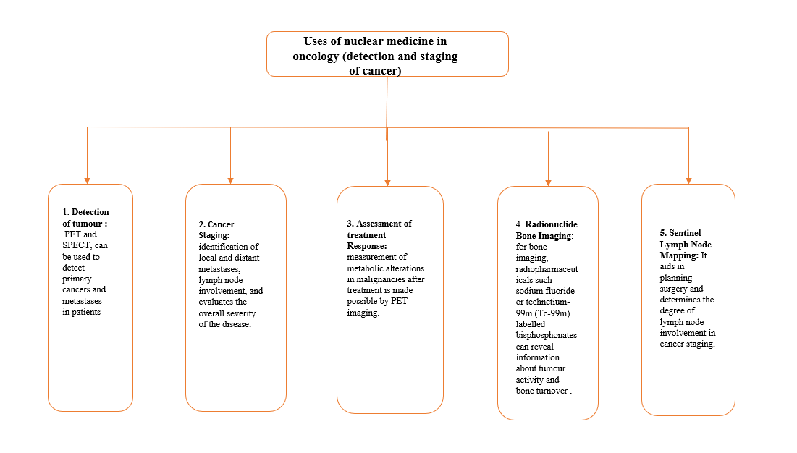
Figure 2: This figure depicts significant clinical uses of nuclear medicine in oncology especially diagnosis and staging of cancer.
- Detection of tumour: nuclear medicine methods for imaging, such as PET and SPECT, can be used to detect primary cancers and metastases in patients. Fluorodeoxyglucose (FDG), a radiotracer used in PET imaging, can show elevated glucose metabolism in tumours, assisting in the diagnosis of cancerous lesions. Utilizing particular radiopharmaceuticals, SPECT imaging can target a variety of cancer-related biochemical processes in order to detect particular tumour types (63, 64).
- Cancer Staging: Cancer staging, which indicates the severity and spread of the disease, depends heavily on nuclear medicine imaging. PET/CT provides comprehensive data for precise staging by fusing functional PET data with anatomical CT images. It aids in the identification of local and distant metastases, lymph node involvement, and evaluates the overall severity of the disease. The right treatment strategy and prognosis can be determined with the use of staging (65, 66).
- Assessment of treatment Response: Nuclear medicine imaging tools can assess a patient's reaction to treatment in the case of cancer. The measurement of metabolic alterations in malignancies after treatment is made possible by PET imaging. Changes in radiotracer uptake might signal therapy success and inform subsequent management choices, such as altering treatment plans or assessing the presence of residual disease (67, 68).
- Radionuclide Bone Imaging: Bone scintigraphy, a routine nuclear medicine procedure, aids in determining the degree of bone involvement in various cancers. It can identify bone metastases, track the development of the illness, and evaluate therapy effectiveness. When utilized for bone imaging, radiopharmaceuticals such sodium fluoride or technetium-99m (Tc-99m) labelled bisphosphonates can reveal information about tumour activity and bone turnover (69, 70).
- Sentinel Lymph Node Mapping: The initial lymph node(s) to which cancer cells are most likely to disseminate are found using a technique called sentinel lymph node mapping (SLN). It aids in planning surgery and determines the degree of lymph node involvement in cancer staging. The identification and biopsy of the SLN are made possible by radiotracer injection and gamma probe-based detection, which reduces the need for additional lymph node dissection (71, 72).

In oncology, nuclear medicine provides useful functional and molecular insights into tumour biology that help in cancer diagnosis, staging, and therapy. By giving details on tumour behaviours and treatment response, it enhances other imaging modalities and adds to individualized patient care.

    - Treatment Response Assessment
A crucial part of cancer care is treatment response assessment, which entails assessing how well a medication reduces or completely eliminates tumor burden. Clinicians can make educated decisions about treatment adjustments, prognosis estimation, and patient care by accurately assessing the treatment response. Treatment response is evaluated using a variety of imaging modalities, including nuclear medicine methods (73).
- Functional imaging methods: Functional imaging methods, such as positron emission tomography (PET) and single-photon emission computed tomography (SPECT), offer useful insights into the metabolic and molecular alterations that take place inside malignancies. These methods enable evaluation of therapy efficacy based on modifications in tumour metabolism, cell proliferation, and particular molecular targets (74).
a. PET imaging: To evaluate therapy response, PET imaging using radiotracers such fluorodeoxyglucose (FDG) is frequently utilized. Standardized uptake values (SUVs), which measure changes in FDG uptake, can be used to assess the metabolic response of malignancies to treatment. After treatment, FDG uptake may decline, indicating a successful outcome, whereas persistent or increasing uptake may signify treatment resistance or disease progression.
b. SPECT Imaging: Using radiopharmaceuticals that are specifically targeted to certain biological processes, SPECT imaging can shed light on how well a treatment is working. For instance, technetium-99m (Tc-99m)-labelled methoxyisobutylisonitrile (MIBI) and radiolabelled somatostatin analogues (Octreoscan) can be used to measure response in neuroendocrine tumours and breast cancer, respectively.
2. Anatomical imaging techniques: Anatomical imaging techniques are frequently used to evaluate tumour size, morphology, and changes in tumour characteristics after treatment. These techniques include computed tomography (CT) and magnetic resonance imaging (MRI). These imaging techniques offer useful anatomical data that can be used to assess therapy effectiveness (75).
a. CT imaging: With the aid of CT scans, tumour size and density changes can be measured and assessed. Treatment response is shown by attenuation and a decrease in tumour size after therapy. Additionally, CT might show the development of a disease or the existence of new lesions.
b. MRI Imaging: MRI scans give an in-depth description of the soft tissue, and they are particularly helpful for evaluating the effectiveness of treatment for cancers of the brain, head and neck, and musculoskeletal system. On an MRI, changes in the tumour’s size, enhancement patterns, and diffusion properties can reveal a patient's reaction to treatment or the disease's development.
3. Additional Evaluation Tools:
Blood biomarkers, such as tumour markers like prostate-specific antigen and carcinoembryonic antigen, and histopathological analysis of tissue samples obtained by biopsies or surgical resections are additional methods used to evaluate the effectiveness of cancer treatment. These instruments, combined with imaging methods, provide a thorough assessment of treatment response (76).
a. Biomarkers: Blood biomarkers can reveal information about the effectiveness of a treatment and the development of a disease. The success of a treatment can be determined by tracking the evolution of tumour marker levels over time.
b. Histopathological Examination: Tissue samples can be examined histopathologically to determine the effectiveness of a treatment. The evaluation of alterations in tumour features, such as cellularity, necrosis, and the presence of live tumour cells, is possible by biopsies or surgical resections.

For optimal patient management and decision-making, accurate assessment of treatment response is crucial. A thorough assessment of the therapy response in cancer patients is made possible by a multidisciplinary approach that incorporates several imaging modalities, biomarkers, and histopathological investigation (77).
    - Radioimmunotherapy and Targeted Radionuclide Therapy
Targeted radionuclide therapy (TRT) and radioimmunotherapy (RIT) are specialized therapies that use radioactive chemicals to deliver radiation to cancer cells only, having localized therapeutic benefits as a result. These methods use the targeting power of antibodies or other agents to precisely target cancer cells while causing the least amount of harm to healthy organs.

- Monoclonal antibodies (mAbs): Monoclonal antibodies (mAbs) combined with radioactive isotopes, often known as radionuclides, are used in radioimmunotherapy (RIT). As a result of these mAbs' precise recognition and binding of antigens found on cancer cells, the radiation is delivered to the desired cells. Radiation damage caused by the radionuclide's radiation emission causes the cancer cells to die (78, 79).

a. Mechanism: RIT makes use of the antibody's dual activity, which allows it to selectively target cancer cells while also inducing lethal effects through the radionuclide's radiation. The radiation can directly destroy the cancer cells or harm their DNA, which will stop them from proliferating and accelerate cell death.
b. Clinical Applications: Non-Hodgkin lymphoma (NHL) and other cancers have both been treated with RIT. For instance, the radiolabeled antibody ibritumomab tiuxetan (Zevalin), which delivers radiation to malignant B cells expressing the CD20 antigen, is utilized in RIT for relapsed or refractory NHL (3). For improved therapeutic benefits, RIT can also be used in conjunction with other treatment techniques, such as chemotherapy.

- TRT (Targeted Radionuclide Therapy) is a more comprehensive term that includes the use of targeted radioactive compounds in addition to antibodies. In order to deliver therapeutic radiation to the site of the disease, radiopharmaceuticals that selectively target cancer cells or their microenvironment must be administered. TRT can use a variety of targeted agents, including peptides, small compounds, and nanoparticles (80, 81).
- Peptide Receptor Radionuclide Therapy (PRRT): In Peptide Receptor Radionuclide Therapy (PRRT), radiolabeled peptides are used to bind to particular receptors that are overexpressed on cancer cells. Somatostatin analogs that have radionuclide labels, such as lutetium-177 (Lu-177) or yttrium-90 (Y-90), for example, specifically target somatostatin receptors that are frequently present in neuroendocrine tumors (82).
- PSMA-focused Radiation therapy: PSMA-focused Radiation therapy targeted by the prostate-specific membrane antigen (PSMA) TRT is used to treat advanced prostate cancer by using radiolabeled PSMA-targeting drugs, such as lutetium-177 (Lu-177) or actinium-225 (Ac-225). These substances provide therapeutic radiation to the tumor by binding selectively to PSMA, which is highly expressed in prostate cancer cells (83,84).
- Additional Targeted Radionuclide Therapies: Different targeting agents and radionuclides that are suited to particular cancer types can be used in TRT. Among others, examples are VEGFR-targeted therapy in neuroendocrine tumours, HER2-targeted therapy in breast cancer, and CD33-targeted therapy in acute myeloid leukaemia (AML) (85, 86, 87).
By fusing the precise targeting powers of antibodies or other agents with the intense lethal effects of radiation, radioimmunotherapy (RIT) and targeted radionuclide therapy (TRT) offer potential treatment methods in oncology. These treatments offer a tailored and localized option for treatment, potentially minimizing the side effects of conventional systemic treatments while maximizing therapeutic effectiveness.
- Recent Advances in Nuclear Medicine
4.1 Novel Radiopharmaceuticals and Tracers
Novel radiopharmaceuticals and tracers are now being found and used in nuclear medicine thanks to developments in radiopharmaceutical development. These substances, which provide superior targeting, improved imaging capabilities, and increased treatment possibilities, are essential in a variety of diagnostic and therapeutic applications. A few instances of innovative radiopharmaceuticals and tracers are shown below as shown in figure 3:
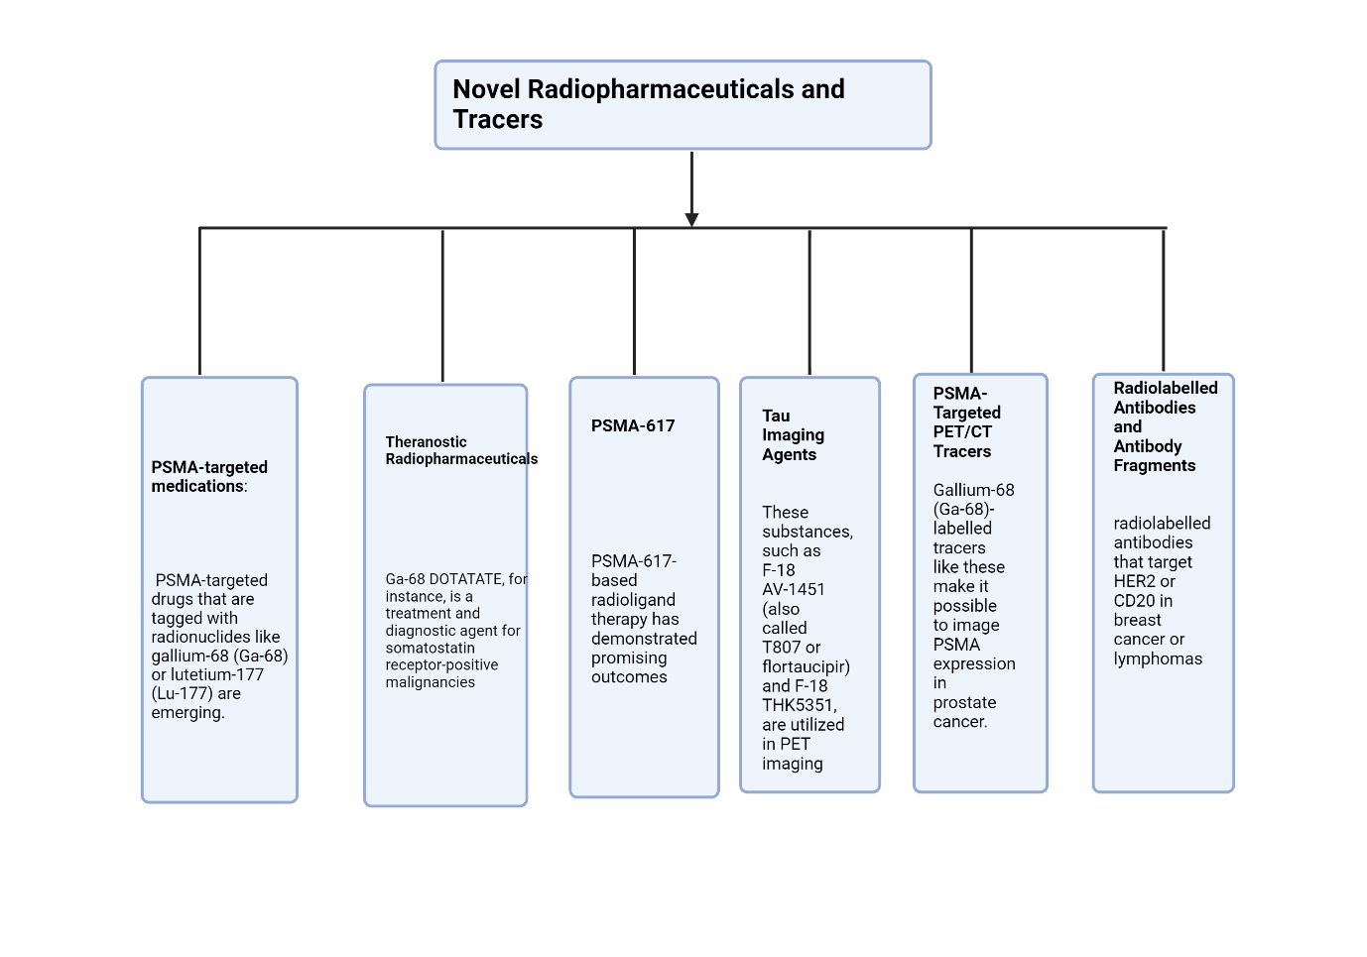
Figure3: This figure depicts Novel radiopharmaceuticals and tracers.

- PSMA-targeted medications: Prostate-specific membrane antigen (PSMA) is a protein that is significantly expressed in cells that are developing prostate cancer. As prospective methods for both targeted radionuclide therapy and diagnostic imaging, PSMA-targeted drugs that are tagged with radionuclides like gallium-68 (Ga-68) or lutetium-177 (Lu-177) are emerging. When used in staging, restaging, and treatment planning, these medicines enable the exact localisation of prostate cancer lesions that express PSMA (88, 89).
- Theranostic Radiopharmaceuticals: The employment of diagnostic and therapeutic substances that focus on the same molecular pathway is known as theranostic radiopharmaceuticals. In the majority of cases, theranostic radiopharmaceuticals combine a therapeutic radionuclide with a diagnostic component, like a PET tracer. With this strategy, the diagnostic radionuclide can be used to image the disease specifically for a given patient, and the therapeutic radionuclide can then be used to treat them. Ga-68 DOTATATE, for instance, is a treatment and diagnostic agent for somatostatin receptor-positive malignancies (90, 91).
- PSMA-617: PSMA-617 is a radiolabeled small molecule that specifically targets PSMA and contains actinium-225 (Ac-225) or lutetium-177 (Lu-177) as one of its radionuclides. In advanced prostate cancer, especially in cases of metastatic castration-resistant prostate cancer (mCRPC), PSMA-617-based radioligand therapy has demonstrated promising outcomes (92, 93). It enables localized therapy with less damaging side effects on healthy tissues by allowing the delivery of radiation to tumor cells that express PSMA specifically.
- Tau Imaging Agents: To see and detect aberrant tau protein deposits in the brain that are linked to neurodegenerative illnesses like Alzheimer's and other tauopathies, one can employ radiopharmaceuticals known as tau imaging agents. These substances, such as F-18 AV-1451 (also called T807 or flortaucipir) and F-18 THK5351, are utilized in PET imaging to offer information about the distribution and severity of tau pathology, assisting in disease diagnosis and monitoring (94, 95).
- PSMA-Targeted PET/CT Tracers: Along with PSMA-targeted therapeutic drugs, PSMA-targeted tracers for PET/CT imaging have attracted a lot of interest in the management of prostate cancer. Gallium-68 (Ga-68)-labelled tracers like these make it possible to image PSMA expression in prostate cancer cells with extreme sensitivity and precision. They help with disease staging, locating recurrent or metastatic illness, and gauging treatment efficacy (96, 97).
- Radiolabelled Antibodies and Antibody Fragments: For targeted imaging and therapy, radiolabelled antibodies and antibody fragments have been created thanks to improvements in antibody engineering. Radiation can be delivered to a precise target with the help of these agents' ability to identify and bind to particular antigens expressed on tumour cells. A couple of examples are radiolabelled antibodies that target HER2 or CD20 in breast cancer or lymphomas, respectively (98, 99).
In a variety of medical specialties, these cutting-edge radiopharmaceuticals and tracers provide better capabilities for illness diagnosis, staging, and tailored treatment. They offer chances for precise and targeted interventions, which could improve clinical results and patient care.

4.2 Image Reconstruction and Data Analysis Techniques

Nuclear medicine imaging relies heavily on image reconstruction and data analysis tools to transform obtained data into useful, understandable images. For these methods to produce high-quality photographs and extract quantitative data, raw data must be processed, manipulated, and analysed. The following are some essential features of nuclear medicine image reconstruction and data analysis techniques as shown in figure 4:
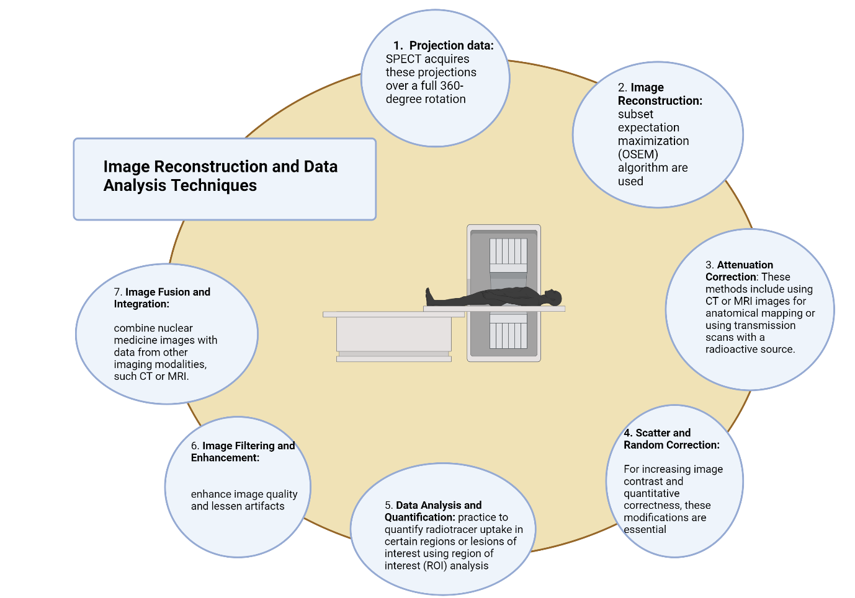
Figure 4: This Figure depicts image reconstruction and data analysis techniques in nuclear medicine.

- Projection data: Acquisition of projection data, which depicts the dispersion of radioactive emissions picked up by gamma cameras or PET scanners, is necessary for nuclear medicine imaging. These data are a collection of projections surrounding the patient that were acquired from various angles. SPECT acquires these projections over a full 360-degree rotation, whereas PET measures concurrent gamma rays using a number of detectors.
- Image Reconstruction: The geographic distribution of radioactivity throughout the body is represented by cross-sectional or three-dimensional images created by image reconstruction techniques using the projection data that was acquired. Filtered back projection and iterative techniques like the ordered subset expectation maximization (OSEM) algorithm are used among other reconstruction techniques. These approaches maximize image quality and reduce artifacts by estimating the radioactive distribution that best fits the obtained data using mathematical models (100, 101).
- Attenuation Correction: In order to account for the attenuation or absorption of gamma rays as they pass through diverse tissues, attenuation correction is a crucial step in the reconstruction of nuclear medicine images. This correction is crucial for PET imaging, which depends on attenuation correction methods for accurate quantification of radiotracer uptake. These methods include using CT or MRI images for anatomical mapping or using transmission scans with a radioactive source (such as germanium-68/gallium-68-line sources) (102, 103).
- Scatter and Random Correction: In nuclear medicine imaging, random and dispersed coincidences can impair quantification accuracy and diminish image quality. The contribution of dispersed gamma rays is estimated and subtracted from the obtained data using scatter correction techniques. In order to eliminate the random coincidences brought on by two unrelated gamma rays being identified as a coincidence event, random correction techniques are required. For increasing image contrast and quantitative correctness, these modifications are essential (104, 105).
- Image Filtering and Enhancement: To enhance certain elements of an image and minimize noise, image filtering and enhancement techniques are used. Low-pass filtering to reduce high-frequency noise and high-pass filtering to improve edges and details are two common filtering techniques. Advanced image processing methods are also employed to enhance image quality and lessen artifacts, such as iterative reconstruction algorithms and noise reduction algorithms (106, 107).
- Data Analysis and Quantification: Quantitative data is extracted from reconstructed pictures using data analysis techniques in nuclear medicine. To measure the uptake of radiotracers in tissues, standardized uptake values (SUVs) are also computed. It is common practice to quantify radiotracer uptake in certain regions or lesions of interest using region of interest (ROI) analysis. Quantitative evaluation of physiological and metabolic parameters is made possible by more sophisticated data processing techniques such kinetic modelling, pharmacokinetic analysis, and voxel-based analysis (108, 109).
- Image Fusion and Integration: For a thorough anatomical and functional evaluation, image fusion and integration techniques combine nuclear medicine images with data from other imaging modalities, such CT or MRI. These methods make it easier to compare the exact anatomical information provided by other modalities with the functional data received from nuclear medicine imaging, allowing for improved localization and characterisation of anomalies (110, 111).
Nuclear medicine's methods for image reconstruction and data analysis are constantly changing due to improvements in imaging technology and processing power. These methods help with patient care and individualized treatment plans by improving diagnostic accuracy, enabling quantitative assessment, and offering insightful information about disease processes.
- Future Perspectives and Challenges
  - Potential Applications and Innovations
Numerous potentials use for nuclear medicine exist, and its continual advances hold the promise of revolutionizing the medical field. These innovations cover both therapeutic and diagnostic methods, enabling better patient care, individualized medicine, and expanded treatment alternatives. Here are some significant nuclear medicine uses and breakthroughs to consider:
- Functional and molecular imaging capabilities: Functional and molecular imaging capabilities are offered by nuclear medicine procedures including positron emission tomography (PET) and single-photon emission computed tomography (SPECT). They can be applied to a variety of illnesses, such as cancer, cardiovascular diseases, neurological disorders, and infectious diseases, for early detection, precise diagnosis, and disease staging (112, 113).
- Targeted radionuclide therapy and theranostics: Theranostics entails combining diagnostic imaging with radionuclide therapy. It permits the delivery of particular radiopharmaceuticals for the targeted treatment of cancers and other disorders and the identification of suitable individuals for therapy based on diagnostic imaging findings (114, 115). Planning individualized treatments and keeping track of therapy outcomes are made possible by this method.
- Precision Medicine and Individualized Treatment: Nuclear medicine contributes significantly to precision medicine by using non-invasive imaging techniques to pinpoint molecular targets, evaluate treatment effectiveness, and personalize therapy for each patient. It helps doctors to choose the best treatment plans and track how they affect the unique disease characteristics of their patients (116, 117).
- Radioimmunotherapy and Targeted Radionuclide Therapy: Radioimmunotherapy employs the use of therapeutic radionuclides and radiolabelled antibodies or antibody fragments to specifically target and eradicate cancer cells (118). This method offers an alternative to conventional chemotherapy and external beam radiation therapy for the treatment of lymphomas and several other forms of solid malignancies (119, 120).
- Hybrid imaging and image fusion: The combination of comparable anatomical and functional data from different imaging modalities, such as computed tomography (CT) or magnetic resonance imaging (MRI) and nuclear medicine imaging, such as PET or SPECT, in a single examination. This integration enables superior image-guided therapies, precise localization and characterisation of anomalies, and more exact treatment planning (121, 122).
- The development of novel radiopharmaceuticals and tracers, such as particular ligands and targeting agents labelled with suitable radionuclides, is the subject of ongoing study. With these developments, nuclear medicine techniques will be able to image and treat a wider variety of disorders (123, 124).
- Artificial Intelligence and Machine Learning: Using AI and machine learning approaches in conjunction with nuclear medicine imaging opens up possibilities for automated picture analysis, improved image interpretation, and improved decision support. Lesion detection, quantitative analysis, and treatment response evaluation can all be aided by AI algorithms, potentially increasing diagnostic effectiveness and efficiency (125, 126).
- Nuclear medicine has traditionally been used to treat cancer, but there is growing interest in using it to treat illnesses that are not related to cancer. Therapeutic Applications Beyond Oncology. This covers osteoporosis pain relief, the treatment of certain cardiovascular disorders, the management of neuroendocrine tumours, and targeted therapy for inflammatory problems (127, 128).
These innovative ideas and possible uses show how nuclear medicine is becoming more and more important in healthcare. Nuclear medicine is being continuously advanced by research and technical developments, opening up new opportunities for precise diagnosis, individualized therapy, and better patient outcomes.
- Conclusion
In summary, nuclear medicine is an area of expertise that integrates the utilization of radiopharmaceuticals and imaging methodologies for the purpose of diagnosing and managing diverse medical ailments. The utilization of this technology has brought about a significant transformation in the field of healthcare, as it has facilitated the acquisition of crucial data pertaining to physiological mechanisms and molecular entities within the human body. This data facilitates the timely identification of diseases, precise diagnostic procedures, individualized treatment strategizing, and monitoring of therapeutic interventions. During the course of this discourse, we have examined various facets of nuclear medicine, encompassing its historical context, fundamental principles, the manufacture of radiopharmaceuticals, imaging modalities, clinical uses, and prospective advancements. Furthermore, we have placed significant emphasis on the significance of ethical considerations and the assurance of patient safety within the field of nuclear medicine practice.
Ethical considerations and ensuring patient safety are essential principles within the field of nuclear medicine. Healthcare professionals are required to acquire informed consent from patients, rationalize and optimize radiation doses, uphold radiation safety protocols, guarantee quality assurance and control, safeguard patient confidentiality and privacy, carry out ethical research, and foster multidisciplinary collaboration. By adhering to these ethical principles and implementing safety protocols, healthcare providers have the ability to provide healthcare services of superior quality, with a focus on the well-being of patients and the reduction of risks associated with radiation exposure. The future of nuclear medicine shows significant potential due to ongoing progress in technology, radiopharmaceutical research, imaging instrumentation, and data analysis methodologies. The incorporation of hybrid imaging modalities, artificial intelligence, and targeted therapies presents novel opportunities for enhanced diagnosis, evaluation of treatment response, and individualized medical care.
In brief, nuclear medicine is an essential component of contemporary healthcare, providing non-invasive imaging modalities and precise therapeutic interventions that contribute to timely detection, efficacious treatment, and improved patient prognoses. The practice of utilizing ionizing radiation and radiopharmaceuticals is guided by a strong emphasis on ethical considerations and patient safety. This ensures that these resources are used responsibly and in accordance with ethical principles. The field of nuclear medicine is constantly advancing due to ongoing research and technological advancements, which offer promising prospects for the future of medical practice.

References:

- Zolle I. Introduction. In: Zolle I, editor. Radiopharmaceuticals: Introduction to Drug Evaluation and Dose Estimation. Springer; 2011. p. 1-4.
- Pfeifer A, Knapp Jr FF. Radiopharmaceuticals. In: Molecular Imaging in Oncology. Springer; 2008. p. 1-17.
- Townsend DW, Carney JP, Yap JT, Hall NC. PET/CT Today and Tomorrow. J Nucl Med. 2004;45(Supplement 1):4S-14S.
- Palestro CJ. The History of Nuclear Medicine. Semin Nucl Med. 2018;48(3):189-192.
- Ziessman HA, O’Malley JP, Thrall JH. Nuclear Medicine: The Requisites. 4th ed. Elsevier Health Sciences; 2013.
- Delbeke D. Nuclear Medicine in the Era of Precision Medicine: A Midlife Crisis? J Nucl Med. 2015;56(6):933-937.
- Signore A, Chianelli M. Clinical Applications of Nuclear Medicine: Progress in Cancer Imaging and Therapy. CRC Press; 2013.
- Schoder H, Herrmann K, Gonen M. Imaging of Lymphoma with PET/CT and Radioimmunotherapy. Cancer J. 2011;17(4):211-218.
- Sgouros G. Targeted Radionuclide Therapy. Annu Rev Biomed Eng. 2014;16(1):29-44.
- Strosberg J. Radionuclide Therapy in Neuroendocrine Tumors. Hematol/Oncol Clin North Am. 2016;30(1):179-191.
- International Atomic Energy Agency. Radiation Protection in Nuclear Medicine. Vienna: International Atomic Energy Agency; 2006.
- Pascual TN, Martin-Comin J, Domenech A, Hernandez A, del Pozo F, Hidalgo P. Radiation Protection in Nuclear Medicine: A New Approach to Education and Training. Semin Nucl Med. 2019;49(6):514-519.
- Cherry SR, Sorenson JA, Phelps ME. Physics in Nuclear Medicine. 4th ed. Elsevier Health Sciences; 2012.
- Ziessman HA, O’Malley JP, Thrall JH. Nuclear Medicine: The Requisites. 4th ed. Elsevier Health Sciences; 2013.
- Saha GB. Fundamentals of Nuclear Pharmacy. 7th ed. Springer Science & Business Media; 2012.
- Mettler FA Jr, Guiberteau MJ. Essentials of Nuclear Medicine Imaging. 6th ed. Elsevier Health Sciences; 2011.
- Bailey DL, Townsend DW, Valk PE, Maisey MN. Positron Emission Tomography: Basic Sciences. Springer Science & Business Media; 2013.
- Pandit-Taskar N, Batraki M, Divgi CR. Radiopharmaceutical Therapy for Malignant Disease. In: Physics in Nuclear Medicine: Expert Consult - Online and Print. Elsevier Health Sciences; 2012.
- Berman DS, Germano G, eds. Clinical Nuclear Cardiology: State of the Art and Future Directions. 4th ed. Elsevier; 2014.
- Saha GB. Fundamentals of Nuclear Pharmacy. 7th ed. Springer Science & Business Media; 2012.
- Mettler Jr FA, Guiberteau MJ. Essentials of Nuclear Medicine Imaging. 6th ed. Elsevier Health Sciences; 2011.
- Townsend DW, Carney JP, Yap JT, Hall NC. PET/CT Today and Tomorrow. J Nucl Med. 2004;45(Supplement 1):4S-14S.
- Zaidi H, editor. Quantitative Analysis in Nuclear Medicine Imaging. Springer International Publishing; 2018.
- Koral KF. Quantitative Analysis in Nuclear Medicine Imaging. J Nucl Med Technol. 2006;34(1):4-10.
- International Atomic Energy Agency. Radiation Protection in Nuclear Medicine. Vienna: International Atomic Energy Agency; 2006.
- Welch MJ, Redvanly CS, editors. Handbook of Radiopharmaceuticals: Radiochemistry and Applications. Wiley; 2003.
- Gopinath G, Gopalakrishnan G, Ananthasivan K, Sivaprasad N. Technetium-99m generators: Historical perspective and recent developments. J Pharm Bioallied Sci. 2010;2(2):80-87.
- Velikyan I. Prospective of 68Ga-Radiopharmaceutical Development. Theranostics. 2014;4(1):47-80.
- International Atomic Energy Agency (IAEA). Radioisotopes for Medicine: Choosing the Right Tool for the Job. 2020. Available from: https://www-pub.iaea.org/MTCD/Publications/PDF/Pub1911_web.pdf
- Natarajan A, Gowrishankar G. Radiopharmaceuticals. In: Molecular Imaging: Principles and Practice. Springer; 2019. p. 81-119.
- Wu H, Carlin SD. Radiopharmaceuticals: Physical and Biological Principles. In: Wu H, Carlin SD, editors. PET/CT in Cancer: An Interdisciplinary Approach to Individualized Imaging. Springer; 2018. p. 19-38.
- McEwan AJB. Quality Control of Radiopharmaceuticals. In: Gupta A, editor. Quality Control in Nuclear Medicine: Radiopharmaceuticals, Instrumentation, and In Vivo Procedures. Springer Science & Business Media; 2013. p. 41-67.
- U.S. Food and Drug Administration (FDA). Radiopharmaceuticals. Available from: https://www.fda.gov/radiation-emitting-products/nuclear-medicine/radiopharmaceuticals
- European Medicines Agency (EMA). Radiopharmaceuticals. Available from: https://www.ema.europa.eu/en/human-regulatory/research-development/scientific-guidelines/radiopharmaceuticals
- Ziessman HA, O'Malley JP, Thrall JH. Nuclear Medicine: The Requisites. 4th ed. Elsevier Health Sciences; 2013.
- Mettler Jr FA, Guiberteau MJ. Essentials of Nuclear Medicine Imaging. 6th ed. Elsevier Health Sciences; 2011.
- Hutton BF, Buvat I, Beekman FJ. Review and current status of SPECT scatter correction. Phys Med Biol. 2011;56(14):R85-R112.
- Zaidi H. Quantitative Analysis in Nuclear Medicine Imaging. J Nucl Med Technol. 2006;34(1):4-10.
- Thomas SR, Williams LE. Principles and Practice of Nuclear Medicine. 2nd ed. Mosby; 1995.
- SPECT. In: Encyclopedia Britannica. Available from: https://www.britannica.com/technology/single-photon-emission-computed-tomography
- Townsend DW, Carney JP, Yap JT, Hall NC. PET/CT Today and Tomorrow. J Nucl Med. 2004;45(Supplement 1):4S-14S.
- Phelps ME. Positron emission tomography provides molecular imaging of biological processes. Proc Natl Acad Sci U S A. 2000;97(16):9226-9233.
- Phelps ME, Mazziotta JC, Schelbert HR. Positron Emission Tomography and Autoradiography: Principles and Applications for the Brain and Heart. Oxford University Press; 1986.
- Cherry SR, Sorenson JA, Phelps ME. Physics in Nuclear Medicine. 4th ed. Saunders; 2012.
- Levin CS, Hoffman EJ. Calculation of positron range and its effect on the fundamental limit of positron emission tomography system spatial resolution. Phys Med Biol. 1999;44(3):781-799.
- Dahlbom M, Hoffman EJ, Schiepers C. Quantitation in PET. In: Physics in Nuclear Medicine. 4th ed. Saunders; 2012. p. 450-486.
- Zaidi H. Quantitative Analysis in Nuclear Medicine Imaging. J Nucl Med Technol. 2006;34(1):4-10.
- Cherry SR. Fundamentals of PET and PET/CT Imaging. Ann N Y Acad Sci. 2011;1228(1):1-18.
- Townsend DW, Carney JP, Yap JT, Hall NC. PET/CT Today and Tomorrow. J Nucl Med. 2004;45(Supplement 1):4S-14S.
- Ziessman HA, O'Malley JP, Thrall JH. Nuclear Medicine: The Requisites. 4th ed. Elsevier Health Sciences; 2013.
- Mettler Jr FA, Guiberteau MJ. Essentials of Nuclear Medicine Imaging. 6th ed. Elsevier Health Sciences; 2011.
- SPECT/CT. In: Encyclopedia Britannica. Available from: https://www.britannica.com/science/single-photon-emission-computed-tomography Q
- PET/CT. In: Encyclopedia Britannica. Available from: https://www.britannica.com/science/positron-emission-tomography
- iessman HA, O'Malley JP, Thrall JH. Nuclear Medicine: The Requisites. 4th ed. Elsevier Health Sciences; 2013.
- Mettler Jr FA, Guiberteau MJ. Essentials of Nuclear Medicine Imaging. 6th ed. Elsevier Health Sciences; 2011.
- Hutton BF, Buvat I, Beekman FJ. Review and current status of SPECT scatter correction. Phys Med Biol. 2011;56(14):R85-R112.
- Zaidi H. Quantitative Analysis in Nuclear Medicine Imaging. J Nucl Med Technol. 2006;34(1):4-10.
- Townsend DW, Carney JP, Yap JT, Hall NC. PET/CT Today and Tomorrow. J Nucl Med. 2004;45(Supplement 1):4S-14S.
- Cherry SR, Sorenson JA, Phelps ME. Physics in Nuclear Medicine. 4th ed. Saunders; 2012.
- Nader M, Krasikova RN. Autoradiography. In: Encyclopedia of Biomedical Engineering. Elsevier; 2019. p. 210-218.
- Wapnir IL, et al. Lymphatic mapping and sentinel lymph node biopsy in breast cancer: A comprehensive review of variations and pitfalls. Am J Clin Pathol. 2015;144(1):14-34.
- Morton DL, et al. technical details of intraoperative lymphatic mapping for early-stage melanoma. Arch Surg. 1992;127(4):392-399.
- Alavi A, Werner TJ, Delbeke D. PET and PET/CT in Oncology. Springer; 2021.
- Fahey FH, Zukotynski KA. Pediatric Nuclear Medicine and Molecular Imaging. Springer; 2017.
- Boellaard R, Delgado-Bolton R, Oyen WJG, Giammarile F, Tatsch K, Eschner W, et al. FDG PET/CT: EANM procedure guidelines for tumor imaging: Version 2.0. Eur J Nucl Med Mol Imaging. 2015;42(2):328-354.
- Weber WA. Use of PET for Monitoring Cancer Therapy and for Predicting Outcome. J Nucl Med. 2005;46(6):983-995.
- Shankar LK, Hoffman JM, Bacharach S, Graham MM, Karp J, Lammertsma AA, et al. Consensus Recommendations for the Use of 18F-FDG PET as an Indicator of Therapeutic Response in Patients in National Cancer Institute Trials. J Nucl Med. 2006;47(6):1059-1066.
- Wahl RL, Jacene H, Kasamon Y, Lodge MA. From RECIST to PERCIST: Evolving Considerations for PET Response Criteria in Solid Tumors. J Nucl Med. 2009;50(Supplement 1):122S-150S.
- Jadvar H. PET in the Assessment of Therapy Response in Patients with Metastatic Bone Disease. PET Clin. 2016;11(4):445-454.
- Cook GJ, Azad GK, Goh V. Imaging Bone Metastases in Breast Cancer: Staging and Response Assessment. J Nucl Med. 2016;57(Supplement 1):27S-33S.
- Goyal A, Newcombe RG, Chhabra A, Mansel RE. Morbidity in Breast Cancer Patients with Sentinel Node Metastases Undergoing Delayed Axillary Lymph Node Dissection (ALND) Compared with Immediate ALND. Ann Surg Oncol. 2008;15(1):262-267.
- Zakaria S, Degnim AC, Kleer CG, Diehl KM, Cimmino VM, Chang AE, et al. Sentinel Lymph Node Biopsy for Breast Cancer: How Many Nodes are Enough? J Surg Oncol. 2007;96(7):554-559.
- Wahl RL, Jacene H, Kasamon Y, Lodge MA. From RECIST to PERCIST: Evolving Considerations for PET Response Criteria in Solid Tumors. J Nucl Med. 2009;50(Supplement 1):122S-150S.
- Shankar LK, Hoffman JM, Bacharach S, Graham MM, Karp J, Lammertsma AA, et al. Consensus Recommendations for the Use of 18F-FDG PET as an Indicator of Therapeutic Response in Patients in National Cancer Institute Trials. J Nucl Med. 2006;47(6):1059-1066.
- Eisenhauer EA, Therasse P, Bogaerts J, Schwartz LH, Sargent D, Ford R, et al. New Response Evaluation Criteria in Solid Tumours: Revised RECIST Guideline (Version 1.1). Eur J Cancer. 2009;45(2):228-247.
- Nishino M, Jagannathan JP, Krajewski KM, O'Regan K, Hatabu H, Shapiro G, et al. Personalized Tumor Response Assessment in the Era of Molecular Medicine: Cancer-Specific and Therapy-Specific Response Criteria to Complement Pitfalls of RECIST. AJR Am J Roentgenol. 2012;198(4):737-745.
- Kelloff GJ, Sullivan DC, Baker H, Clarke LP, Nordstrom R, Tatum JL, et al. Imaging Workshop II: Investigational Imaging of Cancer in Patients. Cancer Res. 2003;63(23):8132-8137.
- ress OW, Appelbaum F, Ledbetter JA, Martin PJ, Zarling J, Kidd P, et al. Monoclonal antibody 1F5 (anti-CD20) serotherapy of human B cell lymphomas. Blood. 1987;69(2):584-591.
- DeNardo GL, DeNardo SJ, Goldstein DS, Kroger LA, Lamborn KR. Use of I-131 labeled monoclonal antibodies for the treatment of melanoma, glioma, and other malignancies. Crit Rev Oncol Hematol. 1993;13(3):181-213.
- Witzig TE, Gordon LI, Cabanillas F, Czuczman MS, Emmanouilides C, Joyce R, et al. Randomized Controlled Trial of Yttrium-90–Labeled Ibritumomab Tiuxetan Radioimmunotherapy Versus Rituximab Immunotherapy for Patients With Relapsed or Refractory Low-Grade, Follicular, or Transformed B-Cell Non-Hodgkin's Lymphoma. J Clin Oncol. 2002;20(10):2453-2463.
- Pandit-Taskar N, Batraki M, Divgi CR. Radiopharmaceutical therapy for malignant disease. Expert Opin Drug Deliv. 2013;10(4):511-521.
- Allen BJ, Raja C, Rizvi S, Li Y, Tsui W, Zhang D, et al. Targeted alpha therapy for cancer. Phys Med Biol. 2004;49(16):3703-3712.
- Bodei L, Mueller-Brand J, Baum RP, Pavel ME, Hörsch D, O'Dorisio MS, et al. The joint IAEA, EANM, and SNMMI practical guidance on peptide receptor radionuclide therapy (PRRNT) in neuroendocrine tumours. Eur J Nucl Med Mol Imaging. 2013;40(5):800-816.
- Hofman MS, Violet J, Hicks RJ, Ferdinandus J, Thang SP, Akhurst T, et al. [177Lu]-PSMA-617 radionuclide treatment in patients with metastatic castration-resistant prostate cancer (LuPSMA trial): a single-centre, single-arm, phase 2 study. Lancet Oncol. 2018;19(6):825-833.
- Modi S, Stopeck AT, Gordon MS, Mendelson D, Solit DB, Bagatell R, et al. Combination of Trastuzumab and T-DM1 with Targeted α-Particle Radiation for HER2-Positive Breast Cancer. JAMA Oncol. 2018;4(7):e180219.
- Jurcic JG, Rosenblat TL, McDevitt MR, Pandit-Taskar N, Carrasquillo JA, Chanel S, et al. Phase I Trial of Targeted Alpha-Particle Therapy with Actinium-225 (225Ac)-Lintuzumab and Low-Dose Cytarabine (LDAC) in Patients with Untreated Acute Myeloid Leukemia (AML). Blood. 2011;118(21):559-559.
- Strosberg J, El-Haddad G, Wolin E, Hendifar A, Yao J, Chasen B, et al. Phase 3 Trial of 177Lu-Dotatate for Midgut Neuroendocrine Tumors. N Engl J Med. 2017;376(2):125-135.
- Hofman MS, Violet J, Hicks RJ, Ferdinandus J, Thang SP, Akhurst T, et al. [177Lu]-PSMA-617 radionuclide treatment in patients with metastatic castration-resistant prostate cancer (LuPSMA trial): a single-centre, single-arm, phase 2 study. Lancet Oncol. 2018;19(6):825-833.
- Fendler WP, Calais J, Allen-Auerbach M, Bluemel C, Eberhardt N, Emmett L, et al. PSMA-PET Guided Radioligand Therapy for Metastatic Castration-resistant Prostate Cancer. J Nucl Med. 2022;63(4):461-471.
- Bodei L, Mueller-Brand J, Baum RP, Pavel ME, Hörsch D, O'Dorisio MS, et al. The joint IAEA, EANM, and SNMMI practical guidance on peptide receptor radionuclide therapy (PRRNT) in neuroendocrine tumours. Eur J Nucl Med Mol Imaging. 2013;40(5):800-816.
- Strosberg J, El-Haddad G, Wolin E, Hendifar A, Yao J, Chasen B, et al. Phase 3 Trial of 177Lu-Dotatate for Midgut Neuroendocrine Tumors. N Engl J Med. 2017;376(2):125-135.
- Hofman MS, Emmett L, Violet J, Zhang AY, Lawrence NJ, Stockler MR, et al. [177Lu]Lu-PSMA-617 radionuclide treatment in patients with metastatic castration-resistant prostate cancer (LuPSMA trial): a single-centre, single-arm, phase 2 study. Lancet Oncol. 2018;19(6):825-833.
- Rahbar K, Ahmadzadehfar H, Kratochwil C, Haberkorn U, Schäfers M, Essler M, et al. German Multicenter Study Investigating 177Lu-PSMA-617 Radioligand Therapy in Advanced Prostate Cancer Patients. J Nucl Med. 2017;58(1):85-90.
- Villemagne VL, Fodero-Tavoletti MT, Masters CL, Rowe CC. Tau imaging: early progress and future directions. Lancet Neurol. 2015;14(1):114-124.
- Harada R, Okamura N, Furumoto S, Furukawa K, Ishiki A, Tomita N, et al. 18F-THK5351: A Novel PET Radiotracer for Imaging Neurofibrillary Pathology in Alzheimer Disease. J Nucl Med. 2016;57(2):208-214.
- Perera M, Papa N, Christidis D, Wetherell D, Hofman MS, Murphy DG, et al. Sensitivity, Specificity, and Predictors of Positive Ga-68-Prostate-specific Membrane Antigen Positron Emission Tomography in Advanced Prostate Cancer: A Systematic Review and Meta-analysis. Eur Urol. 2016;70(6):926-937.
- Fendler WP, Weber M, Iravani A, Hofman MS, Calais J, Czernin J, et al. Prostate-Specific Membrane Antigen Ligand Positron Emission Tomography in Men with Nonmetastatic Castration-Resistant Prostate Cancer. Clin Cancer Res. 2019;25(24):7448-7454.
- Cheson BD, Leonard JP. Monoclonal Antibody Therapy for B-Cell Non-Hodgkin's Lymphoma. N Engl J Med. 2008;359(6):613-626.
- Slamon DJ, Leyland-Jones B, Shak S, Fuchs H, Paton V, Bajamonde A, et al. Use of Chemotherapy plus a Monoclonal Antibody against HER2 for Metastatic Breast Cancer That Overexpresses HER2. N Engl J Med. 2001;344(11):783-792.
- Zaidi H. Quantitative Analysis in Nuclear Medicine Imaging. J Nucl Med Technol. 2006;34(1):4-10.
- Hudson HM, Larkin RS. Accelerated Image Reconstruction Using Ordered Subsets of Projection Data. IEEE Trans Med Imaging. 1994;13(4):601-609.
- Kinahan PE, Hasegawa BH, Beyer T. X-ray-based attenuation correction for positron emission tomography/computed tomography scanners. Semin Nucl Med. 2003;33(3):166-179.
- Carney JP, Townsend DW, Rappoport V, Bendriem B. Method for transforming CT images for attenuation correction in PET/CT imaging. Med Phys. 2006;33(4):976-983.
- Watson CC. New, Faster, Image-based Scatter Correction for 3D PET. IEEE Trans Nucl Sci. 2000;47(3):823-828.
- Ljungberg M, Celler A, Konijnenberg MW, Eckerman KF, Dewaraja YK, Sjögreen K, et al. MIRD Pamphlet No. 26: Joint EANM/MIRD Guidelines for Quantitative 177Lu SPECT Applied for Dosimetry of Radiopharmaceutical Therapy. J Nucl Med. 2016;57(1):151-162.
- Nuyts J, De Man B, Fessler JA, Zbijewski W, Beekman FJ. Iterative reconstruction for helical CT: a simulation study. Phys Med Biol. 2003;48(6):799-813.
- Fessler JA. Model-Based Image Reconstruction for Transmission Tomography. IEEE Trans Med Imaging. 2000;19(4):359-366.
- Boellaard R, Delgado-Bolton R, Oyen WJG, Giammarile F, Tatsch K, Eschner W, et al. FDG PET/CT: EANM Procedure Guidelines for Tumour Imaging: Version 2.0. Eur J Nucl Med Mol Imaging. 2015;42(2):328-354.
- Herrmann K, Czernin J, Wolpers HG, et al. Impact of 3D image reconstruction on PET quantification in non-small cell lung cancer. J Nucl Med. 2007;48(3):519-525.
- Townsend DW. Multimodality Imaging of Structure and Function. Phys Med Biol. 2008;53(4): R1-R39.
- Saha GB. Fundamentals of Nuclear Pharmacy. 6th ed. Springer; 2010.
- Gambhir SS, Czernin J, Schwimmer J, Silverman DH, Coleman RE, Phelps ME. A Tabulated Summary of the FDG PET Literature. J Nucl Med. 2001;42(5 Suppl):1S-93S.
- Valk PE, Bailey DL, Townsend DW, Maisey MN. Positron Emission Tomography: Basic Science and Clinical Practice. Springer; 2003.
- Boellaard R, O'Doherty MJ, Weber WA, et al. FDG PET and PET/CT: EANM Procedure Guidelines for Tumor PET Imaging: Version 1.0. Eur J Nucl Med Mol Imaging. 2010;37(1):181-200.
- Bodei L, Mueller-Brand J, Baum RP, et al. The Joint IAEA, EANM, and SNMMI Practical Guidance on Peptide Receptor Radionuclide Therapy (PRRNT) in Neuroendocrine Tumors. Eur J Nucl Med Mol Imaging. 2013;40(5):800-816.
- Grootjans W, Tixier F, van der Vos CS, et al. The Impact of Optimal Respiratory Gating and Image Noise on Evaluation of Intratumor Heterogeneity on 18F-FDG PET Imaging of Lung Cancer. J Nucl Med. 2016;57(11):1692-1698.
- Hatt M, Lee JA, Schmidtlein CR, et al. Classification and Evaluation Strategies of Auto- Segmentation Approaches for PET: Report of AAPM Task Group No. 211. Med Phys. 2017;44(6):e1-e42.
- Begum NJ, Thiessen JD, Shahbazpour N, et al. Targeted Radionuclide Therapy with 177Lu-DOTATATE: Outcomes from a Real-World, Large-Scale Canadian Cohort. Eur J Nucl Med Mol Imaging. 2020;47(4):866-879.
- Strosberg J, El-Haddad G, Wolin E, et al. Phase 3 Trial of 177Lu-Dotatate for Midgut Neuroendocrine Tumors. N Engl J Med. 2017;376(2):125-135.
- Emmett L, Willowson K, Violet J, et al. Lutetium (177Lu) PSMA-617 Therapy in Men with Progressive Metastatic Castration-Resistant Prostate Cancer: Final Results of a Phase 2, Single-Center Trial. Lancet Oncol. 2018;19(6):825-833.
- Jadvar H, Ahuja S, Vargas HA, et al. Society of Nuclear Medicine and Molecular Imaging Task Force on Nuclear Medicine Imaging of Neuroendocrine Tumors. J Nucl Med. 2018;59(6):909-918.
- Delso G, Ziegler SI. PET/MRI System Design. Eur J Nucl Med Mol Imaging. 2009;36 Suppl 1:S86-S92.
- Kim C, Gupta NC. Preclinical Radiopharmaceuticals. Adv Drug Deliv Rev. 2012;64(6):554-564.
- Deri MA, Zeglis BM, Francesconi LC, Lewis JS. PET Imaging with Copper-64 as a Tool for Real-Time In Vivo Investigations of the Crossroads between Copper and Biology. Dalton Trans. 2014;43(27):10668-10678.
- Dercle L, Lu L, Schwartz LH, et al. Radiomics Response Signature for Identification of Metastatic Colorectal Cancer Sensitive to Therapies Targeting EGFR Pathway. J Natl Cancer Inst. 2020;112(9):902-912.
- Lambin P, Leijenaar RTH, Deist TM, et al. Radiomics: The Bridge between Medical Imaging and Personalized Medicine. Nat Rev Clin Oncol. 2017;14(12):749-762.
- Flamen P, Vanderlinden B, Delatte P, et al. Multimodality Imaging Can Monitor the Biologic Effects of TNFalpha on Tumor Targeting of 111In-DTPA- HEGF. Eur J Nucl Med Mol Imaging. 2008;35(3):509-518.
- Paley MNJ, Pike LC, Njeh CF, Murray RD. The Potential of Imaging Techniques to Assess Fracture Healing. J Biomech. 2017; 52:87-95.

