Targeted Drug therapy in COPD: Futuristic Considerations
Dr. Monika Verma*, Dr.Sushil Kumar**
*MD Pharmacology, Senior Resident, PGIMS Rohtak,Haryana, India
**MD Biochemistry, Medical Officer, Jhajjar, Haryana, India

Chronic bronchitis and/or emphysema collectively constitute chronic obstructive pulmonary disease (COPD), marked by insufficient airflow and persistent breathing challenges. Current pharmacotherapy, including glucocorticoids and bronchodilators, demonstrates therapeutic effectiveness, yet none of these treatments arrest the progression of the disease, and they are associated with numerous side effects. This chapter provides an overview of potential targets implicated in the pathogenesis of COPD and the molecules that interact with them.
Keywords: COPD, Oxidative stress, Reactive Oxygen Species
COPD, or chronic obstructive lung disease, is a major global health concern. The GOLD effort states that COPD is a common, avoidable, and treatable illness that impacts people globally in both genders. It is defined by ongoing respiratory symptoms brought on by anomalies of the airways and/or alveoli, usually as a result of extensive exposure to dangerous particles or gases. This is a multifaceted ailment influenced by a combination of genetic, environmental, and lifestyle components. Environmental risk factors encompass the use of tobacco products, exposure to both outdoor and indoor air pollution, contact with dust and fumes in occupational settings, a prior history of tuberculosis, maternal smoking during pregnancy, childhood asthma, lower socioeconomic status, and respiratory infections. Among these risk factors, tobacco use stands out as the most prevalent.
COPD is further subdivided into emphysema and chronic bronchitis. While the precise cause of COPD is still unknown, oxidative stress, inflammation, immune system deterioration, and an imbalance between proteases and antiproteases have all been suggested as potential contributing factors.
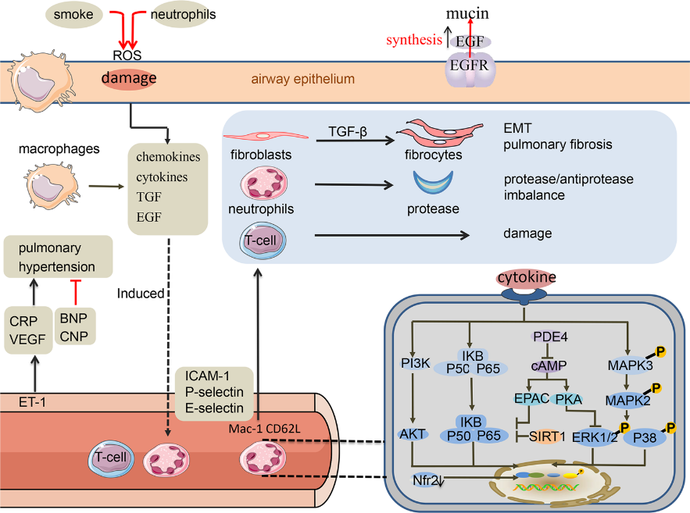
(Figure 1) New insights regarding the pathogenesis of COPD
Wang, C., Zhou, J., Wang, J. et al. Progress in the mechanism and targeted drug therapy for COPD. Sig Transduct Target Ther.2020; 5:248

1. Oxidant-antioxidant imbalance: Oxidative stress can impact various pathogenic pathways, including direct injury to lung cells, heightened mucus secretion, inactivation of antiproteases, and exacerbation of lung inflammation through the activation of redox-sensitive transcription factors. COPD patients experience oxidative stress due to smoking and exposure to harmful chemicals. The lungs, rich in inflammatory cells such as neutrophils and macrophages, generate a significant quantity of reactive oxygen species (ROS). Furthermore, the presence of ROS reduces HDAC activity, causing recoiling of DNA from the histone core, inhibiting transcription. Conversely, histone acetyltransferase is believed to be more active in the presence of ROS, releasing DNA from the histone core to facilitate transcription. Consequently, there is an increased attraction of inflammatory cells, particularly neutrophils and macrophages, to the alveolar spaces.
2.Protease and antiprotease imbalance: In the pulmonary environment, a protease/anti-protease imbalance emerges due to a relative insufficiency of anti-proteases, such as 1-antitrypsin, stemming from their inactivation by oxidants present in cigarette smoke or generated by inflammatory leucocytes. This imbalance in proteases and anti-proteases results in the degradation of the elastin structure. Proteases play pivotal roles in tissue remodeling, inflammation, the pathophysiology of COPD, and the breakdown of components within the extracellular matrix (ECM). The primary forms of elastases in lung diseases encompass serine proteases, caspases, and matrix metalloproteinases (MMPs), with MMP-9 and MMP-2 being most frequently associated with emphysema. MMP-12 contributes to the severity of COPD.⁵
3. COPD and inflammatory cells, cytokines and chemokines
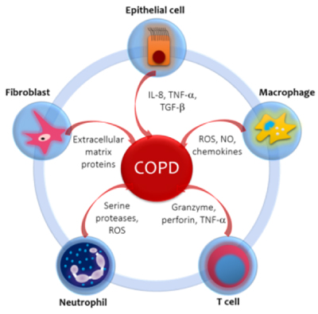
IL-8: Interleukin-8. TNF-α: Tissue Necrosis Factor-α. TGF-β Transforming Growth Factor β. ROS: Reactive Oxygen Species. NO: Nitric Oxide.
Figure 2: Alvarado A (2018) Autoimmunity in chronic obstructive pulmonary disease: Un Update.Clin Res Trials 4
Inflammatory mediators mentioned in the diagram above contributes a lot in development of COPDby airway remodelling and inflammatory cell infiltration, the extent of neutrophilic infiltration in lung tissues correlates with COPD severity.

4. COPD and adhesion factors: Numerous cytokines and adhesion molecules, including vascular cell adhesion molecule-1 (VCAM-1), intercellular adhesion molecule-1 (ICAM-1), and the selectins L, P, and E, are involved in the tightly controlled sequence of events that make up neutrophil migration.⁶

5. COPD and growth factors: Elevation of EGFR and its ligands is observed in chronic inflammation. Mucus production and the expansion of airway epithelial goblet cells are positively connected with EGFR expression and activity. The onset of COPD may be related to EGFR overexpression. TGF-1 chemoattracts neutrophils, mast cells, and macrophages. Individuals diagnosed with COPD exhibit significantly elevated TGF-1 expression in their airway epithelial cells. Additionally, lung function may be further compromised by active TGF-signaling, which is linked to the disease's pathogenesis and facilitates fibrotic remodeling of the airways.7.

6. COPD and peptide factor: An increase in pulmonary arterial pressure (PAP) is a significant outcome of COPD. Endothelial cells secrete Endothelin-1 (ET-1), a potent vasoconstrictor that induces the contraction and proliferation of vascular smooth muscle cells. Levels of endothelin rise during a COPD exacerbation, contributing to the development of pulmonary hypertension.⁸

7. COPD and the NF-κB pathway: When COPD develops, the NF-κB pathway's cytokines intensify oxidative stress and play crucial roles in inflammatory cell migration, further exacerbating the illness.⁹

8. COPD and the p38MAPK: Upon exposure to various environmental stimuli and inflammatory cytokines, p38MAPKs, a subset of the MAPK family, become activated. In the airways and sputum of COPD patients, there was a significant increase in p38MAPK, and the level of activation was found to be correlated with the severity of the disease.¹⁰

9. COPD and the PI3K/Akt pathways: The phosphatidylinositol 3 kinase (PI3K) pathway is one significant mechanism regulating angiogenesis, cell death, growth, proliferation, metabolism, and survival. Certain important COPD neutrophil responses are restored when the PI3K/Akt pathway is regulated in neutrophils.¹¹
These factors lead to the death of alveolar cells, structural loss in the alveolar region, and degeneration of the extracellular matrix. Presently, the main approach is to manage the symptoms of airflow restriction resulting from the aforementioned conditions. However, there is currently no method to halt the progression of the disease, and the existing medications have significant adverse effects. Therefore, several innovative molecularly targeted therapeutic medications are under development to impede the progression of COPD.
The majority of newly developed potential therapeutic medications in recent years are molecular pharmaceuticals designed to target these signal transducing chemicals, as the inflammatory signaling pathways strongly linked to COPD development have been identified. New approaches to COPD therapy are detailed in the sections below.

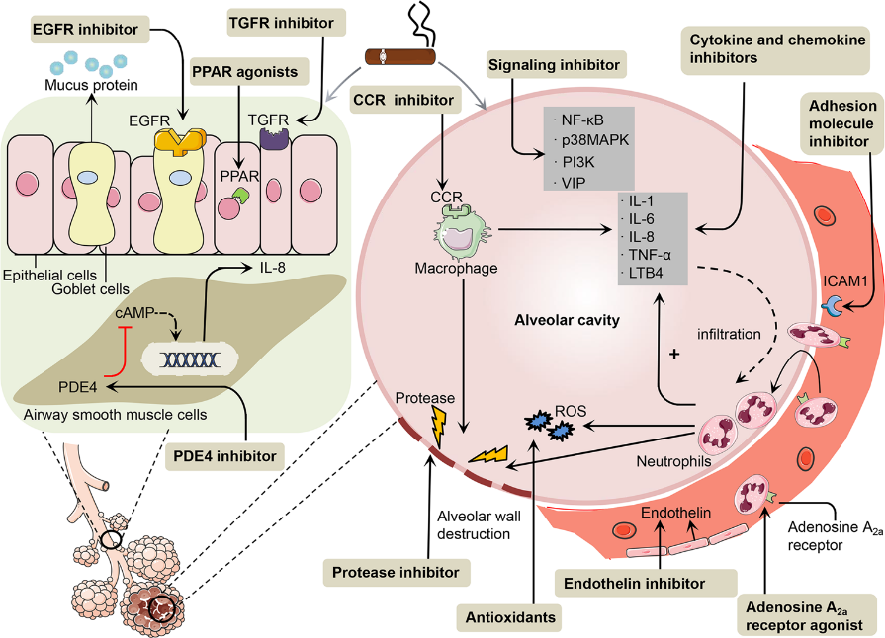
(Figure 3): New Molecular targeted drugs
Wang, C., Zhou, J., Wang, J. et al. Progress in the mechanism and targeted drug therapy for COPD. Sig Transduct Target Ther.2020; 5:248
In recent years, there has been a growing focus on the development of innovative molecular targeted drugs for COPD, driven by insights into its molecular mechanisms. These drugs are designed to target specific facets of the condition. For example, antioxidants play a role in scavenging reactive oxygen species (ROS), thereby mitigating oxidative stress in the lungs, reducing cellular damage, and alleviating inflammation. Protease inhibitors aim to restore the balance between proteases and anti-proteases by inhibiting proteases. Inhibitors of cytokines and chemokines are crucial in reducing the inflammatory response. Inhibitors of adhesion molecules work by preventing inflammatory cells from migrating from blood arteries into the surrounding tissue. Conversely, PDE4 inhibitors reduce PDE4 synthesis to elevate cAMP levels in cells. Various signaling molecules, such as NF-κB, MAPK, PI3K, and VIP, regulate inflammation and airway remodeling in the context of COPD development and represent potential targets for therapeutic interventions. These drugs include vasoactive intestinal peptide (VIP), NF-κB, PI3K, and p38MAPK inhibitors. Additionally, EGFR inhibitors impede EGFR internalization with minimal impact on mucin reserves. Endothelin inhibitors halt the progression of pulmonary hypertension in COPD patients, while TGF-β inhibitors aid in preventing fibrotic airway remodeling and downregulating MMP expression. The adenosine A2a receptor inhibitor functions by inhibiting the release of cytokines, adhesion, phagocytosis, and neutrophil superoxide. Macrolides help reduce COPD inflammation by controlling the PI3K/Akt-Nrf2 pathway and modifying transcription factors like NF-κB and AP-1 to inhibit the production of inflammatory cytokines. Finally, PPAR agonists have anti-inflammatory and antioxidant effects by suppressing NF-κB and other pro-inflammatory transcription factors.
Table 1 Development of antioxidants and protease inhibitors for COPD

Drug | Mechanism | Clinical progress
N-acetylcysteine (NAC) /glutamines | Suppressing oxidative stress | 600 mg bin NAC decreased the degree of deterioration in GOLDII-III COPD patients, according to the one-year DBPCRT PANTHEON trial (Chinese Clinical Trials Registry). TRC-09000460)¹²
Sulforaphane | Boost Nrf2 gene expression to reduce ROS generation linked to inflammation. | In COPD patients, sulforaphanetrial (4 weeks) had no effect on oxidative stress, airway inflammation, or lung function, nor did it cause the production of Nrf2 genes. (NCT01335971).¹³
AZD1236 | Anti MMP-9 and MMP-12 | In patients with moderate-to-severe COPD, AZD1236 (6 weeks) did not achieve statistical significance or have an impact on the clinical symptoms of COPD.¹⁴

Table 2 Development of cytokine and chemokine receptor inhibitors for COPD

Drug | Mechanism | Clinical progress
Canakinumab | Inhibition of IL-1β | Canakinumab phase I/II RDBPCES (45 weeks); statistical analysis for changes in lung function was not reported. ¹⁵
Tocilizumab | Inhibition of IL-6 | More research is needed on tocilizumab's efficacy in COPD clinical trials, however it works well in rheumatoid arthritis.¹⁶
Etanercept | Inhibition of TNF-α | Etanercept (90 days) is no better than prednisone in the treatment of COPD deterioration(NCT00789997).¹⁷

Table 3: Development of other drugs for COPD
Drug | Mechanism | Clinical progress
Bosentan | Blocks endothelin receptor | Bosentan (18 months) can help people with COPD and stop their pulmonary hypertension from getting worse. Patients in GOLD III and IV have a greater significance of this impact. However, bosentan will exacerbate hypoxemia in COPD patients without pulmonary hypertension.¹⁸
Bimosiamose | an artificial pan-selectin antagonist that works against L, P, and E-selectin. Bimosiamose prevents neutrophil adherence in vitro. | In Phase II trials, bimosiamose (TBC 1269) was being used to treat topical psoriasis, injectable reperfusion injury, and inhaled asthma. A separate inhaled formulation of TBC 1269 was studied in preclinical asthma research. Revotar Ag (Germany) is working on developing an inhaled version of TBC 1269 for COPD and asthma, as well as a cream and subcutaneous injection for psoriasis, under license from Encysive (NCT01108913).¹⁹
PDE4 inhibiotr | In order to demonstrate anti-inflammatory properties, inhibit PDE4 and raise cAMP levels in inflammatory cells, controlling inflammatory cell activity and inflammatory factor release.inflammatory effects | The Food and Drug Administration (FDA) has approved rolumilast as a therapy for COPD. Roflumilast produces adverse effects like headache, nausea, and vomiting but also decreases dyspnea symptoms in COPD patients and lowers the frequency of acute bouts. Following bronchodilator therapy, GSK-256066 (4-week inhaled medication) in DBPCRT (NCT00549679) increased residual volume and did not show a meaningful trend in FEV1. ²⁰
PPAR Agonist | Regulates function of multiple cells of the immune system. | Troglitazone, Rosiglitazone, and Pioglitazone are examples of PPARγ agonists. Fenofibrate and clofibrate are examples of PPARα agonists. Compared to patients on other diabetes medications, those taking more than two thiazolidinediones (97.1% rosiglitazone) experienced a markedly slower worsening of COPD. The sponsor or investigator has uploaded the clinical trial's results information (from February, a duration of 10 months) to ClinicalTrials.gov; however, the material is not yet publicly accessible on the website (NCT00103922).²¹

Table 4: Development of proinflammatory signalling pathway inhibitors for COPD.

Drug | Mechanism | Clinical progress
P38 MAPK inhibitor | Inhibition of p38MAPK pathway | The trial was halted, however SB-681323 significantly decreased TNF-α production in COPD (NCT00144859).²²
Nemiralisib (GSK2269557) | Inhibition of PI3K | Patients experiencing an acute exacerbation of COPD in the course of DBPCRTs were treated with GSK2269557 (NCT02522299 for 84 days or NCT02294734 for 28 days). RV1729 (up to 28 days of treatment) is being evaluated at NCT02140346, and significant phase I studies have yielded minimal efficacy evidence.²³

COPD and thioredoxin (Trx): Trx has a molecular weight of 12 kDa and 105 amino acids. It is a protein with several uses. In the sputum of COPD patients, there is a substantial correlation between the degree of hypoxia and Trx expression.24-Trx is administered intraperitoneally to mice to lessen lung inflammation brought on by smoke by stopping the release of chemokines, inflammatory mediators, cytokines, and reactive oxygen species. We are currently developing clinical trials that will concentrate on acute lung disorders.25 In addition to a pre-clinical COPD research, there is ongoing treatment for acute exacerbations via intravenous infusion, stable phase protein inhalation therapy, and oral inducer delivery. Through a variety of mechanisms, it effectively delays the onset and progression of COPD, and its mode of action is well aligned with the disease's pathogenesis.
Challenges: The amplification of inflammatory mediators and cytokines, activation of inflammatory signalling pathways, an imbalance between the protease and the anti-protease, and an imbalance between oxidation and antioxidation are the primary factors in the pathogenesis of COPD. Because of their interdependence, it is challenging to hit a single target and provide the intended therapy outcomes. The extent to which pathogenesis of COPD may be stopped if only one route is suppressed is uncertain due to the overlap in function of molecular targeted inflammatory signals. Advances in our understanding of molecular mechanism underlying the disease coupled with innovations in drug development and personalised medicine, hold promise for more effective treatment in future. Currently, some medications have been shown to be successful in treating COPD in animal studies; however, others are difficult to utilise in human trials due to major adverse effects. Therefore, more research into the roles and processes of numerous target molecules is required.

References:
1. Global initiative for chronic obstructive lung disease-GOLD [Internet]. Global strategy for diagnosis and management of chronic obstructive pulmonary disease 2022 report [cited September 2023]. Available from https://goldcopd.org
2. Schunemann, H. J. et al. Oxidative stress and lung function. Am. J. Epidemiol.1997;146:939–48.
3. Rahman, I., Gilmour, P. S., Jimenez, L. A. &MacNee, W. Oxidative stress and TNF-alpha induce histone acetylation and NF-kappaB/AP-1 activation in alveolar epithelial cells: potential mechanism in gene transcription in lung inflammation. Mol. Cell Biochem. 2002;234-35
4. Chakrabarti, S. & Patel, K. D. Matrix metalloproteinase-2 (MMP-2) and MMP-9 in pulmonary pathology. Exp. Lung Res. 2005;31:599–621
5. Haq, I. et al. Association of MMP-2 polymorphisms with severe and very severe COPD: a case control study of MMPs-1, 9 and 12 in a European population. BMC Med. Genet. 2010;11:7
6. Ley, K., Laudanna, C., Cybulsky, M. I. &Nourshargh, S. Getting to the site of inflammation: the leukocyte adhesion cascade updated. Nat. Rev. Immunol. 2007; 7:678–89.
7. Mahmood MQ, Sohal SS, Shukla SD, Ward C, Hardikar A, Noor WD, Muller HK, Knight DA, Walters EH. Epithelial mesenchymal transition in smokers: large versus small airways and relation to airflow obstruction. Int J Chron Obstruct Pulmon Dis. 2015;10:1515-24.
8. Spiropoulos, K., Trakada, G., Nikolaou, E., Prodromakis, E., Efremidis, G., Pouli, A. et al. Endothelin-1 levels in the pathophysiology of chronic obstructive pulmonary disease and bronchial asthma. Respiratory Medicine. 2003;97(8):983–989.
9. Imanifooladi, A. A., Yazdani, S. &Nourani, M. R. The role of nuclear factor-kappaB in inflammatory lung disease. Inflamm. Allergy Drug Targets.2010;9:197–205.
10. Barnes, P. J. Novel signal transduction modulators for the treatment of airway diseases. Pharm. Ther. 2006;109:238–45
11. Manning, B. D. &Toker, A. AKT/PKB signaling: navigating the network. Cell. 2017;169:381–405
12. Zheng, JP, Wen FQ, Bai CX, Wan HY, Kang J, Chen P, et al. Twice daily N-acetylcysteine 600 mg for exacerbations of chronic obstructive pulmonary disease (PANTHEON): a randomised, double-blind placebo-controlled trial. Lancet Respir. Med. 2014;2:187–94.
13. Wise RA, Holbrook JT, Criner G, Sethi S, Rayapudi S, Sudini KR et al. Lack of Effect of Oral Sulforaphane Administration on Nrf2 Expression in COPD: A Randomized, Double-Blind, Placebo Controlled Trial. PLoS One. 2016;11(11):e0163716.
14. Ostridge K, Williams N, Kim V, Bennett M, Harden S, Welch L et al. Relationship between pulmonary matrix metalloproteinases and quantitative CT markers of small airways disease and emphysema in COPD. Thorax. 2016;71(2):126-32.
15. Botelho FM, Bauer CM, Finch D, Nikota JK, Zavitz CC, Kelly A et al. IL-1α/IL-1R1 expression in chronic obstructive pulmonary disease and mechanistic relevance to smoke-induced neutrophilia in mice. PLoS One. 2011;6(12):e28457.
16. Wendling D, Vidon C, Godfrin-Valnet M, Rival G, Guillot X, Prati C. Exacerbation of combined pulmonary fibrosis and emphysema syndrome during tocilizumab therapy for rheumatoid arthritis. Joint Bone Spine. 2013;80(6):670-1.
17. Chung KF. Inflammatory mediators in chronic obstructive pulmonary disease. Curr Drug Targets Inflamm Allergy. 2005;4(6):619-25.
18. Valerio G, Bracciale P, GraziaD'Agostino A. Effect of bosentan upon pulmonary hypertension in chronic obstructive pulmonary disease. TherAdvRespir Dis. 2009 ;3(1):15-21.
19. Watz H, Bock D, Meyer M, Schierhorn K, Vollhardt K, Woischwill C et al. Inhaled pan-selectin antagonist Bimosiamose attenuates airway inflammation in COPD. PulmPharmacolTher. 2013;26(2):265-70.
20. Luo J, Wang K, Liu D, Liang BM, Liu CT. Can roflumilast, a phosphodiesterase-4 inhibitor, improve clinical outcomes in patients with moderate-to-severe chronic obstructive pulmonary disease? A meta-analysis. Respir Res. 2016;17:17-18.
21. Lakshmi SP, Reddy AT, Zhang Y, Sciurba FC, Mallampalli RK, Duncan SR et al. Down-regulated peroxisome proliferator-activated receptor γ (PPARγ) in lung epithelial cells promotes a PPARγ agonist-reversible proinflammatory phenotype in chronic obstructive pulmonary disease (COPD). J Biol Chem. 2014;289(10):6383-93.
22. Norman P. Investigational p38 inhibitors for the treatment of chronic obstructive pulmonary disease. Expert OpinInvestig Drugs. 2015;24(3):383-92.
23. Fung-Leung WP. Phosphoinositide 3-kinase delta (PI3Kδ) in leukocyte signaling and function. Cell Signal. 2011;23(4):603-8.
24. Lehtonen ST, Ohlmeier S, Kaarteenaho-Wiik R, Harju T, Pääkkö P, Soini Y et al. Does the oxidative stress in chronic obstructive pulmonary disease cause thioredoxin/peroxiredoxin oxidation? Antioxid Redox Signal. 2008;10(4):813-9.
25. Tanabe N, Hoshino Y, Marumo S, Kiyokawa H, Sato S, Kinose D et al. Thioredoxin-1 Protects against Neutrophilic Inflammation and Emphysema Progression in a Mouse Model of Chronic Obstructive Pulmonary Disease Exacerbation. PLoS ONE. 2013;8(11):e79016.

