SYNTHESIS, STRUCTURAL AND ELECTRICAL PARAMETERS OF PURE AND Cu DOPED ZnS NANOPARTICLES
N.KALAISELVI¹, K.U.MADHU²
¹ Department of Electronics, S.T.Hindu College, Nagercoil– 629002
² Department of Physics, S.T.Hindu College, Nagercoil– 629002,
(Affiliated to Manonmaniam Sundaranar University,Abhishekapatti, Tirunelveli)
Tamil Nadu, India.

Abstract
The structural and electrical parameters of pure and copper doped ZnS nanoparticles are reported in this paper. The nanoparticles were prepared by co-precipitation method. The influence of the dopant on the structural behavior was examined by Powder X-ray diffraction analysis. The dielectric constant(εr), dielectric loss factor(tanδ), and the electrical conductivity measurements were carried out for the pure and doped samples.

Keywords: Co-precipitation method, Structural behavior, Electical conductivity.

Introduction
ZnS is one of the important II-VI semiconductor with a wide direct band gap of 3.77 eV that has shown the remarkable properties and it can be exploited for versatile applications including optical coating, electro-optic modulator, photoconductors, optical sensors, phosphors, reflector, dielectric filter, window material, the field emission display and other light emitting materials . Compared to bulk ZnS, nano ZnS possess anomalous physical and chemical properties such as enhanced surface to volume ratio, the quantum size effect, surface and volume effect and macroscopic quantum tunneling effect, more optical absorption, chemical activity and thermal resistance, catalysis, and the low melting point
[1,2,3]. ZnS is also regarded as a low-cost and non-toxic material with high resistance to photochemical degradation[4] However, the nanostructures of ZnS have not been investigated in much detail compared to ZnO nanostructures[5]. Various routes have been adopted for the synthesis of ZnSnanoparticles such as wet chemical [6-8, 9], micro emulsion
[10], chemical vapor deposition [11], hydrothermal technique [12], etc.
In this paper, we report the synthesis and characteristics of zinc sulphide nanoparticles obtained by co-precipitation method. Co-precipitation is a simple method for synthesising nanoparticles that can be made in a variety of sizes. The purpose of the study is to synthesize the pure and Cu doped zinc sulphide nanoparticles and the effect of Cu on its structural and electrical properties.
Experimental Detail
ZnS nanoparticles were prepared by coprecipitation method. The reactants used for the synthesis of ZnS nanoparticles were sodium sulphide (Na₂S.7H₂O) and zinc acetate
(Zn (CH₃COO)₂ · 2H₂O). Cupric acetate (Cu (CO₂CH₃)₂ · H₂O) was used as a dopant and distilled water was used as a solvent.
In a typical process of pure ZnS nanoparticles, zinc acetate and sodium sulphide were taken in 1:3 molecular ratio and dissolved separately in 200 ml of distilled water. Under stirring condition of zinc acetate solution, sodium sulphide solution was added drop wise. The stirrer condition will continue until the precipitate was obtained. The colloidal precipitate obtained was washed several times with distilled water and then with acetone to remove the organic impurities if any. The washed samples were dried in atmospheric air and collected as the yield. Similar, procedure were carried out for the preparation of Cu (5 and 10 wt%) doped ZnS nanoparticles by using cupric acetate along with the precursors used for the preparation of pure ZnS nanoparticles.
Characterization
The crystal structure of pure and doped samples were identified by the powder x-ray diffraction analysis. The AC electrical measurements were carried out by the conventional parallel plate capacitor method using an Agilent 4284A of LCR meter at various temperatures for different frequencies.
Results & Discussion
Figure 1 to 3 shows The PXRD pattern of pure and Cu (5 and 10 wt %) doped ZnS nanoparticles. All the diffraction peaks present in the PXRD pattern of pure and Cu doped ZnS nanoparticles can be indexed using the data available in the JCPDS file (05-0566). From the PXRD pattern the average crystallite size and lattice parameters were determined .The average crystallite size was determined by Scherer formula and it is found to be 3-4 nm. The average particle size increase with increase in the addition of dopant. It confirms that the enclosure of dopant into the host matrix. No peaks corresponding to Cu were indexed in the PXRD pattern of Cu doped ZnS nanoparticles because only a small amount of cupric acetate was added as a dopant. But significant changes in the position of host peaks were noticed in the PXRD pattern of Cu doped ZnS nanoparticles. From the indexed PXRD pattern the structure of prepared pure and Cu (5 and 10 wt %) doped ZnS nanoparticles were found to be cubic with lattice parameter a = 5.368(4) Ǻ. For all samples of ZnS doped with Cu ions, strong absorption peaks were observed corresponding to the lattice planes of (111), (220) and (311) [13,14]. The doping causes the peak broadening and decrease in the intensity of the peaks. The sharpness of the peak exhibits the nanoparticles are perfectly crystallized.

Table 1: Average grain size of pure and Cu doped ZnS nanoparticles
System(with expected) | Grain size(nm)
Pure ZnS | 3.11
5wt% Cu doped ZnS | 3.86
10wt% Cu doped ZnS | 4.74

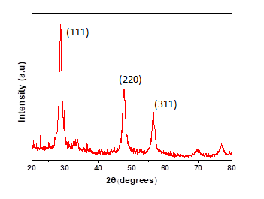
Figure:1 PXRD pattern for pure ZnS nanoparticles

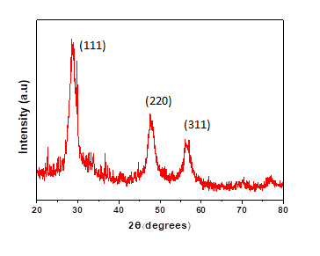
Figure 2: PXRD pattern for 5 wt% Cu doped ZnS nanoparticles

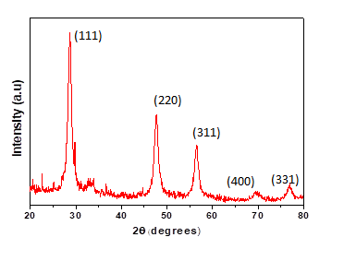
Figure 3: PXRD pattern for 10 wt% Cu doped ZnS nanoparticles

The behaviour of electrical parameters such as dielectric constant, dielectric loss factor and AC electrical conductivity with respect to frequency and temperature is shown in Figure 4 to 12. The variation of dielectric constant with various frequency and temperature were shown in Figure 4 to 6. It was observed that for all the prepared samples the dielectric constant increases with increase in temperature and decreases with increase in frequency.
The variation of dielectric loss with frequency and temperature are shown in Figure 7 to 9. It was observed that for all the prepared samples the dielectric loss factor increases with increase in temperature and decreases with increase in frequency. The charge transport relaxation time was responsible for the variation of dielectric constant with applied field. In heterogeneous structures, the space charge polarization was predominant and it results in the decrease of dielectric constant with increase in frequency.

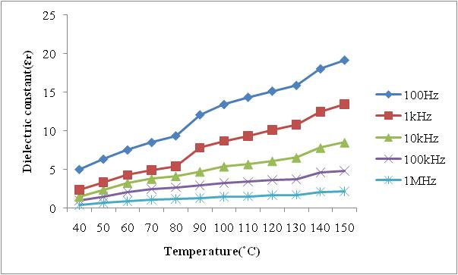
Figure 4: Dielectric constant for pure ZnS nanoparticles
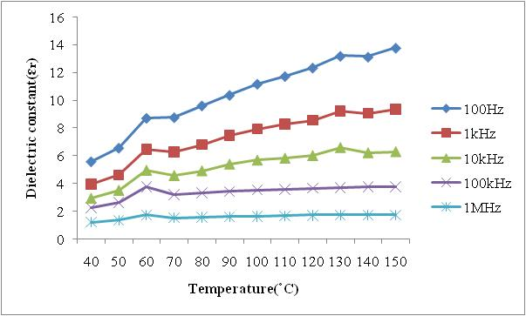
Figure 5: Dielectric constant for 5wt% Cu doped ZnS nanoparticles

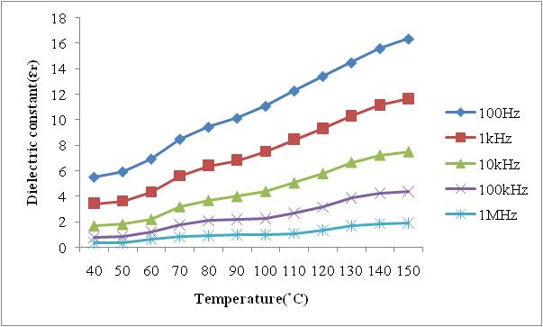
Figure 6: Dielectric constant for 10wt% Cu doped ZnS nanoparticles

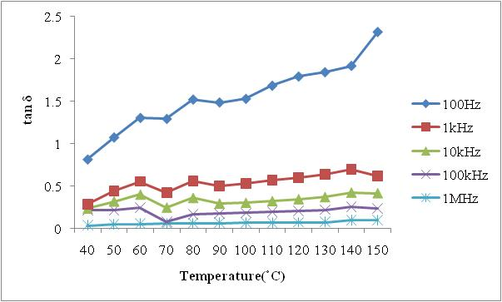
Figure 7: tan δ for pure ZnS nanoparticles
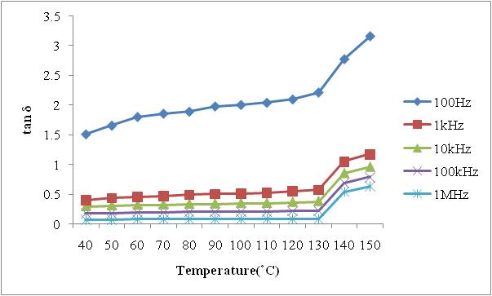
Figure 8: tan δ for for 5wt% Cu doped ZnS nanoparticles

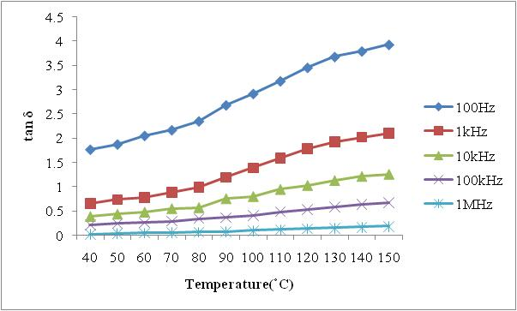
Figure 9: tan δ for 10wt% Cu doped nanoparticles

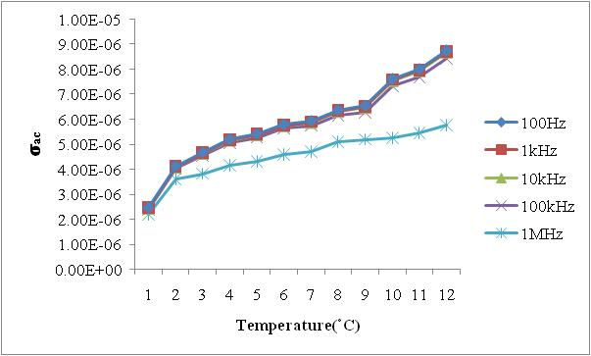
Figure 10: $σ_{ac}$ for pure ZnS nanoparticles

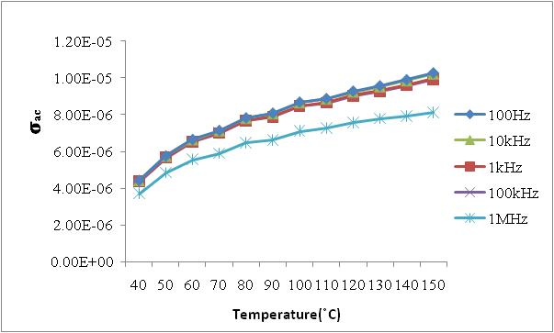

Figure 11: $σ_{ac}$ for 5 wt% Cu doped ZnS nanoparticles

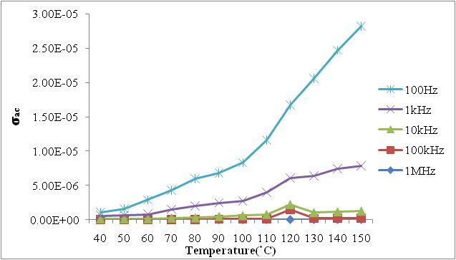

Figure 12: $σ_{ac}$ for 10 wt% Cu doped ZnS nanoparticles

The variation of AC electrical conductivity with frequency and temperature are shown in Figure 10 to 12. It was observed that for all the prepared samples the AC electrical conductivity increases with increase in temperature and frequency. Here the AC electrical conductivity increases with frequency and hence the mechanism of conduction in the prepared samples is localized conduction mechanism. Also the conduction process was due to small polaron hopping since the conductivity increases with frequency. The conductivity of the material is low at low temperatures because the mobility of ion is very low at low temperatures. When the temperature increases the mobility of ion increases thereby increasing the space-charge polarization which in turn the value of capacitance [15 ,16].

Conclusion:
The pure and Cu doped ZnS nanoparticles have been prepared by a chemical coprecipitation method. X-ray diffraction was employed to study the structural properties, the particle sizes increase from 3.1nm to 4.7 nm with a cubic structure. Dielectric constant and dielectric loss factor increase with increase in temperature and decrease with increase in frequency. The AC conductivity values have been found to increase with increase in temperature and frequency. The obtained results showed a good efficiency of nanostructured materials.

References:

1. Kaur N, Kaur S, Singh J, Rawat M. A ,”Review on Zinc Sulphide Nanoparticles: From Synthesis, Properties to Applications”, J Bioelectron Nanotechnol ,1(1) 5, 2016.

2 . lC.S. Pathak , M.K. Mandal , V. Agarwala ,”Synthesis and characterization of zinc sulphide nanoparticles prepared by mechanochemical route “ Superlattices and Microstructures,Vol 58, Pages 135-143, 2013.
3.Ong HC, Chang, “ RPH. Optical constants of wurtzite ZnS thin films determined by spectroscopic ellipsometry”, Appl Phys Let, 79(22): pages 3612–314,2001.
4.Dilpazir S, Siddiq M, Iqbal , “A. Synthesis of zinc sulphide nanostructures by Co-precipitation: effects of doping on electro-optical properties”. Kenkyu J Nanotechnol Nanosci, 1: 34–9, 2015.
5. X. Fang, T. Zhai, U. K. Gautam, L. Li, L. Wua, Y. Bando and D.Golberg, “ZnS nanostructures: From synthesis to applications,” Progress in Materials Science, vol. 56, pages. 175-287, 2011.
6. A. A. Khosic, M. Kundu, L. Jatwa, S. K. Deshpande, U. A.Bhagwat, M. Sastry and S. K. Kulkarni, “Green luminescence fromcopper doped zinc sulphide quantum particles,” Applied PhysicsLetters, Vol. 67, pages 2702–2704, 1995.

7. N. Dixit, H. Soni, M. Chawda and D. Bodas, “Study of electrical and optical properties of Mn doped ZnS clusters,” Materials Letters, vol. 63, pages 2669-2671, 2009.

8. H. Soni, M. Chawda and D. Bodas, “Electrical and optical characteristics of Ni doped ZnS clusters,” Materials Letters, vol. 63, pages 767-769, 2009.

9. D. Denzler, M. Olschewski and K. Sattler, “Luminescence studiesof localized gap states in colloidal ZnS nanocrystals,” J. Applied Physics, vol. 84, pages. 2841-2845, 1998.

10. J. Zhang, B. Han, J. Liu, X. Zhang, G. Yang and H. Zhao, “Sizetailoring of ZnS nanoparticles synthesized in reverse micelles and recovered by compressed CO2,” The Journal of Supercritical Fluids, vol. 30, pages. 89-95, June 2004.

11. T. Zhai, Z. Gu, Y. Ma, W. Yang, L. Zhao and J. Yao, “Synthesis of ordered ZnS nanotubes by MOCVD-template method,” Materials Chemistry and Physics, vol. 100, pages. 281-284, December 2006.

12. T. T. Q. Hoa, L. V. Vu, T. D. Canh and N. N. Long, “Preparation of ZnS nanoparticles by hydrothermal method,” J. Physics, vol. 187, pages 012081-012087, 2009. [APCTP-ASEAN Workshop on Advanced Materials Science and Nanotechnology

13. M. Navaneethan, J. Archana, K.D. Nisha, Y. Hayakawa, S.Ponnusamy and C.Muthamizhchelvan,“Temperature dependence of morphology, structural and optical properties of ZnS nanostructures synthesized by wet chemical route,” J. Alloys and
Compounds, vol. 506, pages. 249-252, 2010.

14. Tran Thi Quynh Hoa, Le Van Vu, Ta Dinh Canh and Nguyen Ngoc Long, “Preparation of ZnS nanoparticles by hydrothermal method”, Journal of Physics: Conference Series 187 (2009) 012081

15.Y.T.Ravikiran,M.T.Lagare,M.Sairam,N.NMallikarjuna,B.Sreedhr,S.Manohar,A.G.MacDiarmid, andT.M.Aminahavi, “Synthesis, characterization and low frequency AC conduction of polyaniline/niobium pentoxide composites", Synthetic Metals ,156, pages1139-1147, 2006.

16.M.M.Abdullah, M.Ajmal khan,G.Bhagavan narayana,and M.A.Wahab,”Science of advanced materials” vol’,3,1,2011.

