Empowering Communities for Sustainable Social Impact - A Case Study of Social Enterprise SWAN Livelihood, Delhi, India.
Meghna Joshi
Founder, SWAN Livelihood, New Delhi, India
Swanlivelihood@gmail.com

Abstract
Social Entrepreneurship (SE) has emerged as a promising avenue in contemporary times to combat social issues like unemployment, poverty, and inadequate social services. Its rise is driven by the limitations of commercial and public sectors in effectively tackling these societal concerns. Social innovation plays a crucial role by offering transformative approaches that bridge the gap between traditional business practices and philanthropic endeavors, leading to sustainable social impact.
This study focuses on the 4-year growth journey of SWAN Livelihood (Skilled Workforce Advancing Nation), a budding social enterprise based in Delhi, India. It provides a comprehensive account of SWAN Livelihood's strategies, impact, and adaptability in meeting the specific needs of local communities. The research analyzes the organization's Business Model Canvas, designed to thrive amidst diverse socio-political and environmental conditions, empowering communities while promoting the Sustainable Development Goals (SDGs).
This case study emphasizes the significance of context-specific models in fostering community empowerment and sustainable development. It demonstrates SWAN's success in creating lasting positive change by integrating social entrepreneurship with a sustainability-driven approach.
Keywords: Social entrepreneurship, Sustainability-driven approaches, Sustainable development goals (SDG’s), Social impact
I. Introduction
In recent decades, there has been a notable surge in the concernregarding the social enterprise in developed countries largely due to the promotion of social and business policies by the governments. Social enterprises are characterized as businesses that prioritize social objectives and employ an organizational structure incorporating trading activities (Dart, 2004). The underlying focus of such enterprises lies in creating social value whileallocating the profits primarily to sustaining the business rather than benefiting shareholders or owners. Social enterprises may also strive to achieve additional social, economic, or environmental goals, such as offering job opportunities to low-skilled individuals or engaging in recycling initiatives (Teasdale, 2012). There may have been a debate regarding the technical definition of social enterprise, however, these can be defined as organizations that draw upon business models, techniques, and practices while simultaneously pursuing a social mission (Farmer et al., 2008).
This paper presents a case study of Delhi based social enterprise, SWAN Livelihood, a social enterprise that integrates social entrepreneurship and sustainability to empower local communities. It showcases the organization's Business Model Canvas that has been designed to thrive amidst diverse socio-political and environmental conditions and is aimed at empowering communities while promoting the Sustainable Development Goals (SDGs). The current study adopts the definition of social enterprise given by the Social Enterprise Alliance (2009) that refers it to a venture, either as a standalone entity or within an existing organization that actively promotes a social mission by employing market-based strategies. These strategies encompass generation of income through exchange of a product, service, or privilege.
This case study emphasizes the significance of context-specific models in fostering community empowerment and sustainable development. It demonstrates SWAN's success in creating lasting positive change by integrating social entrepreneurship with a sustainability-driven approach.
II. SWAN Livelihood–A Social Enterprise
Social entrepreneurship combines a passion for social missions with disciplined, innovative, and determined approach often associated with Silicon Valley's high-tech pioneers (Dees, 1998). Bornstein and Davis (2010) further define social entrepreneurship as a process where citizens build or transform institutions to address social problems and improve lives on a larger scale. The emergence of social entrepreneurship as a global phenomenon can be attributed to increasing environmental and health crises, as well as growing economic inequality (Bornstein, 2004). Governments and multilateral agencies have often been unable to provide timely and effective interventions, leading to a demand for new models that create social and environmental value, such as social enterprises.
SWAN Livelihood (Skilled Workforce Advancing Nation) is a start-up based at Delhi, India. It focuses on empowering youth through specially designed training programs and counselling sessions. Its mission is to bring smiles on scores of youth and develop a congenial atmosphere in the workplace with satisfied employers and the main inspiration comes from seeing the smiling faces.
SWAN Livelihood launched the 'Urban Youth Project' in January 2020 to address the employability needs of economically disadvantaged urban youth aged 18 to 28 years. The project aimed to provide comprehensive youth employability through training, incorporating in-class modules to equip participants with the necessary skills. Additionally, connections were facilitated between the trained participants and employers in the Retail Industry, ensuring support during the post-placement phase. As a result, the program successfully enabled the trained workforce to secure employment as sales associates and cashiers across various retail chains in the Delhi/NCR region.
III. SWAN’s Footprint in Skill Development
During the journey in 2021, it was observed that despite the government's formulation of various assistance programs and policies, many grassroot level communities were unaware of these or faced difficulties in accessing the opportunities. In response, collaboration was established with the Mission Shakti program of the Uttar Pradesh Government to provide training to marginalized women workers employed in various factory areas of Delhi/NCR. The initiative "Mission Shakti – Nirbhaya ek pahal," introduced on September 29, 2021, aims to create a secure environment for women by offering a range of awareness programs and capacity-building workshops. The primary goal of this initiative is to empower women through educational sessions and skill-enhancement activities. (Mission Shakti). These efforts proved to be beneficial for those women whose families were severely affected by the lockdown. They could develop a fair understanding of different government schemes and the application procedures involved.
Another up-skilling platform called the ‘Skill-X’ was launched SWAN Livelihood in the same year. It was done after a thorough assessment of the ongoing situation while highlighting the need for counselling and skill development. It included experiential learning workshops, mentoring sessions and collaborations with various grassroot organizations in building the capacity of the workforce, providing consultancy besides conducting training of the trainer (ToT) programmes. In order to initiate a process of building an ecosystem of youth empowering youth, this platform aims at nurturing and engaging the youth under the agenda of SDGs (Sustainable Development Goals) 2030 No. 4 and 8. This task is being accomplished through a series of campaigns, panel discussions, talks and live sessions with an ultimate aim of creating an ecosystem to nurture the youthful workforce.
In the current year, the focus of the organisation is to empower youth residing in the villages and build capacity of the micro women entrepreneurs thereby helping them to earn livelihood opportunities through its developmental consultancy work and coaching programme.
IV. Business Models
Like any other enterprise, social enterprises also face uncertainties and need to innovate for survival. Business model innovation is one way for social enterprises to drive innovation, but first, it is crucial to accurately define thebusiness model. The Business Model Canvas is a valuable tool for defining a social enterprise's business model. It captures the essential elements necessary for a comprehensive understanding of the enterprise before undertaking business model innovation.
The term "business model" gained significance with the rise of the World Wide Web in the mid-1990s (Zott et al., 2011). It encompasses the content, structure, and governance of transactions that exploit business opportunities and create value (Amit and Zott, 2001). Business models are narratives that explain how enterprises operate (Margretta, 2002) and are essential for organizations to generate revenue and survive (Osterwalder et al., 2005). They involve the creation, delivery, and capture of value. The concept of a business model extends beyond traditional for-profit companies, including non-profit organizations, charities, public sector entities, and for-profit social ventures (Osterwalder and Pigneur, 2010). While traditional business enterprises prioritize financial returns, social enterprises prioritize social causes and public service mandates. These "beyond-profit business models" can be categorized into third-party funded enterprise models and triple bottom line business models (Osterwalder and Pigneur, 2010). Understanding and designing effective business models are crucial for organizations aiming to achieve their goals and sustain their operations in an evolving business landscape.
In the context of SWAN Livelihood, the operations of nearly all the TVET (Technical and Vocational Education and Training) institutions came to a complete halt during the Covid pandemic impacting the job aspirations of innumerable youth. As there were no predictions on the continuity of the lock down like situation and the return to the normal pre-pandemic conditions, the intervening time was utilized to strategize and innovate. SWAN Livelihood embarked upon an in-depth survey to gather information on the pain points of youth from lower socio-economic sections, college students and early to late stage working professional. During this time SWAN spread its wings to the rural villages of Uttarakhand under ‘The Rural Youth’ Project (Joshi, 2021). The village youth are being supported in their career development through online up skilling workshops and counselling session.
During its journey so far, SWAN Livelihood evolved its own Business Model Canvas that includes generation of revenue through fee based model from the following,

- Up-Skilling Workshops: A series of self-reflective mentoring programmes and coaching sessions to empower youth from all walks of life.

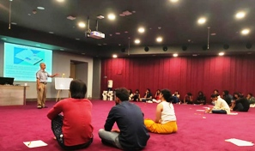 | 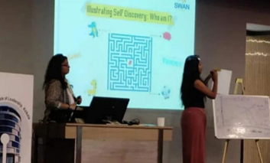
Fig. 1 : Experiential learning session for the fellows of SBI, Youth for India programme

2.) Capacity Building Sessions: Handholding on NGO’s, grass root organisations & corporate stakeholders for programme implementation.

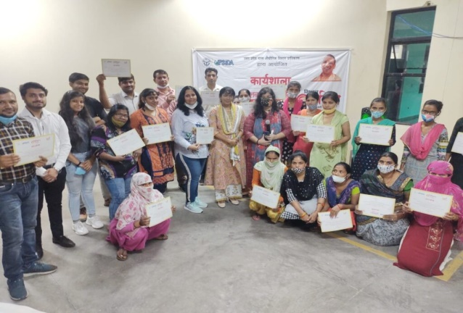 | 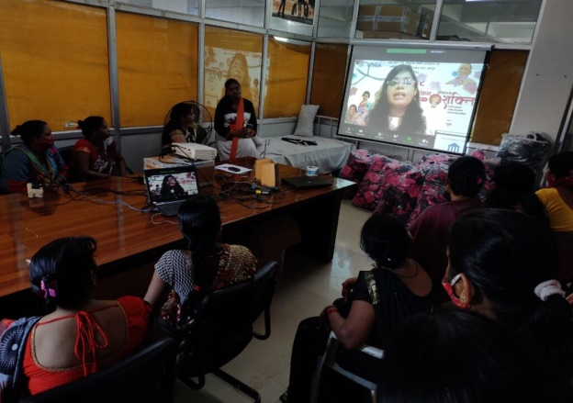
Fig. 2 : Women Factory Workers of an offline Training Programme Fig. 3 : An online training session under progress.
3.) Youth Engagement: Involving youth as change makers to connect through events and campaigns.
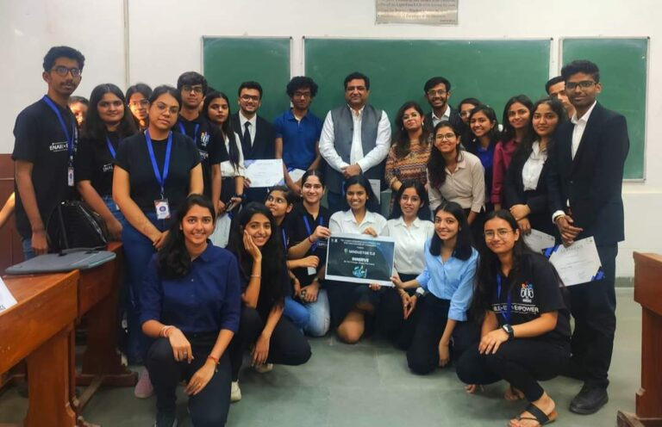 | 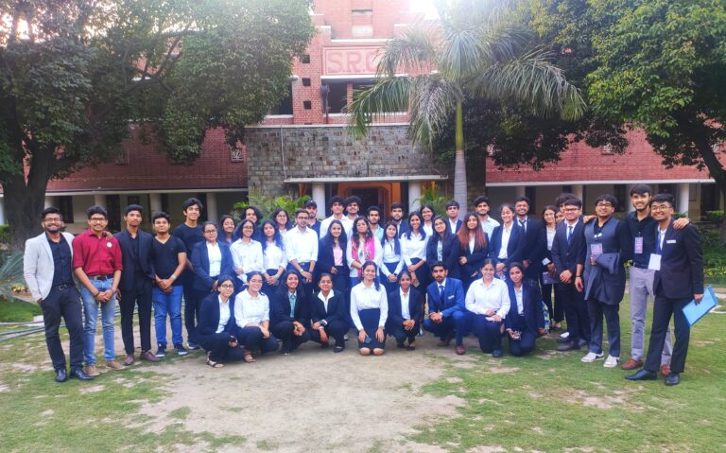
Fig. 4 : Engagement with the students of SRCC, Delhi University as a part of the Socio Business Plan Competition. Innerve : A socio B-Plan Competition | Fig. 5 : Engagement with the students of National Service Scheme (NSS) SRCC, Delhi University.

4.) Development Consultancy: Providing advisory services for any specific client business needs.
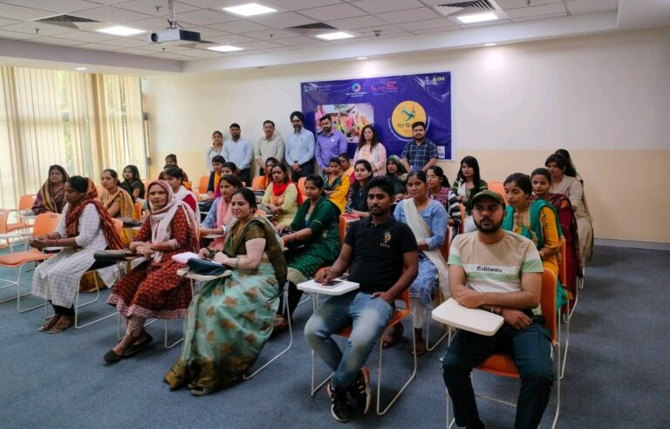 | 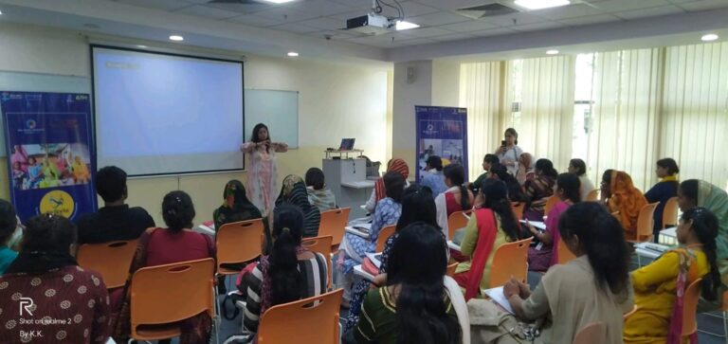
Fig. 6 : Capacity Building Sessions for micro women entrepreneurs from the villages of Haryana in collaboration with ACIC Foundation, BML Munjal University.

V. Business Model Canvas Adaptations for Social Enterprise
The Business Model Canvas by Osterwalder and Pigneur (2010) distinguishes itself by providing not just a definition and components of a business model, but also a visual representation. It enables businesses to present their models in a simple, relevant, and intuitive manner without oversimplifying the intricacies of enterprise operations (Osterwalder and Pigneur, 2010). As a result, the Canvas serves as a common language and a valuable tool for stakeholders to discuss business models. There are nine important components which outlines a business canvas model.
A. Customer Segments: SWAN Livelihood's customer segments for capacity building and developmental consultancy include the workforce from marginalized sections, grassroot level organizations, and institutions. The organization also targets youth between the ages of 16 and 32 for youth engagement activities and upskilling.
B. Value Proposition: SWAN Livelihood offers a range of products and services that provide value to its specific customer segment. SWAN aims to meet the unique needs of its customers through competitive pricing, fast delivery, attractive design, and an exceptional overall customer experience. The organization specializes in tailoring training programs to address the specific pain points of its customers and target communities, thereby enhancing their capacity and enabling growth. All training programmes are curated specially so as to meet the needs of target audience and for the betterment of their lives.
C. Channels: In the business model canvas, channels refer to the methods a company utilizes to engage and reach its customer segments effectively, delivering the value proposition. These channels encompass various forms of communication, distribution, and sales, and can be direct or indirect, owned or facilitated through partnerships.
During the Covid period, SWAN Livelihood found success in utilizing its social media handles as primary channels. These platforms allowed communities to discover and learn about the organization's work fostering connections and engagement. Additionally, active communication through platforms like WhatsApp proved to be an effective channel during this time. Post-Covid, SWAN Livelihood expanded its channels to include publications and features on prominent media channels including Inc91, Socio Story, CNBCTV 18, Nexus of Good, Dailyhunt, Zee News, Hello Entrepreneurs. These efforts played a significant role in establishing connections with industries and forging valuable partnerships. Through the exposure gained from media coverage, the organization could reach a wider audience and showcase its work effectively.
By leveraging a combination of social media, active communication channels, and media collaborations, SWAN Livelihood successfully communicated its value proposition and built meaningful relationships with its customer segments, both during and after the Covid period.
D. Customer Relationships: The customer relationships component in a business model encompasses the types of connections and interactions a company establishes with its specific customer segments. SWAN Livelihood is actively communicating through live sessions and learning programs. These initiatives have enabled the organization to maintain regular contact with its customers, fostering an ecosystem of learning and growth.
SWAN Livelihood is demonstrating its commitment towards the customers development and progress by conducting live sessions and providing ongoing learning programs. These interactions facilitate knowledge sharing and skill-building while establishing a sense of community and connection among participants. By fostering such relationships, SWAN is strengthening its customer base and cultivating loyalty and trust.
Through its continuous engagement efforts, SWAN Livelihood has created an ecosystem where participants can actively learn, grow, and exchange ideas. This proactive approach to customer relationships contributes to the overall success and sustainability of the organization while ensuring that it remains closely aligned with the needs and aspirations of its customer segments.
E. Revenue Streams: The revenue streams component of a business model refers to the income generated by a company from each customer segment. SWAN Livelihood derives its income by providing value-added services to its customers, which include capacity-building sessions, developmental consultancy work, and youth engagement activities. In the case of SWAN Livelihood, the organization has established revenue streams through a fee-based model. This model involves charging a variable subscription fee on program-specific basis depending on factors such as the duration, complexity, and resources required for each program.
The fee-based model ensures a sustainable income for SWAN Livelihood, allowing the organization to continue delivering high-quality programs and services to its customers. By aligning the fees with the value proposition offered, SWAN is effectively monetizing its expertise and resources while meeting the financial needs of the organization.
F. Key Resources: The key resources for SWAN Livelihood's business model include online infrastructure, a team of experts and mentors, and the involvement of young change makers. These resources enable the organization to deliver high-quality training programs, reach a wider audience, and drive revenue generation.
G. Key Activities: The business model canvas outlines crucial activities that are necessary for a company to achieve success with its business model. SWAN, as previously discussed, engages in four primary activities that span across different categories: upskilling workshops, capacity building sessions, youth engagement, and development consultancy. These activities encompass value proposition, expanding market reach, managing customer relationships effectively, and generating revenue. By refining and enhancing these activities, SWAN aims to ensure the overall success of its business model.
H. Key Partnerships: In previous years, SWAN has achieved notable success by establishing partnerships with a diverse range of stakeholders, including government organizations, institutions, corporations, grassroot level organizations, communities, youth groups, and universities. Through these collaborations, SWAN has effectively conducted its training programs that yielded positive outcomes. This collaborative approach has enabled SWAN to leverage the expertise and resources of its partners, resulting in the successful implementation of their training initiatives.
I. Cost Structure: The expenses of SWAN include providing honorarium to the experts and team members who contribute to the smooth functioning of the organization's operations. These individuals play crucial roles in supporting SWAN's activities, such as conducting training sessions, facilitating workshops, and delivering consultancy services. By providing honorarium to these experts and team members, SWAN recognizes their valuable contributions and ensures their continued involvement and dedication to the organization's mission. This expense is essential for maintaining a skilled and motivated team that drives the success of SWAN's initiatives. Expenditure is also being incurred for maintaining the office infrastructure, travel expenses, stationery and printing besides the mandatory auditing and company related Government fees and taxes
VI. Discussion

The tenets of education in the current world are being redefined with an enhanced emphasis on skill development. Its importance as a catalyst for ushering social equality and helping the nation in eradication of poverty is well recognized now. Possession of skills widens the horizon of employability and better avenues of career progression. It is also established that skills are the major determinants of wage differential in India (Singhari and Madheswaran, 2017).

However, it is observed that a sizeable young population in India, after completing schooling or graduation, lacks the basic skills needed for employment and struggles to earn a decent livelihood. Employers’ surveys show that only about 25 percent of the Indian graduates possess employable skills in the organised sector (Nair, 2011). Data reveals that the informal sector, which takes care of about 93 percent of the workforce, lacks any skilling mechanism and largely depends on the skill development taking place on the job (Patel, 2022).
The emergence of social enterprises in the developed world has led to the movement for those sectors where the programmes of the Government agencies have met with limited success. SWAN Livelihood has identified skill development as its core area of activity and emerged successful in providing services to a wide spectrum of youth.
The journey of SWAN Livelihood so far is summarized through the illustration given below,
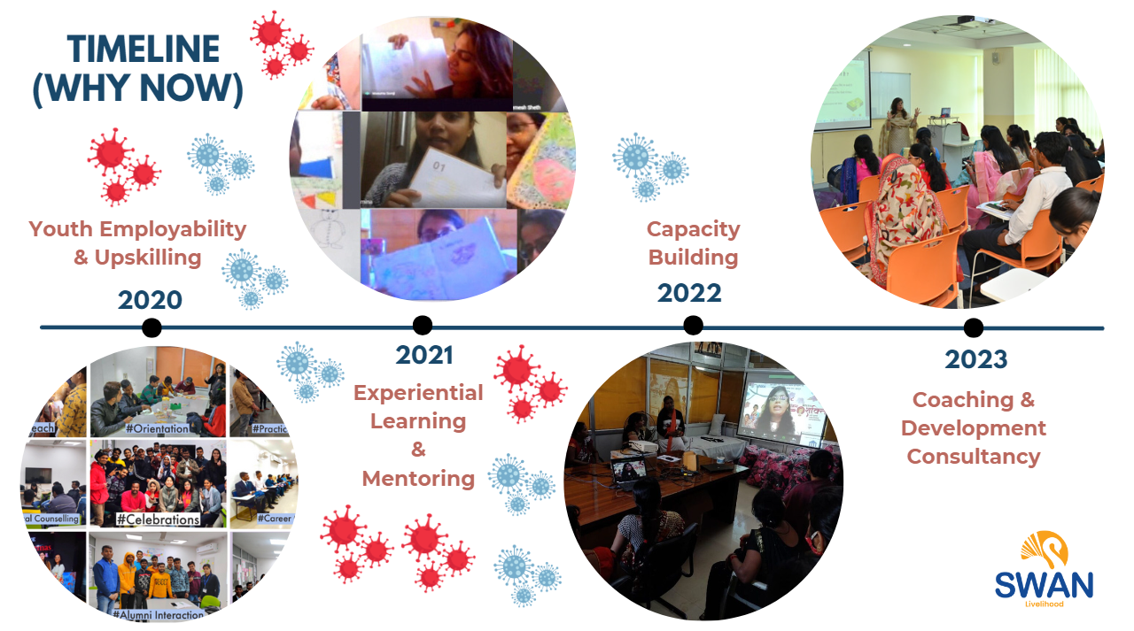

Figure 7 : Discusses the Timeline of the growth journey of SWAN Livelihood
VII. Conclusion
Government agencies and development organizations over the world lay emphasis on skill development and related job placements for youth. However, the success of traditional skill development and job assistance programmes is restricted as these sparsely cover the entire spectrum of training and placement activities involving counselling support, innovative and interactive curriculum, besides hands-on industry exposure followed by post-placement support (OECD, 2016).
The skills deficit is mainly attributed to skill development not finding a prominent place in formal education system, an uninspiring vocational education, insufficient training facilities and non-availability of qualified instructors (Murti and Bino, 2014). Skill development is considered as an essential ingredient for future economic growth of India and for transforming it into a diversified and internationally competitive economy. Thus, the current situation requires a quick reorganization of the skill development ecosystem.
Overall, SWAN Livelihood is dedicated to bridging gaps, providing support, and empowering youth and communities. The ultimate aim of the organization is to contribute to the holistic development of the youth from diverse socio-economic backgrounds and their inclusion or career progression in the workforce. The social enterprise had been successful in emerging stronger from the closure of its activities during the Covid pandemic induced lock down. This period was utilized in conducting surveys and carving its niche, diversification of the activities and developing a business model.
Taking a note from the enhanced online communication facilities that grew tremendously during the Covid pandemic and after it, SWAN Livelihood aims to expand its activities and reach to the youth in tier 1 and tier 2 cities. It proposes to diversify into e-learning programs so that skill-based learning can be imparted to a much larger audience in far-flung areas.

SWAN Livelihood envisages empowering communities to sustain themselves in their respective rural areas preventing migration to cities. This trend would help in creating an environment where individuals can thrive within their own communities contributing to local development and growth. SWAN Livelihood intends to make a meaningful and lasting impact by providing opportunities for skill development and economic empowerment to youth across different regions of India. It is determined to emerge as a true social enterprise through its efforts and contribute towards economic growth of the nation.

VIII. References/Bibliography
[1] Amit, R., & Zott, C. 2001. Value creation in e-business. Strategic Management Journal, 22: 493-520.
[2] Ausin, J., and Rangan, K. (2019). Reflections on 25 years of building social enterprise education.Social Enterprise Journal. Retrieved from Emerald Insight: https://www.emerald.com/insight/content/doi/10.1108/SEJ-05-2019-0015/full/html

[3] Bornstein, D, Davis, S. (2010). Social Entrepreneurship: What Everyone Needs to Know®. Retrieved from https://books.google.co.in/books?hl=en&lr=&id=nujQCwAAQBAJ&oi=fnd&pg=PR9&dq=Bornstein+and+Davis+(2010)&ots=JopYOed8cv&sig=JoRoBSex8wBcHE6FgwmUP2ICf-4#v=onepage&q=Bornstein%20and%20Davis%20(2010)&f=false

[4] Dart, R. (2004). The legitimacy of social enterprise. Nonprofit Management and Leadership, 14, pp. 411– 424. Retrieved from https://onlinelibrary.wiley.com/doi/10.1002/nml.43
[5] Dees, J.G. (1998) The Meaning of “Social Entrepreneurship”. The Kauffman Center for Entrepreneurial Leadership. Kansas City, MO and Palo Alto, CA.
[6] Defourny, J., and Nyssens, M. (2010). Conceptions of social enterprise and social entrepreneurship in Europe and the United States: Convergences and divergences. Journal of Social Entrepreneurship, 1(1), 32-53. https://doi.org/10.1080/19420670903442053
[7] Doherty, B., and Kittipanya-Ngam, P. (2021).The Role of Social Enterprise Hybrid Business Models in Inclusive Value Chain Development.Sustainability, 13(2), 703. Retrieved from MDPI: https://www.mdpi.com/2071-1050/13/2/703
[8] Farmer, J., Steinerowski, A. and Jack, S. (2008) Starting social enterprises in remote and rural Scotland: best or worst of circumstances? International Journal of Entrepreneurship and Small Business, 6(3), 450-464.
[9] Joshi, M. (2021). COVID-19 Induced Reverse Migration: Need for Skill Enhancement for Sustainable Development in Uttarakhand. Labour & Development, 28(1), 128-135. Retrieved from https://vvgnli.gov.in/sites/default/files/Labour%20%26%20Development%20June%202021%20PDF_0.pdf
[10] Kerlin, J. A. (2010). A comparative analysis of the global emergence of social enterprise. Social Entrepreneurship: Theory and Practice, 36(1), 55-72. Retrieved from SpringerLink: https://link.springer.com/article/10.1007/s10551-009-0191-2
[11] Margretta, J. (2002) Why Business Models Matter. Harvard Business Review, 86-92.
[12] Microsoft (2009). Microsoft announces Social Enterprise Alliance. Retrieved from https://news.microsoft.com/2009/05/27/microsoft-announces-social-enterprise-alliance/
[13] Murti, A. B., and Bino, P. G. (2014). Determinants of skill shortages in Indian firms: An exploration. The Indian Journal of Industrial Relations, 50(3), 439-455.
[14] Nair, D. (2011, August 29). 85 percent graduates in India not employable. Retrieved from Rediff.com: https://www.rediff.com/getahead/slide-show/slide-show-1-career-85-percent-of-graduates-in-india-not-employable/20110829.htm
[15] OECD. (2016). Education Innovation and Research Innovating Education and Educating for Innovation: The Power of Digital Technologies and Skills. Retrieved from Organisation for Economic Co-operation and Development (OECD) website: https://www.oecd.org/education/ceri/GEIS2016-Background-document.pdf
[16] Osterwalder, A. and Pigneur, Y. (2010) Business Model Generation: A Handbook for Visionaries, Game Changers, and Challengers. Wiley, New Jersey.
[17] Osterwalder A, Pigneur Y, Tucci,C.L. (2010). Clarifying Business Models: Origins, Present, and Future of the Concept. Retrieved from https://www.researchgate.net/publication/37426694_Clarifying_Business_Models_Origins_Present_and_Future_of_the_Concept
[18] Patel, B. B. (2022). Employment & Unemployment – Dimensions and Challenges in India. Retrieved from Mahatma Gandhi Labour Institute website: https://mgli.gujarat.gov.in/images/mahatma-gandhi/employmentpaperfinal.pdf
[19] Qastharin, A. R. (2015). Business Model Canvas for Social Enterprise. Retrieved from ResearchGate website: https://www.researchgate.net/publication/278647680_Business_Model_Canvas_for_Social_Enterprise
[20] Singhari, S., and Madheswaran, S. (2017). Wage structure and wage differentials in formal and informal sectors in India. The Indian Journal of Labour Economics, 60(3), 389-414.
[21] Teasdale, S. (2011). What’s in a Name? Making Sense of Social Enterprise Discourses. Retrieved from https://journals.sagepub.com/doi/abs/10.1177/0952076711401466
[22] Vial, V. (2016).A Business Model Canvas for Social Enterprises. Retrieved from UniversitiTeknologi Malaysia Institutional Repository website: https://eprints.utm.my/id/eprint/69550/
[23] Zott,C, Amit,R.and Massa, L. (2011). The Business Model: Recent Developments and Future Research. Retrieved from https://journals.sagepub.com/doi/10.1177/0149206311406265

