Vehicle Movement Based Street Light Operation For Preventing Energy and Human Intervention

¹Amgoth Srinivas,
Assistant Professor, Dept. of ECE,
Narsimha Reddy Engineering College, Maisammaguda Telangana 500100, India
srinivas.amgoth916@gmail. Com

²Sangati Ram Mohan, ³Mekala Mallikarjun reddy, ⁴Sandi Anuhya, ⁵Sirinomula Sai Krishna, ⁶Mukkamala sarvari Priya,
^{2,3,4,5,6} Student, Dept. of ECE, Narsimha Reddy Engineering College, Maisammaguda Telangana 500100, India; sandianuhya@gmail.com

ABSTRACT
The goal of this work is to reduce street light energy consumption by implementing an algorithm that can control the electricity at night. This can be done through the use of sensors and an Arduino UNO. The work's counter will monitor the number of objects that pass through the road. This method can help reduce the electricity consumption of the street lights. The system will be designed with the help of an Arduino UNO, which will automatically turn on or off the lights when a vehicle moves. This work's working diagram provides an overview of the various aspects of the project. For instance, if there is no vehicle within the IR sensor module's path, the receiver can't receive the infrared signal. This means that the lights remain on in open loop condition while the circuit is in standby. The IR module is currently in close loop condition. If a car blocks one of the sensors, the microcontroller will switch on the first three LEDs. When the vehicle moves forward, the second sensor will also be turned ON. The first LED from the previous set will then be turned off. This procedure continues for the other sensors and LEDs.

INTRODUCTION
Switching to automation systems is becoming more prevalent as they help cut down on energy consumption. These intelligent devices make our daily lives more comfortable, and they can help us operate various applications such as washing machines and ceiling fans.
Street lights are an exciting application in our environment. They play a vital role in maintaining safety and providing light for traveling at night. In this scenario, if the street lights remain operational for an extended period of time, they consume a lot of energy and, in turn, reduce the lifespan of electrical devices like electric bulbs.
In addition to providing light for traveling at night, street lights are also a major source of energy for cities. An intelligent control system can help lower the cost of street lighting and improve its longevity. One of the main issues with using this technology in street lights is that they tend to be glowing constantly, even though there might not be a vehicle on the road most of the time. They are also the primary source of energy wastage during the night.

An embedded system is a type of computing device that focuses on a specific task. Some examples of embedded devices include mobile phones, air-conditioning units, DVD players, printers, and fax machines. These appliances will have special hardware and processors that are designed to meet specific requirements. They will also have embedded software that is designed to perform the tasks that are required by the application.
The embedded system can be used for various applications, such as word processing and software development. In contrast, the software on the other hand is always fixed. Since the embedded system is designed to perform a specific task, it can't be programmed to do other tasks. An embedded system typically doesn't have a secondary storage device, such as a floppy disk or a CDROM. When it comes to deadlines, an embedded system has to perform against them.
In some embedded systems, which are called real-time systems, deadlines are inflexible. Failure to meet a deadline may result in damage to property or even life. An embedded system is also limited by its power consumption. Since it can operate through a battery, its consumption should be low. Some embedded devices have to operate in harsh environmental conditions, such as humidity and high temperatures.

APPLICATION AREAS

Almost a hundred percent of the processors that are manufactured are embedded. This type of system is commonly used in various applications such as consumer electronics, industrial automation, transportation, military, and biomedical engineering. The embedded market is expected to grow at a high rate due to its wide range of applications.
We use various embedded devices in our homes, such as a DVD player, digital camera, and electronic toys. Some of these include remote controls for air-conditioning units and televisions. In today's high-tech cars, there are about 20 embedded systems that are used for various functions, such as engine control, navigation, and air-conditioning. Other wearable devices, such as palmtops, are also becoming more embedded. These allow us to perform various tasks, such as word processing and playing games, using our wrists.
Office automation products that are embedded include printers, scanners, modems, fax machines, and copy machines.
Today, many industrial sectors such as cement, oil exploration, and pharmaceutical use embedded systems for controlling their processes. These include measuring the temperature, humidity, pressure, voltage, and current in order to determine the appropriate action to take on different devices or send data to a central monitoring station. In dangerous industrial environments, robots are commonly used to perform various tasks. They are capable of carrying out complex and interesting tasks, such as assembling hardware.
In hospitals, almost every type of medical equipment is equipped with embedded systems. These include blood pressure monitors, ECGs, X-ray scanners, and endoscopy equipment. Thanks to advancements in medical electronics, the accuracy of diagnosis has been greatly improved.
A wide range of computer networking products, such as routers, bridges, and switches, are embedded systems that implement the necessary protocols for data communication. A router is a type of device that connects two networks. It can collect data packets from one of the networks and send them to the other one after converting the protocol stack. Most networking equipment, apart from desktop computers, are embedded.
The rise of mobile communication has led to the development of new embedded systems that are designed to provide various interesting applications. One of the most powerful embedded systems that is used today is the mobile phone. This type of device is able to provide voice communication even while we are moving.
The measurement and testing of various parameters are the core requirements of engineering and scientific activities. An embedded system is a device that can be used to carry out these tasks. Some of the commonly used equipment in laboratories include an oscilloscope, a logic analyzer, a radio communication test set, and a spectrum analyzer.
The miniaturization of various types of equipment has made it easier for field personnel to carry out tests and measurements.
Due to the increasing importance of protecting our information and homes, the development of embedded systems has become a lucrative field. These are used in various applications such as security devices for protecting our homes and offices.

An embedded system is a type of device that can be used in various industrial sectors such as transportation, consumer electronics, and medical engineering. It can also be used in the defense and security industry. An embedded system is used to protect the data and voice that are being transmitted over a communication link such as a telephone line. Nowadays, various applications such as banking and access control require the use of biometric systems.

In the past, cash and cheques were the main methods of financial transactions, but now, with the introduction of smart cards, transactions can be made using ATMs and smart cards. A smart card, which is about the size of credit cards, has a small memory and micro-controller, and it can be interacted with an ATM machine. The use of smart cards has the potential to transform the way people conduct transactions. An embedded system works seamlessly and can be seen and felt by anyone.

SYSTEM MODEL
The proposed system model is shown in Figure 1, where as the corresponding circuit diagram shown in Figure 2, that consists of two IR modules. One of these has a data pin that's connected to pin no 2 of the Arduino UNO. The other one has a data pin that's connected to pin 3.
The IR modules' positive and negative pins are connected to the +5V supply of the Arduino UNO using a male-to-female connection. The negative pin is connected to the Arduino UNO's general-purpose board's base. The second and first LEDs are also connected to the Arduino UNO's pin no 6.
The fourth and third LEDs are connected to the Arduino UNO' pin no 7 using the female to male connection. The negative terminal of the IR modules is also connected to the Arduino UNO’s GND.
The laptop is connected to the circuit using a USB Type A to USB Type B adapter cable. The Arduino is also connected to this device using a Type B USB cable. The desktop computer can then be used to upload the program using the software of the Arduino.
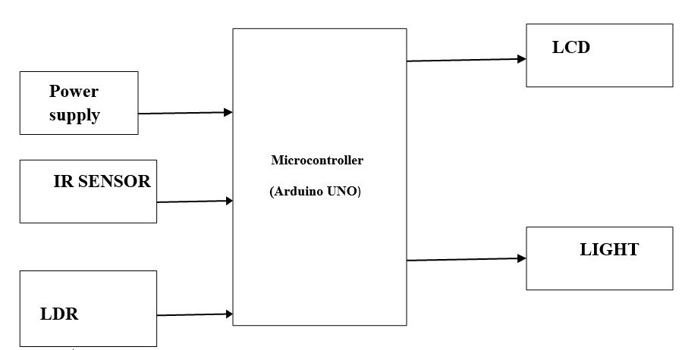

Figure :1.1: Block Diagram Of Automatic Street light.

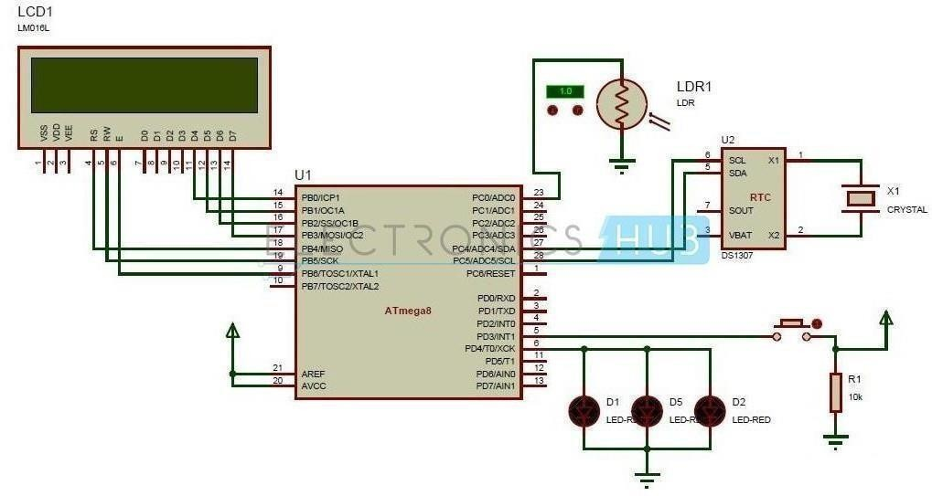
Figure2. Circuit Diagram Of Automatic Street Light

Results and Discussion

Vehicle movement-based street light operation is a system designed to optimize the use of street lights by controlling their operation based on the presence or movement of vehicles on the road. The main goal of this system is to save energy and reduce unnecessary lighting when there are no vehicles around, while ensuring sufficient lighting when vehicles are present. While the benefits of vehicle movement-based street light operation are clear, the effectiveness of the system depends on the accuracy and reliability of the sensing technology used to detect vehicle movement. The system should be designed and calibrated carefully to avoid any inconvenience or safety issues resulting from incorrect readings. Overall, this approach is a step towards creating more sustainable and intelligent urban environments.
By turning off or dimming street lights when there is no vehicular movement, energy consumption can be significantly reduced. This leads to cost savings for the city or municipality operating the street lights and also contributes to environmental conservation by lowering carbon emissions. Reduced Light Pollution: Street lights can cause light pollution, which negatively impacts wildlife and the natural environment. By using vehicle movement-based operation, the intensity of light can be adjusted to meet the required illumination without creating unnecessary light pollution. Extended Light Fixture Lifespan: Dimming or turning off street lights when not needed helps extend the lifespan of the light fixtures, reducing maintenance costs and waste. Increased Safety: When vehicles are present, the street lights can be set to their full brightness, providing better visibility and safety for drivers, pedestrians, and cyclists. This can reduce the risk of accidents and improve overall road safety. Smart and Efficient Lighting: Implementing an intelligent system that responds to vehicle movement demonstrates the adoption of smart city technologies. It showcases the city's commitment to sustainability and efficient resource management. Data Collection: Vehicle movement-based street light operation can be combined with sensors to collect valuable data on traffic patterns and usage, helping municipalities make informed decisions about road infrastructure and traffic management. Public Perception: Implementing an energy-efficient and environmentally conscious system can improve the public perception of the city or municipality. Citizens are likely to appreciate the efforts made to reduce energy consumption and minimize light pollution. Figure 3 shows the ideal state of the proposed experimental setup which is in ideal state, that consists of all required components which are discussed in the earlier sections. Figure 4 shows that the street lights (here LED) are in off mode as the surroundings are light mode, whereas the Figure 5 shows that the street lights are in ON mode as the surroundings are dark. This is how our proposed system will work and saves the energy and human intervention.

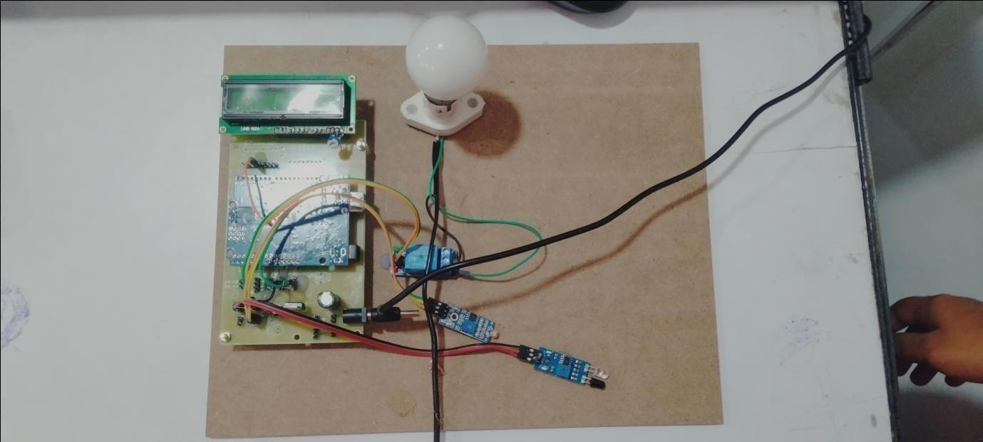
Figure 3: Ideal State

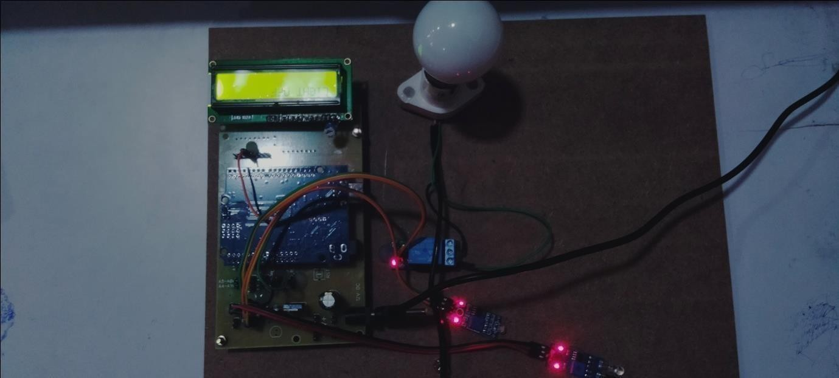
Figure 4: The Light Will Be Off At Brightness

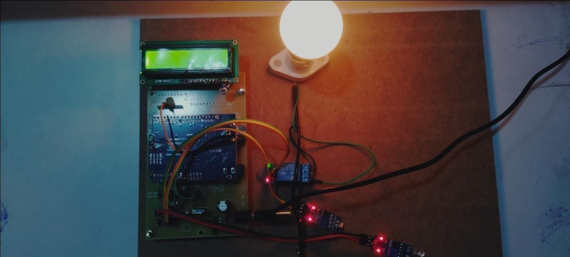

Figure 5: Light is On At Darkness

CONCLUSIONS

The control circuit for street lights can be used in various areas such as highways, roads, and express ways. It can also be utilized in parking areas of hotels, malls, and industrial facilities. The lifespan of LED lights is longer than that of traditional neon lights, which are usually used for street lights. In addition to reducing maintenance costs, the energy consumption of the lights can be saved by automatically turning them ON or off.

REFERENCES

- Vishalsoniindia ‘Smart Street Light Using Ir Sensor With Arduino’, 2018. [Online]. Available:https://www.instructables.com/id/Smart- Street-Light-Using-Ir-Sensor-With- Arduino/ [Accessed: 16- May- 2019].
- Prajapati, Urvish, B. Siva Kumar Reddy, and Abhishek Rawat. "Modeling a data rate-based peripheral security system in GNU radio." Integrated Intelligent Computing, Communication and Security (2019): 353-361.
[3] Sahu, Ritam, et al. "Street Light Glows on Detecting the Vehicle Movement Using Arduino Uno." International Journal of Electrical Engineering & Technology 10.3 (2019): 16-20.
- D. A. Devi and A. Kumar, Design and Implementation of CPLD based Solar Power Saving System for Street Lights and Automatic Traffic Controller, International Journalof Scientific and Research Publications, Vol. 2, Issue11, November 2012.
- K. S. Sudhakar, A. A. Anil, K. C. Ashok and S. S. Bhaskar, Automatic Street LightControl System, International Journal of Emerging Technology and Advanced Engineering, Vol. 3, May2013.
- Reddy, Bathula Siva Kumar. "Experimental validation of non-orthogonal multiple access (NOMA) technique using software defined radio." Wireless Personal Communications 116.4 (2021): 3599-3612.
- Adriansyah, Andi, et al. "Public street lighting control and monitoring system using the internet of things." AIP Conference Proceedings. Vol. 2217. No. 1. AIP Publishing, 2020.
- Viswanathan, Shekar, et al. "A model for the assessment of energy-efficient smart street lighting—a case study." Energy Efficiency 14.6 (2021): 52.
- Pattnaik, Saumendra, et al. "A Novel Intelligent Street Light Control System Using IoT." Intelligent and Cloud Computing: Proceedings of ICICC 2021. Singapore: Springer Nature Singapore, 2022. 145-156.
- Pandharipande, Ashish, and Paul Thijssen. "Connected street lighting infrastructure for smart city applications." IEEE Internet of Things Magazine 2.2 (2019): 32-36.

