**" Discriminant Analysis of Marketing Mix Factors influencing Patient Satisfaction in Eye treatment."**

**Anita Bora, Associate Professor, Pearl Academy, New Delhi**

# **Introduction**

Health services are one of the most demanding industries in terms of customer satisfaction. The need to improve healthcare quality, for achieving higher patient satisfaction, is increasing. All the service providers in healthcare sector, right from hospitals, center for medical care and insurance providers, are striving to better define and measure the quality of health care. The most important component of quality in health care is patient satisfaction. Health care, being a services industry, shares features which have been defined for other service industries like hotel, airlines etc. Like in other service industries, patient is an important part of marketing mix. He is part of the of the service product in the process of delivery and consumption. It is, in fact, a degree more sensitive in health care because process of the service product delivery happens on the patient. Another challenge is that the patient cannot experience the product prior to the purchase. Eye, being the most important organ, makes this vertical of healthcare even more critical. Patient satisfaction is considered to the most important outcome of any eye surgery. A satisfied patient becomes a brand ambassador and forms a critical link for the subsequent patient footfall in any of the eye centers. That’s how most of the centers have grown in terms of the patient base. Patient satisfaction affects clinical outcomes, patient retention, and medical malpractice claims. It affects the timely, efficient, and patient-centered delivery of quality health care. Patient satisfaction is thus a proxy but a very effective indicator to measure the success of doctors and hospitals (Tracy, 2015).

Patient/customer satisfaction is important to the success of health care organizations as Businesses. A satisfied patient will share their positive experience with five others, on average, and dissatisfied patients complain to nine (or more) other people. The Internet promotes rapid and wide dissemination of these opinions. This word-of-mouth marketing is powerful, especially as consumers grow savvier about their health care choices.

Because the cost of obtaining a new patient is high, losing a patient is a substantial loss of investment. You may have attracted a patient through advertising or an insurance contract. And for each new patient, you must establish a patient record and gather payment information. Every interaction with the patient (e.g., reminder and follow-up calls), payer (confirming coverage, etc.), doctor’s office (obtaining files, results of medical diagnosis, etc.), pharmacy (ordering or refilling a prescription), or laboratory (following up on test results) represents a portion of your investment in that patient.

There is evidence of a reciprocal relationship between patient satisfaction and continuity of care (which is associated with better patient outcomes). Conversely, dissatisfaction and complaints can mean not only loss of business/investment, but also increased risk of malpractice lawsuits.

The health services in eye care, like in any service industry, is categorized by its inherent features of intangibility, perishability, inseparability and heterogeneity in their offerings to the patients.

Elements of service marketing mix also apply to health care. These elements are the foundation for successful health care services. And because they change quickly, examining each of these regularly is important in order to sustain and maximize revenue results. Each of the elements carry a very important position in delivering quality services for patient satisfaction.

## **People**

Providing eye-care is fundamentally a people business. The people include patients, clients, customers, prospective patients, providers, staff, and management – everyone – involved in the healthcare organization, facility, or practice. The people who deliver a service are a significant ingredient in the product itself. Patients evaluate their satisfaction level not only based on the quality of treatments and products, but also on perceptions, communication and personal interactions with the eye-care provider. A patient doesn’t have much insight into a doctor’s clinical skills, but they will know if they are pleased based on how the doctor dealt with them as a person. His reputation and his brand are not his alone—it’s a matter of teamwork. However, in the fast pace environment of eye-care practices, it is not easy to maintain the level of communication and interaction desired by both patients and practitioners.

## **Product**

In today’s competitive eye-care market, it is imperative to present the correct products and services with values that meet or exceed the needs and expectations of the customer. The primary determinant is in knowing that customers perceive and receive value and satisfaction by way of healthcare practice or organization.

## **Price**

In any given market, price is a function of value, competition and affordability. Leaving room for flexible pricing is essential for a successful marketing strategy. In the eye-care industry, effective marketing of elective and cosmetic procedures and products is crucial to boosting the revenue of a practice. Customers are especially responsive to price adjustments on these procedures and products but often lack a systematic way to receive the information. Price is a tough nut in the healthcare industry. Sometimes there are few or no options: Price is what it is, or maybe it’s paid through an individual’s insurance.

## **Promotion**

Promotion covers the various forms of communicating with the target audience to effectively present benefits, answer needs and inspire action. Under this list, it is convenient that Promotion begins with a P, but some healthcare professionals react negatively to the “retail” connotation. A better label for this category is **communications,** meaning all the direct and indirect ways of expressing yourself (your practice, your brand, your services) to those who need and want your services.

This includes both personal and direct interaction (one-to-one, inspiring referrals), and interacting with many (advertising, public relations, publicity). In all instances, this is done in a professional way. In the eye-care industry, patients have higher and more specific expectations than average retail customers. They pay attention to factors such as training and experiences of the eye-care practitioner, latest treatment technologies and newest eye-care products. The objective is to critically examine how, where and when you let others know about what you can do for them. (And those in need want this information.)

This is also where you consider changes in the media that’s in play. A few years ago, nobody had a website. And a few moments ago, Social Media Marketing had yet to be invented. Some newspapers have disappeared or gone online only. Magazines and other publications, online and in print, adjust to capture audiences.

## **Place**

The location of promotion must be relevant and accessible to the target customers. A change in where promotion takes place can have a profound impact on the customer’s decision to purchase. When it comes to promoting your eye-care practice and the services and products that it offers, there is no better place to do it than at the practice itself, where patients consider their eye-care options and make purchasing decisions. In eye-care, the place for purchase decision is often separate from where and when product/service is delivered.

## **Physical Evidence**

Physical Evidence represents what the customer perceives and experiences about you, your product/service—tangible and intangible—in every form of visual contact. This is not only the hands-on, physical container of a physical product…the definition is also experiential, and often more so for healthcare services. Looking at this through the end-user’s perspective, and everything counts e.g. the appearance of the physical office or location, the impression of your reception area, the look and feel of brochures and website, and even the appearance of staff. Some doctors never walk through the front door of their own office (First impressions take about 10 seconds to form…and you’ve only got one shot at it)

**2. Problem Definition**

## **2.1 Problem Statement**

Given that Patient Satisfaction is critical for the success of the eye-care practice, it is vital to understand as to what factors influence patient satisfaction. In other words, our goal is to identify as to what marketing mix factors discriminate the most between satisfied and non-satisfied customers. Hence, our goal in this research activity is to perform *Discriminant Analysis* of *Marketing Mix Factors* influencing *Patient Satisfaction* in *Eye Treatment*.

## **2.2 Conceptual Framework**

The framework that we are using for this research is based on the theoretical framework of marketing of services. As per the framework, customer satisfaction in a service environment depends on 7Ps of marketing – Product, Price, Place, Promotion, People, Processes and Physical Evidence. For our research, we are using only five of the seven Ps as the target hospital has little interest in changing promotional strategy (so Promotion is relatively fixed) and given almost perfect competition in this space, an individual hospital is a price taker rather than a price setter.

Hence, our hypothesis is that customer satisfaction depends on the perceived differences in the 5Ps of services marketing. Accordingly, for this study, we will be using these 5Ps – People, Place, Physical Evidence, Process and Product – as independent variables and Patient Satisfaction as a dependent variable as depicted below

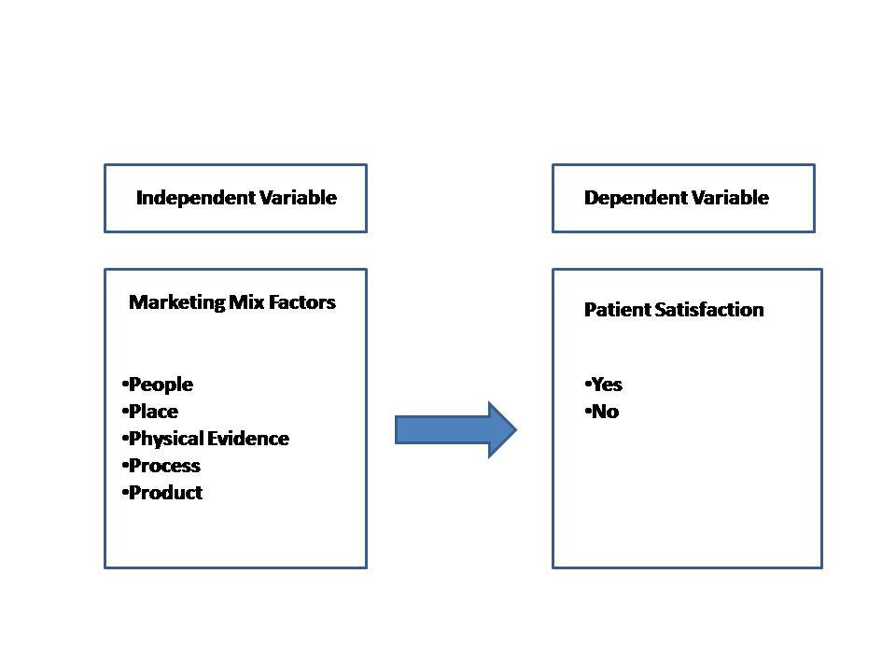

## **2.3 Population and Sampling**

This study involves a conclusive study on the patients who have gone through the cataract surgery in the last one year. To identify the factor influencing patient satisfaction involve descriptive research with help of a survey. The data collection tool was questionnaire.

**Scope of the research:** All the eye care centers of a particular hospital. The hospital has centers in Moti Nagar, Sujan Singh Park, Kirti Nagar and Rajouri Garden in Delhi.

**Sampling Method:** Convenience Sampling

**Sample Size:** 52

## **2.4 Patient Base Analysis: Geographical Reach**

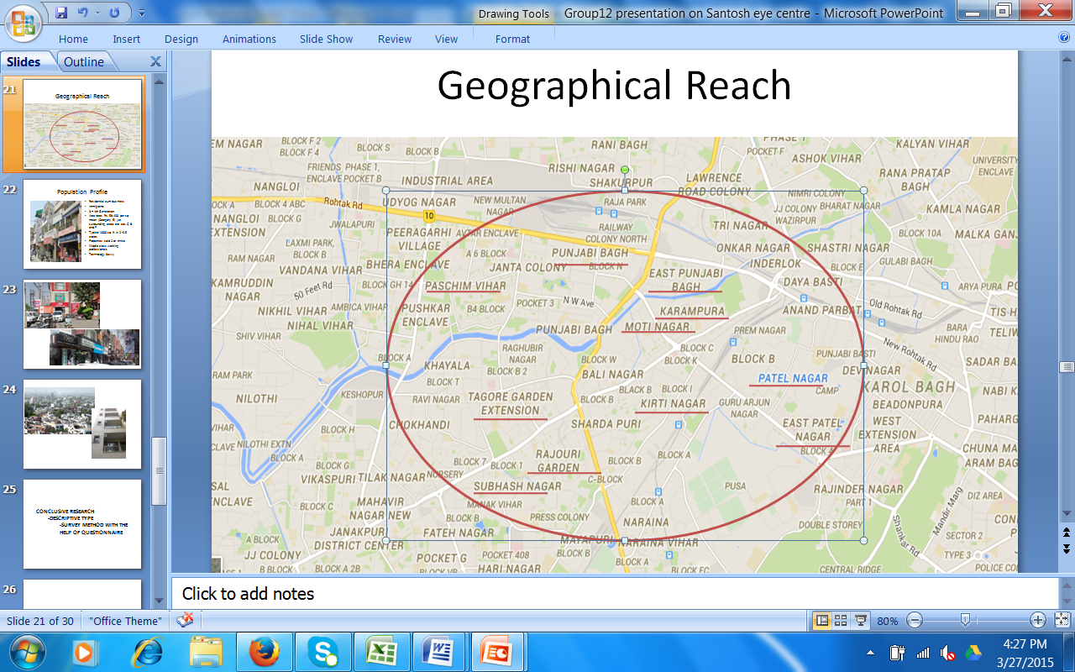

As shown with the help of above map, the majority of the patient belongs to area with a periphery of 2Km of the hospital.

## **2.5 Population Profile**

The area covered for this research is a privately held residential colony. Most of the early residents were immigrants with limited source of incomes but later on the properties have been sold out to the working class as they were getting good rates. Broadly, the profile of majority of the residents may be described as middle class working professionals. They are the third or fourth generation of the residents and are technology savvy.

## **2.6 Pictorial Representation of the Area / population profile**

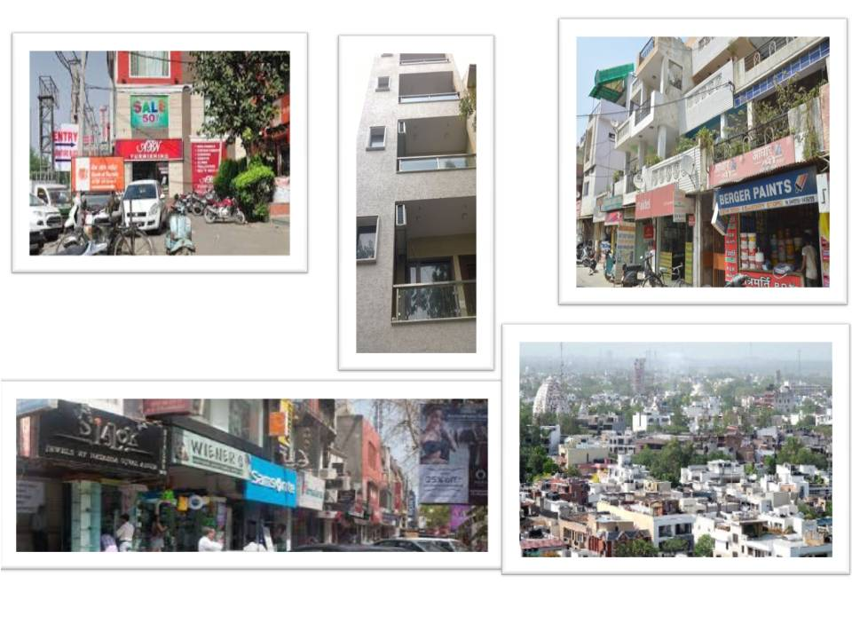

# **3. Literature Review**

For the purpose of this analysis, we have looked at 3 studies linked to the use of marketing in services. The studies are selected in such a way that they cover all the major aspects of the research in the current situation – Patient Satisfaction in Eye Care, Consumer Satisfaction in Hospitals in India and Marketing Mix for services in an equivalent industry.

## **Study I: Patient Satisfaction with Cataract Surgery** (Ehab I Wasfi, 2008)

This study was conducted by Ehab I Wasfi from Eye Department, Assiut University Hospital Assiut, Egypt, P Pai Barrow General Hospital, Barrow in Furness, UK and Alaa A Abd-Elsayed Department of Public Health and Community Medicine, Faculty of Medicine, Assiut University, Egypt.

### **About the Study**

This retrospective study was undertaken for 150 patients underwent cataract surgery at Barrow General Hospital, UK. The survey sample was by postal questionnaire. Patients were surveyed as to the route of their referral, their satisfaction of the time interval before seeing the ophthalmologist, with the eye outpatient clinic service including any information handout given, the explanation before doing the preoperative assessment and the cataract operation. Also patients were asked to rate their views regarding the waiting list time before the surgery and if there were any cancellation or deferral of the operation. Evaluation was done for the anesthetic service given to all patients, and the care given to the patient during and after the surgery.

## **Study II: The Study on Customer Satisfaction in Hospitals** (T Sreenivas, 2012)

This study was conducted on three hospitals in Guntur District, Andhra Pradesh by T Shreenivas and Nidhi Suresh Babu.

### **Objectives**

* To study the satisfaction levels of the patient in sample hospitals.
* To suggest measures to strengthen the administrative practices that improves patient satisfaction in hospitals in India

Seven dimensions of perceived quality were identified, those were

* Admission Procedure,
* Physical Facilities,
* Diagnostic Services,
* Behavior of the staff,
* Cleanliness,
* Dietary Services
* Discharge procedure.

### **Conclusion**

The developed scale is used to measure perceived quality at a range of facility types for patients. Perceived quality at public facilities is only marginally favorable, leaving much scope for improvement. Better staff and physician relations, interpersonal skills, infrastructure, and availability of drugs have the largest effect in improving patient satisfaction. In this study, patient refer to inpatient.

## **Study III: Discriminant Analysis of Marketing Mix Factors** (Pitauk Chancharoen, 2015)

This study was conducted to study the impact of Marketing Mix Factors in the Hospitality Industry (Hotels) by Pitauk Chancharoen, Kwanjai Jariyatatkone and Maniga Thongkong from Thailand. The study was published in International Conference on Global Business, Economics, Finance and Social Sciences.

This research was done to study behavior and discriminant analysis of marketing mix factors influence using the hotel services. The samples in this study consisted of 1,467 customers in 6 hotels which were owned and operated by Rajabhat University in Bangkok Metropolitan Area. The research tools were personal characteristics questionnaires, behavior and marketing perspective in using the hotel services.

The results of the research were as follows:

* Customers and their companions mainly stay for one night and use other services.
* Customer comment of marketing mix factors influence using the hotel services found that high overall level were the staff, process, physical Evidence and presentation, Price, Product and Promotion.
* Discriminant analysis of marketing mix factors influence using the hotel services showed as follows:
  + Discriminating factors for the companions were price and people (or employees).
  + Discriminating factors the period of using the hotel services were promotions, product and place.
  + Discriminating factors using other services were promotions and people or employees

**4. Research Design**

### 

### **Exploratory Research**

The exploratory research has been done with the help of secondary data. The intent of this exploratory research was to formulate a hypothesis for the analysis which would help in the survey design.

### **Conclusive Research**

To identify the discrimination factors the multivariate technique of discriminant analysis was done.

### **Scope of the Research**

Scope limited to areas served by a single hospital and its eye-care centers. These include Moti Nagar, Sujan Singh Park, Kirti Nagar and Rajouri Garden in Delhi.

### **Sampling Method**

Convenience Sampling has been used for this study as a particular hospital was chosen for analysis. The entire data of the patients from that hospital have been arranged chronological order (according to date of operation) and every 10th patient has been chosen from the same list.

### **Sample Size**

After removing the records with missing values, the sample size available for the analysis was 52 unique patients.

### **Field Work**

Data was collected with the help of the front office employees of various eye-care centers of the hospital in discussion. The printed forms were left with the assistants by the team members and were collected a few days later. The researchers had no direct interactions with the end users to avoid any bias.

### **Data Collection**

Data collection was done with the help of a questionnaire. All the current patients were considered as eligible candidates for the sampling.

# **5. Methodology**

The analysis of descriptive statistics for distribution of variables has been done by using frequency, mean and standard deviation. The results has been shown with the help of graphic charts. Thereafter the multivariate technique of discriminant analysis has been applied to identify the discriminating factors of service marketing mix for maximizing the patient satisfaction.

The main purpose of a discriminant function analysis is to predict group membership based on a linear combination of the interval variables. The procedure begins with a set of observations where both group membership and the values of the interval variables are known. The end result of the procedure is a model that allows prediction of group membership when only the interval variables are known. A second purpose of discriminant function analysis is an understanding of the data set, as a careful examination of the prediction model that results from the procedure can give insight into the relationship between group membership and the variables used to predict group membership.

For the current research, we are more interested in the second purpose i.e. using Discriminant Analysis to identify the key perceived factors discriminating the patient’s satisfaction. We have two groups (i.e. Satisfied vs Non-Satisfied) so only one Discriminant Function will be sufficient for our purpose.

# **6. Data Analysis and Presentation**

## **Data Analysis**

### **Family Income**

**Observation & Inference:** More than half of the patient profile belongs to ₹ 50,000 to ₹100,000 per month income category. This implies that

### **Reference Source**

47% patients have come by self-assessment, 33% have referred by their relative and 18% through friends.

### **Perception of Medical Facilities**

**Inference:** 80% of the people perceive Santosh Eye Clinic to be sophisticated in terms of the medical facilities.

### **Overall Satisfaction**

**Observation & Inference:** Close to 63% are very satisfied. The above data suggests that there is a scope of improvement in the overall satisfaction, however situation is not too bad at present also.

### **Courteousness of Staff**

### **Quality of Explanation**

**Observation and inference:** Other parameters like explanation by staff, doctor and pre during and post operation procedures, behavior of staff and doctors have shown the same statistics where people have opined to be very satisfied or very satisfied.

The responses where responses have been varying are as follows:

### **Availability of Parking**

**Observation and inference**: Many people have shown discontentment regarding parking.

### **Explanation of Procedure and Next Steps**

**Observation and inference:** In explaining the next procedure, 4% of patients have shown discontentment.

## **Result and Analysis of Discriminant Analysis**

With the help of the observed data we estimated the discriminant function coefficients. The direct method was used. The result of running two group discriminant analysis on data using SPSS we get the following result.

| **Tests of Equality of Group Means** | | | | | |
| --- | --- | --- | --- | --- | --- |
|  | Wilks' Lambda | F | df1 | df2 | Sig. |
| Staff Courteous | .933 | 2.436 | 1 | 34 | .128 |
| Staff Explanation | .971 | 1.014 | 1 | 34 | .321 |
| Parking | .913 | 3.256 | 1 | 34 | .080 |
| Location | 1.000 | .000 | 1 | 34 | .988 |
| Appointment | .904 | 3.615 | 1 | 34 | .066 |
| Initial Check up | .912 | 3.299 | 1 | 34 | .078 |
| Cleanliness | .999 | .035 | 1 | 34 | .852 |
| Toilet | .896 | 3.930 | 1 | 34 | .056 |
| Doctors Introduction | .903 | 3.668 | 1 | 34 | .064 |
| Doc Explanation | .973 | .944 | 1 | 34 | .338 |
| Patient Relax | .965 | 1.243 | 1 | 34 | .273 |
| Patient Understanding | .998 | .073 | 1 | 34 | .789 |
| Next Step | .996 | .139 | 1 | 34 | .712 |
| Risk | .703 | 14.337 | 1 | 34 | .001 |
| Anaesthesia Check | .452 | 41.191 | 1 | 34 | .000 |
| Explained | .430 | 45.059 | 1 | 34 | .000 |
| Information | .398 | 51.352 | 1 | 34 | .000 |
| Length | .328 | 69.635 | 1 | 34 | .000 |
| Patient Care | .275 | 89.677 | 1 | 34 | .000 |

| **Eigenvalues** | | | | |
| --- | --- | --- | --- | --- |
| Function | Eigenvalue | % of Variance | Cumulative % | Canonical Correlation |
| 1 | 11.342a | 100.0 | 100.0 | .959 |
| a. First 1 canonical discriminant functions were used in the analysis. | | | | |

| **Wilks' Lambda** | | | | |
| --- | --- | --- | --- | --- |
| Test of Function(s) | Wilks' Lambda | Chi-square | df | Sig. |
| 1 | .081 | 61.570 | 19 | .000 |

 

 

## **Interpretation of the Result**

1. The pooled within groups correlation matrix show broadly low correlation between the predictors, expect for few places like staff courtesy and staff explanation. Multicollinearity is unlikely to be a problem
2. The significance F ratio indicates that when predictors are considered individually only risk, Anesthesia check, Explanation by the doctor, Length of the treatment Information provided in writing, Patient care significantly differentiate between those who were satisfied and those who were not.
3. The Eigen value associated with this function is **11.34** and it accounts for 100% variance. The canonical correlation associated with this function is .959 and the square of this correlation is (0.959)2 = .95 which implies that **95%** of the dependent variables have been used to explain by this model.
4. The value of Wilk’s Lamda is .081 which is a badness of fit and must be less than 10% and the significance of chi square in .000 which means the null hypothesis is rejected and the model is fit to explain the data well.
5. The standardized correlation discriminant function reading indicate that Patient Care is the most important predictor of discriminating the patient satisfaction likewise length of the treatment, information given in writing, anesthesia, risk and toilet cleanliness other factors in their descending order value of coefficient in discriminating the patient satisfaction.
6. The hit ratio is 84.6%, which indicates that the model is strong in discriminating the variable determining the patient satisfaction.

## **Conclusion and Final Recommendation**

Based on the above analysis, it clearly visible that the data is able of identify the independent values which are explaining the patient satisfaction after go through the eye treatment. This study strongly recommends that the following factors must be given at most importance in order to achieve greater patient satisfaction:

1. Patient care
2. Length of the treatment,
3. Information given in writing,
4. Anesthesia,
5. Risk and
6. Toilet cleanliness

Five out of the six factors are forming part of the service product and one of the factors is part of physical evidence which indicates that the most discriminating element in service marketing is that product followed by physical evidence.

# **References**

1. Ehab I Wasfi, P. P.-E. (2008). Patient satisfaction with cataract surgery. *International Archives of Medicine*.
2. Pitauk Chancharoen, K. J. (2015). Discriminant Analysis of Marketing Mix Factors’ Influence Using the Hotel Services. *International Conference on Global Business, Economics, Finance and Social Services.* Bangkok, Thailand.
3. T Sreenivas, N. S. (2012). A Study on Patient Satisfaction in Hospitals. *International Journal of Management Research and Business Strategy*.
4. Tracy, B. (2015). *The Seven 7 Ps of Marketing.* Retrieved from Healthcare Success: http://www.healthcaresuccess.com/blog/medical-advertising-agency/the-7-ps-of-marketing.html