ORIGINAL ARTICLE
EFFECT OF INTERFERENTIAL THERAPY ON PAIN LEVEL IN PEOPLE WITH TRAPEZIUS MYALGIA FOLLOWING A SINGLE TREATMENT SESSION
Pinky Dutta – Associate Professor, Garden City University, Bangalore
Corresponding author – dutta.pimky@gmail.com
ABSTRACT
BACKGROUND:
Trapezius myalgia is a leading disability. The microcirculation is disrupted by the mitochondrial disruption, which also results in discomfort and stiffness. By activating large-diameter nerve fibres, IFT(interferential therapy) causes analgesia. IFT is typically offered in a single session per day. IFT is known to alleviate pain; however, it is unknown if the hypoalgesic effect lasts up to 24 hours before the delivery of the following session. Therefore, it becomes necessary to assess IFT's impact on trapezius myalgia sufferers 24 hours after the session.
OBJECTIVES:
To evaluate and compare the degrees of pain in trapezitis prior to the treatment, just after, and 24 hours after providing an IFT session
METHODOLOGY:
Subjects were divided into experimental and control groups. Study group received IFT with suction electrode and a sham therapy to control group. Visual Analogue scale(VAS) and Pain pressure threshold(PPT) was measured before the treatment, immediately after, and 24 hours. Also, a patient report card was given.
RESULTS:
The experimental group showed a significant decrease in pain level and an increase in pressure threshold after the therapy.
DISCUSSION:
IFT and sham therapy both reduced pain right away and for up to 24 hours within and between the groups. But when compared to sham therapy, the pain was significantly reduced by IFT after 24 hours rather than right away. This study suggests that although the immediate effect of IFT on pain levels is not obvious, it has definitely been demonstrated to generate a substantial effect post 24 hours, therefore demonstrating that the IFT has hypolagesic effect which lasts for 24 hours after a single session.

CONCLUSION:
IFT has a hypoalgesic effect on persons with trapezius myalgia's pain level that lasts for 24 hours after a single session.
KEY WORDS:
Interferential therapy (IFT), pain pressure threshold (PPT), trapezius myalgia, visual analogue scale (VAS), hypoalgesic, pressure algometer
INTRODUCTION:
“Myalgia” refers to pain in the muscle. ¹. “Myalgia” is composed of “my(o)” from the greek ‘myos’ meaning muscle and “algia” from the Greek ‘algos’ meaning pain ² . Neck and shoulder muscles are more likely to develop muscle pain. The trapezius is the most common muscle to suffer from trapezitis ^{3,4,5}. Trapezius myalgia causes discomfort to the neck and shoulder. ^{6,7,1}. It can be treated by both invasive and non-invasive therapies like pharmacological drugs, homeopathy, physiotherapy, acupuncture etc. drugs. ^{8,9,10} The basic principle of IFT is that when two medium frequency currents are applied to the skin a low frequency current will be induced that is equivalent to the difference in frequency between the two medium frequency currents ^{9,10,11,12,13}. IFT increases microcirculation¹⁴ . In IFT skin electrodes are used and it modulates the amplitude of electric current to minimize the discomfort of stimulating deeper tissues ^{14.} IFT relieves muscle pain, spasm, swelling, promotes healing, ^{15,16,17,18,19.}
The effectiveness of a single daily session of Interferential Therapy (IFT) on hypoalgesia lasting up to 24 hours in individuals with trapezius myalgia has not been extensively studied in the existing literature. The limited available research does not provide clear guidance to therapists regarding the benefits of delivering IFT once a day to patients with this condition.
Therefore, there is a significant need for further investigation to measure the impact of IFT on pressure pain threshold in people with trapezius myalgia, particularly in the 24 hours following a single session. Conducting rigorous research in this area can help establish whether a daily session of IFT is an effective treatment approach for providing pain relief and improving the condition's symptoms.
By conducting well-designed clinical studies and trials, researchers and healthcare professionals can gather valuable data to determine the optimal frequency and duration of IFT sessions, leading to more evidence-based recommendations for the management of trapezius myalgia. This research could contribute to better-informed decisions when designing treatment plans for individuals suffering from this condition.

AIMS AND OBJECTIVES:
- To assess the level of pain in the study and control group participants with trapezius myalgia before, immediately after and 24 hours after providing an IFT session.
- To assess the degree of pain in study participants with trapezius myalgia and the control group before, immediately after, and 24 hours after receiving a single IFT session.
METHODOLOGY:
The study obtained ethical clearance and includes 50 participants aged 20-35 with trapezius myalgia. Participants must be free from allergies, shoulder/neck fractures, and metal implants. The study uses a digital IFT stimulator, a pressure algometer, and patient-reported cards for data collection.
Procedure of data collection:
In this study, eligible participants were randomly assigned to either an experimental or control group. To prevent bias, the therapist was unaware of participants' pain scores, and a qualified physiotherapist conducted pain and pressure threshold measurements. Participants were also kept unaware of their assigned therapy. Pain was assessed using a Visual Analog Scale (VAS), and Pain Pressure Thresholds (PPT) were measured using a pressure algometer.
In a research study, one group received actual Interferential Therapy (IFT) via suction electrode, while a control group received a sham treatment. Both groups had treatments lasting 20 minutes, with the intensity in the study group adjusted based on patient tolerance.
Parameters used in IFT: Conventional IFT, Carrier wave frequency: 4.0 KHz, Pulse time: 1.25μs, Amplitude modulated Frequency: 100Hz, Duration: 20minutes.
Following the therapy session, both the study and control groups underwent assessments. Immediately after treatment, their Pain Pressure Threshold (PPT) and Visual Analog Scale (VAS) scores were measured. Additionally, patients were provided with cards to report the duration of any pain relief within 24 hours and note the timing of any painkiller usage post-therapy, along with associated VAS scores. The next day, PPT and VAS assessments were repeated, and the patient-reported cards were collected for further analysis. These measures aimed to evaluate the immediate and sustained effects of the therapy in both groups.
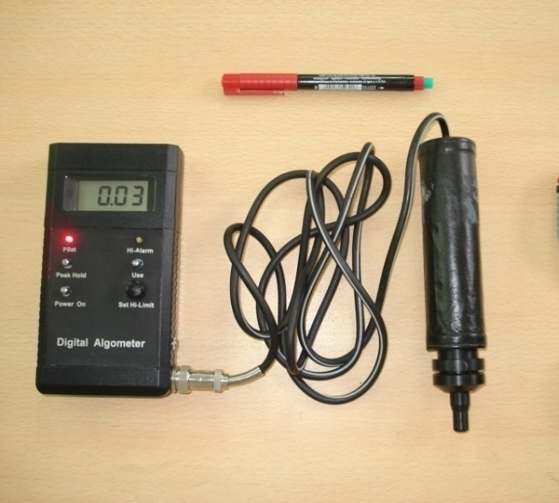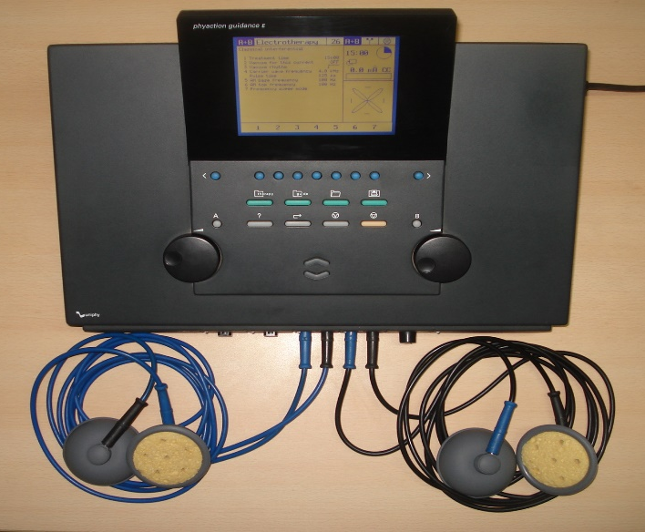
Picture 1: Pressure Algometer Picture 2: IFT with suction electrode
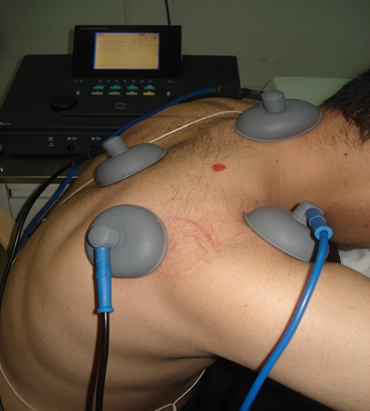
Picture 3: Measuring PPT Picture 4: IFT with suction electrodes
DATA ANALYSIS AND RESULTS:
The Statistical software namely SPSS 15.0, Stata 8.0, MedCalc 9.0.1 and Systat 11.0 were used for the analysis of the data and Microsoft word and Excel have been used to generate graphs, tables etc.

Table 1: Comparison of mean VAS within control and study groups
VAS | Control group  mean±SEM | Study group  mean±SEM
PRE | 4.68 ± 0.30  (2-7) | 5.00 ± 0.30  (3-8)
IMMEDIATE POST | 4.00 ± 0.33  (1-8) | 4.60 ± 0.33  (2-8)
24hours POST | 3.48 ±0.35  (1-8) | 3.32 ± 0.40  (0-8)
SIGNIFICANCE | F=170.71;p<0.001*** | F=175.761;p<0.001**
Bonferroni’s correction as post hoc test:
PRE TO IMMEDIATE POST | F=37.29;p<0.001*** | F=4.800;p<0.013**
IMMEDIATE TO 24 hours POST | F=13.255;p<0.001*** | F=26.540 ;p<0.001***
PRE TO 24 HOURS POST | F=39.273;p<0.001*** | F=45.231;p<0.001***
Percentage of change in VAS score
PRE TO IMMEDIATE POST | 14.53% | 8%
IMMEDIATE TO 24 HOURS POST | 13% | 27.83%
PRE TO 24 HOURS POST | 25.64% | 33.6%

The table 1 shows that there is a statistically significant difference between the VAS scores reported prior to and immediately after the treatment session (p<0.001***). Additionally, the VAS scores taken 24hrs after the treatment are shown to be significantly different from those recorded before and also immediately after the interferential therapy session.

VAS | Control(Mean ±SEM) | Study (Mean ±SEM) | Effect size | 95% CI |  | significance
 |  |  |  | low | high
Pre to immediate post | 1.84 ± 0.111 | 2.52± 0.182 | 0.55(M) | -0.77 | -0.59 | p=0.013**
Immediate post to 24 hours post | 0.78± 0.142 | 0.06 ± 0.248 | 0.62(M) | 0.61 | 0.83 | p =0.037
Table 2: Comparison of mean difference of VAS between control and study groups.

The table 2 shows that the mean difference in VAS from before to immediately after the therapy is of significant difference (p=0.013**) and from immediately after to 24 hours after the therapy the mean difference in the VAS score was p=0.037.

PPT | Control group  mean±SEM | Study group  mean±SEM
PRE | 3.65±0.56  (0.08-9.02) | 2.29±0.32  (0.15-4.94)
IMMEDIATE POST | 3.80±0.54  (0.05-9.05) | 2.45±0.31  (0.19-5.67)
24hours POST | 3.84±0.57  (0.06-10.01) | 3.91±0.46  (0.60-8.74)
SIGNIFICANCE | F=45.187;p<0.001*** | F=67.233;p<0.001***
Bonferroni’s correction as post hoc test:
PRE TO IMMEDIATE POST | F=5.828;p=0.008** | F=4.846; p=0.013**
IMMEDIATE TO 24 hours POST | F=0.470;p=0.170 | F=31.074;p<0.001***
PRE TO 24 HOURS POST | F=8.738;p=0.002*** | F=35.343;p<0.001***
Percentage change in PPT
PRE TO IMMEDIATE POST | 4.11% | 6.99%
IMMEDIATE TO 24 HOURS POST | 0.79% | 59.59%
PRE TO 24 HOURS POST | 4.93% | 70.74%
Table 3: Comparison of mean PPT within control and study groups

The table 3 shows that there is a significant increase in PPT within the control and the study group with a significance of p<0.001*** respectively. The control group shows a strong significance of p=0.008** from before to immediately after but from immediate after to 24 hours after the difference was not significant. The study group showed a significance of p=0.013 from prior to immediately after the intervention and from immediately after to 24 hours after there was a significance of p<0.001***. The overall change in PPT from pre to 24 hours post in the control group has a significance of 0.002** and in the study group there is a significance of p<0.001**

Table 4: Comparison of mean difference of PPT between control and study groups
PPT | Control  Mean ±SEM | Study  Mean ±SEM | Effect  size | 95% CI |  | significance
 |  |  |  | low | high
Pre to immediate post | 0.15±0.063 | 0.16 ±0.075 | 0.02(S) | -0.05 | 0.03 | t =0.146  p=0.885
Immediate post to 24 hours post | 0.04 ±0.056 | 1.40±0.261 | 1.44(VL) | -1.47 | -1.25 | t =5.307  p<0.001***

The table 4 shows that the mean difference from before to immediately after the therapy is not significantly different but between immediately after to 24 hours after the mean difference is statistically significant with p<0.001***.
Recurrence | control | study
Nil | 12(48%) | 18(72%)
Yes | 13(52%) | 7(28%)
Total | 25(100%) | 25(100%)
Inference | Recurrences are 0.35 times less likely in study group with p=0.083+
Table 5: Recurrence of increased pain in Patient Log

Time of recurrence | Control group  (N=25) | Study group  (N=25)
Up to 10 hrs | 11(44.0%) | 0
11-15 hrs | 2(8.0%) | 2 (8%)
16-20 hrs | 0 | 1 (4%)
>20 hrs | 0 | 4 (16%)
Table 6: Time taken for the recurrence of increased pain in Patient Log

The table 6 shows that maximum number of subjects in the control group had recurrence of pain within 10 hours and in the study group after 20 hours.

DISCUSSION

This study evaluated the Effect of IFT on pain level in people with trapezius myalgia before, immediately after and 24 hours after following a single treatment session.
Analysis of VAS and PPT within the study group showed a strong significant reduction in pain level immediately after intervention and persisted up to 24 hours after intervention
This could be because of the hypoalgesic effect of IFT mediated through pain gate mechanism by stimulation of Aß nerve fibres and the vasodilatation that occurs within the muscle which increases the micro circulation in the trapezius muscle (Dr Gareth Noble,2006; John H Brown,2005)
Analysis of VAS and PPT within control group showed a significant reduction in VAS and increase in PPT immediately after intervention which persisted upto 24 hours.
Suction electrodes were used to deliver IFT in both groups.These electrodes creates a negative suction pressure causing a mild massaging effect on the skin. It stimulates the cutaneous sensory nerves and causes vasodilatation, which in turn increases the microcirculation in the localized muscle. (Low J et al; Kitchen S electrotherapy, 2002)
Another reason could be the placebo component (Low J et al; Kitchen S electrotherapy,2002)
So the reduction of VAS and increase in PPT, could be because of the use of suction electrode and placebo component.
The hypoalgesic effect produced between the study and the control group found no significant difference in VAS immediate post and 24hour after intervention.
The difference in these could be because VAS is a subjective measurement.
By analysis of covariance, the immediate post is not statistically significant keeping baseline pressure threshold as covariate with F=0.215; P=0.645 & 24 hours post the pressure threshold in the study group is significantly higher when compared to the control group with F=25.766; P<0.001**.
This shows that immediately after the intervention both the groups had similar effects and 24 hours following intervention the study group had significantly increase in pressure threshold and relief of pain as compared to the control group.
The Immediate effect in the control group could be because of the suction provided by the suction electrodes and the study group it could be because of the suction or the effect of IFT or can be both.

After 24 hours in the study group the pressure threshold has increased when compared to control group(F=25.766; P<0.001**)
This could be that the suction pressure which had caused the vasodilatation effect had faded off and so the control group had decrease in threshold but in the study group the threshold has significantly increased which could be because of the effect of IFT that had persisted following 24 hours post intervention.
Analysis of the patient reported outcome proved that recurrence is 0.35 times less likely in the study group
The higher recurrence level in the control group could be because the physiological effect in the localized muscle caused by the suction pressure is not sufficient enough to cause vasodilatation to increase the microcirculation and stimulate the cutaneous nerves such that the hypoalgesic effect can remain up to 24 hours post intervention
It also revealed that 72% of the subjects in the study group and 45% in the control group had no recurrence of pain within 24 hours.
16% of the subjects in the study group had recurrence of pain after 20 hours, 4% within 16 -20 hours and 8% within 11-15 hours post intervention
44% of the subjects had recurrence of pain within 10 hours, 11% within 11-15 hours post intervention.

LIMITATION: The sample size was limited and subjects were not categorized based on severity of involvement of trapezius myalgia

FUTURE STUDIES: Studies can be conducted by comparing the long term effects of IFT with other electrotherapy modalities

CONCLUSION: It is thus concluded from present study that the effect of IFT on the pain level in people with trapezius myalgia lasts for more than 24 hours following a single session which supports my alternate hypothesis.

ABBREVIATIONS:
IFT – Interferential Therapy, PPT – Pain Pressure Threshold, VAS – Visual Analogue Scale, TENS- Transcutaneous electrical nerve stimulation, NSAID – Non Steroidal Anti Inflammatory Drugs

REFERENCES:
- Last editorial review: 9/05/2005, MedicineNet.co
- Bengtsson Rheumatology Unit,University Hospital,581 85 Linkoping Sweden Editorial The muscle in fibromyalgia,Rheumatology 2002;41:721-24
- Anderson HI, Eilertsson G, Leden I, Rosenberg C. Chronic pain in a Geographical defined general population:studies of differences in age, gender, social class and pain localization. Clin J Pain 1993;9:174-82.
- Larson, Britt. Morphological and electromyographical studies of trapezius Myalgia in cleaners. Faculty of medicine: department of laboratory medicine,Lund: occupational and environmental medicine, 2001.
- Leesa K Huguenin. Myofascial trigger points:the current evidence. Physical Therapy in sport,5, 2004; 2-12
- Kitchen S electrotherapy evidence based practice, 11th edition, London: Churchill livingstone; 2002.
- Low J, Reed A. Electrical stimulation of nerve and muscle. In: Low J, Reed A, Eds. Electrotherapy Explained: Principles and Practise 2nd ed. Oxford, United Kingdom; Butterworth-Heinemann Ltd 1994:39-116
- Noble JG et al, The effect of interferential therapy upon cutaneous blood flow in humans. Clinical Physiology 2000;20:2-7.
- John H Brown. Stimulation-produced analgesia: acupuncture, TENS and Alternative techniques. Anaesthesia and intensive care medicine 6:2. PAIN 2005 The Medicine Publishing company Ltd.
- Mantle J et al Physiotherapy for stress urinary incontinence: a national survey. BMJ.1991;302:753-755.
- Johnson MI et al. A questionnaire survey on the clinical use of interferential Currents(IFC) by physiotherapists. The Pain Society of Great Britain Annual Conference, abstracts, Leicester, United Kingdom; Pain society of Great Britain;1998.
- Chen S-H et al. Current management of myofascial pain syndrome. Clinical Journal of Pain 1996; 6:27-46
- Moore SR, Shurman J: Combined neuromuscular electrical stimulation and Transcutaneous electrical nerve stimulation for treatment of chronic back pain: a double-blind, repeated measures comparision. Archives of Physical Medicine and Rehabilitation 1997; 78:55-60
- Mark I Johnson et al. An investigation into the analgesic effect of interferential Currents and transcutaneous electrical nerve stimulation on experimentally Induced ischemic pain in otherwise pain free volunteers, Physical Therapy; 83:2003:208-223.
- S 11279 Stockholm, Kerstin Fredriksson, National Institute for Working Life & authors 2000. National institute for Working life. Sweden.Nr 2000:14 On causes of neck and shoulder pain in the general population. Epidemiological studies on associations between workload and leisure Time activities, and disorders in the neck/shoulder region
- Backman C, Boquist L, Friden J, Lorentzon R & Toolanen G. Chronic Achilles paratendonitis with tendinosis: an experimental model in the rabbit. Journal of Orthopedics Research, 1998; 8, 541-754.
- Melin B & Lundberg U.A biopsychosocial appraoch to work-stress and musculoskeletal disorders. Journal of Psychophysiology,1997 11, 238-247.
- Hägg G.Muscle fibre abnormalities in the upper trapezius muscle related to occupational static load- A review. In: Christensen H & Sjögaard G Eds. Muscular disorders in computer users: Mechanisms and models.2000; 138-139, Copenhagen.
- Ethne L Nussbaum et al. Reliability of clinical pressure pain algometric Measurement obtained on consecutive days. Physical Therapy, volume 78. February 1998.

