Instantaneous adaptive pq theory based dstatcom with ann for harmonic extraction
Dr.D.Venugopal¹, A.Thirupathi², and Ch,Bhasker³

1Associate Professor, Department of Electrical and Electronics Engineering, Kamala Institute of Technology & Science, Singapur, Huzurabad, Karimnagar, Telangana, India. E-mail: venufacts20m@gmail.com ²Assistant Professor Department of Electrical and Electronics Engineering, Kamala Institute of Technology & Science, Singapur, Huzurabad, Karimnagar, Telangana, India³Assistant Professor Department of Electrical and Electronics Engineering, Kamala Institute of Technology & Science, Singapur, Huzurabad, Karimnagar, Telangana, India.
ABSTRACT The power system suffers from several effects as a result of the employment of non-linear loads, with the quality of the power being one of the main issues. Therefore, it is crucial to provide the power without any interruptions that facilitates this job. Here, PV-fed DSTATCOM is used, which also reduces harmonics. To generate the reference current, an instantaneous adaptive P-Q theory-based ANN is used, and the three-phase VSI's gating sequence is used to extract the harmonic components. In order to manage the flow of active and reactive power in the distribution system, the opposite harmonics are thus injected at the point of common coupling (PCC) using three-phase VSI. Utilizing MATLAB simulation, the suggested methodology is verified. Keywords: DSTATCOM; ANN;Instantaneous adaptive PQ theory; PI Controller.
I. INTRODUCTION
Power quality (PQ) is what creates the standard power system, and PQ issues arise in distributed systems when non-linear demands increase. Electrical harmonics are the most dangerous of the PQ difficulties, as they are produced by electronic equipment [1] [2]. Other PQ issues include low power factor, voltage sag or swell, and flickering. Harmonics cause the supply voltage in distributed systems to be distorted, which disrupts the operation of sensitive loads [3].Utilising FACTS (Flexible AC Transmission Systems) devices, which improve attributes including power flow, stability, voltage profile, power factor, and loss minimization, is one way to address these quality challenges. Static Var Compensators (SVC) and Thyristor Controlled Series Capacitors (TCSC) are two common FACTS devices; in this context, SVC is referred to as shunt compensation and TCSC is referred to as series compensation [4].

Two SVC modes (voltage regulation and volt ampere reactive control mode), which allow the voltage to be adjusted as needed by the system and susceptance to be kept constant, are initially used to address the power quality issue [5]. A drawback of the SVC is its slow dynamic reaction, despite its rapid reactive power provision capability. The SVC issues are further resolved by the use of TCSC, which can be accomplished at both high and extremely high voltages (EHV). The use of TCSC in power systems improves power flow control by limiting current by raising voltage, which allows for the detection of voltage sags [6].The benefit of TCSC is that it limits short circuit current and converts controllable capacitance to controllable inductance. On the other hand, the disadvantage of TCSC is that it causes parallel resonance between the capacitors. Static synchronous compensator (STATCOM) [7], which increases the capacity of power transmission but has the drawback that energy storage is not possible, is used to alleviate the shortcomings of these two FACTS. Distribution static compensator (DSTATCOM) is employed in this case to resolve these FACTS problems.
The initially synchronous reference frame (SRF) theory is one of the theories used in the power system to generate the reference current. SRF is accomplished in a series active filter, which also generates the reference voltage needed by a dynamic voltage restorer. While correct harmonic extraction is highly difficult, it is simple to compute [8]. The P-Q theory, which controls the active power filter and also examines distorted voltage problems, is another theory that is used to address the SRF problem. Although accurate harmonics are recovered, the process is difficult to carry out [9]. Adaptive P-Q theory is employed to address these two problems.
An overview of MPPT and DSTATCOM is provided in this work. In most cases, voltage sag and swell problems caused by PQ are corrected using FACTS devices [10–15]. Problems with power quality result from supply being directed toward the load side. In order to solve this issue, the suggested approach employs DSTATCOM fed PV, which boosts power factor and lowers THD. A VSI is used to convert DC to AC on the DSTATCOM side of the system. DC source in this case is a PV panel. For the creation of current and harmonics extraction, an ANN built on an instantaneous adaptive P-Q theory is used. The extracted harmonics are now fed into a PWM generator, which creates a pulse that is fed into a three-phase voltage source inverter, which injects the opposite harmonics into the PCC and decreases the harmonic content of the source current.

- Proposed System
The proposed block diagram comprises 3Ф AC source, PV system, Luo converter, ANN based MPPT, PWM generator and non-linear load. The proposed block diagram is depicted in Fig 1.
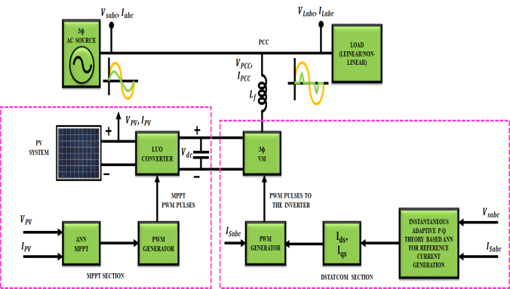
Figure 1. Proposed block diagram

A non-linear load is fed a 3Ф volt AC supply, resulting in PQ problems such voltage sag and swell. In most cases, the voltage and current are in phase. However, non-linear loads can cause harmonic problems that impact the source current. The life of the load and the generator is shortened if THD is present. Distribution static compensator (DSTATCOM), which addresses this issue, is employed. A 3Ф VSI is used on DSTATCOM to inject harmonics at the PCC, and the PCC is coupled to the 3Ф VSI through the coupling inductor. A PV panel is utilized to provide three phase VSI with a DC supply. The Luo converter receives the DC output voltage from the PV panel as its input.
A Luo converter will increase the voltage to a DC since the output voltage of a PV panel varies with changes in temperature and intensity. A PV panel's maximum power can be obtained using MPPT. In order to keep the output voltage constant, an artificial neural network based on MPPT is used. The three phase VSI that converts DC to AC is now provided this voltage. For producing reference current and harmonics extraction, an instantaneous adaptive P-Q theory based ANN is used. Now, the extracted harmonics are fed into a PWM generator, which creates a pulse that is fed into a three-phase voltage source inverter, which injects the opposite harmonics into the PCC, so reducing harmonics and compensating for reactive power.

II.MODELLING OF PROPOSED SYSTEM
- ANN based Instantaneous adaptive P-Q theory for reference current generation
Instantaneous adaptive P-Q theory-based ANN is used to create reference current and to balance out current harmonics and reactive power produced by non-linear loads. This hypothesis states that the powers are measured and that their words in AC and DC are instantly split. When measured from $αβ$frame, the instantaneous powers are represented as,
$\left[\begin{matrix}p \\ q\end{matrix}\right]=\left[\begin{matrix}v_{α} & v_{β} \\ {−v}_{β} & v_{α}\end{matrix}\right]\left[\begin{matrix}i_{α} \\ i_{β}\end{matrix}\right]$ (1)
The source voltage in $αβ$ frame is deduced by the common expression as,
$\left[\begin{matrix}v_{sα} \\ v_{sβ}\end{matrix}\right]={\left[\begin{matrix}i_{α} & i_{β} \\ {−i}_{β} & i_{α}\end{matrix}\right]}^{−1}\left[\begin{matrix}p \\ q\end{matrix}\right]=\frac{1}{{i_{α}}^{2}+{i_{β}}^{2}}\left[\begin{matrix}i_{α} & {−i}_{β} \\ i_{β} & i_{α}\end{matrix}\right]\left[\begin{matrix}p \\ q\end{matrix}\right]$ (2)
The block diagram of reference current generation system is depicted in Fig 2.
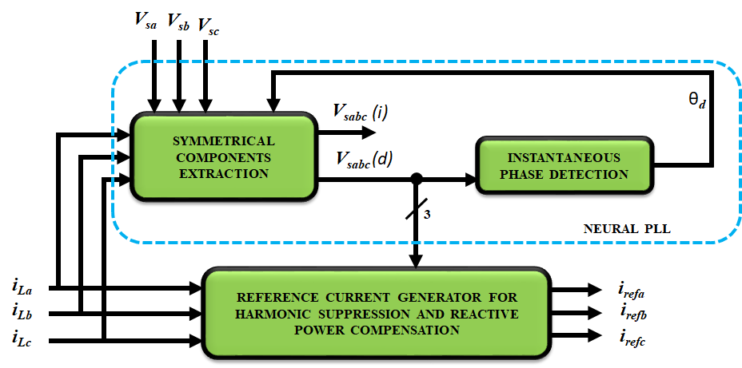
Figure2. Block diagram of reference current generation system
The symmetrical components of extraction system are depicted in Fig 3.
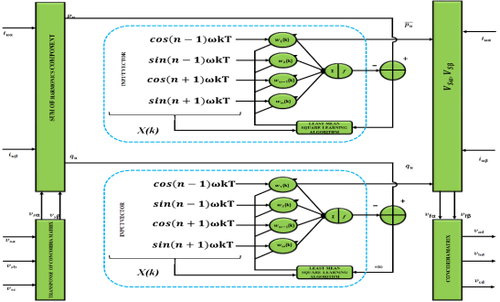
Figure3. Symmetrical components extraction system
The fundamental direct voltage element is also attained from by means of unit amplitude currents, which provides from a direct fundamental element and DC terms of associated fictitious powers.
$\left[\begin{matrix}i_{uα} \\ i_{uβ}\end{matrix}\right]=\left[\begin{matrix}\cos{ωt} \\ \sin{ωt}\end{matrix}\right]$ (3)
The fictitious powers $p_{u} and q_{u}$ are calculated from currents $i_{uα} and i_{uβ}$ and $αβ$ space voltages which is expressed in below equation.
${\left[\begin{matrix}v_{sα} & v_{sβ}\end{matrix}\right]}^{T}=\sqrt{2/3}{C_{32}}^{T}v_{abc}={T_{32}}^{T}v_{abc}$ (4)
Where the Clark and coordinate matrixes are denoted as$C_{32} and T_{32}$.
The sum of harmonics element is expressed as,
$p_{u}=v_{sα}i_{uα}+v_{sβ}i_{uβ}$ (5)
Equation (4) is rewritten with a linearly separable equation which is noted in below equation and it approximated by an ANN. It is expressed as,
$y=X^{T}W$ (6)
The output of an ANN, which is based on supervised learning, is represented as, while the input and weights vectors are denoted as. Sinusoidal signals multiplied by the basic element are used to create the input vector. The output of the ANN is compared to the target value at each iteration. The resulting error is used by an ideal least mean square learning algorithm to adjust the weights for the subsequent sampling time to achieve convergence. After training, the elements' signify power amplitudes, which come from direct voltages at frequency; the currents are derived from equation (2). The fundamental direct voltages of the system are then produced by multiplying the first two elements of equation (1)—the DC components of the instantaneous powers—into the voltage space. The fictional reactive power is also obtained using the same method.
- Reference current generation
In $3Ф$ systems, the instantaneous current and voltages are transformed into instantaneous space vectors. These vectors are simply transformed into $αβ$ orthogonal coordinates and it is expressed as,
$\left[\begin{matrix}i_{cα} \\ i_{cβ}\end{matrix}\right]=\sqrt{\frac{2}{3}}\left[\begin{matrix}1 & −\frac{1}{2} & −\frac{1}{2} \\ 0 & \frac{\sqrt{3}}{2} & −\frac{\sqrt{3}}{2}\end{matrix}\right]\left[\begin{matrix}i_{ca} \\ i_{cb} \\ i_{cc}\end{matrix}\right]=T_{32}\left[\begin{matrix}i_{ca} \\ i_{cb} \\ i_{cc}\end{matrix}\right]$ (7)
The instantaneous real and reactive power with AC and DC termis represented as,
$p=\overline{p}+\hat{p} ; q=\overline{q}+\hat{q}$ (8)
The DC values of $p and q (\overline{p}, \overline{q})$ are generated with positive sequence element of load current and AC values of $p and q (\hat{p} , \hat{q})$ are generated with harmonic component of load current. Now equation (23) is transformed as,
$\left[\begin{matrix}i_{α} \\ i_{β}\end{matrix}\right]={\left[\begin{matrix}v_{α} & v_{β} \\ {−v}_{β} & v_{α}\end{matrix}\right]}^{−1}\left[\begin{matrix}p \\ q\end{matrix}\right]=\frac{1}{∆}\left[\begin{matrix}v_{α} & −v_{β} \\ v_{β} & v_{α}\end{matrix}\right]\left[\begin{matrix}p \\ q\end{matrix}\right]$ (9)
Where $∆={v_{α}}^{2}+{v_{β}}^{2}$
The compensating currents ($i_{refα} and i_{refβ})$ on $αβ$ frame are measured using $−\hat{p} and−\hat{q}$ in order to compensate harmonics and instantaneous reactive power and it is expressed as,
$\left[\begin{matrix}i_{refα} \\ i_{refβ}\end{matrix}\right]=\frac{1}{∆}\left[\begin{matrix}v_{α} & −v_{β} \\ v_{β} & v_{α}\end{matrix}\right]\left[\begin{matrix}−\hat{p}+p_{dc} \\ −q\end{matrix}\right]$ (10)
Where, $p_{dc}$ is known as added power in order to attain voltage capacitor $v_{dc}$ at the side of DC inverter. The compensating reference currents in $a−b−c$ co-ordinates is expressed by the following equation are,
$\left[\begin{matrix}i_{refa} \\ i_{refb} \\ i_{refc}\end{matrix}\right]=\sqrt{\frac{2}{3}}{\left[\begin{matrix}1 & −\frac{1}{2} & −\frac{1}{2} \\ 0 & \frac{\sqrt{3}}{2} & −\frac{\sqrt{3}}{2}\end{matrix}\right]}^{T}\left[\begin{matrix}i_{refα} \\ i_{refβ}\end{matrix}\right]=T_{32}\left[\begin{matrix}i_{refα} \\ i_{refβ}\end{matrix}\right]$ (11)
The reference current signals in this work are produced by Instantaneous Adaptive P-Q Theory-Based ANN and supplied to PWM generator, which compares the reference signal with carrier signal and generates pulses that are supplied to VSI through coupling inductor, which reduces harmonics and compensates for reactive power.
III. RESULTS AND DISCUSSIONS
The effectiveness of the suggested system is evaluated through simulation in MATLAB. The DC-link voltage is kept constant while harmonic reduction is achieved using the instant PQ theory and artificial neural networks. The parameters used for the simulation are listed in Table 1.
Table 1 Design parameters
Parameters | Values
Input Frequency | 50Hz
Input voltage | 415V
Input Source resistor ${(R}_{s})$ | 1Ω
Input Source inductor ${(L}_{s})$ | 0.1mH
DC-link capacitance ${(C}_{DC})$ | 2200µF
Ref. Voltage ${(V}_{DC(ref)})$ | 1200V
Coupling Inductor ${(L}_{f})$ | 3mH

The AC source voltage and current waveforms are depicted in Fig 4&5 accordingly. From the Fig 4,it is noted that the input voltage of $415V$ is maintained. When this $415V$is given to a non-linear load, initially harmonics will occur in the source current and after the time of $0.04ms,$ the waveform becomes sinusoidal due to DSTATCOM whichreduces harmonics.
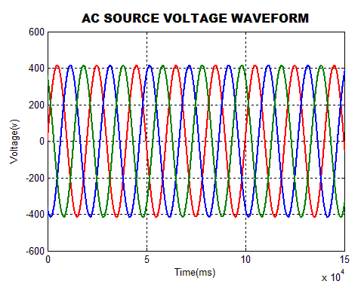  Figure4. AC source voltage waveform | 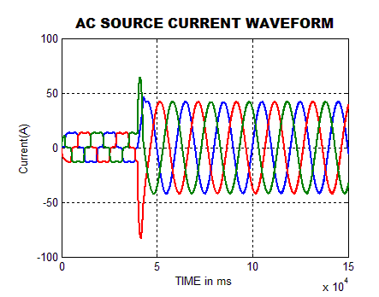  Figure5. AC source current waveform

According to Fig. 6, the waveform of current injected at the PCC without using the suggested inverter and its control circuits will have significant harmonics since the load is not linear. By injecting the opposite phase harmonics at the PCC with the help of the inverter circuit, all of these harmonics must be removed. To lessen the source current harmonics, the voltage source inverter's output voltage is injected into the PCC via a coupling inductor.
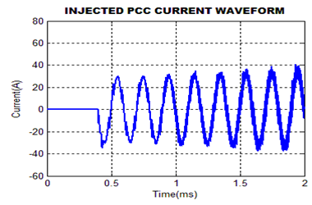
Figure6. Injected PCC current waveform
The load voltage and current waveforms become sinusoidal after injecting the inverter output voltage at the PCC, as seen in Figs. 7 and 8. Furthermore, it has been noted that the load voltage is kept constant and that the waveform changes from square to sinusoidal once the harmonics in the load current that were there initially vanish.

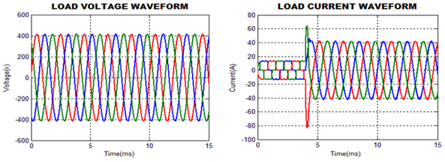
Figure7. Load voltage waveform Figure8. Load current Waveform
The input voltage and current waveform is depicted in Fig 9. From this waveform, it is observed that initially the input voltage and current are not in in-phase and after the time of$4ms,$ it becomes sinusoidal.
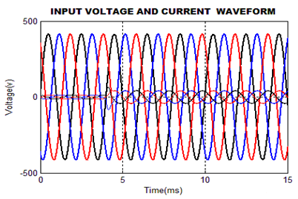
Figure9. Input Voltage and Current waveform
Figures 10 and 11 show the load real and reactive power, respectively. The level of real and reactive powers in the line is determined by the harmonics' amplitude. For the specified load, the reactive power ranges from -170VAR to -50VAR, and the real power is above 16000W.

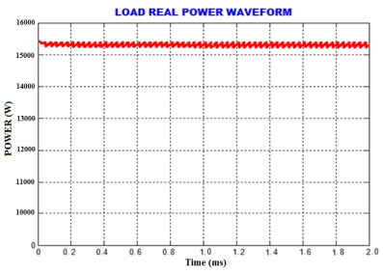  Figure 10. Waveform for Load Real Power | 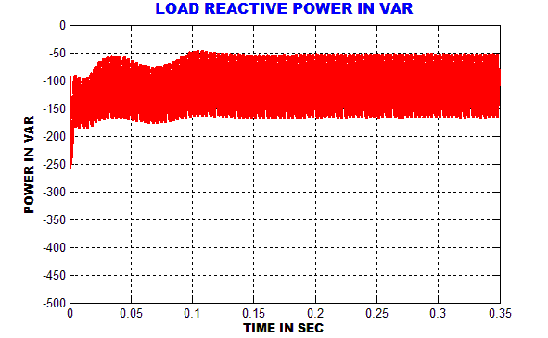  Figure 11. Waveform for Load Reactive Power

The source current THD is depicted in Fig 12. From this figure, it is observed that the THD attained in source current is$3.61\%$.
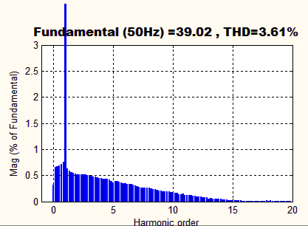
Figure12. Source current THD with ANN controller
The source voltage THD with ANN controller is depicted in Fig 13. From this figure, it is observed that the source voltage of THD with ANN controller attained is $0.68\%$.

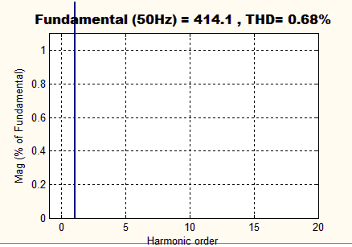  Figure13.Source Voltage THD with ANN controller | Figure14. Comparison of THD
The comparison of Total Harmonic Distortion is depicted in Fig 14.
From the Figure, it is observed that the source current THD with ANN is considered as a best when comparing to PI and FLC since it has the reduced value. The value attained is $3.61\%$.
IV. CONCLUSION
The use of non-linear loads has caused the power system to experience many disruptions, and harmonics are a significant role in these disruptions that have an impact on the quality of the electricity. For the purpose of harmonic mitigation in this study, a PV supplied D-STATCOM is used. By using instantaneous adaptive P-Q theory, the creation of reference current and harmonics is extracted, and the gating sequence for three-phase VSI is afterwards constructed. Injecting opposing harmonics into the PCC by three-phase VSI. By controlling the flow of reactive power through the distribution system, harmonics are reduced and reactive power is compensated. Using MATLAB, the proposed methodology is simulated, and the outcomes are adequate.
V.REFERENCES
[1] Bin Zhou; Renxi Gong, Year: 2019, “Study on Pricing Method of Power Quality Differentiated Market Service in Distribution Grid”, IEEE Access, vol: 7, pp: 147021 – 147028.

[2] FarzamNejabatkhah; Yun Wei Li; Hao Tian, Year: 2019, “Power Quality Control of Smart Hybrid AC/DC Microgrids: An Overview”, IEEE Access, vol: 7, pp: 52295 – 52318.

[3] Piotr Gnaciński; Tomasz Tarasiuk; Janusz Mindy kowski; Marcin Pepliński; Mariusz Górniak; Damian Hallmann; Andrzej Piłlat, Year: 2020, “Power Quality and Energy-Efficient Operation of Marine Induction Motors”, IEEE Access, vol: 8, pp: 152193 – 152203.

[4] Huilian Liao; Sami Abdel rahman; Jovica V. Milanović, Year: 2017, “Zonal Mitigation of Power Quality Using FACTS Devices for Provision of Differentiated Quality of Electricity Supply in Networks With Renewable Generation”, IEEE Transactions on Power Delivery, vol: 32, pp:1975 – 1985.

[5] TetianaBogodorova; Luigi Vanfretti, Year: 2017, “Model Structure Choice for a Static VAR Compensator Under Modeling Uncertainty and Incomplete Information”, IEEE Access, vol: 5,pp: 22657 – 22666.
[6] Yanhong Luo; Shengnan Zhao; Dongsheng Yang; Huaguang Zhang, Year: 2020, “A new robust adaptive neural network backstepping control for single machine infinite power system with TCSC”, IEEE/CAA Journal of AutomaticaSinica, vol: 7, pp: 48 – 56.

[7] Rajiv K. Varma; HesamaldinMaleki, Year: 2019, “PV Solar System Control as STATCOM (PV-STATCOM) for Power Oscillation Damping”, IEEE Transactions on Sustainable Energy, vol: 10, pp:1793 – 1803.

[8] Kangante Vishal; Vijayaganesh R, Year: 2018, “An Improved SRF-Theory Based Controller Applied to Three Phase Grid Interfaced PV-System for Power Quality Improvement and Islanding Detection”, 2018 IEEE Innovative Smart Grid Technologies - Asia (ISGT Asia), Conference Paper, pp:1-6.

[9] Asim Datta; RishirajSarker; Imraj Hazarika, Year: 2019, “An Efficient Technique Using Modified p–q Theory for Controlling Power Flow in a Single-Stage Single-Phase Grid-Connected PV System”, IEEE Transactions on Industrial Informatics, vol: 15, pp:4635 – 4645.
[10] Vedik B, Naveen P and Shiva C K 2020 A novel disruption based symbiotic organisms search to solve economic dispatch Evol. Intel. https://doi.org/10.1007/s12065-020-00506-5
[11] Nandi M, Shiva C K, and Mukherjee V, 2019 Moth-Flame Algorithm for TCSC-and SMES-Based Controller Design in Automatic Generation Control of a Two-Area Multi-unit Hydro-power System Iranian Journal of Science and Technology, Transactions of Electrical Engineering, 1-24.
[12] Mudi J, Shiva C K, and Mukherjee V 2019 Multi-verse optimization algorithm for LFC of power system with imposed nonlinearities using three-degree-of-freedom PID controller Iranian Journal of Science and Technology, Transactions of Electrical Engineering 43(4) 837-856.
[13] Dr Chandan: Nandi, M., Shiva, C. K., & Mukherjee, V. (2019). A moth–flame optimization for UPFC–RFB-based load frequency stabilization of a realistic power system with various nonlinearities. Iranian Journal of Science and Technology, Transactions of Electrical Engineering, 43(1), 581-606.
[14] Dr Chandan: Nandi, M., Shiva, C. K., & Mukherjee, V. (2019). Moth-Flame Algorithm for TCSC-and SMES-Based Controller Design in Automatic Generation Control of a Two-Area Multi-unit Hydro-power System. Iranian Journal of Science and Technology, Transactions of Electrical Engineering, 1-24
[15] H. P. Vemuganti, S. Dharmavarapu, S. K. Ganjikunta, H. M. Suryawanshi and H. Abu Rub. (2020) A Survey on Reduced Switch Count Multilevel Inverters. IEEE Open Journal of the Industrial Electronics Society, doi: 10.1109/OJIES.2021.3050214.

