MULTIFERROIC-BASED PHOTOCATALYSIS FOR THE TREATMENT OF WASTEWATER
Anu Mehraª, Raj Paulª, Shahnaz Kossarª*, Simmer Preet^{b}, Barjinder Kaur^{b}, Majahid ul Islam^{b}, Vanshika Khanna^{b}
^{a, a}*^{,b}School of Natural Sciences, GNA university, Sri Hargobindgarh, Phagwara-Hoshiarpur Road, Phagwara, Punjab -144401
Corresponding author *Email: shazia.rajput0505@gmail.com (Dr. Shahnaz Kossar)

Abstruct
Multiferroic-based photocatalysis presents a promising avenue for wastewater treatment, leveraging materials with coupled ferroelectric and magnetic properties. This innovative approach combines the benefits of traditional photocatalysis with the unique attributes of multiferroic materials, enhancing the efficiency of pollutant degradation. By harnessing the multifunctional characteristics of these materials, we can create photocatalysts that respond to both light and external magnetic fields, allowing for precise control over catalytic processes. This not only accelerates the degradation of contaminants but also enables the treatment of wastewater in challenging conditions. Multiferroic-based photocatalysis holds great potential for sustainable and efficient wastewater remediation, contributing to environmental preservation and clean water availability.

Introduction
Our earth is known as ‘BLUE PLANET’ for the amount of water present on it. But 97% of water present on it is saline and only 3% of its water is fresh water. Now, out of that 3%, only about 1% water is available for drinking and human use, rest of it is present in the form of ice glaciers and ice caps [1]. Water is much needed but scarce natural resource which should be used sustainably. Excessive use of water for agricultural and industrial activities is leading in water scarcity problem. Water conservation is an essential for long-term development and reusing used water is the most effective way to conserve it. Recently, industrial waste effluents are directly dumped into the fresh water [2]. The most effective way to reuse the water and for treatment of waste water is advanced oxidation process (AOP). In this procedure, the oxidation process and specific chemical reactions can eliminate organic contaminants from water [3]. Some AOP’s include radiation, photolysis, photocatalysis, electrochemical oxidation reactions, fenton-based reactions, ozone-based reactions [4]. Among AOP’s, photocatalysis is most beneficial and effective method for detoxification of waste water, which has several benefits, including no secondary pollution, total pollution degradation, and environmental protection [5]. In Photocatalysis, organic waste from water gets degraded into water or CO₂ or some other molecules [6].
The following are the primary characteristics of photocatalytic reactions:
- The reactions take place under the influence of light with different wavelength spectrum which has been absorbed by the reactants, and the catalyst acts as a sensitizer [7].
- The fundamental step is the phototransfer of an electron within a catalyst molecule or its complex with an oxidant [8].
- Free radicals are the major products of the photocatalytic reaction [9].
- Redox changes are always taking place in the catalyst, which is regularly updated due to the influence of oxygen and other substances.
As a result, the catalyst with these characteristics is appropriately referred to as a photocatalyst [10].
A photocatalyst is a material that absorbs light to increase its energy level and then transfers that energy to a reacting substance to cause a chemical reaction [11].
Types of Photocatalysis:
- Homogeneous Photocatalysis
- Heterogeneous Photocatalysis [12]
(a) Homogeneous Photocatalysis:
The existence of reactants and photocatalysts in the same phase is known as homogeneous photocatalysis. However, for this process, both the reactant and the photocatalyst is required to be in the gaseous state [13]. Ozone is a well-known example of a homogeneous photocatalyst. The reactive species in this case is the hydroxyl radical (•OH), which is used for a variety of purposes and objectives [14]. This mechanism of hydroxyl radical (•OH) production by ozone can take either of the two paths listed below:
O₃ + hν → O₂ + O(1D)
O(1D) + H₂O → •OH + •OH
O(1D) + H₂O → H₂O₂
H₂O₂ + hν → •OH + •OH [15]
In this method, light sensitivity of up to 450 nanometers is utilized during the photosynthesis process, which spares it from utilising expensive UV lamps [16]. The homogeneous photocatalysis reactions are more practical and cost-effective [17]. It is important to note, however, that this process has a major disadvantage in terms of pH values being low [18]. Ozone and photo-Fenton systems (Fe+ and Fe+/H₂O₂) are the most commonly used homogeneous photocatalysts [19].
(B) Heterogeneous Photocatalysis:
It is another type of photocatalysis in which the reactants and photocatalyst are present in different phase [20]. A relatively wide range of reactions are involved in heterogeneous photocatalysis, including mild or total oxidation reactions, hydrogen transfer reactions (O₂)¹⁸-(O₂)¹⁶ , deuterium-alkane isotopic exchange reactions, metal deposition, water detoxification and gaseous pollutant removal process [21].
The following are the steps involved in heterogeneous photocatalysis:
(i) Light harvesting. (ii) Charge excitation, (iii) Charge separation and transfer (iv) Bulk charge recombination, (v) Surface charge recombination, (vi) Surface reduction reactions and (vii) Surface oxidation reactions [22]. Figure 1 shows the various process of heterogeneous photocatalysis [23].

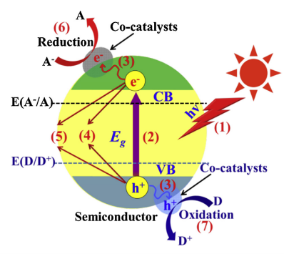
Fig. 1 The core process of heterogeneous photocatalysis [23]

Importance of Heterogeneous photocatalyst and their basic mechanism:
The heterogeneous catalysts are crucial in the production of industrial chemicals which were preferred over homogenous catalysts due to their cost effective, robustness and it is easier recovery/separation from the products, which allows chemical processes to be streamlined [24].
During heterogeneous photocatalysis, semiconductor materials absorb the incoming photons. As a result of which, a solid phase gets distributed in contact with a fluid medium and it absorbs a photon to form an electron-hole pair that reduces and oxidises into two corresponding species in the fluid [25]. There are numerous substances that are used as photocatalysts. The transition metal oxides and semiconductors based photocatalysts are generally utilised by heterogeneous photocatalysis [26]. In contrast to metals, semiconductors generally have ineffective energy zones where these energy levels are not present to develop the re-joining of an electron and a hole produced by light activation in the solid. The band gap is empty and it extends from the top of the filled valence band to the bottom of the empty conduction band [27].
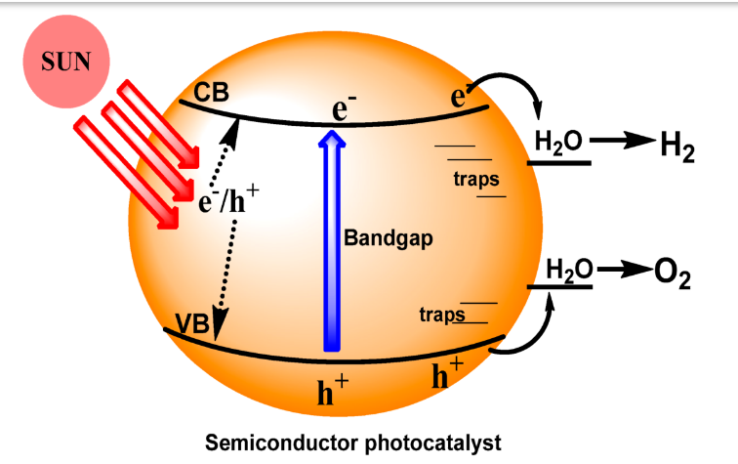

A photon with energy equal to or greater than the band gap of the material is absorbed by the semiconductor used in this process, and an electron excites from the valence band to the conduction band, generating a positive (+ve) hole in the valence band [28]. The exciton is a photo-generated electron-hole pair phenomenon. The excited electron and hole can recombine and the energy gained when the electron was excited is released as heat [29]. Increased amounts of this undesired exciton and recombination make the process ineffective as a photocatalyst [30]. Oxidized products are produced by reactions between the holes generated by the reductants. Redox reactions occur at the surface of semiconductors which results in the generation of positive (+) holes and electrons [31].
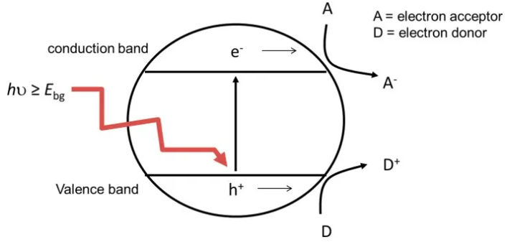
The oxidative reaction mechanism depicts positive holes that react with moisture on the material's (metal oxide) surface to produce a hydroxyl radical (•OH) [32]. This reaction starts with photo-induced exciton generation on the surface of a metal oxide (MO stands for metal oxide, as shown below):
MO + hν → MO (h⁺ + e⁻)
Oxidative reactions due to photocatalytic effect are:
h⁺ + H₂O → H⁺ + •OH
2 h⁺ + 2 H₂O → 2 H⁺ + H₂O₂
H₂O₂→ 2 •OH
Reductive reactions due to photocatalytic effect are:
e⁻ + O₂ → •O₂⁻
O₂⁻+ H₂O + H⁺→ H₂O₂ + O₂
H₂O₂ → 2 •OH [33]
Finally, both of the aforementioned reactions generate hydroxyl radicals (•OH). These hydroxyl radicals (•OH) are extremely oxidative and non-selective, with a redox potential of (E0 = +3.06 V) [34].
Photocatalysts used in waste water treatment include ZnO, ZnS, CdS, SrO₂, WO₃, and Fe-TiO₂ [35]. Due to its stability, low-energy band gap, excellent optical and electronic properties, high photocatalytic activity, high chemical stability, low cost, non-toxicity, and environmental friendliness, Semiconductors has become a promising material that has been widely used in photocatalytic processes [36].
When an ultraviolet light with wavelengths ranging from 200 nm to 400 nm strikes on semiconductor materials, an electron within semiconductor atoms are photoexcited and transferred to the conduction band [37]. Many electron hole (e-h) pairs were formed during this process, which results in a complex
oxidative-reduction chain [38]. Contrary, an ultraviolet A radiation is only about 5% that of sunlight, implying that sunlight's photon efficiency which is quite low [39].
Hence, as a result, its application on a commercial scale are limited and an ultraviolet lamp is required for semiconductor activation; sunlight can be added to artificial light sources [40].
MULTIFERROICS:
Multiferroics, which concurrently exhibit magnetic and ferroelectric ordering, are a subject of intense research because of their intriguing physics and significant potential for utilization. Multiferroic materials are those that display more than one of the essential ferroic characteristics in the same phase which suggests that multiferroic materials exhibit (anti)ferroelectricity, (anti)ferromagnetism, and/or ferro-elasticity [41].

Multiferroics of type I and type II:
D. Khomskii presented a useful classification approach for multiferroics into type-I and type-II multiferroics in 2009 [42].
TYPE-I: type-I Multiferroic refers to substances in which ferroelectricity and magnetism emerge at various temperatures with various methods. The magnetic ordering, which is often antiferromagnetic, takes hold at lower temperatures while the structural deformation that gives birth to ferroelectricity typically happens at high temperatures. At the magnetic phase transition, the majority of type-I multiferroics exhibit changes in dielectric susceptibility as well as a linear magnetoelectric response [43].
TYPE-II: Materials known as type-II multiferroics are those in which the magnetic ordering directly results in the ferroelectricity and breaks the inversion symmetry. The ordering temperatures for the two events in this type are the same [44].
MULTIFERROIC MATERIALS USED IN PHOTOCATALYSIS
The various multiferroic materials used for photocatalysis applications are discussed as under:
- g-C₃N₄
- TbMnO₃CeO₂
- TiO₂
- ZnO
- BiFeO₃ [45]
- g-C₃N₄ BASED PHOTOCATALYSIS:
Heterogeneous photocatalysis, as one of the most appealing and appealing technologies, has been used to directly harvest, transform, and store renewable solar energy for the production of sustainable and green solar fuels as well as a wide range of environmental applications [46]. A wide range of g-C₃N₄-based photocatalysts have been created to drive various reduction and oxidation reactions under suitable light irradiation due to their unique physicochemical, optical, and electrical features. As a metal-free polymer n-type semiconductor, graphite-like carbon nitride (g-C₃N₄) has many promising properties, including unique electric, optical, structural, and physiochemical properties, which make g-C₃N₄-based materials a new class of multifunctional nanoplatforms for electronic, catalytic, and energy applications [47].
g-C₃N₄ has a moderate band gap of 2.7 eV, equivalent to an optical wavelength of 460 nm, making it visible light active. Taking into account thermodynamic losses and over potentials in the photocatalytic process, the band gap of 2.7 eV accidentally lies between 2 eV and 3.1 eV, achieving both water splitting with sufficient endothermic driving forces (much larger than 1.23 eV) and visible light absorption (much smaller than 3.1 eV). The photo-generated electrons in
g-C3N4 have a strong thermodynamic driving force that allows them to decrease various small molecules such as H₂O, CO₂, and O₂. As a result, the proper electrical band structures of g-C₃N₄ make it suitable for a wide range of applications, including photocatalytic water splitting, CO₂ reduction, pollutant degradation, organic synthesis, and disinfection.
Apart from the obvious advantage of having a suitable optical band gap and position, it is widely accepted that this metal-free g-C₃N₄ material also has a stacked 2-D layered structure, in which the single-layer nitrogen hetero-atom substituted graphite nanosheets formed by sp² hybridization of C and N atoms are bound by van der waals forces [48].

PHOTOCATALIC DEGRADATION OF POLLUTANTS BY C₃N₄:
Serious environmental contamination impedes the human race's long-term growth. Because of its great efficiency and low cost, photocatalysis has proven to be a promising technique for environmental decontamination. When exposed to light, the excited semiconductor can create a significant number of electrons in the Conduction Band and holes in the Valence Band. The photogenerated holes (h⁺) have a somewhat high oxidation ability due to the band location of g-C₃N₄. Furthermore, photogenerated electrons can reduce O₂ to form •O₂⁻, whereas photogenerated h⁺ can oxidise OH⁻ to make •OH in some g-C₃N₄-based heterojunctions. Certain contaminants can be oxidised by these active species (h⁺, •O₂⁻, and •OH). Photocatalysis has been shown to be effective in the destruction of organic and inorganic air pollutants, poisonous dyes, phenol, and persistent organic micropollutants in water. Yu et al. reported photocatalytic degradation of gas phase formaldehyde using g-C₃N₄/TiO₂. Yan et al. studied the photocatalytic degradation of RhB and MO by B-doped g-C₃N₄. The active species in photocatalytic degradation reactions vary according to the contaminants. The major active species in photodegradation of RhB was h⁺, whereas the main active species in photodegradation of MO was •O₂⁻.B-doping can improve dye adsorption and light absorption in g-C₃N₄, contributing to its strong photocatalytic activity. Because of the high pollutant adsorption and light absorption capabilities of carbon materials, g-C₃N₄/carbon composite materials are projected to be advantageous for pollutant degradation. Under visible light irradiation, g-C₃N₄/graphene, g-C₃N₄/C₆₀, and g-C₃N₄/carbon spheres have been observed to degrade contaminants.
Furthermore, greater separation of photogenerated charge carriers remains a key feature in photocatalytic pollution degradation. Because of the higher separation efficiency of photogenerated charge carriers, g-C3N4-based type II and Z-scheme heterostructures can significantly improve photocatalytic degradation performance [49].
DRAWBACKS OF C₃N₄ BASED PHOTOCATALYSIS:
However, pristine g-C3N4 has numerous drawbacks, including a narrow visible-light response range, small surface areas, and a low electron-hole pair separation rate. All of these negative conditions limit photocatalytic efficiency greatly (Tan et al. 2021) [50].
IMPROVEMENT CAN BE DONE BY:
Various methods have been developed to improve g-C3N4's abilities for light adsorption and electron-hole pair transfer, including morphology control, the introduction of defects, doping with other atoms, and coupling with metal, semiconductor, and carbonaceous materials [51].
(ii) TbMnO₃ AND CeO₂ BASED PHOTOCATALYSIS:
TbMnO₃ is a well-known multiferroic material that has numerous applications in data storage and other sectors [52]. Kumar et al. used a hydrothermal technique to create TbMnO₃ nanoparticles with strong photocatalytic activity for the breakdown of methyl orange (MO) [53]. According to Jin et al., microwave-assisted TbMnO₃ has a strong photocatalytic activity for the degradation of MO [54]. TbMnO₃ has a high electron hole pair recombination rate and a poor photon utilization rate as a photocatalyst, hence its photocatalytic activity is relatively modest. As a result, employing another semiconductor oxide to build a heterojunction photocatalyst has significant scientific implications [55].
Cerium oxide (CeO₂) is a type of high efficiency photocatalyst that has been widely employed in organic dye degradation. When CeO₂ was utilised to form a heterojunction with other metal oxides and noble metal particles, the overall photocatalytic activity of the system was significantly increased. The creation of type I and type II energy band arrangements is advantageous for semiconductor photocatalysts in order to boost the photocatalytic activity of the system. At the moment, microwave sintering of two types of semiconductor oxides is a simple way for creating heterojunctions [56].
As a result, it is of considerable interest to build TbMnO₃CeO₂ heterojunction composites using microwave aided sintering and investigate their physical and chemical properties [57].
PHOTOCATALYTIC ACTIVITY:
Methyl orange (MO) is a common azo dye that has numerous applications in the culinary, textile, and other industries. However, when it is directly dumped into the environment, it is difficult to decompose, resulting in substantial environmental damage [58]. MO was chosen as the target degradation dye in this experiment, with a concentration of 0.1 g/L, while the catalyst concentration of 0.5 g/L [59]. The photocatalytic degradation curve of the blank experiment is presented below to indicate that methyl orange does not decay when exposed to light [60].
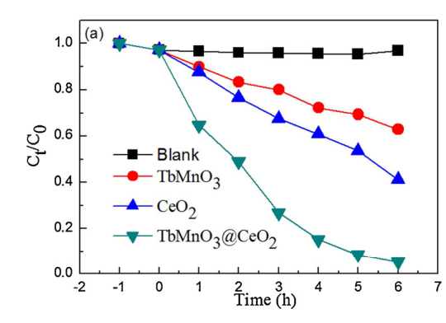
Ct/C0 of MO as the function of irradiation time [61]
Only around 5% had degraded after six hours. The findings indicate that MO is a stable and nondegradable organic dye. The degradation rate of MO increased with increasing irradiation time with the presence of photocatalyst. TbMnO₃, CeO₂, and TbMnO₃CeO₂ composites degrade at around 30%, 62%, and 97%, respectively. The first order kinetics rate of TbMnO₃, CeO₂, and TbMnO₃CeO₂ composites for the degradation of MO is studied to further define the photocatalytic degradation capacity of photocatalysts. The first order kinetics rate is easily stated by the equation below:
1n (C_{t}/C₀) = (-kt)
Where C_{t} is the dye concentration at different light irradiation time (t), C₀ is the initial dye concentration, k is the rate constant.

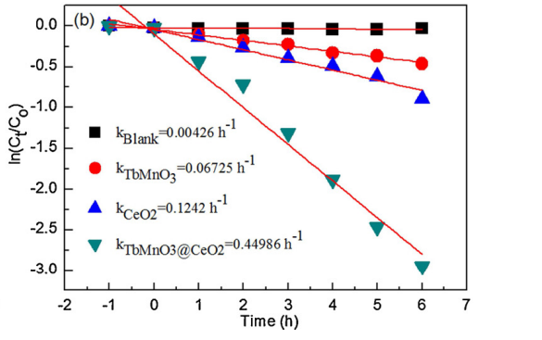
During the photodegradation process, plots of ln(C/C0) vs. irradiation duration were made in the presence of TbMnO₃, CeO₂, and TbMnO₃@CeO₂ composites.
The graphs of ln(C/C0) vs. irradiation time in the presence of TbMnO₃, CeO₂, and TbMnO₃CeO₂ composites during photodegradation are shown above. TbMnO₃, CeO₂, and TbMnO₃CeO₂ composites have k values of 0.06725, 0.1242, and 0.44986 h1 for MO degradation, respectively. The photocatalytic degradation rate of TbMnO₃CeO₂ composites is approximately 6.69 times that of TbMnO₃.
The strong photocatalytic activity of TbMnO₃CeO₂ composites was mostly due to the synergistic effect of light absorption capacity, electron hole pair recombination rate, and hydroxyl radicals. The photo absorption capacity, magnetic characteristics, and photocatalytic activity of the monophase oxide were improved when CeO₂ nanoparticles were added to the TbMnO₃ precursor. TbMnO₃CeO₂ composites have a lower ultraviolet emission peak and a weaker blue emission when compared to CeO₂. TbMnO₃CeO₂ composites have a photocatalytic breakdown rate of MO under visible light irradiation that is approximately 6.69 times that of TbMnO₃ alone [62].

(iii) PHOTOCATALYSIS USING TiO₂:
Anatase, rutile, and brookite are the three polymorphs of natural TiO₂. Rutile and anatase are the most common modifications utilized in photocatalysis. Anatase and rutile both have crystalline tetragonal structures made up of TiO₆ octahedra. TiO₆ octahedra share common edges in the planes (001) and (100) in anatase. Each octahedron has four shared edges that form zigzag chains with their neighbors. TiO₂ octahedra in rutile are joined by ribs on the (001) plane with two adjacent octahedra, forming lengthy ribbons in the crystal lattice. The structural lattice differences between anatase and rutile determine their density and electric band structure. As a result, anatase and rutile absorb light at wavelengths of 388 and 413 nm, respectively.
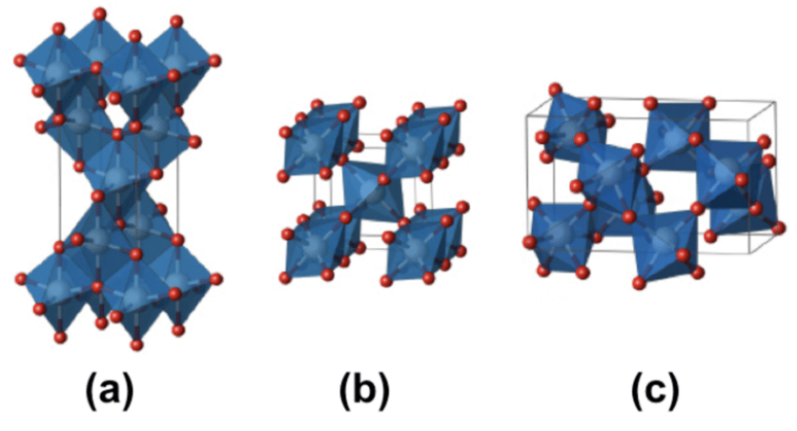
Titanium dioxide comes in three distinct polymorphs. Anatase (a), rutile (b), and brookite (c). The small red spheres indicate oxygen atoms, the large grey spheres represent titanium atoms, and the blue polyhedral forms depict the TiO₆ octahedra's orientation in space.
Rutile has stronger photocatalytic activity than anatase, which is likely due to its narrower band gap. The band gap width is a critical characteristic in photocatalysis because it governs the rate of electron transmission and thus the rate of charge recombination [63].
Photoactive surface formation the absorption of photon energy causes the appearance of holes in the valence zone (h⁺) and electrons in the conduction zone (e⁻) in TiO₂. The last must be greater than or equal to the width of the TiO₂ band gap (3.2 eV for rutile, 3.0 eV for anatase). Holes contribute to the creation of hydroxyl radicals and the oxidation of organic compounds, while electrons contribute to the development of peroxide radicals and the decomposition/oxidation of organic molecules.
Following are the reactions that lead to the formation of hydroxyl and peroxide radicals:
TiO₂ + h → TiO2 (e⁻ CB + h⁺ VB);
TiO₂ (h⁺ VB +e⁻ CB) → TiO₂ (recombination);
TiO₂ (h⁺ VB) + OH⁻ → TiO₂ + ОН•
TiO₂ (e⁻ CB) + О₂ → TiO₂ + О₂ • Where VB stands for valence band and CB represents the conduction band.
The features of TiO₂ (crystallinity, surface area, particle size, defect position, surface charge), as well as the substrate-surface interaction, all have a significant role in the photocatalytic activity of this material. In particular, TiO₂ should have a high specific surface area and tiny particle sizes for the photocatalytic process to be effectively conducted. Because of this, understanding photocatalytic activity necessitates a thorough examination of numerous factors [64].
The effect of TiO₂ surface chemical state on photocatalytic activity:
The chemical condition of the TiO₂ surface influences photocatalytic activity significantly. Figure below depicts the complex of surface physicochemical properties of TiO2 photocatalysts.
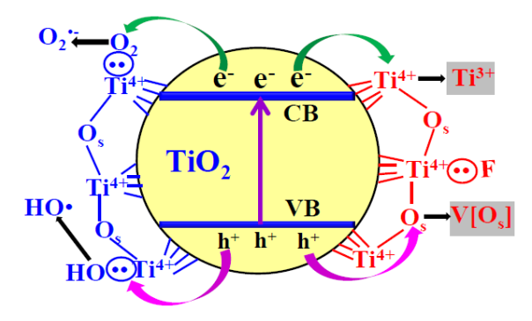
Surface chemical state of TiO2-based modified photocatalysts
Surface charge is critical in determining photocatalytic activity, particularly in the kinetics of photooxidation of organic dyes. The properties of surface charge TiO₂ in water at various pH values are determined by the point of zero charge pH_{Zpc.}
The acid-base equilibrium reactions for titanol groups TiO₂ are as follows:
> Ti‒OH₂ ⁺ ↔ > Ti‒OH + H⁺ (pKa1);
> Ti‒OH ↔ > Ti‒O⁻ + H⁺ (pKa2);.
The pH of the zero-charge point corresponds to the average value of pK (pKa1+pKa2) / 2. The Ph_{Zpc} is determined experimentally by measuring the electrokinetic potential (zeta potential) of suspended particles at various pH levels. The pH_{zpc} of titanium dioxide P25 from Degussa, for example, is 6.2 (pKa1 =4,5 and pKa2 = 8). The surface of TiO₂ particles is positively charged at pH 6.2, and negatively charged at pH > 6.2. Increased efficiency in the production of hydroxyl radicals Because of the ideal concentration of OH⁻, TiO₂ is reached by a weak alkaline media, which leads to the photocatalytic destruction of organic molecules in aqueous solution [65].
The influence of chemical modification on TiO₂ photocatalytic activity:
Free of impurities (chemically pure) TiO₂ typically has unfavorable charge transfer kinetics and band gap width. To increase photocatalytic activity, the chemical state of the TiO₂ surface must be changed. The following basic surface modification strategies for the production of highly active photocatalysts based on TiO₂ can be recognized based on the photocatalysis mechanism:
- Doping can be used to narrow the band gap;
- adding visible light photosensitizers on top of TiO₂ to expand the range of the solar spectrum that is available;
- surface heterojunction formation to optimize charge carrier dynamics
- Nanosized cocatalysts are loaded to prevent surface charge recombination processes.
- improving photocatalytic activity by increasing accessible surface area
- introduction of surface F-effects in TiO₂ to enhance the concentration of free radicals OH, hence enhancing photodegradation efficiency;
- exposing highly reactive faces to light in order to improve surface-active regions and redox capacity
Many investigations have been undertaken in order to create a TiO₂-based photocatalyst that absorbs photons in the visible light spectrum while having a low electron-hole recombination coefficient [66].
ZnO BASED PHOTOCATALYSIS:
AOP based on photocatalysis and employing semiconductor materials has emerged as a viable approach for pollutant degradation. ZnO occurs naturally in the mineral zincite, although the majority of industrial ZnO is produced through the high-temperature oxidation of metallic zinc or zinc ores [67]. ZnO is one of the semiconductor substances that can be utilized as a photocatalyst. Many researchers were drawn to ZnO particles because of their UV absorption applications [68]. Gancheva also stated that zinc oxide has received a lot of attention due to its high photosensitivity, which causes the breakdown of numerous contaminants [69]. Because of its broad band gap, ZnO has has potential as a photocatalyst material. Shakti discovered that zinc oxide is an N-type semiconductor with a significant exciton binding energy of 60 meV and a broad band gap of 3.37 eV [70]. ZnO has been synthesised using a variety of techniques, including hydrothermal synthesis, thermal decomposition, precipitation, and flame spray pyrolysis (FSP). The benefits of FSP include the fact that it is a one-step method that uses an aqueous-base salt solution as a precursor. The product has a generally consistent size and shape, is single and multicomponent, and can be doped with other materials [71].
PHOTOCATALYTIC PROPERTIES OF ZnO:
The rate of decline in amaranth concentration was measured using an ultraviolet-visible spectrophotometer. The drop in amaranth concentration implies that ZnO has photocatalytic capabilities. The ZnO absorbance value was acquired as a result of the measurement. According to Lambert-Beer's rule, the absorbance value of a solution is proportional to its concentration, hence the ZnO absorbance value is proportional to the amaranth solution's concentration. Based on Spectrophotometer Uv-Vis measurements, an amaranth photodegradation chart was created utilizing ZnO photocatalyst synthesised at various rates of oxygen gas flow rates. The figure below shows that in the dark, the concentration of amaranth reduced due to the process of ZnO absorption. In contrast, the photodecomposition mechanism is involved in the decrease in amaranth concentration under direct irradiation circumstances.
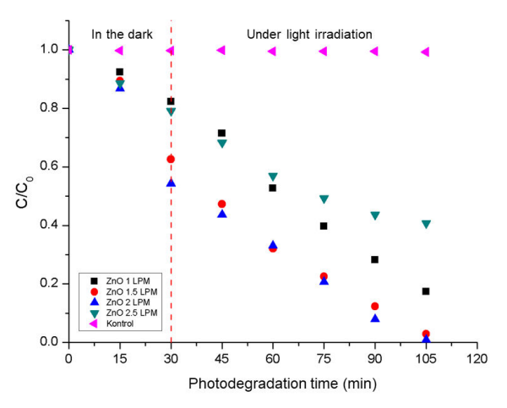
Photocatalytic activity of FSP-prepared ZnO at various O2 flow rates: a) 1, b) 1.5, c) 2, and d) 2.5 L/min
The amaranth concentration decreases with time under direct irradiation conditions, as seen in the above two figures (XRD and SEM figures). At 105 minutes, ZnO with oxygen gas flow rates of 1.5 and 2 L/min. degraded the amaranth solution to close to a C/C₀ value of 0. Whereas ZnO with an oxygen gas flow rate of 1 L/min. can degrade amaranth solution to a C/C₀ value of less than 0.2, ZnO with a flow rate of 2.5 can degrade amaranth solution to a C/C₀ value of 0.4.
Increased oxygen gas flow rates result in greater photocatalytic capabilities, but on Zno with 2.5 L/min. oxygen gas flow rate, the particle floats, making direct contact less effective than in the other samples. At 105 minutes, the oxygen flow rate was able to destroy amaranth dye up to 95.3% [72].
Bismuth ferrite (BiFeO₃) as a newly discovered visible light active nanostructured photocatalyst:
Because there is a scarcity of fresh water for drinking, it is necessary to recycle dirty water. The problem of water contamination is a big challenge, and many researchers are working to find better ways to deal with it [73]. Nowadays, an improved approach called as "advanced oxidation process" is establishing a name for itself in the remediation of dirty water. This approach involves the oxidation of effluents (pollutants) with hydroxyl ions (OH) [74].
The primary phases are as follows: (a) production of hydroxyl ions OH-, (b) hydroxyl radicals assault pollution target molecules and promote their breakdown into smaller compounds until complete mineralization occurs [75]. As a result, it attracted attention due to its ability to eliminate dangerous organic pollutants while avoiding the conversion of pollutants into harmful products [76]. Advanced oxidation processes include ozonation, Sonolysis, fenton process, photo-Fenton process, photocatalysis, bio-degradation and UV-photocatalysis [77].
Photocatalysis is an efficient technology among them since it employs solar energy to remove organic contaminants [78].
Some photocatalysts that have still to be researched include ferrites (LaFeO₃, BiFeO₃, GdFeO₃), tantalates (AgTaO₃, NaTaO₃, KTaO₃), titanates (SrTiO₃, CdTiO₃, NiTiO₃, CoTiO₃, CaTiO₃, FeTiO3, BaTiO₃), and others (LaCaO₃ and LaNiO₃) [79].
The following qualities of BiFeO₃ materials have attracted attention:
- Band-gap exists in visible-light area
- Multiferroic existence at room temperature (25 C), which aids in efficient separation of cations and anions
- Strong chemical stability. [80]

STEPS TO IMPROVE BiFeO₃ PHOTOCATALYTIC EFFICIENCY:
- THE IMPACT OF DOPING:
Many scholars have investigated the use of BFO in heterogeneous photocatalysis [81]. Unfortunately, the reported BFO's photocatalytic reaction rate and efficiency were not met due to the rapid recombination of photogenerated electrons and holes. Thus, it is investigated if metal doping could be an effective technique for improving photocatalytic effectiveness by substituting an iron element in pure BFO, resulting in a longer response in the visible light area [82]. For the cause of aqueous pollutant degradation, several organic contaminants, such as Rhodamine B (RhB), 4-nitrophenol, methyl orange (MO), methylene blue (MB), and 4-chlorophenol, have been utilized as model contaminants for photocatalyst testing [83]. Whereas, the photocatalytic efficiency of a photocatalyst is primarily determined by numerous aspects such as surface area, nano-structuring, photocatalyst loading, initial pollutant concentration, type of organic pollutant, and light source [84].
The doping approach is the most effective way to add impurities into photocatalysts. Typically, a tiny amount of dopant can limit the recombination rate of photo-generated charge carriers, hence increasing the photocatalytic activity of the photocatalyst [85]. The essential factor, however, is the selection of an appropriate dopant. If the amount of dopant surpasses a threshold value, it may act as recombination centres for photo-generated charge carriers, lowering photocatalytic performance [86].
Sarkar et al. used electrospinning to create nanofibers of Dy-doped BiFeO₃ [87]. Methylene blue photocatalytic degradation demonstrated that DY-doped BiFeO₃ nanofiber had improved photocatalytic efficiency under visible light. It could be because Dy reduced the band-gap, which assisted in moving charge carriers to the photocatalytic surface, lowering the rate of charge carrier recombination. Another study discovered that doping Sc onto BiFeO₃ can be effective for methylene blue breakdown using sunlight. It was discovered that Sc-doped BiFeO₃ totally decomposed methylene blue after 3 hours of UV irradiation, but pure BiFeO₃ only degraded 69% of Methylene blue. The deformation in the structure of BiFeO₃ caused by Sc doping improved its ferroelectric characteristics. Following that, researchers began investigating co-doping onto BiFeO₃ with various elements on Bi³⁺ and Fe³⁺ -sites [88].
Vanga et al. chose Nd and Ni as co-dopants for Bi³⁺ and Fe³⁺ sites on BiFeO₃. They discovered that co-doping Nd and Ni facilitated charge transfer and reduced the recombination rate of photo-generated charge carriers, which improved photocatalytic activity under visible light. According to Irfan et al., increasing the charge carriers capturing centres can also enhance and speed up the photocatalytic activity of BiFeO₃ under different wavelengths of light, because these charge carriers capturing centres increased the recombination time of the carriers, which produced more radicals and thus increased the activity [89]. They discovered that the Congo red was degraded in 50 minutes by the La and Se co-doped BiFeO₃ sample (Bi_{0.92} La_{0.08} Fe_{0.925} Se_{0.075} O₃). It could be owing to the increased surface area (3.3-10) m².g1, decreased recombination time, and decreased band-gap (2.06-1.97) eV after co-doping of La and Se onto BiFeO₃. The high crystallinity of pure and co-doped BiFeO₃ was confirmed [90].
As reported by previous researchers, the cobalt (Co) element was thought to be one promising element that may be doped into BFO. Because cobalt element doping materials shown outstanding electrochemical characteristics, the light absorption zone of BFO could be enlarged and strong photocatalytic activity might be expected [91].
Conclusion
In conclusion, the integration of multiferroic materials in photocatalysis for wastewater treatment presents a compelling solution to contemporary environmental challenges. Multiferroic-based photocatalysis offers unparalleled advantages through its ability to respond to both light and external magnetic fields, accelerating pollutant degradation in a controlled and efficient manner. This innovative approach not only enhances treatment efficiency but also enables wastewater remediation in challenging conditions. As we strive for sustainable and clean water resources, multiferroic-based photocatalysis stands as a promising avenue, merging the unique properties of multiferroic materials with the urgency of wastewater treatment, promising a greener and more effective solution for safeguarding our environment and public health.

REFRENCES:
      - Barlow, Maude, and Tony Clarke. Blue gold: the battle against corporate theft of the world's water. Routledge, 2017.
      - Sahoo, Sushil Kumar, and Shankha Shubhra Goswami. "A comprehensive review of multiple criteria decision-making (MCDM) Methods: advancements, applications, and future directions." Decision Making Advances 1.1 (2023): 25-48
      - Deng, Yang, and Renzun Zhao. "Advanced oxidation processes (AOPs) in wastewater treatment." Current Pollution Reports 1 (2015): 167-176.
      - Malakootian, Mohammad, et al. "Advanced oxidation processes for the removal of organophosphorus pesticides in aqueous matrices: A systematic review and meta-analysis." Process Safety and Environmental Protection 134 (2020): 292-307.
      - Kishor, Roop, et al. "Ecotoxicological and health concerns of persistent coloring pollutants of textile industry wastewater and treatment approaches for environmental safety." Journal of Environmental Chemical Engineering 9.2 (2021): 105012.
      - Lachheb, Hinda, et al. "Photocatalytic degradation of various types of dyes (Alizarin S, Crocein Orange G, Methyl Red, Congo Red, Methylene Blue) in water by UV-irradiated titania." Applied Catalysis B: Environmental 39.1 (2002): 75-90.
      - Linic, S., Christopher, P., & Ingram, D. B. (2011). Plasmonic-metal nanostructures for efficient conversion of solar to chemical energy. Nature materials, 10(12), 911-921.
      - Gerasimov, Oleg Vladimirovich, and Valentin N. Parmon. "Photocatalysis by transition metal complexes." Russian Chemical Reviews 61.2 (1992): 154.
      - Yang, Jianhua, et al. "Insights into the formation of environmentally persistent free radicals during photocatalytic degradation processes of ceftriaxone sodium by ZnO/ZnIn2S4." Chemosphere 314 (2023): 137618.
      - Nayak, Susanginee, Lagnamayee Mohapatra, and Kulamani Parida. "Visible light-driven novel gC 3 N 4/NiFe-LDH composite photocatalyst with enhanced photocatalytic activity towards water oxidation and reduction reaction." Journal of Materials Chemistry A 3.36 (2015): 18622-18635.
      - Xiong, Lunqiao, and Junwang Tang. "Strategies and challenges on selectivity of photocatalytic oxidation of organic substances." Advanced Energy Materials 11.8 (2021): 2003216.
      - Gisbertz, Sebastian, and Bartholomäus Pieber. "Heterogeneous photocatalysis in organic synthesis." ChemPhotoChem 4.7 (2020): 456-475.
      - Alberici, Rosana M., and Wilson F. Jardim. "Photocatalytic destruction of VOCs in the gas-phase using titanium dioxide." Applied Catalysis B: Environmental 14.1-2 (1997): 55-68.
      - I Litter, Marta, and Natalia Quici. "Photochemical advanced oxidation processes for water and wastewater treatment." Recent Patents on Engineering 4.3 (2010): 217-241.
      - Elovitz, Michael S., and Urs von Gunten. "Hydroxyl radical/ozone ratios during ozonation processes. I. The Rct concept." (1999): 239-260.
      - Shin, Young-Ho, M. Teresa Gutierrez-Wing, and Jin-Woo Choi. "Recent progress in portable fluorescence sensors." Journal of The Electrochemical Society 168.1 (2021): 017502.
      - Christoforidis, Konstantinos C., and Paolo Fornasiero. "Photocatalytic hydrogen production: a rift into the future energy supply." ChemCatChem 9.9 (2017): 1523-1544.
      - Hennig, H., and R. Billing. "Advantages and disadvantages of photocatalysis induced by light-sensitive coordination compounds." Coordination chemistry reviews 125.1-2 (1993): 89-100.
      - Rashed, I. G., et al. "Removal of Some New Direct Dyes from Their Aqueous Solutions and From Wastewater By Using Fenton's Reaction."
      - Ibhadon, Alex Omo, and Paul Fitzpatrick. "Heterogeneous photocatalysis: recent advances and applications." Catalysts 3.1 (2013): 189-218.
      - Herrmann, J-M. "Water treatment by heterogeneous photocatalysis." Environmental catalysis. 1999. 171-194.
      - Augugliaro, Vincenzo, et al. "Overview on oxidation mechanisms of organic compounds by TiO2 in heterogeneous photocatalysis." Journal of Photochemistry and Photobiology C: Photochemistry Reviews 13.3 (2012): 224-245.
      - 1-s2.0-S016943321631457X-main (1) - Scientific Figure on ResearchGate. Available from: https://www.researchgate.net/figure/The-fundamental-mechanism-of-heterogeneous-photocatalysis-The-typical-stages-1-light_fig2_306804860 [accessed 28 Aug, 2023]
      - Qu, Yongquan, and Xiangfeng Duan. "Progress, challenge and perspective of heterogeneous photocatalysts." Chemical Society Reviews 42.7 (2013): 2568-2580.
      - Cassano, Alberto E., and Orlando M. Alfano. "Reaction engineering of suspended solid heterogeneous photocatalytic reactors." Catalysis today 58.2-3 (2000): 167-197.
      - Cheng, Zhixing, et al. "Recent advances in transition metal nitride‐based materials for photocatalytic applications." Advanced Functional Materials 31.26 (2021): 2100553
      - Gholipour, Mohammad Reza, et al. "Nanocomposite heterojunctions as sunlight-driven photocatalysts for hydrogen production from water splitting." Nanoscale 7.18 (2015): 8187-8208.
      - Medvedev, N., and B. Rethfeld. "Transient dynamics of the electronic subsystem of semiconductors irradiated with an ultrashort vacuum ultraviolet laser pulse." New Journal of Physics 12.7 (2010): 073037.
      - Wen, Xiewen, et al. "Ultrafast probes of electron–hole transitions between two atomic layers." Nature communications 9.1 (2018): 1859.
      - Kosco, Jan, et al. "Photocatalysts based on organic semiconductors with tunable energy levels for solar fuel applications." Advanced Energy Materials 10.39 (2020): 2001935.
      - Wrighton, Mark S. "Photoelectrochemical conversion of optical energy to electricity and fuels." Accounts of Chemical Research 12.9 (1979): 303-310.
      - Wang, Jian Long, and Le Jin Xu. "Advanced oxidation processes for wastewater treatment: formation of hydroxyl radical and application." Critical reviews in environmental science and technology 42.3 (2012): 251-325.
      - Kim, Jaehyun, et al. "Highly efficient photo-induced charge separation enabled by metal–chalcogenide interfaces in quantum-dot/metal-oxide hybrid phototransistors." ACS applied materials & interfaces 12.14 (2020): 16620-16629.
      - da Silva, Thiago Lopes, et al. "Overview of non-steroidal anti-inflammatory drugs degradation by advanced oxidation processes." Journal of Cleaner Production 346 (2022): 131226.
      - Akhoondi, Asieh, et al. "Advances in metal-based vanadate compound photocatalysts: synthesis, properties and applications." Synthesis and Sintering 1.3 (2021): 151-168.
      - Mills, Andrew, and Stephen Le Hunte. "An overview of semiconductor photocatalysis." Journal of photochemistry and photobiology A: Chemistry 108.1 (1997): 1-35.
      - Bajorowicz, Beata, et al. "Quantum dot-decorated semiconductor micro-and nanoparticles: A review of their synthesis, characterization and application in photocatalysis." Advances in colloid and interface science 256 (2018): 352-372.
      - Bertoncello, Paolo, and Paolo Ugo. "Recent advances in electrochemiluminescence with quantum dots and arrays of nanoelectrodes." ChemElectroChem 4.7 (2017): 1663-1676.
      - Teller, Edward, Lowell Wood, and Roderick Hyde. Global warming and ice ages: I. Prospects for physics-based modulation of global change. No. UCRL-JC--128715. Lawrence Livermore National Lab., 1996.
      - Fendrich, Murilo, et al. "Pulsed laser deposition of nanostructured tungsten oxide films: A catalyst for water remediation with concentrated sunlight." Materials Science in Semiconductor Processing 119 (2020): 105237.
      - Petit, Sylvain, and Isabelle Mirebeau. "Puzzling Multiferroics." Neutron News 22.4 (2011): 17-23.
      - Khomskii, Daniel. "Classifying multiferroics: Mechanisms and effects." Physics 2 (2009): 20.
      - Das, Nibedita, et al. "Pr2FeCrO6: A type I multiferroic." Inorganic Chemistry 56.21 (2017): 12712-12718.
      - Zhang, Jun-Jie, et al. "Type-II multiferroic Hf2VC2F2 MXene monolayer with high transition temperature." Journal of the American Chemical Society 140.30 (2018): 9768-9773.
      - Lacerda, Luis Henrique Silveira, and Sergio Ricardo de Lazaro. "Density Functional Theory investigation of rhombohedral multiferroic oxides for photocatalytic water splitting and organic photodegradation." Journal of Photochemistry and Photobiology A: Chemistry 400 (2020): 112656.
      - Habibi-Yangjeh, Aziz, et al. "Review on heterogeneous photocatalytic disinfection of waterborne, airborne, and foodborne viruses: can we win against pathogenic viruses?." Journal of colloid and interface science 580 (2020): 503-514.
      - Ragupathi, Veena, et al. "CuO/g-C3N4 nanocomposite as promising photocatalyst for photoelectrochemical water splitting." Optik 208 (2020): 164569.
      - Wen, Jiuqing, et al. "A review on g-C3N4-based photocatalysts." Applied surface science 391 (2017): 72-123.
      - Kumar, Ome Parkash, et al. "Strategic combination of metal–organic frameworks and C3N4 for expeditious photocatalytic degradation of dye pollutants." Environmental Science and Pollution Research 29.23 (2022): 35300-35313.
      - Wang, Qingtong, et al. "High-efficiency g-C3N4 based photocatalysts for CO2 reduction: Modification methods." Advanced Fiber Materials 4.3 (2022): 342-360.
      - Xing, Yupeng, et al. "Recent advances in the improvement of g-C3N4 based photocatalytic materials." Chinese Chemical Letters 32.1 (2021): 13-20.
      - Jasrotia, Rohit, et al. "Applications of multiferroics." Ferrites and Multiferroics: Fundamentals to Applications (2021): 195-213.
      - Xing, Shule, Shengli Song, and Junke Xiang. "Study on magnetic, optical and photocatalytic activities of TbMnO3@ CeO2 composite multiferroic materials." Optik 220 (2020): 165144.
      - Xing, Shule, Shengli Song, and Junke Xiang. "Study on magnetic, optical and photocatalytic activities of TbMnO3@ CeO2 composite multiferroic materials." Optik 220 (2020): 165144.
      - Castelli, Ivano E., Thomas Olsen, and Yunzhong Chen. "Towards photoferroic materials by design: recent progress and perspectives." Journal of Physics: Energy 2.1 (2019): 011001.
      - Mekonnen, Tigabu Bekele. "An Overview on the Photocatalytic Degradation of Organic Pollutants in the Presence of Cerium Oxide (CeO 2) Based Nanoparticles: A Review." Nanosci. nanometrol 7 (2021): 11648.
      - Xing, Shule, Shengli Song, and Junke Xiang. "Study on magnetic, optical and photocatalytic activities of TbMnO3@ CeO2 composite multiferroic materials." Optik 220 (2020): 165144.
      - Chiong, Tung, et al. "Enzymatic treatment of methyl orange dye in synthetic wastewater by plant-based peroxidase enzymes." Journal of environmental chemical engineering 4.2 (2016): 2500-2509.
      - Li, Yuanshuai, et al. "Deposition of Au nanoparticles on PDA-functionalized PVA beads as a recyclable catalyst for degradation of organic pollutants with NaBH4 in aqueous solution." Journal of Alloys and Compounds 793 (2019): 115-126.
      - Wang, X. H., et al. "Wavelength-sensitive photocatalytic degradation of methyl orange in aqueous suspension over iron (III)-doped TiO2 nanopowders under UV and visible light irradiation." The Journal of Physical Chemistry B 110.13 (2006): 6804-6809.
      - Eyasu, Alemseged, O. Prakash Yadav, and R. K. Bachheti. "Photocatalytic degradation of methyl orange dye using Cr-doped ZnS nanoparticles under visible radiation." Int. J. Chem. Tech. Res 5.4 (2013): 1452-1461.
      - Eyasu, Alemseged, O. Prakash Yadav, and R. K. Bachheti. "Photocatalytic degradation of methyl orange dye using Cr-doped ZnS nanoparticles under visible radiation." Int. J. Chem. Tech. Res 5.4 (2013): 1452-1461.
      - Dharmale, Neerja, Saurabh Chaudhury, and Debashish Dash. "Investigating the naturally occurring forms of TiO2 on electronic and optical properties using OLCAO-MGGA-TBO9: a hybrid DFT study." Modelling and Simulation in Materials Science and Engineering 29.2 (2020): 025001.
      - Chen, Dongjie, et al. "Photocatalytic degradation of organic pollutants using TiO2-based photocatalysts: A review." Journal of Cleaner Production 268 (2020): 121725.
      - Wang, Enjun, Wensheng Yang, and Yaan Cao. "Unique surface chemical species on indium doped TiO2 and their effect on the visible light photocatalytic activity." The Journal of Physical Chemistry C 113.49 (2009): 20912-20917.
      - Chen, Feng, et al. "Photocatalytic performance of a visible light TiO2 photocatalyst prepared by a surface chemical modification process." Catalysis Communications 10.11 (2009): 1510-1513.
      - Abdullah, F. H., NHH Abu Bakar, and M. Abu Bakar. "Current advancements on the fabrication, modification, and industrial application of zinc oxide as photocatalyst in the removal of organic and inorganic contaminants in aquatic systems." Journal of hazardous materials 424 (2022): 127416.
      - Ma, Shuaishuai, et al. "Photochemical synthesis of ZnO/Ag 2 O heterostructures with enhanced ultraviolet and visible photocatalytic activity." Journal of Materials Chemistry A 2.20 (2014): 7272-7280.
      - Shanmugam, Vignesh, and Kalyana Sundar Jeyaperumal. "Investigations of visible light driven Sn and Cu doped ZnO hybrid nanoparticles for photocatalytic performance and antibacterial activity." Applied Surface Science 449 (2018): 617-630.
      - Kumar, Manish, and Shakti Swarup Sahu. Zinc oxide nanostructures synthesized by oxidization of zinc. Diss. 2010.
      - Widiyandari, Hendri, Ngurah Ayu Ketut Umiati, and Rizki Dwi Herdianti. "Synthesis and photocatalytic property of Zinc Oxide (ZnO) fine particle using flame spray pyrolysis method." Journal of Physics: Conference Series. Vol. 1025. IOP Publishing, 2018
      - Guo, Mu Yao, et al. "Effect of native defects on photocatalytic properties of ZnO." The Journal of Physical Chemistry C 115.22 (2011): 11095-11101.
      - Cosgrove, William J., and Daniel P. Loucks. "Water management: Current and future challenges and research directions." Water Resources Research 51.6 (2015): 4823-4839.
      - Saravanan, A., et al. "A detailed review on advanced oxidation process in treatment of wastewater: Mechanism, challenges and future outlook." Chemosphere (2022): 136524.
      - Li, Qi, et al. "Insight into reactive species-dependent photocatalytic toluene mineralization and deactivation pathways via modifying hydroxyl groups and oxygen vacancies on BiOCl." Applied Catalysis B: Environmental 317 (2022): 121761.
      - Preetha, Rajaraman, et al. "Promoting photocatalytic interaction of boron doped reduced graphene oxide supported BiFeO3 nanocomposite for visible-light-induced organic pollutant degradation." Journal of Alloys and Compounds 904 (2022): 164038.
      - Irfan, Syed, et al. "Critical review: Bismuth ferrite as an emerging visible light active nanostructured photocatalyst." Journal of Materials Research and Technology 8.6 (2019): 6375-6389.
      - Murgolo, S., et al. "UV and solar-based photocatalytic degradation of organic pollutants by nano-sized TiO2 grown on carbon nanotubes." Catalysis Today 240 (2015): 114-124.
      - Qin, Hong, et al. "Spinel ferrites (MFe2O4): Synthesis, improvement and catalytic application in environment and energy field." Advances in Colloid and Interface Science 294 (2021): 102486.
      - Bai, Xiaofei, et al. "Size effect on optical and photocatalytic properties in BiFeO3 nanoparticles." The Journal of Physical Chemistry C 120.7 (2016): 3595-3601.
      - Zhong, Xin, et al. "Enhanced activation of persulfate by Co-doped bismuth ferrite nanocomposites for degradation of levofloxacin under visible light irradiation." Materials 12.23 (2019): 3952.
      - Poongodi, G., et al. "Studies on visible light photocatalytic and antibacterial activities of nanostructured cobalt doped ZnO thin films prepared by sol–gel spin coating method." Spectrochimica Acta Part A: Molecular and Biomolecular Spectroscopy 148 (2015): 237-243.
      - Sharma, Surbhi, and Neeraj Khare. "Hierarchical Bi2S3 nanoflowers: A novel photocatalyst for enhanced photocatalytic degradation of binary mixture of Rhodamine B and Methylene blue dyes and degradation of mixture of p-nitrophenol and p-chlorophenol." Advanced Powder Technology 29.12 (2018): 3336-3347.
      - Gupta, Ankur, Jayant Raj Saurav, and Shantanu Bhattacharya. "Solar light based degradation of organic pollutants using ZnO nanobrushes for water filtration." RSC advances 5.87 (2015): 71472-71481.
      - Fan, Cong-Min, et al. "Synproportionation reaction for the fabrication of Sn2+ self-doped SnO2-x nanocrystals with tunable band structure and highly efficient visible light photocatalytic activity." The Journal of Physical Chemistry C 117.46 (2013): 24157-24166.
      - Dholam, R., et al. "Hydrogen production by photocatalytic water-splitting using Cr-or Fe-doped TiO2 composite thin films photocatalyst." International Journal of Hydrogen Energy 34.13 (2009): 5337-5346.
      - Irfan, Syed, et al. "Removal of persistent acetophenone from industrial waste-water via bismuth ferrite nanostructures." Chemosphere 302 (2022): 134750.
      - Irfan, Syed, et al. "Critical review: Bismuth ferrite as an emerging visible light active nanostructured photocatalyst." Journal of Materials Research and Technology 8.6 (2019): 6375-6389.
      - Ponraj, Caroline, G. Vinitha, and Joseph Daniel. "Visible light photocatalytic activity of Mn-doped BiFeO3 nanoparticles." International Journal of Green Energy 17.1 (2020): 71-83.
      - Irfan, Syed, et al. "Enhanced photocatalytic activity of La 3+ and Se 4+ co-doped bismuth ferrite nanostructures." Journal of Materials Chemistry A 5.22 (2017): 11143-11151.
      - Zhong, Xin, et al. "Enhanced activation of persulfate by Co-doped bismuth ferrite nanocomposites for degradation of levofloxacin under visible light irradiation." Materials 12.23 (2019): 3952.

