ADVANCED PHYSIOTHERAPY IN THE MANAGEMENT OF VARIOUS PROBLEMS IN DOWN SYNDROME
Author - Dr.J. Ayesha ( Lecturer in East point College of physiotheraphy, ID - EPCPH029 ) , Dr . G.Sai Chetan ( Lecturer and clinical Physiotherapist in Vydehi Institute of Medical Sciences and Research center, ID - VIRC- 842 ).

INTRODUCTION
This program has been created to enhance the quality of life for children with Down syndrome by providing early stimulation and developmental physiotherapy, which can accelerate their achievement of developmental milestones.
Many infants with Down syndrome often exhibit low muscle tone, limited attention engagement, and restricted mobility. This apparent lack of curiosity and interest in their surroundings is a characteristic of Down syndrome, and it suggests that these children may benefit from increased sensory input. It's easy for these children to miss opportunities for exploration and learning during a crucial period of rapid brain and musculoskeletal growth and development, potentially preventing them from reaching their full potential. Interacting with and playing with the child is crucial in helping them become more aware of their body, their social and physical environment, and the relationships between them. In addition to these general activities, the child may also require specific activities to help them experience the sensations of normal movement.

It is essential to avoid overexerting the child, focusing on short and frequent bouts of exercise. This is particularly crucial for babies with heart issues, as they can fatigue more easily. The activities should be fun and enjoyable for the child. As the child grows and becomes more curious about their surroundings, ensure a wide variety of objects and activities are accessible to support their continuous learning process.

The program we've outlined serves as a guideline, highlighting fundamental principles to assist children with Down syndrome.

DOWN SYNDROME:
Down syndrome is a genetic disorder and the most prevalent autosomal chromosomal anomaly in humans. It occurs when additional genetic material from chromosome 21 is transferred to a newly formed embryo. This surplus genetic content and DNA alterations can lead to variations in the development of the embryo and fetus, ultimately causing physical and cognitive irregularities. It's important to note that each individual with Down syndrome is distinct, and the severity of their symptoms can vary significantly.
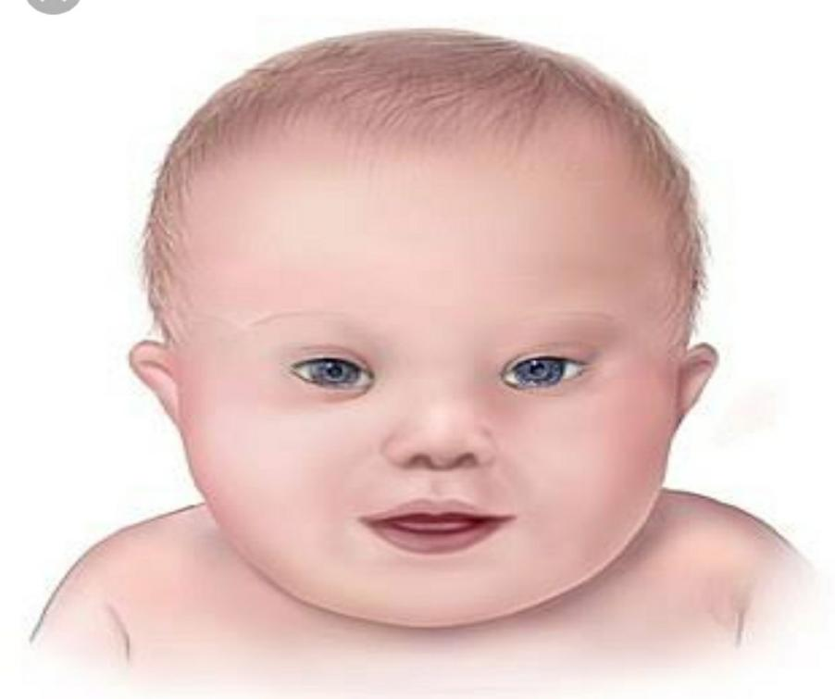

- Incidence

Approximately 1 in 800 to 1 in 1,000 live-born children, regardless of gender, ethnicity, or racial background, are affected by Down syndrome. While the commonly reported incidence of Down syndrome is approximately 1 in 660 live births, the actual occurrence in New Zealand, as documented by the New Zealand Birth Defects Monitoring Programme from 1995 to 1998, is slightly more than 1 in 1,000. This variance can be attributed to both natural occurrences and elective terminations. The incidence is consistent among various ethnic groups, but it does increase with advancing maternal age, with rates of 1 in 1,500 for ages 15-29, 1 in 800 for ages 30-34, 1 in 270 for ages 35-39, 1 in 100 for ages 40-44, and 1 in 50 for ages over 45. It's worth noting that a majority of children with Down syndrome are born to mothers under 30 years of age, simply due to the higher number of pregnancies in this age group.
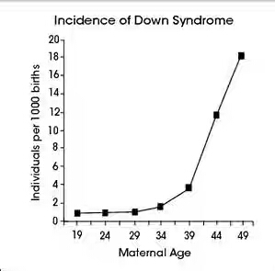
- causes
Down syndrome results from an issue with a baby's chromosomes. Typically, a person has 46 chromosomes, but in the majority of cases of Down syndrome, there are 47 chromosomes present. In rare instances, Down syndrome can also be caused by abnormalities in other chromosomes. The presence of extra or irregular chromosomes leads to alterations in the development of both the brain and the body.
Down syndrome is the outcome of atypical cell division processes involving chromosome 21. These irregularities in cell division result in the presence of an extra, either partial or complete, chromosome 21. It's this additional genetic material that gives rise to the distinctive characteristics and developmental challenges associated with Down syndrome. Any of three genetic variations can lead to the occurrence of Down syndrome.

- Trisomy 21- about 95% of the time Down syndrome caused by trisomy 21 the person has three copies of chromosome 21. Instead of usual two copies in all cells. This is caused by abnormal cell division during the development of the sperm cell or egg cell.
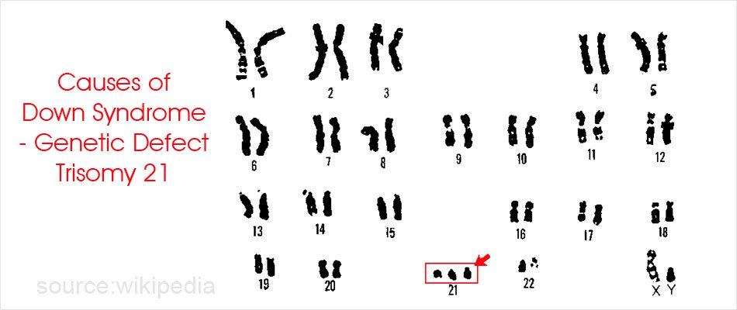

- Mosaic down syndrome- Mosaic Down syndrome, a less common variant of the condition, occurs when an individual possesses extra copies of chromosome 21 in only some of their cells, creating a mosaic pattern of both normal and abnormal cells. This mosaic of cells with different chromosomal compositions arises from irregular cell division that takes place after fertilization.
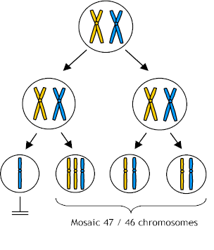
- Translocation down syndrome- Translocation Down syndrome can occur when a segment of chromosome 21 becomes attached (translocated) to another chromosome either before or during conception. Individuals with this form of Down syndrome possess the standard two copies of chromosome 21, but they also have supplementary genetic material from chromosome 21 affixed to another chromosome. It's important to note that there are no identified behavioral or environmental factors responsible for causing Down syndrome .

- Risk factors:
- Advancing maternal age – Maternal age plays a significant role in the risk of having a child with Down syndrome. The likelihood of this condition occurring rises as a woman gets older because older eggs are more prone to experiencing faulty chromosomal division. The risk of conceiving a child with Down syndrome notably escalates after the age of 35.
- Being carrier of the genetic translocation for Down syndrome- both men and women can pass the genetic translocation for Down syndrome to their children.Both men and women have the potential to transmit the genetic translocation associated with Down syndrome to their offspring.
- Signs & symptoms
People with Down syndrome can have a variety of problems some of which become more prominent has they get older. These complications are
- Heart defects
- Gastro intestinal defects
- Immune disorders
- Sleep apnoea
- Obesity
- Spinal problems
- Leukaemia
- Dementia

- Heart defects:
Heart defects are quite common among children with Down syndrome, affecting approximately 50% of them at birth. Some of these heart issues can pose serious risks to the child's health and might necessitate early surgical intervention in infancy.

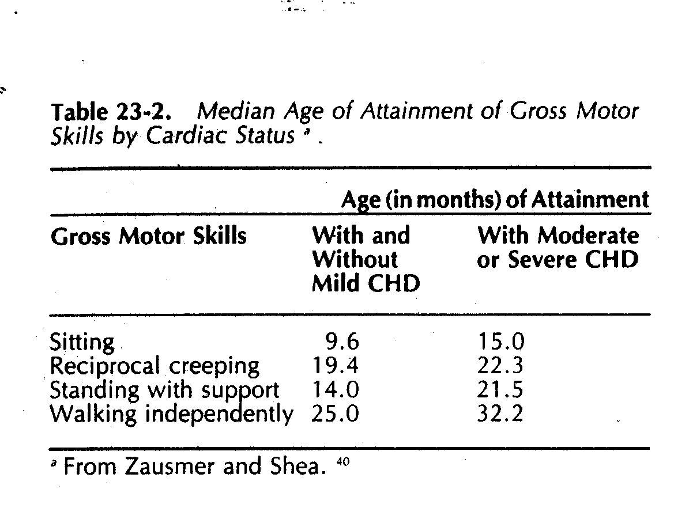
- Gastro intestinal defect:
Digestive abnormalities can manifest in certain children with Down syndrome and may involve irregularities in the intestines, esophagus, trachea, and anus. There is an elevated risk of developing digestive issues like gastrointestinal blockages, gastroesophageal reflux (heartburn), or celiac disease in these individuals.
- Immune disorders:
Individuals with Down syndrome may experience abnormalities in their immune system, making them more susceptible to the development of autoimmune disorders, certain types of cancer, and infectious diseases like pneumoni
- Sleep apnoea:
Due to alterations in soft tissue and skeletal structures that can lead to the blockage of their air passages, individuals with Down syndrome face an elevated risk of developing obstructive sleep apnea.
- Obesity
Individuals with Down syndrome are more prone to obesity when compared to the general population.
- Spinal problems:
Certain individuals with Down syndrome may experience a misalignment of two neck vertebrae known as Atlanto-axial instability. This condition increases the risk of severe spinal cord injury due to the overextension of the neck.
- leukemia
Young children with Down syndrome have an increase risk of leukaemia
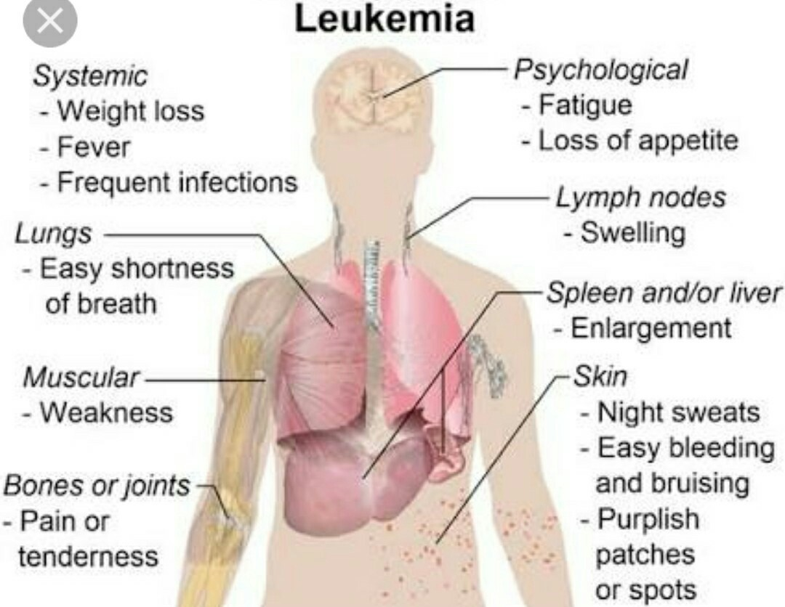
- Dementia:
Individuals with Down syndrome face a significantly heightened risk of developing dementia, and signs and symptoms may typically emerge around the age of 50. Having Down syndrome increases the likelihood of developing Alzheimer's disease.

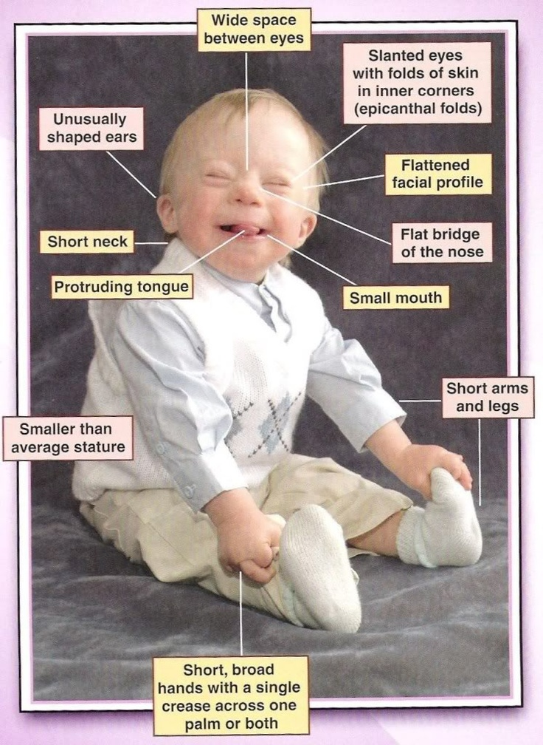
Other problems:
- Endocrinal problems
- Dental problems
- Seizures
- Ear infections
- Hearing and vision problems
- Infections.
- Hypothyroidism
- Hypotonia
- Blood disorders
- Problems with the upper part of the spine
- Disturb sleep patterns and sleep disorders
- Gum diseases and dental problems
- Epilepsy
- Digestive problems
- Celiac disease
- Mental health emotional problems
Vision problems
Over 60% of children with Down syndrome experience vision issues, such as cataracts that can be present from birth. The risk of cataracts tends to rise with age, and other eye problems that may arise include nearsightedness, crossed eyes, and rapid, involuntary eye movements.
Hearing loss
Approximately 70-75% of children with Down syndrome encounter some degree of hearing loss, which can occasionally be attributed to issues with their ear structures. Additionally, children with Down syndrome tend to be more susceptible to frequent ear infections.
Individuals with Down syndrome face a significantly increased risk, 12 times higher, of succumbing to untreated and unmonitored infections. Down syndrome frequently leads to challenges within the immune system, making it challenging for the body to combat infections. Infants born with Down syndrome have a substantially elevated risk, 60 times higher, of developing pneumonia, especially during the initial year after birth.

Hypothyrodism
Hypothyroidism, where the thyroid produces insufficient or no thyroid hormone, is a condition that occurs more frequently in children with Down syndrome.

Blood disorders
Children with Down syndrome have a significantly higher risk, around 10-15 times greater than other children, of developing leukemia. Additionally, individuals with Down syndrome are more prone to experiencing conditions like anemia, polycythemia, and other blood disorders.
Hypotonia
Poor muscle tone and low strength contribute to the delay in rolling over sitting up; crawling and walking that are common in children with Down syndrome weak muscles can cause problems along the digestive tract leading to various digestive problems difficulty in swallowing and constipation.
Problems with upper part of spine
One to two out of every five children with Down syndrome may have malformations in the upper part of their spine, located below the base of the skull.

Disrupted sleep patterns and sleep disorder
Children with Down syndrome commonly experience disturbed sleep patterns and frequently suffer from obstructive sleep apnea, characterized by substantial interruptions in breathing during sleep.
Gum diseases and dental problems
Children with Down syndrome may exhibit delayed tooth development compared to other children. They might also experience teeth coming in different sequences, having fewer teeth, misaligned teeth, and an increased risk of gum disease.
Epilepsy
Children with Down syndrome have a higher likelihood of developing epilepsy, a condition marked by seizures. The risk of epilepsy increases with age, with seizures typically manifesting either during the initial two years of life or after the third decade of life.
Digestive problems
Digestive issues in individuals with Down syndrome encompass a spectrum of problems, including structural anomalies within the digestive system or its organs. Certain individuals with Down syndrome may necessitate a specialized diet that they must follow throughout their lifetime.
Coeliac disease
Individuals with celiac disease encounter digestive issues when they consume gluten, a protein found in wheat and barley.
Mental health and emotional problems
Children with Down syndrome can encounter behavioral and emotional challenges, which may encompass conditions such as anxiety, depression, and attention deficit hyperactivity disorder. Additionally, they may exhibit repetitive movements, aggression, autism spectrum disorder, psychosis, or social withdrawal.
mental retardation
- Almost all down syndrome babies have mental retardation
- Mildly to moderately retarded
- Starts in the first year of life
- Average age of sitting (11months) and walking (26 months) is twice the typical age.
- First words at 18 months
- IQ declines through the first 10 years of age, reaching a plateau in adolescent that continues into adulthood
Growth
- Weight, length are less in down syndrome
- Reduced growth rate
- Prevalence of obesity is greater in down syndrome
- Weight is less than expected for length in infants with down’s syndrome, and then increase disproportionally. So, that they are obese by age 3-4 years.

Eye problems:
Most common disorders are
- Refractory error 35 – 76%
- Strabismus 25-57%
- Nystagmus 18- 23 %
- Cataract occur in 5% of new borns, frequently increases with age
Reproduction:
- Women with Down syndrome are fertile and may become pregnant.
- Nearly all male with Down syndrome are infertile. Due to impaired spermatogenesis.
Skeletal abnormalities:
- Excessive in ability of atlas( c₁) and axis(c₂), may lead to subluxation of the cervical spine( atlanto axial instability)
- Diagnosis made by lateral neck radiograph.
- Flat foot, dysgenisis of middle phalanx in little finger, narrow maxilla, clindactyly.
Skin disorders
- Palm plantar hyperkeratosis
- Seborreic dermatitis
- Fissured tongue
- Cutis marmorata
- Geographical tongue
- Xerosis
- Signs
physical
- In the palm of the hand single crease
- Small ears
- Small mouth
- Upward standing eyes
- Short hands that are wide with short fingers

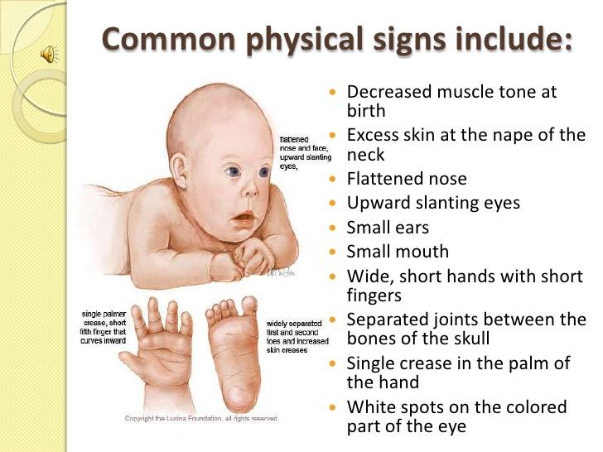

Mental
- Lack of judgement
- Slow learning ability

MEDICAL:
- Birth defects involving the heart
- Problems with the eyes likely to need glasses
- Problems with the hips
- Thyroid is under active.
NEONATAL FEATURES:
- Flat facial profile
- Poor Moro reflex
- Excessive skin at the nap of neck
- Slontated palpebral fissures
- Hypotonia
- Hyper flexibility of joints
- Dysplasia of pelvis
- Anomalous ears
- Dysplasia of mid phalanx of fifth finger.
- Transverse palmar crease( simian)
NERVOUS SYSTEM:-
- Brain weight reduction (76%),
- brainstem and cerebellum 66% of normal
- simplicity in convolutional pattern brain
- Dendrites thin, shorter spines, fewer
- Synaptic density in visual cortex 1 to28% lower than typical
- Reduced surface area of synaptic connections in brain
- Abnormal neurons in cerebrum (paucity)
- Delay in myelination in a few cases (?)
- Premature aging 33% mineral deposits, spinal plaques, neurofibrillary tangles similar to Alzheimer's
Development of Movement
- Delay but huge variability.
- Muscle tone, and health have impact on early motor development

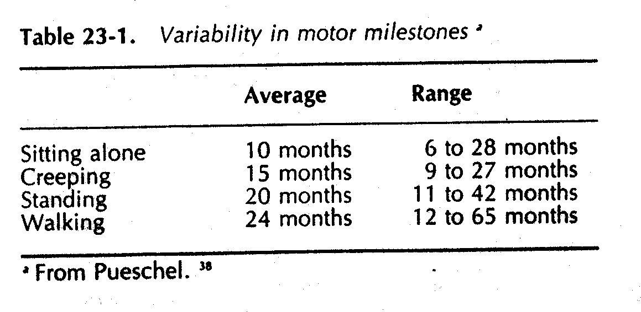
Factors in Motor Delay
- Decreased muscle strength and ability to activate musculature
- Ligamentous laxity in some joints
- Latency of response (CNS) slow reaction time
- Deficits in processing /integrating information across modalities (visual, proprioceptive auditory)
- Slow emergence of righting and equilibrium responses
- Hypersensitivity of hands and knees
Early Motor Development
- Often in infancy, performance on mental scales is superior to performance on motor scales
- Infants often can maintain postures but have difficulty with weight- shifting and rotational components of movement that are essential for transitional movements
- Often spend more time supine with a more limited movement experience
- More likely than typical children (who spend time in supine) to have hypersensitivity in hands and feet
Gait
- Flat footed contact rather than heel-toe
- Reduced push off
- Out- toeing
- Smaller step length
- Reduced time with weight on one leg
- Increased flex at hip and knee during stance phase
- Calf weakness(delayed change to push off)
- There is greater variability in children with DS
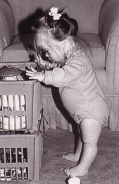

Tone:-
- Resistance to passive movement
- How to measure???
- Compare muscle consistency with foam rolls
- Maintain joint angle against external load persons with D.S-less voluntary stiffening and lack of damping
- Effects of training inconclusive but difficulty activating muscles was seen
Postural control
- Delay in emergence of equilibrium reactions
- Onset latency of reactions
- postural responses slower and less efficient than typical children in response to moving platform resulting in increased muscle sway (Shumway-Cook)
Sensory factors
- Asymmetrical pointing disrupted spatial sense
- Decreased integration of information across modalities; visual/proprioceptive
- Auditory processing consistently more deficient than visual task performance
- Need visual cues for balance longer than typical infants (need for higher level of vestibular input?)
- Improvement with practice
- 78% may have hearing impairment
- Visual imitation a relative strength

TRUNK POPSITIONING:
Trunk position is another illustrative case. Ligamentous laxity, hypotonia, and reduced trunk strength contribute to the emergence of kyphosis, which is frequently noticeable when a child is in the process of learning to sit. Children with Down syndrome often adopt a sitting posture with a posterior pelvic tilt, a rounded trunk, and the head resting backward on the shoulders. They do not acquire the ability to actively adjust their pelvis into a vertical (upright) position, which, in turn, impedes their capacity to maintain their head and trunk in proper alignment. If this posture persists, it can eventually lead to compromised breathing and a diminished ability to rotate the trunk.
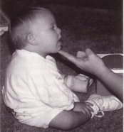

Diagnosis

The American College of Obstetricians and Gynecologists suggests providing all pregnant women with the choice of undergoing screening tests and diagnostic tests for Down syndrome, without considering their age.
- Screening tests -Screening tests can provide an estimate of the probability that a mother is pregnant with a baby who may have Down syndrome. However, these tests cannot definitively confirm or diagnose the presence of Down syndrome in the baby.
Diagnostic tests- Diagnostic tests can confirm or establish whether your baby has Down syndrome or not.Your healthcare provider can engage in a conversation regarding the various test options, their pros and cons, potential advantages and drawbacks, and the significance of your test results. If deemed suitable, your provider might suggest that you consult with a genetic counselor.

Screening tests during pregnancy
Screening for Down syndrome is routinely included in prenatal care. While screening tests can solely determine your likelihood of having a baby with Down syndrome, they can guide you in making informed choices about pursuing more specific diagnostic tests.
Screening tests include the first trimester combined test and the integrated screening test.

The first trimester combined test
The first trimester combined test, which is done in two steps, includes:
- Blood test -Blood tests are used to assess the concentrations of pregnancy-associated plasma protein-A (PAPP-A) and the pregnancy hormone human chorionic gonadotropin (HCG). Irregular levels of these substances may suggest an issue with the baby.
- Nuchal translucency test -The nuchal translucency test employs ultrasound to measure a particular area at the back of your baby's neck. This assessment is known as the nuchal translucency screening test. If abnormalities are present, there tends to be an accumulation of more fluid than usual in this neck tissue.
Based on your age and the outcomes of both the blood test and the ultrasound, your physician or genetic counselor can provide an estimation of your likelihood of having a baby with Down syndrome.

Integrated screening test
The integrated screening test is done in two parts during the first and second trimesters of pregnancy. The results are combined to estimate the risk that your baby has Down syndrome.
- First trimester-During the first trimester, the initial phase comprises a blood test to assess PAPP-A levels and an ultrasound examination to measure nuchal translucency.
- Second trimester-In the second trimester, the quad screen assesses your blood levels of four pregnancy-related substances, which include alpha fetoprotein, estriol, HCG, and inhibin A

Diagnostic tests during pregnancy

If your screening test outcomes show positive or concerning results, or if you are at an elevated risk of having a baby with Down syndrome, you may contemplate pursuing additional tests to verify the diagnosis. Your healthcare provider can assist you in evaluating the advantages and disadvantages of these tests.
Diagnostic tests that can identify Down syndrome include:
- Chorionic villus sampling (CVS)-Chorionic villus sampling (CVS) involves extracting cells from the placenta to examine fetal chromosomes. This procedure is usually carried out during the first trimester, typically between 10 and 13 weeks of pregnancy. The risk of pregnancy loss (miscarriage) associated with CVS is exceedingly low.
- Amniocentesis-Amniocentesis involves the extraction of a sample of amniotic fluid surrounding the fetus by using a needle inserted into the mother's uterus. This fluid sample is subsequently utilized to analyze the chromosomes of the fetus. Typically, this test is conducted during the second trimester, after 15 weeks of pregnancy. Importantly, the risk of miscarriage associated with amniocentesis is extremely low.
Pre-implantation genetic diagnosis (PGD) is a choice available to couples undergoing in vitro fertilization when they face an elevated risk of transmitting specific genetic conditions. In this process, the embryo is screened for genetic abnormalities prior to its placement in the uterus.
Diagnostic tests for newborns
Following birth, the preliminary diagnosis of Down syndrome is frequently made based on the baby's physical characteristics. However, these features can also be present in infants who do not have Down syndrome. As a result, your healthcare provider is likely to request a chromosomal karyotype test to confirm the diagnosis. This test examines your child's chromosomes using a blood sample. If the test reveals the presence of an additional chromosome 21 in either all or some of the cells, the diagnosis of Down syndrome is confirmed.

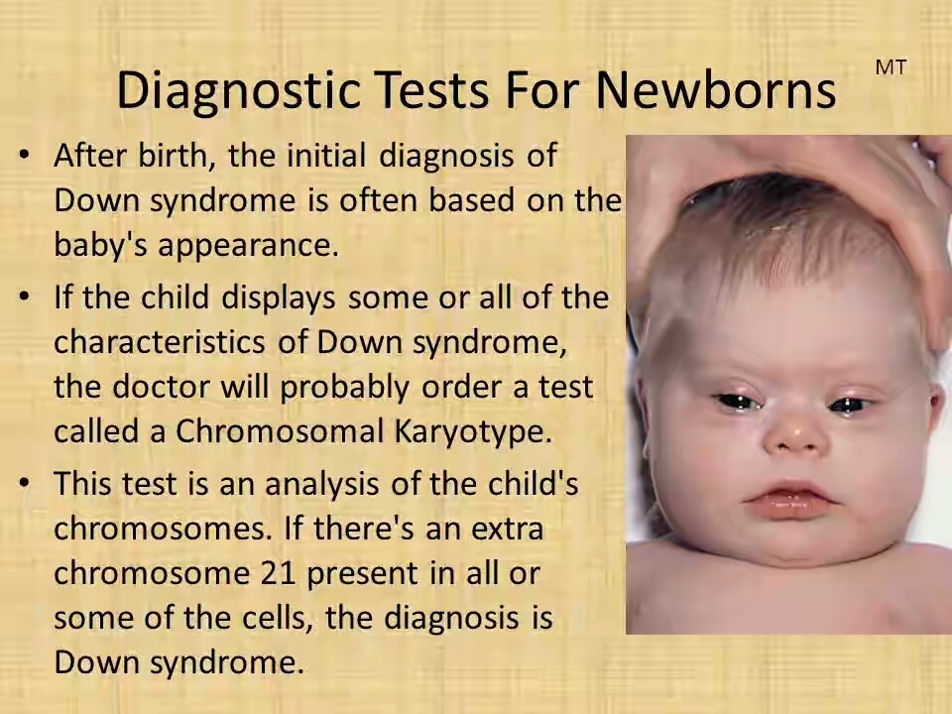

Treatment

Early intervention for infants and children with Down syndrome has the potential to significantly enhance their quality of life. Since each child with Down syndrome is distinct, the approach to treatment will be tailored to their individual requirements. Furthermore, various life stages may necessitate distinct services.

Team care

If your child has Down syndrome, you will typically depend on a group of specialists who can deliver medical care and support in developing their skills to the fullest extent. Depending on your child's specific requirements, your team may encompass a variety of these professionals.
- Primary care pediatrician to coordinate and provide routine childhood care
- Pediatric cardiologist
- Pediatric gastroenterologist
- Pediatric endocrinologist
- Developmental pediatrician
- Pediatric neurologist
- Pediatric ear, nose and throat (ENT) specialist
- Pediatric eye doctor (ophthalmologist)
- Audiologist
- Speech pathologist
- Physical therapist
- Occupational therapist

You'll have to make significant choices regarding your child's medical care and educational opportunities. Assemble a team of healthcare providers, educators, and therapists whom you have confidence in. These experts can assist in assessing the available resources in your locality and provide information about state and federal initiatives designed for children and adults with disabilities.

MEDICATIONS
- Medications can be employed to manage specific health conditions that may arise in individuals with Down syndrome.
- For instance, in the case of an individual with Down syndrome who has a seizure disorder, they would find relief and benefit from using anti-seizure medications.
- Individuals with thyroid issues often use thyroid replacement hormones.
- Although these medications are effective in managing their medical condition, they do not have any impact on their Down syndrome.
- Currently, there is no medication available that can cure Down syndrome.

MEDICAL TREATMENT:
- Individuals with Down syndrome face an elevated risk of specific medical issues.
- Typical issues that individuals with Down syndrome often encounter comprise heart defects, thyroid complications, as well as muscular, joint, vision, and hearing problems.
- Less commonly observed conditions in individuals with Down syndrome encompass leukemia and seizures.

SURGICAL TREATMENT:
- Certain medical conditions observed in children with Down syndrome may necessitate surgical intervention.
- For instance, approximately 40% of children with Down syndrome are born with congenital heart defects. While some of these defects are mild and might resolve on their own, others are more severe and will necessitate surgical treatment.
- Children with Down syndrome may develop intestinal abnormalities that also demand surgical intervention.
- The necessity for surgery is not linked to the cognitive impairment in Down syndrome.
- In simpler terms, if a baby requires surgery, it does not imply that they have a more severe form of Down syndrome.

SYMPTOMATIC PROBLEMS& TREATMENT IN DOWN SYNDROME:
- In Down syndrome, short stature is nearly always present, and its origin is multifaceted. While genetic factors play a role, it can also be associated with conditions like hyperthyroidism, celiac disease, renal diseases, or nutritional deficiencies. However, in most cases, its precise cause cannot be conclusively identified
TREATMENT:
Administering human recombinant growth hormone (hrGH) therapy to children with Down syndrome boosts their growth rate and overall stature.
- Immunology and auto immune disease
Immunology and Autoimmune Disorders: In Down syndrome, irregularities in the immune system are a persistent and intricate aspect.
TERATMENT:
Administering zinc supplements to children with Down syndrome has demonstrated favorable effects on certain immune parameters and a decrease in recurrent infections.
Similarly, selenium supplementation can also lower the frequency of infections in children with Down syndrome.

- COELIAC DISEASE:
It is relatively infrequent and arises from gluten intolerance.
In the context of Down syndrome, its occurrence is significantly higher, specifically at 62%.

TREATMENT:
The treatment involves the complete elimination of gluten from the diet, resulting in full recovery.
However, it's crucial to maintain the gluten-free diet for an extended and indefinite duration.

- LEUKEMIA:
Down syndrome children accounts for approximately 3% of children with acute lymphoblastic leukemia and 5-8% of children with acute myeloid leukemia.
- CONGENITAL MALFORMATION:
Close to 50% of infants born with Down syndrome exhibit congenital heart conditions, which often include atrioventricular canal defects or endocardial cushion defects.
TREATMENT:
Surgical correction is a viable treatment option.
- RESPIRATORY PROBLEMS:
Among individuals with Down syndrome, cardiac anomalies with heightened pulmonary flow are the prevailing issue. Symptoms typically manifest early, and pulmonary artery hypertension rapidly ensues, resulting in conditions like cardiomegaly, hepatic cirrhosis, heart failure, and recurrent respiratory infections.
Treatment:
Surgical corrections are employed as the primary method of treatment.

- GASTRO INTESTINAL MALFORMATIONS:
Gastrointestinal malformations are more prevalent in individuals with Down syndrome, with duodenal stenosis constituting about half of all congenital duodenal stenosis cases.
-Urinary tract malformations such as congenital hydronephrosis and obstructive uropathy can be found in individuals with Down syndrome. Early diagnosis is crucial for these conditions, and surgical corrections are typically required.

- ORTHOPEDIC DISORDERS:
The most prevalent orthopedic disorder in individuals with Down syndrome is ligamentous laxity. Atlanto-axial instability has garnered significant attention.
Common problems include flat feet, patella instability, and genu valgum. Atlanto-axial instability is typically asymptomatic, but there is an increased risk of dislocation after cervical trauma or sudden, forceful head movements.
Compression of the cervical medulla can lead to neurological complications such as an unsteady gait, paraplegia, quadriplegia, and urinary incontinence, often preceded by head deviation.
- Retardation of skeletal maturation
- Retardation in growth of cranium
- Narrow palate-100%
- Rib anomalies
- Decreased acetabular and iliac angles (most)
- Instability patello-femoral joint-4 to 8%
- Increased incidence mild scoliosis
- Foot anomalies; metatarsus primus varus, pes planus, hindfoot valgus
- Increased incidence of muscles missing (finger and wrist flexors,psoas minor)
- Lack of differentiation of midface musculature
- Hyperflexible joints due to ligamentous laxity (deficit in collagen)
- Abnormally large space and excessive movement between first and second cervical vertebrae
- Cord may become compressed.
- 12-20% of children with down syndrome
- estimated 1 to 2% may be symptomatic
- Abnormal gait
- Head tilt, limited neck motion, neck pain
•Symptoms related to the pyramidal tract, including challenges with walking, spasticity, heightened reflexes, lack of coordination, awkward movements, and potential loss of bladder or bowel control.
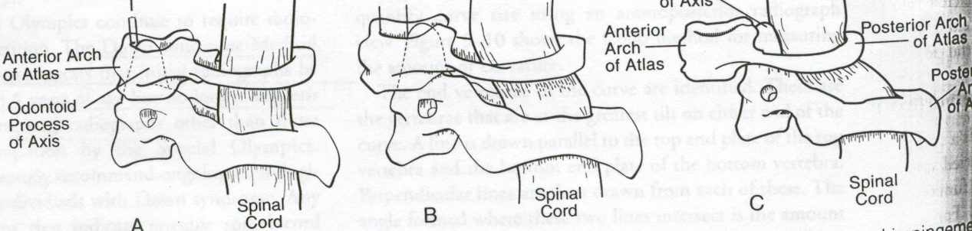

TREATMENT:
Children with an elevated risk of dislocation should avoid engaging in hazardous sports or activities.
For symptomatic cases, surgical stabilization can yield positive outcomes.
- SENSORY DEFICITS:
Sensory deficits, be they visual or auditory, hold significant importance in the mental development of children with Down syndrome.
Ocular abnormalities are more prevalent in this group compared to other children, and there is an elevated incidence of middle ear pathology.
Treatment:

Spectacles and hearing aids can provide positive outcomes.
In severe cases, surgical correction may be required.
10)MUSCULO SKELETAL ABNORMALITIES:
Reduced Muscle Strength: Motor function in individuals with Down syndrome is distinguished by hypotonia and hyperflexibility, which heightens the risk of joint dislocation and delays the development of motor skills.
11) VITAMIN-D DEFICENCY
Their is a damaging effect of vitamin –D insufficiency on musculo skeletal health in children and adolescences.
- BONE MASS:
Skeletal abnormalities are observed in individuals with Down syndrome due to factors such as low bone mineral density, limited physical activity, reduced muscle strength, inadequate sunlight exposure, and low levels of
vitamin D.

Physiotherapy management &assessment in Down syndrome
Physical therapists collaborate with families and healthcare experts to alleviate or prevent these symptoms. Ensuring a robust educational setting and comprehensive medical care, including therapy from preschool through high school and into adulthood, is crucial. The support of families is instrumental in maintaining the health of adults with Down syndrome at optimal levels.
Assessment & evaluation includes:
- Birth and Developmental History:
Physiotherapists will inquire about the child's birth and developmental milestones, including when they achieved head control, rolled over, sat up, crawled, and walked, among other milestones. This assessment assists the physiotherapist in designing a rehabilitation plan that facilitates the child's ability to engage in various activities with greater ease.
- Physical Examination: The physical examination encompasses measurements of the child's height and weight, observation of their movement patterns, hands-on assessments of muscle strength, tone, and flexibility, as well as evaluations of the child's balance and coordination.

- General Health Questions: The physiotherapist may inquire about your child's health, including whether they have been unwell or hospitalized, and if any health issues were discussed during those visits. Additionally, they may ask about your child's most recent visit to a physician or healthcare professional.

- Motor Development Tests: The physical therapist will conduct targeted assessments to evaluate the child's motor development, which may include their ability to sit, crawl, stand up, and walk. Additionally, the physical therapist may assess your child's hand coordination, vision, language skills, cognitive abilities, and other aspects of their development.
As needed, your physiotherapist may collaborate with other healthcare experts to form a comprehensive team dedicated to meeting the child's requirements. A physical therapist plays a vital role in the healthcare and physical fitness aspects of your child's growth. They assist individuals with Down syndrome in building strength and mobility to optimize their performance across all life stages.
Physical activity is an integral component of a child with Down syndrome's overall health, fitness, and well-being. It plays a crucial role in enhancing bone development, refining motor skills, and fostering balance and coordination abilities. Furthermore, engaging in physical activity fosters the growth of social skills, encourages independence, and contributes to maintaining a healthy body weight.
Sufficient physical activity can lead to improved sleep, concentration, academic performance, and self-esteem. Beyond these immediate benefits, regular physical activity offers enduring advantages by reducing the risk of developing conditions such as heart disease, type 2 diabetes, osteoporosis, depression, and obesity. These long-term health benefits are especially significant for individuals with Down syndrome, given their elevated susceptibility to these conditions.

Activity guidelines for children with Down syndrome
According to these guidelines:

Toddlers (1-3 years) and preschoolers (3-5 years) should engage in daily physical activity for a minimum of three hours. This should involve activities like standing, moving about, active play, running, and jumping.
Primary school-aged children (5-12 years) and adolescents (12-18 years) should participate in at least sixty minutes of activities that are of moderate and vigorous intensity each day. For additional health benefits, they should engage in twenty minutes or more of vigorous activity on at least three to four days per week. Moderate activities are those that elevate heart rate and breathing and lead to a mild perspiration.
The provided guidelines represent the minimum recommended thresholds for children's physical activity. Some research indicates that these guidelines may be somewhat conservative and that children and adolescents might benefit from engaging in closer to 120-150 minutes of daily physical activity. As the adage goes, while any amount of physical activity is beneficial, more physical activity offers even greater advantages!
Assessment
  - History: health, progress, current status, caregivers,
  - Observation of spontaneous movement, quality of movement, positioning and handling by parent
  - Postural alignment, resistance to passive movement, strength, range of motion, postural reactions, response to sensory stimuli
Tests
Testing involves the use of standardized assessments, and it's important to avoid placing excessive emphasis on specific developmental ages. Overemphasizing certain developmental milestones may lead to disappointment when later results are expected to be relatively lower. This decrease in performance can be attributed in part to the reduced complexity of tasks at later stages of development
Barriers to physical activity
Parents have reported several common obstacles to their children with Down syndrome participating in physical activity, including:

- The inherent characteristics often linked to Down syndrome, such as reduced muscle strength and cardiovascular fitness compared to typically developing children.
- Juggling competing family responsibilities and parental concerns, including worries about their child's safety.
- The child with Down syndrome having diminished physical or behavioral skills.
- A scarcity of available programs that are easily accessible.
Encouraging physical activity
The top four factors that encourage physical activity, as frequently reported, include:
- The favorable role and impact of the family.
- Opportunities for social engagement with peers.
- Well-structured, inclusive programs that offer adaptations for children with Down syndrome.
- Children who display determination to excel, possess physical abilities, and receive encouragement from both parents and coaches.
Practical Strategies for Promoting Physical Activity

- It is crucial for families to foster a habit of physical activity in children from an early age, whether through organized exercises, sports, or active play. These early habits are more likely to persist into adulthood. When encouraging physical activity in children with Down syndrome, consider the following strategies:
- Opt for active toys and activities over sedentary options. For preschoolers and primary school children, choose toys that help develop essential skills like kicking, throwing, and catching, such as balls, bats, tricycles, and kites.
- Promote traditional childhood games like hopscotch, skipping ropes, hula-hoops, hide-and-seek, obstacle courses, follow the leader, stuck in the mud, or tag, which also enhance movement and skill development.
- Select activities that your child enjoys—music and dance are popular choices among individuals with Down syndrome.
- Keep it simple—activities like running, jumping, dancing, and trampolining provide excellent aerobic exercise.
- Encourage walking or cycling instead of driving, especially for trips to school.
- Opt for stairs over elevators when navigating larger buildings.
- Foster outdoor time for your child, as spending more time outdoors naturally increases physical activity.
- Engage the entire family and use physical activity as an opportunity for social interaction among family members.
- Establish a routine—many children thrive on routines and repetitive behaviors, which allow them to master tasks and skills.
- Offer your child plenty of positive feedback and encouragement.
- Start with small exercise goals and gradually increase them over time.
- Physical activity is vital for overall health, so get moving and stay active.
Parent education
- Guidance on physical handling techniques to encourage the desired movements and postures.
- Enhance and build upon the activities parents engage in by incorporating visual, vestibular, and tactile stimuli.
- Provide additional information and education to parents regarding Down syndrome.
- Intermittent assessment and proactive advice could prove to be satisfactory.
BENEFITS OF PHYSICAL ACTIVITY
Physical activity need not be strenuous to achieve health benefits.
•Both men and women of all ages can benefit from a moderate amount of daily physical activity. This level of activity can be achieved through longer sessions of moderately intense activities (e.g., 30 minutes of brisk walking) or shorter sessions of more vigorous activities (e.g., 15-20 minutes of jogging).
• Engaging in greater amounts of physical activity can offer additional health advantages. Adults who maintain regular, longer, or more intense physical activity routines are likely to experience greater benefits. However, it's essential to be cautious about excessive activity as it can increase the risk of injury.
• Individuals who were previously sedentary and wish to start physical activity programs should begin with short sessions (5-10 minutes) and gradually progress to their desired activity level.
• Adults with chronic health conditions like heart disease, diabetes, or obesity, or those at high risk for these conditions, should consult a physician before commencing a new physical activity program. Men over 40 and women over 50 planning vigorous activity should also consult a physician to ensure they don't have heart disease or other underlying health issues.
Physiotherapy goals:-
- Improve muscle tone
- Improve stability
- Strengthening
- Transitional/rotational movements
- Static and dynamic balancePrevent abnormal posture and movement
STAIR WALKING:
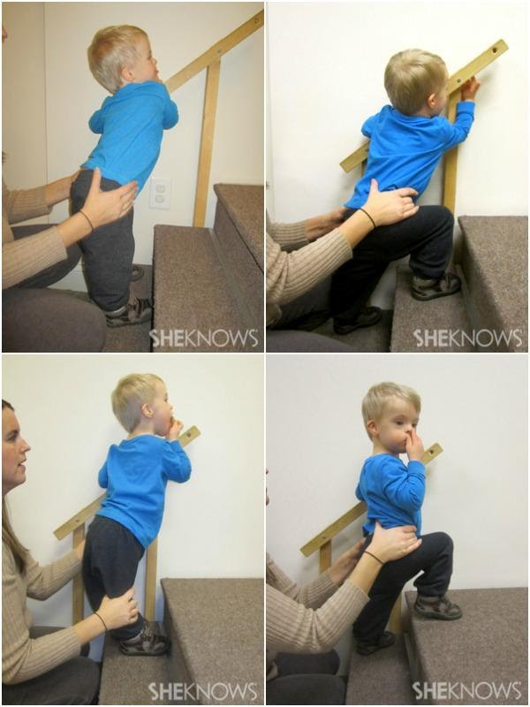
Children with DS often struggle with generalization, which means that a skill they've mastered in one environment may not automatically translate to another. For instance, a child who can confidently climb stairs at home might revert to a less effective technique when encountering stairs in a different place. They may need to reacquire the skill in the new setting before using it consistently.
Learning abilities:-
Children with DS often benefit from receiving information in small, easily digestible portions. When it seems like a child's progress has stalled, it's usually because the next piece of information is too complex, and it should be further divided into smaller, more manageable parts.
GAIT:
Early physical therapy should focus on teaching young children with DS the correct standing posture, which involves positioning their feet under the hips, pointing straight ahead, and maintaining a slight knee bend. By implementing suitable physical therapy, it's possible to reduce or prevent gait issues.
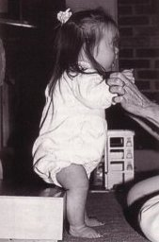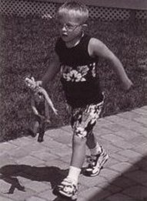

PHYSIOTHEARPY FOR TRUNK COIMTROL:
In physical therapy, it's essential to instruct children with DS on correct sitting posture from an early stage, offering support at various levels before they can sit independently. The progression includes upper trunk support, middle trunk support, support between the scapula and the waist, waist support, and pelvic support. These supports maintain proper spinal and pelvic alignment until the child gains the strength to do so independently. By utilizing appropriate physical therapy, issues related to trunk posture can be reduced.

Components of an effective exercise program
Adolescents and young adults with DS should strive to include the following components in an exercise program.

Strengthening-

Strengthening muscles involves the objective of progressively increasing the muscle's strength. This can be achieved by using weights, gym machines, resistance bands, or one's own body weight, depending on the individual's initial fitness level.
Aim to strengthen all parts of the body —The aim is to enhance the strength of various body parts, including the arms, legs, and core. You may want to explore a structured exercise program created by a physical therapist or exercise physiologist. Alternatively, you can seek guidance from resources like a physical education teacher or participate in an adaptive physical education class to create a tailored workout regimen.
Cardiovascular exercise
While research on the specific responses to exercise in individuals with Down syndrome is ongoing, the advantages of physical activity are readily observable. For instance, cardiovascular exercise can lead to improved endurance for activities such as walking throughout the school day without needing frequent breaks, the capacity to climb hills and engage in play without experiencing breathlessness, and enhanced performance in various sports activities.

There are numerous approaches to include cardiovascular exercise in your child's daily routine, and some of these methods include:
- Participation in a swimming program
- Use of exercise equipment, such as a treadmill, recumbent bike or elliptical machine (under supervision when appropriate)
- Recreational activities, such a walking, biking and jogging
If your child with Down syndrome is not currently engaged in exercise, it's advisable to initiate activity gradually. For instance, encourage your child to begin with a five-minute walk and then progressively extend the duration or distance. Individuals with Down syndrome who are under the care of a cardiologist should seek advice from their physician before commencing a structured endurance exercise program.

Balance activities
Balancing exercises are frequently the most enjoyable aspect of the workout routine and can enhance one's skills in sports or their overall mobility in the community.Encourage your child to practice:
- Engage in stationary activities like balancing on one leg with your hands on your hips, and as it becomes more manageable, challenge yourself by attempting it with your eyes closed.
- Involve in dynamic tasks that test your coordination and motor planning abilities, like skipping, playing hopscotch, or walking across a balance beam. You can also consider more structured options such as yoga, martial arts, or dance classes to enhance your balance.

- 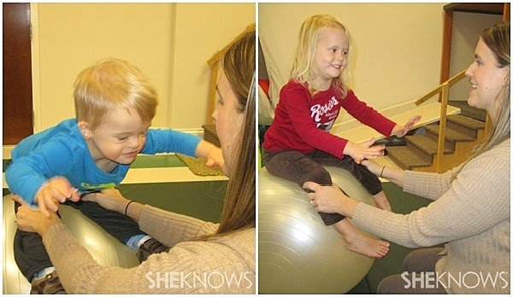

60 minutes a day
- Help your child aim for 60 minutes of exercise each day. This can be a combination of strengthening, cardiovascular and balance activities, and does not need to be completed in one continuous cycle. For example, your child’s activity may include a 10-minute walk to school, 20 minutes of basketball during recess, and a 30-minute yoga session after dinner.

When planning a long-term successful exercise program for a child with Down syndrome, it's essential to consider their preferences and what activities they find enjoyable and meaningful. Here are some considerations:

Identify Interests: Take into account the child's interests. For example, if they enjoy group activities and music, a dance class can be an enjoyable way to elevate their heart rate and keep them engaged.

Water Activities: If the child enjoys being in the water, consider enrolling them in swimming lessons or involving them in a Special Olympics program. These activities can provide valuable skills for lifelong aquatic exercise.

Family Time: If the family's busy schedule makes it challenging to spend time together during the week, schedule regular family activities on weekends, such as bike rides or hikes in the summer and fall. This not only promotes physical activity but also strengthens family bonds.

Personal Meaning: Choose activities that hold personal meaning for you or your child. By incorporating these activities into daily life, you can maintain their interest in physical exercise.

Professional Guidance: If the child has any exercise restrictions or specific needs, consult with a physiotherapist to initiate an exercise program tailored to their requirements.

Prevent abnormal posture and movement
- Weight shifting in prone
- Sitting with narrow base
- Transition to sitting/crawling
- Head and trunk posture
- Facilitate new movement and sensory experiences
- Promote new independent motor and self help skills, safety
- Promote physical activity for play, peer relations and fitness
TIPS FOR GIVING PHYSIOTHERAPY IN DOWN SYNDROME CHILDREN:
- Establish an optimal setup, as structure, consistency, and a familiar environment are vital for children with DS to perform at their best. Avoid introducing new or challenging activities when the child is tired or hungry. Quality is more important than quantity, and minimize distractions in the environment.
- Follow the child's motivation.
The child should be genuinely interested in performing a specific skill.
- Observe the child's reaction to learning new gross motor skills. Some children are cautious, preferring stability, while others are adventurous, enjoying movement. Adjust your approach accordingly. For example, a cautious child will seek more support and may get upset if they fall, while a risk-taking child will embrace movement and be less concerned about support or falls.
- Know when to stop. Some children may only attempt a skill a few times before wanting to move on. Set up activities for success to prevent frustration.
- Plan the session strategically. Focus on skills the child is ready to learn and tackle the most challenging ones early in the session, while the child is still fresh. Alternate between difficult and easier skills to allow the child to recover.
- Provide strategic support. Minimize support to the minimum required for success and remove it as soon as possible, as children with DS can quickly become dependent on support.
- Skills are initially learned in a gross manner and then refined. For example, when learning to walk, children may initially have a wide stance and outwardly rotated feet. This pattern should be allowed initially and refined as the child progresses.
- Avoid interfering with established skills where the child has achieved independence. Instead, make changes at the next level of motor development. For instance, if a child has developed a unique crawling pattern, it's best to teach improvements at the next developmental stage.
Children with DS learn best through a gradual process:
a. Introduction: Slowly introduce the new skill with the goal of helping the child tolerate the movement.
b. Familiarity: Allow the child to become familiar with the skill and understand the activity.
c. Collaboration: Encourage increased collaboration and cooperation while decreasing support.
d. Independence: The final step is when the child has mastered the skill and can perform it independently without support.
Featured Exercises for Children Born with Down Syndrome in the Birth to Walking Stage

- Back-Lying in Your Lap (below)
- Back-Lying and Reaching Upward without Support
- Hip Stretch
- Supported Kneeling at a Sofa Cushion
Back-Lying Exercises for Babies Birth to Walking
Components
When baby is on her back, the components want her to develop are:
- Head in midline and tucking her chin
- Hands to her chest (midline) and beginning reaching toys
- Legs supported together with hips and knees bent, feet on the floor, and knees together; also kicking movements
These movements will take time to develop and will need to support her fully in the beginning. If she is supported in the right way, she can focus her attention on therapist and respond to therapist.
Tendencies
Her tendency will be:
- to turn her head to one side and maintain her head there
- to rest her arms on the surface and infrequently move them to the midline
- to activate her legs since they are the strongest part; this will prevent arm movements because the young infant cannot move arms and legs at the same time
- to position her legs in the "frog leg" position (hips and knees bent and knees wide apart) when at rest, and to develop muscle tightness if she habitually uses this posture
- to use the arching pattern in the head, arms, and trunk, which inhibits chin tuck and moving the hands to the midline
If the baby is not supported, her head will be turned to one side, her arms and hands will rest on the surface, and her legs will be positioned with her hips and knees bent and her knees wide apart or she will do kicking movements. With the activity of her legs, she will not have the strength to move her head to the center to look at the therapist or to lift her arms so she can bring her hands and mouth to her chest. With the tendency of arching, she will pinch her shoulder blades together and her upper chest will puff up and this will prevent chin tuck and moving her arms to the midline. She may also learn to stabilize her arms against the surface to be able to kick her legs more.

Activity: Back-Lying in Your Lap

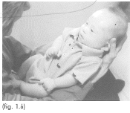
- Place the baby in therapist lap as therapist sit on the couch or other comfortable chair with back support.
- Place her with her head between therapist knees, her hips against the abdomen, and her legs supported against the chest.
- Slide the hands along the sides of her body and under her arms until they are under her head. Hold her head in the center and tilt it upward so she sees you easily.
- With this arm support, she will be able to bend her elbows and bring her hands to her chest or mouth.
- Use the elbows to support her legs so that her knees are in line with her hips and not in a wide position.
- Lean the head and trunk forward so that therapist can be close to her and therapist can see each other. Talk or sing to her and engage with her for as long as tolerated.

2.Back-Lying and Reaching Upward without Support

Activity: Back-Lying and Reaching Upward
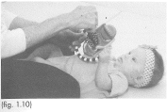
- Place the baby on the floor with her head looking straight ahead, not turned to either side.
- Therapist should take the position on heels infront of baby.
- Place a large toy on her chest and have her reach and touch it with bone or both hands.
- If her legs are very active, support them to calm them down and then she will be better able to reach.
- When she is able to consistently reach to her chest to play with the toy, hold it slightly above her chest so she needs to reach higher.
- Watch her legs and support them if she holds them apart.

3.HIP STRETCH

Activity: Hip Stretch
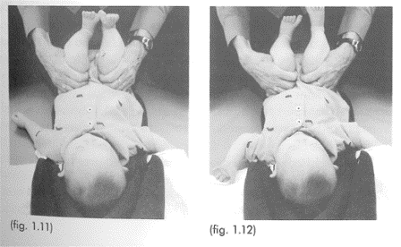
- Bend the baby's hips and knees to 90 degrees and hold the back of her thighs with the palms of the hands. Mover her thighs gently toward neutral rotation (knees pointing up to celing) and if feel resistance, stop there and wait for her legs to relax. When she relaxes, move her thighs more until 5-10 degrees of internal rotation (knees turned slightly inward toward each other).
- Talk to her and maintain the stretch for 1-2 minutes.
- Practice 2-3 times a day and feel less stiffness each day.
- When she can independently move her hips to neutral rotation and adduction (knees pointing up to the ceiling and knees together) then stop this exercise

- 4.Supported Kneeling at a Sofa Cushion
Supported Kneeling Activity
Components:
When your baby is maximally supported in kneeling, the components that you want to develop are:
- Lifting her head in the midline and maintaining it
- beginning weight bearing on her elbows
- trunk supported up straight
- stretching her hips to neutral rotation and beginning weight bearing on her legs
- Tendencies:
Her tendencies will be:
- to arch her head and trunk without control or bend into the surface
- to lose head control suddenly and quickly fall into the surface
- to not take weight on her elbows
- to position her knees wide apart
- to be fussy with taking weight on her knees and need a softer surface
Activity: Supported Kneeling at a Sofa Cushion
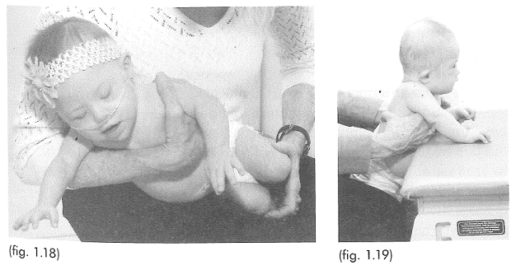

- Begin by selecting a soft surface to kneel on. Place a 7-inch (18 cm) sofa cushion on the surface in front of you. Kneel on your heels and hold your baby sideways across your lap, making sure she faces away from you. Use one arm to support her under her arms and the other hand to gently bring her knees together with her hips and knees bent (see fig. 1.18).

- Position your baby in a kneeling posture with her knees together, snugly placing your knees against hers to keep them stable. Her buttocks should rest on your thighs, slightly elevating her pelvis rather than resting on her heels.

- Help her prop herself on her elbows by placing her elbows on the sofa cushion. Hold her upper trunk under her arms to assist with this. This will position her elbows forward of her shoulders (as seen in the side view), aligning her elbows with her shoulders (see fig. 1.19).

- Once her legs, trunk, and arms are stable, introduce a toy or another person in front of her to motivate her. Encourage her to lift her head. Initially, she may lift her head with a bobbing motion, but as her strength develops, she will be able to lift and hold her head while looking at the motivating object. If she lifts her head too far, lean your trunk forward slightly to prevent her from tilting her head backward.
- Dance Therapy with Physical Therapy for Children with Down Syndrome.

Impact of a dance program on bilateral toe-standing balance and single-point static balance skills in children with Down Syndrome.

The hypothesis was that a dance curriculum designed to integrate dance and traditional physical therapy techniques would be beneficial for children with Down Syndrome. This hypothesis was based on the combined cognitive and motor benefits expected from these two modalities.

The program included elements such as tactile guidance, voluntary control, rhythm, and repetition, incorporating both visual and auditory cues to enhance motor learning

Conclusions

There is a consensus that exercise offers clear benefits to individuals with Down's Syndrome, encompassing cardiovascular and neuromuscular improvements. Exercise not only enhances basic functionality but also positively impacts vocational performance, leading to increased independence in leisure and work opportunities, as suggested by Mendonca et al (2010).It is important to start exercise programs with simple tasks that provide adequate physical demands. Wang et al (1997); (2001) found benefits in activities like jumping exercises. However, for long-term programs, diversity and interest are key to maintaining engagement. Wang et al recommend avoiding activities that are overly complex or overtly perceived as exercise.An example of an engaging program is demonstrated by Lin et al (2012), who combined walking/jogging with virtual reality Wii game console exercises. Shields et al (2008); (2013) also presented two effective exercise intervention options for individuals with Down's Syndrome. One involved group-based training, where two to three participants with Down's Syndrome exercised with a supervisor, and the other featured programs led by student mentors. This approach encourages social interaction and physiological adaptation while avoiding the common barriers associated with prescribed exercise programs, as observed in studies by Millar et al (1993); Monteiro et al (1997); Varela et al (2001).
Recognizing the barriers that individuals with Down's Syndrome face, exercise programs need to be cost-effective and motivating. The high attendance rate of 92% in Shields et al's (2008); (2013) programs and 100% adherence in Lin et al's (2012) study underline the effectiveness of this approach.

References
- Gardner, H (1983). Frames of Mind: the Theory of Multiple Intelligences.Basic Books.
- Kumin, L (2001). Classroom Language Skills for Children with Down Syndrome: A Guide for Parents and Teachers. Woodbine House.
- Oelwin, P (1995). Teaching Reading to Children with Down Syndrome: A Guide for Parents and Teachers. Woodbine House.
- Winders, P (1997). Gross Motor Skills in Children with Down Syndrome: A Guide for Parents and Professionals. Woodbine House.
- Wishart, JG (1995). Cognitive Abilities in Children with Down Syndrome. In: CJ Epstein, T Hassold, I Lott, L Nadel & D Patterson (eds.) Etiology and Pathogenesis of Down Syndrome. Wiley-Liss Inc.
- Wishart, JG (1991). Taking the initiative in learning: a developmental investigation of children with Down syndrome. International Journal of Disability, Development and Education, 38, 27-44.
- Alesi M, Battaglia G, Roccella M, Testa D, Palma A, Pepi A. (2014) Improvement of gross motor and cognitive abilities by an exercise training program: three case reports. Neuropsychiatric Disease and Treatment 10: 479-485
- Almeida GL, Corcus DM, Latash ML. (1984) Practice and transfer effects during fast single-joint elbow movements in individuals with Down syndrome. Physical Therapy 74: 1000-1012
- American College of Sports Medicine. (1993) Position Stand: Physical Activity, Physical Fitness and Hypertension. Medicine and Sports and Exercise. 25: i
- Angelopoulou N, Matziari C, Tsimaras V, Sakadamis A, Souftas V, Mandroukas K. (2000) Bone mineral density and muscle strength in young men with mental retardation (with and without Down syndrome). Calcified Tissue International. 66(3):176-80
- Astrand PO, Rohdal K, Dahl HA, Stromme SR. (2003) Textbook of Work Physiology: Physiological basis of exercise. 4th Canada, Human Kinetics
- Badke MB, DiFabio RP. (1990) Facilitation: New theoretical perspective and clinical approach. In: Basmajian JV, Wolfe SL eds. (1990) Therapeutic exercise. 5th, Baltimore MD, Williams and Wilkins. 77-91
- Bartlo P, Klein PJ. (2011) Physical activity benefits and needs in adults with intellectual disabilities: Systematic review of literature. American Journal on Intellectual and Developmental Disabilities 116(3): 220-232
- Bassett DR, Howley ET. (2000) Limiting factors for maximum oxygen uptake and determinants of endurance performance. Medicine and Science in Sports and Exercise. 32: 70-84
- Baynard T, Pitetti KH, Guerra M, Fernhall. (2004) Heart rate variability at rest and during exercise in persons with Down syndrome. Archives of Physical and Medical Rehabilitation. 85(8):1285-90
- Baynard T, Pitetti KH, Guerra M, Unnithan VB, Fernhall B. (2008) Age-related changes in aerobic capacity in individuals with mental retardation: A 20-yr review. Physical Fitness and Performance 40(11): 1984-1989
- Beange H, McElduff A, Baker W. (1995) Medical disorders of adults with mental retardation: A population study. American Journal on Mental Retardation. 99: 595-604
- Bergh C, Ekblom B, Astrand PO. (2000) Maximal oxygen uptake "classical" versus "contemporary" viewpoints. Medicine and Science in Sports and Exercise. 32: 85-88
- Blair SN, Brodney S. (1999) Effects of Physical Activity and Obesity or Morbidity and Mortality: Current evidence and research issues. Medicine and Science in Sports and Exercise. 31: 46-62
- Bodde AE, Seo D-C. (2009) A review of social and environmental barriers to physical activity for adults with intellectual disabilities. Disability and Health Journal 2: 57-66
- Bopma TO. (1999) Periodisation: Theory and Methodology of Training. 4th, Human Kinetics USA
- Braddock D. (1999) Aging and developmental disabilities: Demographic and policy issues affecting American families. Mental Retardation. 4: 155-161
- Climstein M, Pitetti KH, Barrett PJ, Campbell KD. (1993) The accuracy of predicting treadmill VO2max for adults with mental retardation, with and without Down's syndrome, using ACSM gender- and activity-specific regression equations. Journal of Intellectual Disability Research. (6):521-31
- Cooper CB, Storer TW. (2001) Exercise Testing and Interpretation: A practical approach. 1st ed. Cambridge. Cambridge University Press
- Cowley PM, Ploutz-Snyder LL, Baynard T, Heffernan K, Jae SY, Hsu S, Lee M, Pitetti KH, Reiman MP, Fernhall B. (2010) Physical fitness predicts functional tasks in individuals with Down syndrome. Medicine and Science in Sports and Exercise 42(2): 388-393
- Crespo CJ, Ainsworth BE, Keteyian J, Heath GW, Smit E (1999) Prevalence of physiological activity and it’s relation to social class in U.S. adults: Results from the 3rd National Health and Nutritional Examination Survey 1988-1994. Medicine and Science in Sports and Exercise. 31: 1821-1827
- Croce RV, Pitetti KH, Horvat M, Miller J. (1996) Peak torque, average power, and hamstrings/quadriceps ratios in nondisabled adults and adults with mental retardation. Archives of Physical and Medical Rehabilitation. 77(4):369-72
- Dodd KJ, Shields N. (2005) A systematic review of the outcomes of cardiovascular exercise programs for people with Down’s syndrome. Archives of Physical Medicine and Rehabilitation 86: 2051-2058
- Eberhard Y, Eterradossi J, Foulon T, Groslambert P. (1993) Changes in plasma lipoproteins in adolescents with trisomy 21 in response to a physical endurance test]. Pathology and Biology (Paris). 41(5):482-6
- Fletcher GF, Balady G, Blair SN, Blumenthal J, Caspersem C, Chaitman B, Epstein B, Sivarajan S, Froelicher ES, Froelicher VS, Pina IL, Pollack ML. (1996). Statement on exercise: benefits and recommendations for physical activity programs for all Americans. A statement for health professionals by the Committee on Exercise and Cardiac Rehabilitation of the Council on Clinical Cardiology, American Heart Association. Circulation. 15: 857-862
- Fernhall B, McCubbin JA, Pitetti KH, Rintala P, Rimmer JH, Millar AL, De Silva A. (2001) Prediction of maximal heart rate in individuals with mental retardation. Medicine and Science in Sports and Exercise. 33: 1655-60
- Fernhall B, Otterstetter M. (2003) Attenuated responses to sympathoexcitation in individuals with Down Syndrome. Journal of Applied Physiology. 94: 2158-2165
- Frey GC, Stanish HI, Temple VA. (2008) Physical activity of youth with intellectual disability: Review and research agenda. Adapted Physical Activity Quarterly 25: 95-117
- Fujiura GT. (1998) Demography of family households. American Journal on Mental Retardation. 103: 225-235
- Gordon D, Caddy O, Merzbach V, Gernigon M, Baker J, Scruton A, Keiller D, Barnes R. (2015) Prior knowledge of trial number influences the incidence of plateau at VO₂max. Journal of Sports Science and Medicine. 14: 47-53
- Guerra M, Llorens N, Fernhall B. (2003) Chronotropic incompetence in persons with down syndrome. Archives of Physical and Medical Rehabilitation. 84: 1604-8
- Hakkinen K, Alen M, Komi PV. (1985) Changes in isometric force-and relaxation time, electromyographic and muscle fibre characteristics of human skeletal muscle during strength training and detraining. Acta Physiologica Scandinavia. 125: 573-585
- Heinonen A, Kannus P, Sievnan H, Pasanen M, Oja P, Vuori I. (1999) Good maintenance of high-impact activity-induced bone gain by voluntary, unsupervised exercises: An 8-month follow-up of a randomized controlled trial. Journal of Bone Mineral Research. 14: 25-8
- Heller T, Hsieh K, Rimmer JH. (2004) Attitudinal and psychosocial outcomes of a fitness and health education program on adults with down syndrome. American Journal of Mental Retardation. 109(2)175-85
- Hikuri HV, Jokinen V, Syvanne M, Niemenen MS. (1999) Heart rate variability and progression of coronary atherosclerosis. Arteriosclerosis Thrombosis and Vascular Biology. 19: 1979-1985
- Johnson CC. (2009) The benefits of physical activity for youth with developmental disabilities: A systematic review. American Journal of Health Promotion 23(3): 157-167
- Jones AM, Carter H. (2000) The effects of endurance training on parameters of aerobic fitness. Sports Medicine. 29: 373-386
- Kronhead AC, Moller M (1998) Effects of physical exercise on bone mass, balance skill and aerobic capacity in women and men with low bone mineral density, after one year of training--a prospective study. Scandinavian Journal of Medicine and Science in Sports. 8: 290-298
- Kubukeli ZN, Noakes TD, Dennis SC. (2002) Training techniques to improve endurance exercise performances. Sports Medicine. 32: 489-509
- Lin H-C, Wuang Y-P. (2012) Strength and agility training in adolescents with Down syndrome: A randomized controlled trial. Research in Developmental Disabilities 33: 2236-2244
- Martin JE, Dubbert PM. (1985) Adherence to Exercise. Exercise and Sports Science Reviews. 13 : 137-164
- Martinsen EW (1993) Therapeutic implications of exercise for clinically anxious and depressed patients. International Journal of Sports Psychology. 24: 185-199
- Matsumoto T, Miyawaki T, Ue H, Kanda T, Zenji C, Moritani T. (1999) Autonomic responsiveness to acute cold exposure in obese and non obese young women. Int J Obesity Related Metabolic Disorders. 23: 793-800
- Mendonca GV, Pereira FD. (2009) Influence of long-term exercise training on submaximal and peak aerobic capacity and locomotor economy in adult males with Down’s syndrome. Medical Science Monitor 15(2): CR33-39
- Mendonca GV, Pereira FD, Fernhall B. (2010) Reduced exercise capacity in persons with Down syndrome: cause, effect, management. Therapeutics and Clinical Risk Management 6: 601-610
- Millar AL, Fernhall B, Burkett LN. (1993) Effects of aerobic training in adolescents with Down syndrome. Medicine and Science in Sports and Exercise. 25: 270-274
- Monteiro CP, Varela A, Pinto M, Neves J, Felisberto GM, Vaz C, Bicho MP, Laires MJ. (1997) Effect of an aerobic training on magnesium, trace elements and antioxidant systems in a Down syndrome population. Magnesium Research. 10: 65-71
- Noakes TD. (2001) Lore of running. 5th edition. Human Kinetics USA
- Pastore E, Marino B, Calzolari A, Digilio MC, Giannotti A, Turchetta A. (2000) Clinical and cardiorespiratory assessment in children with Down syndrome without congenital heart disease. Archives of Pediatric and Adolescent Medicine. 4:408-410
- Peran S, Gil JL, Ruiz F, Fernandez-Pastor V. (1997) Development of physical response after athletics training in adolescents with Down's syndrome. Scandinavian Journal of Medicine and Science in Sports. 7:283-288
- Pett M, Clark L, Eldredge A, Cardell B, Jordan K, Chambless C, Burley J. (2013) Effecting healthy lifestyle changes in overweight and obese young adults with intellectual disability. American Journal on Intellectual and Developmental Disabilities 118(3): 224-243
- Phillips AC, Holland AJ. (2011) Assessment of objectively measured physical activity levels in individuals with intellectual disabilities with and without Down’s syndrome. Plos One 6(12): 1-7
- Pomeranz B, McCauly RJ, Caudill MA. (1985) Assessment of autonomic function in humans by heart rate spectral analysis. Journal of Applied Physiology. 248: 151-153
- Rimmer JH, Heller T, Wang E, Valerio I. (2004) Improvements in physical fitness in adults with Down syndrome. American Journal of Mental Retardation. 2: 165-174
- Robinson JL, Rogers MA. (1994) Adherence to exercise programs: Recommendations. Sports Medicine. 17: 39-52
- Robergs RA, Landwher R. (2002) The surprising history of the “HRmax = 220-age” equation. Journal of Exercise Physiology. 5: 1-10
- Sale DG (1988). Neural adaptations to resistance training. Medicine and Science in Sports and Exercise. 20: 135-145
- Shields N, Taylor NF, Dodd KJ. (2008) Effects of a community-based progressive resistance training program on muscle performance and physical function in adults with Down syndrome: A randomized controlled trial. Archives of Physical Medicine and Rehabilitation 89: 1215-1220
- Shields N, Taylor NF, Wee E, Wollersheim D, O’Shea SD, Fernhall B. (2013) A community-based strength training programme increases muscle strength and physical activity in young people with Down syndrome. Research in Developmental Disabilities 34: 4385-4394

