An assessment of subsurface geological study using square array and magneto telluric method in Thamirabarani river basin, Thoothukudi district, Southern India
Richard Abishek S^{1, 2}, Antony Ravindran A¹, Muthusamy S¹, Mohamed Afzal J³,Moorthy GM¹
¹ Department of Geology, V.O.Chidambaram College, Thoothukudi – 628008
² (Reg.no19212232221046) Research scholar in affiliated by Manonmaniam Sundaranar University, Tirunelveli
³Department of Geology, University of Madras, Guindy campus, Chennai, India
*Corresponding author: Richard Abishek S
E-mail: richardabishek9710@gmail.com

Abstract

A comprehensive study focuses on surface water in the Thamirabarani river channel, Thoothukudi district. In this section of the Thamirabarani river channel into the Bay of Bengal, coastal terrace sediments, black soil, red sandy soil, and river alluvium completely fill the studied region. This area includes the meta-sedimentary formation quartzite, weathered gneissic, granitic intrusion, and charnockite. A square array and the magneto-telluric method were used in the area to analyze the river basin surface and subsurface. Decision-makers can better plan for the management and maintenance of water resources if they have a clear understanding of the geographic areas of high water quality. The fractured quartzite has an ohm.m value of 0.15-0.18 and charnockite has an ohm.m value of 0.02-0.32. The water bearing zone is clearly mapped in the Magneto telluric profile at 50m depth. The investigation took place in regions where thick alluvium has been present in the geological record. According to the data, groundwater lowers the resistivity value, and silt lowers the resistivity value even more than groundwater. Groundwater reservoirs are found in saturated sand, saturated sandy clay, and saturated silt, clay, and sand.
Keywords: Thamirabarani river basin, Square array, Magneto telluric, Saturated rock

1. Introduction
The role of geophysical methods in Groundwater Exploration is vital. The aim is to understand the hidden subsurface hydrogeological conditions adequately and accurately. The basis of any geophysical method is measuring a contrast between physical properties of the target and the environs. The better the contrast or anomaly, the better the geophysical response and hence the identification. So, the efficacy of any geophysical technique lies in its ability to sense and resolve the hidden subsurface hydrogeological heterogeneities or variation. The Thamirabarani River is one of the perennial rivers of Tamil Nadu. The electrical resistivity of topographic variation helps identify soil, rock and coastal environments were studied in the Mannar Gulf coastline near the Thamirabarani river channel, Thoothukudi, Tamilnadu (Figure.1). The azimuth square lattice method is used to identify the fractured zone of quartzite rock for an aquifer mapping study performed by (Basheer, A. A., & Alezabawy, A. K. 2020). Resistivity studies were conducted to determine the appropriate thickness of soil and dunes in the study area and groundwater and saltwater infiltration (Antony Ravindran 2012). The study contains, soil, soil rich in clay, alluvium, sandstone, with Kankar / Caliches, weathered gneissic rock with bedrock. In general, river basins are very sensitive to contamination by transport and absorption processes from different sources. The resistivity method essentially measures the resistivity distribution of subsurface materials. The resistivity of several common rocks, soils, and water (Keller and Frischknecht, 1996) High resistivity metre and laptop computer resistivity values are common in igneous and metamorphic rocks. The resistivity of these rocks is mostly determined by the degree of fracture. Electrical resistivity methods have been used to investigate groundwater (Olorunfemi and Fasoyi, 1993; Olasehinde, 1999; Alile et al., 2008). As a result, despite significant interpretation limits, the application of such approaches for groundwater exploration has earned an important role in recent years (Dogara et al., 1998; Singh et al., 2006). Therefore, it is anticipated that the findings of this study will provide extensive information about the groundwater environment, allowing for the recommendation of specific areas within the observatory for the emplacement of deep tube wells (Nmankwo, 2011).
2. Study Area
The study area is located between 8°43'03.2"N of latitude and 77°50'03.1"E of longitude and 8°38'45.1"N of latitude and 78°07'15.5"E of longitude in Thoothukudi District, Tamil Nadu. The water-bearing formations are quaternary alluvium, Teri sands (sand dunes), tertiary sediment sand, weathered zones in gneisses, and charnockite. In the coastal regions, marine and fluvial marine deposits are the main litho units. The Thamirabarani delta is underlain by rocks of the Archean age, which include gneisses, granites, and charnockite. The coastal region is underlain with marine, fluvial marine and eolian sediments. Hydrogeological, the study area contains porous and fissured formations. The prime aquifer systems are weathered and fractured hard rock formations of Archean age and porous sedimentary formations of Tertiary and recent age. The surface layer, mostly covered by alluvium deposits, is occurring in the study area (Figure 1).
3. Materials and Methods
An azimuthal square array with electrical resistivity is used to identify fractures in quartzite, gneiss, and charnockite. This method allows a greater penetration depth than the Wenner and Schlumber gratings. 360 ° rotation of Alfa, Beta, Gamma, Alfa ', Beta', Gamma 'directions allowed measuring fractured quartzite in the study area (Figure 2). Low-frequency magneto telluric equipment ADMT-300S is used to identify quartzite and gneisses, shale, and granite rocks below the surface of deeper structural formations, plotted on a 2D image (Ravindran, A. A., Kingston, J. V., & Premshiya, K. H. 2020). The strength of the natural electromagnetic field corresponds to the subterranean formation of the earth's rock and its resistivity changes measured in the field (Figure 4).
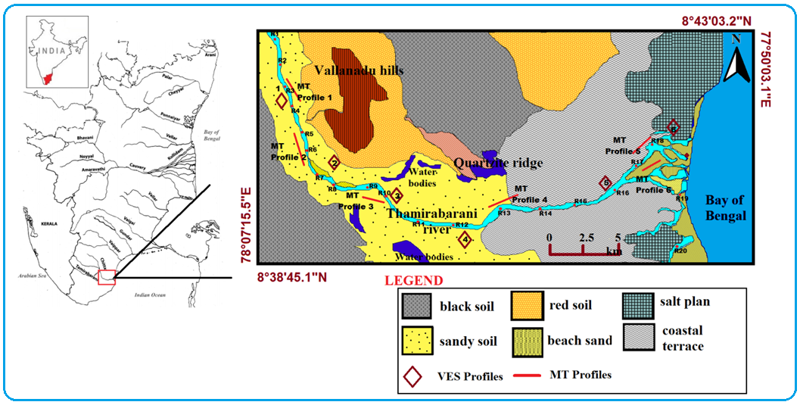
Fig.1 Location Map of the study area
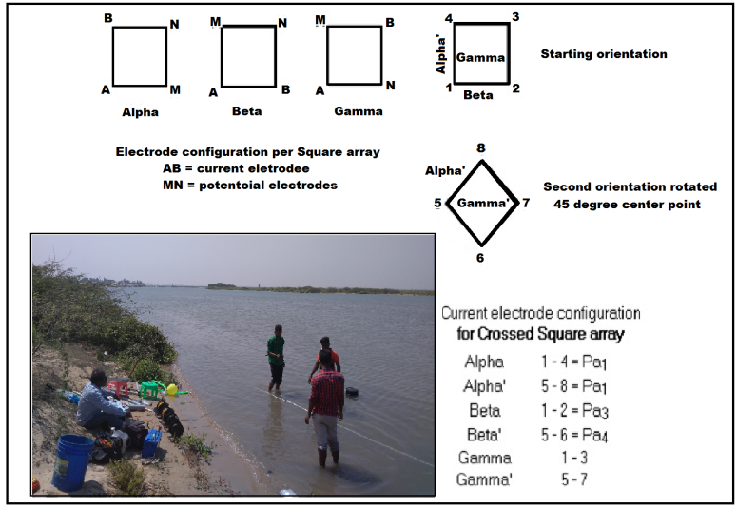
Fig.3 Square array data collection
4. Result and Discussion
4.1Square array method
In the study area, a six-square sounding of the electrical resistance in depth was carried out (Figure.3). It is a useful method and azimuthal variation of the groundwater zone, quartzite, gneisses, and granitic rock intrusions in the study area (Ravindran, A.A., 2018). Totally 6 VES profiles was carried from the Thamirabarani river basin area Table 1.

Table 1.Discussion about the VES profiles.
No.of.VES Profiles | Electrode spacing and depth (m) | Discussion
Profile 1 | 10m and 100m | The apparent resistivity range of 110-120 Ohm.m is indicating the presence of a shallow freshwater aquifer at a depth of 45–50m. The curve of a gradual increase in high resistivity indicates quartzite and massive charnockite rock.
Profile 2 | 10m and 100m | The apparent resistivity ranges from 100-130 Ohm.m, which indicates the presence of a shallow freshwater aquifer at a depth of 35-45m. The curve of a gradual increase in high resistivity indicates the cal-granulite, quartzite and massive charnockite rock
Profile 3 | 10m and 100m | The apparent resistivity in the range of 110-120 Ohm.m, indicate the presence of a shallow freshwater aquifer at a depth of 25-55m. The curve of a gradual increase in high resistivity indicates the gneiss, quartzite intrusion and massive charnockite rock
Profile 4 | 10m and 100m | The apparent resistivity ranges from 100-126 Ohm.m, which indicates the presence of a shallow freshwater aquifer at a depth of 45 and 65m. The curve of a gradual increase in high resistivity indicates the massive charnockite rock.
Profile 5 | 10m and 100m | The apparent resistivity ranges from 100-120 Ohm.m, which indicates the presence of a shallow freshwater aquifer at a depth of 50 and 65m. The curve of a gradual increase in high resistivity indicates the massive charnockite and weathered rock.
Profile 6 | 10m and 100m | The apparent resistivity in the range of 110-120 Ohm.m, indicate the presence of a shallow freshwater aquifer at a depth of 25, 40 and 55 meters. The curve of gradual increase in high resistivity indicates the massive charnockite rock.

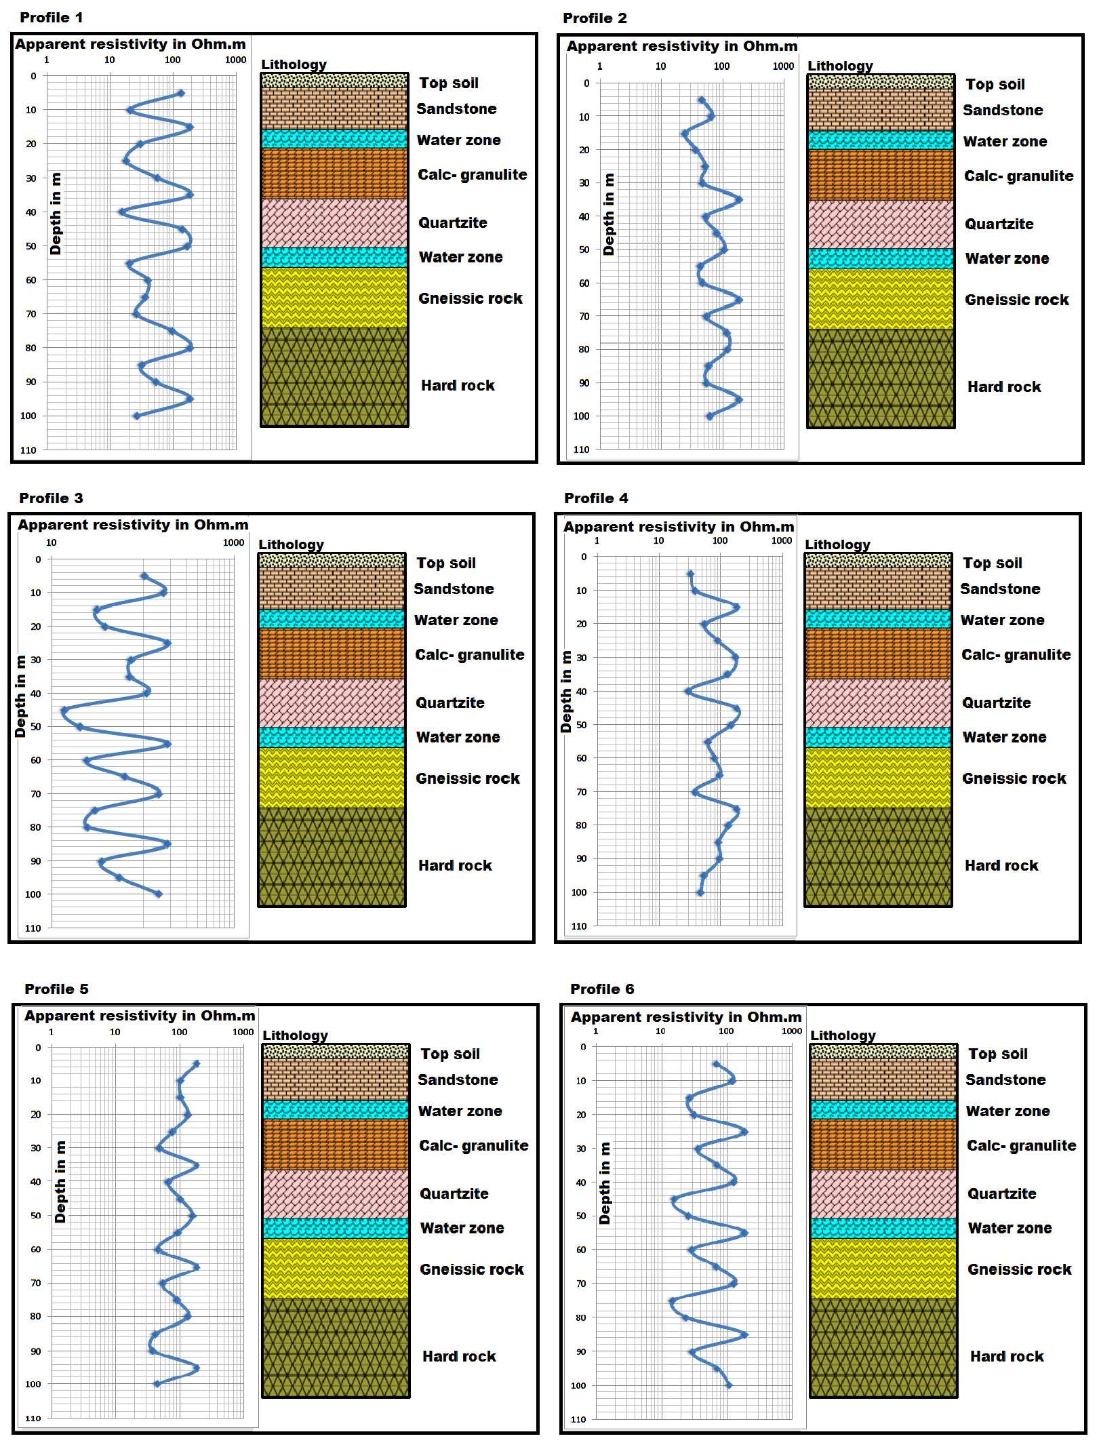
Fig.3 Square array data collection and profiles
4.2 Magneto Telluric Method:
Two copper electrodes are used for M, N electrodes for transmitting diversity to increase it and obtain greater depth information up to 300m (Jeyapaul VK, Jebamalai ARA, Selvam RA, 2020).The Magneto Telluric method carried out from 6 profiles was parallel to the Thamirabarani river basin Table 2.
Table 2.Discussion about the MT profiles.
No.of.MT Profiles | Distance and depth (m) | Discussion
Profile 1 | 120m and 300m | The profile was traversed at a distance of 110m at a depth of 300m. The high resistivity of 0.24-0.32 Ohm • m indicates sandy formations and a number of sandbars present in the area. The range of low resistivity is 0.03-0.12 Ohm m, which indicates moisture in the soil and underground aquifers at a depth of 130m. Weathered formation indicates 0.19-0.25 Ohm.m in lime concrete and gneiss rocks at distance 70m.
Profile 2 | 120m and 300m | The profile was traversed at a distance of 110m at a depth of 300m. A high resistivity of 0.27-0.32Ohm.m indicates sand formations and vertical formations at a distance of 80-90m in the area. The range of low resistivity is 0.03-0.12 Ohm.m, which indicates moisture in the soil and groundwater aquifers at a depth of 50m. Weathered formation indicates 0.12-0.21Ohm.m in calc-granulite and gneiss rocks
Profile 3 | 120m and 300m | The profile was traversed at a distance of 110m at a depth of 300m. The high resistivity of 0.28-0.32Ohm.m indicates sandy formations in the area. The range of low resistivity is 0.04-0.16Ohm.m, which indicates the moisture content of the soil and underground aquifer at a depth of 190-240m. Weathered formation indicates the intrusion of lime concrete and some quartzite, gneiss rocks at 0.19-0.25Ohm.m at a depth of 140m.
Profile 4 | 120m and 300m | The profile was traversed at a distance of 110m at a depth of 300m. The high resistivity of 0.12-0.15Ohm.m indicates sandy formations in the area. The range of low resistivity is 0.04-0.07Ohm.m, which indicates the moisture content of the soil and underground aquifers at a depth of 280m. Weathered formation indicates the presence of 0.09-0.011Ohm.m in the intrusion of quartzite, gneiss rocks depth 90 m.
Profile 5 | 120m and 300m | The profile is covered with a length of 140m at a depth of 300m. The high resistivity of 0.26-0.32Ohm.m indicates the presence of river alluvium or sandy formation in the area. The range of low resistivity is 0.10-0.18 Ohm-m, which indicates moisture in the soil and underground aquifers at distances of 80m, 90m and 100m, weathered formation, indicates and penetration of gneiss rocks to a depth of 30 m and 90 ohms into 0.20-0.24 ohms
Profile 6 | 120m and 300m | The profile is covered with a length of 120m at a depth of 300m. The presence of river alluvium or sandy formation in the area. The range of low resistivity is 0.09-0.21Ohm.m, which indicates soil moisture and groundwater penetration to a depth of 120m. Weathered formation indicates the calc granulite penetration and gneiss rocks at 0.25-0.32Ohm.m, per depths of 30 and 90 meters.

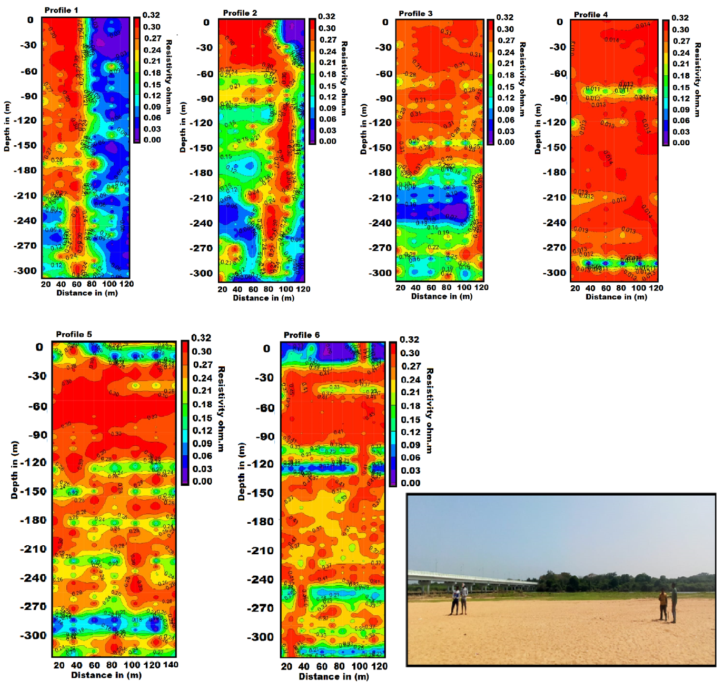
Fig.4 Magneto telluric survey and profiles

5.Conclusion

The Azimuth square array is a useful resistivity array for aquifer mapping for drinking and agriculture purposes. The apparent resistivity range of 110–123 ohm/m denotes fresh water in quartzite. The apparent resistivity ranges of 14–75 ohm.m. (red and sandy soil with rock fragments), 25–100 ohm.m. (weathered gneissic rock), 100–200 ohm.m. (quartzite rock), and 200–1000 ohm.m. (massive charnockite) are used for subsurface geological formation and its aquifer characteristics at shallow and deeper levels. The magneto-telluric method is used for subsurface, deeper aquifer mapping. The average resistivity of 0.03-0.12 ohm/m is indicated for the aquifer. The fractured quartzite is 0.15-0.18 ohm/m, and 0.021-0.32 ohm/m indicates charnockite. The water-bearing zone is clearly mapped in the magneto-telluric profile at 50m depth. The infiltration of rainwater is both a monsoon and irrigation water, and a small part is artificially recharged. Especially for shallow aquifers, the impact of irrigation water infiltration on the recharge of the aquifer is very significant. Rock-water interaction studies are used to distinguish the sources of gneiss and quartzite for drinking water and fresh water for agriculture. The tributary of the Tamirabarani channel adds a zone of broken quartzite.

Acknowledgements
The First author expresses his sincere thanks to Mr. A.P.C.V. Chock lingam, Secretary and our Principal, Dr. C. Veera Bhahu, V.O.C. College, Tuticorin. The helps extended by Dr. P. Sivasubramanian, Professor and Head, PG and Department of Geology, V.O. Chidambaram College, Thoothukudi.

References
Ali, A., Rehman, K., Tayyab, O., Zaman, T., Jameel, M., Khan, A., ... & Irfan, M. (2020). Exploring Placer Gold Deposits through Integrated Geophysical and Geochemical Techniques at the Confluence of the Indus and Kabul Rivers, NW Pakistan. Acta Geologica Sinica‐English Edition, 94(5), 1440-1450. https://doi.org/10.1111/1755-6724.14584
Alile, M. O., Jegede, S. I., & Ehigiator, O. M. (2010). Underground water exploration using electrical resistivity method in Edo State, Nigeria. Asian Journal of Earth Sciences, 3(1), 57-61.
Dogara, M. D., Dewu, B. M., & Ajayi, C. O. (1998). Groundwater potential of Romi, Kaduna, Nig. J. Physics, 10, 85-90.
Jeyapaul, V. K., Jebamalai, A. R. A., Selvam, R. A., Krishnaveni, A. S., & Johnson, A. A. P. A. (2020). A case study of freshwater discharge in porous calcarenite formation in coastal terrace at Manapad, South India. Carbonates and Evaporites, 35(4), 1-14. https://doi.org/10.1007/s13146-020-00641-1
Kammoun, S., Trabelsi, R., Re, V., & Zouari, K. (2021). Coastal Aquifer Salinization in Semi-Arid Regions: The Case of Grombalia (Tunisia). Water, 13(2), 129. https://doi.org/10.3390/w13020129
Keller, G. V., & Frank, C. (1966). Electrical methods in geophysical prospecting.
Mondal, P., Schintu, M., Marras, B., Bettoschi, A., Marrucci, A., Sarkar, S. K., ... & Biswas, J. K. (2020). Geochemical fractionation and risk assessment of trace elements in sediments from tide-dominated Hooghly (Ganges) River Estuary, India. Chemical Geology, 532, 119373. https://doi.org/10.1016/j.chemgeo.2019.119373
Nwankwo, L. I. (2011). 2D resistivity survey for groundwater exploration in a hard rock terrain: A case study of MAGDAS observatory, UNILORIN, Nigeria. Asian Journal of earth sciences, 4(1), 46.
Olasehinde, P. I. (1999). An integrated geological and geophysical exploration techniques for groundwater in the basement complex of west central part of Nigeria. Journal of National Association of Hydrogeologist (Water Resources), 10(1), 46-49.
Ravi, R., Aravindan, S., Ramachandran, C., Balabantaray, S. K., Selvaraj, B., & Santhakumar, K. (2021). Pore resistivity variation by Resistivity imaging technique in sedimentary part of main Gadilam river basin, Cuddalore District, Tamil Nadu, India. Journal of Applied and Natural Science, 13(1), 268-277. https://doi.org/10.31018/jans.v13i1.2541
Ravindran, A. A. (2012). Azimuthal square array method and groundwater potential zone in hard rock area in Thoothukudi District, Tamilnadu. Archives of Applied Science Research, 4(2), 971-979.
Ravindran, A. A., Kingston, J. V., & Premshiya, K. H. (2020). Mitigation Dredging in Seabed Geotechnical Engineering Study Using Marine 2D ERI and Textural Characteristics in Thengapattanam Harbour, South India. Geotechnical and Geological Engineering, 1-11. https://doi.org/10.1007/s10706-020-01530-z(01
Ravindran, A. A., Muthusamy, S., Moorthy, G. M., Vinothkingston, J., & Mohana, P. (2018). Groundwater–quartzite area study using square array method in Puthukottai, Tuticorin District, Tamilnadu, India. International Journal of Advanced Multidisciplinary Scientific Research (IJAMSR) ISSN: 2581-4281 Vol, 1, 43-54. https://doi.org/10.31426/ijamsr.2018.1.10.1016
Sendrós, A., Himi, M., Lovera, R., Rivero, L., Garcia‐Artigas, R., Urruela, A., & Casas, A. (2020). Electrical resistivity tomography monitoring of two managed aquifer recharge ponds in the alluvial aquifer of the Llobregat River (Barcelona, Spain). Near Surface Geophysics, 18(Geoelectrical Monitoring), 353-368. https://doi.org/10.1002/nsg.12113
Suresh, U., & Basha, U. I. (2020). Geophysical studies on the Shallow Groundwater Aquifer in drought prone Somavathi River basin, Ananthapuramu district (Andhra Pradesh), India: A case study. J. Ind. Geophys. Union, 24(5), 36-44.

