Chapter
WASTE MANAGEMENT IN FOOD AND AGRICULTURAL INDUSTRIES

Introduction:
In the 21st century, as a result of increased industrialization and rapid urbanization, the agricultural and farming sectors are undergoing a steady decline. This trend is contributing to a decrease in global food production, exacerbating issues concerning climate change and environmental challenges. These issues have a direct and indirect impact on human well-being, primarily through the generation of surplus in the food and agriculture sector.
To address these pressing concerns, it is imperative to adopt a comprehensive strategy that harnesses a diverse array of technological innovations for effective food and agricultural surplus management. Although many countries have already taken steps to mitigate food and agricultural surplus, the obstacles ahead are formidable, demanding intensified efforts. By collectively advancing the reduction of surplus in the food and agriculture sector, we can substantially improve our ability to manage food costs, tackle environmental problems, and reduce greenhouse gas emissions.
The management of food and agricultural surplus has emerged as a critical concern in the contemporary context. The levels of surplus in food and agriculture have already reached critical proportions, posing a substantial threat to our environment and the planet as a whole. Consequently, it is imperative to implement efficient practices for managing food and agricultural surplus within a framework that prioritizes the principles of reduction, conservation, recycling, repurposing, and reuse.

What is waste?
Waste, often referred to as "wastes" in its plural form, denotes materials that have become unwanted or no longer serve a purpose. It encompasses any substance that is discarded after its initial use or materials deemed to have no value, be defective, or lack utility. In contrast, a by-product can be described as a secondary product with relatively limited economic value. It is important to note that a waste product has the potential to be transformed into a by-product, co-product, or even a valuable resource through the introduction of an innovation or process that increases its value beyond zero.

The Necessity of Waste Management:
The central goal of waste management is to alleviate the adverse effects of waste on both human well-being and the environment. Regrettably, our environment is degrading at an alarming rate, and it might not be too far into the future when our planet struggles to contend with the vast quantities of waste generated and its harmful repercussions.
Given this predicament, one cannot stress enough the importance of effective waste management. Countries across the globe are progressively acknowledging the dangers linked to inadequate waste disposal procedures.

What Constitutes Waste Management?
Waste management, also known as waste disposal, encompasses a set of protocols and actions essential for the handling of waste from its origin to its ultimate elimination. This comprehensive process includes waste collection, transportation, treatment, and final disposal, all while overseeing and regulating the waste management system. It also involves the establishment of laws related to waste, the development of technologies, and economic mechanisms.

The Waste Management Hierarchy:
The waste management hierarchy is a framework that prioritizes diverse waste management practices to attain sustainable waste management. It outlines a sequence of waste management options, ranging from the most favoured to the least favoured:
- Prevention: At the top of the waste hierarchy, the primary focus for sustainable waste management is waste prevention. It aims to prevent materials from becoming waste in the first place, rather than managing them as waste.
- Minimization: Waste minimization involves a series of processes and strategies aimed at reducing the volume of waste generated. By diminishing or eliminating the creation of harmful and long-lasting waste, waste minimization contributes to the promotion of a more sustainable society. This approach entails redesigning products and processes or making changes in societal consumption and production patterns.
- Reuse: Reuse refers to using an item either for its original purpose (conventional reuse) or for a different function (creative reuse or repurposing). It differs from recycling, which involves breaking down used items to create raw materials for producing new products. Reuse, by making use of previously used items without further processing, helps conserve time, money, energy, and resources.
- Recycling: Recycling involves the process of converting waste materials into new materials and objects. This often includes recovering energy from waste materials.
- Disposal: Waste disposal encompasses the methods and steps necessary for managing waste from its generation to its final disposal. This encompasses waste collection, transportation, treatment, and disposal, along with overseeing and regulating the waste management process and implementing waste-related laws, technologies, and economic mechanisms.

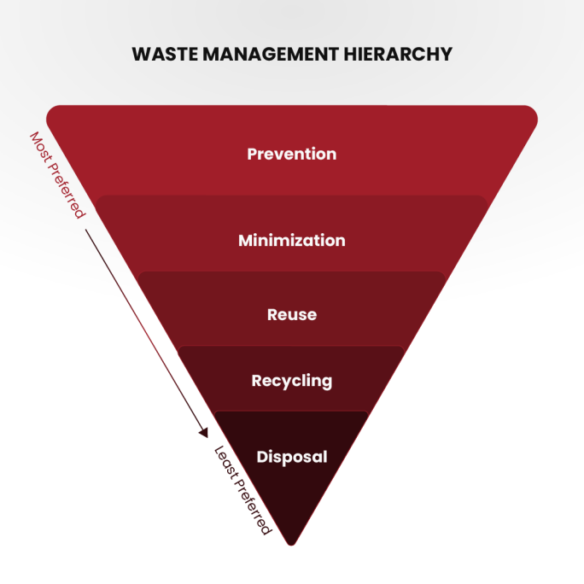
Management of Food and Agricultural Waste:
The food and agricultural waste management system is a meticulously structured framework consisting of all the essential components needed to regulate and harness the by-products generated during food and agricultural production. Its primary objective is to ensure that these by-products are handled in a way that either maintains or enhances the quality of our air, water, soil, flora, fauna, and energy resources.
- Sustainable Agricultural Technology in Food and Agricultural Waste Management: The comprehensive process of collecting, transporting, disposing of, recycling, and monitoring agricultural waste is termed food and agricultural waste management. This pivotal process aims to recycle food and agricultural waste to mitigate the adverse effects of waste on the environment, health, and aesthetics. Various methods are employed for waste management, including landfilling, incineration, anaerobic digestion, pyrolysis, plasma gasification, recycling, and composting. Anaerobic digestion yields biofuel in the form of biogas, while plasma gasification generates electricity from waste. Recycling food and agricultural waste involves collection, sorting, and reprocessing to create new products. Particularly, vermicomposting is the preferred composting method due to its production of vermicompost, often referred to as "black gold" due to its rich nutrient content and growth-enhancing properties.
- The Surge in Waste Accumulation: The accumulation of waste has surged due to the effects of industrialization, urbanization, and the growth in population density. This waste comprises a variety of materials, including radioactive substances, agricultural waste, food waste, industrial waste, and municipal waste, which includes items like garbage and paper waste. The availability of open land and space for waste disposal has dwindled significantly due to the extensive conversion of agricultural land into residential, industrial, and commercial zones. To alleviate the burden of food and agricultural waste on our planet, there is an urgent need to enhance the collection, transportation, recycling, and disposal of these wastes.
- The Significance of Sustainable Management: Managing food and agricultural waste can be financially demanding, underscoring the importance of comprehending effective, sustainable, and secure waste management methods. The principles of "Reduce, Reuse, and Recycle" have become fundamental in food and agricultural waste management due to the increasing waste output, escalating processing expenses, and diminishing landfill capacity. Adaptability is crucial in food and agricultural waste management systems to respond to evolving environmental, social, and economic circumstances. Gathering information and feedback through system analysis is invaluable for optimizing, evaluating, adapting, and defining food and agricultural waste management systems.
- Waste Reduction and Reuse: At the forefront of waste management priorities lies the reduction of food and agricultural waste, as the most efficient waste management approach is to prevent waste generation in the first place. Waste reduction can also be accomplished through the reuse of products. These strategies help conserve natural resources, reduce waste generation, and lower the costs associated with food and agricultural waste disposal.
- Diverse Approaches to Management: Food and agricultural waste management encompasses a wide array of waste forms, including solid, liquid, and gaseous materials. Management techniques vary between rural and urban settings, municipal and industrial waste, and developed and developing nations. Typically, local governments oversee municipal waste management, while farmers are responsible for managing agricultural waste. Developed nations employ innovative technologies and efficient management practices to minimize the adverse effects of waste and harness its potential.

Categories of Agricultural Waste Management:
The food and agricultural sector generates a diverse array of raw and solid waste. These waste materials, originating from food and agriculture, find their way into the atmosphere, water bodies, or the soil. Solid waste comprises materials that are discarded at the place of their origin.
In most food and agricultural sectors, the primary objective is the production of marketable products. Effective management necessitates a delicate balance among multiple intricate and interrelated systems, which encompass:
- Cropping systems
- Livestock systems
- Irrigation and drainage systems
- Pest control systems
- Soil conservation systems
Different techniques and equipment are required to manage food and agricultural waste of varying consistencies. Such waste can manifest in liquid, slurry, semisolid, or solid states. For instance, the consistency of manure can vary throughout the year. The critical factor that determines how this material can be handled is its total solid concentration.
Several factors influence the total solid concentration within a system, including climatic conditions, the type of animals, water usage, and the type of feed. In most cases, the consistency of the waste can be anticipated or determined.

Factors in Food and Agricultural Waste Management:
- Production: This step involves the evaluation of the quantity and characteristics of waste generated by agricultural activities. The need for waste management arises when the volume of waste becomes significant enough to warrant attention. A comprehensive analysis of production takes into account the type, consistency, volume, location, and timing of waste generation. The waste management system should also be adaptable to accommodate fluctuations in production across seasons.
- Collection: Collection refers to the initial gathering and transport of waste from its point of origin or deposition to a designated collection point. This phase includes scheduling collections, estimating labor requirements, procuring necessary equipment, establishing structural facilities, and managing installation costs.
- Transfer: Transfer involves the movement and transportation of waste within the system. It encompasses the transport of waste from the collection point to storage and subsequently to treatment facilities.
- Storage: Storage entails the temporary containment of waste. Storage facilities within the waste management system offer the manager control over the timing and scheduling of system operations.
- Treatment: Treatment includes all processes designed to mitigate the potential for pollution or alter the physical attributes of waste, such as moisture content, to enable more efficient and effective handling.
- Utilization: Utilization involves the reuse and recycling of waste products. Food and agricultural waste can serve as valuable sources of energy, bedding, mulch, organic matter, and plant nutrients, which can have commercial applications.
Food and Agricultural Waste Management Design involves the planning of waste management activities, from production to utilization. It includes a set of practices to be implemented, the location of key components, and a timeline for installation.
Typical Food and Agricultural Waste Management Systems encompass dairy waste management, beef waste management, swine waste management, poultry waste management, and waste management for other livestock such as sheep and goats. It also encompasses waste management for food processing and agricultural chemical waste.

Managing Food Processing Waste:
Food processing facilities generate significant quantities of waste, which can manifest as solid, slurry, or liquid materials. Evaluating the chemical characteristics of this waste is essential before establishing a waste management system. If the waste is of biological origin, it can be managed in a manner similar to how livestock waste is handled.
Certain types of food processing waste can be subject to treatment through waste treatment facilities. To determine the appropriate volumetric or actual loading rates, a thorough analysis of the waste material is required to measure its volatile solids content or biochemical oxygen demand (BOD) concentration. Since some food processing plants operate seasonally, it may be necessary to design facilities with additional capacity to accommodate expected periodic heavy organic loads.
Enhancing methane production can be achieved by combining food waste with animal manure in an anaerobic digester. However, the acceptable ratios of animal manure to food waste mixtures are regulated at the state level.
Prior to land application, obtaining the necessary permits and adhering to state and local regulations is crucial. Many permits stipulate continuous monitoring of groundwater and, in some cases, soil and plant matter. The hydraulic loading aspect is often overlooked in this process. In cases where the site has a high water table or low permeability, the volume of water that can be applied is typically reduced. Additionally, certain instances may involve food processing waste with excessive salt levels, making land application unfeasible. Therefore, it is advisable for most land application sites for food processing waste to be designed by experienced professionals well-versed in these systems.

Managing Agricultural Chemical Waste:
Numerous agricultural operations utilize significant quantities of agricultural chemicals, which can result in escalating labor costs. This heightened chemical usage also elevates the risk of surface and groundwater pollution due to the improper storage of chemical residues, rinse water, unused chemicals, and the improper disposal of empty containers. When designing systems for chemical handling, it is imperative to take into account state and local regulations.

Conclusion:
In summary, governments, civil societies, and private enterprises across the globe have made substantial efforts to confront issues related to food and agricultural waste by implementing legal frameworks, inventive technologies, and alternate approaches. It is essential for individuals to engage in the practices of waste reduction and reuse to safeguard our planet from potential environmental crises. Developed nations should extend their expertise in effective food and agricultural waste management to developing countries, promoting international collaboration in the preservation of our shared Earth for the well-being of future generations.

References:-
- https://pecb.com/article/waste-management-in-food-industry
- https://myethicalchoice.com/en/journal/waste-management/the-importance-of-waste-management/
- https://www.earthreminder.com/waste-management-and-its-importance/
- https://www.researchgate.net/publication/345687135_Modern_Waste_Management_Techniques_-_A_Critical_Review
- Food and Agricultural Waste Management; SanjayMehrotra,Professor in Management Hosei University, Tokyo, Japan, AdvAgriHorti and Ento: AAHE-149,May 02, 2021.

