**Battery Health Monitoring System Using Arduino Nano Microcontroller: Evaluating Performance and Anomaly Detection for 21700-Type Lithium-Ion Batteries**

G.Naresh1, T.Praveen Kumar2*, Aaryan Anil3**#**, M.Aswathy4**#**

1, 2 Department of Automobile Engineering, SRM Institute of Science & Technology, Kattankulathur Campus, Chengalpattu – 603 203, TamilNadu, India.

3, 4 Department of Mechanical Engineering, SRM Institute of Science & Technology, Kattankulathur Campus, Chengalpattu – 603 203, TamilNadu, India.

***\*Corresponding author:- E-mail:*** [praveent@srmist.edu.in](mailto:praveent@srmist.edu.in)**|| *Tel:*** +91 99429 48046

**Abstract**

Battery monitoring plays a vital role in ensuring the safe and efficient operation of batteries in diverse applications. This research presents the development and evaluation of a robust battery health monitoring system, leveraging the versatility of the Arduino Nano microcontroller. The system accurately measures and analyzes essential battery parameters, including voltage, current, and temperature, during charging and discharging cycles of both healthy and physically damaged 21700-type lithium-ion batteries. The results reveal a systematic and comprehensive understanding of battery behavior, confirming the voltage profiles' adherence to fundamental electrochemical principles. The system effectively detects anomalies in physically damaged batteries, indicating reduced capacity and increased internal resistance, using a real-time comparison-based anomaly detection algorithm. This scientific endeavor underscores the significance of battery monitoring systems for proactive maintenance, optimization of battery life, and ensuring sustainable and efficient energy management in contemporary applications.

***Keywords:*** Battery monitoring, Arduino Nano, Lithium-ion battery, Anomaly detection, Energy management.

**1. Introduction**

In recent era, Electric vehicles (EVs), portable electronics, remote power systems, and other environmentally friendly and economically viable demands are made possible by battery advancements [1]. Battery monitoring is a critical process that plays a pivotal role in ensuring the safe and efficient operation of batteries across a wide range of applications, including portable devices, electric vehicles, renewable energy systems, and more [2]. In our context, the research gap revolves around the need for a cost-effective, customizable, and accessible Battery Management System (BMS) solution that can cater to specific research requirements. While numerous commercial BMS options exist, they often entail high costs and offer limited flexibility, which diminishes their suitability for research purposes where customization and experimentation hold paramount importance [3]. The existing research in battery management often focuses on industrial or commercial applications, leaving a gap in the context of academic or small-scale research projects. Researchers and scholars working on EVs and battery-related studies, such as novel battery chemistries, emerging technologies, or innovative BMS algorithms, may face challenges in finding an appropriate motors and BMS solution that aligns with their budgetary constraints and specific experimental needs [4]. Moreover, traditional BMS solutions may be complex and require specialized knowledge in electronics and programming, making them less accessible to researchers from diverse backgrounds, particularly those with limited technical expertise [5]. There is a demand for an accessible BMS platform that can be easily adapted and implemented by researchers in various disciplines, including but not limited to electrical engineering, materials science, renewable energy, and IoT applications [6].

Hence, in our context, there is an opportunity to bridge this research gap by exploring the potential of an Arduino-based Battery Management System. By utilizing the Arduino platform, researchers can develop a BMS that is cost-effective, customizable, and user-friendly. Arduino's open-source nature fosters a supportive community of developers and enthusiasts, providing access to valuable resources and code examples, thereby enabling easier implementation and troubleshooting. Addressing this research gap through an Arduino-based BMS can enhance the research capabilities of academic institutions, research laboratories, and individual researchers. It can facilitate rapid prototyping and proof-of-concept studies for novel battery technologies, while also serving as an educational tool to impart battery management knowledge to students and aspiring researchers. Leveraging the Arduino Nano's unique features, including effortless code uploading via a USB cable and simplified C++ programming, the system is designed to facilitate seamless and efficient monitoring of crucial battery parameters. The primary objective of this research article is therefore to introduce and evaluate the battery monitoring system, elucidating its technical design and capabilities. Specifically, the system monitors essential parameters such as battery voltage, temperature, and current during both charging and discharging cycles. Furthermore, the system's efficacy is assessed by investigating two different battery scenarios: one involving a healthy 21700-type lithium-ion battery and the other a physically damaged counterpart. By providing real-time insights into battery performance and health, this monitoring system empowers users to take proactive maintenance measures, optimize battery life, and ensure safe and reliable energy storage and usage. Therefore, this research aims to address the need for a cost-effective, customizable, and accessible Battery Management System (BMS) that can cater to specific research requirements, particularly focusing on the 21700-type lithium-ion batteries. These batteries offer several unique advantages as reported in literature [7], which make them an ideal choice for modern energy storage and management:

* ***Higher Energy Density****:* 21700-type lithium-ion batteries exhibit a higher energy density compared to traditional battery types, providing longer operational times for devices and systems.
* ***Improved Thermal Performance****:* These batteries typically have better thermal management, reducing the risk of overheating during charging and discharging, which enhances safety.
* ***Enhanced Cycle Life:*** 21700-type cells often have a longer cycle life, maintaining a larger percentage of their initial capacity even after a significant number of charge and discharge cycles.
* ***Higher Discharge Rates****:* They can handle higher discharge rates, making them suitable for applications where rapid bursts of energy are needed.

By focusing on 21700-type lithium-ion batteries and leveraging the Arduino Nano microcontroller, this research endeavours to develop a versatile and effective BMS solution that empowers researchers to explore novel battery technologies, detect anomalies, and optimize energy storage and management for sustainable applications.

In the subsequent sections of this article, we present a comprehensive experimental description detailing the components and setup of the battery monitoring system. Additionally, we provide a thorough analysis of the obtained results during charging and discharging processes of both healthy and physically damaged lithium-ion batteries, followed by insightful discussions. The conclusions drawn from this research will shed light on the potential benefits of employing such monitoring systems and pave the way for future advancements in battery technology.

**2. Experimental Description**

The experimental setup is designed to create a robust and versatile battery monitoring system, integrating various components to accurately measure and analyze crucial battery parameters. The following key components are utilized in the development of the battery monitoring system:

1. *Arduino Nano:* The Arduino Nano (Figure 1) microcontroller board serves as the core component of the battery monitoring system. Its compact size and flexibility make it an ideal choice for embedded applications and real-time data acquisition [8]. The Arduino Nano's open-source nature also enables seamless code uploading via a USB cable and simplified C++ programming, contributing to the system's user-friendliness and accessibility.

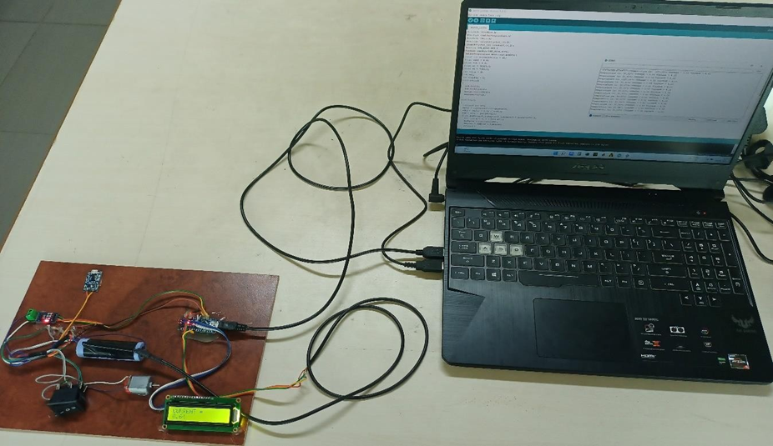

**DAQ**

**TP4056 charging Module**

**ATmega328**

**LCD 12C display**

**Current**

**sensor**

**Li-ion cell**

**Figure 1. Hardware setup using Arduino nano**

1. *TP4056:* A constant voltage linear charger, the TP4056 is specifically designed for charging lithium-ion batteries. It operates efficiently with USB and wall adapters, ensuring a safe and controlled charging process. The charge voltage is fixed at 4.2V, and external control is achieved through a single resistor.
2. *Current Sensor:* Essential for power calculation and management, the Acs712 current sensor accurately measures the current flowing through the battery during charging and discharging cycles. It provides an output analog signal proportional to the magnitude of the current.
3. *Resistance Voltage Measurement:* To achieve precise battery voltage measurements, a voltage or potential divider is implemented. This passive circuit takes advantage of the voltage drops across components connected in series, facilitating accurate voltage monitoring.
4. *LCD Display:* A 16x2 LCD I2C display is incorporated into the system to provide a user-friendly interface for displaying real-time information related to the connected electronic projects.
5. *Temperature Sensor:* The DS18B20 digital temperature sensor is chosen for its high accuracy and wide temperature range. It enables continuous monitoring of battery temperature during charging and discharging processes.
6. *Lithium-ion Battery (good condition battery):* A healthy 21700-type lithium-ion battery (Figure 2) is employed to evaluate the battery monitoring system's performance under standard operating conditions. The specifications of the cell employed is listed in Table 1.

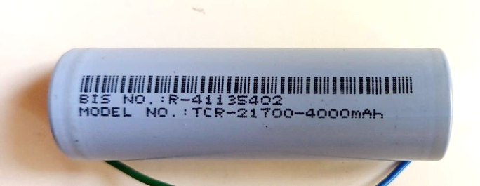

**Figure 2. 21700 Li-ion cell**

**Table 1. Specifications of 21700 Li ion cell**

|  |  |
| --- | --- |
| Typical Capacity | 4000 mAh |
| Nominal Voltage | 3.7 V |
| Charge Current (standard) | 0.25 C/1000 mA |
| Charge Current (maximum) | 0.5 C/2000 mA |
| Charge cut-off voltage | 4.2±0.03V |
| Charge Current (standard) | 0.5 C/2000 mA |
| Charge Current (maximum) | 1 C/4000 mA |
| Cycle Life | ≥80% initial capacity after 1000 cycles |
| Working Temperature | 0 to 45 °C |
| Weight | 69±2 g |

1. *Damaged Lithium-ion Battery:* In addition to the healthy battery, an equal configured yet physically damaged 21700-type lithium-ion battery (Figure 3) is utilized to assess the system's capability to detect anomalies and identify potential battery issues. This component simulates real-world scenarios where battery performance may be compromised due to degradation or physical damage, enabling the system's anomaly detection effectiveness to be assessed.

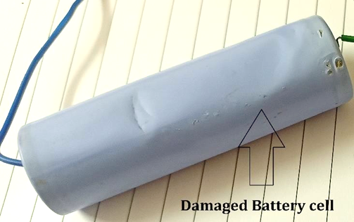

**Figure 3. Physically damaged Lithium-ion cell**

The selection of each component is driven by its compatibility with the monitoring system's objectives and the need to achieve accurate and reliable data acquisition. This comprehensive selection process ensures the effectiveness and robustness of the battery monitoring system for assessing battery health and performance.

The experimental setup follows a systematic approach, beginning with the calibration and configuration of the Arduino Nano microcontroller. The sensors, including the Acs712 current sensor and DS18B20 temperature sensor, are meticulously calibrated to ensure accurate data acquisition. The voltage divider circuit is carefully designed to provide precise battery voltage measurements. The battery monitoring system is then subjected to comprehensive testing and validation. During the testing phase, the healthy 21700-type lithium-ion battery is charged and discharged multiple times, and data is recorded for voltage, current, and temperature at regular intervals. Simultaneously, the 16x2 LCD I2C display shows real-time updates, allowing users to monitor the battery's performance throughout the charging and discharging cycles.

Furthermore, the battery monitoring system is evaluated under challenging conditions using the physically damaged 21700-type lithium-ion battery, following the SAE standards. This damaged battery simulates real-world scenarios where batteries might exhibit abnormal behavior due to degradation, internal faults, or physical damage. The ability of the monitoring system to detect deviations from expected behavior and potential hazards is carefully assessed. The experimental data collected from both the healthy and physically damaged battery scenarios are analyzed and compared. The results are meticulously evaluated to ascertain the system's accuracy, sensitivity, and overall performance. This comprehensive analysis serves to validate the effectiveness of the battery monitoring system and its potential to provide valuable insights into battery health and performance.

**3. Results and Discussions**

The battery monitoring system successfully recorded and analyzed crucial battery parameters during charging and discharging cycles of both healthy and physically damaged 21700-type lithium-ion batteries. The results obtained during the charging process of the healthy battery is plotted in Figure 4, where it can be seen that there is a gradual increase in voltage from approximately 1V to 4.2V over 3 hours and 36 minutes, which is consistent with typical behavior in rechargeable batteries, wherein chemical reactions restore energy during charging [9]. The observed charging time is influenced by battery capacity, charging current, and the adopted charging algorithm.

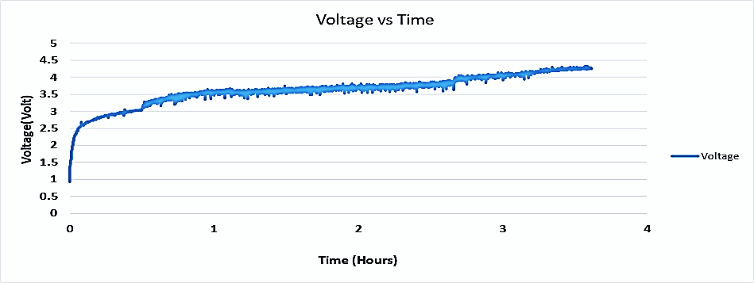

**Figure 4. Voltage vs Time**

Simultaneously, as can be seen from Figure 5, the temperature increased from 32.19°C to 34.75°C due to internal resistance, efficiency, and heat dissipation. During discharging of the healthy battery, the gradual voltage declines from 4.2V to approximately 1V over 5 hours is attributed to the release of stored energy during chemical reactions. The discharge time is influenced by battery capacity and discharge current [10]. The temperature rises from 30.81°C to 35.5°C reflects internal resistance and efficiency-related heating. For the physically damaged battery, charging resulted in a voltage increase from 1V to approximately 2V over 42 minutes, with a corresponding temperature increase from 32.19°C to 33.73°C. The inability of the voltage to reach the optimal level may be attributed to factors such as insufficient charging time, inadequate charging current, or reduced battery capacity [11].

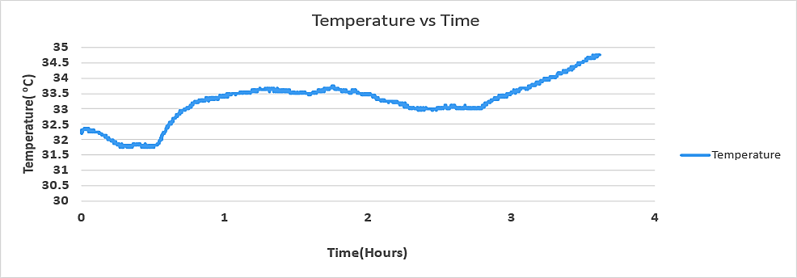

**Figure 5. Temperature vs Time**

During discharging of the physically damaged battery, the voltage rapidly decreased from approximately 2.12V to 0V in 17 minutes, with the current ranging from 0.4A to 0.5A, and the temperature increased from 33.5°C to 34.81°C. Figure 6. shows the discharging of battery and decrease in voltage from fully charged state and Figure 7 shows the simultaneous temperature variation with respect to the time. The observed short discharge time and rapid voltage decline indicate potential health issues, including reduced capacity and increased internal resistance [12]. These results provide valuable insights into battery performance and health, enabling informed decisions for proactive maintenance and safe battery usage.



**Figure 6. Voltage vs Time**



**Temperature(C)**

**Figure 7. Temperature vs Time**

The observed voltage changes during charging and discharging processes conform to fundamental electrochemical principles governing lithium-ion batteries. During charging, the gradual voltage increase is attributed to the movement of lithium ions from the positive electrode (cathode) to the negative electrode (anode), leading to the restoration of stored energy [13]. As the battery reaches its full charge, the charging process terminates, resulting in a stable voltage at 4.2V for lithium-ion batteries. Conversely, during discharging, the voltage decreases as lithium ions move from the negative electrode to the positive electrode, discharging stored energy to power the connected load. The rate of discharge depends on the battery's capacity and the current drawn by the load, with higher discharge currents leading to faster energy depletion and a shorter discharge time [14]. In the case of the physically damaged battery, the inability to reach the optimal voltage level during charging is indicative of internal degradation, which hinders the battery from achieving its full capacity [15]. Similarly, the rapid voltage decline and short discharging time during discharging suggest a compromised battery, possibly due to increased internal resistance and reduced capacity [16]. These scientific insights underscore the significance of employing battery monitoring systems for early detection of anomalies and effective battery health assessment, enabling informed decision-making for safe and efficient energy storage and usage.

**4. Implications and Practical Applications**

The observed anomalies in the physically damaged battery, specifically the reduced capacity and increased internal resistance, have significant implications for both safety and performance in real-world applications. Understanding these implications can guide the development of more effective battery management strategies to enhance safety and optimize performance [17].

In terms of safety, the detection of reduced capacity in a damaged battery is crucial to prevent situations where the battery may unexpectedly run out of power or fail to meet the energy requirements of the application. This finding can prompt proactive maintenance, allowing damaged batteries to be replaced before critical scenarios arise [18]. Furthermore, the ability to identify increased internal resistance is essential for avoiding excessive heat generation, which can lead to overheating, reduced efficiency, and potentially hazardous situations in certain applications, such as electric vehicles or high-power energy storage systems [19].

For performance optimization, the rapid decline in voltage and discharge time in the physically damaged battery highlights the importance of continuous monitoring during operation. By implementing real-time monitoring systems based on the insights gained from this study, users can be alerted to anomalies as they occur, allowing for timely intervention. This, in turn, enables improved energy management, prolonged battery life, and enhanced overall system efficiency [20].

In practical scenarios, such as electric vehicle fleets or renewable energy installations, these findings can be utilized to implement early warning systems for battery health. Integrating the battery monitoring system described in this research could lead to more efficient usage of batteries, reducing downtime and maintenance costs. Additionally, the data collected from the monitoring system could contribute to a database of battery health profiles, enabling predictive maintenance schedules and informed decision-making regarding battery replacements [21].

Overall, the insights gained from this study provide a foundation for the development of robust battery management strategies that prioritize safety, extend battery life, and optimize performance in various applications, ultimately contributing to the advancement of sustainable and efficient energy management practices.

**Conclusion**

The battery monitoring system, built around the Arduino Nano microcontroller, demonstrated its effectiveness in capturing and analyzing crucial battery parameters during charging and discharging cycles of healthy and physically damaged 21700-type lithium-ion batteries. Charging resulted in a gradual voltage increase to 4.2V over 3 hours and 36 minutes, while discharging showed a steady voltage decline to 1V over 5 hours, conforming to electrochemical principles governing lithium-ion batteries. The system effectively detected anomalies in the physically damaged battery, where charging voltage remained below optimal levels and discharging showed rapid voltage decline to 0V in 17 minutes. Scientific reasoning behind these results relates to internal degradation, reduced capacity, and increased internal resistance in the damaged battery. This research underscores the significance of employing battery monitoring systems for early fault detection, informed decision-making, and optimization of battery performance and safety in various applications, contributing to sustainable energy management practices.

**References**

[1] S. Sarmah, Lakhanlal, B.K. Kakati, D. Deka, Recent advancement in rechargeable battery technologies, WIREs Energy and Environment. 12 (2023) e461. https://doi.org/10.1002/wene.461.

[2] C. Semeraro, M. Caggiano, A.-G. Olabi, M. Dassisti, Battery monitoring and prognostics optimization techniques: Challenges and opportunities, Energy. 255 (2022) 124538. https://doi.org/10.1016/j.energy.2022.124538.

[3] L. Komsiyska, T. Buchberger, S. Diehl, M. Ehrensberger, C. Hanzl, C. Hartmann, M. Hölzle, J. Kleiner, M. Lewerenz, B. Liebhart, M. Schmid, D. Schneider, S. Speer, J. Stöttner, C. Terbrack, M. Hinterberger, C. Endisch, Critical Review of Intelligent Battery Systems: Challenges, Implementation, and Potential for Electric Vehicles, Energies. 14 (2021) 5989. https://doi.org/10.3390/en14185989.

[4] S. Dhar, A. Jayakumar, R. Lavanya, M.D. Kumar, Techno-economic assessment of various motors for three-wheeler E-auto rickshaw: From Indian context, Materials Today: Proceedings. 45 (2021) 6572–6579.

[5] S. Park, J. Ahn, T. Kang, S. Park, Y. Kim, I. Cho, J. Kim, Review of state-of-the-art battery state estimation technologies for battery management systems of stationary energy storage systems, J. Power Electron. 20 (2020) 1526–1540. https://doi.org/10.1007/s43236-020-00122-7.

[6] G. Krishna, R. Singh, A. Gehlot, S.V. Akram, N. Priyadarshi, B. Twala, Digital Technology Implementation in Battery-Management Systems for Sustainable Energy Storage: Review, Challenges, and Recommendations, Electronics. 11 (2022) 2695. https://doi.org/10.3390/electronics11172695.

[7] D.K. Madheswaran, Sustainability implications of Lithium ion batteries for electric vehicles - Eco Trade News, Opinion By Invitation Featured. (2023). https://ecotradenews.com/sustainability-implications-of-lithium-ion-batteries-for-electric-vehicles/ (accessed August 14, 2023).

[8] H.K. Kondaveeti, N.K. Kumaravelu, S.D. Vanambathina, S.E. Mathe, S. Vappangi, A systematic literature review on prototyping with Arduino: Applications, challenges, advantages, and limitations, Computer Science Review. 40 (2021) 100364. https://doi.org/10.1016/j.cosrev.2021.100364.

[9] M.A. Hannan, M.S.H. Lipu, A. Hussain, A. Mohamed, A review of lithium-ion battery state of charge estimation and management system in electric vehicle applications: Challenges and recommendations, Renewable and Sustainable Energy Reviews. 78 (2017) 834–854. https://doi.org/10.1016/j.rser.2017.05.001.

[10] S.P. da Silva, P.R.C. da Silva, A. Urbano, J. Scarminio, ANALYSIS OF A COMMERCIAL PORTABLE LITHIUM-ION BATTERY UNDER LOW CURRENT CHARGE-DISCHARGE CYCLES, Quím. Nova. 39 (2016) 901–905. https://doi.org/10.5935/0100-4042.20160109.

[11] M. Adaikkappan, N. Sathiyamoorthy, Modeling, state of charge estimation, and charging of lithium-ion battery in electric vehicle: A review, International Journal of Energy Research. 46 (2022) 2141–2165. https://doi.org/10.1002/er.7339.

[12] G. Piłatowicz, A. Marongiu, J. Drillkens, P. Sinhuber, D.U. Sauer, A critical overview of definitions and determination techniques of the internal resistance using lithium-ion, lead-acid, nickel metal-hydride batteries and electrochemical double-layer capacitors as examples, Journal of Power Sources. 296 (2015) 365–376. https://doi.org/10.1016/j.jpowsour.2015.07.073.

[13] M.A. Hannan, Md.M. Hoque, A. Hussain, Y. Yusof, P.J. Ker, State-of-the-Art and Energy Management System of Lithium-Ion Batteries in Electric Vehicle Applications: Issues and Recommendations, IEEE Access. 6 (2018) 19362–19378. https://doi.org/10.1109/ACCESS.2018.2817655.

[14] M. Woody, M. Arbabzadeh, G.M. Lewis, G.A. Keoleian, A. Stefanopoulou, Strategies to limit degradation and maximize Li-ion battery service lifetime - Critical review and guidance for stakeholders, Journal of Energy Storage. 28 (2020) 101231. https://doi.org/10.1016/j.est.2020.101231.

[15] A. Tomaszewska, Z. Chu, X. Feng, S. O’Kane, X. Liu, J. Chen, C. Ji, E. Endler, R. Li, L. Liu, Y. Li, S. Zheng, S. Vetterlein, M. Gao, J. Du, M. Parkes, M. Ouyang, M. Marinescu, G. Offer, B. Wu, Lithium-ion battery fast charging: A review, ETransportation. 1 (2019) 100011. https://doi.org/10.1016/j.etran.2019.100011.

[16] T. Dong, Y. Wang, P. Peng, F. Jiang, Electrical-thermal behaviors of a cylindrical graphite-NCA Li-ion battery responding to external short circuit operation, International Journal of Energy Research. 43 (2019) 1444–1459. https://doi.org/10.1002/er.4412.

[17] J. Zhu, I. Mathews, D. Ren, W. Li, D. Cogswell, B. Xing, T. Sedlatschek, S.N.R. Kantareddy, M. Yi, T. Gao, Y. Xia, Q. Zhou, T. Wierzbicki, M.Z. Bazant, End-of-life or second-life options for retired electric vehicle batteries, Cell Reports Physical Science. 2 (2021) 100537. https://doi.org/10.1016/j.xcrp.2021.100537.

[18] R. Xiong, W. Sun, Q. Yu, F. Sun, Research progress, challenges and prospects of fault diagnosis on battery system of electric vehicles, Applied Energy. 279 (2020) 115855. https://doi.org/10.1016/j.apenergy.2020.115855.

[19] Q. Wang, B. Jiang, B. Li, Y. Yan, A critical review of thermal management models and solutions of lithium-ion batteries for the development of pure electric vehicles, Renewable and Sustainable Energy Reviews. 64 (2016) 106–128. https://doi.org/10.1016/j.rser.2016.05.033.

[20] D. Shi, J. Zhao, C. Eze, Z. Wang, J. Wang, Y. Lian, A.F. Burke, Cloud-Based Artificial Intelligence Framework for Battery Management System, Energies. 16 (2023) 4403. https://doi.org/10.3390/en16114403.

[21] K. Krot, G. Iskierka, B. Poskart, A. Gola, Predictive Monitoring System for Autonomous Mobile Robots Battery Management Using the Industrial Internet of Things Technology, Materials. 15 (2022) 6561. https://doi.org/10.3390/ma15196561.

Top of Form

3. Conclusion4.