Oropharyngeal Cancers
Dr. Manisha Himthani
MBBS (Gold medalist), MD Radiation oncology
Associate Consultant
Dhararmshila Narayana Superspeciality Hospital, New Delhi
+91-9818218209
drmanisha.oncologist@gmail.com
Synopsis

Oropharyngeal cancer is common worldwide with around 98,400 new cases and 48,100 deaths in 2020¹. Risk factors include smoking, alcohol, and HPV infection. HPV+ OPSCC has a better prognosis per AJCC's 8th edition². Clinical features vary by location, requiring a thorough history and physical examination. CT scans are the initial choice, while MRI and PET CT have their benefits. In low-resource settings, contrast-enhanced CT is preferred. Biopsy and p16 testing are essential for staging and prognosis, distinguishing between HPV+ and HPV- OPCs. Extensive studies are now being carried out highlighting need for dose de-escalation.

Clinical features

The presentation of symptoms in OPSCC is contingent upon the size and location of the primary tumour, with a predominant occurrence (approximately 70%) in the tonsillar region or base of the tongue³. These symptoms exhibit variation between HPV+ and HPV- cancers, and they encompass the following⁴:
a) Prevalence of a neck mass (predominantly observed in HPV+ OPC)
b) Experience of pain (primarily seen in HPV- OPC)
c) Encountering difficulties in swallowing and speech, often described as a "hot potato voice"
d) Sensation of a lump within the throat.

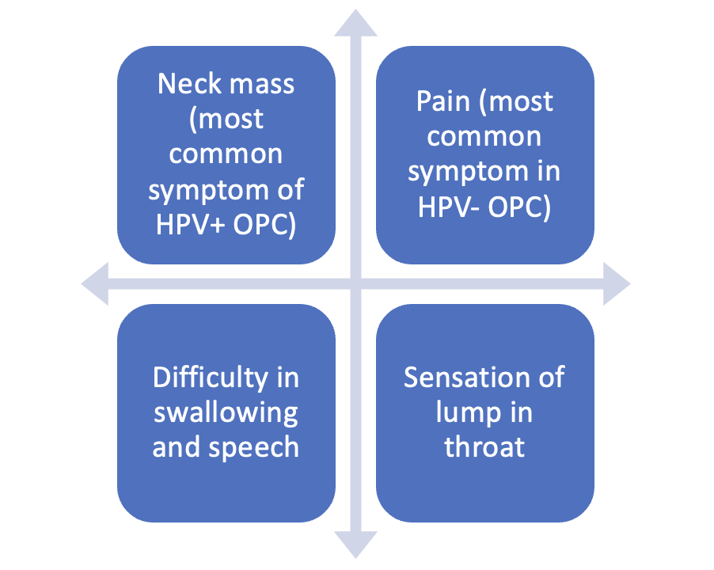
Figure 1a: Illustration depicting common symptoms of oropharyngeal cancers
(Original content, copyright protected, cannot be refurnished without consent)
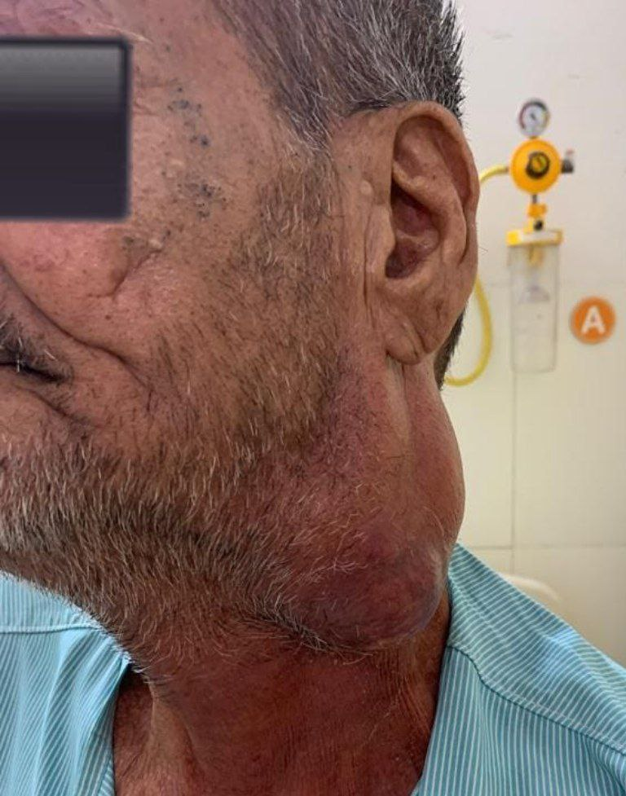
Figure 1b: Patient of oropharyngeal cancer presenting with a huge neck mass

Pain can either present as local pain or sore throat and it might manifest as referred pain to ear. Other common symptoms with which the patient might present trismus and halitosis.
Systemic symptoms are fatigue and unexplained weight loss. Depending on location of primary tumor, symptoms are illustrated below in Figure 2.

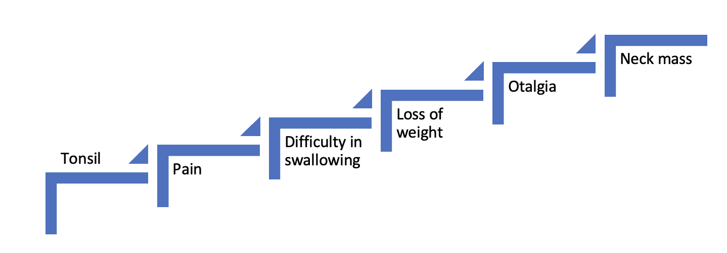
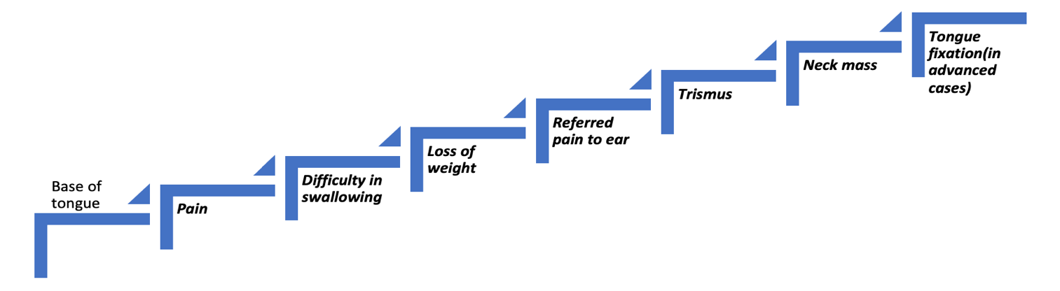

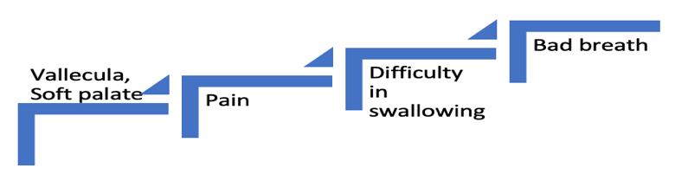

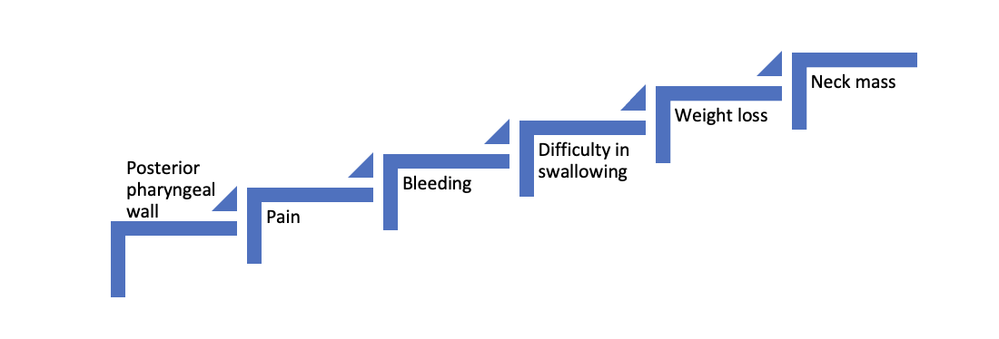

Figure 2: Site wise symptoms OPSCC
(Original content, copyright protected, cannot be refurnished without consent)

Clinical Evaluation

When a patient visits the outpatient department (OPD), a thorough history and physical examination are crucial for clinical assessment. The history should focus on the initial symptom and its duration to determine the tumour’s primary location.

The examination should involve direct visual inspection, indirect laryngoscopy, or flexible fibreoptic laryngoscopy. Palpating the primary tumour and assessing neck nodes for location and size is vital for clinical staging. Figure 3 summarises the clinical evaluation.
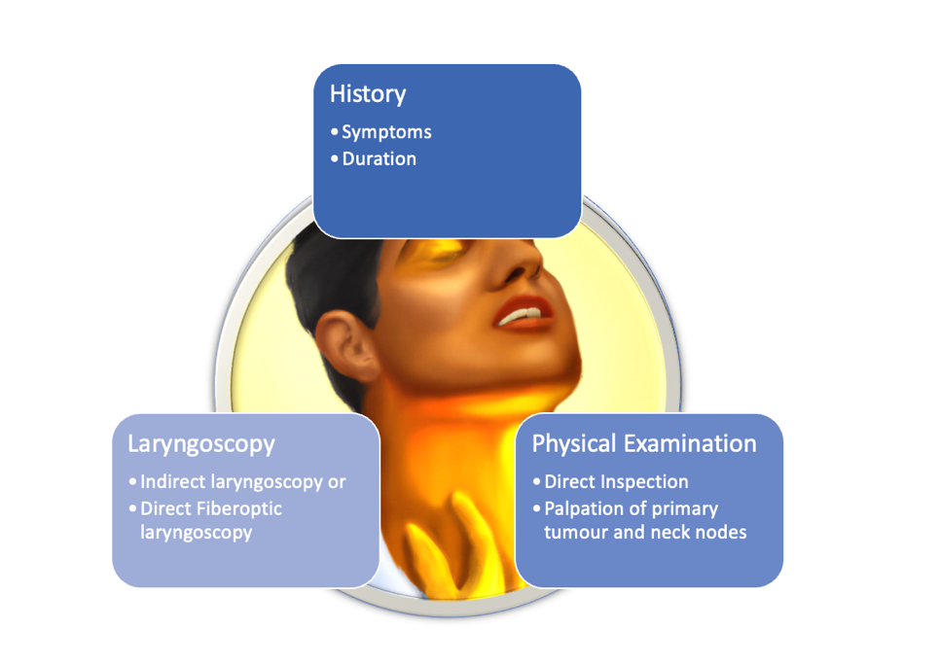
Figure 3: Clinical evaluation of patient of OPC
(Original content, copyright protected, cannot be refurnished without consent)

Complete blood count with basic metabolic panel must be done as laboratory workup.

Radiological evaluation

Recommended evaluations for face and neck issues include CT or MRI with contrast, chest imaging, and dental assessment⁵. CT scans offer advantages like speed, cost-effectiveness, and better bone assessment. MRI excels at evaluating soft tissues and is preferred for cases involving the orbit, skull base, or perineural invasion. In addition, PET CT scans can assess the primary tumour, nodal involvement, and metastatic status. These imaging methods are crucial for accurate staging, with PET CT being superior to CT for nodal assessment, while MRI is less suitable for this purpose^{6,7}. See Figure 4 for a summary of comparative details of these techniques.
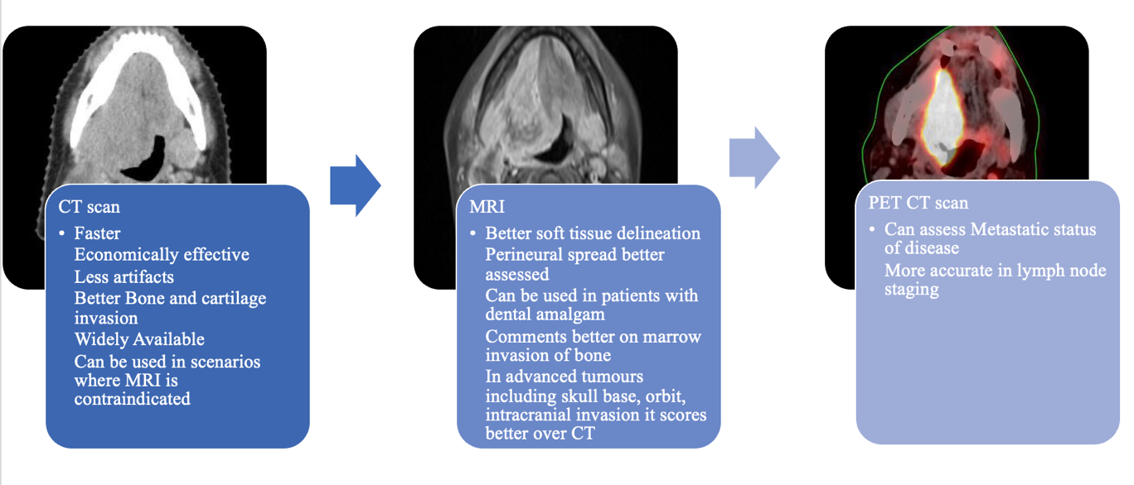
Figure 4: Comparative advantages of various imaging techniques
(Original content, copyright protected, cannot be refurnished without consent)

Pathological evaluation

A biopsy is essential for confirming the disease diagnosis. In the 8th edition of the AJCC staging, modifications have been made for HPV+ and HPV- OPC due to the favourable treatment response and prognosis of HPV+ infection, along with extensive studies on treatment reduction. Therefore, assessing HPV infection is crucial, and p16 evaluation serves as a key indicator. HPV DNA is typically detected through PCR and in situ hybridization (ISH), while its surrogate marker, p16, is identified via immunohistochemistry (IHC) on the biopsy sample⁸.

Additionally, the 8th edition of AJCC staging has introduced separate pathological staging, as the number of nodes was previously the only predictor of disease recurrence. Factors like extra nodal extension, nodal laterality, and node size at presentation were found to be insignificant^{9,10}. A relatively new method, sentinel lymph node biopsy using indocyanine green combined with methylene blue mapping, has proven reasonably reliable¹¹. This technique aids in detecting hidden metastasis in a clinically negative neck.

History and Futuristic trends

The OPC’s were initially related to etiological agents like tobacco chewing and smoking. The disease used present in advanced stages and treatment initially involved surgery with mandibulotomy. Radiation along with chemotherapy later took over the as preferred treatment modality reserving surgery as salvage¹². The mode of delivery of radiation improved and techniques like IMRT and IGRT took over drastically improving the tumor dose and decreasing the toxicities to the organ at risk such as parotid¹³ and dysphagia aspiration related structures¹⁴. Later, the discovery of HPV as the etiological agent, and differences in diseases presentation, treatment and survival were highlighted. HPV+ OPSCC generally present with a larger cystic node with smaller primary. It responds well to concurrent chemoradiation generally necessitating an adaptive radiation therapy approach due to anatomical regression of the tumor. The surgical techniques have also evolved to a minimally invasive approach with the advent of Transoral robotic surgery (TORS)¹⁵. Immunotherapy has also made advancements and various checkpoint inhibitors like nivolumab and pembrolizumab have their role well established¹⁶. With the advances made so far, it is probable, that a more individualized treatment approach would be adopted in the times to come¹⁷.

Various trials are in their preliminary phases in context to HPV positive OPSCC. While few trials like NCT01874171, NCT01855451, NCT01663259 are evaluating replacing different classes of chemotherapy like cisplatin versus cetuximab, other trials like NCT01530997, NCT01088802, NCT01891695 are trying to de-intensify chemotherapy and radiation by decreasing the doses. The dose of radiation has been de-escalated from standard 70Gy to 63Gy and 58.1Gy to 50.1Gy respectively to be given over 35 fractions with cisplatin to be given in first three weeks and last three weeks of radiation. The effectiveness of 39.6Gy in clinically node negative neck is also in its preliminary stages.

NCT01084083, ECOG 1308, NCT01706939 are working over to decrease the dose of radiation to 56 Gy by sequencing it after neoadjuvant chemotherapy depending on the response. Radiation doses can be decreased to 60Gy if the disease is addressed by upfront TORS. Multiple vaccines against HPV and their role is also under trial¹⁸.

Conclusion

Oropharyngeal cancers are on the rise and HPV+ OPC are more commonly seen in younger population. Clinical features are predominantly site specific, and an elaborate history and physical examination is crucial in all patients. While CT scan remains the initial diagnostic evaluation other modalities like MRI and PET CT offer their own set of advantages.
In low resource countries, contrast enhanced CT scan remains the preferred imaging choice owing to its good sensitivity and specificity. Biopsy and p16 testing are must in all cases due to different staging, response, and prognosis of HPV+ versus HPV- OPC’s.

References:
- Lorenzoni V, Chaturvedi AK, Vignat J, Laversanne M, Bray F, Vaccarella S. The current burden of oropharyngeal cancer: a global assessment based on GLOBOCAN 2020. Cancer Epidemiology, Biomarkers & Prevention. 2022 Nov 2;31(11):2054-62.
- Lechner M, Liu J, Masterson L, Fenton TR. HPV-associated oropharyngeal cancer: Epidemiology, molecular biology and clinical management. Nature reviews Clinical oncology. 2022 May;19(5):306-27.
- Martyn Plummer, Catherine de Martel, Jerome Vignat, Jacques Ferlay, Freddie Bray, Silvia Franceschi, Global burden of cancers attributable to infections in 2012: a synthetic analysis, The Lancet Global Health, Volume 4, Issue 9, 2016, Pages e609-e616, ISSN 2214-109X.
- Carpén T, Sjöblom A, Lundberg M, Haglund C, Markkola A, Syrjänen S, Tarkkanen J, Mäkitie A, Hagström J, Mattila P. Presenting symptoms and clinical findings in HPV-positive and HPV-negative oropharyngeal cancer patients. Acta oto-laryngologica. 2018 May 4;138(5):513-8.
- Forastiere AA, Ang KK, Brizel D, Brockstein BE, Burtness BA, Cmelak AJ, Colevas AD, Dunphy F, Eisele DW, Goepfert H, Hicks WL. Head and neck cancers. JNCCN Journal of the National Comprehensive Cancer Network. 2008 Aug;6(7):646-95.
- De Bondt RB, Nelemans PJ, Hofman PA, Casselman JW, Kremer B, van Engelshoven JM, Beets-Tan RG. Detection of lymph node metastases in head and neck cancer: a meta-analysis comparing US, USgFNAC, CT and MR imaging. European journal of radiology. 2007 Nov 1;64(2):266-72.
- Kyzas PA, Evangelou E, Denaxa-Kyza D, Ioannidis JP. 18F-fluorodeoxyglucose positron emission tomography to evaluate cervical node metastases in patients with head and neck squamous cell carcinoma: a meta-analysis. Journal of the National Cancer Institute. 2008 May 21;100(10):712-20.
- Cantley RL, Gabrielli E, Montebelli F, Cimbaluk D, Gattuso P, Petruzzelli G. Ancillary studies in determining human papillomavirus status of squamous cell carcinoma of the oropharynx: a review. Pathology research international. 2011;2011.
- Sinha P, Kallogjeri D, Gay H, Thorstad WL, Lewis Jr JS, Chernock R, Nussenbaum B, Haughey BH. High metastatic node number, not extracapsular spread or N-classification is a node-related prognosticator in transorally-resected, neck-dissected p16-positive oropharynx cancer. Oral oncology. 2015 May 1;51(5):514-20.
- Haughey BH, Sinha P, Kallogjeri D, Goldberg RL, Lewis Jr JS, Piccirillo JF, Jackson RS, Moore EJ, Brandwein-Gensler M, Magnuson SJ, Carroll WR. Pathology-based staging for HPV-positive squamous carcinoma of the oropharynx. Oral oncology. 2016 Nov 1;62:11-9.
- Peng H, Wang SJ, Niu X, Yang X, Chi C, Zhang G. Sentinel node biopsy using indocyanine green in oral/oropharyngeal cancer. World journal of surgical oncology. 2015 Dec;13(1):1-7
- Pignon JP, Bourhis J, Domenge C, Designe L. Chemotherapy added to locoregional treatment for head and neck squamous-cell carcinoma: three meta-analyses of updated individual data. MACH-NC Collaborative Group. Meta analysis of chemotherapy on head and neck cancer. Cancer/Radiothérapie. 2001;2(5):201-2.
- Nutting CM, Morden JP, Harrington KJ, Urbano TG, Bhide SA, Clark C, Miles EA, Miah AB, Newbold K, Tanay M, Adab F. Parotid-sparing intensity modulated versus conventional radiotherapy in head and neck cancer (PARSPORT): a phase 3 multicentre randomised controlled trial. The lancet oncology. 2011 Feb 1;12(2):127-36.
- Petkar I, Rooney K, Roe JW, Patterson JM, Bernstein D, Tyler JM, Emson MA, Morden JP, Mertens K, Miles E, Beasley M. DARS: a phase III randomised multicentre study of dysphagia-optimised intensity-modulated radiotherapy (Do-IMRT) versus standard intensity-modulated radiotherapy (S-IMRT) in head and neck cancer. BMC cancer. 2016 Dec;16:1-0.
- Weinstein GS, O'Malley Jr BW, Magnuson JS, Carroll WR, Olsen KD, Daio L, Moore EJ, Holsinger FC. Transoral robotic surgery: a multicenter study to assess feasibility, safety, and surgical margins. The Laryngoscope. 2012 Aug;122(8):1701-7.
- Dogan V, Rieckmann T, Münscher A, Busch CJ. Current studies of immunotherapy in head and neck cancer. Clinical Otolaryngology. 2018 Feb;43(1):13-21.
- Hay A, Nixon IJ. Recent advances in the understanding and management of oropharyngeal cancer. F1000Research. 2018;7.
- Mirghani H, Amen F, Blanchard P, Moreau F, Guigay J, Hartl DM, Lacau St Guily J. Treatment de‐escalation in HPV‐positive oropharyngeal carcinoma: ongoing trials, critical issues and perspectives. International journal of cancer. 2015 Apr;136(7):1494-503.

