RABIES

GUIDED BY,
MR. ANURAG SINGH
ABSTRACT:
This world is filled with perpetual diseases which are Fascinated by mankind and rabies occupied an non-concessive position even in the present day. Rabies is a zoonotic viral disease caused by Rabies virus (RABV) genotype 1 and this most common lethal infection worldwide. This fear is not due to the incidence it is due to the inevitable clinical signs; the image of furious rabid animal is prepared to bite anything in the path is at the heart of the fear in people who lives in western countries, like Europe, Asia Africa and with bats in America.this chapter gives a explain about the pathophysiology of the rabies virus.
INTRODUCTION
Rabies is a terrifying infectious disease of antiquity and currently ranks in the top ten infections killers of human. The true burden of the disease is unknown because the rabies virus is neglected [1]. Identification and diagnosis of rabies requires a specialized laboratory. According to the reports, extrapolating the reports from the rate of rabies we found that 500000 people are annually affected by dog bites and dog attack around Africa and Asia (Rodney E Willoughby jr). Rabies is caused by rabies virus (RABV) genotype 1[2]. Genotype 1 is said to the most common fatal infectious type which is said to spread worldwide. This type of virus affects the two-third of the human population, remaining of the population is said to be affected by paralytic rabies. Rabies associated with bat RABV has atypical features which is produced by Horner’s syndrome.
Rabies causes viral encephalitis which kills up to 70000 people/year worldwide. Infected animal saliva transmits viral encephalitis to humans[3]. Rabies is one of the oldest known diseases in history with cases dating back to 4000 years ago. For most of human history, a bite from a rabid animal was uniformly fatal. In the past, people were so scared of rabies that after being bitten by a potentially rabid animal, many would commit suicide. This is the most common lethal infection worldwide [4].
Rabies develops symptoms – Anxiety, sleeplessness, hallucinations. Panic attack and aggression. The rapid aggression of rabies death accesses within 5 to 7 days of attack or bite, while the death is medically violent- where the death occurs by respiratory spasms and profound swings in temperature, blood pressure with increase in heart rate and leads to death (Rodney E Willoughby jr). Majority of rabies disease are said to be curable, but the bat bites are said to be unrecognized [5]. In North America rabies are said to be endemic in wild life and the bat bites are said to be a serious thread to infectious transmission to humans
This fear is not due to the incidence it is due to the inevitable clinical signs; the image of the furious rabid animal is prepared to anything in the path is at the heart of fear in people who lives in the western countries, like Europe, Asia, Africa and with the bats in America two third of the patients are infected with dog RABV variant is present in the classic raging rabies and this disease was described centuries ago by scientists. a well recorded [6]. Book by Theodories in (1986) which focused on the seminal work of Pasteur’s Work, Galtier developed the first rabies vaccine at that time. Current knowledge about Rabies has also been well described by Campbell and Charlton in 1988. Progress has been made in recent years about determining the molecular structure of the virus, the molecular biology of its replication and immunological way and Vaccinations[7]. But after this all efforts the rabies virus infection is still not well Understood
ETIOLOGY OF RABIES :-
Rabies is the disease caused by the lyssa viruses belonging to the family rhabdoviruses. The cells of these viruses are bullet shaped and these viruses contain negative stranded RNA genome and these viruses are stable drying lyssa viruses [8]. Rhabdoviruses includes rabies and bat lyssaviruses.
Rabies is transmitted mostly by the bit of a rabid animal which include dog, cat, monkey, bat etc. Rabies is a preventable disease by undergoing proper clinical treatment. RABV affects the central nervous system by affecting the nicotine acetylcholine receptor and this ultimately causing neurological disease and this leads to death if untreated [9].

STRUCTURE OF THE RABIES VIRUSES :-
Viruses belonging to the rhabdoviruses are approximately 75nm wide and 180nm wide. All the viruses belonging to the rhabdoviruses have two major structural components, they are a) ribonucleoprotein and b) envelope surrounding the nucleoprotein [10].
The genome of the rabies encodes five protein nucleoprotein(N), phosphoprotein(P), glycoprotein(G), matrix protein (M), and polymerase enzyme (L). The genomic RNA of the rabies virus is encased tightly by the nucleoprotein [11]. The P protein and the L protein (polymerase) are associated with the ribonucleoprotein. The genomic RNA is enclosed by the nucleoprotein outer layer the glycoprotein of the rabies forms 400 trimeric unit these units bound around the surface of the virus these glycoproteins are soluble glycoproteins the membrane protein is associated with the outer envelope and the ribonucleoprotein acts as the central protein of the rhabdoviruses [12].
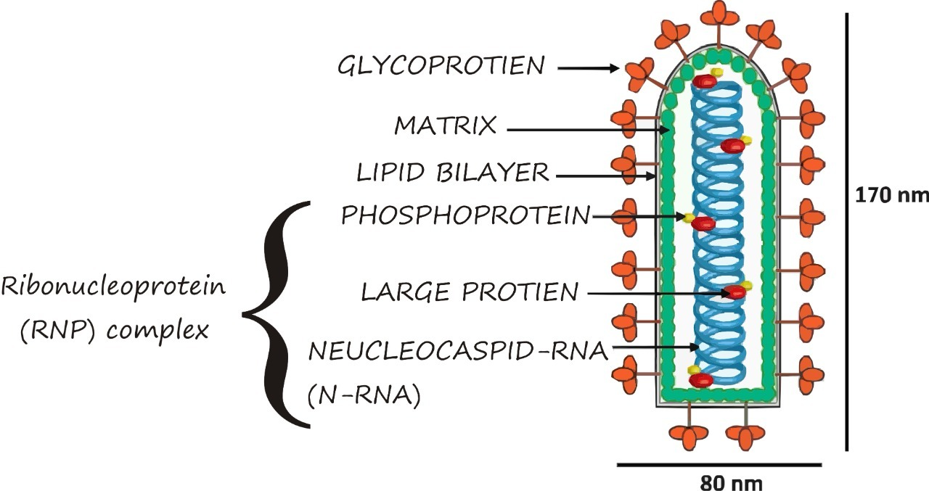
Fig 1: Structure of rabies This figure shows the arrangement of the protein molecules in the rabies virus
INCUBATION PERIOD :-
The highly variable incubation period for the rabies virus is 2 to 6 years and it is averagely ranges from 1 to 3 months and in the other cases it depends on the concentration of the viral substances present in the salivary glands of the rabid animal [13]. The efficient transmission of the virus depends on the severity of the bite of the bite by the rabid animal. The risk of acquisition of the infection is 50 times higher in the rabid animal bid than the normal scratches (1) in some cases transplacental transmission takes place in the new born baby whose mother infected with encephalitic rabies [14]

PATHOPHYSIOLOGY OF RABIES VIRUS:-
Encephalitic rabies is reported to occur at the majority of the human cases hyperactive is the main sign of encephalitic rabies virus appearing as anxiety, nervousness, and mental confusions alter in with period of lucidity and preserved intelligent [15]. The rabies virus comes under the category of rhabadoviridae this virus consists of lyssa virus genome are single strand of negative sense RNA of 12 kilo basis(3).The viral genome serves as a template for 2 essential primary action Transcription of 5 viral mRNA. Replication to generate the full length positive sense antigenome RNA strand[16] .The viral genome of either negative or positive sense are always intimately encapsulated with protein while the P and L protein constitute the catalytic complex performing both transcription and replication..The order of protein genome is N > P > M > G > L the transcription generates a short leader RNA[17] . The L protein is involved in capping and in polyadenylation by shuttering on short stretch of seven to eight uridine

THE RECEPTOR FOR THE RABIES VIRUS BINDING :-
The nicotinic acetylcholine receptors present in the host muscle is most probably responsible for the attachment of rabies viruses(15,11,14) [18]. Alphabungarotoxin is an antagonistic of the nicotinic acetylcholine receptor. This toxin substances causes neuroinvasiveness, neurotropism and neurovirulence. The RAB viral envelope is made up of the two proteins matrix(M) and glycoprotein(G) and host lipid[19].
The type 1: Membrane glycoprotein consist of three potential N-glycosylation site. The endoplasmic reticulum adopts a trimeric form the glycoprotein trimer in the rab virus is responsible for the attachment of the RABV to the cell [20] .
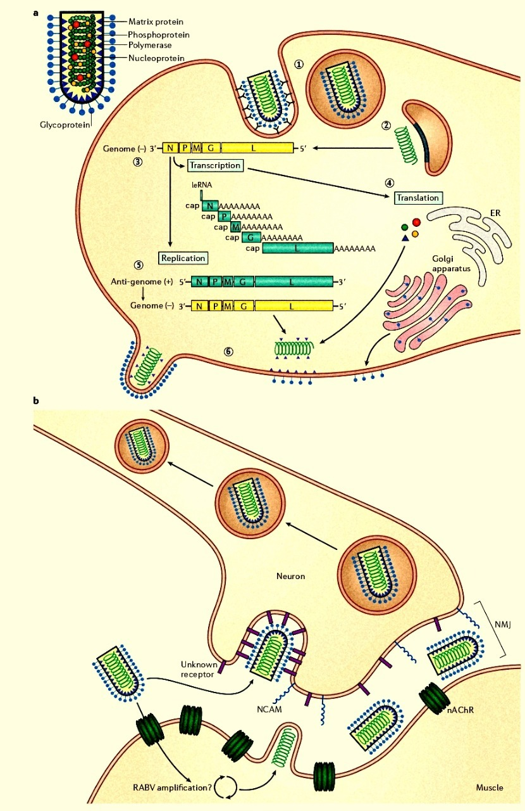 Fig 2: Neuronal transmission of RABV This figure shows the transmission of the RABV from the axon terminal to the axon and the replication of the RABV in the axon
i)Nicotinic acetylcholine receptor :-
Nicotinic acetylcholine receptor is a pentameric ligand gated ion channel. This channel mediates and it modulates the interneuronal communication in the central nervous system and in the pheripheral nervous system[21]. The RABV’S main binding site is on the alpha x subunit of the nicotinic acetylcholine receptor binds alpha bungarotoxin. The acetylcholine produces by the muscles of adult gets accumulated at the axon terminal of the neuron by using alpha bungarotoxin autoradiography is performed this showed nicotinic acetylcholine receptor[22].
The observation made by lentz et al(1982) showed the RABV binds at the location of the NACHR and the observation made by the bracci et al(1988) showed that the alpha subunit present in the muscular nicotinic acetylcholine interacts with the RAVG[23]. The major rabies virus genome binding site on the alpha subunit of the acetylcholine receptor is between the position 173 and 204. These following information shows that the RABV binds on the acetylcholine receptor present in the muscle cell[24].
ii) NCAM (NEUTRAL CELL ADHESION MOLECULE) :-
It is also called as CD56. The NCAM is a neutral cell adhesion molecule acts a cell adhesion glycoprotein. The NCAM belongs to the immunoglobulin family [25]. This is involved in the neuronal migration, emotional behaviour fasciculation, synaptic plasticity and neurite outgrowth[26]. The NCAM has three major isoforms (NCAM-180, NCAM- 160 & NCAM-120). NCAM-120 is bound with the membrane via GPI (glycosyl phosphatidylinositol). Through transmembrane domains (TMD), NCAM-180 and NCAM-160 resides in the plasma membrane[27]. This receptor is involved in the cycling of the receptor and it is also involved in the mobilization of the viral components the NCAM receptor are present in areas occupied by the nerve terminals in the post synaptic membrane NCAM -180 initiates synaptogenesis by mediating the transport of viral substance, protein binding at the site of synapse formation and in the accumulation of the synaptic organelles ie (golgi bodies , vesicles ,and endoplasmic reticulum)[28] . The NCAM receptor acts as an antagonist to the rabies infection since the pretreatment of the RABV with the NCAM neutralises the activity of the RABV, since the soluble proteins present in the NCAM neutralises the RABV antigen. Antigen-antibody interaction takes place by the neutralising the RABV antigen and the NCAM antibody[29].
TRANSMISSION OF RABIES VIRUS:-
The RABVG enables the virus and it is transported to the central nervous system by retrograde pathway(2, . Rabies virus is transmitted by a bite of a rabid animal at the PNS site[30]. Then it follows is axon terminal in a retrograde path to the CNS.The most efficient route of transmission of the rabies is the transfer of RABV containing saliva from the rabid animal. Rabies transmission also occurs by the following ways. i)tissue and organ transplant ii) handling and skinning of infected carcasses iii)inhalation of aerosolised RABV.The consumption of carcasses of the rabid animal also causes rabies infection[31]. RABV in the gastrointestinal tract is due to the abrasions in the oral cavity the virus passage into the neuronal tissue.The rabies cell binds with the glycoprotein (G) and enters by the endocytosis[32]. This takes place in the 1st phase of the rabies virus. In the second phase the encapsulation of the virus takes place by polymerase enzymatic action then followed by the transmission of 5’ end capped MRNA and the translation of the viral protein takes place the translated proteins are protein (N,P,M,G) and polymerase. After the replication process the newly synthesized anti genome acts as a template for the synthesis of additional genomic RNA.In the final step assembling of the viral genomic components takes place and then RABV virion are released starting a new round of infection RABV enter the blood stream and transport in the neuron takes place[33]. RABV binds with the nicotinic acetylcholine receptor which is located in the PNS this enriches the RABV at the neuromuscular junction. this indicates the nicotinic acetylcholine receptor might be used to infect the muscle cells. RABV binding also occurs in the NCAM[34]. The transportation of the virion takes place in the vesicles and released in the cell body of the infected neuron
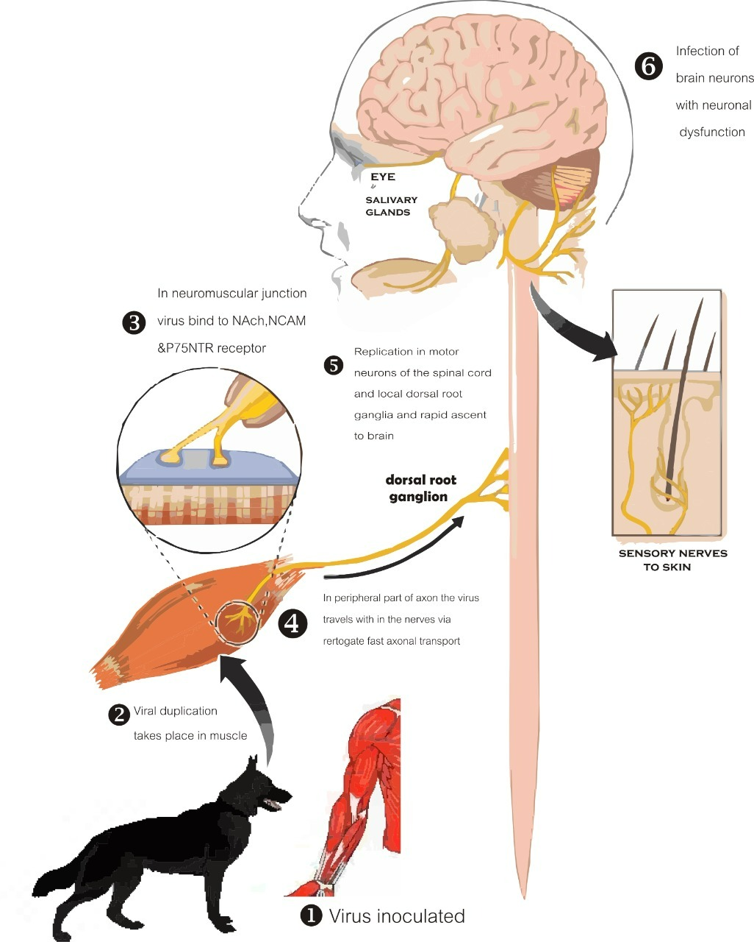 Fig 3: Transmission of the RABV from dog’s saliva to neurons Virus transmission after the dog bit into the muscle and binding with the NAch, NCAM, P75NTR receptor and neuronal transmission

PREVENTION AND CURE:-
all the above discussion and data had enabled disease modelling SS and prevention. In Taiwan, there is an unknown beginning of the host of the virus and they don't know that it is caused by humans or domestic animals[35]. And this can be compromised or prevented by the usage of using dog vaccines in the wild reservoirs and this caused major public health concern there. At present, the discovery of non RABV lyssaviruses and the actual problem is because of unknown clinical signs and they have no difference to normal rabies infection. And in the given situation the bat population plays a major role in the spreading of lyssaviruses. And the prevention of the viruses can be done by mass vaccination of bats but this idea was never implemented if anyhow the bat spreading RAVB is very low but incorporating our knowledge with bats immunity provides protection and prevent spreading of viruses rabies has been vaccine-preventable since 1886 and we have done several advancements against rabies alive recombinant vaccine was engineered by Faber and Dietzschold and a single dose is enough but this is highly inflammatory and this made rabies vaccine more cost-effective [36]. Hooper and Dietzschold came up with rabies virus-neutralizing monoclonal antibody and which is joined with a freely neutralized monoclonal antibody[37]. This is used in phase 2 clinical trail in current times and this gives additional rabies immune globulin. And prevention can be done by combining fertility control in dogs and other vectors that make it simple and less cost-effective and prevention of rabies or eradicating it is doubtful because the other vaccine for respiratory viruses contain has rabies G glycoproteins this may cause a secondary spread of rabies and make in every one vaccinated is always have a problem related to political and economical restain treatment is fully based on symptoms only and for prevention of rabies administration of human rabies immunoglobin, steroids, and anti-thymocyte globulin has no improvement. To avoid exposure the nurses and physicians who are handling rabies patients must be vaccinated to avoid exposure to rabies[38].

Clinical disease:
The transfer of RABV- containing saliva from a bite from the infected animal is the most efficient route of transmission[39]. Other routes of transmission include: inhalation of aerosolized RABV; tissue and organ transplants; handling and skinning of infected carcasses and contamination of open wound, scratch, abrasion or mucous membrane by infected saliva or neural tissues. The efficiency of the bite transmissions depends on virus inocula and viral tissue tropism [40].The incubation period after exposure in rabies in variable, typically 20 to 90 days, but ranges from a few days to a year or more. The symptoms of rabies consist of fatigue, loss of appetite, headache, insomnia, anxiety, irritability and fever lasting up to 10 days of time. The initial neurological symptoms include parenthesis, pain or irritation around the area of bite these reflects on the inflammation in the local roots ie. Dorsal roots and cranial sensory ganglia. These are categorized into Encephalitic rabies (~80%) and paralytic rabies (~20%).The burden of infection is said to revolve over the brain. There are episodes of generalized arousal ability separated by lucid periods. Autonomic dysfunction leads to hypersalivation, sweating and piloerection. This is caused by the direct attack on the autonomous nerves system entering due to the involvement of autonomic pathway of brain through hypothalamus, spinal cord, ganglia.
Vaccines:
Louis Pasteur developed the first rabies vaccines to treat a human bite victim on 6th July 1885, which is considered to be one of the most effective vaccines developed against Rabies[41].This method follows up with an injection to the recipient at the subcutaneous layer of the homogenate which is fully inactive in nature[42]. This homogenate is the RABV- infected rabbit spinal cord that has been desiccated progressively in sterile air. As vaccines produces good, it generated two main problems[43]. The first was consistency of inactivation and secondly, the ability to produce sufficient vaccines from rabbits to meet the demand for treatment. These vaccines also proved to be successful but also at the same time contained high level of myelin that leads to sensitisation in some recipients and in some extreme cases leads to fatal encephalitis[44]. Another most frequently used rabies vaccines were prepared from the brains of a sulking mice which incorporates the methods of fuenzalida and palacios. This helps in the identification of the rate of neurological reactions after the administration of nervous tissue vaccine (ntv) which is based on the idea of that brain which has not yet been myelinated with elicit less of an immunologic reaction to nervous tissue.The ntv efficacy can only be estimated. Obviously no experiments can be done on human beings. The estimated range of ntv is known from 89% to none at all[45].

REFERENCE
1.Tiwari HK, Gogoi-Tiwari J, Robertson ID. Eliminating dog-mediated rabies: challenges and strategies. Animal Diseases. 2021 Dec;1(1):1-3.
2.Hemachudha T, Laothamatas J, Rupprecht CE. Human rabies: a disease of complex neuropathogenetic mechanisms and diagnostic challenges. The Lancet Neurology. 2002 Jun 1;1(2):101-9.
3.Tsiang H. Pathophysiology of rabies virus infection of the nervous system. Advances in virus research. 1993 Jan 1;42:375-412.
4.Banyard AC, Tordo N. Rabies pathogenesis and immunology. Revue Scientifique et Technique (International Office of Epizootics). 2018 Aug 1;37(2):323-30.
5.Dietzschold B, Li J, Faber M, Schnell M. Concepts in the pathogenesis of rabies.
6.Hemachudha T, Ugolini G, Wacharapluesadee S, Sungkarat W, Shuangshoti S, Laothamatas J. Human rabies: neuropathogenesis, diagnosis, and management. The Lancet Neurology. 2013 May 1;12(5):498-513.
7.Schneider G, Schoop U. Pathogenesis of rabies and rabies-like viruses. Ann Inst Pasteur (Paris). 1972 Oct;123(4):469-76. PMID: 4632949.
8.Cenna J, Tan GS, Papaneri AB, Dietzschold B, Schnell MJ, McGettigan JP. Immune modulating effect by a phosphoprotein-deleted rabies virus vaccine vector expressing two copies of the rabies virus glycoprotein gene. Vaccine. 2008 Nov 25;26(50):6405-14

9.Schnell MJ, Tan GS, Dietzschold B. The application of reverse genetics technology in the study of rabies virus (RV) pathogenesis and for the development of novel RV vaccines. Journal of neurovirology. 2005 Jan;11(1):76-81.
10.Koser ML, McGettigan JP, Tan GS, Smith ME, Koprowski H, Dietzschold B, Schnell MJ. Rabies virus nucleoprotein as a carrier for foreign antigens. Proceedings of the National Academy of Sciences. 2004 Jun 22;101(25):9405-
11.Ugolini G, Hemachudha T. Rabies: changing prophylaxis and new insights in pathophysiology. Current opinion in infectious diseases. 2018 Feb 1;31(1):93-101.
12.Hemachudha T, Wacharapluesadee S, Mitrabhakdi E, Wilde H, Morimoto K, Lewis RA. Pathophysiology of human paralytic rabies. Journal of neurovirology. 2005 Jan;11(1):93-100.
13. Lafon M. Rabies virus receptors. Journal of neurovirology. 2005 Jan;11(1):82-7.
14. Lentz TL, Benson RJ, Klimowicz D, Wilson PT, Hawrot E. Binding of rabies virus to purified Torpedo acetylcholine receptor. Molecular Brain Research. 1986 Dec 1;1(3):211-9.
15. Lentz TL, Burrage TG, Smith AL, Crick J, Tignor GH. Is the acetylcholine receptor a rabies virus receptor?. Science. 1982 Jan 8;215(4529):182-4.

16. Schnell MJ, Tan GS, Dietzschold B. The application of reverse genetics technology in the study of rabies virus (RV) pathogenesis and for the development of novel RV vaccines. Journal of neurovirology. 2005 Jan;11(1):76-81.

17. Crowcroft NS, Thampi N. The prevention and management of rabies. Bmj. 2015 Jan 14;350.

18. Gomme EA, Wirblich C, Addya S, Rall GF, Schnell MJ. Immune clearance of attenuated rabies virus results in neuronal survival with altered gene expression.

19. Moallemi M, Yousofpour M. Naming, Definition, and Etiology of Rabies in the Medical Texts of the Islamic Civilization. Journal of Mazandaran University of Medical Sciences. 2019 Sep 10;29(176):167-74.

20. Centers for Disease Control and Prevention (CDC. Human rabies--Texas and New Jersey, 1997. MMWR. Morbidity and mortality weekly report. 1998 Jan 16;47(1):1-5.

21. Zhou H, Li Y, Chen RF, Tao XY, Yu PC, Cao SC, Li L, Chen ZH, Zhu WY, Yin WW, Li YH. Technical guideline for human rabies prevention and control (2016). Zhonghua liu xing bing xue za zhi= Zhonghua liuxingbingxue zazhi. 2016 Feb 1;37(2):139-63.

22. Rosner F. Rabies in the Talmud. Medical History. 1974 Apr;18(2):198-200.

23. Centers for Disease Control and Prevention (CDC. Recovery of a patient from clinical rabies--California, 2011. MMWR. Morbidity and mortality weekly report. 2012 Feb 3;61(4):61-5.

24. Centers for Disease Control and Prevention (CDC. Imported human rabies-New Jersey, 2011. MMWR. Morbidity and mortality weekly report. 2012 Jan 6;60(51-52):1734-6.

25. Saurat P. Etiology: the rabies virus. Informations techniques des services veterinaires. 1979.

26. Centers for Disease Control and Prevention (CDC. Human rabies--California, 1994. MMWR. Morbidity and mortality weekly report. 1994 Jul 1;43(25):455-8.

27. Centers for Disease Control and Prevention (CDC. Human rabies-Kentucky/Indiana, 2009. MMWR. Morbidity and mortality weekly report. 2010 Apr 9;59(13):393-6.

28. WACHTER K. Bite Type, Infection Risk Should Dictate Treatment. Pediatric News. 2005 Jan.

29. Su YL, Kuo LW, Hsu CH, Chiang CS, Lu YJ, Chang SJ, Hu SH. Rabies virus glycoprotein-amplified hierarchical targeted hybrids capable of magneto-electric penetration delivery to orthotopic brain tumor. Journal of Controlled Release. 2020 May 10;321:159-73.

30. Hemachudha T, Wacharapluesadee S, Mitrabhakdi E, Wilde H, Morimoto K, Lewis RA. Pathophysiology of human paralytic rabies. Journal of neurovirology. 2005 Jan;11(1):93-100.

31. Ugolini G, Hemachudha T. Rabies: changing prophylaxis and new insights in pathophysiology. Current opinion in infectious diseases. 2018 Feb 1;31(1):93-101.

32. Fisher CR, Streicker DG, Schnell MJ. The spread and evolution of rabies virus: conquering new frontiers. Nature Reviews Microbiology. 2018 Apr;16(4):241-55.

33. Fisher CR, Lowe DE, Smith TG, Yang Y, Hutson CL, Wirblich C, Cingolani G, Schnell MJ. Lyssavirus vaccine with a chimeric glycoprotein protects across phylogroups. Cell reports. 2020 Jul 21;32(3):107920.

34. Nagarajan T, Mohanasubramanian B, Seshagiri EV, Nagendrakumar SB, Saseendranath MR, Satyanarayana ML, Thiagarajan D, Rangarajan PN, Srinivasan VA. Molecular epidemiology of rabies virus isolates in India. Journal of Clinical Microbiology. 2006 Sep;44(9):3218-24.

35. Sacramento D, Badrane H, Bourhy H, Tordo N. Molecular epidemiology of rabies virus in France: comparison with vaccine strains. Journal of General Virology. 1992 May 1;73(5):1149-58.

36. Wunner WH. The chemical composition and molecular structure of rabies viruses. InThe natural history of rabies 2017 Nov 22 (pp. 31-24). Routledge.

37. Wunner WH, Larson JK, Dietzschold B, Smith CL. The molecular biology of rabies viruses. Reviews of infectious diseases. 1988 Nov 1;10(Supplement_4):S771-84.

38. Tordo N, Poch O. Structure of rabies virus. InRabies 1988 (pp. 25-45). Springer, Boston, MA.

39. Albertini AA, Wernimont AK, Muziol T, Ravelli RB, Clapier CR, Schoehn G, Weissenhorn W, Ruigrok RW. Crystal structure of the rabies virus nucleoprotein-RNA complex. Science. 2006 Jul 21;313(5785):360-3.

40. Dean DJ, Evans WM, McClure RC. Pathogenesis of rabies. Bulletin of the World Health Organization. 1963;29(6):803.

41. Fekadu M. Pathogenesis of rabies virus infection in dogs. Reviews of Infectious Diseases. 1988 Nov 1;10(Supplement_4):S678-83.

42. Murphy FA. Rabies pathogenesis. Archives of virology. 1977 Dec;54(4):279-97.

43. Iwasaki Y, Clark HF. Cell to cell transmission of virus in the central nervous system. II. Experimental rabies in mouse. Laboratory Investigation; a Journal of Technical Methods and Pathology. 1975 Oct 1;33(4):391-9.
44.Baer GM, Abelseth MK, Debbie JG. Oral vaccination of foxes against rabies. American Journal of Epidemiology. 1971 Jun 1;93(6):487-90.
45. Hicks DJ, Fooks AR, Johnson N. Developments in rabies vaccines. Clinical & Experimental Immunology. 2012 Sep;169(3):199-204.

