Bioremediation: A sustainable solution
- Introduction
Life forms are born they grow and reproduce and finally die but, in the process, they inevitably generate a lot of waste. Interestingly this waste in turn serves as a substrate for many microorganisms for energy generation. This cycle leads to natural recycling of generated waste thus keeping the system in homeostasis. This process of natural waste recycling using microorganisms is called bioremediation. Bacteria can hold on to the negatively charged soil particles using ionic bonds and reduce, eliminate or transform the hazardous wastes into innocuous compounds using them to gain energy for themselves and multiply. In absence of such degrading forces waste could accumulate and alter the environment to an extent where it could no longer support healthy life.
The first life forms in the ocean are said to have emerged 3.5 billion years ago. Starting from a very archaic unicellular being evolution proceeded to eukaryotic forms. Cell division followed by differentiation gave birth to multicellular forms which got more and more sophisticated. Eventually life migrated from ocean to land and bifurcated into plants and animals.
Humans are the latest and most advanced products of evolution. We reached a level of cognitive evolution that we were able to control our environment. We graduated from being hunters and gatherers to cultivators. We domesticated plants and animals and made settlements. We actually managed to bend nature to our will. But these achievements came with their own unique set of challenges. Human population only seems to go up even at the expense of other life forms and natural resources. As we surmount one problem, we create many others in our bid to survive. As we evolve socially and cognitively our needs get more and more complicated. We need to feed and house and clothe the perpetually growing population but at the same time we are also fine tuning and upgrading our life style. With the rise of consumerism industries have grown to cater to our various needs. Information technology, medical science, transportation is some such ever growing areas.
This technological revolution however comes at a price. They generate waste at an alarming rate. These industries release substances that are toxic, hazardous, recalcitrant and tend to biomagnified that is they get more concentrated as they move up the food chain. The methods employed in the removal of these substances are severely limited in their capacity. They can be slow and prohibitively expensive. These methods may also generate secondary pollutants thus aggravating the problem. The need has long been felt to evolve cost effective sustainable methods for the removal of these chemicals.
2.The need for bioremediation approaches
The modern approaches of waste removal and management such as cap and contain which involves excavation and dumping of toxic waste into landfills, pyrolysis, soil washing (release and treat), adsorption, encapsulation, vitrification etc. are costly and inefficient. They may release more secondary pollutants into the atmosphere. These methods are not sustainable and ecofriendly. The challenges which warrant an eco friendly approach are many
2.1 Oil spills
All development requires fuel and fossil fuels have proven to be the fuel of choice. The mineral oils found underground are a mix of hydrocarbons of different chain lengths and chemistry. They are mined and transported in large quantities to power industries and civilization at large. This crude oil may leak and spill into the ocean water or through pipelines during transport. These events have repeatedly happened in the past few decades. They have profoundly impacted the ecosystem in the Galápagos islands, France, the Niger delta and Alaska.(Azubuike et al., 2016) The severity depends on the amount of leakage, the location and the effectiveness of the emergency environmental response(Kensa, n.d.).
This oil contamination on the surface of water bodies can completely cut off the oxygen supply to the water thus immediately putting the life of marine organisms in jeopardy. The birds exposed to these oils are less buoyant in air and much vulnerable to temperature fluctuations as the oils soak into their plumage. They ingest the oils accidentally while preening which disrupts their bodily functions and reproductive capacities.(Okagbare Adams et al., 2020)
For the spills occurring on lands, it leads to the alteration of soil micro flora thus compromising the fertility of the soil. The oils can seep into the land eventually contaminating the precious groundwater resources. These oils can act as solvents thus increasing the availability of toxic heavy metals in soil which can run off to water bodies thus compounding the problem. Fire hazard is also a significant risk factor associated with oil spills endangering life and property. Air around these sites gets compromised in quality.
2.2 Pesticides
The human race is considered a biological success because of its capacity to surmount the limitations and challenges of nature. Thus, we have succeeded to indefinitely multiply and grow in number. This logarithmic growth however can’t be matched by a corresponding growth in resources. Food security is the biggest of the challenges that the burgeoning population faces. Land is a limited and non-renewable resource thus we need to grow more and more food from whatever arable lands we have available. Deforestation to access new lands have proven to be an environmentally damaging concept and is now controlled by the government. So farming practices have grown to depend on chemical fertilisers and pesticides.
Pesticides are chemical compounds used to eliminate pests by weakening incapacitating and killing. After 1945 rapid development in agrochemicals led to introduction of herbicides insecticide and fungicides. (Bala et al., 2022)They help improve crop productivity in a very effective and budget friendly manner and thus their use have gone up.
These chemicals however are toxic recalcitrant and as soil runoff are capable of poisoning water supplies.(da Silva et al., 2020)
2.3 Heavy metals and radioactive waste
Metals occur naturally in the earth crust but those with atomic number greater than 50 or density higher than 5grams per cubic centimetre are considered heavy metals(Saigal & Ahmed, 2021). They can be very toxic to life forms due to their tendency of bonding covalently with nuclear materials enzymes proteins and membranes thus disrupting their function. They act as free radicals wreaking havoc on cellular systems. They have industrial demand so they are mined and smelted or can be immobilised from the earth crust or found in industrial wastes(Modu Tarekegn et al., 2020). The higher isotopes of metals can be radioactive. Uranium and thorium are mined for use in nuclear reactors for sustainable energy production but it contributes to contamination by radioactive pollutants. They can be highly carcinogenic and promote mutagenesis. They have a tendency to bioaccumulate and concentrate as it moves up the food chain. They are a challenging group of pollutants because of their high reactivity. They can’t be transformed effectively but can be sequestered and contained. Phytoremediation or removal of pollutants via plants is a very effective tool for the removal of these elements.
2.4 Pharmaceutical waste
In modern times health and fitness has become the centre of attention all over the world. Especially post Covid medical advancements have attracted maximum investment. High population densities and global connectivity achieved in the past decades owing to aviation technology has made the possibility of a recurring pandemic a frightful probability. Also, lifestyle changes have thrown up a gamut of diseases like high blood pressure cholesterol or diabetes. Aesthetic preferences pushed by social media have made the cosmetic industry grow like never before. These introduce into the environment certain contaminants of concern or CECs. In the last decade these pollutants have reached an environmentally relevant concentration and methods are developed to analyse it. Pharmaceuticals, engineered Nanomaterials, licit drugs, synthetic perfumes, food additives and preservatives artificial perfumes, food and enzymes, personal care and veterinary products are examples of these contaminants.
Industries producing these compounds are water intensive and release waste water that may carry pollutants that can be very disruptive to life even at very low concentrations. The risk of such waste water polluting the drinking water supplies is a problem that the world is not ready to deal with.
2.5 Textile dyes
Textile industry is the second largest industry in the world. It uses colours for dying printing and finishing. Due to the ever-growing demand the earlier natural dyes like indigo got completely replaced by synthetic dyes. They artificial tints are cheap and efficient but rarely benign for the environment. They are insoluble in water very observable and recalcitrant. They are chemicals that inevitably end up in the waste water discharged by the textile industry. Such contamination can readily and very perceptibly alter the quality of drinking water on contamination. They are very persistent non-biodegradable and sometimes toxic.
3.What is bioremediation?
The process of waste generation goes hand in hand with life but the cycle of nature takes care of it using biological agents i.e., microbes. Microbes are life forms with the simplest structure and requirements and they are ubiquitous. They are genetically plastic multiply profusely metabolically diverse and adapt quickly to new environments. Due to this unique set of properties, they are impossible to eliminate and flourish in every nook and cranny of the earth. All they need is oxygen and a source of carbon though anaerobic bacteria are also found in the most challenging venues.
Thus, any waste generated in nature can act as a substrate for electron transfer. Bioremediation relies on biological agents such as bacteria fungi and plants for degrading detoxifying transforming and mineralizing pollutants to less toxic more innocuous and simpler forms. Though left to its means the rate of this degradation could be very slow hence a rapid accumulation of waste could breakdown the process by proving toxic to the very microbes that are supposed to degrade it. George Robinson of US microbic first used bacteria to remediate an oil spill in coastal Santa Barbara California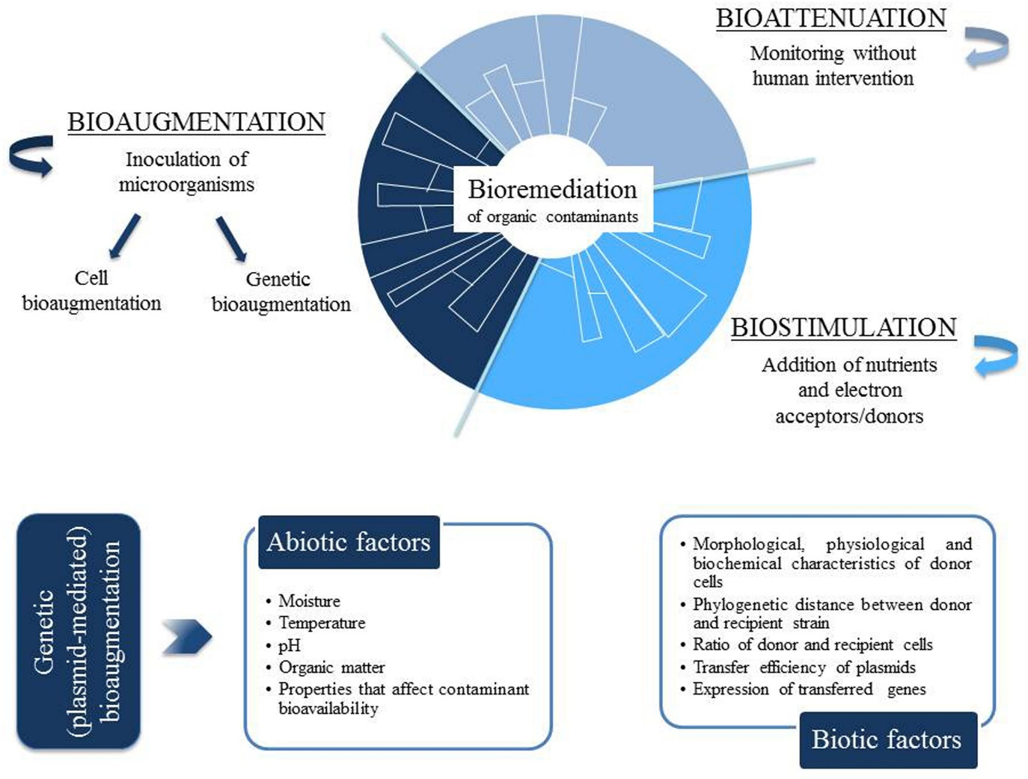.

FIGURE 1 | (A) Strategies for bioremediation of organic contaminants: bio attenuation, bio stimulation and bioaugmentation. (B) Environmental factors affecting the efficiency of plasmid-mediated bioaugmentation.
4.Microbes used in bioremediation
Microbes undergo a redox reaction to produce energy for which they need an energy source or electron donor, an electron acceptor and nutrients as facilitators. Using different electron acceptors such as oxygen, nitrate or manganese bacteria can use a plethora of compounds as food breaking them up to simpler forms (mineralisation). This process however depends on certain other factors

Environmental

conditions affecting degradation
Parameters | Condition required for microbial activity | Optimum value for an oil degradation
Soil moisture | 25-28% of water holding  capacity | 30-90%
Soil P^{H} | 5.5-8.8 | 6.5-8.0%
Oxygen content | Aerobic, minimum air filled  pore space of 10% | 10-40%
Nutrient content | N and P for microbial growth | C: N:P=100:10:1
Temperature | 15-45 | 20-30
Contaminants | Not too toxic | Hydrocarbon 5-10% of dry weight of soil
Heavy metals | Total content 2000 ppm | 700 ppm
Type of soil | Low clay or silt content

4.1Contaminant concentrations
If the concentration is too low the process will not reach saturation and take too long. High concentrations however can poison the microflora so they are not able to multiply.(Okagbare Adams et al., 2020)
4.2contaminant bioavailability
Some contaminants can be charged and sequestered into the crust so they are not accessible for reaction and subsequent removal by the bioremediation bacteria (Harikrishna & Chandan Kumar, 2012a)
4.3Site characteristics
The porosity, water and oxygen saturation, pH of the soil along with the accessibility of the site determine the approach required for effective bioremediation.
4.4Redox potential and oxygen content
Highly reduced compounds serve as a substrate of choice for microbes because of high energy yields. The presence of a variety of electron acceptors such as nitrates, sulphate and iron or manganese oxide can vastly facilitate the degradative processes(Bala et al., 2022).
4.5Nutrients
The presence and bioavailability of the whole range of nutrients complete with the trace elements is the greatest prerequisite for optimizing bioremediation.
4.6Moisture
Microbial growth requires the presence of water as much as any other life form. So, its pivotal to maintain an optimum range of moisture which is generally between 12 to 25 %.
4.7Temperature
Microbial metabolism is a function of enzymatic activity and thus require optimum range of temperature. Too high a temperature can stop the process and too low temperature slows the speed down. So, an optimum range of 20 to 30 degree centigrade is ideal.
5 Types of bioremediations

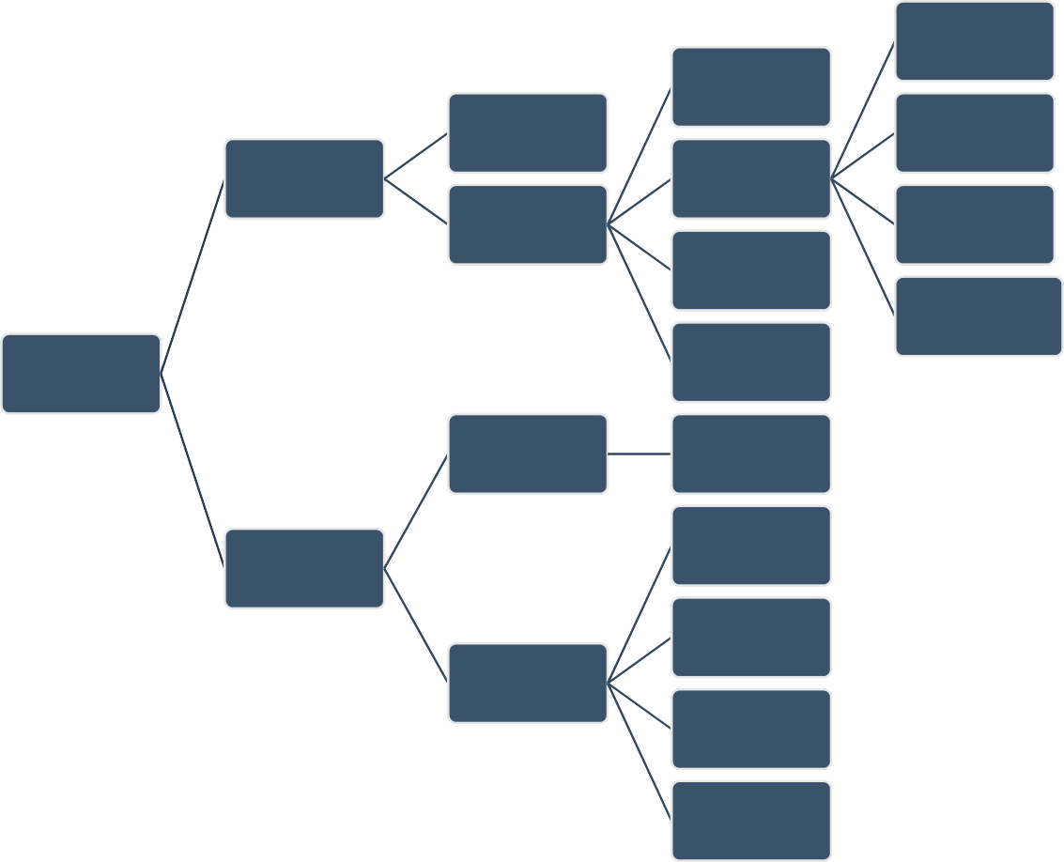
Bio slurping
Intrinsic
Bioremediation
Permeable
Reactive Barriers (PRB)
Bioventing
In Situ
Improved
Techniques
Projected
Bioremediation Biopharming
Bioaugmentation

Phytoremediation
Bioremediation
Bio stimulation
Semi-Solid Phase
Bioremediation
Sludge
Bioreactor
Bio piles
Ex Situ
Land farming
Solid Phase
Bioremediation
Composting
Biofiltration

5.1In situ Bioremediation
It’s the removal of waste by microbes on the site itself without moving the contaminated soil or water.

5.1.1Bio attenuation
Bio attenuation or intrinsic bioremediation is the natural process of degradation of contaminants by autochthonous organisms which is the native microflora with minimum human intervention other than monitoring of pollutant dispersal and the rate of their degradation. It is useful in very sensitive ecosystems like mangroves which need to be preserved. This approach however is time consuming and only works for a mild contamination with simple hydrocarbons like BTEX. Complex and heavy pollution require active intervention.
5.1.2Bio stimulation
Bioremediation is limited by many constraints. The hazardous contaminants are generally a mixture of chemically diverse compounds and thus cannot be digested by a single type of germs. Variety of microbes together can effectively clean up the environment but each may have a different set of requirements. Still most microbes perform productively in an optimum range of factors. We can stimulate the rates of bioremediation by controlling and optimising these factors. This approach is called bio stimulation. The indigenous microflora is provided with conditions which encourage peak efficiency. Temperature humidity ph. oxygenation and nutrient availability can greatly enhance rates of bioremediation. It can be done using organic nutrients for example sewage sludge, wood chips or poultry droppings or inorganic fertiliser like NPK(Maitra, 2018). Bio stimulation by organic nutrients is cheaper but inorganic bio stimulation is fast and specific therefore a combination of the 2 strategies can lead to more desirable outcomes.
BIOSTIMULATION USING ORGANIC NUTRIENTS
Nutrient  Added | Type of  contaminant | Initial TPH  concentration | Percentage Removed | Durati  on | Comment | References
Compost made from wood chips and sewage sludge | Petroleum Hydrocarbon- crude oil | 38,000mg/kg | 100% removal of 2-3 ringed PAHs within the first 3 months | 570  days | Showed 100% removal over a 19-month period with removal linked to the native microbial population and improved growth in the  System | Anagama (2008)
Brewery spent grains, banana skin and spent mushroom compost | Petroleum hydrocarbons- spent lubricating oil | Not indicated | 79% and 92% for 5% oil contamination linked to the presence of organic waste and low contamination while reduction was between 17% and 24% in 15% w/w oil contamination initially and 36% to 55% after 84 days linked to high initial  Concentration | 84 days | Showed significant removal of TPH using the organic nutrient sources | Abioye et al, (2012)
Poultry droppings | Petroleum hydrocarbons- contaminated marine  sediments | 106.4ppm- 116ppm TPH and 96.6 – 104ppm PAH | 95.35% for TPH and 98.92%  for PAH | 56 days | Significant degradation of PAH and TPH in a bioreactor using 20g poultry litter and 1 litter seawater | Chikere et al (2012)
Cow dung | Hydrocarbon polluted  mangrove swamp | 14,103.02mg/kg | 62.96% | 70 days | Significant reduction observed when compared  with control using cow dung as Bio stimulation agent | Orji et al (2012)
Tea leaf,  soy cake and potato skin | Petroleum hydrocarbon- diesel fuel | 100000mg/kg and 200000mg/kg variation in  Concentration | Between 25% and 82% | 126  days | Showed significant degradation of TPH for the treatment with soy cake | Dardanian and Nagamuthu (2013)
Oil palm empty fruit bunch and sugar cane  bar gasses | Petroleum hydrocarbon crude oil | Not indicated | 100% for sugarcane bagasse and up to 97% for empty palm fruit bunch | 20 days | Showed significant biodegradation using these supplements for stimulating microbial growth | Hamzah et al  (2014).

5.2Bioaugmentation
Bacteria quickly adapt to different environments by undergoing selective enrichment. When exposed to a new set of contaminants bacteria with the right set of metabolic machinery multiply quickly using the contaminants and degrading them. Certain sites though may not have a viable population and variety of metabolically relevant microbes capable of bio remediating the site. The indigenous micro flora may be less stress tolerant and may be poisoned by the contaminants. The novel approach of introducing contaminant specific microbes into the affected area is called bio augmentation.
It is of 2 types
5.2.1Cell bioaugmentation
A microbe or a consortium inoculated in the soil grows and degrades the pollutants. The inoculated strains compete with the autochthonous bacteria for resources and their rate of survival is directly related to their success as an agent of waste management. Another limitation is their even distribution based on their tendency to adhere to soil organic matter. Surfactants treatment can assist with the even dispersion

Designing consortium of bacteria to ensure survival of the strains such as a population where the intermediate generated by one set of microbes is catabolised by another set is a clever bioaugmentation strategy. Bacteria which are adhesion resistant and robust with high degradation rates and stress tolerance are the best bet against toxic environments(da Silva et al., 2020).
5.2.2Genetic bioaugmentation
The desirable catabolic genes located on mobile genetic elements is made to be spread into the indigenous microflora.
6 In situ bioremediation techniques
6.1 Composting or adding compost to the site
Composting is a well-established process which has stood the test of time. In the context of bioremediation too it has proven to be an inexpensive and very valuable method. Composting efficiency will depend on temperature and the ratio of waste and soil. It will also depend on the type of pollutant and the material employed for composting. The proportion of bulking agents like peat or wood shavings etc affect the degradation rates. Mixing already remediated soil with compost material introduces already acclimatised bacteria to the site thus enhancing rates of bioremediation.
6.2 Bioventing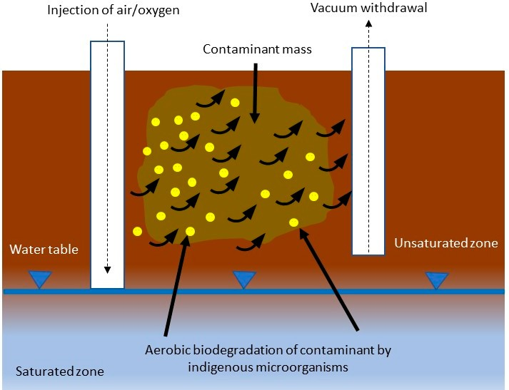
Oxygen saturation is a major limiting factor in biodegradation by microbes. Bioventing is the controlled application of airflow for aerating unsaturated(vadose) areas. Varying speeds of air injection are tested to assess their effectiveness in bioremediation. High air injection rates in case of volatile compounds are much more effective than low rates due to higher volatilization as is the case with toluene(Kensa, n.d.). Low injection rates however bring about a better bioremediation result because it does not lead to a premature saturation of air spaces. The uniformity of the distribution of air using multiple channels leads to better bioremediation gains. Even for the anaerobic degradation of specific recalcitrant chemicals injection of nitrogen rich air with low concentrations of other gases like carbon di oxide or oxygen can be employed. In sites with a soil cover of very low permeability pure oxygen even ozone could be injected to optimise biodegradation.
Soil vapour extraction (SVE) is a variant of bioventing that uses identical hardware but employs very different design or operation.
6.3Bio slurping
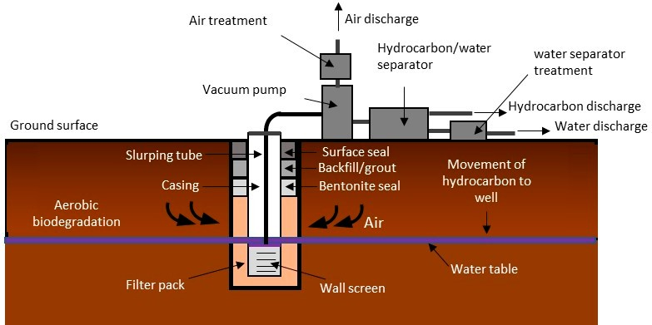

It’s a combination of vacuum enhanced pumping soil vapour extraction and bioventing to remediate and restore sites with a contamination of volatile or semi volatile petroleum compounds(Bala et al., 2022). here the free product available as an immiscible separate phase is separated to reduce the concentration of the contaminant and recovery of light non aqueous phase liquids Z(LNAPLs) using a slurp. They are pumped up to the surface and removed and the rest is bioremediated using conventional bio stimulation strategies.
6.4Biosparging
It’s a variant of bioventing where air is injected at the saturated zone forcing pollutants to move to the unsaturated zones leading to better biodegradation outcomes(Harikrishna & Chandan Kumar, 2012b). Soil permeability and pollutant degradability have a direct bearing on the effectiveness of biopharming. they are especially suitable for aquifers polluted with BTEX.
7 Ex situ bioremediation techniques
Ex situ techniques involve removal of the contaminated resource and treating them under controlled lab conditions. The selection of these Methods depends on many criteria like the cost of operation, intensity of pollution, nature of contaminant, location and nature of site.
These methods yield faster and efficient results due to absolute control of the many variables dictating the rate of remediation. However, it’s also very costly and excavation and movement of pollutants could pose the risk of exposure into the environment. Thus, some precautions need to be taken to prevent the leakage of pollutants.
7.1 Composting
As in the case of in situ remediation ex situ composting is an equally simple cost-effective alternative. Polluted soils are excavated and mixed with organic matter like grass hay or vegetable and animal waste to provide a carbon source and range of bacteria. Bulking agents are mixed to ensure proper permeability by increasing the porosity of the resultant mixture(Azubuike et al., 2016). Thermophilic and mesophilic aerobic bacteria also need a proper carbon to nitrogen ratio which is achieved by dilution with water and the compost soil ratio is maintained between 0.2and 0.7.
Natural carriers used in bioremediation.

Carrier | Removed pollution | Immobilized microorganisms | Efficiency of bioremediation
Plant fibers (Loofah sp.) | Aromatic hydrocarbons | Bacillus cereus | Immobilized — 74%
 |  |  | Immobilized — 79%
 | Phenol | Taramites versicolor | Immobilized — 39%
 |  |  | Immobilized — 87%
 | Methyl parathion | Bacterial consortium | Immobilized — 55%
 |  |  | Immobilized — 98%
 | Carbendazim (pesticide) | Bacterial consortium | Immobilized — 12%
 |  |  | Immobilized — 95%
 | Ni | Chlorella Sorokin Iana | Immobilized — 64%
 |  |  | Immobilized — 88%
Bagasse | Tetradecane | A. venetians | Immobilized — 22.3%
 |  |  | Immobilized — 76.8%
 | Anthracene | P. chrysophobia | Immobilized — 43%
 |  |  | Immobilized — 82%
 | Mesotron (herbicide) | Bacillus poilus HZ-2 | Immobilized — 48%
 |  |  | Immobilized — 75%
 | Chromium | Acinetobacter hemolytic | Immobilized — 38%
 |  |  | Immobilized — 92%
Sawdust | Petroleum oil | Arthrobacter sp. | Immobilized — 18%
 |  |  | Immobilized — 36%
 | Crude oil hydrocarbon | Bacterial consortium | Immobilized — 79.37%
 |  |  | Immobilized — 95.9%
 | Chromium | A. hemolytic | Immobilized — 80%
 |  |  | Immobilized — 99.8%
Corncob | p-Nitrophenol | Arthrobacter proteohormone RKJ100 | Immobilized — 39%
 |  |  | Immobilized — 79%
 | Carbofuran | B. cepacian PCL2 | Immobilized — 67.69%
 |  |  | Immobilized — 96.97%
 | Hexadecane | Pseudomonas sp. | Immobilized — ~33%
 |  |  | Immobilized — ~ 56%
 | Chlorophenols | Bacterial consortium | Immobilized — 87%
 |  |  | Immobilized — 89.7%
Expanded perlite | Methyl tert-butyl ether | Soil consortium | Immobilized — 22%
 |  |  | Immobilized — 50%
 | Hexadecane | Aspergillus Niger | Immobilized — 81%
 |  |  | Immobilized — 96%
 | Styrene | P. aeruginosa | Immobilized — 90%
Tezontle | Sulfonated azo dyes  (Acid Orange 7, Acid Red 8) Propanil (herbicide) | Bacterial consortium  Bacterial consortium | Abiotic test — 16.8 mg/ (L ∗ 24 h) Immobilized — 80 mg/ (L ∗ 24 h)  Immobilized — 36.78 mg/ (L ∗ 24 h)
 | Methyl parathion | Bacterial consortium | Abiotic test — 9%
 |  |  | Immobilized — 58%
 |  | E. coli RAZEK | Immobilized — 49%
 |  |  | Immobilized — 95%
 | DDT (pesticide) | P. ﬂuorescens | Immobilized — 55%
 |  |  | Immobilized — 99%
Coco-peat | Oil | Bacterial consortium | Immobilized — 51.2%
 |  |  | Immobilized — 86.6%
Husks of sunﬂower seeds | Crude oil | Rhod coccus sp. Bot | Immobilized — 28%
 |  |  | Immobilized — 66.1%
Cotton fibers | n-Heptadecane | Acinetobacter sp. HC8-3S | Immobilized — 82%
 |  |  | Immobilized — 96%

Predominance of thermophilic bacteria lead to elevated temperature (54 to 65 degrees) leading to high contaminant solubility and mass transfer rates.
7.2 Bioreactors
Bioreactors are state of the art equipment made of toughened glass or stainless steel that support a bioactive system. They can be aerobic or anaerobic dry or slurry based and very efficient. A all the variables affecting biodegradation can be fine-tuned and optimised in this setup. They can be batch, fed batch, sequencing batch, multistage or continuous depending on the scale of operation and expenditure. Soil pretreatment is a must in this method. It works well for all kinds of contaminants but depending on the scale of pollution can get prohibitively costly.
7.3 Bio piles
It’s another popular ex situ bioremediation technique where a waterproof base like a plastic cover or cement is laid with rows of excavated contaminated soil and aerated. They are covered and proper drainage is ensured. Operation time is3 to6 months. more advanced systems have a leachate collection component. Moisture content is maintained between 40 to 85 % and ph. should be between 6 to 8(Azubuike et al., 2016). They are efficient and eco-friendly. When used as a synergistic system of bio stimulation and bioaugmentation they can be very effective irrespective of the type of soil and ambient temperature. They are easily scalable to field projects but requires pretreatment of the soil to ensure homogeneity. They also need less space than landfarming.
7.4 Windrows
They involve intermittent turning of piles of polluted soil along with humidification to increase the activity of indigenous degradative bacteria by increased aeration. This ensures uniform distribution of pollutants and nutrients and also keeps the soil friable. Soils contaminated with toxic volatile compounds however are not a good candidate for this treatment due to potential risk of exposure.
7.5 Landfarming
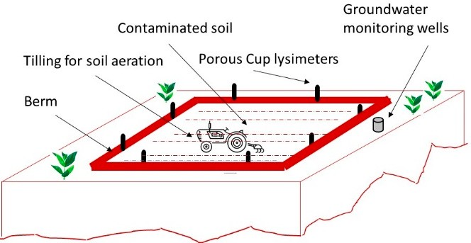
they are the simplest low cost and low maintenance setups for ex situ bioremediation. When the contamination is less than 1 metre deep then it can be used as an in-situ technique eliminating the need for excavation. Contamination deeper than 1.7 metre are excavated and transported to fresh lands for bioremediation. They are then spread in thin layers and repeatedly tilled to ensure uniform aeration. The base is kept impermeable to minimize leaching of pollutants and nutrients. Nutrients and moisture are added to help the autochthonous germs in degrading the waste. The energy cost is negligible here but vast land area is required.
8. Optimization of bioremediation
8.1Immobilization methods
bacteria naturally make biofilms on various surfaces and when bound to a stable surface tend to be more viable and efficient in their catalytic capacities. It makes them reusable thus cutting down cost, resistant to genetic mutation and shearing pressure of bioreactors. Their shelf life goes up along with their stress tolerance and toxicity threshold. It’s achieved by adsorption surface binding, flocculation in liquid or semi solid systems, entrapment or encapsulation.it requires a nontoxic, cheap, stable and insoluble carrier. High bioremediation efficiency is achieved using immobilized microbes.
8.2Use of surfactants
Surfactants are amphiphilic molecules that bring down the interfacial tension between oil and water thus facilitating mass transfer of hydrocarbon compounds from oil to aqueous phase. They maybe cationic anionic zwitterionic or non-ionic. Contaminants frequently adhere to the soil particles and are not readily accessible for metabolism by microbes. Surfactants can increase their bioavailability by emulsification, solubilization and facilitated transport. They may also alter the surface properties of bacterial cells making them more porous. Though special care needs to be taken to select bacterial strains which do not degrade surfactants or are poisoned by them. Inorganic surfactants are highly effective but frequently toxic. Biosurfactants that biodegrade after use are a promising area of research.
8.3Genetically engineered microbes

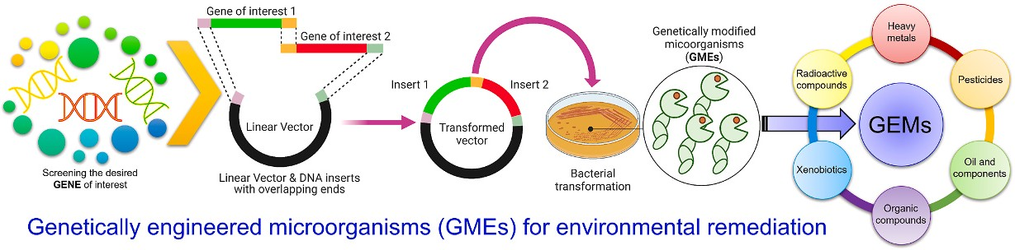
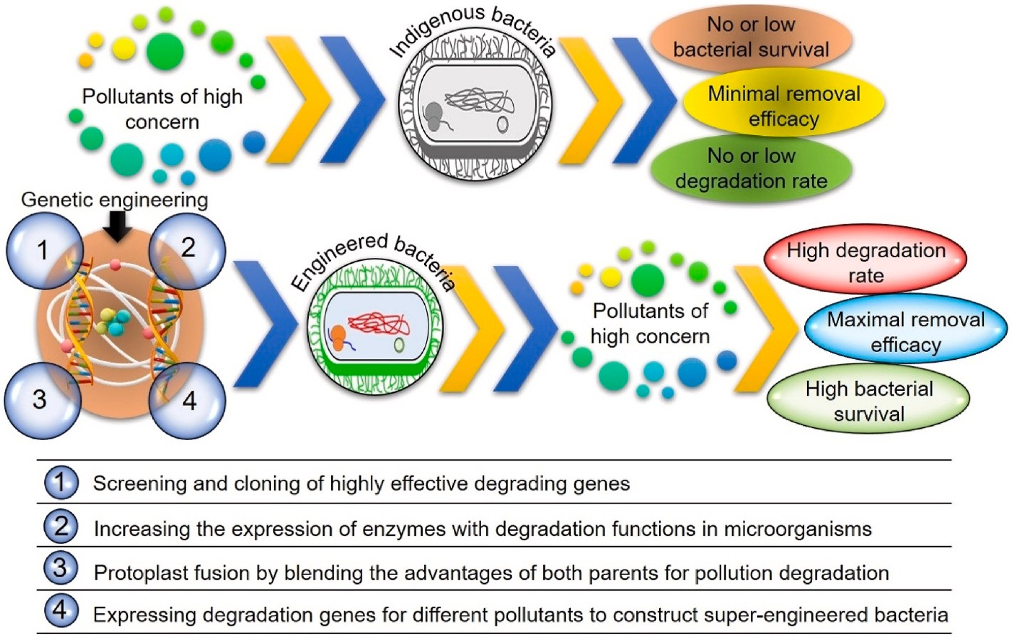
Microbes have genetic material that encodes enzymes for breaking down of waste. Exposure to contaminants lead to acquisition of appropriate metabolic machinery. The indigenous microflora on polluted sites may lack certain desirable traits required for effective bioremediation. These traits can be incorporated into bacteria using molecular biology tools of gene cloning and insertion. These genetically modified microbes or GEMs can be used for bioaugmentation of affected sites for a successful cleanup.

9 Conclusions
The growing population and industrial revolution have accelerated the problems of waste disposal to an extent that has become tough to manage by conventional methods. Physicochemical methods of waste remediation like landfill deposition and pyrolysis etc are costly, cumbersome and generally ineffective. Therefore, the natural ability of microbes to breakdown various organic substances into their basic innocuous forms comes in handy as a cost-effective sustainable solution to our unprecedented environmental problems.
Microbes have the required genetic plasticity to adapt to the whole spectrum of pollutants introduced into the environment by anthropogenic activity. These methods require minimum low-cost interventions and are ecofriendly. Although these methods do have their limitations. They are very slow and don’t have any well accepted end points. They may generate secondary pollutants too. Ex situ methods are faster and more effective but require transportation and pretreatment of soils. In situ methods require careful control of microbial environment on a large area over a long period of time. The use of surfactants and genetic modification of bacteria to make super germs for better bioremediation results are some ongoing areas of interest. Scaling up lab models to field operations is also a challenge. With more research and application of modern cutting-edge tools like bioinformatics and nanotechnology bioremediation can well be the future of environmental biotechnology.

10 References
Azubuike, C. C., Chikere, C. B., & It’s, G. C. (2016). Bioremediation techniques–classification based on site of application: principles, advantages, limitations and prospects. In World Journal of Microbiology and Biotechnology (Vol. 32, Issue 11). https://doi.org/10.1007/s11274-016-2137-x
Bala, S., Garg, D., Thirumal’s, B. V., Sharma, M., Sridhar, K., Inbaraj, B. S., & Tripathi, M. (2022). Recent Strategies for Bioremediation of Emerging Pollutants: A Review for a Green and Sustainable Environment. In Toxics (Vol. 10, Issue 8). https://doi.org/10.3390/toxics10080484
da Silva, I. G. S., de Almeida, F. C. G., da Rocha e Silva, N. M. P., Casazza, A. A., Convert, A., & Sarabu, L. A. (2020). Soil bioremediation: Overview of technologies and trends. In Energies (Vol. 13, Issue 18). https://doi.org/10.3390/en13184664
Harikrishna, S., & Chandan Kumar, D. (2012a). A Review on: Bioremediation. International Journal of Research in Chemistry and Environment, 2, 13–21. www.ijrce.org
Harikrishna, S., & Chandan Kumar, D. (2012b). A Review on: Bioremediation. International Journal of Research in Chemistry and Environment, 2, 13–21. www.ijrce.org
Kensa, V. M. (n.d.). BIOREMEDIATION-AN OVERVIEW.
Maitra, S. (2018). In Situ Bioremediation - an overview | ScienceDirect Topics. Research Journal of Life Sciences, Bioinformatics, Pharmaceutical and Chemical Sciences, 4(6).
Modu Tarekegn, M., Zewdu Salalah, F., & Eshetu, A. I. (2020). Microbes used as a tool for bioremediation of heavy metal from the environment. In Cogent Food and Agriculture (Vol. 6, Issue 1). Informa Healthcare. https://doi.org/10.1080/23311932.2020.1783174
Okagbare Adams, G., Tawari Okagbare, P., Peruke Okoro, S., & Erinome, I. (2020). Bioremediation, Bio stimulation and Bioaugmentation: A Review. International Journal of Environmental Bioremediation & Biodegradation, 3(1), 28–39. https://doi.org/10.12691/ijebb-3-1-5
Saigal, A., & Ahmed, O. B. (2021). Advances in Heavy Metal Bioremediation: An Overview. In Applied Bionics and Biomechanics (Vol. 2021). Hinai Limited. https://doi.org/10.1155/2021/1609149

