PRO-DRUG DEVELOPMENT

ANJALI PALWAR, MOHD.ARSHAD*, ANJALI,
AMAN BHARTI, ANKIT SINGH, SUNIL PRATAP SINGH RAJA BALWANT SINGH ENGINEERING TECHNICAL CAMPUS, BICHPURI (AGRA) - 283105

Introduction

- Prodrug is one of the effective methods of modern research in the field of medicine.[4]
- The development of prodrug have gained increasing more importance in current medication system and therapy.[4]
- Prodrugs refer to a pharmacologically inactive compound which is transformed into an active substance by either chemically or metabolic process.[4]
- Prodrug in modern therapy is actually demonstrated by the fact that in the last ten years several books in this field have been published and thousands of article in scientific database are investing new potential molecules.[4]
- About half or most of prodrugs are hydrolyzed to the active form in particular by hydrolysis of ester.[4]
- Now a day‘s approximately 10% of drugs used in therapy are administered as prodrug.[4]

The concept of prodrugs was first described in the late 1950s, but prodrugs have existed for more than a century.[1]

Aspirin is one of the first prodrug that was widely used and also first marketed prodrug in 1899.[1] It turns into a substance called salicylic acid after it enters the body.[1]
In the past, the prodrugs used to be considered as last resort in drugs development not only is this no longer the case. But now days the prodrug approach is considered at very initial stages of drugs research and development.[2]

Making a prodrug indeed means dealing with a new chemical entity, which eventually may save time money and efforts.[2]

History of prodrugs

- Chloramphenicol is the first synthesized drugs as prodrugs. The concept of prodrug, the concept of prodrug was intentionally used for the first time by the Parke Davis Company.
- The Parke Davis Company modifies the structure of chloramphenicol in order to improve the antibiotics bitter taste and poor solubility in water.
- Chloramphenicol sodium succinate with a good water solubility and chloramphenicol palmitate used in the form of suspension in children. Were two synthesized prodrugs form of chloramphenicol?
- Another historical prodrugs was synthesized German scientific. Aspirin is that historical prodrugs.
- Dresser introduced aspirin into medicine in 1899.
- Acetanilide was the first compound that fulfilling the classicalteria of prodrugs. Introduced into the medical practice by Cahn and help in 1867 as antipyretic agents.

- Acetanilide is hydrolated to biologically active acetaminophen.

What are prodrugs?
The international union of pure and applied chemistry. Defines a prodrug as a chemical that is transformed before it has pharmacological effects. [1]

A prodrug can be defined as a prodrug substance that is inactive in the intended pharmacological action and it must to be converted in to the pharmacologically active agent by metabolic physio-chemically transformation.[1]

In other words, after you take prodrug, it changes in your body before it starts working.
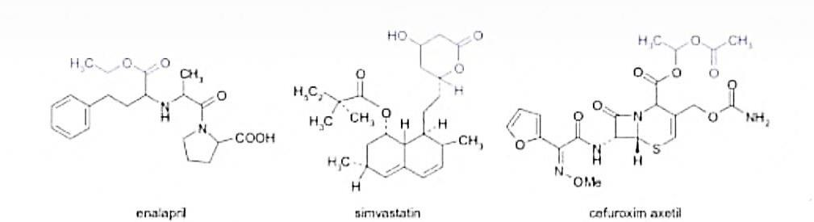
Fig.1 the chemical structure of a few frequently used prodrugs.[4] The prodrug concept has been used to improve undesirable properties of drug.
The actual term ‗prodrug‘ was introduced for the first time by ―ADRIAN ALBERT‖ for drug‘s that are inactive by themselves but which formed an active derivative by biotransformation.

The concept was completed by ―HARPER‖ in 1959 was introduced the term of drug latentiation referring to drug that were specifically designed to require bio-activation.

A prodrug is a chemically modified inert precursor of the drug that on the biotransformation liberates the pharmacologically active parent compound. A prodrug is also called proagent, bio reversible derivative of latentiated drug. The design of prodrug approach is also called drug latentiation.

The place and speed of biotransformation are closely related to chemically structure, as well as the pharmacokinetic properties of the molecules.

The concept of prodrug has to be differentiated from drugs that are active of their own, but by biotransformation are forming one or more active metabolites and the biologically effects occur as a common result of the original drug and metabolites.

In some cases, a prodrug may consist of two pharmacologically active drugs that are coupled together in a single molecule, so that each acts as a promoiety for the others. Such derivative are called ―CODRUGS‖.[4] (E.g. sultamicillin, sulfasalazine, benorylate)
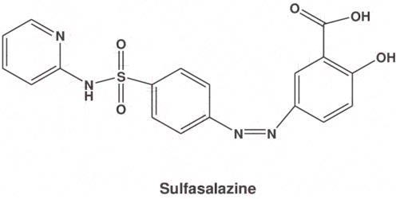

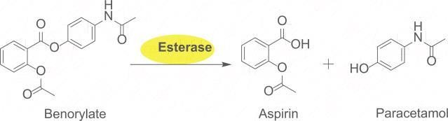
Fig.2 structures of some prodrugs

Ideal properties of prodrugs

The ideal properties of a prodrug are as follows:

- Drugs and the carrier linkage must be cleared in vivo.
- It should not have intrinsic pharmacologic activity.
- IT should rapidly transform, chemically or enzymatically, into that active form where desired.
- The metabolic fragments, apart from the active drug, should be nontoxic.

The purpose of designing prodrugs

The purpose of designing prodrugs are mainly based on two objectives:-

  - Improving bioavailability when the drug candidate is not drug like due to unfavorable physical properties as:-
    - Poor water solubility
    - Low lipophilicity
    - Chemical instability
    - Unacceptable taste or smell
    - Local irritation, pain
  - Improving bioavailability when the drug candidate is not drug-like, due to pharmacokinetics properties
    - Low bioavailability
    - Poor penetration through biological membranes
    - Increased first-pass metabolism
    - Slow absorption by parental route
    - Rapid absorption/elimination instead of long lasting effect
    - Lack of specificity in certain tissues

The main specific objective of prodrug design is to optimize unfavorable physiochemical properties to increase chemical and metabolic stability to achieve planned delivery.[4]

  - Pharmaceutical objectives
- To improve solubility, chemical stability, and organoleptic properties.
- To reduce problem related with the pharmaceutical technology of the active agent.
- To decrease irritation and pain after local administration.

  - Pharmacokinetic objective
- To improve absorption (oral and non-oral routes).
- To increase organ/tissue selective delivery of the active agent.
- Presystemic metabolism should be reduced in order to enhance the time profile.
  - Pharmacodynamics objectives
- In order to reduce toxicity and increase therapeutic index
- To create dual-drug combinations as single chemical entities (co-drugs technique).
The prodrug is used to overcome many complication related to biopharmaceutical, pharmacokinetic or pharmacodynamics obstacles, including poor chemical stability, solubility limitation lack of site specificity, extensive drug metabolism passing through biological barriers, exploiting endogenous metabolic pathways, toxicity.
Prodrugs design to give optimal oral bioavailability and consequent therapeutic effects, the prodrug is used for the optimization of newly discovered chemical entities.
These approaches improve the properties of already marketed drugs.[3]

Classification of prodrugs
Prodrugs can exist naturally such as many phytochemical/botanical constituents and endogenous substance. They can result from synthetic or semisynthetic process.[2]
There are potentially many methods of classifying prodrugs. These could include:
- Based on therapeutic categories for example, anticancer prodrugs. Antiviral prodrugs.
- Based on the categories of chemical linkage or moiety/carriers that attach to the active drug; for example esoteric prodrugs, glycoside prodrugs, bipartite prodrugs.
- Based on functional categories using strategic approaches to circumvent deficiencies inherent to the active drugs; for example,
  - Prodrugs for improving site specificity
  - Prodrugs to bypass high first pass metabolism.

Classification based on conversion in body:
- Type Ist Prodrugs turn into their active forms inside the cells. These are also called intracellular prodrugs.
- Type IInd Prodrugs turns into their active forms outside of cells such as in blood or other fluids. These are also called extracellular prodrugs.[3]

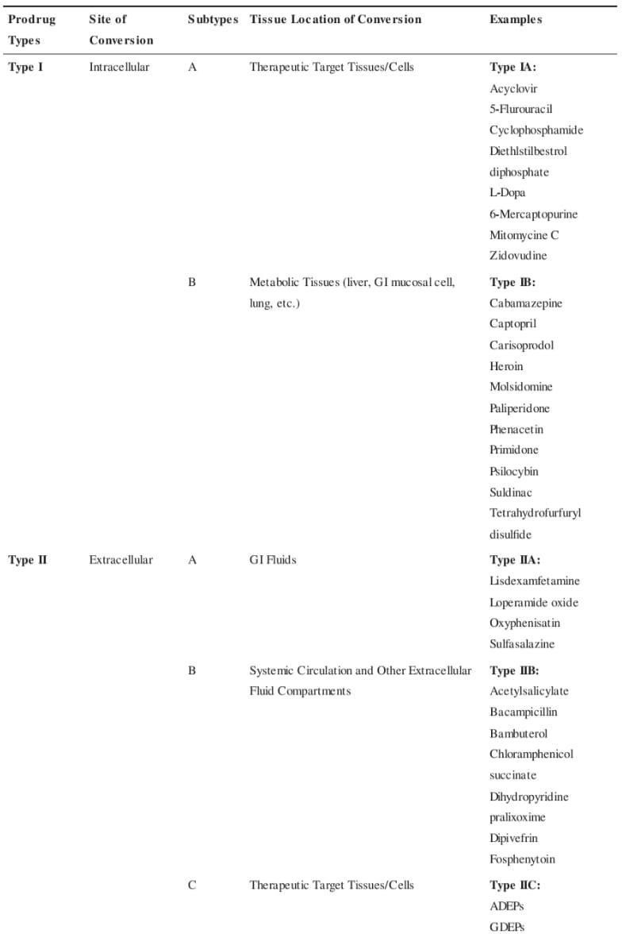

Classification based on chemical criteria

- Carrier linked prodrugs or simple prodrugs-
They are generally esters or amide carrier linked prodrugs are those ones where the active drug is covalently linked to an inert carrier or transport moiety. Such prodrugs modify the lipophilicity due to the attached carrier. The active drug is released by hydrolytic cleavage, either chemically or enzymatically.[6]
These are also called conventional prodrugs obtained by chemical derivatization the desired objective is to optimize transport properties; as on the parent molecule are grafted functional groups that promote absorption.[4]

Ideal properties of carrier
- It does not alter the structure of prodrug until reaches the site of action.
- It must be nontoxic and unstable molecule.
- It does not affect the chemical or enzymatic action of drug and helps to release in active form of drugs.
- It must bear biochemical inertness
- The drug at the location of action does not alter by the carrier and maintained by carrier.

Example- chloramphenicol succinate

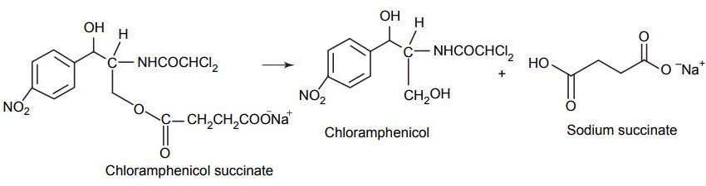

Fig.4 Chloramphenicol[6]

It consist the attachment of a carrier group to the active drug to alter its physiochemical properties. The succeeding enzymatic or non-enzymatic mechanism releases the active drug moiety

Carrier linked prodrugs can be divided into 3 categories:

➔ Bipartite prodrug

➔ Tripartite prodrug
➔ Mutual prodrug

Bipartite Prodrug
    - Bipartite prodrug consist one carrier (group) directly attached to the drugs.
    - The attached carrier have greatly modified lipophilicity in such prodrugs the active drug is released by hydrolytic cleavage either chemically or enzymatically.[5]
    - E.g. Tolmetin- glycine prodrug
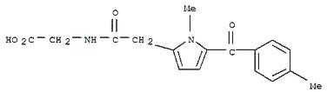
Fig.5 Tolmetin

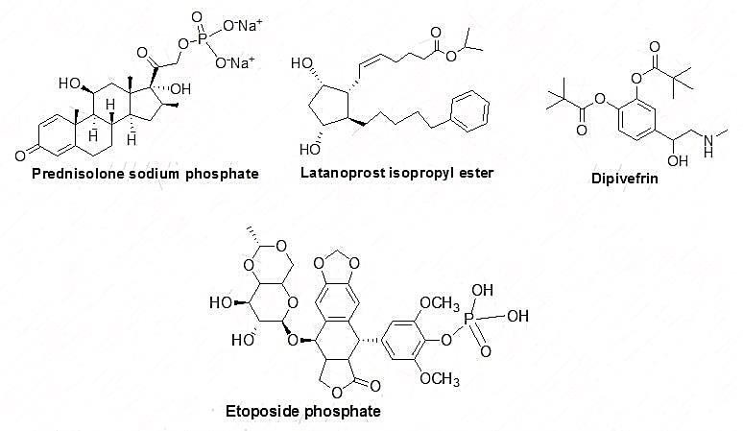

Most of the carrier linked prodrug is bipartite.

- Tripartite Prodrug: in this type of prodrug uses a spacer or linkage between the drug and a pro moiety.
- To overcome the unstable nature of bipartite prodrug due to the inherent nature of the drug promoiety bonding. Tripartite prodrugs are developed and synthesize.
EX: - pivampicillin and bacampicillin are some example of tripartite prodrug.

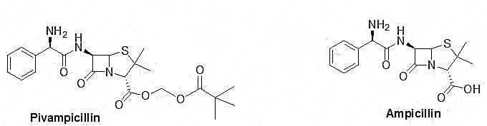
Fig.6

- It consists of pivaloyloxymethly ester, B lactam, ampicillin, and –CH₂- group as a linker to connect to ampicillin and the pivallic acid.
- Pivampicillin has better bioavailability than ampicillin because the ester group creates higher lipophilicity.[5]

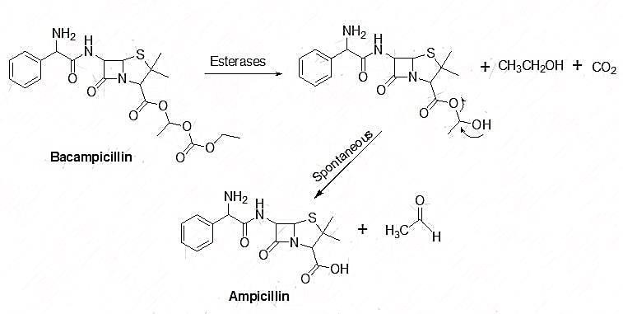

- Mutual prodrugs: these are the prodrugs which consist of two pharmacological active agent coupled together so that each acts as a promoiety for the other agent and vice versa.
- In this type of prodrug the carrier is a synergistic drug with the drug to which it is linked. It is both a bipartite or tripartite prodrugs.
- A mutual prodrug has two potent agent bound together in such a way acts as two synergistic drugs linked to each other where one drug serves as the carrier for the other and opposite.
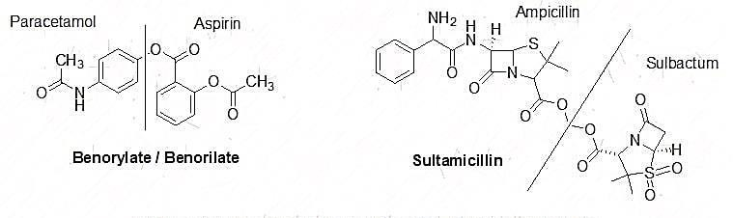
Fig.7
EX; benorylate and sultamicillin are the some ideal examples of mutual prodrugs. In benorylate aspirin is linked covalently to pracetamol through an ester linkage. This drug is suitable for improved analgesic power and decrease gastric irritation.[5] Bio precursors
Bio precursor does not contain a carrier. They are the prodrugs which are inert molecule and obtained from the chemical modification of the active drug.

The bio-precursors are different from the carrier linked prodrug on the basis of metabolic activation they are activated by oxidation and reduction by oxidation and reduction rather than hydrolysis.

These medication based on the active principle itself. And designed from a molecule modification.

They have no carrier and do not contain a temporary linkage between the active drug and carrier moiety.

The molecule must be metabolized to undergo functional be metabolized to undergo functional group transformation for example, if a drug contains a carboxylic acid group, the bio-precursor can be a primary amine that can be metabolized first to the aldehyde and then to the acid.

EX: - nabumetone, pronslosil
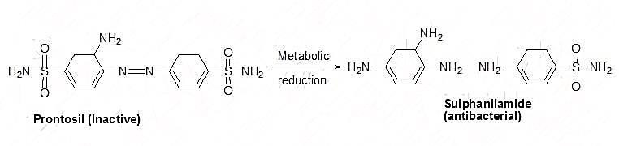

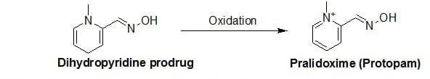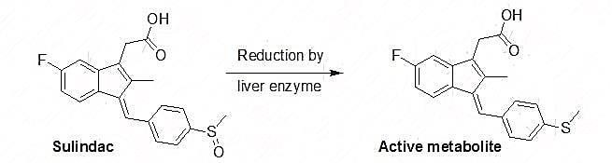

There are some ideal example of bio precursor like sulindac an anti-inflammatory agent. It contains sulfoxide group. Which has activation by the reduction mechanism by liver enzymes. The sulfoxide transformed to a thither and the active metabolite generates after reduction.
It is used to treat chronic and acute inflammatory problems on the comparison it has lower concentration so, decrease GI irritation and side effects than other non-steroidal anti-inflammatory drug like ibuprofen.

Pralidoxime is the another example of bio precursor. It is used to treat poisoning organ phosphorus molecules as an antidote. It is activated through oxidation process in this pyridine group is replaced with dihydropyridine to generates a prodrug and thus enhances lipophilicity to cross the blood brain barrier because pralidoxime is very polar and unable to crosses the blood brain barrier to overcome this problem. The dihydropyridine is converted to pyridine is converted to pyridinium to give the parent drug Pralidoxime.[5]

Characteristics | Carrier prodrugs | Bio precursors
Bio activation | Hydrolytic | Oxidative or reductase
Lipophilicity | Stronger modified | Slightly modified
Catalysis | Chemical or enzymic | Only enzymatic
Constitution | Active principle 1 carrier group | No carrier

Fig.9 differences between bio-precursor and carrier prodrugs[6]

polymeric prodrug- this is the arrange in which drug mint of the drug diffused and contain the polymer (both) naturally occurring and synthetically prepared system between drug and polymer. It is also called as macromolecular prodrug.

EX: - an ideal example of macromolecular prodrug is includes p-phenylene diamine mustered is covalently attached to polyamino polymer
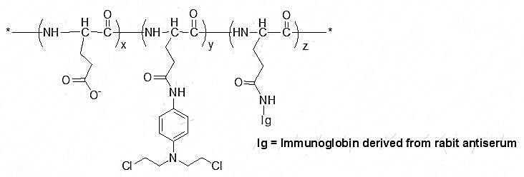
Fig.10

This poly (methacrylate chain was linked to the polymer due to an increase of water solubility it is a synthetic polymer linking & a linking of poly (methacrylate with testosterone &does not have and androgenic effect. So to overwhelm this problem an insertion of a linker between the polymer and testosterone has effects like testosterone.[5]

Classification based on the functional groups.
- Prodrugs are also classified according to the functional group, as follow:

Carboxylic acids and alcohols
- Amines

Azo linkages
(vi) Carbonyl compound

- Carboxylic acids and alcohol – prodrugs of carboxylic and alcohols functioning based on the conversion of esters. The esters can be easily hydrolyzed by esterase enzymes (e.g. lipase, ester hydrolase, cholesterol esterase, acetyl cholinesterase, and carboxy peptidase) present in plasma and other tissue to give active drugs. [6]

EX: - chloramphenicol, palmitate
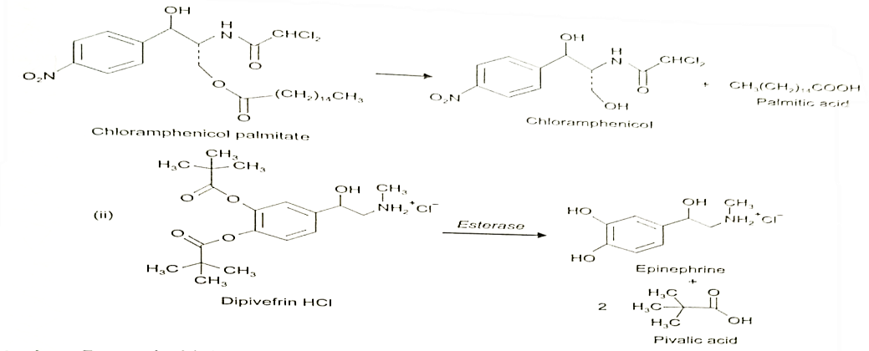
Fig.11

- Amines- prodrug of amines has high stability and lack of amides enzymes necessary for hydrolysis, due to lack of conversion amides enzymes of amines to amide as a prodrugs is not been used for most

of the drug. The adaption of mannich bases as prodrug form of amines is a more common approach of amines.[6]

EX: - hetacillin is a prodrug form of ampicillin in which amide nitrogen and amino functionalities have been allowed to react with acetone to give a mannich base imidazolidine ring system. This leads to decrease in the basicity and increase in the lipophilicity and absorption.
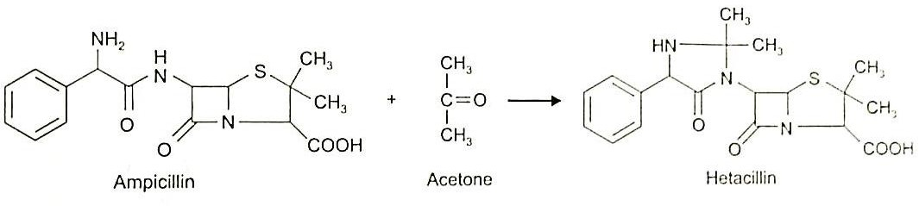
Fig.12 Hetacillin

- AZO linkages- these are the prodrugs often prepared by incorporating them in to an AZO Linkages with prodrugs of amines. Conversion of prodrugs is occur by the action of AZO reductaze the amino compounds are released in vivo.[6]

EX: - prontosil drug is inactive in vitero, but it is active in vivo since it is converted to sulphanilamide by azo reductase enzymes.
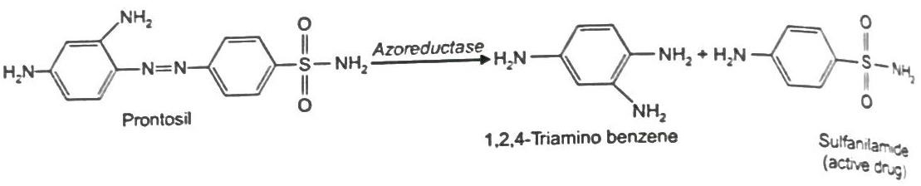
Fig.13
- Carbonyl moiety- these prodrug function on the conversion of carbonyl moiety, in to aldehyde and ketone.[6]

  - These prodrugs have not been found wide clinical use. The sp² carbonyl carbon is converted as sp³ hybridized carbon attached to heteroatom. To form a derivatives.
  - These prodrugs are re-converted to carbonyl compound by hydrolysis.[6]
EX: - Hexamine releases formaldehyde in the urine (acidic pH), which acts as an antibacterial agents.
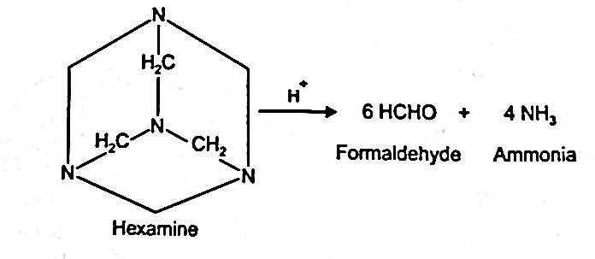
Fig.14 Hexamine

Designing prodrug using different functional group as carrier
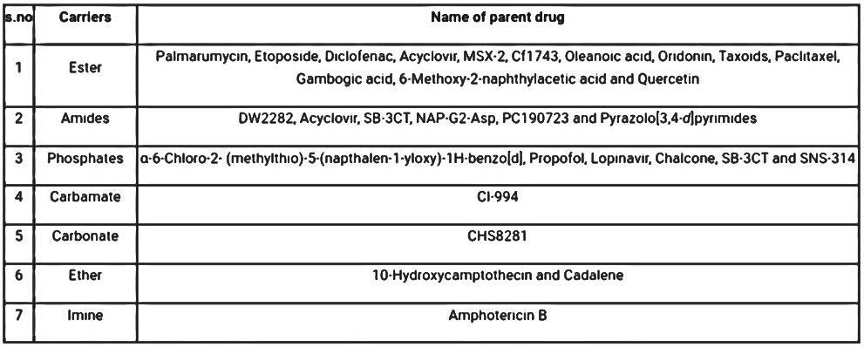

Fig.15

Development of prodrug

(1) Recent development in therapeutic nanoparticles based on prodrug:

This article introduces two concepts for drug design and formulation that can be used independently or in combination to help with some of the inherent challenges of drug development. The first is the usage of a prodrug approach, which emphasizes how chemically changing an active pharmaceutical ingredient (API) can be a versatile strategy to optimize the central feature of a drug for therapeutic and pharmacological advantages. This section is supported with therapeutically relevant examples that demonstrate how prodrugs can be used to enhance an API’s pharmacokinetic (PK), pharmacodynamics (PD), formulation qualities, and toxicity profile. A few of the challenges encountered in the development of prodrugs are also discussed.[7]

Next, the key benefits of a medication delivery system based on nanoparticles are highlighted. Improved stability and bioavailability, controlled drug release and biodistribution, increased therapeutic efficacy, and reduced toxicity are some of these benefits. This overview offers the foundation for using nanoparticles as a means of controlling the use of prodrugs in PNDDS. Although PNDDS is a relatively new and emerging field.[7]

Example of PNDDS products under development provide evidence in favor of the case for combining the benefits of the prodrugs and NP methods into a single product. A PNDDS‘s increased complexity will be tolerable, nevertheless, only if it offers substantial advantages.[7]

These include enhancing the prodrug’s targeting and release to diseased tissue, improving the stability, bioavailability, or systemic exposure, or improving the efficacy and safety of the prodrug. There is a trend toward adopting a combination prodrug nanoparticle method in various disease domains, such as infectious, inflammatory, cardiovascular, neurological, and pulmonary disorders, even if the majority of examples relate to cancer reasons. This section underlines that while PNDDS is an emerging field with a lot of potential and promise, more work is still needed to get these novel technologies from the lab to the clinic and establish PNDDS as a strategy for commercially successful drug development. Improvements in the prodrugs stability, bioavailability, or systemic exposure, as well as better targeting and release to sick tissue, may boost the prodrugs effectiveness and safety. Even though the majority of cases include cancer indications, there is a trend toward using a combination prodrug nanoparticle approach in a number of disease domains, including infectious, inflammatory, cardiovascular, neurological, and pulmonary problems.

This sections underlines that while PNDDS is an emerging subject with lots of potential and promise, further work is needed to verify PNDDS as a commercially viable drug development technique and get these novel technologies from the bench to the bedside.[7]

(2). Nanoparticle- Based drug delivery system

Since they can transport significant therapeutic drug payloads and preferentially deliver them to particular tissue or place, nanoparticle have attracted increasing interest as treatment in recent years. Cover different nanoparticle based delivery strategies, include liposomes, solid lipid nanoparticle, micelle, cub some, polymeric nanoparticle, and inorganic nanocarrier. By using nanoparticle-based drug delivery techniques, the PK characteristics of their APIs may be changed, potentially leading to a longer half-life and more distribution to the site of action, which can improve efficacy and reduce adverse effects. Poorly soluble hydrophobic drugs can be improved and distributed via a variety of administration routes thanks to nanoparticle formation. Medication can be contained in nanoparticles in a synergistic molar ratio to maximize clinical efficacy or with targeting moieties to transport medications more specifically to the site of action in addition to their biological availability. Other design elements are focused on the optimum release of drug target site once the nanoparticle has reached the target site. Environmentally sensitive nanoparticle-based delivery techniques are used when temperature, pH, or other physiological variables change enable the matrix to release drugs slowly or continuously. [7]

Additionally, certain inorganic nanoparticle exhibits stimuli responsive properties, such as the ability to remotely initiate the release of medicine using either an external magnetic field or their surface plasma resonance feature. The creation of nanoparticle is a process that is intrinsically complex and necessitates a thoroughly grasp of the fundamental principle that underline particle production, stability, and perform. Schematic representation of various uses are shown in and have been explored elsewhere. The use of nanoparticle-based drug delivery techniques in clinical settings dates back to the early 1990s, but the field has continued to grow along with technical advancement to improve therapeutic delivery. Clinically approved nanoparticle-based drug delivery systems that contained unaltered pharmaceuticals have undergone a detailed review of their development and advancement. This section’s main theme will be the challenges and future of these platforms..[7]

(2.1) Difficulties and direction for the future:

Nanoparticle technologies can be advantages, but there is still a poor success rate for clinical translation. Some difficulties. The difficulties that nanoparticle-based delivery systems still need to overcome include the requirement for even more control over drug release kinetics and bio distribution, as well as improvement to formulation attributes including stability and encapsulation efficacy. In one case, SPI-77, a cisplatin-encapsulating long-circulation liposome that is now undergoing clinical testing, failed because of the drug's slow and inefficient release from the encapsulation. Another illustration L-NDPP (Aroplatin), a cisplatin analog (cis-bis-neodecanoato-Trans-R,R-1,2-diaminocyclohexane platinum II) encapsulated in non-PEGylated multilamellar liposome, has a limited clinical efficacy due to unfavorable liver accumulation.
Additionally, after reconstition, there were significant amounts of complex degradation, which rendered the medication inactive. LiPlaCis, a brand new liposomal formulation of cisplatin with triggered release capability, serves as another illustration. It is intended to be broken down by secretory phospholipase A2 in tumor areas. Numerous individuals experienced an acute infusion reaction due to renal toxicity, although the lackluster safety profile suggests that further reformulation and optimization are required. Understanding how biology influences Nano carrier PK is crucial in order to deliver the best pharmacology and toxicity profiles. Plasma proteins in vivo absorption on nanoparticle can change the by that nanoparticle interact with biomolecules, changing their pharmacological.[7]

Characteristics, therapeutic efficacy, and toxicity, which helps explain by in vitro and in-vivo results don‘t always correlate. This mechanism known as protein corona (or bio corona) creations is perhaps the most important one influencing how nanoparticle behave and end up when given intravenously. The clinical translational potential of the formulation may also be hampered by their structural and physicochemical

complexity because it can be difficult to pharmaceutically produce complicated nanoparticle system on a big scale. Overcoming inadequate batch-to-batch stability and consistency, low product output, poor quality control, and lack of product purity is expensive. The therapeutic potential of nanoparticle drug delivery systems is exciting, nevertheless, and as these current obstacles are removed, the evidence for their considerable impact on human health will become stronger.[7]

(3) Prodrug formulation in nanoparticle is progressing:

Two major approaches were discussed in the portion of this review that comes before them for enhancing pharmaceutical PK, safety profile, and therapeutic effectiveness. In first involve directly altering an API chemically to create a prodrug, while the second involves encapsulating medicines inside of Nano carriers. Despite the benefits listed in both tactics have obstacles to overcome, as discussed in the preceding section. Prodrugs without protection may clear fast and decay prematurely, while delivery systems based on nanoparticles may have inadequate drug loading and leakage. Combining these two methods gives formulation scientists greater control over the chemical and biological properties of therapies, which may enhance clinical translation. For instance, the degradation of prodrugs can be reduced with the protection of Nano carriers to explore different administration methods. Improved efficacy can be attained by changing the nanoparticle surface chemistry. This section reviews a number of PNDDS articles from 2018 or later, showing their potential benefits over prodrug or nanoparticle only approaches.[7]

(3.1) Oncology

Many candidates are in the clinical developments stage, even though there is only one PNDDS that is now approved without a doubt, oncology has produced the most prodrug based nanoparticle formulation that is being used in clinical setting. This is perhaps because more acceptable cancer treatment are so desperately needed. These attempts are discussed needed. These attempts are discussed in numerous publications, many of which have also been examined elsewhere. The most present PNDDS for the treatment of cancer are listed here by API.[7]

(3.1.1) Platinum based substance

Despite a number of serious drawbacks, platinum based medication is among the most effective chemotherapeutics now on the market. The main ones are medication resistance brought on by in effective cellular intake, glutathione (GSH) inactivation, and metallothionein detoxification, as well as dose limiting adverse effects. In order to overcome these limitations, several efforts have been made to develop novel platinum-based medicines that lower toxicity and increase therapeutic efficacy. One of these is a group of platinum-based prodrugs known as pt(IV)n that are redox responsive and contain different hydrophobic carboxylate ligands. When the Pt(IV) n prodrugs are coupled with amphiphilic lipid PEG, the hydrophobic prodrug self-assembled to create a pt(IV) n prodrug based nanoparticle delivery system (Pn NP) for cancer therapy. Lead formulations caused by endocytosis and exposure to intracellular GSH have an exhausting effect, which reduces the possibility of platinum detoxification when it is treated with thiols. The PEG functionalization of nanoparticles resulted in longer blood circulation and increased tumor accumulation in vivo. Our PEGylated P6 in vivo tumor xenograft mice mode . Improved treatment was produced by the NP delivery platform. The micellar nanoparticle formulation NC 6004, also known as nanoplatin, uses carboxylate from PEG poly (glutamic acid) block copolymers.. The platinum metal center of this type of Pt medication is cross-linked to block co-polymers by co-ordination bond, forming labile bond that enables it to be categorized as prodrug and causes micelles to self-assemble. In a variety can cancer animal model, nanoplatin was more well tolerated than cisplatin and provide more antitumor efficacy. In phase IB/II clinical trials, advanced solid tumor patients treated with nanoplatin and gemcitabine were able to achieve higher cisplatin equivalent doses without encountering clinically significant toxicity issues, suggesting a potential wider therapeutic window.[7]

DACH-Pt, 1,2-diaminocyclohexane platinum II, a platinum-based prodrug, was investigated as a potential treatment for recurrent ovarian cancer using several formulations and a comparable design methodology. These formulations are often utilized. They include a copolymer that increases plasma half-life and a chelator that binds inactive platinum spaces at physiological pH to inhibit target effects. After being subjected to a low pH environment that is prevalent in a tumor, the active platinum spaces are released to achieve targeted delivery. For nanoparticle production to occur, the platinum the species must be chelated the most sophisticated formulation, known as ProLinDac or AP5346, contains and amidomalonato chelator and a hydroxypropylmethacryamide (HPMA) copolymer and was both secure and affective in a phase II clinical trials. In a recently developed multi-drug resistant lung cancer treatment (NP-TPGS-Pt), the DACH-Pt prodrug was repackaged as a self-assembled bio-degradable dendritic copolymer-based drug delivery system. In this study, a PAMAM-MH2-G3 dendrimer was conjugated to glutamic acid to produce carboxylate moieties, which were then used to chelate the Pt metal center and the a tocopheryl PEG 1000 polymer unit. Formulation NP-TPGS-Pt prevented the emergence of drug resistance. A unique approach to treating tumors that are resistant to many drugs is to treat cancer cell in vivo.[7]

(3.1.2) Camptothecin

Camptothecin is another frequently used chemotherapeutic medication. Since its discovery, a great deal of research has concentration on creating novel camptothecin analog in an effort to increase its water solubility and anticancer activity. Irinotecan and topotecan, two camptothecin analog, have been authorized for use in cancer treatment. As a result, the most in-depth research has been done on the prodrug irinotecan, which is transformed into its active metabolite SN-38 by non-specific carboxylesterases. Rapid drug clearance and major dose-limiting toxicities like neutropenia and diarrhea are just a few of the detrimental clinical consequences of irinotecan. A carefully designed drug delivery system might offer a technique to get around these limitations by preventing irinotecan from being metabolized too soon. The liposomal formulation of irinotecan, which was developed for the treatment of metastatic pancreatic cancer, is one example of such a system. It was approved by the FDA in 2015 and administered along with leucovorin and 5-fluorouracil. Patients who have previously undergone gemcitabine therapy are supposed to use it. In the phase III NAPoli-1 research, the onivyde/5-flurouracil/leucovorin combination continued to improve overall survival. Both the 12-month follow-up and a sufficient safety and tolerability profile were favorable when compared to 5-fluorouracil/leucovorin treatment alone. Because monotherapy did not demonstrate superior efficacy compared to the treatment with 5-fluorouracil/leucovorin and was associated with more adverse effects than combination therapy, oniyde is only authorized for use in conjunction with this drug.[7]

Additionally, a phase I/II open- label (NCTO2551991) is currently being conducted to examine the safety, tolerability, and dose- limiting toxicities of onivyde when used as a first-line therapy for people with metastatic pancreatic cancer. Onivyde is compared against oxaliplatin, leucovorin, and 5-fluorouracil in this experiment. This additional onivyde combination therapy is a prospective way to improve the clinical outcome for the treatment of many tumor types by addressing the shortcoming of anticancer single-drug treatment. This sample delivered the active metabolite SN-38 as part of a liposomal formulation, as was previously addressed in the prodrug section of this review article. However, by altering the labile bond type and the pro-moiety structure, different prodrug design methodologies can be imagined for almost every active molecule. Researchers have developed alternative prodrug/nanoparticle administration techniques for SN-38.[7]

Example of a hydrophobic SN-38 redox hypersensitive Nano rod, a redox-responsive lipophilic SN-38 prodrug, and SN-38 grafted amphiphilic phosphorylcholine polymers.[7]

The compound 10-hydroxcamptothecin (HCPT), which is more potent and less toxic than camptothecin, is another camptothecin analog. The use of HCPT in clinical settings on a broad scale is not possible due to its poor water solubility and chemical instability, which is brought on by the opening of its labile lactone ring at physiological pH. Different Nano medicines have been created to assist HCPT in achieving more efficacies with lesser toxicity.[7]

The most recent invention was a phenylboronic acid pinacol ester Nano carrier that responds to ROS and is HCPT-Gu, a guanidine-modified HCPT prodrug, is included. Applying a poly (L-glutamic acid)-g-methoxy PEG (PLG-g-mPEG) nanoparticle that has already been produced to a hyper- branched aliphatic polyester (HAPE) using steglich esterification, PLG-g-mPEG-HAPE (PgP-HA) was created. In terms of stability and drug loading capacity, the PgpHA Nano carriers for the drug HCPT-Gu displayed very good performance. Due to hydrophobic interactions, stacking of the phenylboronic acid pinacol ester group of the PgP-HA and the HCPT prodrug, and the overlapping hydrogen bonds from the guanidine and carboxyl groups.[7]

An in vitro absorption experiment showed that HCPT-Gu improved cellular uptake in comparison to HCPT alone because of guanidine's propensity for cell penetration. According to in vivo PK experiments, PgP-HA/HCPT-Gu nanoparticles showed a longer circulation duration than HCPT-Gu alone, indicating a greater ability to reach and maintain high levels of medication at the target tumor location. PgP-Ha-/HCPT-Gu nanoparticle demonstrated an 80.6% growth inhibition rate with little toxicity in vivo antitumor effectiveness studies, which is consistent with the better PK profile. However, while having a moderate level of systemic toxicity, HCPT and HCPT-Gu only significantly decreased tumor growth by 27.4% and 34.6%, respectively. The potential of PNDDS manufacture for the development for the development of cancer therapy is overall shown in this study.[7]

(3.1.3) Etoposide

As a targeted treatment for a variety of tumor types, glycoside prodrug like etoposide have been created. However, their use has been constrained by the prodrug‘s complicated production and poor in vivo API modification. There was a ketal glycoside prodrug created a overcome these problems.[7]

Recently created to release its active metabolite after coming into contact with both glycosidase enzymes and low pH circumstances. By combining hydroxyl group-containing ETP with hydroxyl group-containing monosaccharides via pH-sensitive acetone-based ketal linkages, the ketal glycoside etoposide (ETP) prodrug was produced. The resulting amphiphilic ketal glycoside prodrug was then self-assembled into glucose-coated nanoparticles by nano precipitation. As shown by a hydrolysis experiment that indicated the ketal glycoside prodrug released only native ETP and glucose, the prodrug created using this method demonstrated glycosidase and acid prompted self immolative hydrolysis.. [7]

Due to the overexpression of glucose transporters in A549 cells , which are lung cancer cells, these prodrug Nano particles showed substantial cellular accumulation , indicating that this technique . Using a combination of the EPR effect and uptake mediated by glucose transporter binding, the prodrug nanoparticles were also shown to preferentially concentrate in tumors in a mouse model of an A549 xenograft. Because of the acidic, high-glucosidase environment of tumor cells, tumor tissue was more hydrolyzed than tissue from other organs.The prodrugs embellished with glucose can be used as immunotherapies or as a building block to make prodrugs that self-immolate in response to stimuli for targeted chemotherapy without causing any harm.[7]

(3.1.4) Gemcitabine:

Gemcitabine, a nucleoside derivative, is used to treat different malignancies. However, its use in clinical settings has been hampered by early metabolism, negative PK, and off-target activity. To get around these issues with squalenic acid chains, many prodrug methods have been investigated by conjugating gemcitabine with long fatty acids. Recently, pH-sensitive gemcitabine polyketal prodrug nanoparticles were developed with the goal of enhancing anticancer effectiveness by achieving effective gemcitabine accumulation at the humor site in addition to lengthening systemic circulation time. This study's prodrug was made by combining gemcitabine with a polyketal backbone utilizing pH-sensitive ketal linkages, then encasing the Nano precipitation. Prodrug nanoparticles demonstrated sustained release of the active metabolite in a pH-dependent manner during in vitro drug release experiments. In a xenograft mouse model, better anticancer effects were shown in the A2780 ovarian cancer cell line, resulting to greater survival rates and improved tolerability when compared to free gemcitabine. This study demonstrates that pH-sensitive polyketal prodrugs may improve the antiviral and anticancer properties of diol nucleoside analogues.[7]

(3.1.5). Dual - drug treatment

To combat drug resistance, increase overall therapeutic impact, and reduce side effects brought on by the need for higher doses when administering the same treatments individually, the dual-drug cocktail method has been widely used in cancer therapies. Contrarily, co-delivery PK differences between different medications in clinical settings may lead to lower efficacy, making it difficult to combine multiple therapies. One co-delivery strategy, which has lately attracted attention due to its benefits over free drug cocktail-based delivery regimens, delivers two pharmaceuticals simultaneously.These PNDDS combine a variety of APIs, either as covalently linked co-drugs or with at least one being a prodrug, to provide a more promising form of chemotherapy. Triple negative breast cancer (TNBC), which is defined by tumors lacking the cellular expression of the estrogen receptors (ER) and progesterone receptors (PR), accounts for approximately 15% of all breast cancer cases. Furthermore, the HER2 protein is not overexpressed on their surface. Due to their poor response to hormone-targeted therapies like tamoxifen (TAM) or HER2-targeted therapy, these triple negative tumors are more aggressive and have prognoses. The use of histone deacetylase (HDAC) inhibitors can restore the expression, and as a result, the utilization of functional ER. It is interesting to note that various studies have shown that histone DE acetylation contributes to the suppression of ER gene expression. The first pan-HDAC inhibitor approved by the FDA for treatment in a variety of cancers was vorinosat (suberoylanilide hydroxamic acid, SAHA), which was used to implement this technique.Studies have shown that SAHA treated TAM-resistant cells with hormone therapy and increased the effectiveness of TAM when given along with SAHA. Due to SAHA's poor stability, its limited oral bioavailability, and the insufficient distribution of the two medications to the tumor sites, combination therapy does confront some substantial challenges. In order to get around these limitations, researchers developed a SAHA prodrug-based nanoparticle delivery method to co-deliver SAHA and TAM for a more effective combo therapy. The polymeric prodrug POEG-co-PVDSAHA, which contains SAHA, was made by reversible addition- fragmentation transfer polymerization. Using polymers with redox-responsive disulfide linkages. SAHA participates in the amphiphilic polymer's hydrophobic domain in this formulation, making it easier to produce stable micelles and encapsulate TAM. Comparing the resulting TAMloaded POEG-co-PVDSHA micelles to free SAHA, free TAM, and a combination of the two, they exhibit enhanced and synergistic cytotoxicity against TNBC cell lines. Another approach to improve TNBC's sensitivity to cisplatin is the use of structure-transformable co-drug-based nanoparticle technology. Pt (IV) - ADD is a collection of self-assembled co-drugs based on cisplatin and adjudicating (ADD). Due to the various ways these drugs function, mitochondria dependent apoptosis, and DNA damage, the Pt (IV) - ADD co-drug can combine to kill cells. Pt (IV)-ADD and 1,2-distearoyl-sn-glycero-3-phosphoethano lamine-PEG (DSPE-PEG) have an amphiphilic character that allows them to self-assemble into uniform nano-formulations with high drug loading. One of the resulting NP formulations, C24-PtADD@PEG NP, changed into an aware structure after IV administration thanks to a dynamic equilibrium between ADD and the conjugated carbon. Chains indicating the thermodynamic stability of its shape. In cisplatin-sensitive and cisplatin-resistant cell lines, C4-Pt- ADD@PEG NPs demonstrated increased therapeutic efficacy in comparison to free cisplatin and the non-transformable formulations. In mice with MDA-MB-231 tumors that were resistant to cisplatin, higher drug retention at the tumor site and greater tumor inhibition were seen. This may be related to the secondary structural rearrangement, which may promote drug retention, as well as the synergistic effect of add and cisplatin. Combination therapy and this structure-transformable nanoparticle have the potential to further the fight against TNBCs. A lipid-PLGA nanoparticle was employed to carry out a two-in-one co-delivery design in another instance of co-drug nanoparticle-based combination therapy. In this instance, the co-drug (Tolfplatin) was produced by combining cisplatin hydrate with tolfenamic acid (Tolf), a highly specific COX-2 inhibitor. Lipid- PLGA@ Tolfplatin nanoparticles (LPTP NPs) were produced by an inhibitor that made cisplatin less polar by joining it to the incredibly hydrophobic Tolf. The two active substances that use different mechanisms of action to produce apoptosis are Tolf and cisplatin hydrate. Tolf damages DNA, whilst cisplatin hydrate enhances p53 expression. In a breast tumor-bearing animal model, when cisplatin hydrate and Tolf were released after intracellular endocytosis, the LPTP NPs passively localized to and aggregated at the tumor site via an EPR effect of combined anticancer effects. In compared to free cisplatin, free Tolf, and the combination of the two free drugs, this co-drug-based nanoparticle delivery strategy demonstrated superior tumor accumulation and enhanced treatment efficacy. No off-target tissue injury was also visible. [7]

(4) Other indications:

Although oncology has given PNDDS the most attention, they have been examined in a variety of indications, including infectious, inflammatory, cardiovascular, neurological, and pulmonary diseases.[7]

(4.1). Including infectious diseases:

A few PNDDS have been utilized to treat infectious diseases brought on by both bacteria and viruses. For instance, a proTide-type prodrug approved for the treatment of hepatitis C, sofosbuvir, was adsorbed onto amino-decorated mesoporous silica nanoparticles. In contrast to not employing a nanoparticle vehicle, sofosbuvir's plasma exposure doubled and its time to C tripled, according to a rat PK experiment. Additionally, the drug release profile might be controlled by surface functionalizing the nanoparticle with either polyvinyl alcohol (PVA) or 3-aminopropyltriethoxysilane (APTES).[7]

For instance, the mesoporous silica nanoparticle APTES coating demonstrated an initial burst release of around 30% of the sofosbuvir in the first hour, followed by a continuous release of the remaining sofosbuvir over the course of 16 hours. It should be emphasized that for PVA-coated particles, 100% release was not achieved. Instead, the PVA-coated particles displayed an initial release of 10% or so of sofosbuvir in the first hour, followed by a rapid release of up to 85% of sofosbuvir after four hours. These findings demonstrate once more how changing the shape of nanoparticles can impact medication delivery and that, frequently, fine-tuning the entire formulation is required to produce the desired results. [7]

The formulation of a drug delivery system for the prodrug tenofovir alafenamide, which was also discussed in the prodrug section of this review article and is optimized for improved cell uptake in anti-HIV combination therapy, may further improve outcomes for groups at high risk of HIV infections by increasing compliance. applying preventative measures before to exposure. Compliance is typically impaired by the multiple administration occasions or the adaptable nature of the advised dose regimens. One example of a medication that may improve adherence comes from recent study by Mandal et al., who developed a long-acting release formulation encasing the antiHIV prodrug combo therapy tenofivir alafenamide-emtricitabine (TAFFTC) inside pluronic F-127 and PLGA-based nanoparticles..[7]

The nanoparticles Formulation's AUC was three to five times greater and its half-life at the site of infection in vaginal tissue was at least 6.5 times longer than that of TAF/FTC medicine solution. In a humanized mouse model of HIV infection, controlled release nanoparticles were found to be 60% more efficient at preventing infection when given 7 or 14 days before the viral challenge than the free drug control group. Together, our data suggest that a pre-prophylaxis drug strategy based on nanoparticles may allow for a reduction in dose frequency, which may have a major impact on compliance and treatment outcomes. [7]

To get around the virus's defense mechanism in latent reservoirs, a "shock and kill" therapeutic approach has been carefully studied. This method uses latency-reversing agents (LRAs) to activate viral replication in the infection by using cytotoxic medicines that are specific to HIV-1 cells or immune-mediated clearance. This tactic is still controversial and has produced conflicting results in clinical settings. These results may be due to insufficient drug concentration at the target sites, ineffective LRA immunotherapy, off-target toxicity, or nonspecific T cell activation. The utilization of delivery methods based on nanoparticles would be an interesting strategy to get around these challenges. [7]

To enable the co-delivery of various LRAs (JQ1, DSF, Ing3A, cholesterol butyrate (chol-but), prostratin, and panobinostat, or PANO), lipid-coated PLGA hybrid nanoparticles (LCNPs) were coated and added to the (4.2.1). LCNPs. (Ing3A- PLGA, PRs- PLGA, and PANO- PLGA), infectious illnesses, Chemical conjugation to PLGA using an ester or an amide bond (JQ1/LCNP, DSF/ Ing3A- PLGA, Prs- PLGA, and PANO- PLGA), chemical conjugation to PLGA using an ester or an amide bond (JQ1/LCNP, DSF/ LCNP, Ing3A- PLGA), chemical insertion into the lipid bilayer (chol-but LCNP), or any combination of these methods. Additionally, insertion into the lipid bilayer (chol-but LCNP), self-assembly into LRA-loaded LCNPs (like Ing3A-LCNP), or any combination of these techniques. Additionally, compared to loose LRAs or physically enclosed LRAs, self-assembly into LRA-loaded LCNPs (such Ing3A-LCNP, Prs-LCNPs) reduces the unwanted first burst release. All LRA-LCNPs demonstrated cytotoxicity in the J-Lat Tat-GFP cell line model that was either equal to or less toxic than the free drug, showing that LCNPs could deliver higher doses for increased efficacy while limiting toxicity. In order to balance the trade-off between toxicity, potency, and synergy, it was determined that the combination of Ing3A-LCNP and JQL/LCNP was the best option. [7]

Treatment with his combination also synergistically increased HIV-1 mRNA expression levels in CD4 T cells from infected patients maintained on suppressive highly active antiretroviral therapy. Following subcutaneous administration, the Ing3A - LCNPs aggregated in lymph nodes, particularly linked to and activated CD4 T cells in mice, and did so by including CD4 antibodies as the active targeting motif on their surfaces. The positive results of this emerging sector for finding an HIV treatment, despite the need for more study to thoroughly examine the latency reactivation in a non-human monkey simian immunodeficiency virus model. [7]

For the treatment of bacterial infections, nitric oxide (NO)-releasing polymers and NO-prodrugs that are polymer-encapsulated are being studied. By destroying DNA, deactivating metabolic enzymes, and reducing the potency of bactericidal activity without running the danger of the emergence of antimicrobial resistance. The non-specific nature of the unique interest in solving this problem, however, presents challenges for the therapeutic efficacy of this approach. In one study, NO triggered the dissolution of bacterial biofilms at pico- and nanomolar concentrations, leading to planktonic microbes that were resistant to antibiotic treatment. Utilizing this result, Nguyen et al. In order to create combined NO and antibiotic micelles, a gentamicin-decorated amphiphilic block copolymer of poly ((oligoethylene glycol) methyl ether methacrylate) and 3- vinylbenzyladehyde (POEGMA - b - PVBA) was directly conjugated to a NO-donor (Ndiazeniumdiolate (NONOate)). Using free gentamicin alone, a NO-donor alone, or micelles alone, in vitro treatment of biofilm mass was compared to slight reductions following treatment. Similar outcomes were observed when evaluating the survivability of biofilms, demonstrating that a dispersing agent may be useful in enhancing the efficacy of traditional antibiotic drugs against biofilm-related infections. [7]

(4.2).Inflammatory diseases:

Studies on the effects of PNDDS medication on inflammatory diseases, such as arthritis, have also been conducted. Polymeric micelles and protein nanoparticles are examples of non-prodrug nanoparticle-based delivery methods that physically enclose drugs; nevertheless, one downside is that these systems commonly burst release. low drug loading behavior or both. In order to improve the design of the delivery systems, cutting-edge prodrug techniques can be implemented, which can help to increase the clinical translation of these techniques. In order to treat rheumatoid arthritis, Xu et al. created modular pH-sensitive acetone-based ketal linked prodrugs of dexamethasone (AKP-dexs) [301]. Eight AKP-Dexs of different chain lengths were made, and they were combined with the amphiphilic polymer DSPE-mPEG200 to form nanoparticles. Because of their longer carbon chains, long-chain alcohols were more potent pro-moies. The compatibility of dexamethasone with DSPE-mPEG2000 enables the production of stable nanoparticles with outstanding encapsulation efficiency. In a rat model of arthritis with collagen, the AKP-dex-loaded nanoparticles showed increased accumulation in arthritic joints as well as effective dexamethasone release. The microenvironment of arthritic joints is acidic in comparison to the free water soluble prodrug, dexamethasone sodium phosphate. According to this study, pH-sensitive prodrug nanoparticles may provide a promising platform for their improved therapeutic efficacy and low systemic side effects. [7]

For example: polymeric micelles containing diclofenac are another example of a PNDDS that may be used to treat inflammatory illnesses. Some of the most frequently given treatments for pain and inflammation are non-steroidal anti-inflammatory drugs like diclofenac.
They do, however, have a number of negative effects, including increased cardiovascular to the level of drug present in the heart. By limiting the heart's exposure to diclofenac. Diclofenac's cardiovascular risks were reduced by administration with polymeric micelles, according to research by AI- Lawati et al. [7]

In this study, traceable polymeric micelles (DFEE-TM) were produced by combining diclofenac ethyl ester with the block copolymer PEO-b-PCL coupled with the near-infrared probe cyanine -5.5 azide using a solvent evaporation approach. Adjuvant arthritis (AA) inflamed joints showed elevated fluorescence levels following a single IV injection. In ex vivo near-infrared optical whole-body imaging, rats' joints were compared to the joints of healthy rats, proving that the DFEE - TM were concentrated in the inflamed areas due in part to the inflammation to the PEO's long-term properties. In addition, after seven daily doses of DFEE -TM compared to dosing with free diclofenac, in the hearts of AA rats was significantly decreased. An important cardio toxicity indicator was decreased in the heart and plasma of AA rats, which is consistent with this finding. By modifying their biodistrubution and improving their accumulation in the permeable vasculature of the subject, this study proved that prodrug - incorporating polymeric micelles can lessen the toxicity of conventional medicines.[7]

(4.3) Cardiovascular diseases:

A thrombus-targeting aspirin particle for the treatment of thrombotic illness is a PNDDS with potential for use in cardiovascular medicine. Aspirin (ESA; ethyl salicylate) had been created. In this study, thrombus-targeting aspirin polyconjugate particles (T-APP) with anti-inflammatory and anti-coagulant properties were created by combining APP, a polymer-drug conjugate, with the anti-coagulant and anti-inflammatory drug. APP was combined with fibrin-binding peptide Gly- Pro- Arg- Pro- Pro (GPRPP)-lipid conjugates, DSPE-PEG-GPRPP. Release of ESA from T-APP was tested in H202-stimulated arterial endothelial cells, and the results showed that intracellular ROS were present. When T-APP was examined in a mouse model of blood vessel thrombosis and tail bleeding, it was shown that therapy with TAPP increased the bleeding time by over two times when compared to treatment with free aspirin, indicating a higher anti-thrombotic impact. After IV injection in a rat model of carotid artery thrombosis, T- APP was also closely linked to a synthetic thrombus. Once the, this result was ruled out. Free fibrin-targeting GPRPP - peptide has previously been administered to rats to block T- APP binding. [7]

(3)

In addition to the potent anti-inflammatory capabilities of T-APP, these investigations suggest a possible new application for aspirin in the treatment of life-threatening blood clots in the body. Nanoparticles composed of chitosan and alginate have also been employed to enhance the therapeutic effects of FDA-approved prodrugs like lovastatin. The cholesterol-lowering prodrug lovastatin's active hydroxyl acid form is hydrolyzed in vivo and prevents changes in 3-hydroxy-3-methylglutaryl-Coenzyme A that have an impact on cholesterol production. Although its short half-life (approximately three hours) necessitates evening administration, which reduces patient compliance and restricts its application. In this study, lovastatin encapsulating alginate/chitosan nanoparticles were produced in order to control the release of a drug named and establish a good absorption and distribution profile. The interaction between the polymer and lovastatin in the final formulation (ACL nanoparticles), which occurs through hydrogen bonding and dipolar-dipolar interactions, controls the structure and shape of the nanoparticles. When a solution's pH was raised, ACL nanoparticles released lovastatin more quickly and at a faster rate. The release was rapid (80%–90%) for the first 10 hours, and then the final 10%–20% trickled out gradually for up to 30 hours. The ACL nanoparticles were also discovered to be safe in trials of acute and subchronic toxicity following oral administration to healthy animals. These results demonstrate that ACI nanoparticles could be employed to enhance the pharmacological impact of lovastatin due to their controlled release property. [7]

(4.4) Neurological disease:

A mixed prodrug nanoparticle approach has also been used to treat neurological issues. The prodrug section. describes a dopamine prodrug, an FDA-approved Parkinson's medication. A medication called levodopa (L-DOPA) has high BBB absorption. However, the digestive system and systemic circulation swiftly degrade it. The use of a Nano carrier to shield levodopa from serum decarboxylase activity while successfully crossing the BBB and concentrating on the brain offers a new approach, even if many additional dopamine prodrugs are being developed to solve this issue. L-DOPA-AuNFs, which have been functionalized with the targeting ligand L-DOPA, were created by Gonzalez-Carter et al. As a potential brain-penetrating delivery mechanism.

Using an in vitro human BBB model (hcMEC/D3 cell line), they demonstrated that, contrary to what has been reported in the literature, more L-DOPA-AuNFs traveled across the brain. [7]

Furthermore, the pace at which they were transported across the BBB monolayer matched that of a monolayer comprised of cells from the exterior of the human umbilical vein. Brain macrophages ingested L- DOPPA-AuNFs extensively in vitro without manifesting inflammation. Even though the pharmacological effect of these prodrug-loaded gold nanoparticles has not been investigated, these encouraging results raise the possibility of improvements in the way brain diseases are treated. [7]

(4.5) Pulmonary diseases:

PNDDS may be used as a form of treatment for pulmonary disorders. For instance, pulmonary arterial hypertension (PAH), a disorder that worsens with time and is characterized by elevated pulmonary arterial pressure maintained by occulted and/or restricted pulmonary vasculature, persists despite the use of a number of effective medications..[7]

In 5 year survival rate is still low for PAH treatment. Numerous PAH medications already in use are also liked to negative side effects induced on by systemic exposure. Analogue of one of the three prostacyclins that have been approved to treat analogues that have been approved to treat PAH is the vasodilator treprostinil, which comes in the form of an oral tablets (Orenitram), a continuous infusion (Remodeling) and an inhalable solution (tyvaso). Although local API administration to the lung is made possible by the nebulized tyvaso formulation, it requires four dosages per day and is linked to serious side effects brought on by systemic exposure. The vasodilator treprostinil, available as oral tablets (Orenitram), an inhalation solution (Tyvaso), and a continuous infusion (remodeling), is one or three prostacyclin analogues that have been approved to treat PAH. even so. The tyvaso formulation, which required four dosages per day and was associated with local side effects like coughing and sore throats, delivered the API to the lungs. To overcome these limitations, a novel treprostinil-based nanoparticle formulation was developed and is currently undergoing clinical development to treat PAH.[7]

The solubility profile of treprostinil palmitil has been significantly altered, and its water solubility has decreased. Treprostinil palmitil is a prodrug that combines palmitil alcohol as the pro-moiety and an ester link to mask the carboxylic acid functional group of treprostinil acid.[7]

the therapeutic elements of treprostinil palmitil and treprostinil acid API. The prodrug can be included in a lipid nanoparticle comprised of squalane and DSPE-PES2000 due to the latter's enhanced lipophilicity. Squalane serves as a hydrophobic filler, while the DSPE-PEG2000's "stealth coating" improves formulation stability and reduces prodrug discharge. [7]

Why the prodrugs are used:

- Improved chemical consistency:

Every medicinal agent needs to maintain its chemistry. The prodrug technique, as stated above, depends on changing the functionality responsible for the unstable character. This technique aims to alter the drug's physical properties as well, which reduces the drug's ability to interact with the media. Propranolol, for instance, is used as an antihypertensive medication (Figure 27, R = R' = H). An oral dose has a lower bioavailability than an intravenous injection dose due to first-pass exclusion of the medication. The three main metabolites of this medication are p-hydroxy propranolol (Figure 27, R = OH, R' =H), propranolol, and its O-glucuronide synthesis. The plasma levels of propranolol can be eight times higher when propranolol hemi succinate is taken orally as compared to when propranolol is used.[5]

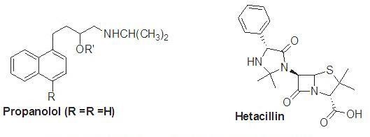

A member of the beta-lactam antibiotic family is hetacillin. This prodrug has no antibacterial properties; however it can convert acetone into the antibiotic ampicillin in the body. The Ampicillin produces polymeric species by preventing auto-aminolysis, which is made possible by the NH2 group's ability to connect to the other molecules -lactam structure. A prodrug of ampicillin binds up the amino functionality and inhibits auto-aminolysis by forming hetacillin.[5]

Improvement of bioavailability:

The gastrointestinal absorption of multiple drugs, including vitamins, natural purine and pyrimidine nucleosides, dopamine, ampicillin and carbenicillin, phenytoin, and GI toxin, is poor. These chemicals' weak lipophilicity, polarity, and metabolic tendency are the main causes of their weak immersion. The thiolate ion is treated to create a fat-soluble prodrug, which enhances the absorption of vitamins. The medical benefits of dopamine are achieved by L-Dopa, its precursor. A polar molecule is L-dopa. This is transmitted by the L- amino acid active transport process and dopamine is reborn via a decarboxylation pathway.[5]
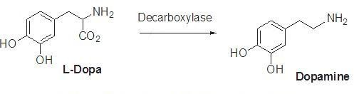
A prodrug of zanamivir called L-valyl zanamivir has been created. Through the PepT transporters, this prodrug is more easily absorbed. Its oral absorption can be improves by this procedure.[5]

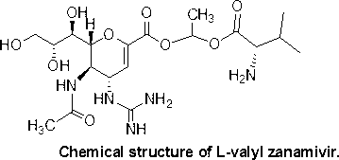

Because it is unstable under physiological settings, cur cumin has a low bioavailability. Due to poor absorption and a fast metabolism, it exits the body. The bioavailability of cur cumin has been improved using a variety of techniques that solve problems. Diacids, amino acids, and glucose are conjugated. This process appears in.[5]
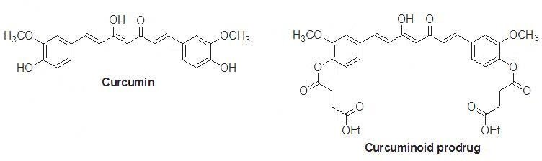

Preventing presystemic metabolism:

A successful drug should pass using the liver and digestive system before reaching the transmission. Many medications can be metabolized through oxidative N- and O-DE alkylation, ester hydrolysis, or peptide breaking. The stomach's acid swiftly breaks down the first category of medications. The liver and digestive mucosa's enzymatic processes break down the second group of medicines. If a specific capability is safeguarded by derivatization, the metabolism of the medication is blocked. The drug's physicochemical properties can also be changed. For example, naltrexone, an opioid addiction treatment drug, is rapidly absorbed in the digestive tract and undergoes presystemic metabolism.[5]
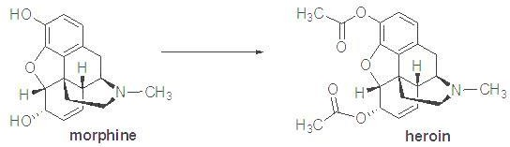

Presystemic metabolism extension:

The activity duration of a drug can be maintained by the prodrug if a medication has a short half-life period and is administered frequently with an equal dosage. Prodrugs like testosterone propionate, estradiol propionate, and fluphenazine deaconate have the respective active substances of testosterone, estradiol, and fluphenazine as the main components.[5]

Drugs with a prolonged half-life are essential for treating psychosis. This group's patients need their medications for a longer period of time. The maximal plasma level of the sedative and tranquilizer haloperidol is observed 2 to 6 hours after intake. If administered intramuscularly, the prodrug haloperidol deconate remain active for one month.[5]
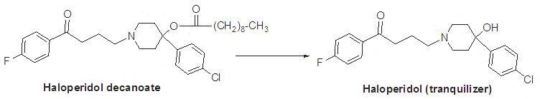
Antipsychotic medication's effect lasts for 6–8 hours, but fluphenazine's activity lasts for a month.

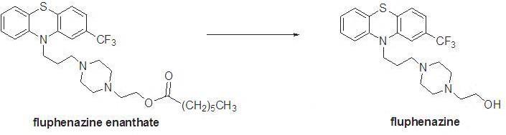
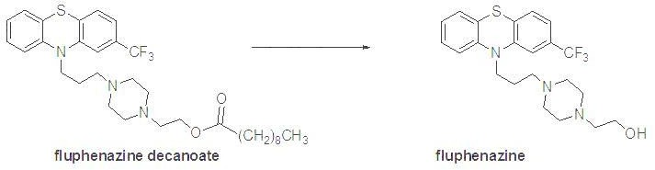

Tolmetin sodium, an anti-inflammatory medication, is changed into a glycine conjugate to improve action and extend its highest concentration to about 9 hours. the prodrug amide bond's weak hydrolysis can result in this.[5]

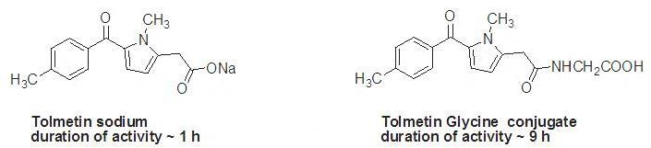

Decrease in toxicity:

Prodrug toxicity should be minimal or absent. Eye medication epinephrine causes numerous ocular and systemic adverse effects. Prodrug dipivaloyl epinephrine has a better profile and is more active than

epinephrin. Doxorubicin is a cancer-fighting medication. However, due to its cardio toxicity, this medication must be used with caution. Designing medications that would boost doxorubicin availability in cancer cells but minimizing its effects on heart function was significant. To do this, a galactoside prodrug with doxorubicin and a carbamate group was created.[5]
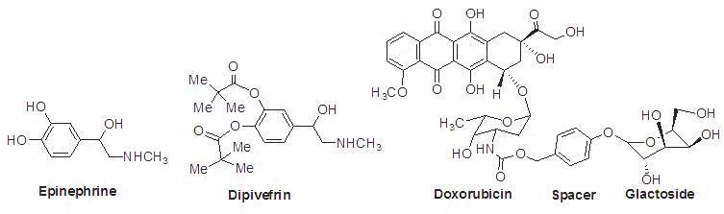
The negative effects of sulindac are much less than those of indomethacin and it has no impact on the stomach. A diisobutyrate ester of terbutaline used to treat glaucoma is called ibuterol. Number 38 This prodrug is 100 times stronger, takes up to three times as long, and doesn't have any local or systemic side effects.[5]
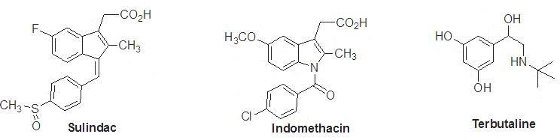

Particular delivery to the site:

If the physicochemical properties of the original drug and the prodrug are suitable with the target site, the targeting of medications to the internal organs using conversion to a prodrug works well. Different body parts are targeted by the medications. By prodrug-designing the medication to target the actual source of the issues, this constraint is overcome. After that, the target tissue undergoes the prodrugs conversion to the drug's active form. Specific enzymes or acidity can cause this process to happen. Phosphate and amides are present in higher concentrations in tumor cells than normal cells. If these enzymes are needed for the prodrug to be activated, a cytotoxic prodrug is then administered to the tumor cells. For the site-specific administration of diethylstilbestrol to patients with prostate cancer, diethylstilbestrol di-phosphate has been developed. Given rectally, oxyphenisatin is a bowel sterilant. Oxyphenistatin acetate, an acetylated prodrug, is taken orally. Finally, it is converted to oxyphenisatin at the digestive level.[5]
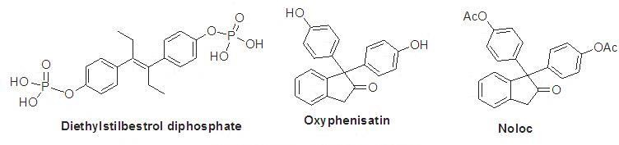

Structures, applications, and use of a few prodrugs with FDA approval from 2008 to 2018 [80– 89]:

- Fesoterodine Fumarate:

To obtain the active substance, 5-hydroxymethyl tolterodine, esterase hydrolyzes the prodrug fesoterodine fumarate (trade name: Toviaz). It helps to use a muscarinic receptor antagonist to treat hyperactive bladder muscles that cause problems with frequency, urgency, and leaking.[5]
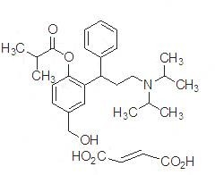

Fospropofol disodium:

Alkaline phosphatase transforms the prodrug fospropofol disodium (which is marketed as Lusedra) into its active component, propofol. An intravenous sedative-hypnotic drug called fospropofol, which is frequently given as disodium injection, is advised for adult patients having supervised local anesthesia care sedation, such as endoscopy.[5]
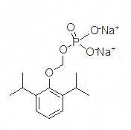

Fosaprepitant dimeglumine:

The prodrug fosaprepitant dimeglumine, also known as Emend, is activated by phosphatase-catalyzed DE phosphorylation to produce the substance that acts aprepitant. In chemotherapy regimens, fosaprepitant dimeglumine is used together with other antiemetics to minimize both early and delayed nausea and vomiting following the application of some cancer chemotherapy treatments.[5]
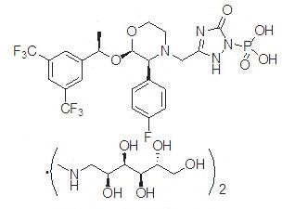

Prasugrel:

The prodrug of prasugrel (brand name: Effient) decreases by esterase and CYP450 metabolism to produce the active drug, R-138727. Patients with acute coronary syndrome with heart disease who have a specific heart operation as well as those with specific heart or blood vessel changes take prasugrel in combination with aspirin to prevent blood clots.[5]

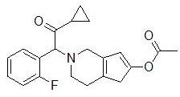

Romidepsin Prasugrel:

Intracellular glutathione activates the prodrug romidepsin prasugrel (trade name Istodax), resulting in the production of the drug's active metabolite, which has a free thiol group. An injection of romidepsin, an HDAC inhibitor, should be considered for the treatment of cutaneous T-cell lymphoma in patients who have received at least one prior systemic therapy and at least one other form of treatment.[5]

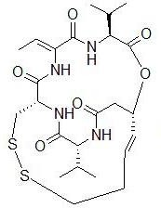

Application of prodrugs:

In most situations, the objective of pro -drug development is to address certain pharmaceutics, pharmacological, and pharmacokinetic issues. The following are the primary objective of pro -drum:(8)

  - Taste improvement
  - Odor improvement
  - Bioavailability is improved
  - improvement to the qualities of stability and solubility
  - Decreased toxicity and negative effects
  - Enhanced site specificity
  - Increase duration of pharmaceutical effect
  - Pharmacokinetics is affected by drug absorption, distribution, metabolism, and excretion.

Taste improvement

The bitterness, acidity, or causticity of the medicine is one of the factors contributing to low patient compliance, particularly in children. The foul taste of the medication is addressed using two methods. The bitterness is marked by the first strategy, which reduces the drug‘s solubility in saliva, and the second involves lowering the drug‘s a few example of medication with enhanced flyover.

Table Of Drugs With Improved Taste
Parent drug | Pro-drug with improved taste
Chloramphenicol | Palmitate ester
Clindamycin | Palmitate ester
Sulfisoxazole | Acetyl ester
Erythromycin | Estolate

Oder improvement
The vapor pressure of a substance affects its smell; a liquid with a high vapour pressure will have a strong smell. Ethyl mercaptan, for instance, is a leprosy therapy that uses a foul – smelling liquid. A diethyl dithioisophthalate with a higher boiling point and no Oder is created when this is converted to phthalate ester.
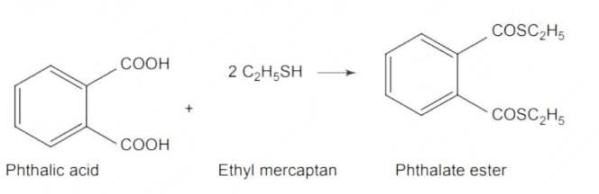

Bioavailability is improvement

Ampicillin has a low lipophilicity and is only 30% -40% absorbed when taken orally since chain contain an amino groups .By esterifying the free carboxy group , this antibiotic ‗s polarity can be changed , resulting in compounds that are more bioavailable than the parent ampicillin because they are entirely absorbed.
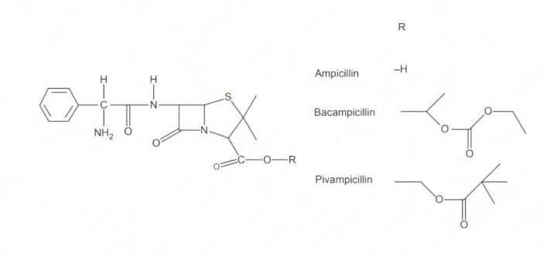

Improvement to the qualities of stability and solubility

Stability: The prodrug method is a useful technique to increase their stability. When taken orally, a no. of medications can decrease during their shelf life or in the gastro intestinal tract [ GLT]. Azacytidine easily in an acidic pH, although its bisulphite prodrug is more stable. Solubility: In order to formulate such

medication for parenteral or ophthalmic use, hydrophilic or water – soluble compound are required. By using half ester like hemi – glutarate or hemi -phthalates, which carry sodium, potassium, or amine ions on their other half and make the moiety soluble, drugs having hydroxyl functional groups can be transformed into their hydrophilic form.
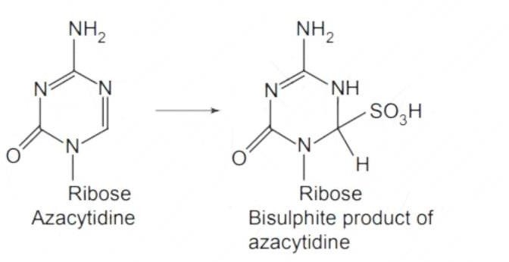
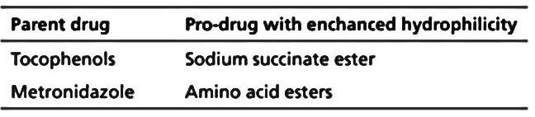

Decreased toxicity and negative effects

In some case, phenols and carboxylic acids are too harmful to be used in therapeutic setting. The absence of stomach ulcer genic activity in ester prodrugs of acidic non-steroidal anti-inflammatory drugs is thoughts to be one of the causes of these medication negative side effects.
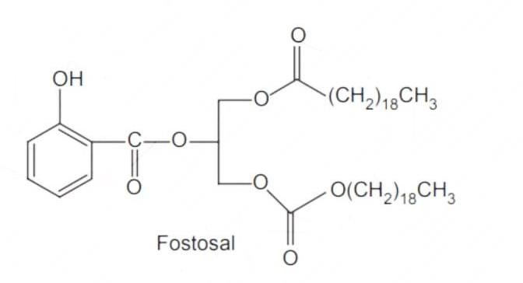

Enhanced site specificity

Many pro-drugs may be designed in such a way that they are only toxic to certain organs when they are administered to a chemical to the brain, the dihydropyridine / pyridinium redox system is particularly useful.

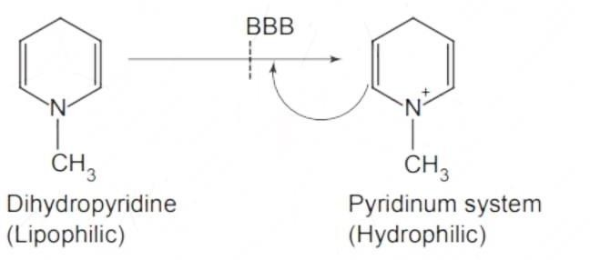

Increase duration of pharmaceutical effects

N-butyl noradrenaline‗s pro-drug di-p-toluate ester gives bronchodilator activity that lasts longer then the parents medication. The bronchodilator action is produced because the pro-drug is preferentially transported into the lung tissues compared to the plasma or the heart.

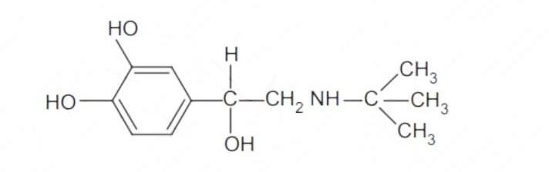

# BIO-PRECURSOR PRODRUG

A bio-precursor pro-drug contains a latent ability instead of a carrier or a promoiety, which is transformed into an active drug molecule through metabolic or chemical processes. Chemical activation processes including oxidation, reduction, and phosphorylation are examples of phase I activation.
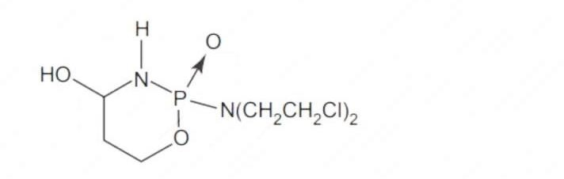
Bio – activities: The pro-drug is transformed into the cytotoxic phosphoxamide mustard by cyclophosphamide‗s breakdown. N-DE alkylation: This chemical process changes several drug into their active metabolites form.

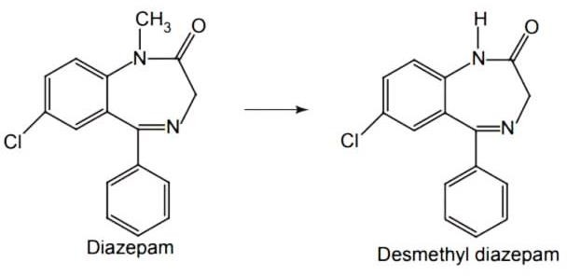

Oxidation: The prodrug nabumetone, in which the formyl groups was generated, a carboxylate group is formed, resulting in the production of the active substance.

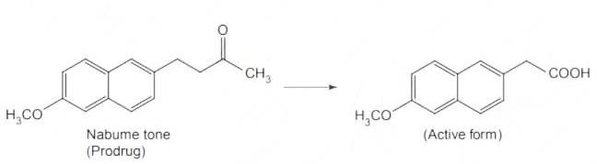
Reduction: sulindac is converted in vivo from its nonsteroidal anti - inflammatory drug form to its active form.

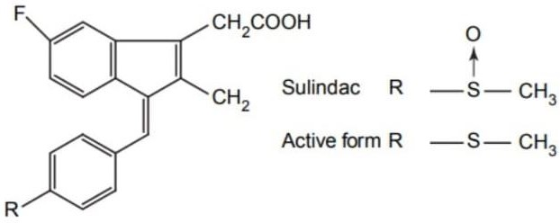

Conclusion

In this chapter we have completer prodrugs about prodrugs, what is prodrug & history of prodrugs,, ideal properties of prodrugs, the purpose of designing prodrugs, classification of prodrugs, development of prodrugs, uses of prodrugs and application of prodrugs. These all topics are important for prodrugs. These all topics are important for prodrugs information and used for better formulation to inhance safety, stability and other parameters.

Reference
- https://www.goodrx.com/healthcare-access/medication-education/what-is-a-prodrug (Accessed on 05/07/2023).
- Milica M , Shimon S.B , Arik D, Prodrugs for improved Drug delivery: lesson learned from recently developed and marketed products, Journal of pharmaceutics 2020,12 (11),1-15.
- Kuei-Meng W, A New Classification of prodrugs: regulatory perspectives, Journal of Pharmaceutical, 2009, 2(3), 1-7.
- https://www.researchgate.net/publication/309383341_Prodrug_Strategy_in_Drug_Development
(Accessed on 10/07/2023)
- Pal A, Banik B.K, Highly efficient prodrug design and therapeutic applications, Oriental journal of Chemistry. An international research journal of pure & Applied chemistry, 2022, 36(6),1-19.
- V. Alagarsamy [Published by CBS Publisheds & Distribution Pvt Ltd Volume 1, Edition fourth] textbook of Medicinal chemistry Prodrugs, 157-164.
- Juchin K , Adam J. P, Franziska L G, kang J Y, Cipoola D, Recent Advance in prodrug-based nanoparticle therapeutics, European Journal of Pharmaceutics and Biopharmaceutics, 2021, 1-25.
- https://www.pharmacy180.com/article/application-of-pro-drugs-2096/ (Accessed on 15/07/2023)

