Visualization

Dr.B.Suchitra Mrs.V.Valarmathi

Assistant professor Assistant Professor

Sri Krishna Arts and Science College Sri Krishna Arts and Science College

suchitrab@skasc.ac.in valarmathiv@skasc.ac.in

Coimbatore-8 Coimbatore-8

Introduction

As the name suggests, visualization is the representation of information in the form of chart,diagram and picture.In today’s world data visualization tool afford an manageable way to perceive and recognize inclinations and forms in data. The finest way in data visualization are first and foremost one should know the goal, have to use the correct set of data, have to keep visualization and dashboard to be modest, usage of right chart and colors. In this chapter, we will confer the top most visualization tools used in industry

General types of Data Visualizations

Charts

Graphs

Maps

Infographics

Top Most Tool Used
- Power BI
- Tableau
- QlikSense
- Looker

Power BI

Power BI standpoints for Power Business Intelligence. This tool is mainly used by business analyst. Power BI tool allows the user to connect with heterogeneous sources of data, visualize the data in the form of reports and dashboards and then share with anyone.

Three Elements of Power BI:

Power BI Desktop:

It is used for building and designing reports

Power BI Mobile Apps:

Simultaneously viewing reports and dashboards

Power BI Architecture:
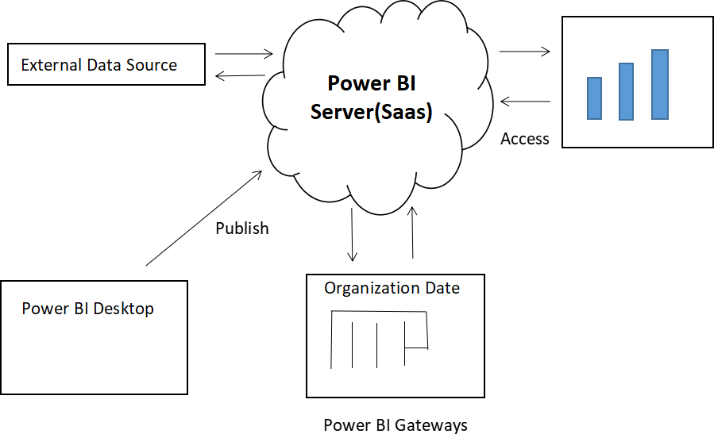

Data Sources castoff in Power BI are

Azure Cloud
Blank Query
OData Feed
SQL Database
Online Sevices
Flat Files

Power BI

Other Data Sources

The datasets voguish Power BI can be limit of 1GB data in free version. Cloud storing is used by Power BI, and its setup is straightforward.

(2)Tableau

Tableau is another important visualization tool used in the market. It can unite to a huge quantity of files, relational and big data file to obtain and progression the data.
Tableau tool supports all categories of data such as relational, unstructured and big data sources for obtaining and processing data.
It is a BI tool which is used to examine the data visually. Tableau can pull data from files, relational databases, and big data sources, as well as process it.
Data can be analyzed over diverse time periods, dimensions and measures
Connect To
Data Source
Build Data
View
Enhance
Data Views
Create
Worksheets
Create And
Organize Dashboards
Create A
Story

Terminology of data used in Tableau

- Alias- alternative name given to field/measurement member
- Bin-handler-defined grouping of procedures
- Bookmarks-it is a .tbm file which is considered to be a bookmark folder in the tableau warehouse which contains sole worksheet
- Calculated field- a new field can be created by using a formula to modify the existing field in data source
- Cross tab- a text table view
- Dashboard- blend of multiple perspectives on one page
- Data pane- a data pane displays the fields of the data sources to which tableau is connected. It is comprising of dimensions and measures.
- Dimension- a field of categorial data. It also retains distinct information that cannot be aggregated, including members and hierarchies.
- Extract -a saved subset of data source which is used to improve performance and analyze offline.
- Workbook-a file with .twb extension that contain one or supplementary worksheet
- Worksheet-a sheet where we can construct views of our data by dragging fields onto shelves

Types of charts supported by tableau

- Bar
- Line
- Pie
- Cross tab
- Bubble chart
- Box plot
- Tree map
- Bullet graph
- Bump chart
- Histogram
- Motion
- Waterfall charts

(3)Qlik sense

A programme for data analysis and visualisation is called Qlik sense. It has an QIX engine which enables the user to link and associate data from varied sources and carrying out dynamic searching and selections.
Qlik sense is an solicitation which is used for imagining and examining data. It facilitates data extraction from numerous data sources and the creation of interactive dashboards and reports.

Major components of Qlik Sense Architecture

- Qlik sense hub
- Qlik management console

Qlik sense hub:

User can do countless tasks on data, comportment exploration and build application appropriate for data visualization.

Management console:

- Management console shows a dynamic role in qlik sense. without the management console, the administrators cannot monitor and control the operations that are taking place on qliksense.

Services done by the management console

(4)Looker

Looker is a cloud-based (BI) solution that aids in data exploration, archiving, and visualisation for better business decisions.
It uses DMC (Data Modelling Language) and it include predetermined framework.

Features of looker:

- Breakdown barriers from insights
- Increase performance and optimizing cost
- Multi cloud platform
- Common data
- Embedded data experience
- Augmented analytics
- Tailored data applications

Looker Application

- Sales analytics
- Digital marketing analytics
- Web analytics

Applications of Data Visualization
- Bestowing Statistics
- Mapping
- To Display change over time
- To Compare values
- To Show Associates

Conclusion
Data is Everywhere . industrialist, academicians and entire world Is rely on Data. Data insights play a vital role. Data representation and presentation in visualization is significant. In this chapter, we understand the important tools supported by data visualization

