Artificial Intelligent, Energy and Environment
Ms.P.Barkavi¹, Ms. S. Muthu Meena², Ms. S. Shapna³
Assistant professor^{1, 2,3}
Department of Computer Applications,
Ayya Nadar Janaki Ammal College,
Sivakasi, Tamilnadu, India.
barkavip1906@gmail.com

Abstract:
Artificial Intelligence (AI) has emerged as a powerful tool in addressing the complex challenges of energy and the environment. This abstract explores the intersection of AI, energy, and the environment, highlighting the various applications, benefits, and concerns associated with this convergence. In recent years, AI has proven its potential to revolutionize the energy sector by optimizing energy generation, distribution, and consumption. Through machine learning algorithms, AI can analyze large datasets and identify patterns, enabling more accurate energy demand forecasting and load management. This capability enhances the integration of renewable energy sources into the grid, thus promoting a cleaner and more sustainable energy mix. AI-driven optimization techniques also improve the efficiency of power generation processes, leading to reduced emissions and enhanced operational performance. Moreover, AI plays a crucial role in environmental monitoring and conservation efforts. By leveraging remote sensing data and AI algorithms, it becomes possible to track and analyze environmental changes at both local and global scales. AI can identify deforestation patterns, monitor air and water quality, and detect anomalies in wildlife behavior, aiding in early warning systems and conservation planning. Furthermore, AI-powered predictive models can support climate change mitigation strategies by simulating the impact of various policies and interventions.
Keywords:
Artificial Intelligence, Energy efficiency and optimization, Renewable energy integration, Environmental monitoring, Precision agriculture, Ethical and social considerations.

- Introduction:
The global energy and environmental challenges that we face today require innovative solutions that can optimize resource use, reduce emissions, and promote sustainable development. Artificial Intelligence (AI) has emerged as a powerful tool that can transform the energy and environmental sectors. AI technologies, such as machine learning and data analytics, can help optimize energy production, reduce consumption, and improve environmental monitoring and management.
AI is a broad term that encompasses a range of techniques and approaches for building intelligent systems that can mimic human cognitive abilities. Machine learning, a subset of AI, involves training algorithms on large datasets to identify patterns and make predictions. This technology has been used in a wide range of applications, from image and speech recognition to autonomous vehicles and healthcare. The energy and environmental sectors represent a new frontier for AI applications, offering significant opportunities for innovation and impact.
AI can be used to forecast energy demand, optimize the scheduling of power generation, and manage energy storage systems, enabling more efficient use of renewable energy sources such as solar and wind power. AI can also contribute to environmental conservation and management efforts. For instance, AI algorithms can be used to analyze satellite imagery and detect changes in land use patterns, monitor air and water quality, and identify areas where wildlife populations are under threat.
These technologies can provide valuable insights for environmental policymakers, helping them make informed decisions that promote sustainability and conservation. However, the use of AI in energy and environmental applications also raises important ethical and social concerns. For instance, there is a risk that AI algorithms may perpetuate existing biases or lead to unintended consequences. There is also a need to ensure that AI systems are transparent and accountable, so that they can be trusted by stakeholders and users.

- Uses of AI, Energy and Environment :
AI has a wide range of potential applications in the energy and environmental sectors. Some of the most promising uses include:
- Energy efficiency and optimization
- Environmental monitoring and management
- Renewable energy integration
- Precision agriculture
- Smart cities

  - Energy efficiency and optimization
The use of AI in energy efficiency and optimization can have a significant impact on reducing energy consumption and promoting sustainable energy use. Here are some specific examples of how AI can be applied in this area,
- Building energy management
AI can be used to optimize energy use in buildings by analyzing data on energy consumption, weather patterns, occupancy levels, and other variables. AI algorithms can then adjust heating, ventilation, and air conditioning systems, lighting, and other energy-consuming devices to reduce energy waste while maintaining occupant comfort.
- Energy storage optimization
Renewable energy sources such as solar and wind power are intermittent, meaning that energy storage systems are required to ensure a reliable supply of energy. AI can be used to optimize energy storage systems by analyzing data on energy demand and supply, weather patterns, and other variables. This can help ensure that energy is stored and used efficiently, reducing energy waste and promoting the use of renewable energy sources.
- Smart grid management
The traditional power grid is designed to deliver energy from centralized power plants to consumers. However, with the increasing use of renewable energy sources and distributed energy generation, a more flexible and dynamic power grid is required.
AI can be used to optimize the operation of the power grid by analyzing data on energy demand and supply, weather patterns, and other variables. This can help ensure that energy is delivered where and when it is needed most, reducing energy waste and promoting the use of renewable energy sources.

- Industrial process optimization
Many industries consume large amounts of energy in their production processes. AI can be used to optimize these processes by analyzing data on energy consumption, production output, and other variables. AI algorithms can then adjust production processes to reduce energy waste while maintaining production efficiency.

  - Environmental monitoring and management
The use of AI in environmental monitoring and management has the potential to transform how we understand and address environmental issues. Here are some specific examples of how AI can be applied in this area,
- Environmental monitoring
AI can be used to analyze satellite imagery and other data sources to detect changes in land use patterns, identify areas of deforestation, monitor air and water quality, and track the movement of pollutants. This can provide valuable insights for environmental policymakers, enabling them to make informed decisions on issues such as land use planning, pollution control, and habitat conservation.
- Wildlife conservation
AI can be used to analyze camera trap images and other data sources to monitor wildlife populations and identify areas where they are at risk. This can help inform conservation strategies and prevent the loss of biodiversity.
- Climate modeling
AI can be used to model the impacts of climate change on ecosystems and human populations.
By analyzing data on weather patterns, sea level rise, and other variables, AI algorithms can help policymakers and communities plan for and mitigate the impacts of climate change.
- Disaster response
AI can be used to analyze satellite imagery and other data sources to assess the impacts of natural disasters such as floods, hurricanes, and wildfires. This can help emergency responders target their efforts more effectively and ensure that resources are directed where they are most needed.
- Water resource management
AI can be used to analyze data on water availability, usage, and quality to improve water resource management. This can help communities plan for and mitigate the impacts of droughts, floods, and other water-related disasters, as well as promote sustainable water use.

  - Renewable energy integration
The integration of renewable energy sources into the electricity grid is a critical challenge facing the energy sector today. AI can play a key role in addressing this challenge by optimizing the integration of renewable energy sources into the grid. Here are some specific examples of how AI can be applied in this area,
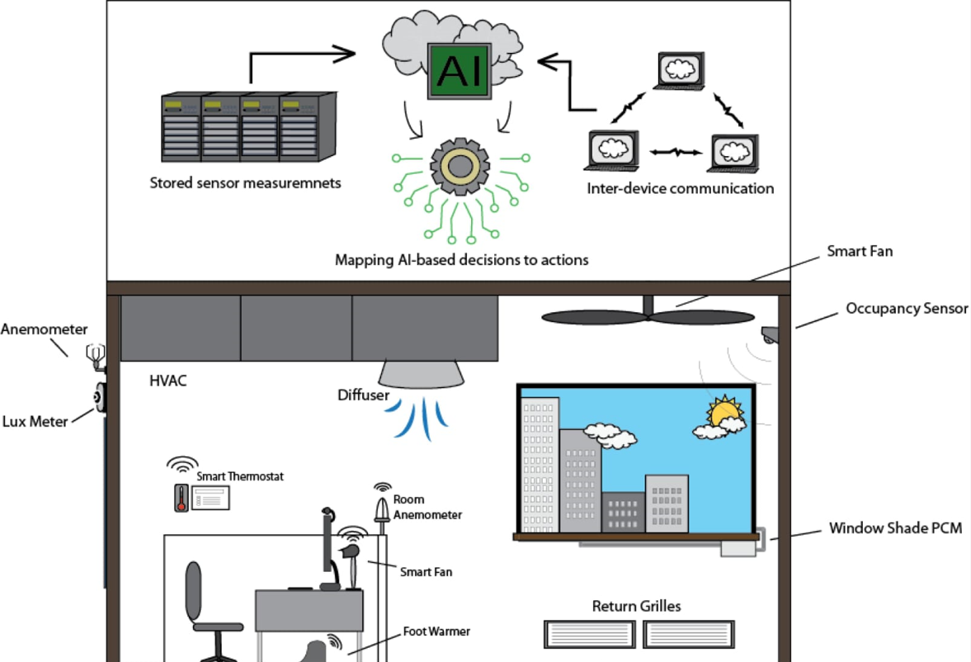
Fig No: 2.1.1 Renewable Energy Integration

- Renewable energy forecasting
AI can be used to forecast the output of renewable energy sources such as solar and wind power. By analyzing data on weather patterns, historical energy production, and other variables, algorithms can provide accurate forecasts of renewable energy production. This can help grid operators plan for and manage the integration of renewable energy sources into the grid.
- Grid optimization
AI can be used to optimize the operation of the electricity grid to ensure that renewable energy sources are used efficiently. For example, AI algorithms can balance the output of different energy sources to ensure a stable supply of electricity. They can also identify and mitigate potential grid stability issues caused by fluctuations in renewable energy production.
- Energy storage optimization
AI can be used to optimize the use of energy storage systems such as batteries and pumped hydro storage. By analyzing data on energy demand and supply, weather patterns, and other variables, AI algorithms can ensure that energy is stored and used efficiently. This can help ensure a reliable supply of energy from renewable sources and reduce the need for backup power generation from fossil fuels.

- Smart grid management
AI can be used to manage the operation of the smart grid, which is a more flexible and dynamic electricity grid that can handle the integration of renewable energy sources. AI algorithms can analyze data on energy demand and supply, weather patterns, and other variables to optimize the operation of the smart grid. This can help ensure that energy is delivered where and when it is needed most, reducing energy waste and promoting the use of renewable energy sources.

  - Precision agriculture
Precision agriculture refers to the use of technology to optimize agricultural production and reduce waste. AI can play a significant role in precision agriculture by providing insights and recommendations to farmers that can help them make more informed decisions about crop management. Here are some specific examples of how AI can be applied in precision agriculture,
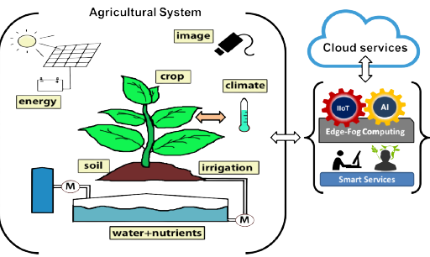
Fig No: 2.1.2 Precision agriculture

- Crop monitoring
AI can be used to monitor crop growth and health using satellite imagery and other data sources. By analyzing data on weather patterns, soil conditions, and other variables, AI algorithms can identify areas of the field that require attention, such as areas where crops are not growing as well as they should. This can help farmers target their efforts more effectively and reduce waste.
- Predictive analytics
AI can be used to predict crop yields and identify potential issues before they occur. By analyzing data on weather patterns, soil conditions, and other variables, AI algorithms can provide farmers with insights and recommendations on when to plant, irrigate, fertilize, and harvest their crops. This can help farmers optimize their production and reduce waste.
- Precision irrigation
AI can be used to optimize irrigation by analyzing data on weather patterns, soil moisture, and other variables.
By providing real-time recommendations on when and how much to irrigate, AI algorithms can help farmers reduce water usage and improve crop yields.
- Pest management
AI can be used to identify and manage pest infestations by analyzing data on weather patterns, pest populations, and other variables. By providing real-time recommendations on when and how to apply pesticides, AI algorithms can help farmers reduce the use of pesticides and minimize the impact on the environment.

  - Smart cities
AI plays a crucial role in enabling the transformation of cities into smart and efficient urban environments. Here are some specific examples of how AI can be applied in smart cities in relation to energy and the environment,
- Energy management
AI can optimize energy consumption in buildings, infrastructure, and transportation systems. AI algorithms can analyze data on energy usage patterns, occupancy levels, and weather conditions to automate and optimize the operation of smart grids, energy distribution, and energy storage systems. This can lead to reduced energy waste, lower carbon emissions, and cost savings for both the city and its residents.
- Traffic management
AI can optimize traffic flow and reduce congestion by analyzing real-time data from traffic cameras, sensors, and GPS systems. AI algorithms can dynamically adjust traffic signal timings, reroute vehicles, and provide real-time traffic information to drivers, thereby reducing travel times and carbon emissions.
- Waste management
AI can improve waste management processes by analyzing data on waste generation patterns, optimizing waste collection routes, and implementing smart bin systems that can monitor and manage waste levels. This helps optimize resource utilization, reduce environmental pollution, and improve overall waste management efficiency.

- Environmental monitoring
AI can monitor and analyze environmental parameters such as air quality, noise levels, and pollution levels in real-time. By integrating data from sensors placed throughout the city, AI algorithms can provide early warnings and insights to help manage environmental risks and take proactive measures to ensure a healthy and sustainable urban environment.
- Water management
AI can optimize water distribution systems by analyzing data on water consumption patterns, pressure levels, and leak detection. AI algorithms can optimize water usage, detect leaks, and manage irrigation systems, leading to more efficient water management and conservation.
- Public safety and emergency response
AI can enhance public safety and emergency response systems by analyzing data from surveillance cameras, sensors, and social media. AI algorithms can help detect and predict potential safety threats, optimize emergency response routes, and provide real-time information to authorities and citizens during emergencies.

- Challenges in AI, Energy and Environment
Despite the significant potential benefits of using AI in energy and environmental management, there are also several challenges that need to be addressed. Here are some of the key challenges,
- Data quality and availability
- Data privacy and security
- Interoperability and standardization
- Ethical and social considerations
- Cost and scalability

  - Data quality and availability
One of the main challenges in using AI in energy and environmental management is the quality and availability of data. Here are some of the key challenges,
Fig No: 2.1.3 Data quality and availability
- Limited access to data
In many developing countries and regions, data on energy usage and environmental parameters may be limited or inaccessible, making it challenging to develop accurate AI models. This can be due to factors such as insufficient data collection infrastructure or lack of data sharing agreements between different organizations.
- Incomplete data
Even when data is available, it may be incomplete or missing critical information, making it difficult to train accurate AI models. This can be due to factors such as faulty sensors, incomplete data collection methods, or incomplete data integration.
- Data quality issues
Data may be subject to errors or inconsistencies that can affect the accuracy of AI models. This can be due to factors such as faulty sensors, human error in data collection and entry, or changes in data collection methods over time.
- Data bias
Data may be subject to biases that can affect the accuracy of AI models. This can be due to factors such as uneven data collection or sampling, or underlying social or cultural biases in data collection methods.

  - Data privacy and security
The use of AI in energy and environmental management requires the collection and analysis of sensitive data, such as energy usage patterns and environmental parameters.
Ensuring the privacy and security of this data is crucial to building trust and promoting widespread adoption of AI technologies. Here are some of the key challenges in data privacy and security:
Fig No: 2.1.4 Data privacy and security

- Data breaches
AI systems that rely on large amounts of data are vulnerable to data breaches, which can lead to the theft of sensitive data or the exposure of personal information.
- Data misuse
There is a risk that sensitive data collected for energy and environmental management purposes can be misused for other purposes, such as targeted advertising or insurance pricing, without the user's consent.
- Algorithmic bias
AI algorithms may be biased towards certain outcomes or groups, which can lead to unfair or discriminatory practices. This can be due to factors such as biased training data or the use of inappropriate algorithms.
- Lack of transparency
AI algorithms can be difficult to interpret or understand, which can make it challenging to identify potential privacy or security risks. This can be due to factors such as the use of complex algorithms or lack of transparency in the data used to train the algorithm.

- Regulations and standards
The regulatory framework for data privacy and security in energy and environmental management is still evolving, which can make it challenging to develop effective policies and standards to protect user privacy and security.

  - Interoperability and standardization
Interoperability and standardization are crucial for the successful implementation of AI in energy and environmental management. Interoperability refers to the ability of different systems to work together seamlessly, while standardization refers to the adoption of common standards and protocols to ensure compatibility and consistency across systems. Here are some of the key challenges in interoperability and standardization,

- Lack of common standards
There is a lack of common standards and protocols for data collection, analysis, and reporting in the energy and environmental management sector. This can make it challenging to integrate different systems and ensure that data is consistent and reliable.
- Complexity of data integration
Integrating data from different sources can be complex and time-consuming, especially if the data is stored in different formats or uses different protocols. This can make it challenging to create a unified view of energy and environmental data across different systems.

- Vendor lock-in
Some vendors may use proprietary data formats or systems, which can make it difficult to integrate with other systems or switch vendors if needed.
- Legacy systems
Legacy systems may be incompatible with newer systems, which can make it challenging to integrate data from these systems into newer AI systems.

- Cultural and organizational barriers
Cultural and organizational barriers can make it challenging to adopt common standards and protocols, especially if different organizations have different ways of working or different priorities.

  - Ethical and social considerations
The use of AI in energy and environmental management raises a range of ethical and social considerations. Here are some of the key challenges in this area,
- Bias and discrimination
AI algorithms can be biased towards certain groups or outcomes, which can lead to discrimination and perpetuate inequalities.
- Transparency and explain ability
AI algorithms can be difficult to understand, which can make it challenging to ensure that they are making fair and ethical decisions. It is important to ensure that AI systems are transparent and explainable, so that users can understand how decisions are being made.
- Privacy and data protection
The collection and use of sensitive data in energy and environmental management raises important privacy and data protection concerns. It is important to ensure that data is collected and used in a way that is consistent with ethical principles and legal requirements.
- Social and environmental impact
The use of AI in energy and environmental management can have a range of social and environmental impacts, such as job displacement, resource depletion, and ecosystem degradation. It is important to consider these impacts and ensure that AI is used in a way that supports sustainable development.
- Human control and autonomy
There is a risk that AI systems could be used to make decisions without appropriate human oversight or control.
It is important to ensure that humans remain in control and that decisions made by AI systems are subject to human review and intervention.

  - Cost and scalability
Cost and scalability are key challenges in the deployment of AI in energy and environmental management. Here are some of the key challenges in this area,
- Data acquisition and processing costs
Collecting and processing large amounts of data can be expensive, especially if the data is generated from multiple sources or requires specialized sensors or equipment.
- Infrastructure costs
Building and maintaining the infrastructure required to support AI applications, such as data centers and high-performance computing clusters, can be expensive.
- Integration costs
Integrating AI systems with existing infrastructure and processes can be challenging and may require additional investments in hardware and software.
- Talent and skills shortages
There is a shortage of skilled AI professionals who can design, develop, and deploy AI applications in energy and environmental management.
- Scalability
As the volume of data and complexity of AI applications increases, it can be challenging to scale up AI systems to handle larger workloads and more complex tasks.

- Advantages
The use of AI in energy and environmental management offers several advantages. Here are some of the key advantages in this area,
- Increased energy efficiency
AI can help optimize energy use and reduce waste, leading to increased energy efficiency and cost savings.

- Improved environmental monitoring and management
AI can help monitor and analyze environmental data, leading to better understanding and management of natural resources, pollution, and climate change.
- Enhanced renewable energy integration
AI can help integrate renewable energy sources into the grid, reducing reliance on fossil fuels and contributing to a cleaner and more sustainable energy system.
- Cost savings
By optimizing energy use, reducing waste, and improving resource management, AI can help reduce costs for individuals, businesses, and governments.
- Faster and more accurate decision-making
AI can process large amounts of data quickly and accurately, leading to faster and more informed decision-making in energy and environmental management.

- Disadvantages
- Cost
Implementing AI systems can be expensive, especially for small and medium-sized businesses that may not have the resources to invest in new technology.
- Data quality and availability
AI systems rely on high-quality data to make accurate predictions and recommendations. If the data is incomplete or inaccurate, the AI system may not perform as expected.
- Security and privacy
The use of AI in energy and environmental management requires the collection and analysis of large amounts of data, raising concerns about data privacy and security.
- Complexity
AI systems can be complex, requiring specialized skills and expertise to develop and maintain.

- Lack of transparency
Some AI systems may be opaque, making it difficult to understand how they make decisions or provide recommendations.

- Conclusion
In conclusion, the use of AI in energy and environmental management offers many advantages, including increased energy efficiency, improved renewable energy integration, and better environmental monitoring and management. However, there are also challenges and potential disadvantages to consider, including data quality and availability, security and privacy concerns, complexity, lack of transparency, and bias. To fully realize the benefits of AI in energy and environmental management while mitigating these challenges, a collaborative approach is needed. This includes collaboration between industry, government, academic institutions, and other stakeholders to develop and implement AI solutions that are effective, scalable, and ethical. In addition, addressing the challenges associated with AI in energy and environmental management requires a focus on technical and non-technical solutions.

Reference:
- Li, X., Li, Y., Li, J., Wang, L., & Li, Y. (2019). Application of artificial intelligence in energy management for smart buildings: A review. Applied Energy, 239, 264-278.
- Ren, H., Gao, Y., Huang, G., & Ma, X. (2020). Artificial intelligence for energy and environmental sustainability: challenges and opportunities. Energy Sources, Part B: Economics, Planning, and Policy, 15(5), 446-455.
- Tang, L., Chen, X., Li, C., & Huang, L. (2020). AI-based energy management systems for renewable energy integration: A review. Applied Energy, 277, 115508.
- Wang, H., Zhang, H., Gao, F., & Dong, X. (2020). Artificial intelligence for precision agriculture: A review. Journal of Agricultural Informatics, 11(1), 40-54.
- Yang, Q., Liu, Y., & Tong, Y. (2021). A review of artificial intelligence applications in smart cities: Opportunities and challenges. Sustainable Cities and Society, 72, 103059.
- Zhang, J., Liu, X., & Tian, X. (2020). Smart energy management based on artificial intelligence: Opportunities and challenges. Journal of Cleaner Production, 245, 118940.
- Amin, S. M., & Chakrabarti, S. (2019). Artificial intelligence and machine learning for energy systems: A review. Renewable and Sustainable Energy Reviews, 101, 329-343.
- Jin, Y., Lin, B., Cao, Y., Zhang, N., Guan, Y., & Liu, Y. (2020). A review on artificial intelligence applications in energy systems: Progress and challenges. Renewable and Sustainable Energy Reviews, 127, 109883.
- Rathnayaka, S., & Amarasinghe, I. (2021). Artificial Intelligence in Energy and Environment: A Systematic Literature Review. Energies, 14(2), 355.
- Wang, Y., Wu, J., Wu, Z., & Lu, H. (2021). The Application of Artificial Intelligence in Energy System: A Review. IEEE Access, 9, 84652-84663.

