Performance Improvement of Household Refrigeration System Using Various Nano Additives-A Review

Dr.K.Arumuganainar¹*, Dr.N.Sivakumar²,Dr.K.Krishnamoorthy³, Wenish.G.D⁴
Assistant Professor¹
Professor²
Professor³
Research Scholar⁴
¹Department of Mechanical Engineering, J.P.College of Engineering, Tenkasi,
Tamil Nadu,India
^{2,} Department of Mechanical Engineering, AMC Engineering College, Bengaluru,
Karnataka,India
³Department of Automobile Engineering, PSN Engineering College, Tirunelveli,
Tamil Nadu,India
⁴Department of Mechanical Engineering, KalaignarKarunanidhi Institute of Technology, Coimbatore, Tamil Nadu,India

*Corresponding Author
E-mail Id:-arumuganainar@jpcoe.ac.in

ABSTRACT
Nano-based refrigerants, which are both energy efficient and ecologically beneficial, are currently being favored. The new trend, possibilities, and research of nano-based refrigerant in refrigeration systems are discussed in this study. It was discovered that different thermal properties of nano refrigerants have been observed to be favorable. Reduced power consumption, increased coefficient of performance (COP), enhanced tribological pressure drop characteristic of nano-lubricant, and increased thermal conductivity of hybrid-refrigerant are just a few of the benefits. As a result of this debate, nanoparticles appear to be a strong contender for inclusion in a standard refrigeration system.

Keywords: Heat transmission; pressure fall; refrigerant; nanoparticles; COP

1.INTRODUCTION
Refrigeration systems typically require a lot of energy. According to studies, the refrigeration systems in supermarkets might consume between 50 and 80 percent of the total electricity utilized [1]. As a result, experts have been looking for ways to improve refrigeration systems. Physical qualities of refrigerants such as viscosity, thermal conductivity, and specific gravity play critical roles in high-performance energy delivery to the cooling compartment in refrigerating and cooling operations like the one depicted in Figure 1. The creation of a more efficient thermal system has risen to the forefront in recent years, since the need for energy continues to rise as the world's population grows.The increase in the mean temperature as a result of the release of dangerous compounds and greenhouse gases into the environment is also a source of worry. The majority of these emissions are caused by the depletion of fossil fuels and the usage of environmentally unfriendly refrigerants. Sustainability necessitates the development of ecologically friendly and more efficient energy-carrier refrigerants. Each nano-feedstock, on the other hand, has its own set of thermo-physical properties. Nanofluids, on the other hand, have been used in a variety of fields and sectors, including medication delivery and medicine, nuclear energy, automotive, lubrication, microchannels, renewable energies, electronic cooling, heating and cooling processes, and heat exchangers [2–25]. The usage of refrigerant-based nanofluids is gaining traction, despite the fact that the disadvantages are still being studied.

The feedstock is being studied, as well as the loading of nanofluids into refrigeration systems, in order to achieve considerable beneficial effects. They want to make smaller and more economical refrigeration equipment by exhibiting several promising elements such as improved pool boiling and convective heat transfer coefficients [26].We provide a brief overview of nano refrigerant uses in home and industrial refrigeration systems in this study. In addition, numerical analysis will be used to examine the effects of nanorefrigerantsin a variety of thermal systems. We also present a review of key limitations of nanoparticles for refrigeration systems that must be considered during various investigations, as well as potential future research areas and gaps that require greater attention from researchers in the current work.

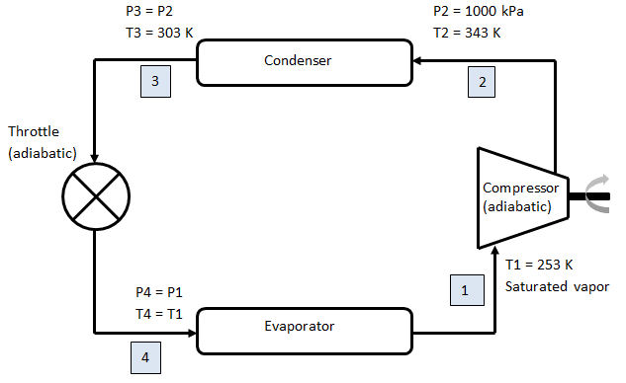
Fig.1:.Vapour compression refrigeration system

2.NANOREFRIGERANTS IN REFRIGERATION SYSTEMS
A quick overview of the field of nanofluids for refrigeration systems development.This field of study's research space was studied to gain a sense of the work that has been done in the area. The inquiry was carried out using the search term "Nanorefrigerant OR Nanoparticle-based Refrigerant" and "Thermal Performance OR heat transfer performance," and the following was discovered: (Figures 2 to 7).

Fig.2.:A plot of annual scientific production

Figure 2 shows a consistent increase in publications in the nanorefrigerant research domain from 2006 to 2020. This increase demonstrates that this field of study has enormous promise for improved refrigerants and refrigeration systems.

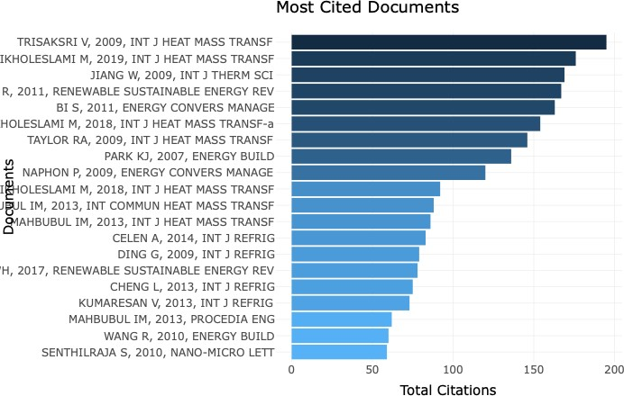
Fig. 3:.A plot of most cited documents

The top referenced writers in nanorefrigeration are displayed in Figure 3. In descending order, the most referenced writers are Trisaksri, Ikholeslami, and Jiang, all of whom have studied significantly in this topic and delivered interesting results. Trisaksri and Wongwises, for example, conducted a thorough examination of these fluids. Similar work has been done in this area by others.

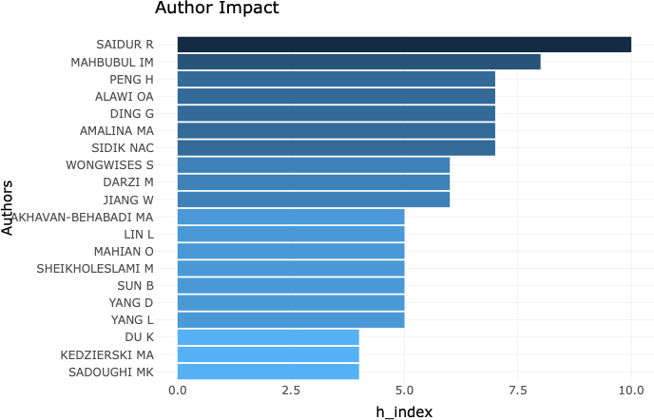
Fig. 4: A plot of author’s h-indices

Figure 4 depicts a plot of h-indices for authors working in the nanorefrigeration field. We can observe that Saidur and Mahbubul are among the top performers in this category. They have an h-index of at least 7.5.

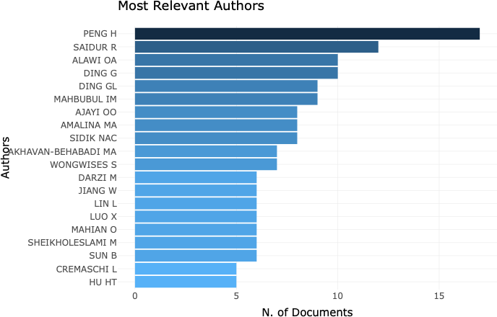
Fig. 5:.A plot of the number of documents by authors in this area

Peng and Saidur have the most documents in the field of nanorefrigerants, as shown in Figure 5. They each have a number of documents in excess of ten, indicating that they are actively working in this field.

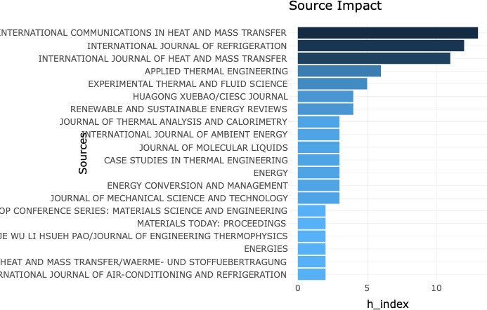
Fig.6.:A conspire of the h index of different journals

The h-index of international communications in heat and mass transfer, international journal of refrigeration, and international journal on heat and mass transfer is more than 10, as seen in Figure 6. demonstrating that these journals have published significant papers in this field.

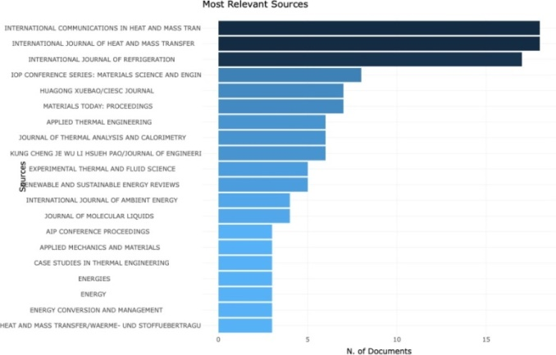
Fig.7. A conspire of number of documents published by different journals

International communications in heat and mass transfer, International journal on heat and mass transfer, and International journal of refrigeration all include more than 15 papers, as shown in Figure 7. Demonstrating that these journals have published a large number of articles in this field.
Nanofluids increase the performance of refrigeration and air-conditioning systems.
This paper examines the impact of nanofluids on the performance of nanofluids in refrigeration and air-conditioning systems. Nanofluid can play any of the following functions in improving the performance of refrigeration and air conditioning systems: (1) as lubricant-based nanofluids (nanolubricant), (2) as refrigerant-based nanofluids (nanorefrigerant), and (3) as secondary fluid (coolant for heat rejection in refrigeration systems, and secondary refrigerant for the evaporator side) [27-36].
The thermophysical characteristics of nanorefrigerants and how they impact the performance efficiency of refrigerators and air conditioners were investigated by Mahbubul et al. [37]. Based on established correlations, a combination of Aluminum oxide (Al₂O₃) and R-134a containing 4.5% metallic oxide was employed as a nanorefrigerant in an even horizontal pipe at 283K to 308K temperature range. In terms of density (12%), viscosity (13.48%), and thermal conductivity, a nanorefrigerant blend of Al₂O₃ and R134a outperforms R134a when used alone (27.51percent ). R-134a, on the other hand, had a larger specific heat capacity than the nanofluid combination. In comparison to R-134a, the nanorefrigerant combination had a better coefficient of performance in density (3.18%), specific heat capacity (2.43%), and thermal conductivity (14.2%). Application and preparation techniques for nano-refrigerants were discussed [38].The nanofluid's stability potential was also investigated, and it was discovered to be influenced by the nanoparticle concentration in the refrigerant [39]. As a result, the nanoparticle concentration must be tuned to ensure long-term stability.
Several studies [40-43] have been conducted to determine the thermal characteristics of refrigerant-based nanofluids. The frictional pressure loss in a vapour compression refrigeration cycle was investigated using R600a and CuO [44]. The results revealed that adding nanoparticles to the refrigerant improved the frictional pressure decrease significantly. Conduction and convection were also observed to increase as a result of the CuO nanoparticles being added to the refrigerant. The refrigeration system was also charged with a mixture of R134a and CuO and/or Polyalkylene glycol nanoparticles [42]. Their research revealed an increase in the coefficient of performance and a decrease in power usage.The use of synthetic oil in the nano-mixture was also shown to increase the frictional qualities of the nano-mixture [42]. Different refrigerants were used to examine an aluminium oxide (Al₂O₃) based nanofluid [40,41]. The experimental experiments of demonstrated a promising improvement in the heat transfer characteristic, with the vapour compression refrigerator consuming roughly 11.2% less power [40]. The temperature of the cooling compartment of the refrigerator dropped significantly from around 6% to 10% when the baseline case-R134a was compared to the nanorefrigerant case (R134a + Al₂O₃) [41]. Similarly, in R134a [45], the heat transfer coefficient of nano refrigerant was investigated using Al₂O₃ nanoparticles.Their findings revealed that when particle concentration grew, the total heat transfer coefficient, thermal conductivity, and specific heat decreased.
A group of researchers looked through the literature to see how nanofluids affect the energy efficiency of systems that utilisenanorefrigerants and nanolubricants [46]. They discovered that using nanofluids in refrigeration systems improves the mechanical and thermodynamic features of the system. The use of zinc oxide nano lubricant (R152a) saved 19.1% of energy while posing no threat to the ozone layer, lowering the risk of global warming, and improving the efficiency of refrigeration systems. Using titanium oxide (TiO₂) nanoparticles charged into several common refrigerants, the cooling efficacy of refrigerants was investigated [47-49].In a residential refrigerator, different concentrations (g/L) of titanium oxide in a 25g of refrigerant R600a were investigated [47]. The use of TiO2 particles has been proven to boost cooling rates while drastically lowering energy usage. R-134a, on the other hand, was used in their experiment [49]. Their findings revealed that adding TiO2 nanoparticles to the refrigerant system enhanced the refrigerator's COPr considerably [49]. When comparing pure R600a to R600a, a group of researchers determined that R600a consumes around 11% less energy [48].
A group of researchers performed a numerical analysis on a nanofluid made from mango bark [50]. The original notion was put to the test, and the results revealed a significant increase in Nusselt number of roughly 68 percent. The performance of the condenser of the refrigerator's vapour compression was investigated using the mass flow rate and heat rejected [51]. When nanorefrigerant was used, their results showed an increase in mass flow rate and a decrease in heat rejected at the condenser unit. CuO as the nanoparticle and isobutene as the source fluid were used to study the pressure drop of nanorefrigerant [52].Their research used a variety of nanoparticle mass fluxes, and the findings revealed a considerable pressure reduction owing to the refrigeration cycle's condensation flow pattern. To explore the energy characteristics of LPG refrigerant, researchers used various quantities of Al₂O₃ [53]. According to a group of researchers, a concentration of 0.5 g/L yielded the best results, while a concentration of 0.3 g/L outperformed other concentrations in terms of COP [53]. However, at a concentration of 0.5 g/L, the temperature of the discharge was lost. Exergy measurement is taken into account in the analysis [54]. When compared to other nanomaterials, TiO₂ and CuOnano-based refrigerants use the least amount of energy.
In the refrigerant R134a, two distinct nanorefrigerants (Al₂O₃-Ethylene glycol and TiO2-Ethylene glycol oils) are used as nano-based particles. With the application of Al₂O₃, the COPr of the refrigeration system increased by around 11%, whereas TiO2 delivers a noteworthy increase of about 20% in terms of COP [55]. In another study, aluminium oxide was used with an R290/R600a refrigerant combination [56]. The blend concentration of all the fluids involved determines how much better the coefficient of performance improves. The optimum result is obtained when the R290/R600a ratio is 0.8:0.2 and Al₂O₃ nanoparticles are used [56]. With the inclusion of nano-particles in the refrigerant blend, COP rises while power consumption decreases.

Nano-oil in R600a refrigerant was investigated using a micro-fin tube [57]. The loading parameters of the nano-oil, as well as the condensation pressures, were studied. The cooling cycle was likewise conducted in its purest form, with no additives. The results revealed that using isobutene (R600a) in the refrigerator's heat exchanger enhances heat transmission (condenser). The heat transmission coefficient is raised to a substantial level of around 77%.

According to one set of researchers, loading nanoparticles with low vapour quality appears to be extremely effective for high heat transmission [57]. The refrigerant R718 and other refrigerants were used to do computational and experimental assessments of nanoparticles [58].When compared to when they didn't employ nano-particles, their thermal performance improved by 25%. However, the best results were obtained when Al₂O₃was used in R134a, whereas the worst results were obtained when TiO2 was used in R404a. CuO and R134a have also been used in computational investigations [59].

The introduction of Cu based nanoparticles boosts the heat transfer coefficient, according to the findings. For experimental assessment, the refrigerants R134a, R600a, and PAG oil were employed with CuO-based nanoparticles [60]. Their findings revealed that R134a has a lower COPr than R600a due to R600a's lower energy consumption when compared to R134a.

The Nusselt number was calculated using TiO2 nanoparticles in R134a refrigerant [61]. During the testing, a variety of nanoparticle concentrations were utilised. Increases in heat flow, Reynolds number, and nanoparticle concentration were shown to enhance Nusselt numbers [61].Cu, CuO, Al, and Al₂O₃ nanoparticles were investigated as a potential agent for improving the refrigeration efficiency of R141b in smooth and internally corrugated tubes, and the results showed that Cu-R141b nanofluid performed significantly better when compared to other nanofluids, with corrugated tubes performing better than smooth tubes [62].

Table 1. A summary of numerical studies on nanorefrigerants
Authors | Nanorefrigerants | Single/Two-Phase Modeling (Nanoparticles &  Refrigerants) | Application
Alawi et al., 2015b | Alumina, ZnO, CuO,  SiO₂ - R141b | Single-phase approach | Annulus cylindrical pipes
Tashtoush et al., 2017 | Alumina, CuO - R123, R134a, R141b, R152a,  R22, R290, R600, R717 | Single-phase approach | An ejector refrigeration system
Zohud et al., 2018 | Alumina, ZnO, CuO,  SiO₂ - R1270 | Single-phase approach | Circular tube subject to  uniform heat flux
Coumaressin and  Palaniradja, 2014a | CuO - R134a | Single-phase approach | Domestic refrigerator
(Helvaci& Khan, 2017) | CuO, MgO, SiO₂, Al₂O₃  - HFE 7000 | Single-phase approach | Horizontal circular tube
(I. Mahbubul, Fadhilah,  Saidur, Leong, &Amalina, 2013) | Al₂O₃- R134a | Single-phase approach | Horizontal smooth tube
(S. Sanukrishna, Ajmal,  & Prakash, 2018) | TiO₂ - R134a | Two-phase approach | Boiling in a circular tube
(Hernández et al., 2016) | Al₂O₃ - R133, R123,  R134a | Two-phase approach | Refrigeration system
(Ajayi, Ibia, Ogbonnaya, Attabo, & Michael,  2017) | Cu, Al- R134a, R600a | Two-phase approach | Capillary tube of a vapor refrigeration system
(Rahman et al., 2019) | SWCNT - R407c | - | Air conditioning system
(Dey&Mandal, 2021) | Al₂O₃ - R600a | Single-phase approach | Shell-and-tube evaporator
(Mohamadi et al., 2021) | Al₂O₃, SiO₂- HFE7000 | Single-phase approach | Horizontal circular tube

3. DISCUSSION OF THE PROPERTIES OF NANO REFRIGERANTS
This section presents a review of the impacts of nanorefrigerant characteristics on refrigeration systems, as well as a study of the effects of nanorefrigerant properties on refrigeration systems. [63] Conducted a thorough examination of the thermophysical parameters and performance aspects of a refrigeration system employing refrigerant-based nanofluids.

They proposed, among other things, that refrigerant thermal conductivities and nanoparticle thermal conductivities have a considerable influence in the distinctive behaviour of nanofluids, especially when they are utilised for heat transfer applications. The coefficient of performance and the efficiency of the refrigeration system are then determined by heat transfer. The thermal conductivities of typical refrigerants and nanoparticles are shown in Table 2.

The qualities of the refrigerant are reported to enhance when nanoparticles are added.This improvement is dependent on the nanoparticle's concentration, size, and material qualities, such as thermal conductivity, density, and electrical conductivity.

The flow and heat transfer characteristics of an alumina/isobutanenanorefrigerant were investigated by Dey and Mandal [64]. They looked at volume fractions of 1 to 5% alumina particles at various temperatures, as well as the mass flow through a smooth tube. They found that reducing the volume fraction of nanoparticles reduces the thermal conductivity, viscosity, convective heat transfer coefficient, and density of the nanorefrigerant while increasing the Nusselt number and specific heat at any temperature for the nanorefrigerant (alumina/isobutane).

However, when temperature increased, the Nusselt number, thermal conductivity, specific heat, and convective heat transfer coefficient all increased, while density and viscosity decreased.

Table 2. Thermal conductivity of refrigerants and nano-materials.

Refrigerant and Nano-material | Thermal Conductivity  (W/m K)
R11 | 0.102
R22 | 0.097
R134a | 0.082
R410 | 0.013
R600a | 0.107
R404a | 0.014
Al₂O₃ | 40
CuO | 33
TiO₂ | 4.8

Researchers often explore with attributes such as viscosity, temperature, volume concentration/volume size of nano-particles, thermal conductivities, and density. Hydrofluoroethers-7000, for example, are a new baseline generation refrigerant.

Table 3 summarizes the various refrigerant-based fluids that were investigated. The table summarises the performance of several combinations of nano particles in the base fluid. This will help refrigerator designers understand the characteristics of different hybrid-refrigerants.

As a result, it will provide insight into the right selection of nanoparticle(s) for better refrigeration system performance.

Table 3. Synopsis of the studies of Nano-based refrigerant.
Nanofluids/Nano-based  refrigerant source | Outcomes | Researchers
SiO₂ in HFE-7000 | 26% increase in the thermal conductivity  reported at 0.03% volume fraction. | (Nawi, Rehim, Azmi, &  Razak, 2018)
TiO₂ in R600a  TiO₂ R600a/mineral oil | 9.5% less energy consumed employing 0.4 g/Lof TiO₂-R600a. The freezing was swifter with the employment of TiO₂  The coefficient of performance (COPr)  significantly improved to 60.4% | (S. Bi et al., 2011)  (Jatinder et al., 2019)
Al₂O₃ in /Mineral oil Al₂O₃ inR141b  Al₂O₃ inR134a | 19.91% of energy saved With heat flux of 152kWm-2, the heat transfer coefficient improves by 122%.31% increase in the thermal conductivity; 12% increase in density,17% improvement in COP and 15% increase in viscosity.COP rose by (9 - 12)%. | (Padmanabhan &Palanisamy,2012)  (I.M. Mahbubul, A.Saadah,  R.Saidur,M.A.Khairul,&  A. Kamyar, 2015)  (I.M. Mahbubul et al., 2015) (Singh &Lal, 2014)  (Kotu& Kumar, 2013)
Al₂O₃ inR113/CuO  R141b/CuO inR113 | Migration ratio is directly proportional to the liquid phase density of the refrigerant and inversely proportional to the mass fraction, density, viscosity, and heat flux.  Heat enhancement of about 33% was reported. | (HaoPeng, Ding, &Hu, 2011b)  (H. Peng, Ding, & Hu, 2011c)
CuO in R134a | 28.6% increase in heat transfer enhancement was reported with 21.4%maximumfrictional pressure drop across thesystem. | (Bartelt, Park, Liu,&Jacobi,2008)
CuO in R134a | An increase in heat transfer was also reported. | (Henderson, Park, Liu, & Jacobi, 2010) (Abdel-Hadi  et al., 2011)
CuO in R134a | Better performance and evaporator heat transfer | (T. Coumaressin & K.  Palaniradja, 2014)
TiO₂ in R141b | Reduction in heat transfer | (V. Trisaksri & S.  Wongwises, 2009)
SiO₂ in R134a | 162% of heat transfer was recorded.  Heat transfer reduced with increased concentration of the particle. | (S. S. Sanukrishna, Shafi, Murukan, & Prakash, 2019)
ZnO in R134a | Thermal conductivity improved by 42% for cubic shape and by 26% for spherical shape.  23% reduction in energy consumed. | (Maheshwary,Handa,&Nemade, 2018) (D. S.Kumar Elansezhian, 2014)
TiO₂ in R123 | Reduction in viscosity as the nano-particle concentration increases.  However, low concentration was suggested for maximum performance | (I. M. Mahbubul, Saidur, &Amalina, 2012) (O.Alawi,Sidik, &Kherbeet, 2015)
TiO₂ in R134a | COP improved by 19%; about 17% lesser poweris consumed | (Subramani, Mohan, &  Prakash, 2013)
Ti in R11 | Efficiency increased significantly | (Naphon,Thongkum, &  Assadamongkol, 2009)
Al in R141b | Heat transfer increased with theuse ofnanoparticle | (B. Sun & Yang, 2013)

The coefficient of heat transfer improves when the concentration of Al2O3 in the vapour compression refrigeration system increases, according to (Kanthimathi et al., 2017). (Table 4). The best nanomaterial to use is still a work in progress, since the best results are dependent on a variety of circumstances. As seen in Figures 2 and 3, the heat transmission and thermal conductivity rise significantly as the refrigerant concentration increases.

Table 4. Thermal conductivity and coefficient of heat transfer for Al2O3 at various concentrations (Kanthimathi et al., 2017).
Concentration (%) | 0.04 | 0.2 | 1.2 | 3.1 | 4.0
Heat Transfer Coefficient  (Wm⁻²K⁻¹) | 436.3 | 554.6 | 2945.6 | 6784.6 | 10693.4
Thermal Conductivity (W/m K) | 0.0828 | 0.084 | 0.086 | 0.091 | 0.094

Tests [65] were carried out using the same geometry and input requirements for four different baseline refrigerants. In Table 5, the refrigeration coefficient of performance (COP) varies depending on the input parameter. Despite the fact that the choice of an environmentally friendly refrigerant has recently become the topic of research. Because of the impact of greenhouse gases on our biodiversity, we cannot remain complacent with current refrigerants. R600a and R290 had the same percentage improvement in COP at 5% volume fraction of Al2O3 (Table 5) in four different refrigerants, according to [65]. However, in terms of COP improvements, R134a and R404a lag behind the other refrigerants. The coefficient of performance of a refrigeration system is calculated using Equation 1.

COP = Q out/Win | (1)

Table 5. Characteristics of COPr for Al2O3 at 5% volume fraction [65].
Refrigerant | Improvement in COP (%)
R134a | 19
R290 | 22
R404a | 17
R600a | 22

Table 6 lists the features of typical nano-based particles for simple comparison, reference, and selection. Here are the results of five main intrinsic features of nano-based particles.

These characteristics are especially important in the heat transmission of the hybrid energy carrier. The combination of Tables 3 and 6 is required for in-depth examination when selecting nanoparticles for refrigeration systems. When comparing parameters like thermal conductivity of the based-nanoparticles in Table 6 with the potential results in Table 3, inferences may be derived.

As a result, these features (Table 6) are critical for nanorefrigerant physical chemistry and heat transfer arguments.

Table 6. Properties of nano-based particles
Nano-based particles | Properties
SiO₂ | Specific heat - 745 Jkg⁻¹K⁻¹  Density – 2.4 gcm⁻³  Thermal conductivity – 1.4 Wm⁻¹K⁻¹  Molecular mass – 60 g mol⁻¹
TiO₂ | Specific heat - 683 Jkg⁻¹K⁻¹Density – 4.23 gcm⁻³  Thermal conductivity – 4.8 Wm⁻¹K⁻¹  Molecular mass – 79.9 g mol⁻¹
CuO | Specific heat, - 880 Jkg⁻¹K⁻¹Density – 6.31 gcm⁻³  Thermal conductivity – 32.9 Wm⁻¹K⁻¹  Molecular mass – 79.55 g mol⁻¹
Al₂O₃ | Specific heat, - 525 Jkg⁻¹K⁻¹Density – 3.9 gcm⁻³  Thermal conductivity – 36 Wm⁻¹K⁻¹  Molecular mass – 101.96 g mol⁻¹
ZnO | Specific heat - 523.35 Jkg⁻¹K⁻¹Density – 5.6 gcm⁻³  Thermal conductivity – 23.4Wm⁻¹K⁻¹  Molecular mass – 81.38 g mol⁻¹
Ti | Specific heat, - 521 Jkg⁻¹K⁻¹Density – 6.31 gcm⁻³  Thermal conductivity – 17 Wm⁻¹K⁻¹  Molecular mass – 79.55 g mol⁻¹
Al | Specific heat, - 921.1 Jkg⁻¹K⁻¹ ;  Density – 2.7 gcm⁻³

3.1Boundaries of nanoparticles for refrigeration system
One of the challenges in producing nanoparticles for refrigerants is ensuring proper particle dispersion in the fluid to avoid rapid settling in the fluid medium (refrigerant). According to [66-68], this barrier has been mostly eliminated. Effective heat transfer improvement from nano-based fluids is critical for the effective delivery of job output as demanded by numerous industries throughout the world. It is suggested that particle sizes of roughly 10nm and lower be used. Metallic fluids have a substantially greater thermal conductivity than normal fluids, according to research [65]. Clogging and abrasion are concerns with nanofluids that are dependent on nano–based particles in conventional fluids.Clogging and abrasions are likely to be less of an issue with nano-sized suspensions than with micro-sized suspensions [65].

The nano-sized particle [65] is 1000 times larger than the micro-sized particle. The increased surface area allows for a significant increase in heat conductivity, corrosion reduction, and fluid stability. When nanoparticles are generated in powdered form, there is an issue with clustering, which causes the particles to settle in the liquid. To avoid overheating of the nanoparticles, dispersion is normally done with the use of an intermittently regulated ultrasonicator in liquid. The use of a hydrocarbon-based nanorefrigerant also poses a danger of flammability. Several investigations were conducted to assess its applicability and to lower the risk.

3.2Proposed research directions
The following study directions are recommended based on a review of publications published in the open literature:

1. No research on the application of biobasednanorefrigerants has been published. The utilisation of biobasednanorefrigerants will be a fascinating research that will also benefit the environment.
2. It was discovered that the concentration of nanoparticles has a significant impact on heat transport and thermophysical characteristics of nano refrigerants. It will need research to determine the best nano refrigerant ratio based on particle size, concentration, temperature, and flow conditions.
3. There is a scarcity of research on numerical and analytical models for predicting physical attributes in the open literature. In this regard, future work is suggested.
4. While most numerical studies concentrated on utilising a single-phase technique to deal with nanorefrigerants, future study will face challenges using the two-phase mixture model due to its high accuracy and high computing cost at the same time.
5. There are few studies in the open literature on the use of nanoparticles with natural refrigerants such hydrocarbons, NH₃, and CO₂. In terms of commercial and industrial applications, these investigations are required.
6. There have been no research on the influence of nanoparticles on new blend refrigerants like R1234yf.
7. Research on the flow of nano refrigerants through microchannels, twisted taped tubes, corrugated tubes, and other improved geometries is restricted.The effect of utilisingnano refrigerants on these geometries on heat transfer coefficients and overall thermal performance of refrigerating systems will require further research.

4. CONCLUSIONS
This study evaluated numerous studies in nano-based refrigerants, assessed the new trend and potential in the field, and proposed some creative future research in the field. The major point of debate was that nanoparticles have a lot of potential if they're used in a standard refrigeration system. Nanorefrigerant has been shown to improve refrigeration system performance and heat transmission.

It was also discovered that the lower cost, longer life of the refrigeration system, and increased overall rate of heat transfer all contribute to the refrigeration system's improved performance. The following are the particular conclusions:

• The use of nanomaterials in refrigerants has the potential to improve the efficiency of refrigeration systems.
• Adding nanoparticles to refrigerant enhances the refrigeration system's heat transfer coefficient and thermal conductivity.
• The use of nanoparticles in refrigerants minimizes the amount of energy used.
• The use of nanorefrigerants improves the overall thermal performance of the refrigeration system.
Competing Interests
The authors state that they have no competing interests.

REFERENCES
- M.A. Abbas, Y.Q. Bai, M.M. Rashidi, & M.M. Bhatti, “Application of Drug Delivery in Magnetohydrodynamics Peristaltic Blood Flow of Nanofluid in a Non-Uniform Channel”, Journal of Mechanics in Medicine and Biology, Vol. 16, No. 04, 2016.doi:10.1142/s0219519416500524
- E.A.H. Abdel-Hadi, S.H. Taher, A.H.M. Torki, & S.S. Hamad, “Heat transfer analysis of vapor compression system using nano CuO-R134a”, Paper presented at the IPCSIT, Int. Conf. Adv. Mater Eng.,2011.
- D.S. Adelekana, O.S. Ohunakina, J. Gillb, O.E. Atibaa, I.P. Okokpujiea, & A.A. Atayero, “Performance of a Domestic Refrigerator infused with Safe Charge of R600a refrigerant and various concentrations of TiO₂ nanolubricants”, Procedia Manufacturing, Vol. 35, Pp. 1158–1164, 2019.doi:10.1016/j.promfg.2019.06.071
- M.M. Ahmadpour, M.A. Akhavan-Behabadi, B. Sajadi, and A. Salehi-Kohestani, “Experimental Study of R600a/Oil/MWCNTNano-refrigerantCondensingFlowInsideMicro-finTubes”,HeatandMassTransfer,Vol. 56, Pp. 749–757, 2020. doi:10.1007/s00231-019-02739-2
- O.O. Ajayi, D.E. Ibia, M. Ogbonnaya, A. Attabo, & A. Michael, “CFD analysis of nanorefrigerant through adiabatic capillary tube of vapour compression refrigeration system”, Procedia manufacturing, Vol. 7, Pp. 688-695,2017.
- O. Alawi, N. Sidik, & A. Kherbeet, “Measurements and correlations of frictional pressure drop of TiO₂/R123 flow boiling inside a horizontal smooth tube”, International Communications in Heat and Mass Transfer, Vol. 61, Pp. 42-48,2015.
- O.A. Alawi, & N.A.C. Sidik, “Influence of particle concentration and temperature on the thermophysical propertiesofCuO/R134ananorefrigerant”,InternationalCommunicationsinHeatandMassTransfer,Vol.58, Pp. 79-84, 2014.
- O.A. Alawi, N.A.C. Sidik, & R. Mamat, “Performance analysis of nanorefrigerants in heated and rotating concentric and eccentric annulus cylinders”, JurnalTeknologi, Vol. 77, No. 8,2015.
- M. Anish, G. Senthil Kumar, N. Beemkumar, B. Kanimozhi, &T. Arunkumar, “Performance study of a domestic refrigerator using CuO/AL₂O₃-R22 nanorefrigerant as a working fluid”, International Journal of Ambient Energy, Vol. 41, No. 2, Pp. 152-156,2020.
- W. Azmi, M. Sharif, T. Yusof, R. Mamat, & A. Redhwan, “Potential of nanorefrigerant and nanolubricant on energy saving in refrigeration system–A review”, Renewable and Sustainable Energy Reviews, Vol. 69, Pp. 415-428,2017.
- T. Babarinde, S. Akinlabi, & D. Madyira, “Enhancing the performance of vapour compression refrigeration system using nano refrigerants: a review”, Paper presented at the IOP Conference Series: Materials Science and Engineering, 2018.
- T. Babarinde, S. Akinlabi, & D. Madyira, “Experimental Study of Performance of R600a/CNT-Lubricant in Domestic Refrigerator System”, Trends in Mechanical and Biomedical Design, Pp. 741-751,2021.
- S. Banooni, H. Zarea, & M. Molana, “Thermodynamic and Economic Optimization of Plate Fin Heat Exchangers Using the Bees Algorithm”, Heat Transfer-Asian Research, Vol. 43, No. 5, Pp. 427-446, 2014. doi:10.1002/htj.21087
- K. Bartelt, Y. Park, L. Liu, & A. Jacobi, “Flow boiling of R-134a/POE/CuOnanofluids in a horizontal tube”, Paper presented at the International Refrigeration and Air Conditioning Conference Purdue,2008.
- S. Baskar, M. Chandrasekaran, T. VinodKumar, P. Vivek, & S. Ramasubramanian, “Experimental studies on flow and heat transfer characteristics of secondary refrigerant-based CNT nanofluids for cooling applications”, International Journal of Ambient Energy, Vol. 41, No. 3, Pp. 285-288,2020.
- S.S. Bi, L. Shi, & L.I. Zhang, “Application of nanoparticles in domestic refrigerators”, Applied Thermal Engineering ,Vol.28, No.14,Pp.1834-1843,2008.
- doi:https://doi.org/10.1016/j.applthermaleng.2007.11.018
- S. Bi, K. Guo, Z. Liu, & J. Wu, “Performance of a domestic refrigerator using TiO₂-R600a nano-refrigerant as working fluid’, Energy Conversion and Management, Vol. 52, No. 1, Pp. 733-737,2011.
- J. Buongiorno, L.W. Hu, G. Apostolakis, R. Hannink, T. Lucas, & A. Chupin, “A feasibility assessment of the use of nanofluids to enhance the in-vessel retention capability in light-water reactors”, Nuclear Engineering and Design, Vol. 239, No. 5, Pp. 941-948, 2009.doi:10.1016/j.nucengdes.2008.06.017
- J. Buongiorno, L.W. Hu, S.J. Kim, R. Hannick, B. Truong, & E. Forrest, “Nanofluids for enhanced economics and safety of nuclear reactors: An evaluation of the potential features, issues, and research gaps”, Nuclear Technology, Pp. 80-91, 2008.
- A.J. Chamkha, M. Molana, A. Rahnama, &F. Ghadami, “On the nanofluids applications in microchannels: A comprehensive review”, PowderTechnology, Vol. 332, Pp.287-322,2018.doi:10.1016/j.powtec.2018.03.044
- J.M.Corberán,J.Segurado,D.Colbourne,&t..,J.G.“Reviewofstandardsfortheuseofhydrocarbon refrigerants in A/C, heat and refrigeration equipment”, Int. J. Refrig, Vol. 31, Pp. 748–756, 2008.
- T. Coumaressin, & K. Palaniradja, “Performance Analysis of a Refrigeration System Using Nano Fluid”, International Journal of Advanced Mechanical Engineering, Vol. 4, No. 5, Pp. 521-532,2014.
- D.S. Adelekana, O.S. Ohunakina, J. Gillb, O.E. Atibaa, I.P. Okokpujiea, & A.A. Atayeroa, “Performance of a Domestic Refrigerator infused with Safe Charge of R600a refrigerant and various concentrations of TiO₂ nanolubricants”, Procedia Manufacturing, Vol. 35, Pp. 1158–1164,2019.
- M. Darzi, M.K. Sadoughi, & M. Sheikholeslami, “Condensation of nano-refrigerant inside a horizontal tube”, Physica B: Condensed Matter, Vol. 537, Pp. 33–39, 2018.doi:10.1016/j.physb.2018.02.002
- P. Dey, & B.K. Mandal, “A numerical approach to estimate the thermophysical properties and convective heat transfer characteristics of Al2O3/R600a nanorefrigerant”, Paper presented at the AIP Conference Proceedings,2020.
- P. Dey, & B.K. Mandal, “Performance enhancement of a shell-and-tube evaporator using Al2O3/R600a nanorefrigerant”, International Journal of Heat and Mass Transfer, Vol. 170, Pp. 121015,2021.
- Y. Diao, C. Li, Y. Zhao, Y. Liu, & S. Wang, “Experimental investigation on the pool boiling characteristics and critical heat flux of Cu-R141b nanorefrigerant under atmospheric pressure”, International Journal of Heat and Mass Transfer, Vol. 89, Pp. 110-115,2015.
- E. Ghasemi, S., Vatani, M., Hatami, M., &Ganji, D.D., “Analytical and numerical investigation of nanoparticle effect on peristaltic fluid flow in drug delivery systems”, Journal of Molecular Liquids, Vol.215,Pp. 88-97, 2016. doi:10.1016/j.molliq.2015.12.001
- E.O.L. Ettefaghi, H. Ahmadi, A. Rashidi, A. Nouralishahi, & S.S. Mohtasebi, “Preparation and thermal properties of oil-based nanofluid from multi-walled carbon nanotubes and engine oil as nano-lubricant’, International Communications in Heat and Mass Transfer, Vol. 46, Pp. 142-147, 2013. doi:10.1016/j.icheatmasstransfer.2013.05.003
- R. Ghasemiasl, M.A. Taheri, M. Molana, & N. Raoufi, “Experimental investigation of thermal performance of the graphene oxide-coated plates”, Heat Transfer-Asian Research, Vol. 49, No. 1, Pp. 519-532, 2020. doi:10.1002/htj.21625
- B. Ghorbani, M. Akhavan-Behabadi, S. Ebrahimi, & K. Vijayaraghavan, “Experimental investigation of condensation heat transfer of R600a/POE/CuOnano-refrigerant in flattened tubes”, International Communications in Heat and Mass Transfer, Vol. 88, Pp. 236-244,2017.
- A.J. Hamad, “Experimental investigation of vapor compression refrigeration system performance using Nano-refrigerant”, WasitJournal of Engineering Sciences, Vol. 2, No. 2, Pp. 12-27,2014.
- Q. He, S. Wang, M. Tong, &Y. Liu, “Experimental study on thermophysical properties of nanofluids as phase-change material (PCM) in low temperature cool storage”, Energy Conversion and Management, Vol. 64, Pp. 199-205,2012.
- H. Helvaci, & Z.A. Khan, “Heat transfer and entropy generation analysis of HFE 7000 based nanorefrigerants”, International Journal of Heat and Mass Transfer, Vol. 104, Pp. 318-327,2017.
- K. Henderson, Y.G. Park, L. Liu, & A.M. Jacobi, “Flow-boiling heat transfer of R-134a based nanofluids in a horizontal tube”, Inernational Journal of heat and Mass Transfer, Vol. 53, No. 5, Pp. 944–951, 2010.
- D.C. Hernández, C. Nieto-Londoño, & Z. Zapata-Benabithe, “Analysis of working nanofluids for a refrigeration system’, Dyna, Vol. 83, No. 196, Pp. 176-183,2016.
- T.G. Hovgaard, L.F. Larsen, M.J. Skovrup, & J.B. Jørgensen, “Power consumption in refrigeration systems-modeling for optimization”, Paper presented at the 2011 International Symposium on Advanced Control of Industrial Processes (ADCONIP),2011.
- A.Ijam,&R.Saidur,“Nanofluidasacoolantforelectronicdevices(coolingofelectronicdevices)”, Applied Thermal Engineering, 32, 76-82, 2012. doi:10.1016/j.applthermaleng.2011.08.032
- S. Izadi, T. Armaghani, R. Ghasemiasl, A.J. Chamkha, & M. Molana, “A comprehensive review on mixed convection of nanofluids in various shapes of enclosures”, Powder Technology, Vol. 343, Pp. 880-907, 2019. doi:10.1016/j.powtec.2018.11.006
- G. Jatinder, O.S. Ohunakin, D.S. Adelekan, O.E. Atiba, A.B.J. Daniel, Singh, & A.A. Atayero, “Performance of a domestic refrigerator using selected hydrocarbon working fluids and TiO₂–Mo nanolubricant”, Applied Thermal Engineering, Vol. 160, Pp. 114004,2019.
- W. Jiang, G. Ding, & H. Peng, “Measurement and model on thermal conductivities of carbon nanotube nanorefrigerants”, International Journal of Thermal Sciences, Vol. 48, No. 6, Pp. 1108-1115, 2009.
- C.S. Jwo, L.Y. Jeng, T.P. Teng, & H. Chang, “Effects of nanolubricant on performance of hydrocarbon refrigerant system”, Journal of Vacuum Science & Technology B: Microelectronics and Nanometer Structures Processing, Measurement, and Phenomena, Vol. 27, No. 3, Pp. 1473-1477,2009.
- T. Kanthimathi, A. Teja, D.P. Saradhi, K.S.S.A. Reddy, & K.S. Kumar, “Enhancement of Heat Transfer Using Nano-Refrigerant”, International Journal of Pure and Applied Mathematics, Vol. 115, No. 7, Pp. 349-354,2017.

- A. Kaood, & M.A. Hassan, “Thermo-hydraulic performance of nanofluids flow in various internally corrugated tubes”, Chemical Engineering and Processing-Process Intensification, Vol. 154, Pp. 108043, 2020.
- M.A. Kedzierski, M. Gong, & M.A. Kedzierski, “Effect of CuOnanolubricant on R134a pool boiling heat transfer with extensive measurement and analysis details: US Department of Commerce”, National Institute of Standards and Technology,2007.
- E.E. Khalil, & A. Kaood, “Numerical Investigation of Thermal-Hydraulic Characteristics for Turbulent Nanofluid Flow in Various Conical Double Pipe Heat Exchangers”, Paper presented at the AIAA Scitech 2021 Forum, 2021.
- T.B. Kotu, & R.R. Kumar, “Comparison of heat transfer performance in domestic refrigerator using nanorefrigerant and double pipe heat exchanger”, Int. J. Mech. Indust. Eng., Vol. 3, No. 2, Pp. 67-73,2013.
- B.P. Krishnan, K. Gokulnath, R.D. Vijayan, & A.R.G. Prabhu, “Performance Analysis of a Nano Refrigerant Mixture in a Domestic Refrigeration System”, Advanced in Natural and Applied Sciences, Vol. 11, No. 6, Pp. 508-516,2017.
- B.P.Krishnan,R.Vijayan,K.Gokulnath,S.Vivek,&G.Sathyamoorthy,“Experimental analysis of a Vapour Compression Refrigeration System by Using Nano Refrigerant (R290/R600a/Al2O3)”,AIP Conference Proceedings, 050023, Pp. 1-12, 2019. doi:10.1063/1.5117995
- D.S. Kumar, & R. Elansezhian, “ZnOnanorefrigerant in R152a refrigeration system for energy conservation and green environment”, Front. Mech. Eng., Vol. 9, No. 1, Pp. 75-80,2014.
- K.D. Kumar, &T. Ayyappa, “An Experimental Investigation on Application of Al2O3 Nanoparticles as Lubricant Additive in VCRS”, International Journal of Engineering Research and Application, Vol. 6, No. 10, Pp. 32-38,2016.
- R.R. Kumar, K. Sridhar, &M.Narasimha, “Heat transfer enhancement in domestic refrigerator using R600a/mineral oil/nano-Al2O3 as working fluid”, International Journal of Computational Engineering Research, Vol. 03, No. 4, Pp. 42-50,2013.
- S.Kumar,&A.C.Tiwari,“AnExperimentalInvestigationofVCRSUsingR134a/R600a/PAGoil/Nano-Cu as Working Fluid”, International Journal of Innovative Research and Technology, Vol. 6, No. 7, Pp. 116-120, 2019.
- V.S. Kumar, A. Baskaran, & K.M. Subaramanian, “A performance study of vapour compression refrigeration system using ZrO2 nano particle with R134a and R152a”, Int. J. Sci. Res. Publ., Vol. 6, Pp. 410-421,2016.
- L. Kundan, & K. Singh, “Improved performance of a nanorefrigerant-based vapor compression refrigeration system: A new alternative”, Proceedings of the Institution of Mechanical Engineers, Part A: Journal of Power and Energy, Vol. 235, No. 1, Pp. 106-123,2021.
- P.K. Kushwaha, P. Shrivastava, & A.K. Shrivastava, “Experimental Study of Nanorefrigerant (R134a+Al2O3) Based on Vapor Compression Refrigeration System”, Vol. 4, No. 3, Pp. 90-95,2016.
- K. Lee, Y. Hwang, S. Cheong, L. Kwon, S. Kim, & J. Lee, “Performance evaluation of nano-lubricants of fullerene nanoparticles in refrigeration mineral oil”, Current Applied Physics, Vol. 9, No. 2, Pp. e128-e131, 2009.
- K.Y. Leong, R. Saidur, S.N. Kazi, & A.H. Mamun, “Performance investigation of an automotive car radiator operated with nanofluid-based coolants (nanofluid as a coolant in a radiator)”, Applied Thermal Engineering, Vol. 30, No. 17-18, Pp. 2685-2692, 2010.doi:10.1016/j.applthermaleng.2010.07.019
- J. Li, F. Meng, B. Yanga, &P. Xiao, “Research Progress of Nano-refrigerant and Its Application in Refrigeration”, 3rd International Conference on Architectural Engineering and New Materials, Vol. 978, Pp. 308-312,2018.
- Z. Li, F.L. Renault, A.O.C. Gómez, M. Sarafraz, H. Khan, M.R. Safaei, &E.P. BandarraFilho, “Nanofluids as secondary fluid in the refrigeration system: Experimental data, regression, ANFIS, and NN modeling”, International Journal of Heat and Mass Transfer, Vol. 144, Pp. 118635,2019.
- I. Mahbubul, S. Fadhilah, R. Saidur, K. Leong, & M. Amalina, “Thermophysical properties and heat transferperformanceofAl2O3/R-134ananorefrigerants”,InternationalJournalofHeatandMassTransfer,Vol. 57, No. 1, Pp. 100-108, 2013.

- S. Sanukrishna, N. Ajmal, & M.J. Prakash, “Thermophysical and Heat transfer Characteristics of R134a-TiO₂ Nanorefrigerant: A Numerical Investigation”, Paper presented at the Journal of Physics: Conference Series,2018.
- S.S. Sanukrishna, M. Shafi, M. Murukan, & M.J. Prakash, “Effect of SiO₂ nanoparticles on the heat transfer characteristics of refrigerant and tribologicalbehaviour of lubricant”, Powder Technology,2019.
- S.S. Sanukrishna, A.S. Vishnu, & M.J. Prakash, “Nanorefrigerants for energy efficient refrigeration systems”, Journal of Mechanical Science and Technology, Vol. 3, No. 8, Pp. 3993 – 4001, 2017. doi:10.1007/s12206-017-0746-4

