A NOVEL PREDICTION MODEL FOR PSORIASIS SKIN DISEASE DETECTION USING COMPUTER VISION APPROACH.

Iyli Chiranjeevi
Department of Electronics and Communication Engineering ACED, Alliance University,
Bangalore, Karnataka, India.
Email: iylichiranjeevi03@gmail.com

Raksha S
Department of Electronics and Communication Engineering ACED, Alliance University,
Bangalore, Karnataka, India.
Email: Rakshasureshgowda2003@gmail.com

K Sai Rishitha
Department of Information Technology ACED, Alliance University,
Bangalore, Karnataka, India.
Email: rishitha.kovur@gmail.com

Tera Mahitha
Department of Computer Science Engineering ACED, Alliance University,
Bangalore, Karnataka, India.
Email: mahithatera@gmail.com

Rajesh S
Department of Electronics and Communication Engineering ACED, Alliance University,
Bangalore, Karnataka, India.
Email: sandurrajesh374@gmail.com

Neelapala Anil Kumar
Department of Electronics and Communication Engineering ACED, Alliance University, Bangalore, Karnataka, India.
Email: elegantanil2008@gmail.com

ABSTRACT
According to the advanced overview, more than 125 million people are suffering from Psoriasis and skin cancer. The skin cancer rate has quickly increased over the last few decades, Melanoma is especially the foremost differentiating skin cancer. Dermatophytosis moreover incorporates a tall rate, particularly within the country zones.
If skin infections are not treated at a prior arrangement, it may lead to complications within the body including the spreading of the disease from one person to the other. Skin maladies can be avoided by examining the contaminated locale at an early arrange. The characteristics of the skin pictures are broadened, so it makes it challenging work to plan proficient and strong calculations for the programmed discovery of skin illness in its seriousness. Skin tone and skin colour play an imperative part in skin illness detection. The colour and coarseness of skin are outwardly distinctive. Programmed handling of such pictures for skin investigation requires a quantitative discriminator to distinguish these infections.
The proposed system is a combo demonstration that is used for the anticipation and early location of skin cancer, psoriasis and Dermatophytosis [1]. Essentially skin illness determination depends on diverse characteristics just as shape, color, surface etc. There are no officially acknowledged treatments for skin infections. Diverse doctors will treat in an unexpected way for the same side effects. A key figure in skin malady treatment is early location assist treatment solid on the early discovery.
The Proposed framework is utilized for the conclusion of numerous skin illnesses utilizing measurable parameter investigation. Measurable examination is on edge with an examination of irregular information. Irregular information is designed for skin illnesses [2]. A standard database is utilized for this information does not have any scientific expression; it has a few measurable properties. To examine irregular information, we must analyze factual properties of it.

Keywords- Artificial Neural Networks (ANN), Deep Learning, Image Processing, Median Filter, Over-the-counter (OTC), Supervised Learning.

- INTRODUCTION
The objective of this venture is to execute a robotized discovery of skin malady utilizing computerized picture preparation. Utilizing MATLAB to extricate and distinguish the influenced region which can classify distinctive skin maladies like Psoriasis, Melanoma, and Dermatophytosis. An early avoidance of these illnesses makes a difference in empowering pharmaceutical to be performed to anticipate and indeed remedy these infections and the same is actualized by a miniaturized scale controller. The scope of this venture includes utilizing MATLAB and machine learning image procedures (e.g.: changing over picture to twofold arrange, re-sizing the picture, clamor evacuation, highlight extraction and factual investigation) and MATLAB capacities (e.g.: rgb2gray (RGB), imshow (I), medfilt2 (N) etc.) to get the crave last picture and influenced regions backed and spoken to investigation usage and planning of major skin infections.
- ANATOMY OF SKIN
Skin is the biggest organ within the body. It covers the body's whole outside surface, serving as a first-order obstruction against pathogens, UV light, and chemicals, and gives a mechanical boundary to harm. It moreover controls temperature and the sum of water discharged into the environment. The skin has seven layers of ectodermal tissues and watches the muscles, bones, tendons and inner organs of the body with the assistance of the since it interfaces with the environment, skin plays a major resistance part in ensuring the body against pathogens and over the top water misfortune. The human skin is composed of at slightest two major layers of tissues the epidermis and dermis. The epidermis is the furthest layer, giving the introductory obstruction to the outside environment. It is isolated from the dermis by the storm cellar layer. In people, skin pigmentation changes among populaces, and skin sort can extend from dry to sleek. Such skin assortment gives a wealthy and differing environment for microscopic organisms that number generally 1000 species from 19 phyla, displayed on the human skin.

- INTEGUMENTARY SYSTEM
The skin may be a portion of a critical organ framework called the integumentary framework. The integumentary framework comprises skin, nails, hair and exocrine organs It may serve as a water confirmation, secures the more profound tissues, excretes squander and controls body temperature [3], and is the connection location for tactile receptors to distinguish torment, sensation, weight and temperature.
• Ensure the body's inside living tissues and organs
• Secure against intrusion by diseases living beings
• Secure the body from parchedness
• Secure the body against unexpected changes in temperature
• Makes a difference to discharge of squandered materials through sweat
• Ensure the body against sunburns by emitting melanin
• Produce vitamin D through introduction to bright light
• Store water, fat, glucose, vitamin D
• Arrangement of modern cells from stratum germanium to repair minor wounds
• Secure from UV beams.
• Controls body temperature.

- ECTODERM
It is one of the three essential germ layers within the exceptionally early fetus. The other two layers are the mesoderm (center layer) and endoderm with the Ectoderm as the foremost outside (or distal) layer. It develops and begins from the external layer of germ cells. The Ectoderm is one of the essential layers of cells that exist in a fetus. The ectoderm cells separate into cells that shape several outside structures such as skin, sweat organs, skin sensor receptors, and hair follicles. In expansion, the ectoderm shapes the outside surfaces of the eyes (cornea and focal point), teeth (finish), mouth, and rectum, as well as the pineal and pituitary organs. In vertebrates, the Ectoderm has three parts: The outside ectoderm (also known as surface, ectoderm), the neural peak, and the neural tube. The last mentioned two are known as neuroectodermal Skin has three layers:
The epidermis, the peripheral layer of skin, gives a waterproof boundary and makes our skin tone.
The dermis, underneath the epidermis, contains extreme connective tissue, hair follicles, and sweat organs. The more profound subcutaneous tissue (hypodermis) is made of fat and connective tissue.
The skin's color is made by extraordinary cells called melanocytes, which deliver the shade melanin. Melanocytes are found within the epidermis. [4]
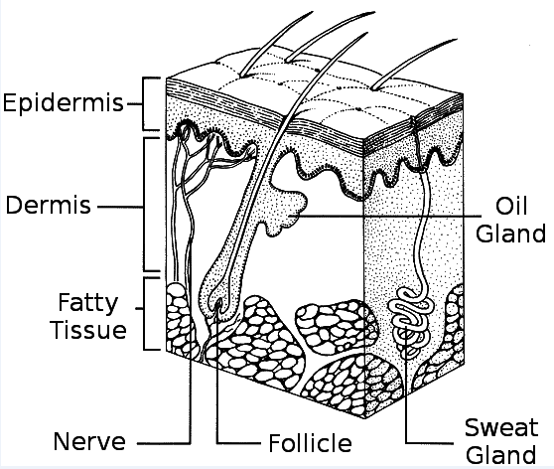
Fig 1: Layers of skin.

Epidermis:
The skin's beat layer, the epidermis, is super lean on a few parts of your body (your eyelids) and thicker on others (the bottoms of your feet). The epidermis is the layer of skin in charge of:
Making modern skin cells:
This happens at the foot of the epidermis. The skin cells travel up to the beat layer and chip off, around a month after they shape.
Giving skin it's color:
The epidermis makes melanin, which is what gives your skin its color securing your body:
The epidermis has extraordinary cells that are a portion of your resistant framework and assist you in remaining solid.
Dermis:
A parcel happens within the following layer, the dermis. The employments of the dermis incorporate.
Making sweat:
There are small pockets called sweat organs within the dermis. They make sweat, which goes through small tubes and comes out of gaps called pores. Sweating keeps you cool and makes a difference. We get freed of terrible stuff your body doesn't require. [5]
Helping you're feeling things:
Nerve endings within the dermis assist you in feeling things. They send signals to your brain, so you know how something feels in case it harms us(meaning you ought to halt touching it), is bothersome or feels pleasant after you touch it.
Developing hair:
The dermis is where you'll find the root of each modest small hair on your skin. Each root connects to a little small muscle that fixes and gives you goosebumps once you are cold or frightened.
Making oil:
Another sort of small take, or organ, in your skin, makes oil. The oil keeps your skin delicate, smooth and waterproof. Some of the time the organs make as well as much oil and provide pimples.
Bringing blood to your skin:
Blood bolsters your skin and takes absent terrible stuff through small tubes called blood vessels.
Subcutaneous fat:
The foot layer of the skin is the subcutaneous fat layer. This layer plays an imperative part in your body by the following.
Connecting the dermis to your muscles and bones:
This layer contains an extraordinary interfacing tissue that joins the dermis to your muscles and bones.
Making a difference in the blood vessels and nerve cells:
Blood vessels and nerve cells that begin within the dermis get greater and go to the rest of your body from here.
Controlling your body temperature:
Subcutaneous fat is the layer that makes a difference and keep our body from getting as warm or as cold.
Putting away your fat:
This fat cushions your muscles and bones and protects them from bumps and falls.

- DISEASES CHARACTERISTICS CORRESPONDING TREATMENTS
Psoriasis:
Psoriasis could be a common, inveterate, immune system illness that causes dry, ruddy, flaky patches and drops to appear on the skin. The hasty regularly goes absent for a while, but at that point, it flares up once more, frequently as a result of a trigger, [6] such as stretch. It is thought to happen when the safe framework erroneously begins creating skin cells as well rapidly. Psoriasis affects around 3 per cent of individuals all-inclusive, and around 7.5 million individuals within the Joined together States (U.S.). It influences men and ladies similarly. It can start at any age, but it is most common between the ages of 15 and 35 for a long time, and once more between 50 and 60 a long time. The normal age is 28 for a long time. Around 15 per cent of cases rise sometime recently to the age of 10 a long time.

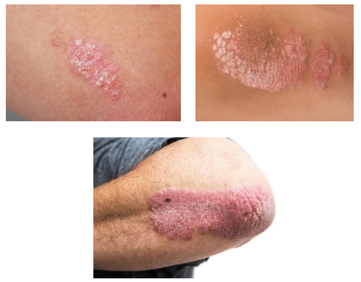
Fig 2: Images of Psoriasis

Symptoms:
Skins cells shed all the time, but in psoriasis, both dead and live cells collect on the skin's surface, since the substitution preparation is so quick. The most common indications of psoriasis are [7] Ruddy, flaky, dried-up patches, secured with brilliant scales that shed effectively seriously tingling and burning In any case, side effects can contrast, agreeing to the sort. Seriousness can extend from gentle to extreme. Agreeing to the National Psoriasis Establishment Gentle psoriasis covers less than 3 per cent of the body; direct psoriasis influences between 3 and 10 per cent extreme psoriasis covers over 10 per cent of the body. Around 80 per cent of individuals have mellow psoriasis, and the other 20 per cent have direct to extreme psoriasis. Psoriasis can influence any portion of the body, but it generally shows up as little patches on the elbows, knees, lower back, and scalp. Sorts There are a few shapes of psoriasis.
• Plaque psoriasis:
Approximately 80 to 90 per cent of individuals with psoriasis have plaque psoriasis. It shows up as raised, aroused, ruddy injuries, secured by brilliant, white scales, ordinarily on the elbows, knees, scalp, and lower back.
• Converse psoriasis:
Inverse psoriasis shows up within the armpits, the crotch, beneath the breasts, and in other skin folds such as around the privacy, and the buttocks. It to begin with shows up as ruddy injuries, ordinarily without the scale associated with plaque psoriasis. It may show up smooth and sparkly. Bothering from rubbing and sweating can make it more awful, because of its area in skin folds and delicate ranges. It is more common in individuals who are overweight and in those with profound skin folds. It can influence the genital zone.
• Erythrodermic psoriasis:
Erythrodermic psoriasis may be an especially provocative shape that can influence expansive parts of the body surface with a red-hot redness. Erythema implies blushing. It for the most part shows up on individuals with unsteady plaque psoriasis, where injuries are not clearly characterized. There may moreover be peeling, or shedding of the skin, serious tingling, and torment. Erythrodermic psoriasis is connected to a lopsidedness within the body's homeostasis. [8] This could cause protein and liquid misfortune that can lead to extreme ailments. Edema, or swelling from liquid retention, especially around the lower legs, may also be created. The body may have difficulty controlling its temperature, and this may cause shuddering. Erythrodermic psoriasis can trigger disease, pneumonia, and congestive heart disappointment. The complications of erythrodermic psoriasis can be life-debilitating. Anybody who may have any indications of this condition ought to see a specialist at once. Individuals with extreme cases of this condition may spend time within the clinic.
• Guttate psoriasis:
Guttate psoriasis regularly begins in childhood or youthful adulthood. It shows up as little, ruddy, person spots on the skin that are not ordinarily as thick or as dried up as the injuries in plaque psoriasis. A run of conditions can trigger it, including upper respiratory infections, streptococcal infections, tonsillitis, push, damage to the skin, and the utilization of certain drugs, including lithium, and beta-blockers. This shape of psoriasis may go absent from its possession and not come back, or it may clear for a time and return afterwards as patches of plaque psoriasis.
• Pustular psoriasis:
Pustular psoriasis influences grown-ups more than children, and it accounts for less than 5 per cent of psoriasis cases. It shows up as white pustules, or rankles, of non-infectious discharge, encompassed by ruddy skin. It can influence certain regions of the body, for illustration, the hands, and feet, or most of the body. It isn't a disease, and it is not infectious. Pustular psoriasis tends to occur after a cycle, in which blushing of the skin is taken after the arrangement of pustules and scaling.
• Psoriatic joint pain:
Up to 40 per cent of individuals with psoriasis have joint irritation with side effects of joint pain, known as Psoriatic joint pain. This causes irritation and dynamic harm to the joints. It is most common between the ages of 30 to 50 for a long time. Other complications Individuals with Psoriatic infection commonly encounter social prohibition and mood self-esteem. Besides the physical inconvenience, tingling, and torment of psoriasis, this will affect their quality of life. Possibly because of these components, psoriasis has been connected to sadness. Psoriasis has moreover been connected to a better hazard of cardiovascular infection and other well-being conditions.
Causes:
• Psoriasis is an immune system illness. It happens when an issue happens with the safe framework.
• The safe framework includes a sort of cells known as T cells. A trigger causes the T cells to act on the off chance that they are battling contamination or recuperating a wound. They create chemicals that cause aggravation.
• In psoriasis, this leads to an intemperate development of skin cells and aggravation.
• Ordinarily, skin cells take around 21 to 28 days to supplant themselves, but, in patients with psoriasis, they take around 2 to 6 days.
• What triggers this response is vague, but individuals with psoriasis may discover that stretch and uneasiness, wounds to the skin, diseases, and hormonal changes can lead to a flare-up.
• Solutions that can trigger it incorporate lithium, antimalarial, quinidine, and indomethacin. A few individuals relate psoriasis with sensitivities, diet, and weather, but this is often not demonstrated. It isn't infectious.
Risk factors
Some factors increase the likelihood of developing psoriasis. These include having cardiovascular disease and metabolic syndrome trauma to the skin and family history. About 1 in 3 people with one close relative with psoriasis will develop the condition. If one parent has psoriasis, there is a 10 per cent chance of developing it, and if both parents have it, the chance is 50 per cent. This suggests an underlying genetic component, but the disease may not emerge unless an environmental factor triggers it to become active. At least 10 per cent of the population is thought to have the gene that causes psoriasis, but only 2 to 3 per cent of people develop it. Among younger people, psoriasis may appear after an infection, notably strep throat. Between 33 and 50 per cent of young people with psoriasis will notice a flare-up between 2 and 6 weeks following an earache or a respiratory infection such as strep throat, bronchitis, or tonsillitis. [9]

- SKIN DISEASE DIAGNOSIS
A person who has a persistent rash that does not go away with over-the-counter (OTC) treatment should consider asking a doctor about it. The doctor will look at the symptoms and ask about personal and family history, and they may carry out a skin biopsy. There are no blood tests for psoriasis. Treatment If a diagnosis is confirmed, treatment will depend on the type and severity of the condition. The main options include topical therapy, systemic therapy, and phototherapy. Topical treatment is applied directly to the skin. It is usually the first line of treatment, and the aim is to slow down the growth of skin cells and reduce inflammation. These treatments are available over the counter (OTC) or on prescription and include non-steroids and steroids. To help reduce itching, the following are available: A keratolytic product can help remove flaking skin. OTC options may contain salicylic acid, lactic acid, urea, or phenol. OTC products, such as calamine, hydrocortisone, camphor, diphenhydramine hydrochloride (HCl), benzocaine, and menthol, may help, but these can also dry the skin. The individual should see what works best. Systemic therapies work through the body system. Some affect the whole system, and they are used for people with moderate to severe psoriasis and psoriatic arthritis. These are taken by mouth or by injection, and they include acitretin, cyclosporine, and methotrexate. Biologic drugs are a type of systemic therapy. A biologic is a protein-based drug that is made from living cells grown in a laboratory. Biologics target the specific T cells that are associated with psoriasis.
Phototherapy:
Phototherapy is light therapy. The skin is exposed regularly to ultraviolet light, either in the doctor's office or at home. This is done under medical supervision. Tanning beds are not recommended as a substitute. Home remedies are not possible to avoid psoriasis, but some strategies can help people to cope with it. Tips include lowering stress by doing yoga, exercise, meditation, or both getting a balanced diet and maintaining a healthy weight recognizing and avoiding food triggers joining a support group or blog to talk with others with a similar experience not smoking or drinking alcohol excessively. [10] Home remedies for reducing itching include keeping the skin moisturized. A dermatologist can recommend a suitable product for taking a cold shower for up to 10 minutes or use a cold pack that avoids hot showers, as they can dry the skin.
- MACHINE LEARNING
It is an application of manufactured insights (AI) that gives frameworks the capacity to naturally learn and progress from encounters without being unequivocally modified [15]. Machine learning centers on the improvement of computer programs that can get information and utilize it to learn for themselves. We utilized bolster forward back proliferation manufactured neural arrange (ANN) for this step. The ANN comprised of one input layer, two covered-up layers and one yield layer. Since we have utilized an administered machine learning calculation, the highlight table obtained after picture preparation was encouraged to the input layer and their comparing comes about to the yield layer for preparing [16]. A profound learning strategy utilizing the neural organize device in MATLAB which trains the demonstration utilizing a personality work was utilized to initialize the parameters of the show, the weight frameworks.
DEEP LEARNING:
Profound learning could be a portion of the broader family of machine learning wherein the learning can be directed, unsupervised or semi-directed. Profound learning is not at all like machine learning employments an expansive information set for the learning, and the number of classifiers utilized gets diminished substantially [17]. Seeing preparing time for the profound learning calculation increments since of the utilization of the exceptionally expansive information set. Profound learning calculation chooses its claim highlights not at all like the machine inclining making the prediction process simpler for the conclusion client because it does not utilize much pre-processing. We utilize directed machine learning calculations in this venture.
Renowned machine learning methods:
Machine learning calculations are regularly categorized as administered or unsupervised. Directed machine learning calculations can apply what has been learned in the past to modern information utilizing named illustrations to anticipate future occasions. Beginning from the investigation of a known preparing information set, the learning calculation produces a deduced work to form expectations almost the yield values. In differentiation, unsupervised machine learning calculations are utilized when the data utilized to prepare is not one or the other classified nor named. Unsupervised learning thinks about how frameworks can gather work to portray a covered-up structure from unlabeled information. Semi-supervised machine learning calculations drop someplace in between directed and unsupervised learning since they utilize both named and unlabeled information [18], [19] for regularly preparing a small sum of named information and a huge sum of unlabeled information. The frameworks that utilize this strategy can significantly improve learning accuracy. Fortification machine learning calculations could be a learning strategy that is interatomic with its environment by producing activities and finding blunders or rewards. Trial and blunder look and deferred compensation are the foremost pertinent characteristics of fortification learning. This strategy permits machines and program operators to consequently decide the perfect behaviour inside a particular setting in order to maximize its execution.
- ALGORITHM DESIGN
Algorithm Design
The preparatory step within the calculation plan is to recover the database picture tests of the maladies and change them from colour to grey scale. A parallel picture is obtained from the dark color picture and the converted picture undergoes the method that appeared within the flowchart. Within the proposed framework, we utilize a standard database for the improvement and testing of the proposed framework. To begin with this system performs picture preparation for denoise the picture and upgrades the picture for measurable examination. [11] After sifting highlight extraction is connected. It calculates the entropy, Standard deviation, and surface figure to find the run of parameters utilized in the picture. The table shows the range of measurable parameters of images as per their category. We utilize a two-level classifier to induce way better results. With the advantage of the Ada Boost classifier, it connects the pictures by choosing the run of relationship by the help of cruel, standard deviation based on escalated classifier classifies biomedical pictures.

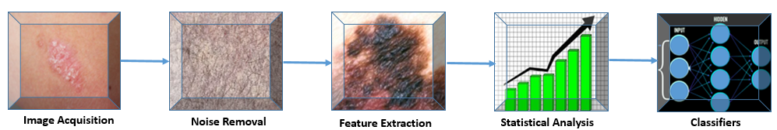

Fig 3: Algorithm Design

STEPS INVOLVED
1) Image Acquisition
2) Noise Removal
3) Feature Extraction
4) Statistical analysis
5) Classification

Image Acquisition:
The primary organization of our mechanized picture investigation framework is picture securing. This arrangement is basic for the rest of the framework; hence, if the picture isn't obtained palatably, at that point the remaining components of the framework may not be achievable, or the outcome will not be sensible. In this organization, to begin with, the picture framework requires the re-sized picture for the way better comes about. The input picture given to the framework is in RGB shape. However, our proposed framework requires gray pictures. Subsequently utilizing RGB to gray transformation in MATLAB we change RGB pictures into gray pictures. At that point, re-sizing the picture takes put for decreasing the method speed amid the MATLAB coding handle.
Noise Removal:
It's vital to have quality pictures without any commotion to urge precise results. A loud picture may lead your calculation towards erroneous results. Thus, it is fundamental to de-noise the picture. Picture de-noising is an imperative picture preparation assignment. There are numerous ways to de-noise a picture. The critical for a great image de-noising show is that it'll expel commotion while protecting edges. Customarily, straight models have been utilized. To de-noise the picture we will utilize the middle channel. The middle channel does the work of smoothening the picture. We utilize the middle channel to de-noise the picture.
Feature Extractions:
To urge precise results in biomedical picture handling it is continuously essential that biomedical pictures must be of very good quality. Be that as it may, essentially usually not simple. Due to diverse reasons get moo or medium quality pictures. Subsequently, it gets to be vital to progress their quality. To progress the quality of the picture utilizing picture improvement calculation. This calculation improves the picture by centering on parameters like contrast, and brightness alteration. In this handle the picture is analyzed and appears within the way of the histogram, to know how much range it is secured.
Statistical Analysis:
Measurable investigation of skin picture is gathered to grant diverse measurements such as entropy standard deviation Surface figure relationship figure depending on this parameter to begin with discover out the extend for person’s skin illness. To discover out run of these parameters utilized for standard skin illness picture database. We calculate the meaning.
$$m_{1}=\frac{ \sum_{i=l1}^{l2}{I_{i}}(i)}{l2-l1}$$First, we calculate the variance with the benefit of sample mean.
$${σ_{l}}^{2}= \frac{\sum_{l=l1}^{l2}{\begin{aligned}{\left(I_{1}(i)-m_{i}\right)}^{2}\end{aligned}}}{l_{2}-l_{1}}$$
With the benefit of variance, we calculate the energy of image I by taking the mean square of variance. We then calculate the luminance of image with the benefit of RGB components of image I, we calculate the RGB components of image by taking mean of R, G and B components.
$$R_{n }= \frac{R}{R+G+B} \\ G_{\begin{aligned}n \\ \end{aligned}}= \frac{G}{R+G+B}$$
$$B_{n }= \frac{B}{R+G+B}$$
$$L= \sqrt{(\left(0.3*r^{2}\right)+\left(0.587*g^{2}\right)+\left(0.114*b^{2}\right))}$$
We calculate sample similarity measurement with the benefit of resized image I2, texture T2, window and luminance L. Wee calculate the standard deviation of image
$$σ_{i}= \sqrt{{{(σ}_{i})}^{2}}$$
We calculate the entropy of the image
$$entropy= -sum(p*\log^{2}{(p))}$$
Classification:
In this we use the frame two-level classifiers. At first level it classifies normal or abnormal and second level it classifies in specified category i.e. Melanoma, Psoriasis or Dermo. The first stage of this framework is to perform image processing to detect and exclude the noise, after that the ROI of the skin lesion is segmented. Then, the image features are extracted. Next, the extracted features are fed to the classifier. [12]
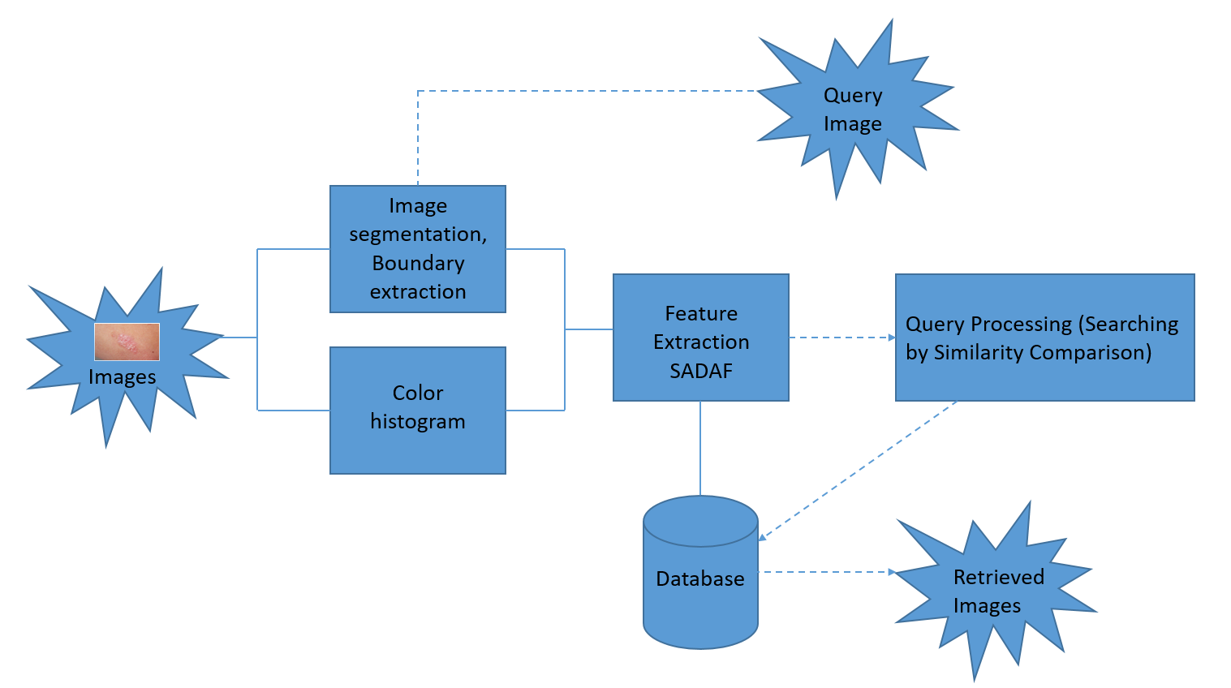
Fig 4: Architecture of the proposed method

RGB TO Gray Color diagrams Required:
The preparatory step within the calculation plan is to recover the information base picture tests of infections and change over them from colour to gray scale.
Unused outline = rgb2gray(map) returns a grayscale color outline identical to outline.
Note:
A grayscale picture is additionally called a gray-scale, gray scale, or gray-level picture.

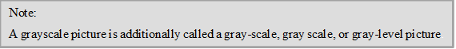
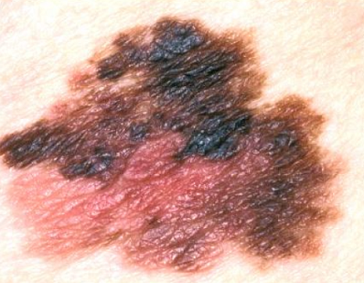

Fig 5: Original Image Fig 6: RGB to Gray color

Considering the picture to be a grey one will disentangle the division address and lead to straightforward calumniation but lose a few picture data [13]. Considering the picture to a color one will be supportive to de-noise the picture but leads to more calculations. In this manner, if we have a clean picture, which implies no commotion, at that point it is likely ready to treat it as a gray picture.
Re- sizing the image:
In this preparation we diminish the estimate of the picture since in the event that the picture measure is expansive it takes time to handle the whole program. So in the event that we decrease the measure of the picture at that point the it takes less utilization time and capacity space also will be less so within the picture securing we go for RGB to gray and re-sizing.
Fig 7: Median Filter
Middle sifting could be a common step in picture handling. In picture preparing it is ordinarily fundamental to perform tall degree of commotion diminishment in a picture some time recently performing higher-level handling steps, such as edge location. The middle channel could be a non-linear computerized sifting strategy, regularly utilized to evacuate clamor from pictures [14] or other signals. The thought is to look at a sample of the input and choose on the off chance that it is agent of the flag. Typically performed employing a window comprising of an odd number of tests. It is especially valuable to diminish dot clamour and salt and pepper commotion. Its edge-preserving nature makes it valuable in cases where edge obscuring is undesirable.
B = medfilt2(z) performs middle sifting of the lattice A utilizing the default 3-by-3 neighborhood.

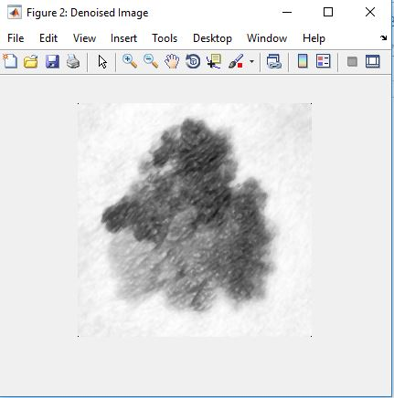
Fig 8: Median Filter
Extracting the Required Region:
For the sifted picture a filling administrator is connected to fill the locales which are unaffected region and calculated the range for the influenced portion of the locale.
After filling (vertically & evenly) the unaffected region as white locale. The number of pixels is calculated within the influenced locale. The region will be calculated for the influenced region (black portion) in micrometers.

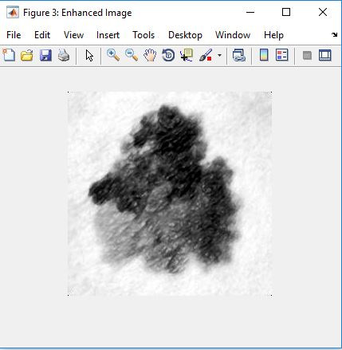
Fig 9: Extracting region

- SOFTWARE USED
MATLAB program being utilized in our extent where MATLAB (lattice research facility) could be a numerical computing environment and fourth-generation programming dialect. Created by Math-works, MATLAB permits framework controls, plotting of capacities and information, usage of calculations, creation of client interfacing, and meddle with programs composed in other dialects, counting C, C++, Java, and Fortran. We utilize MATLAB 2016a adaptation in our venture. Although MATLAB is aiming basically for numerical computing, a discretionary tool stash employments the Mu Cushion typical motor, permitting get to typical computing capacities. An extra bundle, Simulink, includes a graphical multi-domain reenactment and model-based plan for the energetic and implanted framework.

FEATURES:
It could be a high-level dialect for numerical computation, visualization, and application advancement.
MATLAB:
Unused different y-axis plots, polar plots, and condition visualization Delay, investigate, and continue MATLAB code execution.
Neural organize tool kit:
Profound learning with convolutional neural systems (CNNs) for picture classification assignments utilizing GPU speeding up in Parallel Computing Tool kit.
Typical math tool kit:
Integration with the MATLAB Live Editor for altering typical code and visualizing comes about and changing over Mu Cushion scratch pad to live scripts. Insights and machine learning tool stash:
Classification Learner app that trains numerous models naturally, visualizes comes about by lesson names, and performs calculated relapse classification.
Control framework tool kit:
Unused and updated apps for planning SISO controllers, naturally tuning MIMO frameworks, and making reduced-order models Picture securing tool stash: Bolster for Kinect for Windows v2 and USB 3 Vision Computer vision framework tool stash Optical character acknowledgement (OCR) Coach app, the person on foot location, and structure from movement and bundle alteration for 3-D vision.
Exchanging tool kit:
Exchange fetched examination for trading, sensitivity, and post-trade execution.
GRAPHICAL USER INTERFACE:
GUI s (too known as GRAPHICAL Client INTERFACE) give point -and- press control of program applications, killing the got to learn a dialect or sort commands in arrange to run the application [20]. In us extend we are going to make a separate GUI for showing an each out independently. we make a record at that point we embed all the steps in this record, after that we embed the picture in this record we get the pictures step by step handle .This the most handle of GUI in our
X. MATLAB FUNCTIONS
 | COMMAND | DESCRIPTION
1 | imread | Imread which reads the grayscale or color image.
2 | imshow | imshow displays the grayscale or color image
3 | imresize | Imresize which resizes the image
4 | imadjust | Imadjust maps the intensity values in grayscale image
5 | imhist | Imhist (J) calculates the histogram for a grayscale image .

- SIMULATION RESULTS
Within the proposed framework, we utilize a standard database for the improvement and testing of the proposed framework. Within the to begin with arrange, this system performs picture preparing to de-noise the picture and improvement the picture for factual examination. After sifting include extraction is connected, It calculates the entropy, Standard deviation, and surface factor to find the extend of parameters utilized within the picture. Table 1 appears the run of measurable parameters of pictures as per their category. We use a two-level classifier to induce way better comes about. With the good thing about the classifier, it relates the images with choosing the extend of relationship with the assistance of cruel, standard deviation based on escalated classifier classifies biomedical pictures.
Within the proposed system as result of the classifier, ready to classify the typical, psoriasis, Dermo and melanoma pictures with exactness of 90% or more. Table II appears comes about for standard deviation. This mechanized picture examination module where Picture preparing module classifies beneath which category the picture falls (Psoriasis, Melanoma and Dermatophytosis).

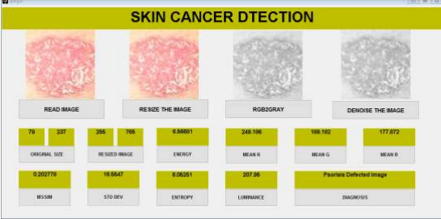
PSORIASIS

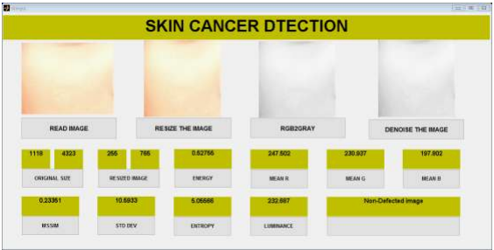
NORMAL SKIN

Result for statistical parameter analysis:
 | Luminance | Standard deviation | Entropy
Normal skin | 226.8690 - 244.7091 | 4.0219 - 19.6765 | 3.6991 - 5.6361
Psoriasis | 200.1013 - 225.3665 | 9.5709 - 30.91 | 5.065 - 6.7293

- CONCLUSION
The images examination framework for avoidance and discovery of skin maladies. Utilizing factual investigation with relationship calculation we will determination psoriasis skin illnesses as well as classify skin infection. Diverse measurable parameters have been examined among them are luminance, standard deviation, entropy these are chosen to discover out likelihood of infection. Agreeing to advance prerequisite in case essential measurable parameters can be expanded. Result of this framework is supposed to analyse different skin maladies as well because it classifies skin diseases. This future work may diminish the handling time of dissemination speed. That creates the framework quicker.

REFERENCE
[1] Cheng, Yu-Wen, et al. "A desperate need for psoriasis health care in remote regions as revealed by a live interactive teledermatology program serving Penghu Islands in Taiwan Strait." Telemedicine and e-Health 28.8 (2022): 1109-1116.
[2] Pathania, Yashdeep Singh, et al. "Non‐invasive diagnostic techniques in pigmentary skin disorders and skin cancer." Journal of cosmetic dermatology 21.2 (2022): 444-450.
[3] Osterhout, Jessica A., et al. "A preoptic neuronal population controls fever and appetite during sickness." Nature 606.7916 (2022): 937-944.
[4] Frischhut, Nina, et al. "The spectrum of melanocytic nevi and their clinical implications." JDDG: Journal der Deutschen Dermatologischen Gesellschaft 20.4 (2022): 483-504.
[5] Snyder, Ashley M., et al. "Atopic Dermatitis: A Qualitative Study on the Burdens of Living with Itchiness." The Journal of Clinical and Aesthetic Dermatology 16.7 (2023): 22.
[6] Pouzesh, Mohsen, and Saleh Mobayen. "Event-triggered fractional-order sliding mode control technique for stabilization of disturbed quadrotor unmanned aerial vehicles." Aerospace Science and Technology 121 (2022): 107337.
[7] M. Shamsul Arifin, M. Golam Kibria, Adnan. F, M. Ashraful Amini, Hong Y, Dermatological disease diagnosis using color-skin images, Published in Proceedings of the 2012 International Conference on Machine Learning and Cybernetics, Xian, 15-17 July, 2021 .
[8] Florence T,Ernest M, Fred N. K, An image-based diagnosis of virus and bacterial skin infections, International Conference on Computing and ICT Research,2022.
[9] Damilola A. O, Olidayo O. O, Soloman A. O, Automating skin disease diagnosis using image classification, Published in Proceedings of the World Congress on Engineering and Computer Science 2013 Vol II WCECS 2018, 23-25 October, 2019, San Francisco, USA.
[10] Diepgen TL, Yihune G et al. Dermatology Online Atlas. Published online at: http://www.dermis.net/doia/.
[11] Teck T. T, Li Z, Ming J, , An intelligent decision support system for skin cancer detection from dermoscopic images in 12th International Conference on Natural Computation, Fuzzy Systems and Knowledge Discovery (ICNC-FSKD) .
[12] Er. Shrinidhi G, Ansari N, Ansari Z Shaikh R,An Innovative Approach for Skin Disease Detection Using Image Processing and Data Mining. In International Journal of Innovative Research in Computer and Communication Engineering.
[13] B.V.Dhandra, Shridevi Soma, Shweta Reddy, “Color Histogram Approach For Analysis Of Psoriasis Skin Disease”, IEEE system Journal, vol.99,pp. 25-29.
[14]. A. Karargyris, O. Karargyris, A. Pantelopoulos, “DERMA/ care: An Advanced Image- Processing Mobile Application for Monitoring Skin Cancer,”in IEEE 24th International Conference on Tools with Artificial intelligence(ICTAI), 2023, PP.1-7
[15]. R. Siegel, D. Naishadhama, A. Jemal, “Cancer Statistics, 2012,”CA: a cancer journal for clinicians, vol.62,2012, pp.10-29.
[16]. T. Wadhawan, N. Situ, K. Lancaster, X. Yuan, G. Zouridakis, “SkinScan: A Portable Library for Melanoma Detection On Handheld devicees,” in IEEE International Symposium On Biomedical Images: from nano to micro,2011,2011,pp.133-136.
[17]. Omar Abuzaghleh, Buket D. Barkana, Miad Faezipour, “SKIN cure: A Real Time Image Analysis System to Aid in the malignant melanoma Prevention and Early Detection.”Member IEEE SSIAI 2014, pp. 85-88.
[18]. Ho Tak Lau, Adel Al-Jumaily, “Automatically early detection of skin cancer,” International conference of soft computing and pattern recognition, IEEE 2009, pp.375-380.
[19]. Romero G, García M, Vera E, Martínez C, Cortina P, Sánchez P, Guerra A. “Preliminary results of DERMATEL: prospective randomized study comparing synchronous and asynchronous modalities of teledermatology.” Actas Dermosifiliogr. 2006 Dec; vol.97
[20]: pp 630-36. [8]. Scherr, D.; Zweiker, R.; Kollmann, A.; Kastner, P.; Schreier, G. & Fruhwald, F. “Mobile phone based surveillance of cardiac patients at home Journal of Telemedicine and Telecare,” 2006, vol 5, pp 255-261.

