ENTREPRENEURIAL COMPETENCIES AND RISK RESILIENCE: INSIGHTS FROM A BIBLIOMETRIC ANALYSIS
*Niraj Plaha, Research Scholar, MSB, Lovely Professional University
**Dr. Pooja Sharma, Associate Professor, MSB, Lovely Professional University
***Aastha, Research Scholar, MSB, Lovely Professional University
ABSTRACT:
Entrepreneurial competencies and risk resilience play a significant role in the growth of the business. Entrepreneurs must possess diverse skills, knowledge, imagination, creativity, the ability to identify opportunities, and the ability to overcome high-impact entrepreneurial challenges in the face of adverse situations. There has been an increased interest in the role of entrepreneurial competencies and risk resilience attitude for the growth of business due to the changing conditions in the global marketplace. The purpose of this study is to provide a bibliometric analysis of the research on entrepreneurial competencies and risk resilience. A total of 443 and 353 studies were published from the year 2000 to 2021. The study attempts to identify the significant journals in the area, most cited studies, top authors, and top countries' participation. The key statistical aspects and collaboration networks in this topic are highlighted by a bibliometric analysis of the obtained material. The data was obtained from the Scopus database. The VOSviewer software was used to create a co-authorship network map. This research adds to the body of knowledge on entrepreneurial competencies and risk resilience. Bibliometric techniques provide a far more comprehensive and reliable view of this field.
KEYWORDS:Entrepreneurs, Entrepreneurial Competencies, Risk Resilience, Bibliometric analysis

1. INTRODUCTION
1.1. Entrepreneurial Competencies
Competencies are often motivated by a desire to improve performance and as a result, the opportunity for financial benefit or company success(Bhardwaj, 2016; Vinet & Zhedanov, 2011; Wasowska, 2019). The term competency was first used by Boyatzis in 1982, to distinguish superior from the average performance of managers which further describes the underlying characteristic of an individual that is causally related to effective or superior performance (Wickramasinghe & de Zoyza, 2009). The competence of managers considering managerial skills is one of the main factors of success in any organization. The effectiveness of managers in terms of their competencies i.e. managerial skills can help the organization to build up its reputation and achieve its goals and objectives (Ghorbani, S., Khodayari, A., & Mohammadi, 2014).The competencies include many variables such as knowledge and various skills like leadership, team management, and many more. Here, knowledge plays an important role because all the competencies are based on specific knowledge of each variable including its knowledge. Hence, Knowledge can be defined as the possession and understanding of the principle, facts, processes, and many more things(Krabel, 2018; Shah et al., 2020).
Research on entrepreneurial competencies has rapidly grown over the past twenty years. A wide variety of studies have been conducted on various topics related to entrepreneurial competencies(Bloemer et al., 2013; Botha et al., 2019; Cortellazzo et al., 2020; Rambe et al., 2015). However, only a handful of studies could be found that have attempted to provide a bibliometric analysis or review of the available literature on entrepreneurial competencies. So far, the most significant review study has been conducted by Fagadar in 2021. The study has covered 160 articles. Those articles were related to only subjects like education, economics, and business management. The other subject’s related articles were not considered. This was the gap identifiedin this paper.Furthermore, the following were extracted: the article title, author name(s) and affiliation, journal name, number, volume, pages, date of publication, abstract, and cited references. Then the bibliometric analysis was conducted byVosViewer.

1.2. Risk - Resilience
The term risk resilience refers to the ability to get better to a steady state after being exposed to a disruptive situation.(Enoch, 2012; Gee & Casey, 2015; Mikami & Hinshaw, 2006; Winn et al., 2011). Disruptions are unavoidable, and there are a variety of internal and external variables that contribute to disruptions in companies. When it comes to resilience, the main concerns are organizational vulnerability, disruptions, and complexities, as these are the main challenges that affect the system's resilience. Vulnerability to a disruptive event can be defined as a mix of the likelihood of disruption and the severity of the disruption (Escamilla-Fajardo et al., 2021; Gulati & Weiler, 2021; Petzold et al., 2020).

2. RESEARCH METHODOLOGY:
A bibliometric analysis is frequently used to determine the quantitative changes in a specific research discipline, as well as to determine the pattern of publications on a specific topic and to determine the publication propensity within that discipline. The findings of such a study provide practical, valuable, and timely information for both professionals and specialists interested in evaluating such scientific efforts. Another benefit of bibliometric analysis is that it allows for a quantitative objective study of a given discipline.
The Scopus database was utilized to find publications about “entrepreneurial competencies” and “risk resilience” that were published between 2000 and 2021. This database was chosen because it has a larger number of high-quality journals. The search filter was applied to find only such studies whichcontained the words “entrepreneurial intentions” and “risk-resilience” separately in either their title or abstract or keywords.

Figure 1: Research Methodology
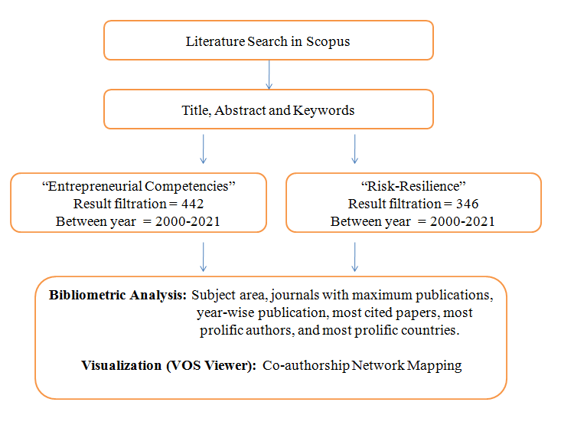
(Source: Author’s creation)
For the Entrepreneurial competencies,the search reflected a total of 443 studies. To confirm whether the studies in thesearch results were genuinely related to the intended topic or not, the title, abstract, andkeywords of each paper, were manually read by the author. Consequently, it was found thatout of the 443 studies, one study was done before the year 2000, and hence it was not considered. Furthermore, 353 studies were found out of which seven studies were done before the year 2000 and thus they were not considered.
The title, abstract, and keywords of each paper were personally read by the author to validate if the studies in the search results were related to the desired topic or not. Furthermore, a classification of these studies is provided based on the Subject area, journals with maximum publications, year-wise publication, most cited studies, most prolific authors, and most prolific countries.

3. RESULTS AND FINDINGS:
3.1 SUBJECT AREA:
It has been observed that maximum studies are written in the subject area of Management and Accounting. Furthermore, subject area such as Economics and Social science also has 113 and 78 studies respectively. There are 30 studies in Decision science and 10 in Engineering.
Figure 2: Subject Area

(Source: Scopus Data Base)
3.2 JOURNALS WITH MAXIMUM PUBLICATIONS:
All the 437studies in this study belong to their respective 135 journals. The below-mentioned table shows the top twenty journals, which published the maximum number of studies on Entrepreneurial Competencies. The highest number of studies were published in the Journal of Education and Training with 12 studies. Furthermore, the Journal of Entrepreneurship Education and Journal of Small Business and Enterprise Development were 9 and 8 studies respectively
Table 1: Journals with maximum publications
Journal’s Name | Number of Studies
Education And Training | 12
Journal Of Entrepreneurship Education | 9
Journal Of Small Business And Enterprise Development | 8
Advances In Intelligent Systems And Computing | 7
Contributions To Management Science | 7
International Journal Of Business And Globalisation | 7
Sustainability Switzerland | 7
Academy Of Entrepreneurship Journal | 6
International Entrepreneurship And Management Journal | 6
International Journal Of Entrepreneurship | 6
International Journal Of Management Education | 6
Frontiers In Psychology | 5
International Journal Of Entrepreneurship And Small Business | 5
Journal Of Small Business Management | 5
International Journal Of Entrepreneurial Behaviour And Research | 4
Journal Of Entrepreneurship In Emerging Economies | 4
Advances In Entrepreneurship Firm Emergence And Growth | 3
Communications In Computer And Information Science | 3
Education Sciences | 3
Entrepreneurship And Sustainability Issues | 3
(Source: Scopus Data Base)
3.3 YEAR WISE PUBLICATION:
This table shows the number of studies published from the year 2000 to 2021. It can be seen that the research on entrepreneurial competencies has been growing over the years. Thenumber of published studies was very minimal during the years 2000 to 2014. Then, therewas an impressive increase from the year 2014 to 2019, the number of studies rose from 16 to
75. Further, it can be seen that a maximum number of studies have been published in the last five years.The number of studies exponentially increased from 32 to 68 from the year 2016 to 2021.The maximum number of studies was published in 2019 with 75 studies. This clearly shows that the interest of researchers has grown tremendously in thisfield, in recent times.

Figure 3: Year-wise Publications

(Source: Scopus Data Base)
3.4 MOST CITED PAPER:
Focussing on the Scopus content, a list of the twenty most cited studies is presented in the table. The most cited paper 572 citation is by Man T.W.Y., Lau T., Chan K.F. In this work, a conceptual model is constructed to link the characteristics of owner-managers of small and medium-sized businesses (SMEs) and their company's performance. Competitive scope, organizational capabilities, entrepreneurial talents, and performance are the four constructs of the model (Man et al., 2002).

The second most cited paper with 328 citations is “Entrepreneurial competencies: A literature review and development agenda” by Mitchelmore S., Rowley J.The goal of this paper is to conduct a literature review of entrepreneurial competence research to provide an integrated account of contributions relating to entrepreneurial competencies by different authors working in different countries, different industry sectors, and at different times; and develop an agenda for future research and practice about entrepreneurial competencies (Mitchelmore & Rowley, 2010)

Furthermore, the third most cited paper with 267 citations is “The Evolution of Entrepreneurial Competencies: A Longitudinal Study of University Spin-Off Venture Emergence” by Rasmussen E., Mosey S., Wright M. The goal of this article is to gain a better understanding of how entrepreneurial skills develop in non-commercial academic settings to start new businesses. To assist identify these competencies and explain their development trajectories, we use an evolutionary viewpoint that considers where resources come from (Rasmussen et al., 2011).

Then the fourth most cited paper with 246 citations is “A competency-based perspective on entrepreneurship education: Conceptual and empirical insights” by Morris M.H., Webb J.W., Fu J., Singhal S. The competencies required for entrepreneurial action are studied in this research. Competencies are viewed as an outgrowth of the learning of scripts derived from interactions between the individual and the environment, based on structuration theory. The distinction between managerial and entrepreneurial skills is made, with the latter helping to define the subject of entrepreneurship education (Morris et al., 2013).

Table 2: Most cited studies
Sr. No | Authors | Title | Year | Cited by
1 | Man T.W.Y., Lau T., Chan K.F. | The competitiveness of small and medium enterprises: A conceptualization with focus on entrepreneurial competencies | 2002 | 572
2 | Mitchelmore S., Rowley J. | Entrepreneurial competencies: A literature review and development agenda | 2010 | 327
3 | Rasmussen E., Mosey S., Wright M. | The Evolution of Entrepreneurial Competencies: A Longitudinal Study of University Spin-Off Venture Emergence | 2011 | 266
4 | Morris M.H., Webb J.W., Fu J., Singhal S. | A competency-based perspective on entrepreneurship education: Conceptual and empirical insights | 2013 | 246
5 | SÃ¡nchez J.C. | The impact of an entrepreneurship education program on entrepreneurial competencies and intention | 2013 | 238
6 | SÃ¡nchez J.C. | University training for entrepreneurial competencies: Its impact on intention of venture creation | 2011 | 199
7 | Rasmussen E., Mosey S., Wright M. | The influence of university departments on the evolution of entrepreneurial competencies in spin-off ventures | 2014 | 138
8 | Mitchelmore S., Rowley J. | Entrepreneurial competencies of women entrepreneurs pursuing business growth | 2013 | 132
9 | Taatila V.P. | Learning entrepreneurship in higher education | 2010 | 112
10 | Rasmussen E., Wright M. | How can universities facilitate academic spin-offs? An entrepreneurial Competency perspective | 2015 | 108
11 | Man T.W.Y., Lau T., Snape E. | Entrepreneurial Competencies and the Performance of Small and Medium Enterprises: An Investigation through a Framework of Competitiveness | 2008 | 104
12 | Hazlina Ahmad N., Ramayah T., Wilson C., Kummerow L. | Is entrepreneurial competency and business success relationship contingent upon the business environment?: A study of Malaysian SMEs | 2010 | 82
13 | LackÃ©us M. | An emotion-based approach to assessing entrepreneurial Education | 2014 | 79
14 | Boyles T. | 21st-century knowledge, skills, and Abilities and entrepreneurial competencies: A Model for undergraduate entrepreneurship education | 2012 | 75
15 | Kyndt E., Baert H. | Entrepreneurial competencies: Assessment and predictive value for entrepreneurship | 2015 | 72
16 | Rasmussen E., Mosey S., Wright M. | The transformation of network ties to develop entrepreneurial competencies for university spin-offs | 2015 | 70
17 | Man T.W.Y., Lau T. | The context of entrepreneurship in Hong Kong: An investigation through the patterns of entrepreneurial competencies in contrasting industrial environments | 2005 | 69
18 | Obschonka M., Hakkarainen K., Lonka K., Salmela-Aro K. | Entrepreneurship as a twenty-first-century skill: entrepreneurial alertness and intention in the transition to adulthood | 2017 | 65
19 | Sirelkhatim F., Gangi Y. | Entrepreneurship education: A systematic literature review of curricula contents and teaching methods | 2015 | 61
20 | Verzat C., Byrne J., Fayolle A. | Tangling with spaghetti: Pedagogical lessons from games | 2009 | 55
(Source: Scopus Data Base)
3.5 MOST PROLIFIC AUTHORS:
It shows the top twenty most prolific authors. All 437studies belong to their respective 159 authors. Upon analyzing the data, a list of the top twenty authors with maximum publications was prepared. Further, it was found that the most prolific author on entrepreneurial competenciesisMamun, A.A andZali, M.R. with sevenstudies. The authors Ahmad, N.H, Al Mamun, A, andFazal, S.A. each have published sixstudies. Furthermore, Botha, M. and Zainol, N.R.have published five studies(Al Mamun & Fazal, 2018; Botha et al., 2019; Botha & Taljaard, 2019)
Figure 4: Most Prolific Author

(Source: Scopus Data Base)
3.6 MOST PROLIFIC COUNTRIES:
All the studies belong to their respective authors from 80 plus different countries. The papershows the top twenty countries with a maximum number of studies on entrepreneurial competencies. Malaysia tops the list with 48 total studies. Secondly, the United Kingdom and Indonesia each have published 38 studies respectively. Furthermore, Spain and India have 27 and 22 respectively studies.

Figure 5: Most Prolific countries

(Source: Scopus Data Base)

3.7 AFFLICTION OF AUTHORS
The figure shows the affiliation of authors. It has been observed that the maximum number of authors are afflicted University Sains Malaysia with 13 in numbers and secondly from University Malaysia Kelantan has 12 authors. The University of Tehran has 9 authors’ afflictions. Furthermore, the University of Pretoria and the Institute of Technology Bandung have 7 authors' affliction respectively.

Figure 6: Affliction of Authors

(Source: Scopus Data Base)

3.8 CO-AUTHORSHIP NETWORK MAPPING:
The figure shows the co-authorship network map generated by the VOSviewer software.The figure consists of big and small circles connected with several lines. Thoseauthors who have co-authored with more authors are assigned bigger circles andlabels. The figureshows the names of the top 96 authors, who have co-authored with themaximum number of other authors in the data set.

Figure 7: Co-authorship Network Mapping
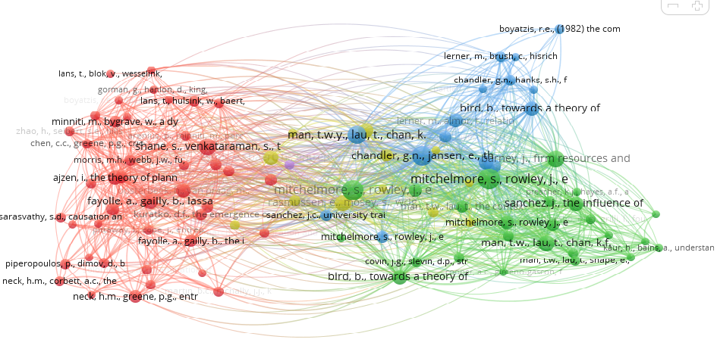
(Source: VOS viewer)

4. RISK - RESILIENCE
The ability of a company to undergo and develop in a dynamic and uncertain environment is referred to as resilience. The ability to get better to a steady state after being exposed to a disruptive situation is referred to as resilience. Disruptions are unavoidable, and there are a variety of internal and external variables that contribute to disruptions in companies. When it comes to resilience, the main concerns are organizational vulnerability, disruptions, and complexities, as these are the main challenges that affect the system's resilience. Vulnerability to a disruptive event can be defined as a mix of the likelihood of disruption and the severity of the disruption.

4.1 SUBJECT AREA:
It has been observed that a maximum number of studies are written in the subject area of Social Science with 139 studies. Furthermore, the subject area such as Medicine and Social Science also has 92 and 76 studies respectively. There are 53 studies in Environmental Science and 43 in Engineering.
Figure 8: Subject Area

(Source: Scopus Data Base)

4.2 JOURNALS WITH MAXIMUM PUBLICATIONS:
All the 342 studies in this study belong to their respective 136 journals. The below-mentioned table shows the top twenty journals, which published the maximum number of studies on Entrepreneurial Competencies. The highest number of studies were published in the Journal of Early Adolescence with 12 studies. Furthermore, sustainability Switzerland,Structure of Infrastructure Engineering, and International Journal of Disaster Risk Science were having 5studieseach respectively.
Table 3: Journals with maximum Citations
Journal’s Name | No of Studies
Journal Of Early Adolescence | 12
International Journal Of Disaster Risk Science | 5
Structure And Infrastructure Engineering | 5
Sustainability Switzerland | 5
International Journal Of Disaster Risk Reduction | 4
Children And Youth Services Review | 3
Development And Psychopathology | 3
International Journal Of Environmental Research And Public Health | 3
Journal Of Abnormal Child Psychology | 3
Annals Of The New York Academy Of Sciences | 2
Biological Psychiatry | 2
Brain And Behavior | 2
Child And Family Social Work | 2
Clinical Child And Family Psychology Review | 2
Cultural Diversity And Ethnic Minority Psychology | 2
Families In Society | 2
ISPRS International Journal Of Geo-Information | 2
International Journal Of Behavioral Development | 2
International Journal Of Production Research | 2
Journal Of Adolescent Health | 2
Journal Of Human Behavior In The Social Environment | 2
(Source: Scopus Data Base)
4.3 YEAR-WISE PUBLICATIONS:
This table shows the number of studies published from the year 2000 to 2021. It can be seen that the research on risk resilience has been growing over the years. The number of published studies was very minimal during the years 2000 to 2012. Then, there was an impressive increase from the year 2014 to 2021, the number of studies rose from 20 to 47. Further, it can be seen that a maximum number of studies have been published in the last five years. The number of studies exponentially increased from 31 to 47 from the year 2019 to 2021. The maximum studies were published in 2020 with 48 studies. This clearly shows that the interest of researchers has grown tremendously in this field, in recent times.

Figure 9: Year-wise Publications

(Source: Scopus Data Base)
4.4 MOST CITED STUDIES:
Focussing on the Scopus content, a list of the twenty most cited studies is presented in the table. The most cited paper 372 citation is “The role of early life stress as a predictor for alcohol and drug dependence” by Enoch, M.-A. The second most cited paper with 209 citations is “Beyond Risk, resilience, and Dysregulation: Phenotypic Plasticity and human development” by Belsky, J., Pluess, M.(Belsky& Pluess, 2013).
Furthermore, the third most cited paper with 202 citations is “Risk, resilience, and gene x environment interactions in rhesus monkeys” by Suomi, S.J.Then the fourth most cited paper with 179 citations are "Risk-resilient heuristics and genetic algorithms for security-assured grid job scheduling” by Song, S., Hwang, K., Kwok, Y.-K(Song et al., 2006).

Table 4: Most cited studies
Sr. No | Authors | Title | Year | Cited by
1 | Enoch, M.-A. | The role of early life stress as a predictor for alcohol and drug dependence | 2011 | 372
2 | Belsky, J., Pluess, M. | Beyond risk, resilience, and dysregulation: Phenotypic plasticity and human development | 2013 | 209
3 | Suomi, S.J. | Risk, resilience, and Gene x environment interactions in Rhesus monkeys | 2006 | 202
4 | Song, S., Hwang, K., Kwok, Y.-K. | Risk-resilient heuristics and genetic algorithms for security-assured grid job scheduling | 2006 | 179
5 | Frangopol, D.M., Soliman, M. | Life-cycle of structural systems: recent achievements and future directions | 2016 | 177
6 | Swain, J.E., Kim, P., Spicer, J., Ho, S.S., Dayton, C.J., Elmadih, A., Abel, K.M. | Approaching the biology of human parental attachment: Brain imaging, oxytocin and coordinated assessments of mothers and fathers | 2014 | 172
7 | Enoch, M.-A. | Genetic and environmental influences on the development of alcoholism: Resilience vs. risk | 2006 | 162
8 | Winn, M., Kirchgeorg, M., Griffiths, A., Linnenluecke, M.K., Gunther, E. | Impacts from climate change on organizations: A conceptual foundation | 2011 | 152
9 | Boyden, J., Mann, G. | Children's risk, resilience, and coping in extreme situations | 2005 | 149
10 | Frangopol, D.M., Dong, Y., Sabatino, S. | Bridge life-cycle performance and cost: analysis, prediction, optimization, and decision-making | 2017 | 137
11 | Coaffee, J. | Risk, resilience, and environmentally sustainable cities | 2008 | 121
12 | Russell, S.T. | Beyond risk: Resilience in the lives of sexual minority youth | 2005 | 111
13 | Petzold, M.B., Bendau, A., Plag, J., Pyrkosch, L., MascarellMaricic, L., Betzler, F., Rogoll, J., GroÃŸe, J., StrÃ¶hle, A. | Risk, resilience, psychological distress, and Anxiety at the Beginning of the COVID-19 pandemic in Germany | 2020 | 109
14 | Mizock, L., Lewis, T.K. | Trauma in transgender populations: Risk, resilience, and clinical care | 2008 | 106
15 | Gee, D.G., Casey, B.J. | The impact of developmental timing for stress and recovery | 2015 | 102
16 | Mikami, A.Y., Hinshaw, S.P. | Resilient adolescent adjustment among girls: Buffers of childhood peer rejection and attention-deficit/hyperactivity disorder | 2006 | 97
17 | Lonsdorf, T.B., Merz, C.J. | More than just noise: Inter-individual differences in fear acquisition, extinction and return of fear in humans - Biological, experiential, temperamental factors, and methodological pitfalls | 2017 | 96
18 | Gladstone, B.M., Boydell, K.M., McKeever, P. | Recasting research into children's experiences of parental mental illness: Beyond risk and resilience | 2006 | 94
19 | Enoch, M.-A., Hodgkinson, C.A., Yuan, Q., Shen, P.-H., Goldman, D., Roy, A. | The Influence of GABRA2, Childhood Trauma, and Their Interaction on Alcohol, Heroin, and Cocaine Dependence | 2010 | 93
20 | Game, E.T., McDonald-Madden, E., Puotinen, M.L., Possingham, H.P. | Should we protect the strong or the weak? Risk, resilience, and the selection of marine protected areas | 2008 | 89
(Source: Scopus Data Base)
4.5 MOST PROLIFIC AUTHORS:
It shows the top twenty most prolific authors. All 342 studies belong to the respective 159 authors. Upon analyzing the data, a list of the top twenty authors with maximum publications was prepared. Further, it was found that the most prolific author on risk resilience is Enoch, M.A.with six studies. The authors Shahar, G, Frangopol, D.M., and Dong, Y.each has published fivestudies. Furthermore, Botha, M. and Zainol, N.R. have published five studies.(Botha & Taljaard, 2019; Rizvi et al., 2012)(Enoch, 2006; Enoch et al., 2010; Frangopol et al., 2017; Frangopol & Soliman, 2016; Phong et al., 2020; Rizvi et al., 2012)(Ghorbani, S., Khodayari, A., & Mohammadi, 2014; Vinet & Zhedanov, 2011)
Figure 10: Most Prolific author

(Source: Scopus Data Base)
4.6 MOST PROLIFIC COUNTRIES:
All the studies belong to their respective authors from 55 plus different countries. The papershows the top twenty countries with a maximum number of studies on risk resilience. The United States tops the list with 41% of total studies. Secondly, the United Kingdom and Canada each have published 10% and 9% studies respectively. Furthermore, Australia and China have 7% and 5% respectively studies.

Figure 11: Most Prolific Countries

(Source: Scopus Data Base)
4.7 AFFLICTION OF AUTHORS
The figure shows the affiliation of authors. It has been observed that the maximum number of authors are afflicted Lehigh University with 9 in numbers and secondly from Pennsylvania State University, the University of Pennsylvania, and the University of Toronto have 7 each.
Figure 12: Affliction of authors

(Source: Scopus Data Base)

4.8 CO-AUTHORSHIP NETWORK MAPPING:
The figure shows the co-authorship network map generated by the VOSviewer software.The figure consists of big and small circles connected with several lines. Thoseauthors who have co-authored with more authors are assigned bigger circles andlabels. The figureshows the names of the top 29 authors, who have co-authored with themaximum number of other authors in the data set.
Figure 13: Co-authorship Network Mapping

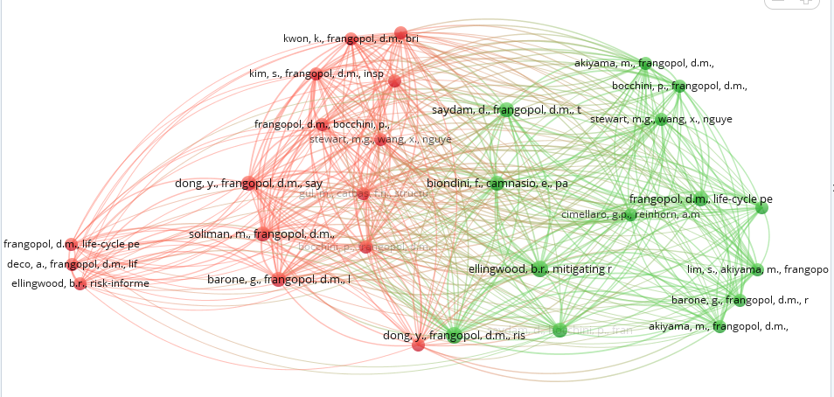
(Source: VOS viewer)

CONCLUSION:

A bibliometric analysis is carried out in this study to analyze the research on entrepreneurial competencies from the year 2000 to 2021. The maximum number of studies related to Entrepreneurial competencies is in education and training with 12 studies. A maximum paper on entrepreneurial competencies has been published in 2019. Maximum studies on risk resilience have been published in 2020 with 48 studies and the maximum was published in the US.

REFERENCES:

Al Mamun, A., & Fazal, S. A. (2018). Effect of entrepreneurial orientation on competency and micro-enterprise performance. Asia Pacific Journal of Innovation and Entrepreneurship, 12(3), 379–398. https://doi.org/10.1108/apjie-05-2018-0033
Belsky, J., & Pluess, M. (2013). Beyond risk, resilience, and dysregulation: Phenotypic plasticity and human development. Development and Psychopathology, 25(4 PART 2), 1243–1261. https://doi.org/10.1017/S095457941300059X
Bhardwaj, A. (2016). Assessing planning and administration competency of working managers: A preliminary study. International Journal of Advanced Research in Management and Social Sciences, 5(7), 46–56.https://www.indianjournals.com/ijor.aspx?target=ijor:ijarmss&volume=5&issue=7&article=006
Bloemer, J., Pluymaekers, M., & Odekerken, A. (2013). Trust and affective commitment as energizing forces for export performance. International Business Review, 22(2), 363–380. https://doi.org/10.1016/j.ibusrev.2012.05.002
Botha, M., Carruthers, T. J., & Venter, M. W. (2019). The relationship between entrepreneurial competencies and the recurring entrepreneurial intention and action of existing entrepreneurs. The Southern African Journal of Entrepreneurship and Small Business Management, 11(1), 1–15. https://doi.org/10.4102/sajesbm.v11i1.191
Botha, M., & Taljaard, A. (2019). The bidirectional relationship between entrepreneurial intention and entrepreneurial competencies for nascent and existing entrepreneurs. South African Journal of Economic and Management Sciences, 22(1), 1–12. https://doi.org/10.4102/sajems.v22i1.2230
Cortellazzo, L., Bonesso, S., & Gerli, F. (2020). Entrepreneurs' behavioral competencies for internationalization: Exploratory insights from the Italian context. International Journal of Entrepreneurial Behaviour and Research, 26(4), 723–747. https://doi.org/10.1108/IJEBR-12-2018-0806
Enoch, M. A. (2006). Genetic and environmental influences on the development of alcoholism: Resilience vs. risk. Annals of the New York Academy of Sciences, 1094, 193–201. https://doi.org/10.1196/annals.1376.019
Enoch, M. A. (2012). The influence of gene-environment interactions on the development of alcoholism and drug dependence. Current Psychiatry Reports, 14(2), 150–158. https://doi.org/10.1007/s11920-011-0252-9
Enoch, M. A., Hodgkinson, C. A., Yuan, Q., Shen, P. H., Goldman, D., & Roy, A. (2010). The Influence of GABRA2, Childhood Trauma, and Their Interaction on Alcohol, Heroin, and Cocaine Dependence. Biological Psychiatry, 67(1), 20–27. https://doi.org/10.1016/j.biopsych.2009.08.019
Escamilla-Fajardo, P., Parra-Camacho, D., & Núñez-Pomar, J. M. (2021). Entrepreneurship and resilience in Spanish sports clubs: A cluster analysis. International Journal of Environmental Research and Public Health, 18(10). https://doi.org/10.3390/ijerph18105142
Frangopol, D. M., Dong, Y., & Sabatino, S. (2017). Bridge life-cycle performance and cost: analysis, prediction, optimization, and decision-making. Structure and Infrastructure Engineering, 13(10), 1239–1257. https://doi.org/10.1080/15732479.2016.1267772
Frangopol, D. M., & Soliman, M. (2016). Life-cycle of structural systems: recent achievements and future directions. Structure and Infrastructure Engineering, 12(1), 1–20. https://doi.org/10.1080/15732479.2014.999794
Gee, D. G., & Casey, B. J. (2015). The impact of developmental timing for stress and recovery. Neurobiology of Stress, 1, 184–194. https://doi.org/10.1016/j.ynstr.2015.02.001
Ghorbani, S., Khodayari, A., & Mohammadi, S. (2014). The relationship between managerial skills with organizational climate in managers and staff in the national Olympic committee of Iran. European Journal of Experimental Biology, 4(1), 321–326.https://www.primescholars.com/articles/the-relationship-between-managerial-skills-with-organizational-climate-in-managers-and-staff-in-national-olympic-committee-of-iran.pdf
Gulati, B., & Weiler, S. (2021). Risk, recessions, and resilience: towards sustainable local labor markets through employment portfolio analysis. Sustainability (Switzerland), 13(14), 1–20. https://doi.org/10.3390/su13147926
Krabel, S. (2018). Are entrepreneurs made on campus? The impact of entrepreneurial universities and graduates’ human capital on graduates’ occupational choice. Journal of International Entrepreneurship, 16(4), 456–485. https://doi.org/10.1007/s10843-017-0218-z
Lonsdorf, T. B., & Merz, C. J. (2017). More than just noise: Inter-individual differences in fear acquisition, extinction and return of fear in humans - Biological, experiential, temperamental factors, and methodological pitfalls. Neuroscience and Biobehavioral Reviews, 80, 703–728. https://doi.org/10.1016/j.neubiorev.2017.07.007
Man, T. W. Y., Lau, T., & Chan, K. F. (2002). The competitiveness of small and medium enterprises: A conceptualization with focus on entrepreneurial competencies. Journal of Business Venturing, 17(2), 123–142. https://doi.org/10.1016/S0883-9026(00)00058-6
Mikami, A. Y., & Hinshaw, S. P. (2006). Resilient adolescent adjustment among girls: Buffers of childhood peer rejection and attention-deficit/hyperactivity disorder. Journal of Abnormal Child Psychology, 34(6), 825–839. https://doi.org/10.1007/s10802-006-9062-7
Mitchelmore, S., & Rowley, J. (2010). Entrepreneurial competencies: A literature review and development agenda. International Journal of Entrepreneurial Behaviour & Research, 16(2), 92–111. https://doi.org/10.1108/13552551011026995
Morris, M. H., Webb, J. W., Fu, J., & Singhal, S. (2013). A competency-based perspective on entrepreneurship education: Conceptual and empirical insights. Journal of Small Business Management, 51(3), 352–369. https://doi.org/10.1111/jsbm.12023
Petzold, M. B., Bendau, A., Plag, J., Pyrkosch, L., Mascarell Maricic, L., Betzler, F., Rogoll, J., Große, J., & Ströhle, A. (2020). Risk, resilience, psychological distress, and anxiety at the beginning of the COVID-19 pandemic in Germany. Brain and Behavior, 10(9), 1–10. https://doi.org/10.1002/brb3.1745
Phong, N. D., Thao, N. T. P., & Nguyen, N. P. (2020). Entrepreneurial intent of business students: Empirical evidence from a transitional economy. Cogent Business and Management, 7(1). https://doi.org/10.1080/23311975.2020.1747962
Rambe, P., Africa, S., Makhalemele, N., & Africa, S. (2015). Emerging Technology Firms And Business Internet Cafés Performance In South Africa. International Business & Economics Research Journal, 14(4), 678–692, July/August,
Rasmussen, E., Mosey, S., & Wright, M. (2011). The Evolution of Entrepreneurial Competencies: A Longitudinal Study of University Spin-Off Venture Emergence. Journal of Management Studies, 48(6), 1314–1345. https://doi.org/10.1111/j.1467-6486.2010.00995.x
Shah, I. A., Amjed, S., & Jaboob, S. (2020). The moderating role of entrepreneurship education in shaping entrepreneurial intentions. Journal of Economic Structures, 9(1). https://doi.org/10.1186/s40008-020-00195-4
Song, S., Hwang, K., & Kwok, Y. K. (2006). Risk-resilient heuristics and genetic algorithms for security-assured grid job scheduling. IEEE Transactions on Computers, 55(6), 703–719. https://doi.org/10.1109/TC.2006.89
Vinet, L., & Zhedanov, A. (2011). A “missing” family of classical orthogonal polynomials. Journal of Physics A: Mathematical and Theoretical, 44(8), 3–16. https://doi.org/10.1088/1751-8113/44/8/085201
Wasowska, A. (2019). Social-cognitive antecedents of new venture internationalization: The role of entrepreneur intention, self-efficacy, and positive orientation. Baltic Journal of Management, 14(3), 462–479. https://doi.org/10.1108/BJM-09-2018-0325
Wickramasinghe, V., & de Zoyza, N. (2009). A comparative analysis of managerial competency needs across areas of functional specialization. Journal of Management Development, 28(4), 344–360. https://doi.org/10.1108/02621710910947371
Winn, M., Kirchgeorg, M., Griffiths, A., Linnenluecke, M. K., & Gunther, E. (2011). Impacts from climate change on organizations: A conceptual foundation. Business Strategy and the Environment, 20(3), 157–173. https://doi.org/10.1002/bse.679

