An Evaluation of Thin Layer Chromatography as a Biotechnology Tool for the Isolation of Bioactive Compounds from Medicinal Plants: A Brief Review
Ria Bhar¹*, Amit Gamit²

¹Department of Biotechnology, School of Life Science and Biotechnology, Adamas University, Kolkata, India.
²ICAR-IVRI, ERS, Kolkata-700037

*Corresponding Author: Ria Bhar
Address for Correspondence:
E-mail addresses: bhar.riya89@gmail.com (R.Bhar)

Abstract:
A review of the fundamental ideas and the significance of Thin Layer Chromatography (TLC) in research in general and in phytochemistry in particular were attempted in this paper. For many years, general chemistry laboratories have frequently employed thin layer chromatography to separate chemical and biological components because it is straightforward, affordable, and user-friendly. The analyte spots on the TLC plate are typically observed using chemical and optical techniques. It has numerous uses in locating contaminants in a chemical. The evaluation of TLC and its application for qualitative and quantitative determination of bioactive components from therapeutic plants is highlighted by St.
Keywords: Thin Layer Chromatography, TLC Principle, TLC Benefits, and TLC Uses.
Introduction:
Non-volatile mixtures can be separated using a process called thin layer chromatography. The experiment is carried out on a piece of glass, plastic, or aluminum foil that has been lightly covered with an adsorbent substance. Typically, silica gel, cellulose, or aluminum oxides are utilized as the substance.
Once the separation is complete, each component is seen as vertically separated spots. The retention factor (Rf) for each position is denoted as follows:
Rf = sample travel distance / solvent travel distance
The solvent system, quantity of substance spotted, adsorbent, and temperature all affect the retardation factor. One of the quickest, cheapest, simplest, and most straightforward chromatographic methods is TLC.
One of the most helpful techniques for monitoring the development of organic chemical reactions and determining the purity of organic substances in phytochemistry and biotechnology is thin layer chromatography (TLC). TLC, like all chromatographic methods, separates complex mixtures of organic compounds by utilizing the analyte's changing affinities for the mobile and stationary phases. To make a TLC plate, a thin coating of a solid adsorbent is placed to a sheet of glass, metal, or plastic. A small amount of the combination to be tested is located near the bottom of this plate. The TLC plate is then immersed in a shallow pool of solvent in a developing chamber, with only the plate's very bottom submerged. TLC plates are sheets of glass, metal, or plastic coated with a thin coating of a solid adsorbent (often silica or alumina). A small amount of the combination to be tested is located near the bottom of this plate. The TLC plate is then placed in a shallow pool of solvent in a developing chamber, so that only the very bottom of the plate is submerged in the liquid. This liquid, also known as the eluent, softly ascents the TLC plate via capillary action and is referred to as the mobile phase. Change the polarity of the solvent to determine the best solvent or solvent combination (a "solvent system") for developing a TLC plate or chromatography column loaded with an unknown mixture. All of the mixture's components will move faster as the polarity of the solvent system increases (and vice versa when the polarity decreases). The best solvent system is the one that delivers the best separation. TLC elution patterns are commonly translated from column chromatography elution patterns. TLC is widely used to select the best solvent system for column chromatography because it is a much faster method than column chromatography. For instance, selecting a solvent solution for a flash the ideal chromatographic process separates the desired component from its nearest neighbour by at least 0.20 differences in TLC Rf values and moves the desired component of the mixture to a TLC Rf of 0.25 to 0.35. TLC is used to evaluate a mixture in order to select the best solvent(s) for a flash chromatography procedure. Thin layer chromatography can be used to track the progress of a reaction, identify the chemicals present in a product, and determine the purity of a substance. The struggle between the solute and the mobile phase for binding sites on the stationary phase is the basis for compound separation. For instance, silica gel used as the stationary phase in a normal phase reaction can be regarded as polar. When two molecules with differing polarity engage with silica more strongly, the more polar molecule is better able to remove the mobile phase from the binding sites. As a result, the less polar compound rises to the top of the plate. If the mobile phase is changed to a more polar solvent or mixture of solvents, all compounds on the TLC plate will climb higher up the plate because it is better able to dislodge solutes from the silica binding sites. Using a combination of ethyl acetate and heptane as the mobile phase, this practically means that adding more ethyl acetate results in higher. In most cases, switching the polarity of the mobile phase won't cause the compounds to run in reverse order on the TLC plate (1, 2, 4, 6, 7 ).
Principle of TLC:
The separation principle underpins thin-layer chromatography (TLC), as it does all other chromatographic procedures. The separation is driven by the relative affinity of chemicals for the two phases. The chemicals in the mobile phase pass over the surface of the stationary phase. The compounds with a larger attraction to the stationary phase travel slowly, whereas the other compounds move swiftly. The mixture is thus successfully separated. After the separation technique is completed, the constituent components of the mixture appear as spots on the plates at the right levels. To assess their nature and character, appropriate detection techniques are used (16).
Calculation of the Rf Value:
An amount of a compound's behavior in TLC is what distinguishes it. It is a decimal fraction and is represented as R. The R is calculated by dividing the displacement of the chemical from its starting location by the displacement of the solvent from its beginning position (the solvent front). The nature of the adsorbent: various adsorbents give various R values for the same solvent. Only an adsorbent with uniform particle size and binder may be replicated. Plates should be stored in desiccators over silica gel before use, and samples should be applied quickly to avoid the plate accumulating air water vapor. Due to the difficulties inherent in the activation activities, it is more preferable to use plates that have been stored at room temperature rather than activating them. Measurements are typically taken from the plate to aid in the identification of the compounds present. These figures contain the solvent's travel distance as well as the travel distances of the individual locations. When the solvent front approaches the top of the plate, the plate is removed from the beaker and the position of the solvent identification of a material is identified. If the identity of a compound is suspected but not yet established, an authentic sample of the compound, or standard, is spotted and run on a TLC plate side by side (or on top of each other) with the chemical in question. If two substances have the same Rf value, they are most likely (but not always) the same chemical. If their Rf values differ, they are obviously distinct substances. It is important to note that this identification check must be carried out on a single plate because it is challenging to replicate all the variables that affect Rf precisely from trial to experiment (5, 7, 8, 14, 15).

View in chromatography: Chromatogram:
As the solvent slowly moves up the plate, the various components of the dye mixture ravel at different rates, separating the mixture into different coloured areas.
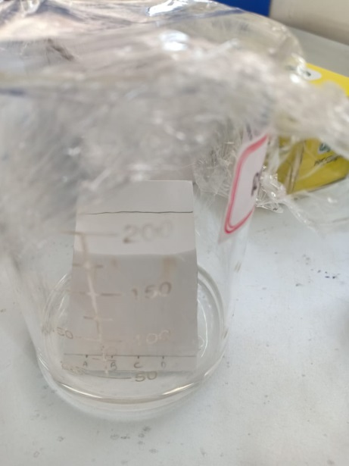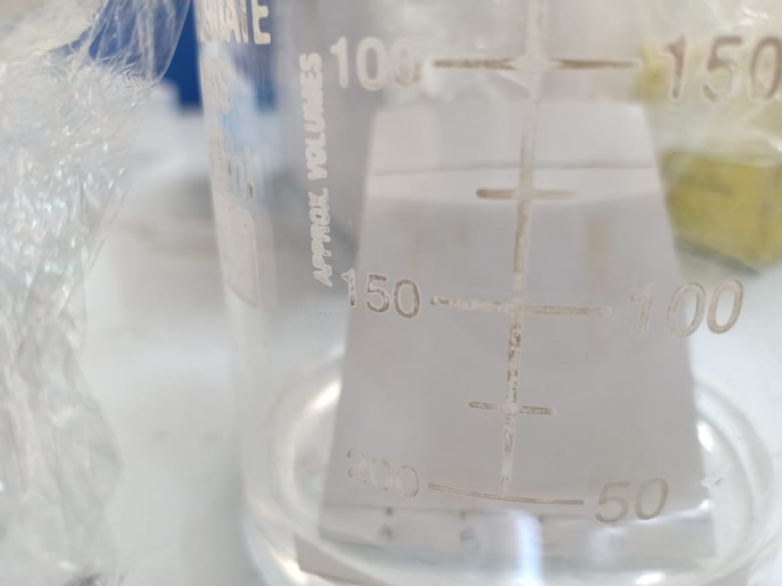
Figure 1: Chromatogram Figure 2: Developing Tank
is marked with another line before it has a chance to evaporate. These measurements are taken as:
Figure 3: Spots as compounds

The Rf value for each dye is then worked out using the formula:
Rf = sample travel distance / solvent travel distance
For example, if the red component travelled 1.7 cm from the base line while the solvent had travelled 5.0 cm, then the Rf value for the red dye is:
If we could repeat this experiment under identical conditions, the Rf values for each colour would remain constant. The Rf value for red dye, for example, would always be 0.34. That is no longer true if anything changes (the temperature, the specific makeup of the solvent, and so on). We must keep this in mind if we want to utilize this technique to identify a certain dye. Further down the page, we'll look at how thin layer chromatography can be used for analysis.
The Rf for a compound is a constant from one experiment to the next only if the chromatography conditions below are also constant:
• Solvent system
• Adsorbent
• Thickness of the adsorbent
• Amount of material spotted
Because it is difficult to keep these variables consistent from experiment to experiment, relative Rf values are commonly used. The term "relative Rf" refers to values reported in relation to a standard or to comparisons of compounds performed concurrently on the same plate and their respective Rf values. Compound Rf increases the distance a compound travels on the TLC plate. When two different compounds are compared and run under identical chromatographic conditions, the chemical with the higher Rf is less polar because it interacts less strongly with the polar adsorbent on the TLC plate. In contrast, if you know the structures of the compounds in the combination, you may predict that a compound with low polarity will have a greater Rf value than a polar compound run on the same plate. The Rf can provide additional information about the identify of a chemical. If the identity of a compound is suspected but not yet established, an authentic sample of the compound, or standard, is spotted and run on a TLC plate side by side (or on top of each other) with the chemical in question. If two substances have the same Rf value, they are most likely (but not always) the same chemical. If their Rf values differ, they are obviously distinct substances. It should be noted that this identification check must be carried out on a single plate because it is challenging to precisely duplicate all the variables that affect Rf from trial to experiment (5, 7, 8, 14, 15).
Preparation of Plate:
To improve reproducibility, commercially available TLC plates frequently include preset particle size ranges. They are created by combining an inert binder like calcium sulphate (gypsum), a little amount of water, and an adsorbent like silica gel. This slurry is applied to a nonreactive carrier sheet, which is commonly constructed of plastic, glass, or thick aluminium foil. The finished plate is dried and activated in an oven for 30 minutes at 110 °C. For analytical purposes, the adsorbent layer is typically between 0.1 and 0.25 mm thick, while for preparative TLC, it is between 0.5 and 2.0 mm thick(6,10,11).
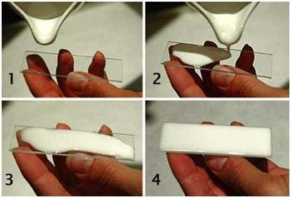
Figure 4: Steps of Preparative TLC (S.kumar, 2012).
Spotting the plate:
Capillary forces because the fluid to rise to the surface when the spotter's thin end is submerged in a diluted solution. Touch the plate briefly at the starting line. Once the solvent has evaporated, spot in the same location. In this approach, you will achieve a targeted and compact spot. Avoid spotting too much material because it will lower the separation's (or "tailing's") quality significantly. The dots must be adequately separated from one another and from the boundaries. Mark the compound or mixture on the plate, along with the raw components and any potential intermediaries, if at all possible (1, 12, 13).
Location of the places spots:
There are several ways to locate the positions of different solutes that have been separated using TLC. When viewed against a stationary phase, colored compounds are immediately apparent, but colorless substances cannot be seen without the aid of a spraying agent that creates colored regions in the area they occupy. The following can be utilized to spray the invisible places in TLC specifically:
1. Corrosive substances, which are entirely inorganic in nature, can also be sprayed on the undetectable patches.
2. Potassium dichromate solution in concentrated sulfuric acid. Most organic chemicals, especially those used for sugars, decrease potassium dichromate (yellow) to chromic sulfate (green) throughout the process.
3. Warming fuming sulfuric acid causes sulfur trioxide to be formed, which chars organic compounds and turns them into dark blotches.
4. Potassium permanganate solut ion.
5. Iodine vapors.
Saturated hydrogen sulfide solution, 0.2N aqueous ammonium sulfide, 0.1% alcoholic quercetin, 0.2% methanolic 1-(2- pyridylazo)- 2- napthol, 1% methanolic oxine, and 0.5% aqueous sodium rhodizonate are further popular reagents. If the TLC plate's adsorbent contains a fluorescing substance, the solutes can be seen under ultraviolet light (1, 14, 18).
Development solvents:
The type of material and the adsorbent utilized on the plate define the appropriate solvent to use. A development solvent should be chosen in such a way that it does not chemically react with the mixture under investigation's components. Avoid using solvents that are either detrimental to the environment (such as dichloromethane) or carcinogenic (such as benzene). There are two types of solvent systems: polar and non-polar. Non-polar solvents are often used because highly polar solvents cause any component of the solvent combination to adsorb. Among the commonly used developing solvents are petroleum ether, carbon tetrachloride, pyridine, glycol, glycerol, diethyl ether, formamide, methanol, ethanol, acetone, and n-propanol (1, 4, 10).
Mobile Phase:
The mobile phase in silica gel chromatography is an organic liquid or a combination of organic solvents. The analyte travels through the particles of the stationary phase as the mobile phase moves across the surface of the silica gel. If the analyte molecules are not attached to the surface of the silica gel, they can move freely with the solvent. As a result, an analyte's retention factor is defined as the percentage of time spent attached to the silica gel's surface compared to the percentage of time spent in solution. The capacity of an analyte to bind to the surface of silica gel in the presence of a specific solvent or mixture of solvents is the result of two competing interactions. For starters, the analyte and polar groups in the solvent may fight for binding sites on the silica gel's surface. If a highly polar solvent is utilized, it will strongly interact with the surface of the silica gel, leaving few open sites on the stationary phase to bind the analyte. As a result, the analyte will pass through the stationary phase quickly. Similarly, polar groups in the solvent might strongly interact with the polar functionality of the analyte, preventing it from interacting with the surface of the silica gel. As a result of this process, the analyte exits the stationary phase fast. The polarity of a chromatography solvent can be estimated by calculating its dielectric constant and dipole moment. The solvent is more polar if these two values are greater. The solvent's ability to form hydrogen bonds must also be considered. Methanol, for example, being an excellent hydrogen bond donor, will considerably limit the ability of all but the most polar analytes to adhere to the surface of the silica gel (1,8, 12,14).
Developing a Plate:
A TLC plate can be made in a beaker or tightly covered jar. Fill the container halfway with the solvent (mobile phase). A small spot of solution containing the sample is placed to a plate one centimeter from the bottom. After dipping the plate in a suitable solvent, such as hexane or ethyl acetate, it is placed in a sealed container. The solvent climbs up the plate due to capillary action and encounters the sample mixture, which the solvent dissolves and transports up the plate.
Various compounds in the sample mixture move across space at varied rates due to differences in their attraction to the stationary phase and solubility in the solvent. The separation of components (as defined by the Rf value) can be altered by changing the solvent or possibly utilizing a combination. To prevent the spots from dissolving, the solvent level must be lower than the TLC's beginning line. The lower edge of the plate is then immersed in a solvent. The components of the samples move at different speeds as the solvent (eluent) goes up the matrix by capillary due to their varied degrees of interaction with the matrix (stationary phase) and solubility in the developing solvent. Non-polar solvents will drive non-polar chemicals to the top of the plate because they dissolve quickly and do not interact with the polar stationary phase. Allow the solvent to rise up the plate to about 1 cm from the top. Remove the plate and immediately put a notation on the solvent front. Allow no solvent to spill over the plate's edge. Allow the solvent to completely evaporate(1, 8).
Visualization:
When the solvent front has migrated to within 1 cm of the top end of the adsorbent after 15 to 45 minutes, the plate should be taken from the developing chamber, the location of the solvent front documented, and the solvent let to evaporate.
It is feasible to see the individual pieces of the sample clearly if they are coloured. If not, they can be seen on occasion by shining ultraviolet light on the plate or by leaving the plate in a closed container with an iodine-vapor-rich atmosphere for a brief length of time. It is sometimes feasible to see the spots by spraying the plate with a reagent that will react with one or more of the sample's components (1, 10).
Analysis:
The components, which are detectable as single dots, are identified by comparing the distances travelled by the components to those of the recognized reference materials. Determine the distance between the starting line and the solvent front. Then compute the distance between the center of the spot and the beginning line. Subtract the distance travelled by the solvent from the distance travelled by each site. The resulting ratio is known as the Rf-value. It is possible for the compounds being separated to be colorless, thus there are several ways to see the dots. To enable the sight of spots under a blacklight (UV254), the adsorbent is commonly coated with a small amount of a fluorescent material, typically manganese-activated zinc silicate. As a result, the adsorbent layer naturally glows a light green colour, but analyte spots reduce this fluorescence. Iodine vapours are a nonspecific colour reagent, however there are specialist colour reagents that can be dipped into or sprayed directly onto the TLC plate. The Rf value, or retention factor, of each visible spot is calculated by multiplying the distance travelled by the product by the sum of the distances t ravelled by the solvent (the solvent front). These values are not physical constants and vary depending on the type of TLC plate and solvent used (1, 5, 8).
Identifying chemicals with thin-layer chromatography:
Assume you wanted to determine the specific amino acids present in an amino acid mixture. For the purpose of simplicity, we'll assume you're aware that the mixture can only contain five of the most prevalent amino acids. A small drop of the mixture is put on the bottom line of the thin layer plate, and small spots of the recognized amino acids are placed next to it. The plate is then immersed in an appropriate solvent and allowed to develop as usual. In the diagram, the known amino acids are labeled 1 through 5, and the mixture is represented by the letter M. When the solvent front has nearly reached the top of the plate, it is illustrated in the left-hand diagram. The spots are still unnoticeable. The second image represents how it might look after being sprayed with ninhydrin. There is no need to quantify the Rf values because it is straightforward to compare the spots in the mixture with those of known amino acids based on their positions and colours. The amino acids 1, 4, and 5 are represented in this image. What if the combination contains amino acids that were not in the baseline? There would be places in the combination that did not match the known amino acid sites. To draw a comparison, you would need to repeat the test with different amino acids (1, 12, 16).
The compound's and the adsorbent's interactions:
The strength of an organic compound's ion-dipole, dipole-dipole, hydrogen bonding, dipole induced dipole, and van der Waals forces dictates how strongly it binds to an adsorbent. The dipole-dipole type of interaction between the adsorbent and the components to be separated predominates in silica gel. Weakly polar molecules are held less tightly, whereas highly polar molecules interact strongly with the polar SiOH groups on the surface of these adsorbents and tend to stick or adsorb onto the adsorbent's small particles. In general, weakly polar molecules pass through the adsorbent faster than polar species. The compounds essentially follow the elution order indicated above (1, 10).
Application:
Thin layer chromatography has been a useful tool in numerous applications of pharmaceutical importance (1).
Amino Acid:
Because amino acids are colourless, TLC is more difficult than TLC of inks. As a result, once the plate has fully formed and dried, the dots are invisible to the naked sight. To see the spots, use either the black-light visualization approach or the ninhydrin visualization method. Proteins, peptides, and amino acids, for example, 8: Silica gel plates have been successfully utilized to separate and isolate a combination of 34 amino acids, proteins, and peptides from urine. These substances all tested positive for ninhydrin. Initially, phenol-water was used, followed by chloroform-methanol-20% ammonium hydroxide.
Pharmaceuticals and drugs:
TLC is used in the creation of synthetic medicines for process control, as well as the identification, purity testing, and concentration determination of active ingredients, auxiliary compounds, and preservatives in drugs and drug formulations. A number of pharmacopoeias have authorized the TLC technique for detecting contaminants in medications and chemicals such as antibiotics. Penicillins were separated on silica gel "G" using two solvents, acetone-methanol (1:1) and iso-propanol-methanol (3:7). To use the iodine-azide reaction as the detecting agent, the dried plates were sprayed with a 0.1% iodine solution containing 3.5% sodium azide.
Separation of multicomponent pharmaceutical formulations:
Additionally, it is utilized to separate pharmaceutical compositions with many components.

Qualitative analysis of alkaloids:
For the qualitative analysis of alkaloids, it is used in the control phase of both pharmaceutical formulations and plant-based therapies. TLC has been used in toxicology to isolate and identify alkaloids, with the 30-60 minute runs providing a substantial advantage over the 12-24 hour time frame required for paper chromatography. Purine alkaloids were identified via TLC on silicic acid, silica gel, and aluminium oxide. The dots can be seen by spraying a 25% HCL- 96% ethanol solution followed by an alcoholic iodine-potassium iodine solution.
Clinical chemistry and Biochemistry:
For identifying active compounds and their metabolites in biological matrices, as well as for identifying metabolic abnormalities in children including phenylketonuria, cystinuria, and maple syrup disease. It is a helpful instrument for the analysis of numerous urine constituents, including steroids, amino acids, porphyrins, and bile acids, which are formed from lipids. In order to detect and resolve small metabolites fully free of other components, urinary analysis by TLC works best when combined with other chromatographic procedures.
Cosmetology:
When identifying dye raw materials, finished goods, preservatives, surfactants, fatty acids, and scent ingredients.
Food Analysis:
To determine the presence of pesticides and fungicides in drinking water, the presence of residues in fruits, vegetables, salads, and meat, the presence of vitamins in soft drinks, the presence of German-banned additives (such as sandalwood extract in fish and meat products), and the adherence to limit values (such as polycyclic compounds in drinking water and aflatoxins in milk and milk products).
Analysis of Heavy Petroleum Product:
Even though petroleum products are among the most complicated materials, thin-layer chromatography (TLC), which is frequently utilized in the analysis of complex mixtures, is rarely used in the study of these items. There is no such information in the literature, particularly with regard to heavy petroleum products. At the same time, this approach has advantages over column chromatography that are well known, including simplicity, affordability, and efficiency. TLC technique employed (in the preparative variation) for a quick analysis of the group composition of heavy petroleum products (asphalts, pitches, and remains), as well as in association with spectroscopic investigations of the chemical composition of the fractions obtained.
Separation of aromatic amines:
On silica gel layers, aromatic amines have been separated by thin-layer chromatography using cat ionic and non-ionic surfactant-mediated systems as mobile phases. The impact of surfactant concentration on amine mobility both below and beyond its critical micellar concentration was studied. Additionally, the impact of organic and inorganic additions in micellar solutions, such as alcohols, urea, NaCl, and NaBr, on the mobility and separation effectiveness of amines is evaluated.
Applications related to Organic Chemistry:
- A lot of other separation processes have utilized it to check them. TLC has also been utilized successfully in a number of purification procedures, including the analysis of distillation fractions and the monitoring of the molecular distillation process for purification.
- TLC has been used as an analytical approach in organic chemistry due to its fast separation speed and applicability to a wide range of chemical compounds. Its primary application is the separation and isolation of individual components of mixtures, but it has also been used in organic chemistry for purification processes, determining sample purity, identifying organic compounds, researching various organic reactions, and characterizing and isolating a wide range of compounds, including acids, alcohols, glycols, amides, alkaloids, vitamins, amino acids, antibiotics, food ingredients, and food products. TLC analysis of the reaction mixture determines whether or not the reaction is finished. This method is also used to test other separation and purification procedures, including as distillation and molecular distillation.
Because high sensitivity makes it possible to detect contaminants in purportedly pure samples, TLC's great sensitivity is utilized to ensure sample purity (3, 17).

Conclusion:

Thin layer chromatography is a straightforward, affordable, and user-friendly phytochemical and biochemical technology with a wide range of uses, including the creation of novel medications and a variety of formulations from medicinal plants. Additional thorough documentation is required for the sustained development of research and teaching.

Reference:

- A. Archana, Bele and Anubha Khale, An overview on thin layer chromatography, IJPSR, 2(2), 2011, 256-267.

- A. M ohammad, S.A. Bhawani and S. Sharma, Analysis of herbal products by thin-layer chromatography: a review, International Journal of Pharma and Biosciences, 1(2), 2010, 1-50.

- A.H. Beckett, J.B.St enlake, Practical pharmaceutical chemistry, thin layer chromatography, CBS publishers, 4th edition, 2005, 115-128.

4. A.V. Kasture, K.R. M ahadik, S.G.W adodkar, H.N. More, A textbook of pharmaceutical analysis, instrumental methods, Nirali Prakashan, 9th edition, 2, 2005, 18-30.

- B. Fried, J. Sharma, Thin-layer chromatography, fourth edition, revised and expanded, M arcel Dekker inc., New York - Basel, 1999, 499.

- B.K.Sharma, Instrumental methods of chemical analysis, Goel publishing house, Meerut, 5th edition, 2007, 241-264.

- D.A.Skoog, F.J.Holler and T.A. Nieman, “ Principles of instrumental analysis, Saunders college publishing, 5th edition, 2006: 761-766.

- E. Dreassi, G. Ceramelli, P. Corti, Thin-layer chromatography in pharmaceutical analysis. In practical thin-layer chromatography—a multidisciplinary approach. Fried b., Sharma J. (eds.) Crc press, Boca Raton, fl, 1996, p. 231.

- G. Szepesi, M . Gazdag , St eroids. In handbook of thin layer chromatography, Sharma G, Fried B (eds.) M arcel Dekker, New York, 1991, 907.

- G. Szepesi, M . Gazdag , St eroids. In handbook of thin layer chromatography, Sharma G, Fried B (eds.) M arcel Dekker, New York, 1996, 971.

- G.Just us, Kirchner, Thin-layer chromatographic quantitative analysis, Journal of Chromatography a-1, 82(1), 1973, 101- 115.

- G.R. Chatwal, S.K Anand, Instrumental methods of chemical analysis, Himalaya publishing house, 5th edition, 2008, 2.599-2.616.

- H.T. Quach, R.L. St eeper, G.W.Griffin, Separat ion of plant pigments by thin layer chromatography. Journal of Chemical Education. 81, 2004, 385-7.

- M Ali and V. Agrawal, Thin-layer chromatography of aromatic amines, Separation Science and Technology, 37, 2002, 363 - 377.

- R.M. Scot t , Clinical analysis by thin-layer chromatography techniques. Ann Arbor science publishers, Ann Arbor, mi. 1969.

- S Singhal, N singhal, S Agarwal, Pharmaceutical analysis-II, Thin Layer Chromat ography, Pragati Prakashan, first edition, 2009, 98-111.

17. Vidya Sagar, Instrumental methods of drug analysis, Pharma M ed Press, first edition 2009,263.

