Challenges of Holding Simultaneous Elections in India - Some Observations
Kongkham Biplob Singha
Assistant Professor, Oriental College (Autonomous), Imphal, Manipur
Email: kbsingha@gmail.com

Abstract:
Democratic systems ensure the constitutional transfer of power through the vital process of conducting smooth, timely and clean elections. For many years, the idea of holding simultaneous elections in both federal and unitary democratic systems has been a source of both academic and political debate. Proponents of this notion say that it will save time, money, and resources, while opponents argue that it will erode democratic and federalist values. However, this essay delves into the complicated issues of holding simultaneous elections in a country as varied as India. It investigates the implementation limits and complexity, constitutional consequences, logistical issues, uneven political cycles, and the potential impact on regional parties and federalism. The paper concludes by proposing potential solutions and an analysis of the advantages and disadvantages of such a system. The study incorporates existing literature analysis, official reports, and expert comments to create a comprehensive picture.
Keywords: Simultaneous Elections, India, Democratic System, Challenges, Electoral Process
Introduction:
Simultaneous elections, often known as 'One Nation, One Election,' are a democratic electoral reform that intends to synchronize elections at all levels of government (national, state, and municipal) within a democratic system. Proponents say that this policy can save money, prevent lengthy election campaigns, and promote better government. However, due to its enormous population, federal political framework, and widely varying regional dynamics, India confronts particular obstacles in executing simultaneous elections. In post-independence India, general elections were initially held simultaneously with elections to state legislative assemblies (Barthwal, 2023). While the practice continued until 1967, the system of simultaneous elections was interrupted when several state assemblies were dissolved early in 1968 and 1969. Several decades later, and relatively in pursuance of its election manifesto, the Narendra Modi-led Union government constituted a high-level committee on 2nd September, 2023. This committee, chaired by former President Ram Nath Kovind was formed to explore the possibility of conducting simultaneous elections to the Lok Sabha, the Legislative Assemblies, Municipalities, and Panchayats. This article aims to explore and analyze the challenges associated with holding simultaneous elections in India in the contemporary electoral scenario.
Rationale
In a huge federal polity like India with an electorate population next to none, conducting elections is a mammoth task for concerned constitutional authorities. Simultaneous elections, wherein state and national elections are held together, have long been deliberated as a potential reform in India to streamline the electoral process. Proponents argue that it would enhance governance, reduce campaign expenditures, and ensure political stability. The proposed benefits are manifold which may include the following:
- Election synchronization reduces the financial burden on political parties, governments, and the electoral system, resulting in significant cost savings. For instance, according to the Election Commission of India, expenditures for the 2019 Lok Sabha elections cost nearly Rupees 4500 crores as against Rupees 10 crores approximately in 1952 Elections.
- When elections are held concurrently, political parties and candidates can more efficiently utilize their resources, including time and people, optimizing their campaigns.
- By lowering the frequency of elections, simultaneous elections can lead to more stable and continuous governance by allowing for better long-term planning and policy implementation.
- Politicians and governments can devote more time to governing and policymaking rather than being distracted with election campaigns, potentially leading to better governance outcomes.
- Voters may suffer less tiredness with fewer election cycles, resulting to better voter turnout and more informed engagement in the democratic process.
Frame of Reference
Almost all modern nation-states have embraced different forms of democratic constitutional institutions and processes. Such political structures may be solely federal or unitary, parliamentary or presidential, or even constitutional monarchies and junta-dominated polities. Some systems may even exhibit a blend of these constitutional structures in varying degrees that are specific to their political culture. Even highly authoritarian regimes are arguably built upon, and rely on some constitutional mechanisms to claim their political and functional legitimacy. While the level of genuine democratization and political development across different states may differ, each democratic system has a specific electoral system in place. The nature and character of electoral or voting systems depend upon a multitude of factors such as; political history, demographic profile, size of the territory, and the prevailing party system. The most prominent of these (which includes different variations and subtypes) are majoritarian system, proportional system, and the mixed system.
Different countries use these voting systems to elect representatives to their legislatures at various levels – federal, provincial or local. As such, very few countries such as Sweden, Belgium and South Africa are currently known to conduct simultaneous elections to different legislative bodies (Das, 2023). Indonesia, the world’s third largest democracy and the fourth most populous country will conduct a ‘one-day election’ in February 2024 to elect its President, Vice-President and all other lawmakers at both the national, regional and local levels (Krismantari, 2023). The same is now being seriously considered in India as well. The vast majority of nations simply find it impracticable and unsuitable to conduct single day or simultaneous elections. Many people are concerned about the notion for simultaneous elections. The most significant of these is the impact on federalism. Then there's the issue of feasibility: what happens if, say, a state government falls? Then there are the legal considerations about the constitutional adjustments that would be required, and of the possible requirements of ratification by states (Sampath, 2023)
Political Challenges
India has a multi-party system consisting of a few dominant national parties and a host of regional, state and local parties. Party formations hinge on several factors including ideology, caste, regional aspirations, leadership, personality cult and dissidence. One of the foremost challenges of simultaneous elections in India lies in achieving political consensus among various political parties. The country's diverse political landscape makes reaching consensus often difficult. Coalition politics at both the federal and state levels have also been a prominent feature of Indian political life. Different legislative bodies are frequently dissolved before the end of their predetermined, constitutionally mandated terms. As a result, weak coalitions, factionalism, regional concerns, and political opportunism frequently obstruct the achievement of a uniform electoral calendar. Furthermore, the overlapping periods of different levels of government result in frequent dissolutions, making synchronization of elections demanding and complicated. Simultaneous elections would force the early dissolution or extension of certain state assemblies, upsetting the democratic process and compromising elected legislators' accountability. Simultaneous elections may harm regional parties and diminish their ability to represent their constituents.
Logistical Challenges
Concurrent elections necessitate extensive logistical planning, including voter registration, personnel training, polling station setup, security deployment, and counting procedures. Simultaneous elections will also require the coordination of several constitutional obligations, such as term limits, no-confidence motions, and assembly dissolution. Overcoming these problems will necessitate significant constitutional modifications as well as cautious preparation.
Table 1 Expenditure incurred on different Lok Sabha Elections
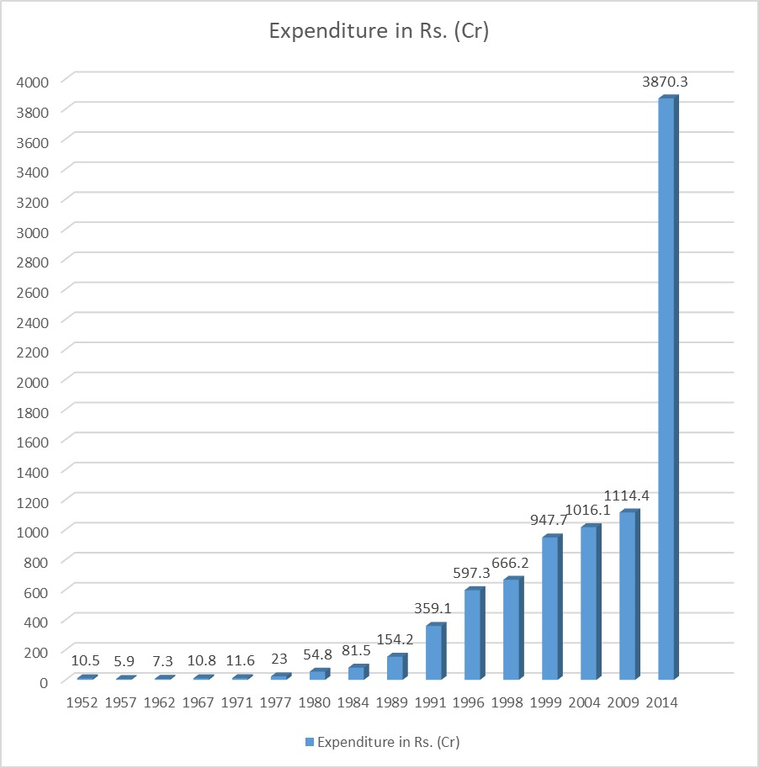
Table 1 indicates how government expenditure on Lok Sabha elections alone have skyrocketed in recent decades since the first general elections of 1952. The consolidated financial burden on the state exchequer for conducting different elections across all levels since independence is obviously humongous. A single unified election has the potential to significantly reduce costs but there are several constraints that may hinder such a prospect. In a country with diverse terrains, infrastructural deficiencies, and large populations, these logistical challenges amplify further. As evident from Table 2, India has more than 91 (ninety-one) crore electorate population in the 2019 Lok Sabha Election and the number would certainly grow in the upcoming 2024 election. But ensuring fair representation, conducting voter education campaigns, and managing law and order across thousands of polling stations is a herculean task.
Table 2. Electorate Population of India in 2019 Lok Sabha Election
(Sourced and adapted from ECI data)

STATE WISE NUMBER OF ELECTORS*
 |  | GENERAL (Including NRIs) |  |  |  | GRAND (including Service Voters)
Sl. No. | STATE/UT | MALE | FEMALE | THIRD GENDER | TOTAL | MALE | FEMALE | THIRD GENDER | TOTAL
1 | Andaman & Nicobar Islands | 168701 | 149168 | 9 | 317878 | 169274 | 149188 | 9 | 318471
2 | Andhra Pradesh | 19462339 | 19879421 | 3957 | 39345717 | 19521053 | 19880957 | 3957 | 39405967
3 | Arunachal Pradesh | 394456 | 403793 | 0 | 798249 | 399747 | 403816 | 0 | 803563
4 | Assam | 11235129 | 10755492 | 491 | 21991112 | 11292580 | 10756988 | 491 | 22050059
5 | Bihar | 37535721 | 33525735 | 2164 | 71063620 | 37681329 | 33532797 | 2164 | 71216290
6 | Chandigarh | 341640 | 304423 | 21 | 646084 | 342201 | 304507 | 21 | 646729
7 | Chhattisgarh | 9516963 | 9481597 | 679 | 18999239 | 9533561 | 9482222 | 679 | 19016462
8 | Dadra & Nagar Haveli | 132389 | 117629 | 3 | 250021 | 132397 | 117629 | 3 | 250029
9 | Daman & Diu | 60986 | 60743 | 0 | 121729 | 60997 | 60743 | 0 | 121740
10 | Goa | 555768 | 580043 | 0 | 1135811 | 556059 | 580054 | 0 | 1136113
11 | Gujarat | 23428119 | 21696571 | 990 | 45125680 | 23454110 | 21697273 | 990 | 45152373
12 | Haryana | 9614613 | 8336280 | 258 | 17951151 | 9716412 | 8340340 | 258 | 18057010
13 | Himachal Pradesh | 2657464 | 2604615 | 47 | 5262126 | 2724111 | 2605996 | 47 | 5330154
14 | Jammu & Kashmir | 4068407 | 3776320 | 160 | 7844887 | 4145202 | 3777176 | 160 | 7922538
15 | Jharkhand | 11698655 | 10665595 | 230 | 22364480 | 11737557 | 10667069 | 230 | 22404856
16 | Karnataka | 25798590 | 25248016 | 4826 | 51051432 | 25840779 | 25248925 | 4826 | 51094530
17 | Kerala | 12684839 | 13466521 | 174 | 26151534 | 12736005 | 13468657 | 174 | 26204836
18 | Lakshadweep | 27921 | 27136 | 0 | 55057 | 28053 | 27136 | 0 | 55189
19 | Madhya Pradesh | 26958507 | 24834753 | 1417 | 51794677 | 27029410 | 24836647 | 1417 | 51867474
20 | Maharashtra | 46315251 | 42246878 | 2406 | 88564535 | 46425348 | 42249192 | 2406 | 88676946
21 | Manipur | 943426 | 995773 | 45 | 1939244 | 963066 | 996452 | 45 | 1959563
22 | Meghalaya | 946248 | 965124 | 0 | 1911372 | 949622 | 965174 | 0 | 1914796
23 | Mizoram | 383603 | 404169 | 5 | 787777 | 388241 | 404218 | 5 | 792464
24 | Nagaland | 607859 | 598428 | 0 | 1206287 | 615274 | 598503 | 0 | 1213777
25 | NCT OF Delhi | 7873159 | 6442816 | 669 | 14316644 | 7882633 | 6444347 | 669 | 14327649
26 | Odisha | 16618058 | 15833424 | 2923 | 32454405 | 16659698 | 15835141 | 2923 | 32497762
27 | Puducherry | 459266 | 513799 | 96 | 973161 | 459503 | 513811 | 96 | 973410
28 | Punjab | 10950733 | 9829917 | 560 | 20781210 | 11059826 | 9832287 | 560 | 20892673
29 | Rajasthan | 25427332 | 23391621 | 265 | 48819218 | 25560063 | 23395485 | 265 | 48955813
30 | Sikkim | 220306 | 212000 | 0 | 432306 | 222110 | 212018 | 0 | 434128
31 | Tamil Nadu | 29597630 | 30271899 | 5793 | 59875322 | 29662809 | 30273230 | 5793 | 59941832
32 | Telangana | 14919826 | 14775949 | 1504 | 29697279 | 14930804 | 14776307 | 1504 | 29708615
33 | Tripura | 1319702 | 1285609 | 14 | 2605325 | 1328960 | 1285744 | 14 | 2614718
34 | Uttar Pradesh | 78804664 | 67046092 | 7797 | 145858553 | 79070809 | 67055997 | 7797 | 146134603
35 | Uttarakhand | 4053930 | 3711300 | 243 | 7765473 | 4142856 | 3713219 | 243 | 7856318
36 | West Bengal | 35845053 | 34045369 | 1329 | 69891751 | 35951289 | 34048666 | 1329 | 70001284
 | TOTAL: | 471627253 | 438484018 | 39075 | 910150346 | 473373748 | 438537911 | 39075 | 911950734

Constitutional Challenges:
One of the biggest challenges of holding simultaneous elections in India is the constitutional challenge. The Indian Constitution mandates fixed terms for all legislative bodies; however, terms within different tiers of government may overlap due to dissolutions, by-elections, or constitutional amendments. Changing this characteristically staggered provision would require a constitutional amendment, which is a lengthy and complicated process. Aligning these various terms constitutionally is bound to be a complex, time-consuming process.
Additionally, simultaneous elections require constitutional amendments to redefine the powers and jurisdictions of different levels of government, which involves extensive debates and discussions. Besides, imposing a single election system and enforcing compliance from the states would tantamount to disturbing the federal character and spirit of the nation. Simultaneous elections might compromise the autonomy of states and undermine the essence of cooperative federalism (Ramani, 2023).
Operational Challenges:
With a broad electorate dispersed across diverse and difficult geographical terrain, India is the world's largest democracy. Coordination of simultaneous elections logistics, including voter registration, electronic voting machines (EVMs), security measures, and staff, poses significant operational issues. Coordination of many stakeholders, including electoral commissions, political parties, security services, and the bureaucracy, is required to carry out simultaneous elections. Simultaneous elections in India will also present significant security issues. India has a history of election-related violence, and holding polls necessitates a large number of security officers. As a result, holding simultaneous elections would necessitate a vast deployment of security officers, which may be impractical.
Coordinating between federal and state election commissions, ensuring the availability of adequate security forces, engaging civil society organizations, and managing electoral infrastructure pose operational challenges that require meticulous planning and coordination. Table 3 demonstrates the ever-growing and constantly expanding scale of Lok Sabha elections alone. Organizing an effective and efficient voter participation in a single election still is a mammoth task, especially in the context of a significantly high number of illiterate and ill-informed voters.

Table 3 Data indicating the expanding scale of Lok Sabha Elections (Source: ECI)

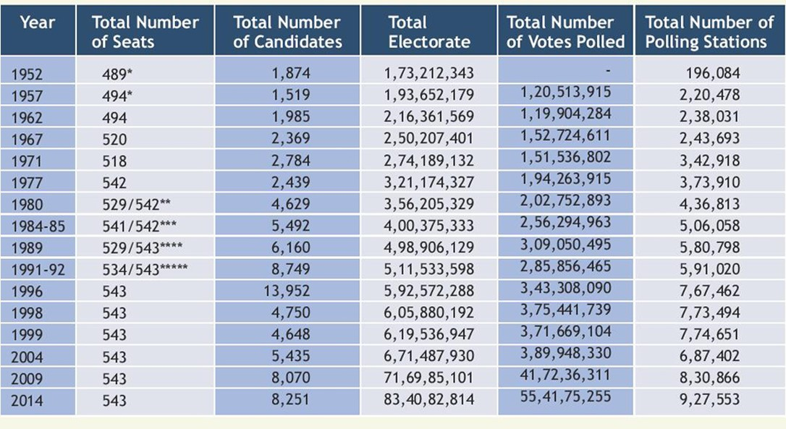
Potential Solutions:
Establishing a framework for dissolution of assemblies in sync with fixed election schedules and synchronizing election commissions at the national and state levels could help alleviate some logistical challenges. To mitigate the challenges of simultaneous elections in India, the formulation of a harmonized electoral calendar that ensures minimal disruptions to the legislatures' terms is advisable. Consultative decision-making processes involving political parties, constitutional experts, and electoral officials can help build consensus and resolve constitutional roadblocks. Additionally, it is essential to invest in building electoral infrastructure, strengthening security measures, and enhancing the capacity of election administration to streamline the operational aspects.
Holding single and simultaneous elections would necessitate the cooperation and consensus of all major parties. To reach an agreement on this all-important issue, the government would need to consult with all political parties and secure favourable public opinion. The Election Commission of India would be responsible for planning and coordinating the logistics of holding such elections. This would then require the mobilisation of extra resources and staff. Additional funds would be required by the government to hold simultaneous elections, but the cumulative costs of holding multiple elections are likely to be reduced to a great extent. To lower the expense of holding elections, the government should investigate the use of electronic voting machines and adopt further cost-cutting measures.
Conclusion:
The idea of simultaneous elections in India has generated immense discourse, driven by the potential benefits it offers. However, implementing simultaneous elections in India also poses numerous challenges arising from constitutional, logistical, and political complexities. While the idea has merits, it requires careful consideration and consensus among stakeholders. A comprehensive analysis of potential solutions and their impact on federalism and regional representation is essential to determine the viability of this electoral reform. Addressing these challenges requires collective efforts from political stakeholders, electoral commissions, policymakers, and administration. By adopting an inclusive approach and investing in strengthening the electoral machinery, India can progressively overcome these obstacles and eventually achieve simultaneous elections, thereby reaping the anticipated advantages of this electoral reform.
References:
Barthwal, P. (2023, September 8). Prospects of simultaneous elections: A much-needed call for nation’s growth. Organiser. https://organiser.org/2023/09/08/194634/bharat/prospects-of-simultaneous-elections-a-much-needed-call-for-nations-growth/
Das, Y. S. (2023, September 1). One nation, one election? India will enter a 3-country club. India Today. https://www.indiatoday.in/india/story/one-nation-one-election-india-will-be-among-countries-that-hold-simultaneous-polls-2429716-2023-09-01
Dubbudu, R., & Dubbudu, R. (2019, March 12). 1951 to 2014 – How did the Lok Sabha election numbers change? FACTLY. https://factly.in/1951-to-2014-how-did-the-lok-sabha-election-numbers-change/
Election Commission of India (2018). “The Functions (Electoral System of India)”. Available at: https://eci.gov.in/about/about-eci/the-functions-electoral-system-of-india-r2/
General Elections 2019 with News Services Division, All India Radio. (n.d.). https://newsonair.gov.in/General-Election-2019/Election-Analytics.aspx
Krismantari, I. (2023, August 5.). Indonesia will hold the world’s biggest single day election: here is what you need to know. The Conversation. https://theconversation.com/indonesia-will-hold-the-worlds-biggest-single-day-election-here-is-what-you-need-to-know-208673
Kumar, V. (2023, January 1). One nation one election: Indian perspective. International Journal of Political Science and Governance, 5(1), 165–168. https://doi.org/10.33545/26646021.2023.v5.i1c.217
Ramani, J. N. (2023, September 19). Why ‘one nation, one election’ would strike a blow against federalism | Data. The Hindu. https://www.thehindu.com/data/why-one-nation-one-election-would-strike-a-blow-against-federalism-data/article67300405.ece
Sampath, G. (2023, September 8). One Nation, One Election: How feasible is it and what would be its impact? | In Focus podcast. The Hindu. https://www.thehindu.com/podcast/one-nation-one-election-how-feasible-is-it-and-what-would-be-its-impact-in-focus-podcast/article67284721.ece

