Chemistry of Some Interesting Selenium-Nitrogen Containing Mixed Donor Macrocycles; Synthesis and Structural Viewpoints
Partha Pratim Das
P. G. Dept. of Chemistry, Magadh University, Bodh-Gaya
Abstract:
Since the development of thia-crown ethers and their vast coordination chemistry and practical applications in numerous fields, scientists have shown huge interest in analogeous selena-macrocycles. Due to its “soft” nature, all selena donors containing macrocycles with multiple Se donors and variable core diameter has been synthesized and investigated. However over the years, there have been attempts to include hard or moderately soft other hetero donor atoms. This presence of hard as well as soft donor centers in a single ligand framework enables the ring to bind a wide range of metal ions, leading to not only intriguing coordination chemistry but also a large range of potential practical applications. In this chapter selena-macrocycles possessing hard nitrogen donor atoms are highlighted. Selena-aza crown ethers, selena-aza schiff base-corwn ethers, selena-aza cryptands, macrocycles containing protonated polyammonium groups and their chemistry have been discussed, from their synthetic and structural viewpoints.

Introduction:
Since the groundbreaking find made by Pedersen¹, Cram², and Lehn³, the field of "supramolecular chemistry" or "host-guest chemistry" has advanced tremendously. Supramolecular chemistry includes, but is not limited to, the chemistry of molecules with a highly structured architecture or the chemistry that extends beyond conventional covalent bonding. The internal structure of the adducts is controlled by a multitude of relatively weak forces, which includes as H-bonding, π−π stacking, ion-dipole, dipole-dipole forces, van der Waals interactions, etc. Merely a handful of the many applications utilising exclusive interaction with metal ions include chemical sensing, the precise extraction of radioactive or poisonous metal ions from waste streams, membrane transport, the immobilisation of radioisotopes, phase-transfer catalysis, and other uses. Additional important areas include the development of (metallo)enzyme prototyping systems, activating small molecules, the precise interactions of anions, and the nucleophilic parts of neutral substances. Mixed donor macrocycles attracted a lot of interest because of having incredibly specialised capacity for binding/chelating metal ions. The insertion of a large Se donor atom should change the size of the ring's diameter and enable some novel coordination behaviour. Due to Se's low electronegativity, macrocycles comprising Se also behaves as effective ligands for bonding to transition metals, and this topic has received extensive research. As a result, macrocycles containing hard donor elements such, N, or O in their ring structure may serve as potential hetero dinuclear macrocyclic ligands. These macrocyclic ligands will have neighbouring 'hard' and 'soft' binding spots, enabling them to interact with both 'hard' and 'soft' guest ions and/or molecules. Alkali and alkaline earth metal ions possessing weak polarizability are referred to as "hard". Transition metal ions are commonly mentioned as "soft" cations because they are very simple to polarise. Whenever a hard cation along with a soft transition-metal cation combine together to produce complexes, both staying inside the same macrocycle, the redox properties displayed by the transition-metal cations will vary. These substances can be used for bimetallic catalysis⁴, molecular activation as well as the building supramolecular networks. This chapter briefly discusses selena-macrocyclic ligands that also include hard nitrogen donor centers from their synthesis, metal complex formation, as well as structural perspectives.
Selenium-Nitrogen donor atom containing macrocycles:
Researchers studied novel selena-aza-crown ether; L¹ and using its Pt^{II} compound catalysis of the hydrosilylation reaction of olefins by triethoxysilane were performed. Pt^{II} complex having L¹: Pt^{II} = 2:3 (confirmed by elemental analysis) was synthesised and used as catalyst⁵. Synthesis of the ligand is shown in Scheme 1 and the catalysis reaction is shown in Scheme 2. There were also a number of selena-azacrown ethers (L²-L⁵) described by Hanseng et.al.⁶. The synthesis procedures are depicted in Scheme 3.
Using Scheme 4, the novel Se-aza-crown ether, L⁶, was produced. The analogous Cu^{I} and Pt^{II} compounds are produced when [Cu(H₂O)₆](ClO₄)₂ and [PtCl₄] are reacted with L⁶, respectively. Even though Cu^{II} and Pt^{IV} were used during the first stages of the reaction, the production of Cu^{I} and Pt^{II} compounds {[Cu^{I}(L⁶)](ClO₄)},{[Pt^{II}(Ring-contracted-L⁶)Cl₂]} could be the result of the electron-transfer mechanism from Se atoms into the coordinating metal sites⁷. The complexation methods are shown in Scheme 5. The interaction of Cu^{I} through four Se atoms resulting in a distorted-tetrahedral configuration without π−π interactions among the surrounding complex components is visible in the crystalline form of the Cu^{I} compound. Switching the core Cu^{I} ion into a Pt^{II} ion to create a ring shrunk compound that reduces a 20-membered ring to a 10-membered ring. Two Se atoms and two Cl⁻ connect the Pt^{II} core, completing a square planar architecture without any contact among Pt^{II} and nitrogen. The Pt^{II} compound's packing architecture reveals a variety of connections between the compound's monomers. The structures are displayed in Figure 1.
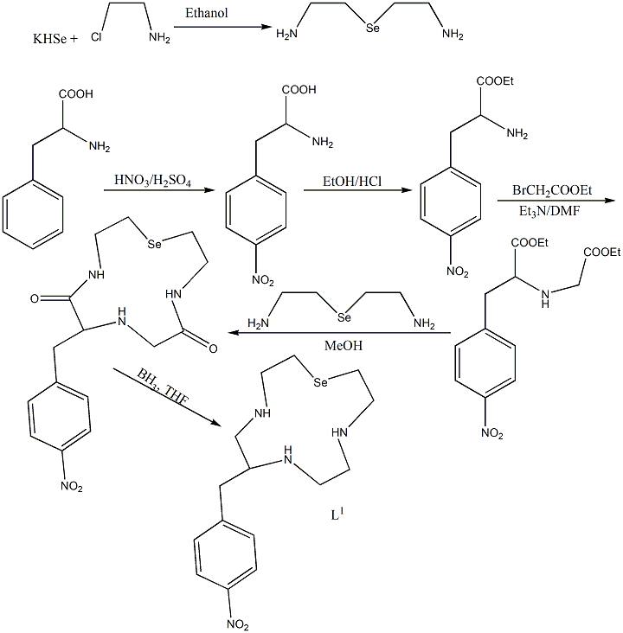
Scheme 1
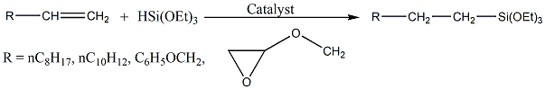Scheme 2

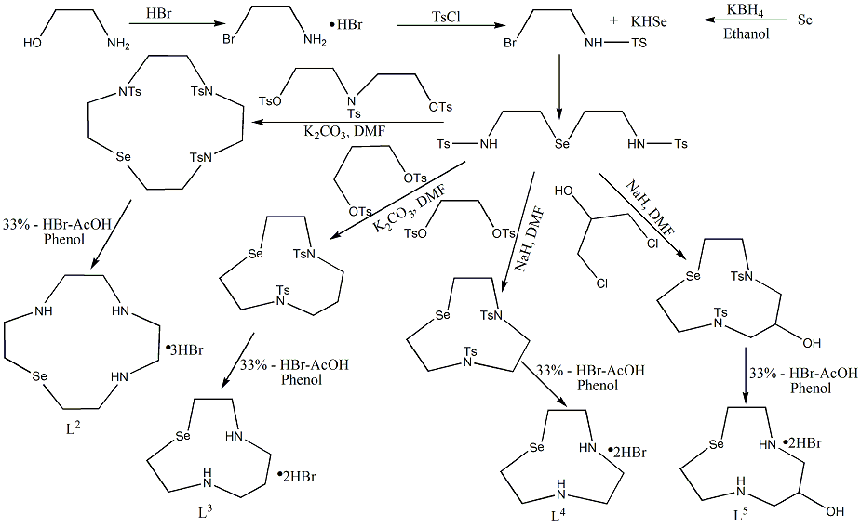
Scheme 3
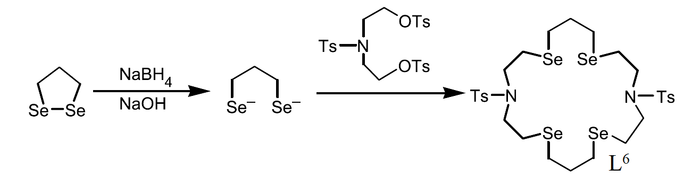
Scheme 4
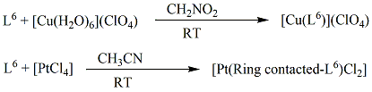
Scheme 5
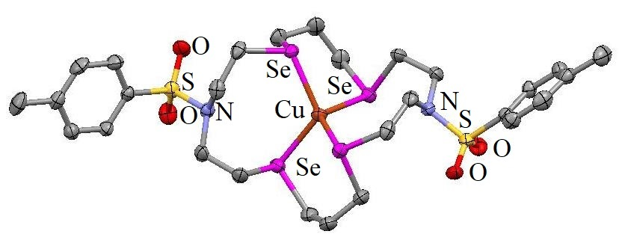  Cation of [Cu(L⁶)](ClO₄) | 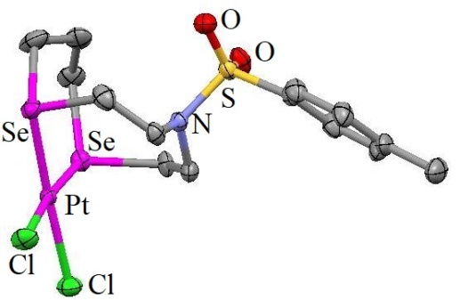  [Pt(Ring-contracted-L⁶)Cl₂]
Figure 1
In accordance with Scheme 6, an exclusive set of Se-macrocycles was produced through metal-free [2+2] condensing of bis(o-formylphenyl) selenide with a number of diamines^{8,9,10}. It marked the first occasion where macrocyclic Schiff base had been found to contain Se. By minimising the unfavourable lone pair-lone pair interaction among the N atoms, secondary intramolecular Selenium-Nitrogen interaction provides a crucial part in the generation of the macrocycle and serves as a model towards the synthesis of the ring.
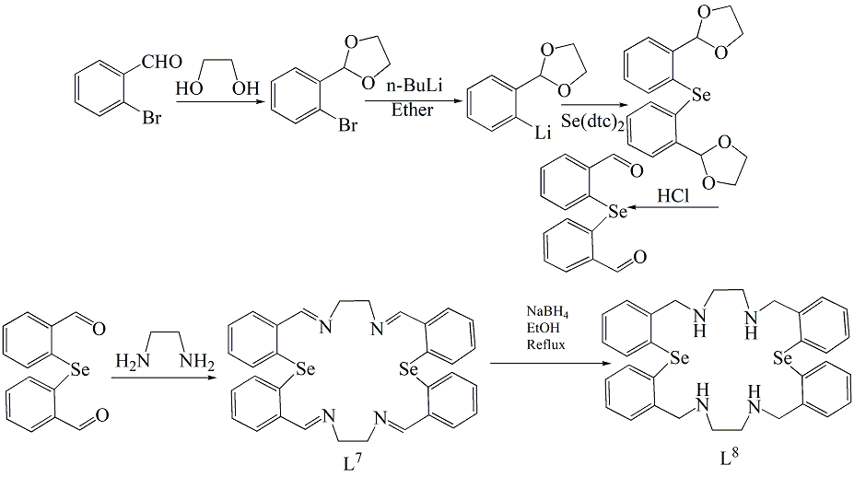
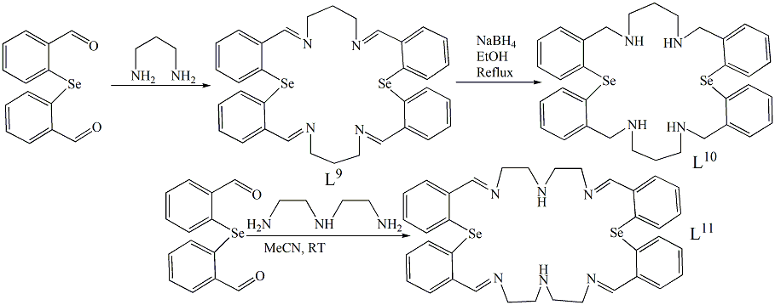
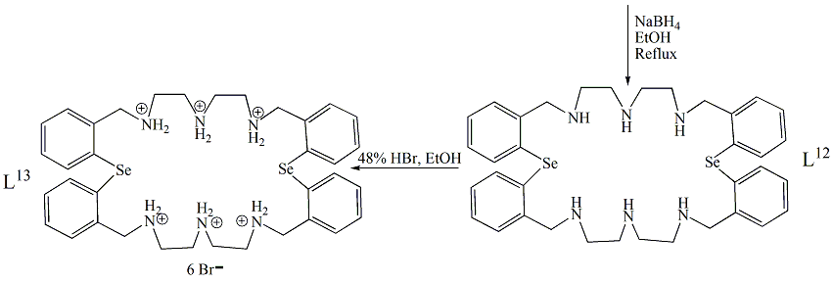
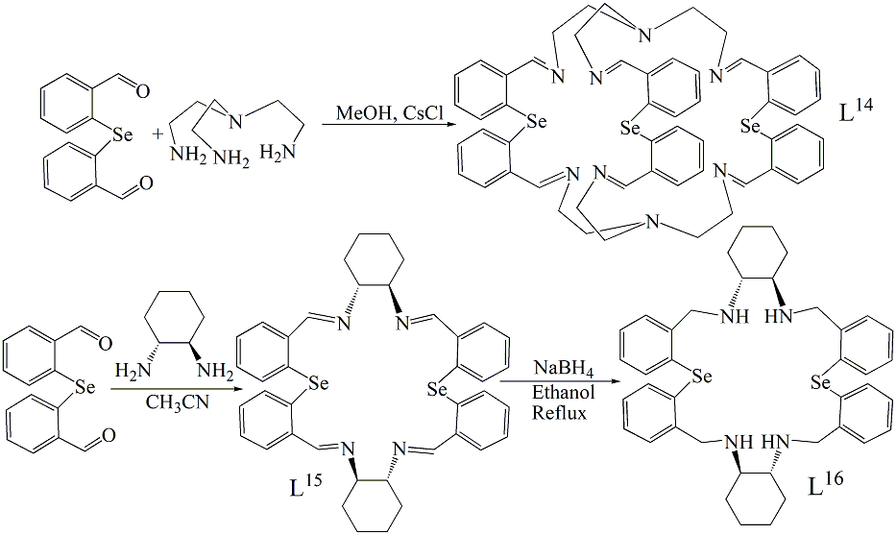
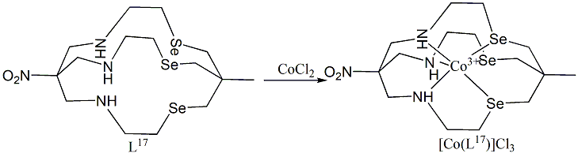
Scheme 6
Secondary Se……..N connections may be seen in the frameworks of all macrocycles, with the 22-member L⁷ exhibiting the strongest interactions. The largest transannular Se……Se separation is found in L⁹. The molecules' crystalline shape suggests that each Se atom only has one attractive interaction. The cavity dimensions are significantly altered [L¹⁵] by substituting a cyclohexane bridging for an ethylene link. The corresponding compounds are produced when L⁷ or L⁹ react with [PdCl₂(COD)] (COD = 1,5-cyclooctadiene) in refluxing CH₃OH, as indicated in Scheme 7. Figure of L⁷, L⁹, L¹¹, L¹⁵ and Pd^{II} complex of L⁷ are shown in Figure 2.
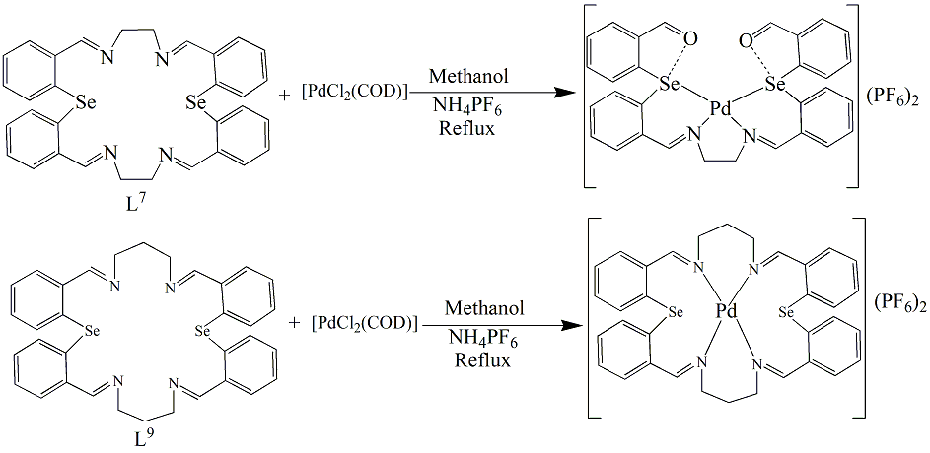
Scheme 7
The crystalline architecture for the compound supports the microanalytical as well as spectroscopic findings that demonstrate the hydrolysis of two -CH=N of the macrocycle (L⁷) to -CHO groups⁸. This hydrolysis might be driven by high ring stress that pushes the metal to assume a planar shape. Instead cationic complex [Pd(L)]²⁺ [L = macrocycle formed by bis(o-formylphenyl) telluride and 1,2-diaminoethane]¹¹ is produced by an equivalent interaction between the Pd^{II} precursor and the 22-member Te analogue with no hydrolysis¹². This could be explained by the Te analog's greater diameter of cavity (Te.....Te 4.979 Å). Via N₂Se₂ interaction, the structure surrounding Pd^{II} is square planar. The Se atom and O atom have a moderate interaction (2.855 Å). The microanalytical as well as spectroscopic information provided confirmation of the composition and geometry of [Pd(L⁹)](PF₆)₂. L⁹'s huge ring diameter (24 member; Se…..Se distance 7.229 Å) likely prevent Se atoms from being coordinated to Pd^{II}.
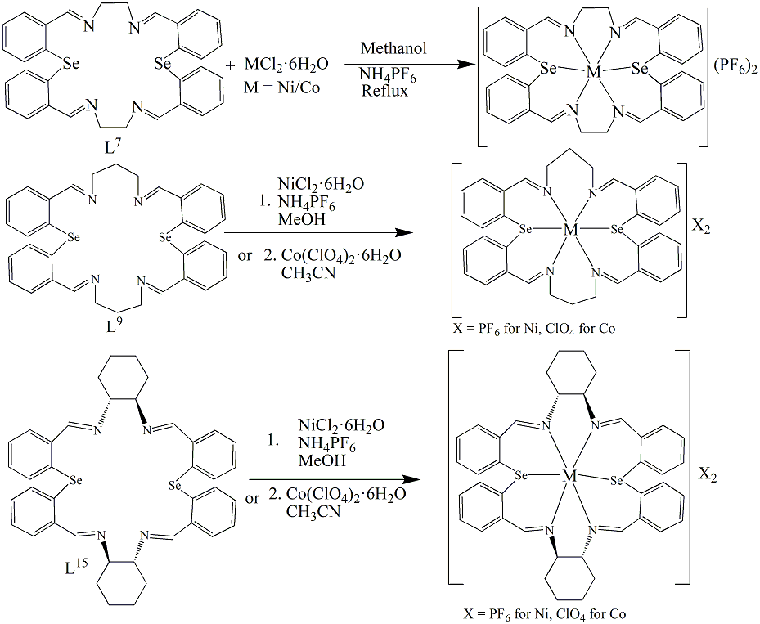
Scheme 8
The corresponding paramagnetic metallic compounds are produced when MX₂.6H₂O [M= Ni^{II}, X= Cl or Co^{II}, X= Cl/ClO₄] is reacted with L⁷, L⁹, or L¹⁵ (Scheme 8). Distorted octahedral geometry is completed by the Ni^{II} ion inside, which is bound to all four N and two Se donors. Two Se atoms are always mutually cis- to one another. The Ni^{II} compound and the corresponding Co^{II} complexe of L⁹ are isostructural. Unexpectedly, the Co^{II} compounds of L⁷ as well as L¹⁵ have low-spin, while the combination for L⁹ is high-spin^{8,10}. Crystal structures of [Ni(L⁷)](PF₆)₂, [Ni(L⁹)](PF₆)₂, [Ni(L¹⁵)](PF₆)₂ and [Co(L⁹)](ClO₄)₂ are displayed in Figure 2. When exposed to metal salts, such Schiff base macrocycles become vulnerable to hydrolysis as well as transmetallation, resulting in macrocycle fragmentation. Therefore, reduction of each of the macrocycles (L⁷, L⁹, L¹¹, and L¹⁵) was carried out in order to produce the amino counterparts that are higher in chemical stability as well as flexibility compared to their Schiff base ancestors^{8,9,10}. This was done in order to analyse the binding behaviour of the reduced version of the Schiff base macrocycles. Additionally, compared to the original Schiff base macrocycles that consist of sp² hybridised donor atoms, the reduced version of macrocycles just consist of sp³ hybridised donor atoms, as a consequence are capable of supporting a broader variety of shapes and sizes.
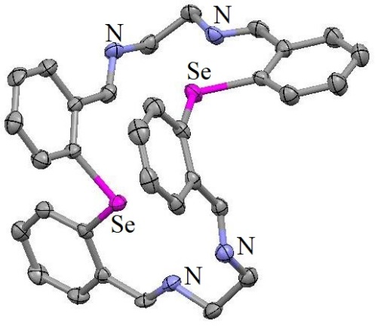 | 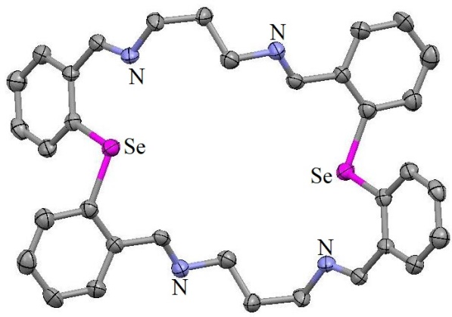
L⁷ | L⁹
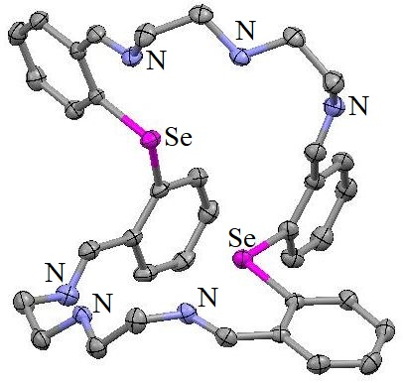  L¹¹ | 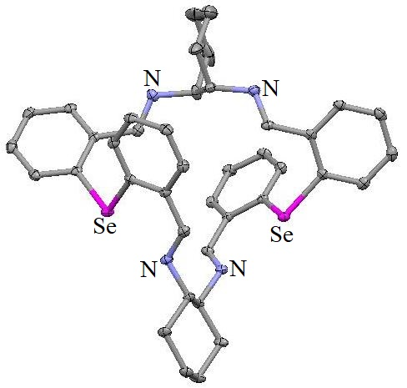  L¹⁵
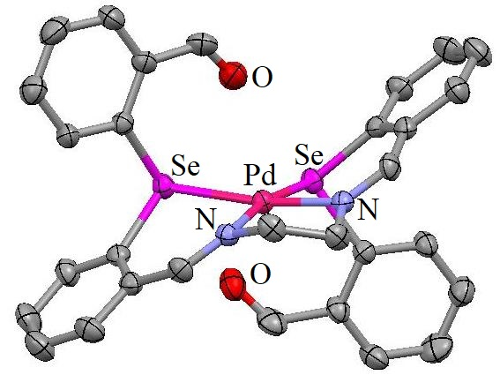 | 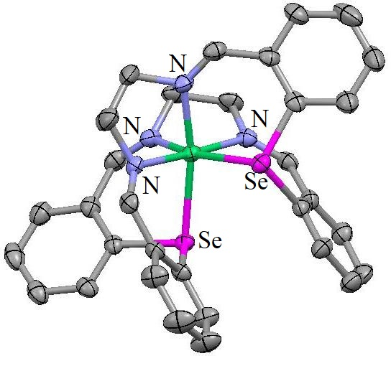
Cation of Pd^{II} complex of modified-L⁷ | Cation of [Ni(L⁷)](PF₆)₂
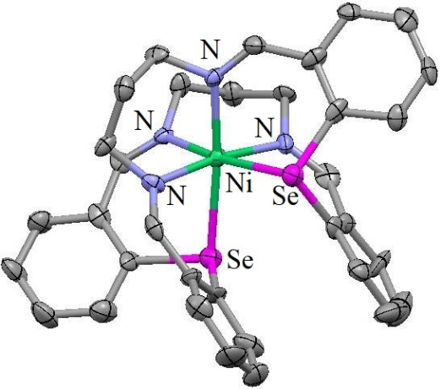 | 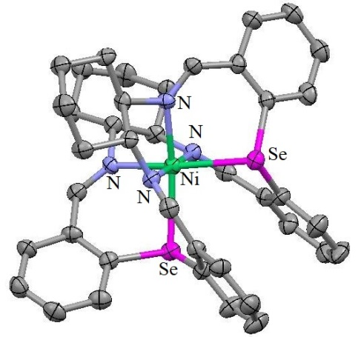
Cation of [Ni(L⁹)](PF₆)₂ | Cation of [Ni(L¹⁵)](PF₆)₂
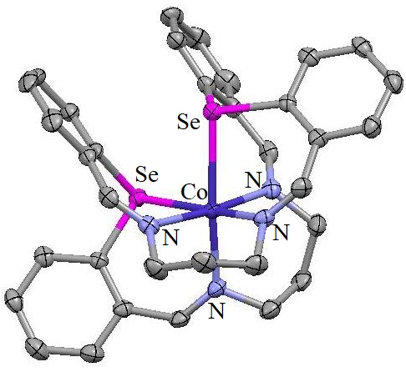 | 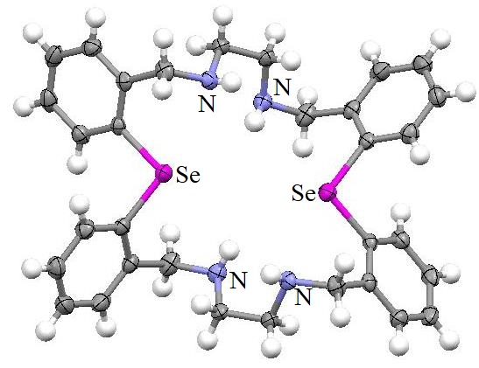
Cation of [Co(L⁹)](ClO₄)₂ | L⁸
Figure 2
The multinuclear NMR spectra as well as single crystal X-Ray architectures of the macrocycles show decreased Se…..N interactions in the reduced versions. Only one among the two potential N donors accessible for interacting with the Se atom interacts with it, as shown by the molecular framework of L⁸ (Figure 2). The greater cavity diameter compared to its corresponding Schiff base L⁷ is indicated by the increased Se……N as well as Se…...Se lengths, respectively. Researchers investigated their metal complex formation reactions using different transition metal ions. The Ni^{II} compound [Ni(L⁸)](PF₆)₂ has an architecture¹³ that is comparable to [Ni(L⁷)](PF₆)₂. For the distorted octahedral configuration, the two Se donors exist cis- to one another just as the case is in the original Schiff base compound [Ni(L⁷)](PF₆)₂. The synthesis of the hydrolyzed compound⁸ with L⁷, as indicated in Scheme 7, is in contrast with the generation of specified 1:1 compounds¹³ [Pd(L⁸)](PF₆)₂ and [Pd(L⁸)]Cl₂ via the interaction of Pd^{II} salts with L⁸ [Scheme 9]. This might be because L⁸'s diameter of the cavity is greater than L⁷'s. A likelihood of Se binding with the metal in solution Phase, that does not appear in the crystal framework, is suggested by the downfield shift of the peaks of [Pd(L⁸)](PF₆)₂ as well as [Pd(L⁸)]Cl₂ from ⁷⁷Se NMR spectroscopy (δ = 869 and 787 ppm, respectively). The ¹H NMR spectroscopic investigation of [Pd(L⁸)](PF₆)₂ at different temperatures (20–120°C) in dimethylsulfoxide solution demonstrates the fact that the coalescence of the spectra might be caused by the compound's fluxional behaviour in solution phase. The sole fluxional mechanism that successfully makes the metal hop across the macrocycle's all six donor regions is the one that delivers this outcome [Scheme 10]. They are isostructural, both compounds. In its crystal structure, Pd²⁺ assumes a square planar shape involving linkage around its four N donors (Figure 3). In contrast, softer donor sites Se/Te bind to Pd^{II} for compounds of mixed donor Se/Te macrocycles comprising Oxygen or Phosphorus^{14,15,16,17}. This unusual behaviour is caused by the chelate effect as well as the geometrical requirements of the ligand surrounding the core Pd^{II} ion for interaction with donor atoms¹³.
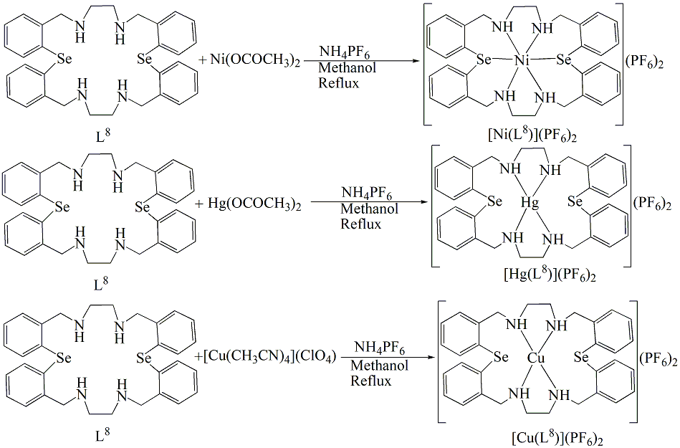
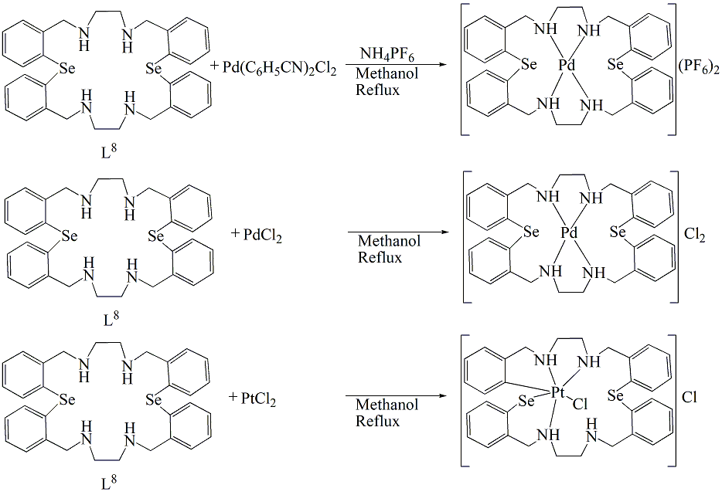
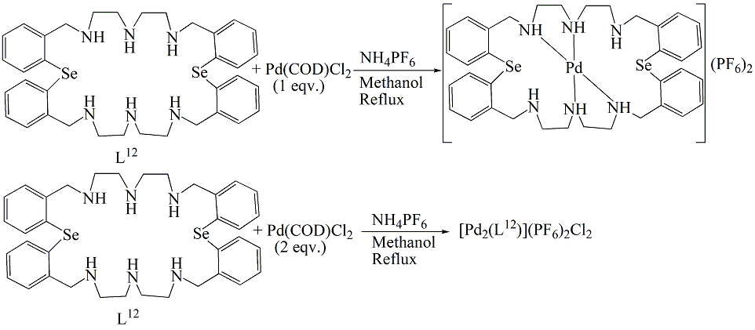
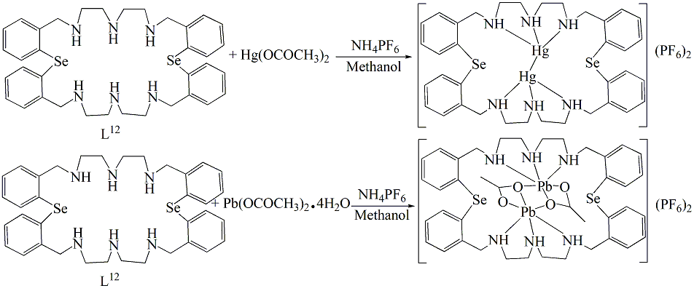
Scheme 9
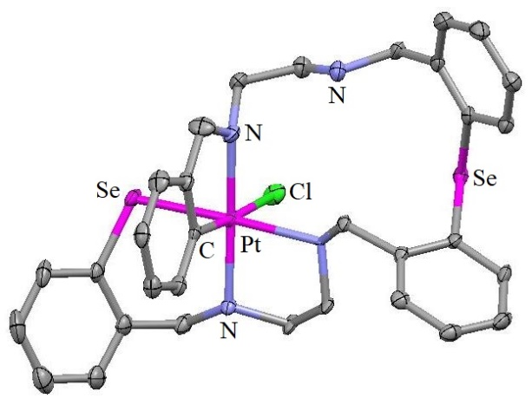 |  |  |  | 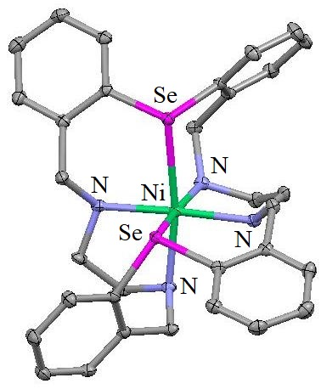
Cation of Pt^{IV} complex with modified-L⁸ |  |  |  | Cation of [Ni(L⁸](PF₆)₂
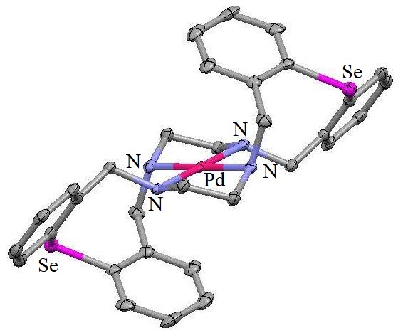 | 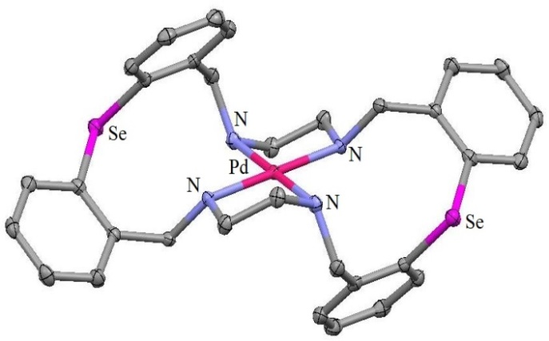
Cation of [Pd(L⁸)]Cl₂ | Cation of [Pd(L⁸](PF₆)₂
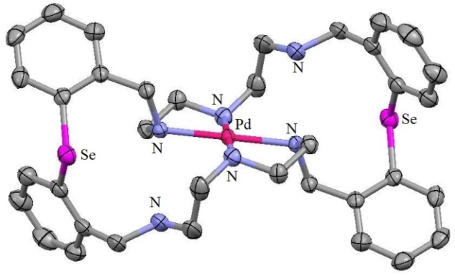 |  |  | 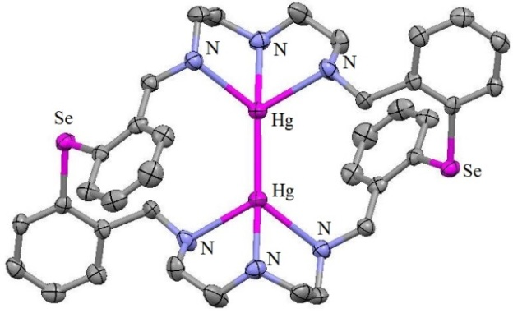
Cation of [Pd(L¹²)](PF₆)₂ |  |  | Cation of [Hg₂(L¹²)](PF₆)₂
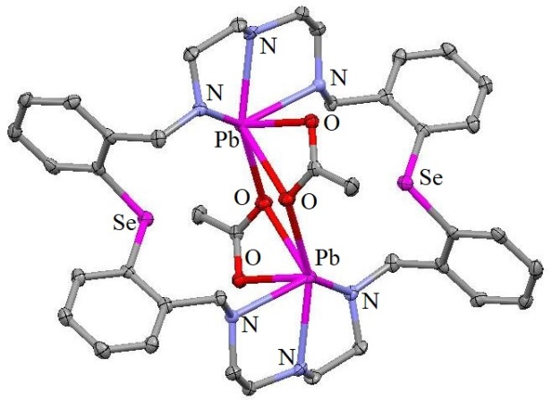 |  | 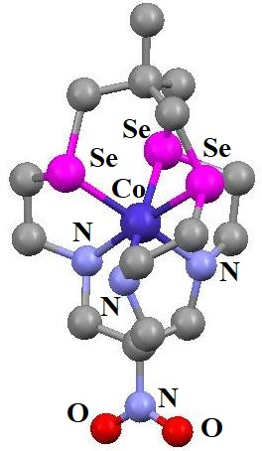
Cation of [Pb₂(L¹²)(OAc)₂](PF₆)₂ |  | Cation of [Co(L¹⁷)]Cl₃
Figure 3
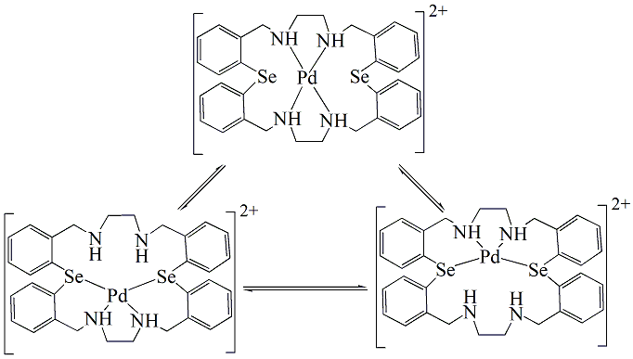
Scheme 10
Similar interaction between PtCl₂ and L⁸ result in metal complex with ligand modifications^{13,18}. The Pt^{IV} compound of L⁸'s architecture (Figure 3) strongly supports the development of an unanticipated 23-member metalla-macrocyclic compound containing a C-Pt-Se link. Octahedral structure surrounds Pt^{IV}. Due to the significant trans- effect of -SePh, the Pt-N bond trans- to Pt-Se is lengthier compared to the remaining two Pt-N bonds. Contrary to the published stable Pt^{II} and Pt^{IV} compounds containing homodonor as well as mixed donor cyclic Se-ether ligands, the behaviour of L⁸ that produces the Pt^{IV} compound by oxidative addition of the C-Se bond to the Pt^{II} core is different^{15,19,20,21}. The considerably more polar C-Se bond resulting from the Nitrogen→Selenium intramolecular interaction that exists in the original macrocycle (L⁸) might have helped the easy oxidative addition for this instance. C-Se bond oxidative addition to Pt^{II} is quite uncommon. The stable behaviour of the cationic Pt^{IV} component that has a selenolate bonding at the macrocyclic ring is additional new aspect regarding this metalla-macrocycle. The 1:1 interaction¹³ of [Cu(CH₃CN)₄](ClO₄) with L⁸, in the presence of NH₄PF₆ in methanol, produced the compound [Cu(L⁸)](PF₆)₂. The square planar shape of the compound is confirmed by EPR spectrum as well as the magnetic moment (1.79 BM). The analogous Hg^{II} compound [Hg(L⁸)](PF₆)₂'s ⁷⁷Se NMR spectra shows a single signal at δ = 315 ppm (for L²⁸; δ = 55, 329 ppm), showing that Se and Hg^{II} have no interaction¹³ (Scheme 9). Using a 1:1 and 1:2 (ligand:metal) proportion, respectively, the compounds [Pd(L¹²)](PF₆)₂ and [Pd₂(L¹²)](PF₆)₂Cl₂ were produced by the interaction of L¹² with Pd^{II} precursors (Scheme 9). The inability to completely characterise [Pd₂(L¹²)](PF₆)₂Cl₂ was caused by its weak solubility. Via the coordination of N₄ donors from the potential N₆Se₂ coordinating environment, the crystalline framework of [Pd(L¹²)](PF₆)₂ exhibits the square planar architecture¹³ of the cationic unit [Figure 3]. A mercurous cation is coordinated inside the macrocycle²² core of [Hg₂(L¹²)](PF₆)₂. This is the very first and most uncommon instance of a structurally characterised Hg^{I} compound of a monocycle [Figure 3] having Hg₂²⁺ confined within the monocycle's cavity. Potential binding of the Se donors to Hg₂²⁺ in solution is ruled out by the insignificant difference between the peak locations of [Hg₂(L¹²)](PF₆)² and L¹² in ⁷⁷Se NMR. Despite the anticipated soft-soft interaction among the Hg₂²⁺ ion and the Se donor atoms, it binds to six N atoms to generate four five-member rings where the configuration surrounding Hg^{I} is antiprismatic. Instead of the development of six-member chelate rings that would occur via coordination by Se, this phenomenon is ascribed to the generation of stable five-member chelate rings. The generation of the mercurous ion might be caused by the association of the impurity HgO with Hg⁰, and the interaction between Hg^{II} and Hg⁰ significantly favours Hg₂²⁺, according to Catalano et al^{23,24}. The ⁷⁷Se NMR analysis of the dinuclear Pb compound [Pb₂(OCOCH₃)₂(L¹²)](PF₆)₂ demonstrates that there is no connection between Se and Pb, allowing the compound to maintain its solid state structure in solution also²². Pb^{II} coordinating by both S as well as N atoms is observable when analogous interaction with the azathia macrocycle happens²⁵. Stereochemically active lone pair of Pb²⁺ causes the structure around each Pb^{II} to be distorted octahedron. A central four-member Pb₂O₂ ring is formed by the bridging O atoms, and the two Pb^{II}. As shown in Figure 3, each OAc⁻ ion within the structural unit bridges between two metal ions by using one of its oxygen atoms and also acts as a chelating ligand towards one metal ion.
Additionally, cryptands with Se and N donor atoms have been reported. The large Se atom's inclusion ought to alter the dimensions of the cage cavity, allowing certain intriguing coordinating behaviour. Nitro-capped cage L¹⁷ having N₃Se₃ donor set has been reported [Schme 6]. Its Co^{III} compound; [Co(L¹⁷)]Cl₃, reveals that metal ion is enclosed inside N₃Se₃ cage²⁶. Its crystal structure is shown in Figure 3. Using Cs⁺ ions as the template, the cryptand L¹⁴ was synthesised via [2+3] condensing from tris(2-aminoehyl)amine and bis(o-formylphenyl) selenide [Scheme 6]⁹.
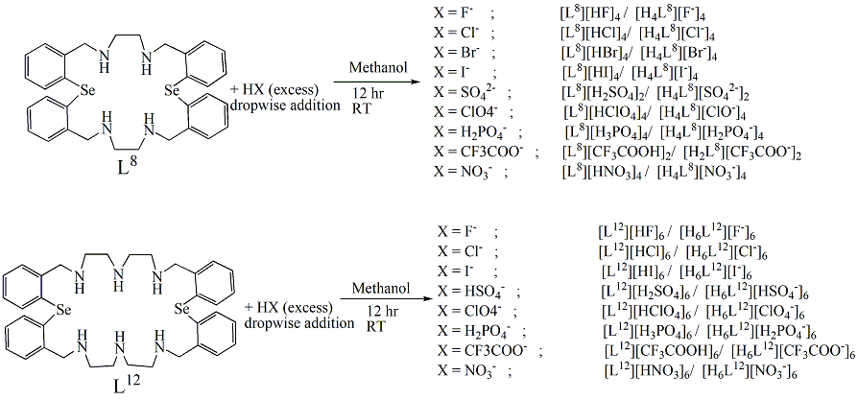
Scheme 11
Polyamine macrocycles [e. g. L⁸, L¹²] can serve as receptors for anions, cations, and neutral compounds as well. They can be polyprotonated in solution to produce positively charged polyammonium cations, that can form adducts with a range of inorganic, organic, and physiologically significant anions [such as; halides, sulphate, bisulphate, perchlorate, biphosphate, trifluoroacetate, nitrate etc.]²⁷ through electrostatic forces and hydrogen bonding. As shown in Scheme 11, several macrocyclic compounds with various counter anions have been produced. The anion adducts of the Se-aza macrocycles' ⁷⁷Se NMR spectrum show the fact that the sulphate adduct L⁸ [{H₄(L⁸)}(SO₄²⁻)₂], exhibits a significant upfield shift (the variation of ~241 ppm) in peak position relative to L⁸, while other adducts exhibit only a slight change. Shorter interactions between SO₄²⁻ and L⁸ in solid form as well as in the solution phase can account for this upfield shift in the case of the adduct [{H₄(L⁸)}(SO₄²⁻)₂]. Of all the anions investigated, L⁸ exhibits the highest affinity for binding for SO₄²⁻, based to the ⁷⁷Se NMR chemical shift value and the binding constant determined via the NMR titration technique. L⁸ and L¹² form notable H-bonded compounds when combined with anions which are located above and below the macrocycle architecture, according to their crystal structures. While every other adducts reveal the macrocycles having been completely protonated, the trifluoroacetate adduct of L⁸; [{H₂(L⁸)}(CF₃COO⁻)₂] assumes the di-protonated version of the macrocycle. Both significant H-bonding and π−π stacking interactions among the adducts are visible for the packing diagram of [{H₆(L¹²)}(ClO₄)₆]. The unit cell of the adduct [{H₄(L⁸)}(Br⁻)₄] is made up of two separate molecules having a lot of H-bonding amongst them. To accommodate individual atoms' different bonding patterns, the macrocyclic framework has an extremely puckered ellipsoid shape. Here, neither of the Br⁻ ions is located within the macrocyclic cavity, while one is located above the macrocyclic plane and generates intramolecular H-bonds with NH₂⁺ and one water molecule's hydrogen atom. Bifurcated H-bonds are there between one of the N atoms and two Br- ions, while the second N atom is H-bonded to one Br- and a water molecule. The anionic adducts are shown in Figure 4.
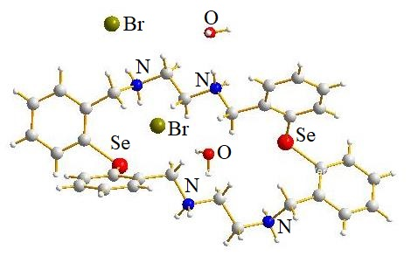  [{H₄(L⁸)}(Br⁻)₄] adduct | 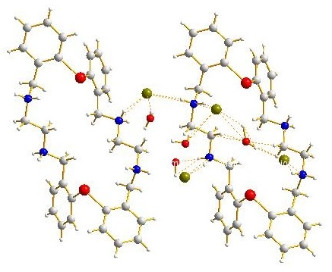  H- bonding in [{H₄(L⁸)}(Br⁻)₄] adduct
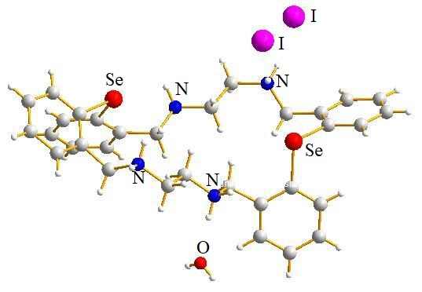  [{H₄(L⁸)}(I⁻)₄] adduct | 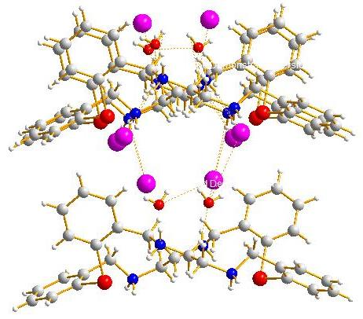  Packing diagram of [{H₄(L⁸)}(I⁻)₄] adduct
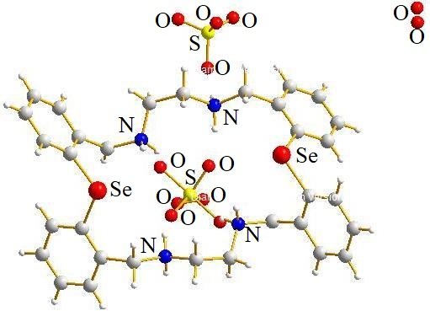  [{H₄(L⁸)}{(SO₄)²⁻}₂] adduct | 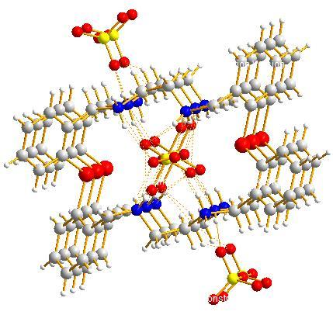  Packing diagram of [{H₄(L⁸)}{(SO₄)²⁻}₂]
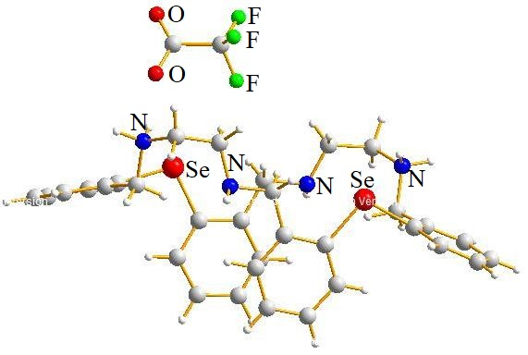  [{H₂(L⁸)}(CF₃COO⁻)₂] adduct | 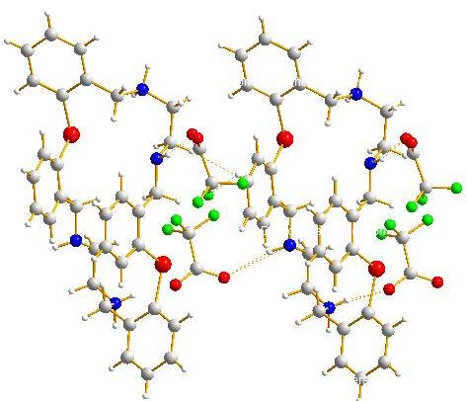  Packing diagram of [{H₂(L⁸)}(CF₃COO⁻)₂]
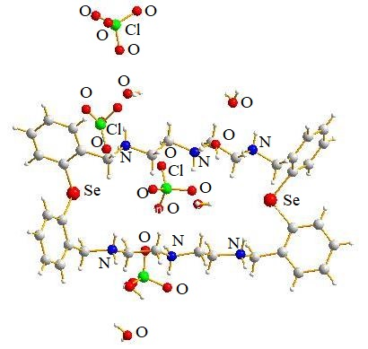  [{H₂(L¹²)}(ClO4⁻)₄] adduct | 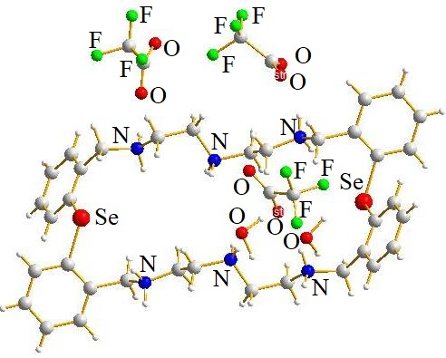  [{H₂(L¹²)}(CF3COO⁻)₄] adduct
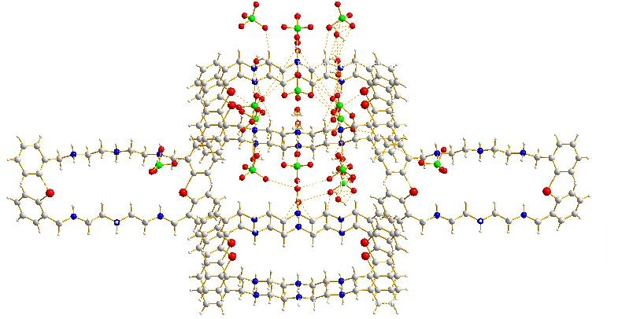
Packing diagram of [{H₂(L¹²)}(ClO4⁻)₂]
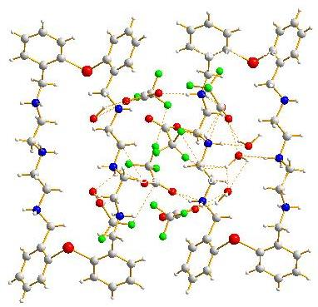
Packing diagram of [{H₂(L¹²)}(CF3COO⁻)₄]
Figure 4
Conclusion:
In a nutshell, the Schiff base Se-macrocyles are appropriate for binding to different transition metal ions but are vulnerable to hydrolysis as well as transmetalation when exposed to metal salts, causing the macrocycle to cleave. The Te analogue generates transmetalated end-products with Pt^{II,12} and Hg^{II,11} ions, while the Se-aza Schiff base macrocycle L⁷ produces a hydrolysis compound using the Pd^{II} ion⁸. These Se-aza macrocycles can be converted into more flexible form by reducing their Schiff base parts. With regard to various metal ions, these reduced Schiff base macrocycles exhibit intriguing coordination characteristics. The Pd^{II} compound of L⁸, which interacts via solely N atoms compared to the N₂Te₂ coordination that exists in the Te counterpart¹⁸, is of particular significance. Te and Pd^{II} are coordinated because Te has a higher σ-donor characteristic than Se, which causes soft-soft interactions and stabilises the six-member chelate ring. Additionally, the 28-member Se₂N₆ macrocycle L¹² exhibits possibilities as a binuclear binding ligand. The structural requirements of the ligand surrounding the metal ions and the chelating ring effect are thought to be the primary factors responsible for the remarkable non-interaction involving Se donor and metal ions throughout all of the compounds of L¹². Anion recognition is still one of the very significant categories to investigate, despite the fact that cation's recognition and binding has been studied in much more details over several decades. Most of the enzyme substrates are anionic in nature. The designing and production of receptors for particular anion binding have undergone a revolution in the last two decades because of the significance of anion recognition. In order to explore how protonated analogues interact with various anionic substrates, the protonation of the amino counterparts was thereafter performed.
References:
- C.J. Pedersen, “Cyclic polyethers and their complexes with metal salts”, J. Am. Chem. Soc., Vol. 89, pp. 7017–7036, 1967.
- D.J. Cram, “The Design of Molecular Hosts, Guests, and Their Complexes (Nobel Lecture)”, Angew. Chem. Int. Ed. Engl., Vol. 27, pp. 1009-1020, 1988.
- (a) J.M. Lehn, “Design of organic complexing agents Strategies towards properties”, Struct. Bond. (Berl.) Vol. 16, pp. 1-69, 1973. (b) J.M. Lehn, “Supramolecular Chemistry—Scope and Perspectives Molecules, Supermolecules, and Molecular Devices (Nobel Lecture)”, Angew. Chem. Int. Ed. Engl., Vol. 27, pp. 89-112, 1988.
- F. C. J. M. Van Veggel, W. Verboom and D. N. Reinhoudt, “Metallomacrocycles: Supramolecular Chemistry with Hard and Soft Metal Cations in Action”, Chem. Rev., Vol. 94, pp. 279-299, 1994.
- X. Wei, L. Xiufang, L. Xueran and X. Hansheng, “Studies On A Selena-aza-crown Ether: Synthesis and Catalytic Behavior In Hydrosilylation”, Wuhan Univ. J. Nat. Sci., Vol. 2, pp. 464-466, 1997.
- X. Hansheng, X. Guangya,W. Jun and L. Xiufang, “Studies on Hetero-Macrocyclic Polyether (X VII) the Synthesis of Selena-aza Crown Ethers”, Wuhan Univ. J.Nat. Sci., Vol. 4, pp. 85-88, 1999.
- Y. Liu, J. -R. Han, Y. Chen, A. Yu, Z. -Y. Duan and H. -Y. Zhang, “Synthesis and Structural Elucidation of N,N’-Ditosyl-1,11-diaza-4,8,14,18-tetraselena-cycloicosane and its Copper and Platinum Complexes”, Supramol. Chem., Vol. 17, pp. 623-628, 2005.
- A. Panda, S.C. Menon, H.B. Singh, C.P. Morley, R. Bachman, T.M. Cocker and R.J. Butcher, “Synthesis, Characterization and Coordination Chemistry of Some Selenium-Containing Macrocyclic Schiff Bases”, Eur. J. Inorg. Chem., Issue 6, pp. 1114-1126, 2005.
- A. Panda, S. C. Menon, H. B. Singh and R. J. Butcher, “Synthesis of some macrocycles:bicycles from bis(o-formylphenyl) selenide: X-ray crystal structure of bis(o-formylphenyl) selenide and the first 28-membered selenium containing macrocyclic ligand”, J. Organomet. Chem., Vol. 623, pp. 87-94, 2001.
- U. Patel, H. B. Singh and R. J. Butcher, “Synthesis and Characterization of Some New 22-Membered Chalcogenoaza Macrocycles and Their Co^{II} and Ni^{II} Complexes”, Eur. J. Inorg. Chem., Issue 24, pp. 5089-5097, 2006.
- S. C. Menon, H. B. Singh, R. P. Patel and S. K. Kulshreshtha, “Synthesis, structure and reactions of the first tellurium-containing macrocyclic Schiff base”, J. Chem. Soc. Dalton Trans., Issue 7, pp. 1203-1207, 1996.
- S. C. Menon, A. Panda, H. B. Singh and R. J. Butcher, “Synthesis and single crystal X-ray structure of the first cationic Pd(ii) complex of a tellurium-containing polyaza macrocycle: contrasting reactions of Pd(ii) and Pt(ii) with a 22-membered macrocyclic Schiff base”, Chem. Commun., Issue 2, pp. 143-144, 2000.
- S. Panda, S. S. Zade, H. B. Singh and R. J. Butcher, “The Ligation Properties of some Reduced Schiff Base Selena/Telluraaza Macrocycles: Versatile Structural Trends”, Eur. J. Inorg. Chem., Issue 1, 172-184, 2006.
- C. Bornet, R. Amardeil, P. Meunier and J.C. Daran, “Structural and complexation properties of diselenacrown ethers. Synthesis and crystal structure of a novel cationic palladium tetraselena complex”, J. Chem. Soc. Dalton Trans., Issue 7, pp. 1039-1140, 1999.
- M. J. Hesford, W. Levason, M. L. Matthews and G. Reid, “Synthesis and complexation of the mixed tellurium–oxygen macrocycles 1-tellura-4,7-dioxacyclononane, [9]aneO₂Te, and 1,10-ditellura-4,7,13,16-tetraoxacyclooctadecane, [18]aneO₄Te₂ and their selenium analogues”, Dalton Trans., Issue 14, pp. 2852-2858, 2003.
- X. Zeng, X. Han, L. Chen, Q. Li, F. Xu, X. He, Z. -Z. Zhang, “The first synthesis of a calix[4](diseleno)crown ether as a sensor for ion-selective electrodes”, Tetrahedron Lett., Vol. 43, pp. 131-134, 2002.
- J. L. Li, J. B. Meng, Y. M. Wang, J. T. Wang and T. Matsuura, “Synthesis of phosphorus- and selenium-containing macrocycles and their complexation with Pd(II)Cl₂”, J. Chem. Soc. Perkin Trans., Vol. 1, pp. 1140-1146, 2001.
- S. Panda, H. B. Singh and R. J. Butcher, “Contrasting coordination behaviour of 22-membered chalcogenaaza (Se, Te) macrocylces towards Pd(II) and Pt(II): Isolation and structural characterization of the first metallamacrocyle with a C–Pt–Se linkage”, Chem. Commun., Issue 3, pp. 322-323, 2004.
- N. R. Champness, W. Levason, J. J. Quirk, G. Reid and C. S. Frampton, “Synthesis, spectroscopic and structural characterization of Pd^{II} and Pt^{II} complexes of the cyclic diselenoether 1,5-diselenacyclooctane, [8]aneSe₂”, Polyhedron, Vol. 14, pp. 2753-2758, 1995.
- N. R. Champness, P. F. Kelly, W. Levason, G. Reid, A. M. Z. Slawin and D. J. Williams, “Selenoether Macrocyclic Chemistry: Syntheses, NMR Studies, Redox Properties, and Single-Crystal Structures of [M([l6]aneSe₄)](PF6)₂.2MeCN (M = Pd, Pt; [16]aneSe₄ =1,5,9,13-Tetraselenacyclohexadecane”, Inorg. Chem., Vol. 34, pp. 651-657, 1995.
- W. Levason, J. J. Quirk and G. Reid, “Selenoether Macrocyclic Complexes of Platinum(IV): Synthesis and Spectroscopic Studies of [Pt([l6]aneSe₄)X₂][PF₆]₂ (X = C1, Br). X-ray Structure of [Pt([l6]aneSe₄)Cl₂][PF₆]₂”, Inorg. Chem., Vol. 33, pp. 6120-6122, 1994.
- S. Panda, H. B. Singh, R. J. Butcher, “Synthesis and Structure of Mercurous Ion and Dinuclear Lead(II) Complexes of the 28-Membered Selenaaza Macrocycle: Dominance of the Chelate Ring Size Effect and Conformational Requirement over Soft-Soft Interactions”, Inorg. Chem., Vol. 43, pp. 8532-8537, 2004.
- V. J. Catalano and M. A. Malwitz, “Pd(0) and Pt(0) Metallocryptands Encapsulating a Spinning Mercurous Dimer”, Inorg. Chem., Vol. 41, pp. 6553-6559, 2002.
- N. N. Greenwood and A. Earnshaw, “Chemistry of the Elements”, Pergamon Press: Oxford, 1994.
- A. Bashall, M. Mcpartlin, B. P.Murphy, H. R. Powell and S. Waikar, “Interaction of Environmentally Important Metal Ions with Nitrogen-Sulfur-donor Macrocycles. The Crystal Structures of Seven-co-ordinate Lead(II) and Mercury(II) Complexes of an 18-Membered N,S, Macrocycle”, J. Chem. Soc. Dalton Trans., Issue 9, pp. 1383-1390, 1994.
- R. Bhula, A. P. Arnold, G. J. Gainsford and W. G. Jackson, “A macrobicyclic cage incorporating selenium donor atoms: synthesis and structure of [Co^{III}L]C1₃ (L = l-nitro-8-methyl-6,10,19-triselena-3,13,16-triazabicyclo [6.6.6] icosane)”, Chem. Commun., Issue 2, pp. 143-144, 1996.
- S. Panda, S. S. Zade, A. Panda, H. B. Singh and R. J. Butcher, “Anion binding with some 22- and 28-membered selenaaza macrocycles: Structural aspects and ⁷⁷Se NMR studies”, J. Organomet. Chem., Vol. 691, pp. 2793-2809, 2006.

