**Microgrid Development with Power Management and Quality Power capability**

, Shri Harsha J1, Thejaswini R2

1Vidya Vikas Institute of Engineering and Technology, Mysuru

1shriharsha86j@gmail.com

2 Sri Siddhartha Institute of Technology, Tumkur

2thejaswinir@ssit.edu.in

* Shri Harsha J

**Abstract**- Microgrid is an combination of more than one distributed generators and Grid like solar PV system ,Diesel Generator and Grid connection that provide quality electric power to consumers .Portable microgrid technology is suitable for the places where there is an emergency condition like disaster due to landslides and other natural calmities. Portable Microgrid has to manage generated power and supply quality power to loads connected. This is a key challenge to quality power supply in hybrid generation. This paper proposes the implementation of power management scheme using using Dynamic Programming and Fuzzy Logic System and power qulaity improvement a technique for enhancing the performance of DSTATCOM and by designing a control strategies used for calculation of reference current and the triggering circuit designed for firing the circuit.

**Keywords:**Microgrid,Power mangement,Dynammic Programming,Fuzzy logic,Power Quality, DSTATCOM, Krill Herd Technique

1. **Introduction**

Natural disasters are sudden change in the environmental factors that results in damages of shelter and normal life. Level of disaster depends on magnitude of damage occurred, number of living beings affected, time span of event etc, which will disturb the daily life thus enhancing human sufferings .The victims will lose their shelter and will have cut in electricity supply and takes many days to get grid supply for normal life. [1][2].

Microgrid is an electrical power system that is connected both load and distributed energy sources, it have the ability to control and manage load and electrical power system, it includes grid supply or may include area electrical power supply and are intentionally planned [3]. A microgrid organization consist of non-conventional and conventional energy sources, such as Diesel engine, Solar panels, with energy storage system and Grid Supply. The solar and wind energy sources is used as are primary energy[4], The energy of which will be fetched when available from solar irradiation and win velocity. Since the Wind velocity and solar irradiance are not constant so support energy system is required to increase the operation of microgrid, which is carried out using battery as an energy storage system [5]. For smooth operation of electrical power generation management state-of-the-art technology should be used. The several artificial intelligence algorithms like expert system, fuzzy logic, genetic algorithm and many more have been developed and tested for the various sectors in power system. The artificial intelligence approach makes the power system operation and control a smart way [11]. The elucidation for PQ issues depends on various factors such as location, their cause, locations, their accuracy duration and frequency which eventually impact on the end user products. Therefore the increased demand of the power electronics components has developed the custom of dynamic compensation scheme that revamp the load and network variations. The traditional passive filter does not riposte to the fluctuations in power system conditions. Hence, Power system researchers have developed Active Power Filters to manifest the power quality issues [9].

**2. Microgrid Development with Power Management and Quality Power Capability**

**2.1 Microgrid Development**

The portable microgrid simulated is as shown in the Figure.1 which is connected to photovoltaic system of 100KW with boost constant voltage converter, wind generator, battery storage system used is Lithium ion battery of 180 Ah, 48V,diesel generator, grid and load. The grid rectified voltage of grid is injected to the bus through static switch to supply power when renewable energy sources and battery do not have sufficient energy to supply load. Resistive load of 1.5kW is supplied from dc bus out of which 500W of critical load[6].

In this work on microgrids, the modeling and simulation of power systems in MATLAB/SIMULINK is introduced with Simscape Electrical. The DERs in this example include renewables, such as solar, a diesel Generator, and energy storage system (ESS).Distribution system with residential load changer or unintentional islanding of the microgrid is simulated[7][8].

**2.2 Result of Microgrid Development:**

Since microgrid systems commonly have inverter-based controls for solar and ESS, different levels of simulation fidelity can be useful to study the microgrid operation. Figure 2 shows the output of the microgrid system designed. Simscape Electrical can be used to simulate Phasor or Electromagnetic Transients (EMT) as shown in Figure 3.The transient developed in the output shows that there is need for power quality improvement.

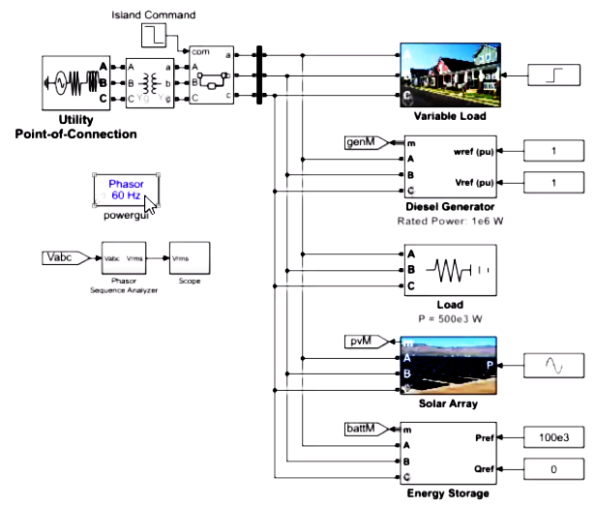

**Fig. 1. Simulink model of Microgrid connected to load and supply**

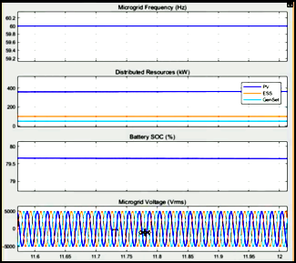

**Fig. 2. Simulation outpur of Microgrid**

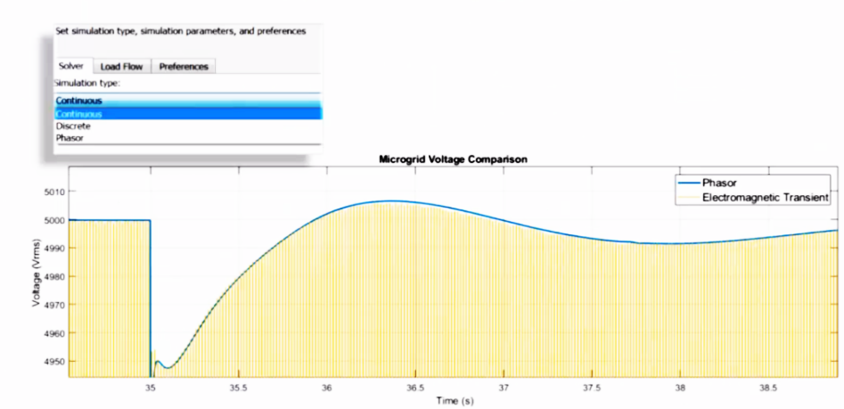

**Fig. 3. Electromagnetic Transients developed in microgrid**

**3. DSTATCOM for Power Quality Improvement**

Many meta-heuristic algorithms have been developed with biological inspiration and many researches are also carried out. Meta-heuristic algorithm combination is developed by considering both qualities of exploitation and exploration, which is the most important point in meta-heuristic algorithm. To strengthen this in 2012, Gandomi suggested Krill Herd (KH) algorithm a bio-inspired optimization technique to solve any multistage complex problem. In this algorithm the Krill which is small shellfish in the sea develops a herd by increasing density to protect from the attacker or to reach food. The method of framing a herd has developed an optimizing technique. In KH algorithm there are three main components to find the optimized value such as, a) Induced Motion, b) Forging Motion and c) Physical Diffusion[9].

The working of DSTATCOM is based on injection of harmonic current to the grid by using active filters in conflicting phase of the grid, by injecting this pure sinusoidal voltage waveform is obtained. Hence, by injecting the shunt active filters to the distribution system the improved power quality is achieved.

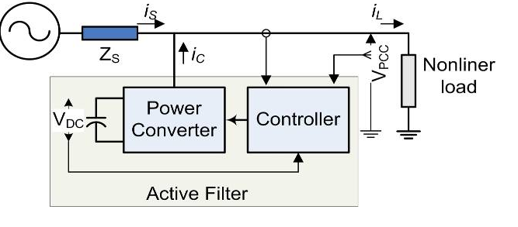

**Fig. 4. DSTATCOM Functional Diagram**

In Figure 4 shows a nonlinear load with balanced supply voltage .The current $i_{L}^{}$ is the current flowing through the load with harmonics. To compensate harmonics in $i_{L}^{}$ an active filter generates suppressing current $i_{S}^{}$, applying KCL we get[10],

$i_{S}^{}=i_{L}^{}- i_{c}^{}$ (1)

The source current must be in phase with voltage to achieve it, hence active power consumed by the load must be transferred to $i_{S}^{}$ as shown in equations shows active component of all three phases (R-Y-B) in load is as in equation below,

$i_{sR}^{}=\frac{P_{L}^{}}{V^{2}}U_{R}^{};i_{sY}^{}=\frac{P_{L}^{}}{V^{2}}U_{Y}^{}$;

$i_{sB}^{}=\frac{P_{L}^{}}{V^{2}}U_{B}^{}$; (2)

Where

$V^{2}= \frac{1}{T}V_{R}^{2}+V_{Y}^{2}+ V_{B }^{2}$ (3)

At balanced condition

$V^{2}=3V_{R}^{2}$ (4)

Where $V_{R}^{}=V_{Y}^{}=V_{B}^{}$-> rms value of the phase voltage.

The operation of the DSTATCOM is based on the exchange of real and reactive powers between the distribution grid and inverter output of the DSTATCOM [13]. The equation of P and Q power is given by equations 5 and 6 respectively

$P=\frac{V_{{PCC}^{}}V_{C^{}}sin∝}{X}$ (5)

$Q=\frac{{V_{{PCC}^{}}(V}_{{PCC}^{- }}V_{C^{}}cos∝)}{X}$ (6)

Where α -> angle between the bus and inverter voltages, VC -> inverter output voltage, VPCC -> voltage of coupling, and X->reactance between the coupling point and grid.

**3.1 Krill Herd-Fuzzy Controller Algorithm**

The very interesting approach in meta-heuristic algorithm is it uses a combination of random search and local search. The Investigation and manipulation are carried out in chorus using Krill herd algorithm(KHA)[11]. The block diagram in of the proposed Krill herd-Fuzzy algorithm is as shown in Figure 5.

**Fig. 5. Artifacts block diagram in of the proposed Krill herd-Fuzzy algorithm**

3.2 Result of **Krill Herd-Fuzzy Controller Algorithm**

3.2.1Performance of DSTATCOM Using Novel KRILL HERD-FUZZY(KH-F) Controller:

The main aim of this work is to choose a technique for enhancing the performance of DSTATCOM and by designing a control strategies used for calculation of reference current and the triggering circuit designed for firing the circuit

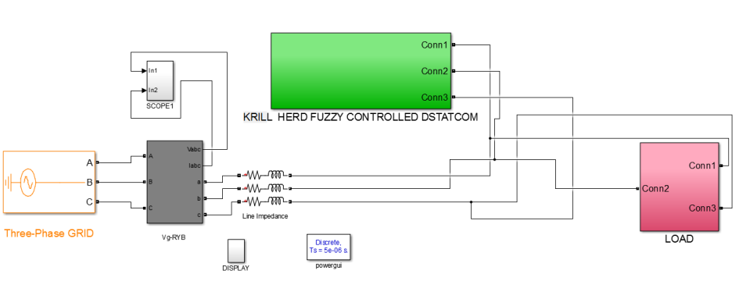

**Fig. 6. Simulink Model of Grid Connected KH-F Controller**

The Krill herd search starts without having any information about optimal solution, high random search property of Krill discover local optimal value of DC link voltage the simulation model is has shown in Figure 6, and also by setting the optimal value in lowest quantity the Krill herd algorithm lay emphasis on manipulation of optimal value using local search[12] . The fuzzy controller is used has tuner to tune between the investigating and manipulation and hence gives the best values. The THD get reduced with combination to 0.03% as shown in Figure 7. The grid voltage and grid current is shown in Figure 8 shows the Gating Signal S1, S2 and S3 applied to the Voltage source Inverter with DC Voltage from KH-F Controller[13] .

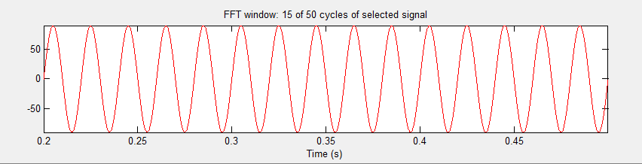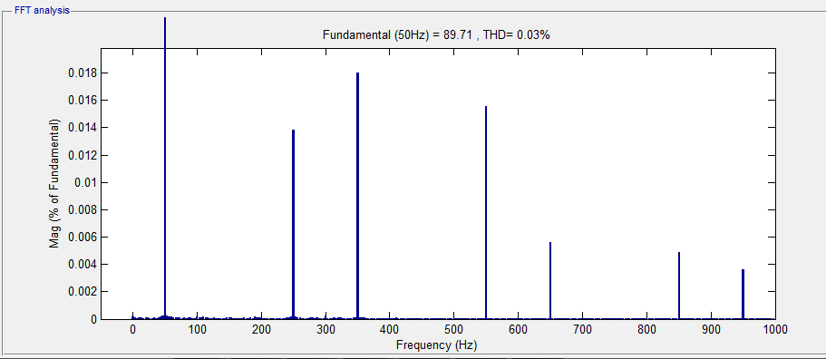

**Fig. 7. FFT of Source Current with KH-F Controller**

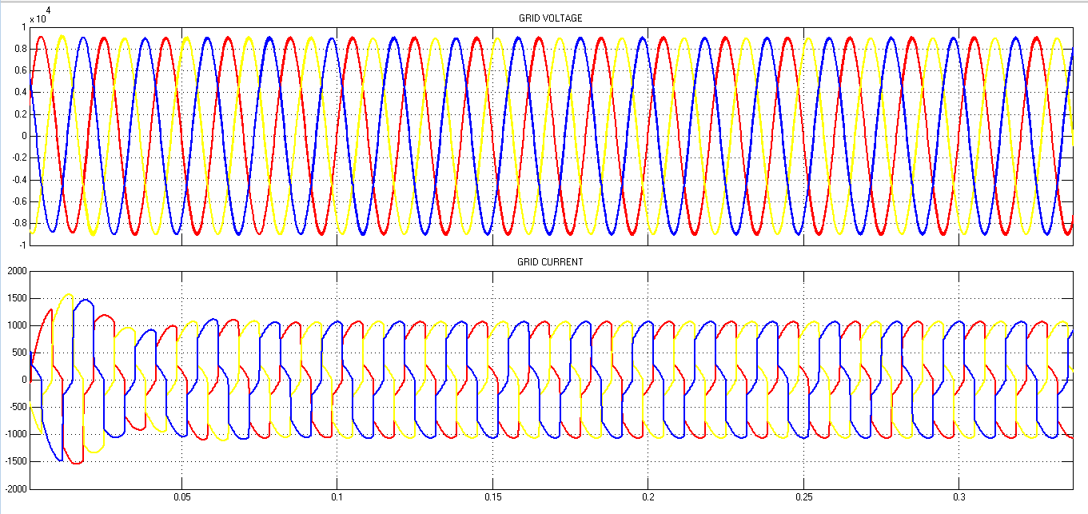

Fig. 8. Grid Voltage and Grid Current with KH-F Controller

**4. Fuzzy Logic Based Effective Generation Management**

The fuzzy is nothing but “not very clear” or “vague” or “blur”. If there is uncertainty in framing the data then Fuzzy Logic System (FLS) is recommended. The FLS able to consider all the possible values between true or false based on the task to be performed. The fuzzy logic concept was introduced in the year 1920 and it was used in 1965 by Lotfi Zadeh , a Professor of UC Berkeley in California.

The four generation units like 1 Diesel Generator, 1 Grid connection, 1 solar based generation unit and 1 wind based generation unit are considered for simulation purpose. The two thermal unit fuel cost functions are as shown in equation (6) and (7) respectively[14]

F1=0.00486 $P_{g1}^{2}$ +16.09 $P_{g1}$ +1000 (6)

F2=0.00211 $P_{g2}^{2}$ +16.09 $P_{g2}$ +1120 (7)

The tariff for thermal power station is 4.91Rs/Unit. This cost designed comprises of heat rate, fuel rate, capital cost, hot start , cold start and many more.[paper]

Solar Based Generation : Fuel Cost (Direct Cost) is 5.39 Rs/Unit, this cost is referred to cost designed at Shivanasamundra, Mandya district Solar Power Plant. The direct cost or tariff designed take cares of start-up cost, capital cost, penalty cost , reserve cost and many more[15].

4.1 Result of Fuzzy Logic Based Effective Generation Management

Wind Based Generation: Fuel Cost (Direct Cost) is 3.0 Rs/Unit, this also comprises start-up cost, capital cost, penalty cost , reserve cost and many more. The aforesaid generation units are managed using dynamic programming and fuzzy logic system. The system constraints and unit constraints like power balance constraint, generation limit and ramp up and ramp down constraints respectively are framed and satisfied. The two different scripts are coded for Dynamic Programming Approach as well as Fuzzy Logic System for cost comparative purpose.

Case 1:

**Table 1.Generator 3 and 4 connected**

|  |  |  |  |
| --- | --- | --- | --- |
| **Sl. No.** | **Generation Unit** | **Pmin in MW** | **Pmax in MW** |
| 1 | 1 | 0 | 0 |
| 2 | 2 | 0 | 0 |
| 3 | 3 | 10 | 20 |
| 4 | 4 | 10 | 35 |

**Table 2. Dynamic Programming Generating Unit Combination and Cost Incurred for Case 1 Generator Data and Demand**



**Table 3. :Fuzzy Logic System Generating Unit Combination and Cost Incurred for Case 1 Generator Data and Demand**



**Case2:**

**Table 4.Generator1,2, 3 and 4 connected**

|  |  |  |  |
| --- | --- | --- | --- |
| **Sl. No.** | **Generation Unit** | **Pmin in MW** | **Pmax in MW** |
| 1 | 1 | 15 | 35 |
| 2 | 2 | 15 | 30 |
| 3 | 3 | 15 | 35 |
| 4 | 4 | 15 | 30 |

**Table 2. Dynamic Programming Generating Unit Combination and Cost Incurred for Case 2 Generator Data and Demand**



**Table 3. :Fuzzy Logic System Generating Unit Combination and Cost Incurred for Case 2 Generator Data and Demand**



Inference : Compared to case 1 with only solar and wind plants with case 2 having Diesel, Grid as well as two distribution generating plants the cost incurred is reduced. The fuzzy system could able generate feasible generating units.

The four generating units like Diesel unit, Grid units, 1 solar based generating unit and 1 wind based generating unit are considered to obtain the cost effective combination of units using Dynamic Programming and Fuzzy Logic System Two cases 1 and 2 are considered and compared the cost between Dynamic Programming and Fuzzy Logic System. It is found that fuzzy logic system gives most effective combinations of generating units.

**5. Conclusion**

The microgrid developed with power management and power quality improvement using DSTATCOM will support the victims of disaster from lose of electricity supply and will not take days to get grid supply for normal life The output of the microgrid system designed shows the transient developed in the output shows that there is need for power quality improvement.The implementation of power management scheme using using Dynamic Programming and Fuzzy Logic System shows that that fuzzy logic system gives most effective combinations of generating units.and power qulaity improvement a technique for enhancing the performance of DSTATCOM and by designing a control strategies used for calculation of reference current and the triggering circuit designed for firing the circuit.

**References**

1. Dr.Dayananda.K.C, “Analysis of August 2018 Disaster in Kodagu: An Overview”, IOSR Journal Of Humanities And Social Science (IOSR-JHSS) Volume 24, Issue 8, Ser. 4 (August. 2019) 43-48 e-ISSN: 2279-0837, p-ISSN: 2279-0845.
2. Kushal M and Sangita Deb Barman.”Kodagu disaster (Floods - Emphasis on Catchment Fragmentation Index and unscientific land usage) analysis using GIS”. IOP Conf. Series: Earth and Environmental Science 1032 (2022) 012036 IOP Publishing .
3. A. M. Faisal, H. N. Koivo, “System Modeling and Online Optimal Management of Microgrid with Battery Storage”, International Conference on Renewable Energies and Power Qualities (ICREPQ'07), March 2007
4. M. Agrawal, A. Mittal, “Micro Grid Technological Activities across the Globe: A Review”, International Journal of Research and Reviews in Applied Sciences, Vol.7, Issue 2, May 2011
5. Yogesh S. Bhavsar, Prasad V. Joshi, Sonali M. Akolkar, “Simulation of Microgrid with Energy Management System”, 2015 International Conference on Energy Systems and Applications (ICESA 2015) Dr. D. Y. Patil Institute of Engineering and Technology, Pune, India 30 Oct - 01 Nov, 2015.
6. C. M. Colson, and M. Hashem Nehrir, ”Comprehensive Real-Time Microgrid Power Management and Control with Distributed Agents”, IEEE Transactions on Smart Grid, Vol. 4, no. 1, March 2013
7. Rashad M. Kamel, Aymen Chaouachi, Ken Nagasaka,“Three Control Strategies to Improve the Micro grid Transient Dynamic Response During Isolated Mode: A Comparative Study”, IEEE Transactions on Industrial Electronics, Vol. 60, NO. 4, April 2013.
8. Wen LU, Yangdong, Weixing LI, Hongwei DU ,“Design and Application of Micro Grid Operation Control System Based on IEC 61850”, Springer, 2014.
9. Om PrakashMahela , Abdul GafoorShaik,”Power quality improvement in distribution network using DSTATCOM with battery energy storage system”,Electrical Power and Energy Systems 83 (2016) 229–240.
10. YadaiahCh , S.K. Goswami , DebashisChatterjee ,”Effect of network reconfiguration on power quality of distribution system”,Electrical Power and Energy Systems 83 (2016) 87–95.
11. Amir H. GANDOMI, Amir H. ALAVI,” An Introduction Of Krill Herd Algorithm For Engineering Optimization”, Journal of Civil Engineering and Management,ISSN 1392-3730 / eISSN 1822-3605,2016 Volume 22(3): 302–310
12. Gokulakrishn and Govindaraghavan, Ramesh Varadarajan,“Hybrid KHSO Based Optimal Location and Capacity of UPFC for Enhancing the Stability of Power System”,Journal of Science, GU J Sci, Part A, 5(4): 141-157 (2018)
13. Prof.AbhishekW.Bankar , Prof. SandeshShete, “Power Quality Improvement by SRF Based Control Using D-STATCOM”, International Research Journal of Engineering and Technology (IRJET), ISSN: 2395-0072, Volume 04 Issue, 06 June -2017.
14. Xiaoyue Zhao and Xinyan Zhang, “Artificial Intelligence Applications in Power System”,Advances in Intelligent Systems Research, Volume 133, 2016.
15. DánielDivényi, and András M. Dán,”AgentBased Modeling of Distributed Generation in Power System Control”, IEEE Transactions On Sustainable Energy, 2013