IoT Based Monitoring of Dual Axis Tracker Fed PV System
R. R. Ramya^{1*}, J. Banumathi²
¹ Research Scholar, Department of Information Technology, University College Of Engineering, Nagercoil, India. ramyarr628@gmail.com
²Assistant professor, Department of Information Technology, University College of Engineering, Nagercoil, Tamilnadu, jbanu85@yahoo.co.in.

ABSTRACT
We are currently living in a new era of modernism known as the Internet of Things (IoT). In this proposed system, the performance and monitoring of solar energy are significantly improved by using the IoT. It is a method for monitoring solar panel performance to provide the most power for active use. To trap maximum energy from PV, dual axis solar tracker is used. The strongest feature of these trackers is their ability to travel in all directions, which allows them to track the Sun's motion for longer while also supplying more energy. They don't hold off until the sun's rays touch the panels. Instead, during the day, the panels move in sync with the Sun. The DC-DC converter equipped with an MPPT controller is necessary to increase the PV cell's utilization efficiency. In this system, a SEPIC converter is employed to raise the voltage to the desired level with little voltage stress. Moreover, in order to achieve optimal efficiency, Type -2 fuzzy based MPPT approach is employed for tracking the maximum power when solar array module output power changes in case of sun insolation and temperature fluctuation. The proposed system works well in generating high power as well as it enhances the system effectiveness. With the use of MATLAB, the simulation results of the proposed system were obtained. The findings describes that the proposed PV model’s productivity and efficiency have greatly improved compared to conventional approaches
Keywords: Internet of Things (IOT), Dual axis solar tracker, Photovoltaic (PV) panel, Single Ended Primary Inductor Converter (SEPIC) and Type-2 fuzzy based MPPT
1. INTRODUCTION
Renewable energy has effectively attracted a great deal of attention in the world of energy production due to today's rapid population growth, growing standards of living and the enhancement of energy-consuming activities [1]. Solar energy looks to be the most potent kind of renewable energy that is used to create electricity. In most nations, it is almost always accessible from sunrise to dusk. However, due to the shifting spatial distribution of the sunlight, solar power has a restricted capacity for energy production, especially when immovable solar panels are used. In order to optimise the amount of power produced from solar energy, it is critical to ensure that the incident sun rays are always perpendicular to the surface of the solar panel. For the solar panels to produce relatively constant amounts of energy throughout the day, they must consequently change orientation throughout the day to track the sun's location in the sky. Through the use of an automatic solar tracking device, this might be accomplished [2]. At first, fixed-type solar panels constituted the majority of PV systems utilised globally. Due to the solar source’s continuous motion as well as solar panels' inability to absorb all the solar radiation, this system is found to be less efficient. To sort out this problem, an efficient dual axis tracking technique is employed. Dual axis solar trackers have the highest output power and are perpetually dependable and precise [3] while contrasted with single-axis solar trackers.
However, the electrical energy produced by renewable sources is erratic and unpredictable. In these circumstances, the low voltage from the dc source is changed into a greater voltage. According to the literature, a lot of work has been done in the previous years to design and implement extremely efficient DC-DC converters for a variety of applications. The traditional boost converters work at greater duty cycles to achieve large transformation ratios, but this causes significant conduction losses [4]. Hence voltage-lift and switched capacitor converters are used to attain high voltage gain. Nonetheless, the voltage output is the same as the voltage present over the switch and transient switch current causes additional conduction losses [5-7]. With the aid to solve the problem of conduction losses, coupled inductor- based converters were used which produces high voltage gain but it involves some flaws that, leaking of energy creates greater voltage notches on the switch [8] and necessitates the use of an additional clamping circuit to recycle the energy. To reclaim leaked power, a number of step-up converters having active clamp circuits are employed. However, due to the increased cost of converter, its usage is limited in wide range of applications [9]. This proposed system was employed with SEPIC converters to guarantee both high and low voltage stresses over all parts and switches.
Maximum power point tracking needs to be managed in order to reduce transient time, power fluctuations, and increase efficiency. This is performed through regulating the switching components of the DC-DC converter, whereby the load receives energy from the PV panel. The P&O algorithm is a commonly used conventional method of tracking MPP. The drawback, however, is the deviation from MPP when a sudden weather change takes place and will fail to monitor MPP, which results in an energy loss [10]. Utilising modified incremental conductance, energy loss is avoided. However, it suffers from flaws such as slow convergence to reach the ideal point and substantial oscillation around the MPP in steady state [11]. Therefore, this system suggests an MPPT (maximum power point tracking) solution based on a fuzzy type-2 controller to address these issues. One of the most well-liked controllers created in recent years [12], the Type 1 fuzzy logic controller, is utilised to produce great performance of the system in both transient and steady-state settings. However, larger levels of uncertainty, disruptions, and parameter alterations in the system render Type 1 fuzzy logic controller unable to perform successfully. In light of this, a Type-2 fuzzy logic controller is suggested. Type-2 fuzzy sets are used to more effectively model ambiguity and inaccuracy due to their increased effectiveness and resilience to abrupt changes in external variations.
The Internet of Things is an age of change that the world is entering right now, one in which anything is available online. An IOT-based system for observing the solar energy is given in this suggested system. IOT-based solar energy monitoring aims to maximize the outcome energy of the solar arrays. When photovoltaic cells process sunlight into electricity, voltage and current sensors are employed to record their output parameters. The obtained outputs are represented on the display screen using IOT technology. With the use of this technology, the working of the solar panel is tracked and even spot issues before they become serious.
2. RELATED WORKS
Yousif et al [12] discusses the functioning prototype created using an embedded framework and automatic dual axis sun tracker that was custom developed. This prototype has undergone extensive testing in order to determine and approve its global functionality. The developed method successfully generates the largest amount of energy output from PV panels anywhere in the world with an appropriate tracking precision. Only 0.62% to 0.68% of the energy gain was used to power the working energy of the developed tracking system. The system is adaptable and can accommodate huge solar cells having few adjustments needed, that entails replacing the motor driving components and panel actuators.
Rasool et al [13] discusses the proposed P&O algorithm to stop PV power from oscillating around the peak point. The programme successfully recognises oscillation and adds a boundary constraint to stop it from diverging from the MPP. By increasing efficiency under both slow and fast irradiance changes, the suggested P&O algorithm performs better under dynamic irradiance changes. It has been demonstrated that under a variety of environmental conditions, the suggested P&O algorithm could track the irradiance profile with little variation from MPPs. As a result, more power loss is reduced and tracking accuracy is improved, but this system still needs to be improved for quick convergence at the operational point.
Nishant et al [14] examines maximum power harvesting (MPH) via solar panel arrays using an incremental conductance approach featuring embedded choice-making and evolution capabilities. Three sequential points of execution grounded in the power and voltage features form the foundation of the self-adapting incremental conductance algorithm's function. Such points intelligently locate the maximum power peak (MPP) zone both under dynamic and regular conditions. High system efficiency is achieved by the algorithm's quick and effective convergence to the MPP. When the PV module works close to local maxima or minima of the voltage-current characteristic, the algorithm could not function properly.
Mohammed et al [15] presents a novel transformer-free buck boost dc-dc conversion device. Given buck-boost converter has a straightforward structure. The suggested converter uses a single main switch, which lowers the power switch's conduction loss and increases efficiency. The suggested buck-boost converter having a reduced voltage stress over the switch with an enhanced step-up voltage gain but due to the irregularity of output capacitor's charging current, it results in a larger output capacitor and EMI issues,
Abdul et al [16] demonstrates a flexible DC chopper with high dependability that is effective for MVDC (Medium-voltage DC) grids operations. When using the suggested converter, every power unit is established and operated to carry power between the mains supply to the load using two microscopic film capacitors. This aspect avoids the requirement for large capacitors with electrodes having a tendency to fail frequently and temperature sensitivity, however the primary downside of the Cuk converter lies in the switch's high current stress.
3. PROPOSED SYSTEM
3.1 Description of the system
Traditional energy sources are becoming scarce due to the rising demand for energy hence it is vital to switch to non-conventional energy sources. Solar power being a limitless resource that can be readily harnessed from various locations throughout the globe and transformed into electrical energy utilising gadgets like PV arrays. But the resultant energy produced by these solar cells becomes unstable because solar source travels from eastward towards the westward and its incident angle changes. To maximize the production of power out of the photovoltaic array, dual axis tracker that spins the panel along its two main axes, is needed. This method guarantees effective sun tracking and maximum solar panel power generation.
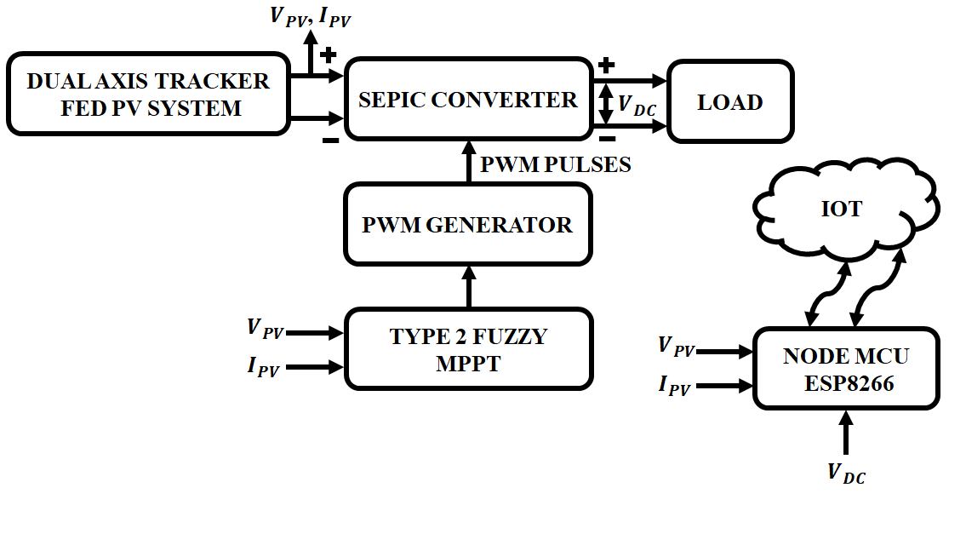
Figure 1: System block representation
Due to varying climatic condition, the output from PV panel is not constant and the produced output power is low. A DC-DC converter is necessary to boost the voltage towards the intended range in order to meet the load demand. The SEPIC converter is used with type-2 fuzzy logic based MPPT to monitor the maximum power from PV. In the case of partial shadowing and irradiation mismatch, the aforementioned design permits devices to increase green energy generation. To keep track of the generated energy and ensure that it is always at its highest level, this device is linked to the IOT. The sensors are used to detect the outputs of voltage and current and the sensed output is stored in the cloud via the Node MCU (Microcontroller Unit) ESP8266. This microcontroller comprises the LCD display to show the voltage and current’s resulting readings. By this approach, the resulting voltage and current is monitored and the adjustments are made if the voltage drop occurs.
3.2 Dual Axis Solar Tracker
DAST is a tool that increases the efficiency of converting sources of clean energy by maximizing the incident angle among the panels and the solar source. To maximize the electricity production, the device is intended to spin the PV arrays with respect to the solar source by sensing its movement across the sky. Dual-axis solar tracking devices use the sun's azimuth and elevation angles to determine the position of the sun. While the solar elevation angle is determined between the horizon and the solar source’s center, the solar azimuth angle is the horizontal angle involving the observer's vantage point and the sun's vertical plane.
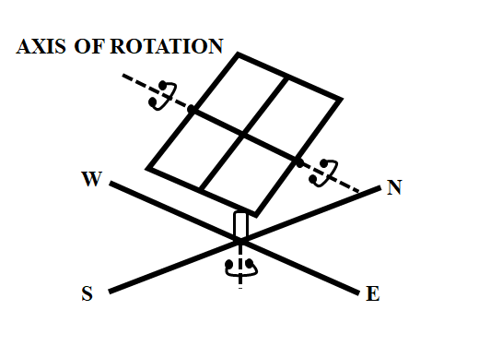
Figure 2: Dual axis tracking PV array
Solar elevation angle
The elevation angle that is frequently employed simultaneously with altitude angle represents the measurement of the solar source’s angular height in the atmosphere starting at the flat plane. At dawn, the elevation is 0 degrees, and at noon, it is 90 degrees. The latter is referred to as maximum elevation angle and is a crucial factor in the structure of solar systems. Location of certain spot and the day both affect the angle of elevation that varies over the day. The expression in equation 1 is used to calculate the elevation.
$β_{s}=\sin^{-1}{(\cos{γ\cos{δ}}}+\sin{δ\sin{ϕ}})$ (1)
Where γ is the hour angle, the local latitude ϕ, as well as earth’s declination angle is indicated by δ.
Solar azimuth angle
The compass's orientation is indicated by the azimuth angle, in which the sun's rays are projected onto the horizontal plane in relation to true north. The solar azimuth angle (0°) results from the fact that the sun stays pointing south at the noon hour in the northern part of the globe. Azimuth angle fluctuates throughout the day. The sun rises perfectly from the east and sinks exactly to the west, no matter what latitude, therefore the azimuth angles at the beginning and end of the day are 90° and 270°, correspondingly, at the equinoxes. Using the expression in equation (2), the solar azimuth angle is calculated.
$α_{s}=\cos^{-1}{[\frac{\sin{δcosϕ-cosγcosδ\sin{ϕ}}}{\cos{β_{s}}}}]$ (2)
The dual axis tracker device follows the sun's path and positions the photovoltaic array for optimum generation of electricity.
3.3 SEPIC Converter
Figure 3 depicts the circuit diagram of SEPIC converter. A pair of energy-storing inductors L1 and L2 and switch, "S," are utilized in this converter. C1, C2, and C0 are capacitors, whereas D1, D2, and D0 are diodes.
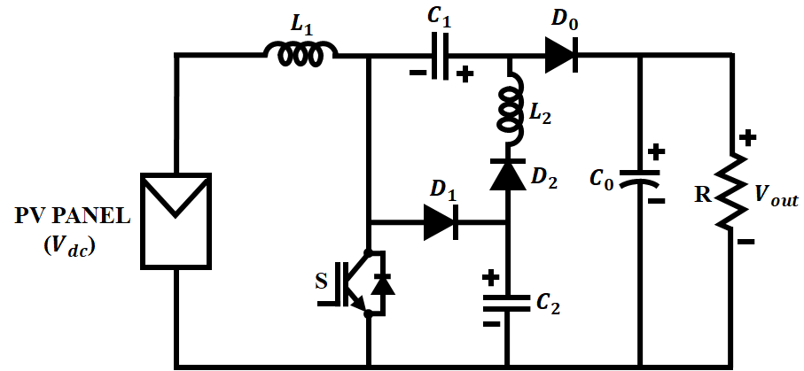
Figure 3: Circuit diagram of SEPIC Converter
3.3.1 Operation in Mode 1
When operating in mode 1, Switch "S" as well as diode D2 are in the conducting state. The output side diode D0 and the diode D1 are both operating in reverse bias mode. In the suggested converter, a PV panel serves as an input source of Vdc. It transfers its energy to the L1, C1, C2, and L2. The input source "Vdc" delivers energy to the inductor L1 and L2. The output capacitor C0 that allows energy to be simultaneously discharged to the load. This operation is depicted in figure 4.
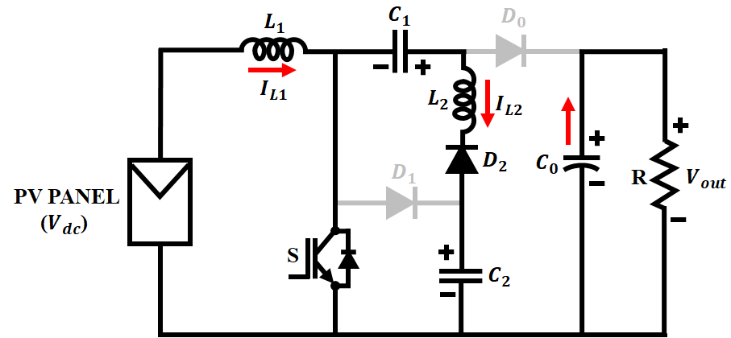
Figure 4: Mode 1 operation of SEPIC Converter
3.3.2 Operation in Mode 2
When operating in mode 2, diodes D1 and D0 have been conducting since the start of the interval. During this mode, diode D2 and the active switch "S" are both in the OFF position. Both the inductor L1 and the output capacitor C0 discharge their energy to the capacitor C1 and the diode D0, respectively. The mode-II operation is shown in Figure 5.
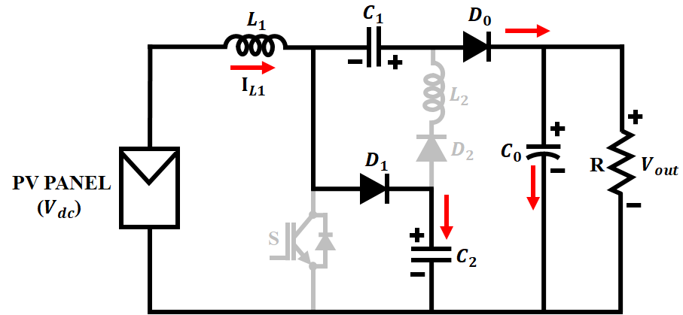
Figure 5: Mode 2 operation of SEPIC converter
3.3.3 Mathematical modelling of SEPIC Converter
Voltage of capacitor $C_{1}$ is given by,
$V_{c1}-V_{c1}D-V_{dc}D=0$ (2)
$V_{c1}-V_{c1}D=V_{dc}D$ (3)
$V_{C1}=\frac{DV_{dc}}{1-D}$ (4)
Voltage of capacitor $C_{2}$ is given by
$V_{c2}-V_{c2}D-V_{dc}=0$ (5)
$V_{c2}-V_{c2}D=V_{dc}$ (6)
$V_{c2}=\frac{V_{dc}}{1-D}$ (7)
Overall converter output gain is provided by
$V_{0}-V_{0}D-V_{dc}-V_{dc}D=0$ (8)
$V_{0}-V_{0}D=V_{dc}+V_{dc}D$ (9)
$\frac{V_{0}}{V_{dc}}=\frac{1+D}{1-D}$ (10)
With minimal voltage stress, the SEPIC converter increases voltage gain. To monitor the maximum power from PV in the event of partial shadowing and irradiation mismatch, the SEPIC converter is employed with type-2 fuzzy logic based MPPT.
3.4 Type-2 fuzzy logic based MPPT
Harvesting highest possible quantity of electrical power is crucial when attempting to increase the effectiveness of power transformation in PV solar panels. This system's dc-dc converter is controlled by the T2FLC that includes the advantage of being robust and does not need an in-depth knowledge about the device's computational framework. The suggested approach also provides a superior reaction to any solar cell disruptions. This method works well with nonlinear systems.
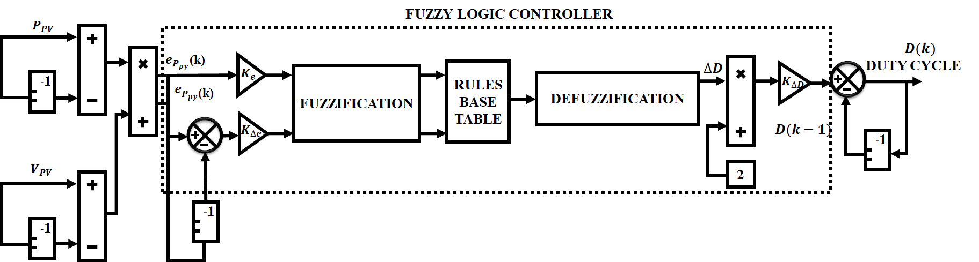
Figure 6: Type-2 fuzzy based MPPT
The error of the power PV generator and changes to this error are taken as input variables to the MPPT-type2 fuzzy logic and its formula is as follows:
$e_{pv}\left(k\right)=K_{pv}\frac{P_{pv}\left(k\right)-P_{pv}(k-1)}{V_{pv}\left(k\right)-V_{pv}(k-1)}$ (11)
$∆e_{pv}\left(k\right)=K_{∆pv}(e_{pv}\left(k\right)-e_{pv}(k-1)$ (12)
Where $\left(K_{pv}\right), (K_{∆pv})$ represents the normalization gains of errors and variation of errors
Seven fuzzy sets are utilised to change these errors and their variations into linguistic variables. The seven fuzzy sets are represented as Positive big (PB), positive small (PS), Negative big (NB), Negative small (NS), medium positive (PM), medium negative (PN) and zero (ZE). As shown in table 1, a decision table with 49 rules are produced by using seven fuzzy levels for the inputs and output.

Table 1: Fuzzy rules
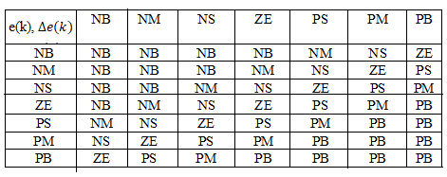
Each rule represents an operational state in the inference system and executes the necessary control action. The output variable is the duty cycle change, which is calculated using the centre of gravity relationship shown below.
$∆D=\frac{\sum_{i=1}^{49}{μ_{i}\left(D_{i}\right). D_{i}}}{\sum_{i=1}^{49}{μ_{i}(D_{i})}}$ (13)
Where the duty cycle is represented as D and$∆$𝐷 is the duty cycle variation.
Type-2 fuzzy logic more efficiently extracts the maximum power from PV modules, eliminates fluctuations, and reacts quickly to changes in solar irradiance.
4. RESULTS AND DISCUSSION
To examine its effectiveness under various operating situations, the proposed technique is thoroughly tested and simulated using MATLAB. The simulation is modelled using the parameter specifications in Table 2 and considers the impact of temperature and irradiance, which are crucial elements impacting the effectiveness and stability of the system. A thorough knowledge of the proposed approach's robustness and flexibility is examined under solar panel’s dynamic and steady state condition.
Table 2: Parameter specification
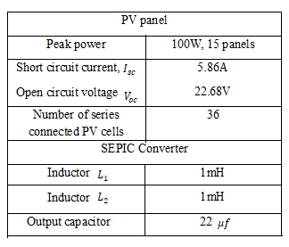

i) At Varying Solar Panel Temperature and Intensity
The solar panel varying temperature and irradiation waveform are illustrated in 7(a) and 7(b) accordingly. The temperature waveform varies from ${25}^{o}C$to ${35}^{o}C$ and the irradiation waveform varies from 800 to 1000$W/M^{2}$.
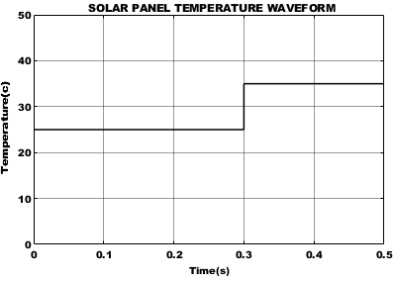
Figure 7(a): Temperature waveform of solar panel
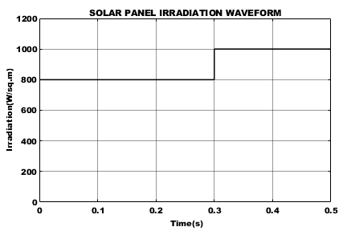
Figure 7(b): Irradiation waveform of solar panel
The variation in the irradiance and temperature resulted in noticeable changes in the PV system's current and voltage waveform outputs, as seen in Fig. 8. The voltage waveform varies from 40 to 48V and the current waveform is maintained constant at 0.8A after slight fluctuation at 0.3s.
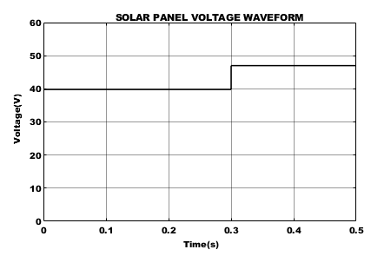
Figure 8(a): Voltage waveform of solar panel
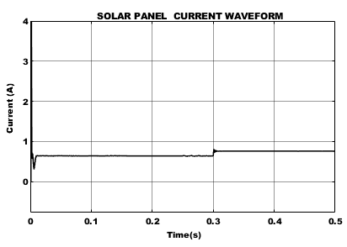
Figure 8(b): Current waveform of solar panel
The output converter voltage and current waveforms are shown in figure 9(a) and (b) respectively. The waveforms of the converter undergoes slight variation in the initial stage and after that the converter voltage and current are maintained constant at 300V and 0.2A respectively.
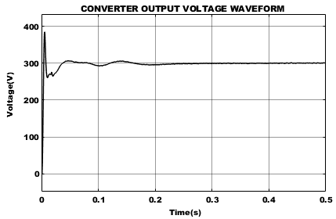
Figure 9(a): Output voltage waveform of converter
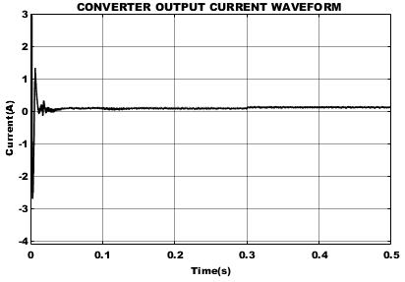
Figure 9(b): output current waveform of converter

ii) At Constant Solar Panel Temperature and Intensity
The constant temperature and irradiation waveform are represented in figure 10(a) and (b) correspondingly. The solar temperature is maintained at ${35}^{o}C$ and irradiance at 1000$W/M^{2}$.
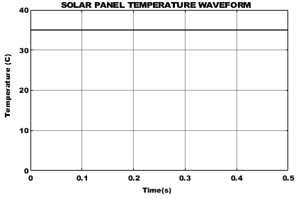
Figure 10(a): Solar panel constant temperature waveform
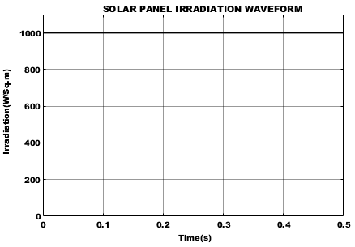
Figure 10(b): Solar panel constant irradiation waveform
The solar panel voltage and current waveform under constant temperature and irradiation is represented in figure 11(a) and 11(b) respectively. It is noticed that the voltage waveform on the solar panels is kept consistent at 48V and current waveform at 0.8A.
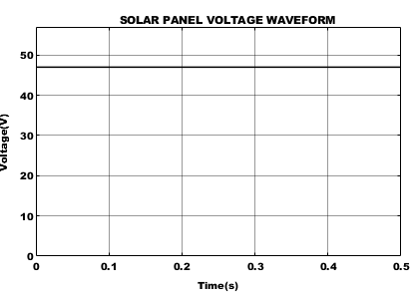
Figure 11(a): constant voltage waveform of solar panel
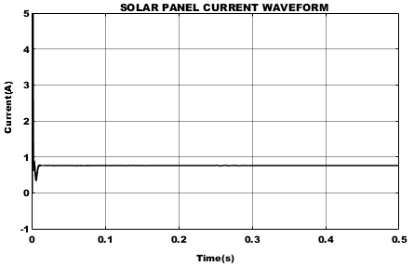
Figure 11(b): Constant current waveform of solar panel
It is clear that, when the temperature and light exposure are constant, the solar panel voltage and currents tends to be in the state of constant mode which in turn the output tends to fluctuate in case of varying conditions. The converter output voltage and current waveform under constant state are depicted in figure 12(a) and 12(b) respectively.
Figure 12(a): voltage waveform of converter output
Figure 12(b): Current waveform of converter output
The comparison of MPPT tracking efficiency is shown in figure 13. Making use of type-2 fuzzy logic, the tracking efficiency is improved with 98% compared to controllers such as Perturb and observe, modified incremental conductance as Well as type-1 fuzzy logic based MPPT. It achieves high efficiency in tracking the MPP when PV is exposed to external disturbances such as varying temperature and irradiation.
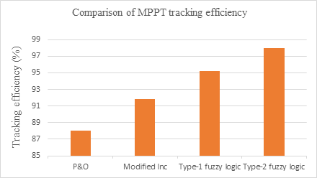
Figure 13: Comparison of MPPT tracking efficiency
Table 3 Comparison of proposed method with other MPPT techniques
Type | Perturb and Observe (P&O) | Modified Incremental conductance | Type-1 fuzzy logic | Type-2 fuzzy logic
Tracking speed | Slow | Fast | Fast | Very fast
Tracking accuracy | Low | Accurate | Accurate | Highly accurate
Steady state oscillation | High | Low | Zero | Zero
Power efficiency | High (uniform insolation)  Low (partial shading condition | Medium | High | Very high
Dynamic response | Poor | Good | Good | Good
Tracking efficiency (%) | 88 | 91.8 | 95.2 | 98

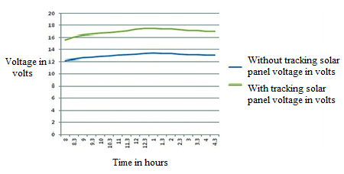
Figure 14: Comparison of solar panel voltage without and with tracking
The graph in Figure 14 compares the solar panel voltage with and without tracking. Green line indicates solar panel voltage value with tracking, while blue line indicates solar panel voltage value without tracking. With tracking, the solar panels' voltage is high.
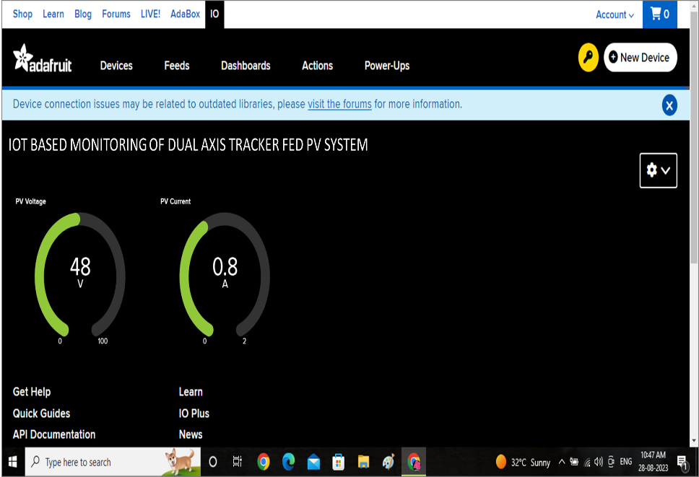
Figure 15: Display output using IOT
Figure 16 displays the output current and output voltage as seen through IOT. User can use this for monitoring the output energy and make sure it is constantly at its highest level.
5. CONCLUSION
The proposed system implements the IOT based monitoring of dual axis tracker fed PV system. Using a dual-axis solar tracker is a great technique to increase the efficiency of solar panels. The design provides a cheap, easily constructed gadget that enhances the effectiveness of solar energy. Solar panel is positioned for optimal energy output using technology that follows the sun's course. The system uses IOT to monitor PV array's output power and notify the individual if alterations are necessary. DAST provides an efficient means that increase the amount of electricity that PV panels produce and lessen the need for conventional energy sources. Moreover, the SEPIC converter is used along with the type-2 fuzzy based MPPT to achieve optimal efficiency in case of varying climatic conditions. The Type-2 fuzzy based MPPT tracking achieves high efficiency of 97.2%. The proposed system outperforms the other conventional approaches in tracking the efficient energy output from PV.
REFERENCES
- Rajvikram Madurai Elavarasan, G.M. Shafiullah, Sanjeevikumar Padmanaban, Nallapaneni Manoj Kumar, Annapurna Annam, Ajayragavan Manavalanagar Vetrichelvan, Lucian Mihet-Popa, Jens Bo Holm-Nielsen 2020, “A Comprehensive Review on Renewable Energy Development, Challenges, and Policies of Leading Indian States With an International Perspective”, IEEE Access, vol. 8, no. 4, pp. 74432-74457.
- Carlos D. Rodríguez-Gallegos, Oktoviano Gandhi, S. K. Panda, Thomas Reindl 2020, “On the PV Tracker Performance: Tracking the Sun Versus Tracking the Best Orientation”, IEEE Journal of Photovoltaics, vol. 10, no. 9, pp. 1474-1480.
- Mahdi Saeedi, Reza Effatnejad 2021, “A New Design of Dual-Axis Solar Tracking System With LDR Sensors by Using the Wheatstone Bridge Circuit”, IEEE Sensors Journal, vol. 21, no. 7, pp. 14915-14922.
- Seok-Kyoon Kim 2019, “Output Voltage-Tracking Controller With Performance Recovery Property for DC/DC Boost Converters”, IEEE Transactions on Control Systems Technology, vol. 27, no. 5, pp. 1301-1307.
- Alireza Rajabi, Amirhossein Rajaei, Vahid Moradzadeh Tehrani, Payman Dehghanian, Josep M. Guerrero, Baseem Khan 2022, “A Non-Isolated High Step-Up DC-DC Converter Using Voltage Lift Technique: Analysis, Design, and Implementation”, IEEE Access, vol. 10, no. 1, pp. 6338-6347.
- Farzad Mohammadzadeh Shahir, Ebrahim Babaei, Murtaza Farsadi 2018, “Voltage-Lift Technique Based Nonisolated Boost DC–DC Converter: Analysis and Design”, IEEE Transactions on Power Electronics, vol. 33, no. 7, pp. 5917-5926.
- Masatoshi Uno, Kazuki Sugiyama 2019, “Switched Capacitor Converter Based Multiport Converter Integrating Bidirectional PWM and Series-Resonant Converters for Standalone Photovoltaic Systems”, IEEE Transactions on Power Electronics, vol. 34, no. 2, pp. 1394-1406.
- Gang Wu, Xinbo Ruan, Zhihong Ye 2018, “High Step-Up DC–DC Converter Based on Switched Capacitor and Coupled Inductor”, IEEE Transactions on Industrial Electronics, vol. 65, no. 7, pp. 5572-5579.
- K. I. Hwu, Y. T. Yau 2014, “High Step-Up Converter Based on Coupling Inductor and Bootstrap Capacitors With Active Clamping”, IEEE Transactions on Power Electronics, vol. 29, no. 6, pp. 2655-2660.
- M. A. Elgendy, B. Zahawi, and D. J. Atkinson 2016, “Operating characteristics of the P&O algorithm at high perturbation frequencies for standalone PV systems,” IEEE Trans. Energy Convers., vol. 30, no. 1, pp. 189–198.
- K. S. Tey and S. Mekhilef 2014, “Modified incremental conductance MPPT algorithm to mitigate inaccurate responses under fast changing solar irradiation level,” Solar Energy, vol. 101, no.1, pp. 333–342.
- Avinash Kumar Pandey, Varsha Singh, Sachin Jain 2023, “Maximum Power Point Tracking Algorithm Based on Fuzzy Logic Control Using P-V and I-V Characteristics for PV Array”, IEEE Transactions on Industry Applications, vol. 59, no. 7, pp. 4572-4583.
- Yousif R. Al-Saadi, Monaf S. Tapou, Areej A. Badi, Shahab Abdulla, Mohammed Diykh 2022, “Developing Smart Self Orienting Solar Tracker for Mobile PV Power Generation Systems”, IEEE Access, vol. 10, no. 8, pp. 79090-79099.
- Rasool Kahani, Mohsin Jamil, M. Tariq Iqbal 2023, “An Improved Perturb and Observed Maximum Power Point Tracking Algorithm for Photovoltaic Power Systems”, Journal of Modern Power Systems and Clean Energy, vol. 11, no. 4, pp. 1165-1175.
- Nishant Kumar, Ikhlaq Hussain, Bhim Singh, Bijaya Ketan Panigrahi 2018, “Self-Adaptive Incremental Conductance Algorithm for Swift and Ripple-Free Maximum Power Harvesting From PV Array”, IEEE Transactions on Industrial Informatics, vol. 14, no. 5, pp. 2031-2041.
- Mohammad Reza BanaeiH, ossein Ajdar Faeghi Bonab 2017, “A Novel Structure for Single-Switch Nonisolated Transformerless Buck–Boost DC–DC Converter”, IEEE Transactions on Industrial Electronics, vol. 64, no. 1, pp. 198-205.
- Abdulgafor Alfares, Brad Lehman, Mahshid Amirabadi 2022, “A Ćuk-Based Modular DC–DC Converter For Medium Voltage Direct Current (MVDC) Applications”, IEEE Open Journal of Power Electronics, vol. 3, no. 8, pp. 560-573.

