OPTIMIZATION AND BIO-SYNTHESIS OF C. OVALIFOLIUMMEDIATED NICKEL OXIDE NANOPARTICLES
Dr.G.Dayana Jeyaleela* Ms. L. Raveena
Assistant Professor, II-M.Sc Chemistry,
PG & Research Department of Chemistry, PG & Research Department of Chemistry,
St.Joseph’s College (Autonomous), St.Joseph’s College (Autonomous),
Affiliated to Bharathidasan University, Affiliated to Bharathidasan University,
Tiruchirapalli-2, Tamilnadu, India Tiruchirapalli-2, Tamilnadu, India

Corresponding Autor’s Email ID: princedayana1221@gmail.com
ABSTRACT
If the synthesis of new chemical entities a greater attention for a medical plant and biomolecular it has a fantastic use and many feels such as a pharmaceutical company’s nanotechnology cosmetic industries and the corrosion fields the main purpose biosynthesis of zinc oxide nano particle. The main aim of the research is to optimize and synthesis of nickel oxide nanoparticles using medicinal plant C. ovalifolium extract. The factor major influencing the synthesis of nanoparticles are concentration of the precursor, additive concentration, precursor – additive ratio, pH, time and the temperature. In the optimization process these factors are screened and based on the optimization results, the bulk synthesis of nickel oxide nanoparticles was carried out. From the optimization results, it concluded that the best combination for the C. ovalifolium mediated nickel oxide particles is 1:4, the suitable precursor concentration is 0.1M, the pH range is 4 and favorable the temperature is 40ºC. The synthesized nickel oxide nanoparticles were characterized by UV-Visible, FT-IR, SEM, XRD and EDX.
Key words: Melia Dubia, Nickel oxide Nanoparticles, Optimization, Synthesis
- INTRODUCTION
Nanotechnology is an interdisciplinary field that integrates knowledge from several disciplines like chemistry, physics, biology, and other related fields. Nanotechnology is an interdisciplinary field encompassing the manipulation and regulation of matter at the atomic or molecular scale. This technology has significant promise regarding its potential impact on environmental conservation. The domain of nanoparticles (NPs) represents a viable avenue for exploring the realm of nanotechnology. This field employs nanoscale materials comprising particles ranging from 1 to 100 nm. Singh and colleagues discovered notable distinctions between nanoparticle (NPs) characteristics and their corresponding bulk counterparts. There are many techniques for producing micron-sized particles including chemical, physical, and biological methods. The chemical method of synthesis may create an enormous volume of nanoparticles in a short time, but it requires capping agents to stabilize the size of the nanoparticles. The nanoparticle production and stabilization process need hazardous chemicals that produce waste that is harmful to the environment. The growing interest in biological methods that eliminate harmful chemicals as byproducts is a result of the demand for environmentally safe synthetic processes for nanoparticle production. Consequently, there is a rising need for "green nanotechnology." currently, numerous biological methods utilizing bacteria, fungi, and plants have been investigated and documented for the fabrication of extracellular and intracellular nanoparticles. Plants serve as a better biosynthesis platform for nanoparticles since they provide natural capping agents and are free of hazardous chemicals. Additionally, using plant extracts lowers the price of microbe isolation and culture media. [1-5].
Nickel oxide nanoparticles are widely used in pharmaceuticals, photonics, chemical sensing, electronic devices, biosensors, and catalysis due to their unique optical, chemical and catalytic properties. The use of nickel oxide nanoparticles in biological applications, such as antibacterial effects, has tremendous potential. Antibacterial properties of nickel oxide nanoparticles make them suitable for usage in a variety of household items, including fabrics, home appliances, food storage containers, and medical devices. Nickel oxide has little toxicity and is a powerful antibacterial agent. Due to their appealing physiochemical features, nickel oxide nanoparticles have a significant impact on biology and medicine. Since ancient times, nickel oxide-based substances have been utilised for the prevention and treatment of a variety of illnesses, most notably infections. These products are known to have potent inhibitory and bactericidal effects as well as a broad spectrum of antimicrobial activity. [6,7] According to reports, nickel oxide nanoparticles have anti-viral, anti-inflammatory, anti-angiogenesis, and antifungal properties.
The literature evidenced the stem bark extract of the C. ovalifolium is taken orally for the treatment of jaundice and as a medication for snakebite. Similarly, the leaf extract of C. ovalifolium also demonstrated the bacterial activity. In Amravati Maharashtra, a decoction of C. ovalifolium leaves is administered to treat the menstruation issues. It is also used as a source of fiber in South Gujarat, India, and fiber from branches a ideal for firewood and is used to prepare livestock. The vessels are primarily cleaned using the crushed stem as a scrubber. The leaves are utilized as fodder, while the branchlets' fiber is used to produce rope. According to a review of the literature, fruit extract exhibits the positive results on alkaloids and tannins which are present the plant in large quantity. The main aim of the research is to optimize and synthesis of nickel oxide nanoparticles using medicinal plant C. ovalifolium extract. [8]

- EPERIMENTAL METHODS
Our materials are purchased from Ponmani and Co-biochemical suppliers Trichy, India. The precursor Nickel sulphate, Ethanol, and double distilled water is used in the studies. The preliminary phytochemical analysis was done and it was published previously [9] based on the phytochemical profile results, the 70%ethanol solvent is used for the extraction. The C. ovalifolium extract was prepared by percolation method using the 70% ethanol.
Synthesis of nickel oxide nanoparticles was carried out by simple precipitation method. The factor major influencing the synthesis of nanoparticles are concentration of the precursor, additive concentration, precursor – additive ratio, pH, time and the temperature. In the optimization process these factors are screened and based on the optimization results, the bulk amount of nickel oxide nanoparticles was synthesized. Then synthesized NiONPs were confirmed by UV- visible spectroscopy, FT-IR (functional group), SEM (morphology), XRD (elemental analysis), was analyzed. [10-18]
- RESULT AND DISCUSSION
Optimization results:
Additive-Precursor Combination:
In the optimization process initially the additive (C. ovalifoliume xtract) and precursor (nickel sulphate solution) combinations of 1:1, 1:4, 2:3, 3:2, and 4:1 were performed. Addition of excess additive increase the formation of nickel nanoparticles. The combined absorption spectral results of five combinations were given in the figure-1. The 1:1 ratio shows the absorption maximum at 379nm, 2:3 ratio at 383nm, 4:1 and 3:2 ratios at 387nm and 1:4 exhibits highest absorption at 399nm. From the spectral report it is understood that all the combinations shows the absorbance peaks at are shifted to longer wavelength when increase the ratio of additive. The combination 1:4 exhibits highest absorbance peak compare to other combinations.
Figure 1: Optimization of Additive -Precursor combination of NiONPs
Concentration of the Precursor
In this study five different concentration of precursor nickel sulphate are used such as 0.0001M, 0.001M, 0.01M, 0.1M and 1M. The 1:4 combination mixture are prepared in 5 bottles by using the different concentrations of precursor and are named as A, B, C, D and E respectively. The combined absorption spectral results of 5 precursor concentration combinations were given in the figure-2. From the spectral report it is understood that the change of precursor concentration shifts the maximum absorption spectra from 305 to 413nm. Sample E (0.1M) revealed the highest absorption maxima compared to A, C, D and E. This is due to insufficient of reducing agents. In this process the additive ratio is fixed only the concentration of the precursor is changed. At 0.1M concentration reducing reduce maximum nickel element and further increase of concentration of precursor lowers the absorption spectra. From that, the concentration precursor is fixed as 0.1M and it is maintained in throughout the optimization process.
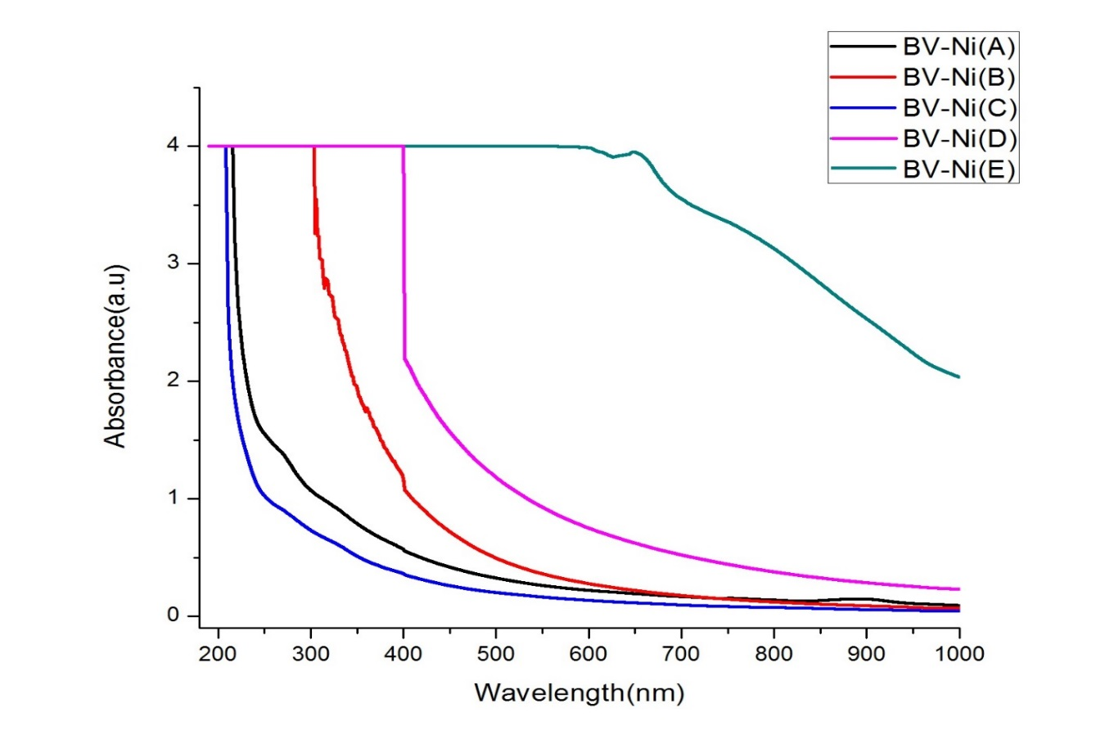
Figure 2: Optimization of Precursor Concentration of NiONPs

pH of the reaction mixture
Since, 1:4 combination favours the nickel nanoparticle formation it is fixed for further optimization process. The 1:4 additive-precursor combination mixture are prepared in 11 bottles. The pH of the normal reaction mixture is found to be 5.3. After 48 hours, one milliliters of each combinations are collected then taken for UV-Visible spectral analysis to confirm the nanoparticle formations. The combined absorption spectral results of 11 pH combinations were given in the figure-3. The change of pH directly affects the stability of the nanoparticles. From the spectral report it is understood that the change of pH from 2 to 12 shifts the absorption spectra from 253 to 320nm. The pH from 6 to 2 there is an increase in wavelengths which is due to the increasing of size of the nanoparticles (the acidic medium favors). Similarly, at above neutral pH i.e. 8 to 12 the wavelength are shifted from higher to lower and are due to decreasing size of the nanoparticles (basic medium). The summarized results shows that, at pH 4 there is an increasing yield of the nanoparticle as well as the maximum absorption than the others.
Figure 3: Optimization of pH of the medium of NiONPs
Temperature of the reaction mixture
Since, 1:4 combination favours the nickel nanoparticle formation it is fixed for further optimization process. The 1:4 additive-precursor combination mixture are prepared in 9 bottles. In the temperature optimization process each bottles are maintained in different temperature as follows 30, 40, 50, 60, 70, 80, 90, and 100. From the spectral report (fig-4) it is understood that the change of temperature shifts the absorption spectra from 263 to 451nm. The temperature at 40ºC, the absorbance is found to be maximum (451nm with 2.6 absorption maximum) warm condition favors the synthesis of nickel oxide nanoparticles.
Figure 4: Optimization of Temperature of NiONPs
Reaction time
The double the amount of 1:4 additive-precursor combination mixture prepared in 100ml beaker. In the time optimization process once additive added to the precursor immediately one ml of sample is taken out from the mixture and analyzed the UV-Visible spectrum. Similarly at the time intervals of 30minutes, 1hour, 2hours and 3 hours the samples were taken out from the reaction mixture and tested its absorption properties. The colour changes is observed during the time interval it is found that when time extended from 0 to 3hours the reaction mixture colour changes from light reddish pink to dark brown with colloidal form. At ‘0’ minutes no reaction is observed and after 30mins the reduction of nickel is taken place and it shows corresponding peak at 260nm and the wavelength increased to 319nm while time increased to 3 hours. The growth and stability of nanoparticles was depended on time. When time increased the quality and the quality of synthesized nanoparticle is found to high.
Figure 5: Optimization of Additive -Precursor combination of NiONPs

Bulk Synthesis of C. ovalifolium mediated Nickel Oxide Nanoparticles:
Based on the optimization results, the bulk synthesis of nickel oxide nanoparticles were carried out. From the above results, it concluded that the best combination for the C. ovalifolium mediated nickel oxide particles is 1:4, the suitable precursor concentration is 0.1M, the pH range is 4 and favorable the temperature is 40ºC. In the bulk synthesis 100ml of 0.1M of nickel sulphate solution is initially taken in the 500ml beaker and kept on the magnetic stirrer with stirring. To this initially 50ml of C. ovalifolium extract is added in drop wise and set the temperature 40ºC then allowed to react for 1 hour on stirrer with continuous stirring and the pH of the medium maintained at 4. Likewise every one hour time interval 50ml of C. ovalifolium extract is added. After complete addition of 400ml of extract the whole reaction mixture is allowed to stirring on magnetic stirrer for 5 hours. Once the reaction is over the whole reaction mixture is stored in reaction chamber for 48 hours. Then, visibly can understand that the nickel nanoparticles were settled in the bottom of the beaker and the unreacted nickel sulphate solution and extract was move to the liquid layer. Finally, the nickel nanoparticles were collected by centrifuging at 6000rpm and collected particles were again washed with double distilled water followed by the methanol to remove the unreacted additive and precursor. In the obtained particles (precipitate) nickel is in the form of hydroxide and to make it into oxide the precipitate is further calcinated at 200ºC at muffle furnace.
Characterization of C. ovalifolium mediated Nickel Oxide Nanoparticles (C. OVALIFOLIUM-NiONPs):
UV-Visible observation of NiONPs
The UV-visible spectra (fig-6) of aqueous extract of C. ovalifolium extract showed the three absorption maxima at 212 nm, 220 nm, and 330 nm which are due to presence of unsaturated double bond or hetero atoms (C=C, S, N, O) in the primary and secondary metabolites of the C. ovalifolium extract. Mostly the metabolites such as anthocyanins, flavonoids, phenolics, terpenoids and alkaloids are present in the C. Ovalifolium extract which are having the above functional and hetero grops. UV-Visible spectroscopy measure the surface plasmon resonance of the nanoparticles in solutions. From the literature it is evidenced that, the nickel oxide nanoparticles shows (fig-7) the plasmon resonance between 350-340nm. The obtained NiONPs revealed the absorption maximum at 390nm which confirms the nickel oxide plasmon resonance and are close agreement with the previous studies. [19-22]
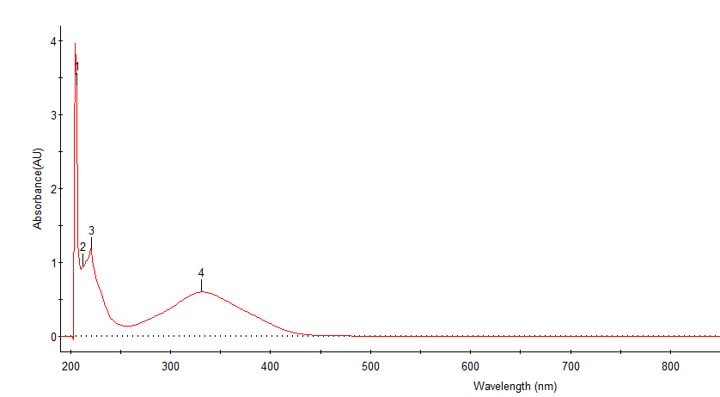
Figure 6: C. ovalifolium Extract UV Image
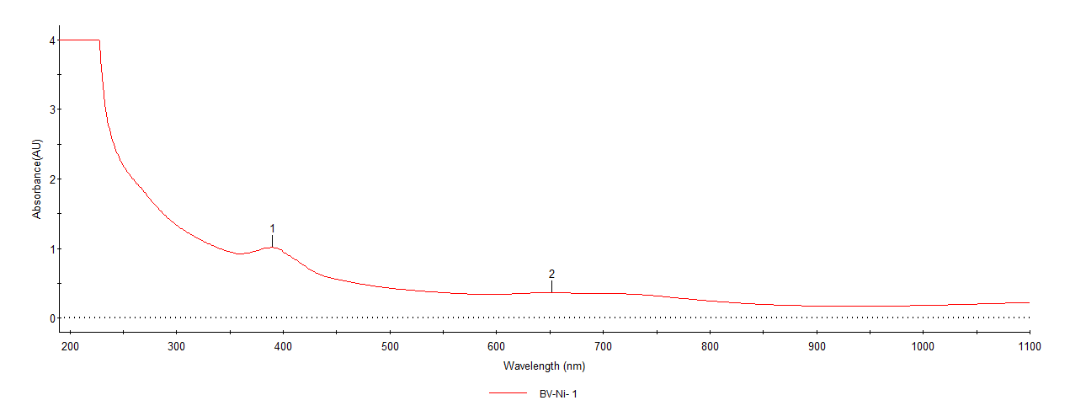
Figure 7: NiONPs UV image
FT-IR of C. OVALIFOLIUM and C. OVALIFOLIUM-NiONPs
The resulted FT-IR data of extract reveals the following functionalities of intermolecular bonding of O-H stretching of alcohol (3409cm⁻¹), C-H stretching of alkanes (2948cm⁻¹, 2864cm⁻¹ & 2840cm⁻¹), S-H stretching of thiol(2522cm⁻¹),C=C stretching of alkene (1648cm⁻¹) , C-H bending of alkane (1453cm⁻¹), S=O stretching of sulfonyl chloride(1412cm⁻¹), C-O stretching of aliphatic ether (1111cm⁻¹), C-O stretching of secondary alcohol (1053cm⁻¹), CO-O-CO stretching (1017cm⁻¹), and C-halogen stretching (655cm⁻¹). Likewise synthesized NiONPs showed the few absorption peak on FT-IR analysis and the observed frequencies are 3432cm⁻¹, 2924 cm⁻¹, 2853cm⁻¹, 1606 cm⁻¹, 1383 cm⁻¹, 1120 cm⁻¹, and 839 cm⁻¹ which are due to O-H stretching of intra molecular bonding of alcohol, C-H stretching of alkane, C-H stretching of aldehyde, C=C stretching of unsaturated ketone, C-H bending of aldehyde, O-H bending of alcohol, C=C bending of alkene and C-X stretching. Similarly the bands at 617 cm⁻¹ (below 650 cm⁻¹) responsible for M-O stretching of metal-oxygen bonds. The combined spectral results of FT-IR reveals that, after forming the nanoparticles the O-H, and C=C frequencies are gets suppressed and the range below 650 cm⁻¹ (M-O bond) the peaks were elongated which confirms the Cu-O metal bonds in the C. ovalifolium mediated nickel oxide nanoparticles. [23-25]
Figure 8: FT IR spectrum of Extract and NiONPs
XRD of C. OVALIFOLIUM-NiONPs
XRD spectral analysis provides the structural and crystalline nature of the synthesized C. OVALIFOLIUM-NiONPs. XRD peaks of obtained C. OVALIFOLIUM-NiONPs showed the 2ϴ values of 36. 54⁰, 41.69⁰, 63.19⁰, and 69.44⁰ which are well agreement with the plane of (111), (200), (220), and (311). The reported XRD peak data with the plane are matches closely with the standard nickel oxide diffraction card JCPDS file number of 48-1548. In addition the average sizes of the C. Ovalifolium-NiONPs was estimated by the Debye-Scherer formula and shapes of the C. Ovalifolium--NiONPs were confirmed as face center cubic. [26-30] Beside that with the assigned peaks some of the unassigned peaks were noticed in the XRD data and are due to the phytocompounds of aqueous extract of C. ovalifolium and which is displayed in the figure-9. The average crystalline size of the C. Ovalifolium--NiONPs is found to be 42.12nm.
Figure 9: XRD pattern of synthesized C. Ovalifolium--NiONPs
SEM images of C. OVALIFOLIUM-NiONPs
The structural and the morphological characterizations of biogenic synthesized C. Ovalifolium-NiONPs nanoparticles were examined with the Scanning Electron Microscope. The accelerating voltage used in the analysis is 15.00kV. The magnifications images of synthesized C. Ovalifolium--NiONPs are shown in the figure10. It is found that the obtained nickel oxide nanomaterials are in polydispered form. The shape of C. Ovalifolium--NiONPs were found at combinations of hexagonal, spherical, and few rectangular shaped morphologies along with the accumulations. This is because various phytochemicals involved in the reduction process of nickel.
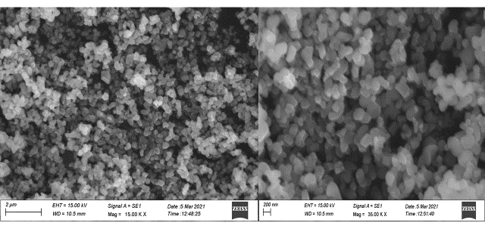
Figure- 4: SEM images of synthesized C. Ovalifolium-NiONPs
EDX of C. OVALIFOLIUM-NiONPs
In qualitatively and quantitatively the elemental composition of the synthesized C. Ovalifolium-NiONPs are screened by the EDX. The resulted EDX images are shown in the figure and can identified that the prominently the nickel peak is reported with the weight percentage of 51.54% followed by oxygen at 43.16% and carbon at 5.3%. The obtained narrow and the strong diffraction peaks of the C. Ovalifolium-NiONPs revealed the high crystalline nature of that. Along with the existed nickel and oxygen peaks some of the impurities peaks also found in the results and are due to the plant pytoconstituents present in the aqueous extract (involved in the M-O complexation). [30-33]
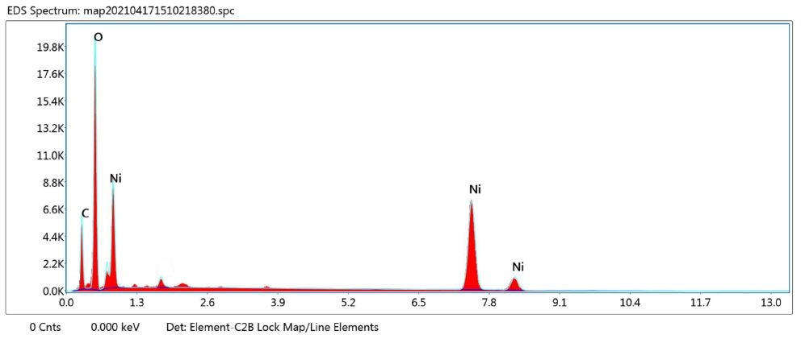
Figure- 4: EDX of synthesized C. OVALIFOLIUM-NiONPs
- CONCLUSION

The synthesized nickel oxide nanomaterial from plant source moreover this is a bio reductive approaches it's effective, simple and ecofriendly in nature. In medicinal values of C.combretum extract is due to biomolecules present in the extract which can reduces the toxicity of nickel in the nickel oxide and it is act as a reducing, capping and stabilizing reagents C. Combretum extract plays important role in a reducing ,stabilizing and capping reagents. In this process the nickel oxide nanoparticles were synthesize by simple homogeneous precipitation method spectroscopy are characterized by UV visible spectroscopy FT-IR, XRD, EDX and SEM analysis. The various application of synthesised nickel nanoparticles is under process. The toxicity and the pharmaceutical potential of combretum ovalifoilum mediated nickel oxide nanoparticle will be studied in future.
REFERNCE:
- V Colvin, M. Schlamp and A. P Alivisatos, Light-emitting diodes made from cadmium selenide nanocrystals and a semiconducting polymer, Nature, 1994, 370, 354-365.
- Y. Wang and N. Herron, Nanometer-sized semiconductor clusters: materials synthesis, quantum size effects, and photophysical properties, J. Phys. Chem., 1991, 95, 525-532.
- G. Schmid, Large clusters and colloids, metals in the embryonic state, Chem. Rev.,1992, 92, 1709-1727.
- A. J. Hoffman, G. Mills, H. Yee and M. R. Hoffman, Q-sized cadmium sulfide: synthesis, characterisation and efficiency of photoinitiation of polymerisation of several vinylic monomers. J. Phys. Chem.,1992, 96, 5546-5552.
- Y. Wang, Nonlinear optical properties of nanometer-sized semiconductor clusters, Accounts Chem. Res., 1991, 24, 133-139.
- H. S. Mansur, F. Grieser, M. S. Marychurch, S. Biggs, R. S. Urquhart and D. N. Furlong, Photoelectrochemical properties of Q-state CdS particles in arachidic acid Langmuir-Blodgett films, J. Chem. Soc. Farad. T., 1991, 91, 665-672.
- S. Panigrahi, S. Kundu, S. Ghosh, S. Nath and T. Pal, General method of synthesis for metal nanoparticles, J. Nanopart. Res., 2004, 6, 411414.
- Mafatlal M Kher and Nataraj M, ―Micropropagation of Combretum ovalifolium Roxb.: a medicinally important plant‖. Rendiconti Lincei-Scienze Fisiche E Naturali, June 2017. DOI 10.1007/s12210-017-0625- z.
- G. Dayana Jeyaleela, J. Rosaline Vimala, T. Anthony Diwakar chandran, A. Benno Susai Vijayakumar, Preliminary Phytochemical Analysis, Antioxidant activity and
- Identification of Bioactive Compound in Stem and Leaf of Combretum Ovalifolium, International Journal of Scientific & Technology Research, 9(3) (2020) 3125-3132.
- B. Sasi, K. G. Gopchandran and P. K. Manoj, Studies on nanocrystalline nickel oxide thin films for potential applications, Mater. Today Proceedings, 2017, 4, 4123-4129.
- S. Sudhasree, A. S. Banu, P. Brindha and G.A. Kurian, Synthesis of nickel nanoparticles by chemical and green route and their comparison in respect to biological effect and toxicity. Toxicol&Environm. Chem., 2014, 96, 743-754.
- N. Gong, K. Shao, W. Feng, Z. Lin, C. Liang and Y. Sun, Biotoxicity of nickel oxide nanoparticles and bio-remediation by microalgae Chlorella Vulgaris. Chemosphere, 2011, 83, 510-516.
- M. P. Abbracchio, J. Simmons-Hansen and M. Costa, Cytoplasmic dissolution of phagocytised crystalline nickel sulfide particles: a prerequisite for nuclear uptake of nickel, J. Toxicol. & Environ. Health., 1982, 9, 663-676.
- O. V. Kharissova, H. V. R. Dias, B. I. Kharisov, B. O. Perez and V. M. J. Perez, The greener synthesis of nanoparticles, Trends Biotechnol., 2013, 31, 240-248.
- R. S. Varma, Greener approach to nanomaterials and their sustainable applications, Curr. Opin. Chem. Eng., 2012, 1, 123-128.
- A. A. Ezhilarasi, J. J. Vijaya, K. Kaviyarasu, L. J. Kennedy, R. J. Ramalingam and H. A. Al-Lohedan, Green synthesis of NiO nanoparticles using Moringaoleifera extract and their biomedical applications: Cytotoxicity effect of nanoparticles against HT-29 cancer cells, J. Photochem. Photobiol. B, Biol., 2016, 164, 352-360.
- M. I. Din, A. G. Nabi, A. Rani, A. Aihetasham and M. Mukhtar, Single step green synthesis of stable nickel and nickel oxide nanoparticles from Calotropisgigantea: Catalytic and antimicrobial potentials, Environ. Nanotechnol. Monitor. &Manag., 2018, 9, 29-36.
- S. Srihasam, K. Thyagarajan, M. Korivi, V. R. Lebaka and S. P. R. Mallem, Phytogenic generation of NiO nanoparticles using Stevia leaf extract and evaluation of their in-vitro antioxidant and antimicrobial properties, Biomolecules, 2020, 10, 89-101.
- N. Behera, M. Arakha, M. Priyadarshinee, B. S. Pattanayak, S. Soren, S. Jha and B. C. Mallick, Oxidative stress generated at nickel oxide nanoparticle interface results in bacterial, membrane damage leading to cell death, RSC Adv., 2019, 9, 24 888-24 894.
- V. Helan, J. J. Prince, N. A. Al-Dhabi, M. V. Arasu, A. Ayeshamariam, G. Madhumitha, S. M. Roopan and M. Jayachandran, Neem leaves mediated preparation of NiO nanoparticles and its magnetisation, coercivity and antibacterial analysis, Results Phys., 2016, 6, 712-718.
- A. Simon-Deckers, S. Loo, M. Mayne-Lhermite, N. Herlin-Boime, N. Menguy, C. Reynaud and M. Carriere, Size, composition-and shape-dependent toxicological impact of metal oxide nanoparticles and carbon nanotubes toward bacteria. Environ. Sci. & technol., 2009, 43, 8423-8429.
- Y. W. Baek and Y. J. An, Microbial toxicity of metal oxide nanoparticles (CuO, NiO, ZnO, and Sb₂O₃) to Escherichia coli, Bacillus subtilis, and Streptococcus aureus, Sci. Total Environ., 2011, 409, 1603-1608.
- K. K. Wong and X. Liu, Silver nanoparticles-the real "silver bullet" in clinical medicine? Med. Chem. Comm., 2010, 1, 125-131.
- M. A. Nasseri, F. Ahrari and B. Zakerinasab, A green biosynthesis of NiO nanoparticles using aqueous extract of Tamarixserotina and their characterisation and application, Appl. Organomet. Chem., 2016, 30, 978-984.
- M. I. Din and A. Rani, Recent advances in the synthesis and stabilisation of nickel and nickel oxide nanoparticles: A green adeptness, Int. J. Anal. Chem., 2016, 4, 1-14.
- C. J. Pandian, R. Palanivel and S. Dhananasekaran, Green synthesis of nickel nanoparticles using Ocimum sanctum and their application in dye and pollutant adsorption, Chin. J. Chem. Eng., 2015, 23, 13071315.
- G. Angajala, R. Ramya and R. Subashini, In-vitro anti-inflammatory and mosquito larvicidal efficacy of nickel nanoparticles phytofabricated from aqueous leaf extracts of Aegle marmelos Correa, 2014, Acta Trop., 135, 19-26.
- R. Yuvakkumar, J. Suresh, A. J. Nathanael, M. Sundrarajan and S. I. Hong, Rambutan (Nepheliumlappaceum) peel extract assisted biomimetic synthesis of nickel oxide nanocrystals, Mater. Lett., 2014, 128, 170-174.
- M. Hafeez, R. Arshad, M. U. Hameed, B. Akram, M. N. Ahmed, S. A. Kazmi, I. Ahmad and S. Ali, Populusciliata leaves extract mediated synthesis of zinc oxide nanoparticles and investigation of their antibacterial activities, Mater. Res. Express, 2019, 6, 1-8.
- M.Hafeez, R. Arshad, J. Khan, B. Akram, M. N. Ahmad, M.U. Hameed and S. Haq, Populusciliata mediated synthesis of copper oxide nanoparticles for potential biological applications, Mater. Res. Express, 2019, 5, 1-8.
- V Helan, J. J. Prince, N. A. Al-Dhabi, M. V Arasu, A. Ayeshamariam, G. Madhumitha, S. M. Roopan and M. Jayachandran, Neem leaves mediated preparation of NiO nanoparticles and its magnetisation, coercivity and antibacterial analysis, Results Phys., 2016, 6, 712-718.
- G. Basak, D. Das, N. Das, Dual role of acidic diacetatesophorolipid as biostabilizer for ZnO nanoparticle synthesis and biofunctionalizing agent against Salmonella enterica and Candida albicans, J. Microbiol. Biotechnol., 2014, 24, 87-96.

