Pearl Millet: Health Benefits and Nutritional Characteristics
Introduction
As we know cereals are important likewise millets psuedocerials are also important. Pearl millet (Pennisetum glaucum (L.) R. Br.), is the most popular cereal crop grown in tropical semi-arid regions of the world. Locally known as Bajra in Gujarat, a western state of India, the total area in which pearl millet is produced in Gujarat is 7033 ha [2008-2009]. Gujarat ranks third in pearl millet yield compared to all other states in India [2]. In Gujarat, the highest production is found in the northern plains of Banaskantha (2558 mt). Banaskantha is one of the 25 administrative districts, located in the northeast part of Gujarat. It produces 26.61% of pearl millet, followed by wheat (11.7%), as per the season crop report of 2007-2008 of Gujarat Government.
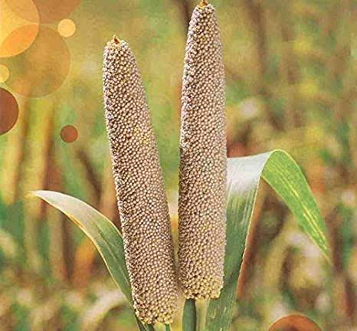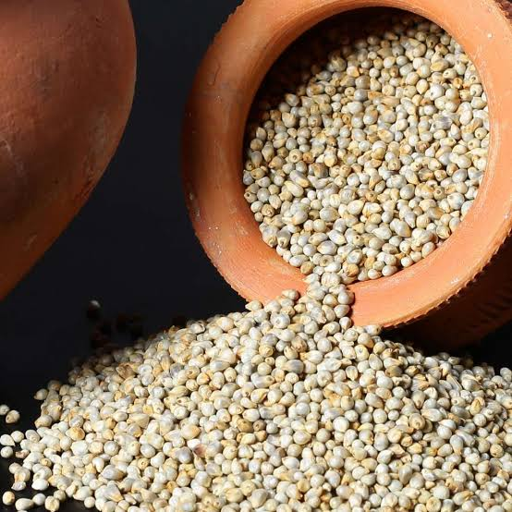

Climate change Improved heat tolerance and drought resistance help pearl millet fight climate change

The reference genome and analysis of 1,000 lines of the pearl millet genome have provided clues as to how this dry grain survives temperatures in excess of 42 degrees Celsius.

As higher global temperatures may affect the nutrient quality of crops and their productivity, it is time to develop crops that are resistant to the adverse effects of climate change. The Pearl Millet looks to be the solution of the future as temperatures rise. The decoding and sequencing of the pearl millet grain by a team of 65 scientists from 30 research institutes showed its adaptability and increasing drought tolerance. The research results were published in the journal Nature Biotechnology.

A study coordinated by the International Crops Research Institute for the Semi-Arid Tropics in India, BGI-Shenzhen in China and France's National Research Institute for Sustainable Development used the latest innovations in DNA sequencing and analysis to identify new genetic tools such as Identify markers associated with drought and heat tolerance, as well as other important traits such as an improved nutrient profile and pest resistance.

This will help increase farmer productivity as pearl millet is a staple for millions of people living in the arid and semi-arid areas of Africa and Asia. As experts suspect, due to climate change, there will be increased drought and high temperatures on both continents in the coming years. Pearl millet is now cultivated on around 27 million hectares worldwide and is the daily food of over 90 million people. It is also an important food source for millions of farms. However, yields have been low for six decades because the grain is grown on poor soil.
Varieties of pearl millet
Most of the pearl millet area is grown with hybrids while the varieties are preferred in drought prone ecologies. The latest list of hybrids and varieties of pearl millet is given below.

Region/ State |  | Recommended Hybrid | Recommended Variety
Rajasthan | Kharif | KBH 108, GHB 905, 86M89, MPMH 17, Kaveri Super Boss, Bio 448, MP 7872, MP 7792, 86M86, 86M66, RHB-173, HHB 67 | MBC 2, PC 443, JBV 3, PC 383, ICMV 221, Raj 171
 | Summer | Nandi 70, Nandi 72, 86M64
 | Kharif – arid parts | HHB 234, Bio 70, HHB-226, RHB-177 | CZP 9802
Gujarat | Kharif | KBH 108, GHB 905, 86M89, MPMH 17, Kaveri Super Boss, Bio 448, MP 7872, MP 7792, 86M86, 86M66, RHB-173, HHB 67 | MBC 2, PC 443, JBV 3, PC 383, ICMV 221, Raj 171
 | Summer | Nandi 70, Nandi 72, 86M64
 | Kharif – arid parts | HHB 234, Bio 70, HHB-226, RHB-177 | CZP 9802
Haryana | Kharif | KBH 108, GHB 905, 86M89, MPMH 17, Kaveri Super Boss, Bio 448, MP 7872, MP 7792, 86M86, 86M66, RHB-173, HHB 67 | MBC 2, PC 443, HC 20, JBV 3, PC 383, HC 10, ICMV 221, Raj 171
 | Kharif – arid parts | HHB 234, Bio 70, HHB-226, RHB-177 | CZP 9802
Punjab | Kharif | KBH 108, GHB 905, 86M89, MPMH 17, Kaveri Super Boss, Bio 448, MP 7872, MP 7792, 86M86, 86M66, RHB-173 | PCB 164, ICMV 221, Raj 171
Delhi | Kharif | KBH 108, GHB 905, 86M89, MPMH 17, Kaveri Super Boss, Bio 448, MP 7872, MP 7792, 86M86, 86M66, RHB-173 | JBV 3, PC 383, ICMV 221, Raj 171
Uttar Pradesh | Kharif | KBH 108, GHB 905, 86M89, MPMH 17, Kaveri Super Boss, Bio 448, MP 7872, MP 7792, 86M86, 86M66, RHB-173 | JBV 3, PC 383, ICMV 221, Raj 171
Madhya Pradesh | Kharif | KBH 108, GHB 905, 86M89, MPMH 17, Kaveri Super Boss, Bio 448, MP 7872, MP 7792, 86M86, 86M66, RHB-173 | JBV 4, JBV 3, PC 383, ICMV 221, Raj 171
Maharashtra | Kharif | Kaveri Super Boss, Pratap, PKV Raj, Shine, MP 7792, 86M86, PAC 909, 86M64, 86M53 | ABPC-4-3, PC 612, Parbhani Sampada, Samrudhi, ICMV 221, Raj 171, ICMV 155
 | Summer | Nandi 70, Nandi 72, 86M64
Tamil nadu | Kharif | Kaveri Super Boss, Pratap, Co 9, Shine, MP 7792, 86M86, PAC 909, 86M64, 86M53 | PC 612, CoCu 9, Samrudhi, ICMV 221, Raj 171, ICMV 155
 | Summer | Nandi 70, Nandi 72, 86M64
Andhra Pradesh | Kharif | Kaveri Super Boss, Pratap, Shine, MP 7792, 86M86, PAC 909, 86M64, 86M53 | PC 612, Samrudhi, ICMV 221, Raj 171, ICMV 155, Ananta
Karnataka | Kharif | Kaveri Super Boss, Pratap, Shine, MP 7792, 86M86, PAC 909, 86M64, 86M53 | PC 612, Samrudhi, ICMV 221, Raj 171, ICMV 155

Pearl millet production and cultivation
Geographically, pearl millet is mainly cultivated in Africa and Asia on more than 32 million hectares. India has the largest area (8.8 million hectares) for growing pearl millet in the world (FAO 2016). Global production of pearl millet is estimated at 30 million tons in 2016. In the late 1980s, pearl millet production in India remained relatively stable and steadily increased with the introduction of high-yielding hybrids.Annual millet production increased in India by 2000, but per capita consumption in the country fell by 50-75%. In 2016, 10.28 million tons of pearl millet grains were produced on nearly 8.8 million hectares of land in Rajasthan, Uttar Pradesh, Haryana, Maharashtra, Gujarat, Madhya Pradesh and Karnataka. Pearl millet consumption was also higher in these states. Although consumed by the population, it has recently gained a lot of importance due to its nutritional value and is therefore used in snacks such as noodles, pappad and vermicelli; Ladoos are special specialties made from pearl millet. The acceptance of the chapati increased when processed (blanched or acid-treated or heat-treated) beans were used. Pearl millet is also used in the preparation of traditional foods: ogi (a Nigerian grain dish), fura (a traditional Nigerian product)
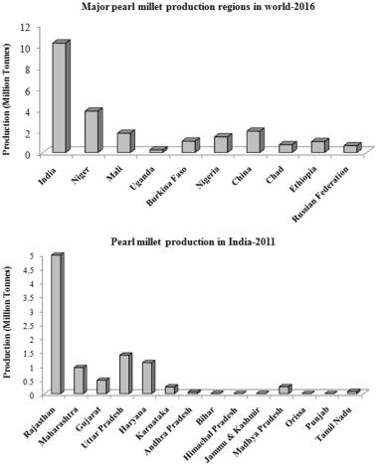
Major pearl millet production regions in the world and india
Nutrients in pearl millet
Pearl millet (Pennisetum glaucum) is a rich source of nutrients as compared to the major cultivated cereal crops. However, major factors which limit its utilization are the presence of anti-nutritional factors (phytate, tannins and polyphenols) which lower availability of minerals and poor keeping quality because of higher lipase activity.
Nutrient composition of pearl millet
The food value of pearl millet is superior to other cereals in its protein content with an excellent balance of amino acids and relatively high vitamin A content.It is also considered a “high-energy” cereal as it contains more oil than maize. The nutrient composition of pearl millet is detailed in below table. The protein content in pearl millet ranges from 9- 11.8% is Protein of pearl millet consists of albumins and globulins (22–28%), prolamin and prolamin-like (22–35%), glutelin and glutelin-like compounds (28–32%) of total N. Pearl millet is 40% richer in amino acid methionine and lysine. Pearl millet is also richer in fat content (4g/100 g) than rice, maize, wheat, and sorghum. About 70% of the dry grain is predominantly carbohydrates, consisting of 56–65% starch, of which 20–22% is amylase.
Nutrients | Per 100 g
Protein (g) | 11.8
Carbohydrate (g) | 67.0
Fat (g) | 4.8
Minerals (g) | 2.3
Fibre (g) | 3.3
Calcium (mg) | 42
Phosphorous (mg) | 238
Iron (mg) | 8
Energy (kcal) | 36.5
Thiamine (mg) | 0.37
Niacin (mg) | 2.5
Source: Nutritive value of Indian foods, national institute of nutrition, hyderabad (2021)
Health benefits of pearl millet
1. Good for a Diabetic Diet - Millet contains carbohydrates that are digested slowly and keep glucose levels stable over a long period of time. This makes it a healthy option for diabetics.
2. Heart Health Benefits – High in fiber and cholesterol-lowering properties, these cereals are good for heart patients.
3. Ideal for celiac disease and gluten intolerance – Patients with celiac disease and gluten intolerance can opt for a millet diet as it is gluten-free and well tolerated by everyone
4. Heals People Suffering From Frequent Acidity And Stomach Ulcers - Millet is one of the few foods that reduce stomach acid, thereby reducing the formation of ulcers and the discomfort caused by frequent hyperacidity.
5. Prevents Constipation – Bajra benefits include promoting good gut health. Simply put, consuming pearl millet prevents constipation. The reason for this is the presence of insoluble fiber in the bagel.
6. Provides Protein for Vegetarians - Vegetarians cannot get the protein they need from meat and fish products. This is where pearl millet comes into play. Bajra's health benefits also include its ability to provide vegetarians with the protein they need. Bajra flour becomes complete when combined with seeds like Rajma, Moong Dal, Chana Dal, etc.
7. Lowers Blood Pressure – Bajra is known to be rich in potassium, which people with high blood pressure need. Eating more potassium-rich foods helps remove sodium from your body, which lowers your blood pressure.
8. Strengthens Bones – Alcohol's high phosphorus content helps strengthen bones.
9. Helps Relieve Constipation – The high fiber content helps build mass and relieves constipation.
10. Lowers Cholesterol – Millet contains the right amount of good fats, which is a desirable dietary quality for sufferers of high cholesterol.
11. Nutrient-Rich Baby Food - Millet is easily digested and well tolerated by babies, making it an indispensable part of baby meals during and after weaning.
12. Rich in Antioxidants - Reduces free radical damage in the body and prevents premature aging, Alzheimer's disease, Parkinson's disease and cardiovascular disease and supports wound healing.
13. Ideal for weight control and obesity.
14. Reduces the risk of colon cancer – It makes the pH of the stomach alkaline, thus reducing the risk of colon cancer.
15. A healthy diet for pregnant and lactating women due to its iron and folic acid content.
Pearl Millet or Bajra comes in various forms for daily consumption. You can use it as a flour for buns or dosas, as a granola for oatmeal, as a processed grain like poha or upma for breakfast, and as a ready-to-eat snack like millet or multigrain cookies. The great health benefits of bajra make it an ideal superfood that is optimal for regular consumption by all. You can pair your favorite millet recipe with high-protein dishes like lentils, cottage cheese, soybean chunks, fresh fruit and a veggie smoothie or salsa to create the perfect recommended meal for a balanced diet. .
Advantages and disadvantages of pearl millet
Whole grains are increasingly recognized as one of the best holistic food sources available to mankind. Bajra is a nutrient-dense whole grain that is in high demand for its many health benefits.
1. Pearl millet supports digestion
2. Pearl millet helps in losing weight
3. Pearl millet may improve diabetes control
4. Pearl millet improves muscle mass
5. Pearl millet prevents hypersensitivity to gluten
Bajra, like all millet groats, is high in fiber. Dietary fiber is one of the most valuable nutrients for gut health, as it helps maintain the balance of the various intestinal flora, protects the gastric and intestinal mucosa, and also improves intestinal function.
Pearl millet helps to lose weight
One of the main reasons for the popularity of bajra is that it can promote weight loss, especially as a substitute for unhealthy carbohydrates in weight loss diets.Bajra is low in calories but high in fiber. The fiber in the bagel can also aid in digestion and speed up your metabolism.
Pearl millet may improve diabetes control
Pearl millet has a low glycemic index of 54 and a glycemic load of 6.06. Both numbers suggest that Bajra is unlikely to cause a postprandial spike in blood sugar. This in turn indicates that bajra is safe to consume by people with diabetes and pre-diabetes.
Pearl millet improves muscle mass
The protein in the bagel is a high quality plant protein rich in nearly all essential amino acids. This means that regular consumption of bajra can help you build and maintain muscle mass, especially if you are an athlete. It can also help those at risk of suffering from or already suffering from malnutrition, protein deficiency and muscle wasting.
Pearl millet prevents hypersensitivity to gluten
Pearl millet is a gluten-free grain, meaning it will not cause gluten intolerance, gluten allergy, or wheat allergy.The manufacturing process of Bajra and Bajra products does not require or involve the addition of any other grains or flours. This ensures that Bajra products are gluten-free and safe for moderate consumption by people with celiac disease or other gluten-related issues.
Disadvantages
Pearl millet is a healthy and nutritious food that is safe for most people to consume. However, in some cases, excessive consumption of bajra can also lead to side effects. Below are all the health problems that can be caused or aggravated by the consumption of bajra.
1. Pearl millet can cause malabsorption syndrome
2. Pearl millet can cause kidney stones
3. Pearl millet can increase indigestion
4. Pearl millet may aggravate thyroid dysfunction
5. Pearl millet can cause malabsorption syndrome

Pearl millet can cause malabsorption syndrome
Pearl millet contains many nutrients or phytochemicals and the particular class of nutrients in this grain are also known as antinutrients. Antinutrients like phytic acid are plant compounds that interfere with the body's ability to absorb essential nutrients and are generally not a problem in a balanced diet free of antinutrients - heavy grains and legumes.
Pearl millet can cause kidney stones
Pearl millet contains large amounts of calcium and oxalates. Both compounds tend to build up in the body and form kidney stones in the long run, especially if the bajra is not washed and cooked properly.
Pearl millet can increase indigestion
Pearl millet is high in fiber, which is great for most people but a nightmare if you already have digestive issues. If you have irritable bowel syndrome, an inflammatory bowel disease, consuming even small amounts of bajra can cause your intestines and stomach lining to catch fire.
Pearl millet may aggravate thyroid dysfunction
Millet, like pearl millet, can contain high levels of goiter-forming compounds such as glucosylvitexin, glycosylvitexin, and vitexin.Consuming excessive amounts of Bajra can therefore impair thyroid function, primarily by impairing iodine absorption. Eating too much bajra puts you at risk of hypothyroidism, iodine deficiency, and even goiter.

References
- https://vikaspedia.in/agriculture/crop-production/package-of-practices/cereals-and-millets/bajra-1
- FAO (2016). http://www.fao.org/faostat/en/#data/QC. Accessed 18 Dec 2017

- Savita Rani, Rakhi Singh, Rachna Sehrawat, Barjinder Pal Kaur, Ashutosh Upadhyay.(2018).Nutrition & Food Science.ISSN: 0034-6659 Pearl millet processing: a review
- Ref. FAO (2016). http://www.fao.org/faostat/en/#data/QC. Accessed 18 Dec 2017
- Ref. https://pharmeasy.in/blog/12-nutritional-benefits-of-bajra-pearl-millets/
- Nutritive value of Indian foods, national institute of nutrition, hydrabad (2021)
- www.downtoearth.org.climate change of pearl millet.

