Internet of Things and it’s Advanced Application Areas
Preethi B¹  Assistant Professor, CSE Department  R R Institute of Technology, Bengaluru,  Karnataka, India, vinaypre0723@gmail.com | Dr. Manjunath R²  Professor, CSE Department  R R Institute of Technology, Bengaluru  Karnataka, India, drmanjunath.raj@gmail.com
Shivashankar³  Professor, ECE Department  R R Institute of Technology, Bengaluru,  Karnataka, India, chenduss123@gmail.com | Dr. Shivakumar Swamy R⁴  Professor, CSE Department  R R Institute of Technology, Bengaluru,  Karnataka, India, nsshivakumar519@gmail.com
ABSTRACT
The Internet of Things (IoTs) are the organization of gadgets which permit them to convey and trade data with other savvy gadgets over the Web. The implanted sensors and related programming make these IoT gadgets as brilliant. In this section, we are finding a few significant uses of IoT and what its future resembles vehicular IoT, Medical services IoT and Rural IoT are portrayed in this part. The consistently expanding creation populace inspirations up the order for agrarian harvests. Notwithstanding, the relocation of youngsters to world weakens the humanoid asset obligatory for rural advancement. IoT and related it's abilities will be fundamental in robotizing cultivating improvements and satisfying food interest. IoT empowered system has made remote observing in medical care region conceivable, delivering the possibility to keep patients protected and solid and allowing doctors to appropriate standout consideration. IoT has likewise expanded patient meeting and satisfaction as trades with specialist has become simpler and more effective. IoTs likewise impact diminishing medical services costs essentially and further developing therapy results. Agribusiness IoT applications are the subject which cover the numerous uses of IoT expertise in cultivating and horticulture. The utilization of sensors to assortment of information, remote organizations and information investigation is as of now fostering the cultivating and rural fields.

- INTRODUCTION TO VEHICULAR IOT
Vehicular IoT additionally alludes to as 'Car IoT' or 'associated vehicles framework'. It is only to inserting IoT innovations into auto frameworks to make new applications and arrangements which empower vehicles to give a more astute, more secure, more proficient, and more happy with driving experience.
The utilization of associated vehicles is expanding quickly across the globe. Thus, the quantity of on-street mishaps and blunder of traffic is likewise expanding. The rising number of vehicles leads to the issue of leaving. Nonetheless, the development of IoT assists with framing an associated vehicular climate to productively oversee transportation frameworks. Vehicular IoT frameworks tended to the various parts of the transportation biological system, including
• On-street to go 4x4 romping traffic the executives
• Driver wellbeing for weighty to little vehicles
• Security in open transportation.
• Vehicles are fit for imparting and sharing their data.
• A vehicle proprietor effectively tracks his vehicular resource from a distance.

- THE ARCHITECTURE OF A VEHICULAR IOT SYSTEM

The basic architecture of the vehicular IoT is partitioned into three sub layers are presented in figure 1.
• Gadget layer
• Haze layer
• Cloud layer

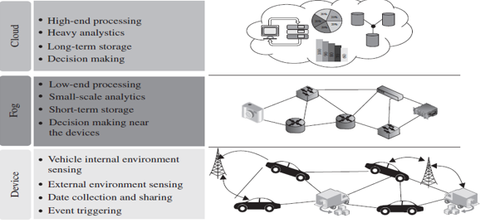
Figure 1: architecture of the vehicular IoT.

A. Device layer
The gadget layer is the base most layer, which comprises of the fundamental foundation of the situation of the associated vehicle. This layer incorporates the vehicles and street side units (RSU). These vehicles contain specific sensors which assemble the interior data of the vehicles. Then again, the RSU fills in as a neighborhood unified unit that deals with the information from the vehicles.
B. Haze layer
In vehicular IoT frameworks, quick navigation is relevant to keep away from mishaps and traffic blunder. In such circumstances, haze registering assumes a urgent part by giving choices continuously, much close to the gadgets. Thus, the haze layer assists with limiting information transmission time in a vehicular IoT framework.
C. Cloud layer
Fog computing handles the information handling close to the gadgets to quickly take choices. Be that as it may, for the handling of enormous information, haze processing isn't sufficient. Thusly, in such a circumstance, distributed computing is utilized. In a vehicular IoT framework, distributed computing assists with taking care of cycles that include a tremendous measure of information. Further, for long haul stockpiling, distributed computing is utilized as a versatile asset in vehicular IoT frameworks displayed in figure 2 and 3.

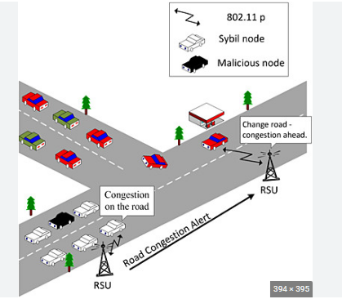
Figure 2: vehicular IoT system.

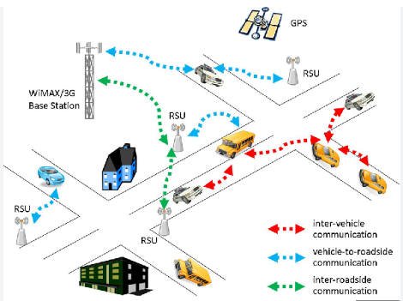
Figure 3: Scalable resource in vehicular IoT systems.

- COMPONENTS OF VEHICULAR IOT
The cycles associated with a vehicular IoT have a few parts, alongside numerous functional difficulties. Current vehicles come furnished with various kinds of sensors and electronic parts. These sensors sense the inner climate of the vehicle and communicate the detected information to a processor. The on-street sent sensors sense the outer climate and send the detected information to the concentrated processor is introduced in figure 4.
The fundamental parts are as per the following:
- Sensors
- Satellite
- Remote Availability
- Street side unit (RSU)
- Cloud and for Figuring
- Analytic

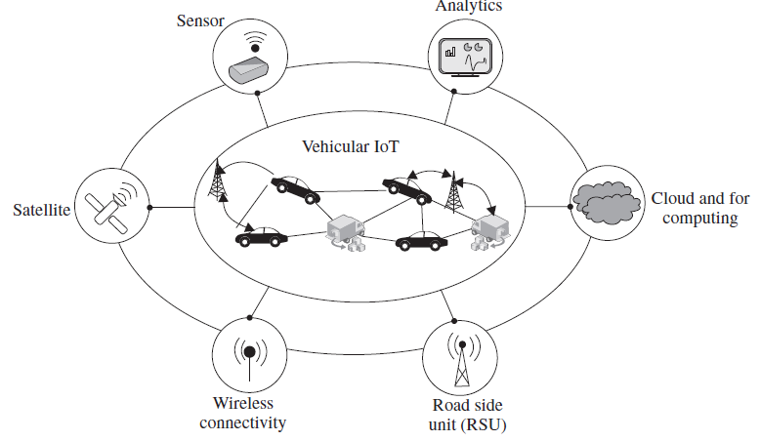
Figure 4: Components of vehicular IoT.

Sensors: In vehicular IoT, sensors screen different ecological circumstances and make the framework more practical, effective, and hearty. Two kinds of sensors are utilized.

Internal sensors: The sensors are utilized inside the vehicle to detect boundaries that are straightforwardly connected with the vehicle. These inside sensors in a vehicle are associated with the processor board and actuator, to which they communicate the detected information. Further, the detected information are handled to make certain predefined moves. Instances of interior sensors are GPS, fuel measure, ultrasonic sensors, closeness sensors, accelerometer, pressure sensors, and temperature sensors.

External sensors: It measures data like shrewd traffic frameworks and empty parking areas outside the vehicle. The still pictures and recordings from cameras are significant contributions to create choices in a vehicular IoT framework. Thusly, on-street cameras are broadly utilized as outside sensors to catch actually pictures and recordings. The caught pictures and recordings are handled, either in the haze or in the cloud layer, to make certain pre-customized moves. For instance, a camera sensor can catch the picture of the tag of an over speeding vehicle at a traffic light.

Satellites: In vehicular IoT frameworks, programmed vehicle following and crash location are among the significant accessible elements. Satellites assist the framework with following vehicles and distinguish on-street crashes, recognizing on-street clogs, and detours.

Remote availability: As vehicular IoT manages associated vehicles, correspondence is a significant empowering part. It conveys the detected information from various sensors to RS from RSUs to the cloud. In the vehicular IoT situation, the high portability of the vehicles requires the availability type to be remote for down to earth and continuous information transmission. Different correspondence advancements, like Wi-Fi, Bluetooth, and GSM, are normal in vehicular IoT frameworks.

Road Side Unit (RSU): The RSU is a static substance that works cooperatively with interior and outer sensors. The RSUs are furnished with sensors, correspondence units, and mist gadgets. To take choices continuously, the mist gadgets connected to the RSUs cycle the detected information and make a vital move speedily. In the event that a vehicular framework includes weighty calculation, the RSU sends the detected information to the cloud end. RSUs likewise fill in as middle of the road correspondence specialists between two vehicles.

Fog computing: It handles the lightweight cycles geologically nearer to the vehicles than the cloud. - It is utilized for quicker decision-production in vehicular IoT frameworks. For instance, find the gridlock at closer areas with the assistance of detected information. - Further, the clog data can be shared by the RSU among another street vehicles, accordingly recommending that they stay away from the blocked street.

Cloud computing: It is utilized for heavyweight processes and handles a gigantic measure of information in Vehicular IoT frameworks. It gives greater versatility of assets when contrasted with haze. The decision of the utilization of haze and distributed computing relies upon the circumstance and applications in vehicular IoT frameworks. Deciding standard on-street blockage, forecasts are regularly taken care of with the assistance of distributed computing. For the normal clog expectation, the cloud end requirements to process a colossal measure of quick information, as well as, verifiable information for that stretch of street traversing back a couple of months to years.

Analytics: In vehicular IoT, investigation is a critical part. Foreseeing different dynamic and static circumstances in the traffics is utilized. For instance, solid information investigation is expected to anticipate on-street traffic conditions that might happen at location after an hour.
A. Advantages of vehicular IoT
- Simple following: In a vehicular IoT framework, the following of vehicles is clear; the framework can gather data about the area and vehicle data.
- Quick navigation: The majority of the choices in the associated vehicle climate are time basic. Quick and dynamic independent direction is significant for keeping away from mishaps. In the vehicular IoT climate, cloud and haze registering help to settle on quick choices with the information got from the sensor-based gadgets.
- Associated vehicles: A vehicular IoT framework gives a chance to stay associated and divide data between various vehicles.
- Simple administration: With the assistance of sensors, a correspondence unit, handling gadgets, and GPS, the administration of the vehicle turns out to be simple. The network among various parts in a vehicular IoT empowers frameworks to follow each movement in and around the vehicle.
- Security: Both the interior &external sensors put at various areas give security to the vehicle, its tenants, as well as individuals around it.
- Record: The record might be of any structure, like video film, actually pictures, and documentation. By exploiting cloud and mist registering engineering, vehicular IoT frameworks keep every one of the expected records put away in their data set.

Crime assistance in a smart IoT transportation system: This section gives a contextual investigation on shrewd security in vehicular IoT foundation. The framework features a haze system for wise public security in vehicular conditions (mist FISVER). The essential point of this framework is to Guarantee Shrewd Transportation Wellbeing (STS) openly transport administrations.

- HEALTHCARE IOT
The IoT had an immense effect on the clinical field, particularly wearable medical care. These advances have brought about little, power-effective, wellbeing observing and analytic frameworks. As of now, different IoT-empowered medical services gadgets are in wide use all over the planet for diagnosing human illnesses, observing human ailments, and really focusing/checking on elderly folks, youngsters, and even newborn children.
The IoT-based medical care frameworks and administrations help to build the personal satisfaction for normal people; as a matter of fact, it has a promising extent of changing medical services in emerging countries. IoT-based medical care gadgets give access and information about human physiological circumstances through handheld gadgets. In IoT-based medical care benefits, the sensors are explicitly intended to gauge and evaluate different physiological states of their clients/patients.

- Architecture for healthcare IoT
The architecture into four layers. The point-by-point portrayal of these layers is shown in figure 5.
Layer 1: It contains different physiological sensors that are put on the human body. These sensors gather the upsides of different physiological boundaries. The physiological information are investigated to separate significant data.
Layer 2: It gathers momentary capacity and low-level handling information from layer 1. Layer 2 is outfitted with neighborhood handling units (LPU). These units gather the detected information from the physiological sensors joined to the body and interaction it in view of the design's necessities. Further, LPUs forward the handled information to Layer.

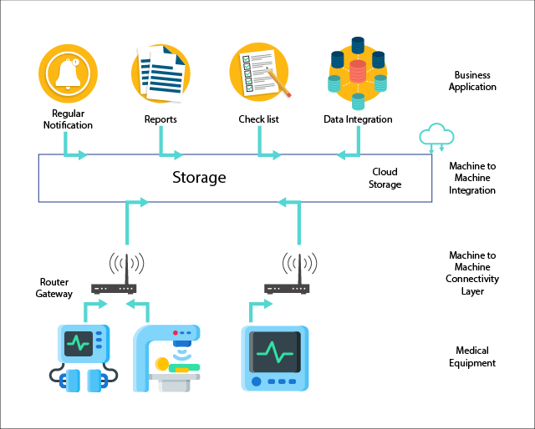
Figure 5: Architecture for healthcare IoT.

Layer 3: This layer comprises of cloud design or top of the line servers that perform application-explicit significant level investigation. The information from various patients, which might be from the equivalent or various areas, are gathered in this layer. Postanalysis of information, a few surmisings or results are given to the application in Layer 4.
Layer 4: The end-clients straightforwardly connect with Layer 4 through recipient side applications. The methods of openness of these administrations by an end client are commonly through mobile phones, PCs, and tablets.

- Components of Healthcare IoT
Sensors: Utilizations physiological sensors that gather the physiological boundaries of the patient. Usually utilized medical services sensors.
Wireless Connectivity: Wireless connectivity is ideally used to convey between the wearable sensors and the Neighborhood Handling Unit (LPU) with the assistance of Bluetooth and ZigBee. Then again, the correspondence between the LPU and the cloud or server happens with Web network like Wi-Fi and WLAN. The medical care information are gotten toward the end clients with various gadgets like workstations, work areas, and PDAs by utilization of 3G/4G/5G or Wi-Fi.
Privacy and Security: It is a central issue in medical care IoT administrations. In a medical services IoT engineering, a few gadgets interface with the outside world. In the event that any of the gadgets are compromised, it might bring about the robbery of the wellbeing information of a patient, prompting serious security breaks and following claims. To expand the security of medical care information, different medical care specialist co-ops and associations are executing medical services information encryption and assurance plans.
Analytics: It changes over crude information into significant data. The specialists, medical caretakers, and patients access medical care data in an alternate modified design. Examination is likewise utilized for diagnosing an illness from the crude physiological information accessible.
Cloud and Fog Computing: It assumes an essential part in the capacity of huge volumes of heterogeneous wellbeing information created from the patient body. This information is utilized for really taking a look at the patient's set of experiences, ebb and flow wellbeing status, and future for diagnosing various illnesses and the side effects of the patient. To store wellbeing information in a medical services IoT framework, distributed storage space is utilized. Examination of the put away information in distributed storage space is utilized for drawing different deductions. The significant difficulties away are security and defer in getting to the information.
Interface: The connection point is the main part for clients in a medical services IoT framework. Among IoT applications, medical care IoT is an exceptionally pivotal and touchy application. Consequently, the UI should be planned so that it can portray all the expected data obviously and, if fundamental, reformat or address it with the end goal that it is straightforward. Besides, a connection point should likewise contain all the valuable data connected with the administrations.

- Advantages and risks of healthcare IoT
Real-time: A medical care IoT framework empowers clients, like specialists, end clients at the patient side, and staff in a medical care unit, to get constant updates about the medical care IoT parts. It empowers a specialist to notice a patient's medical issue progressively even from a distant area and can propose the sort of care to be given to the patient. Then again, clients at the patient end can without much of a stretch take various choices, for example, where to take a patient during basic circumstances. Besides, the staff in a medical services unit are better mindful of the ongoing circumstance of their unit, which incorporates the quantity of patients conceded, accessibility of the specialists and beds, all out income of the unit, and other such data.
Low cost: Health care IoT frameworks work with clients with various administrations for minimal price. For instance, an approved client can undoubtedly find the accessibility of beds in an emergency clinic with straightforward Web network and an internet browser-based gateway. Additionally, different enlisted clients can recover a similar data all the while.
Simple administration: Health care IoT is a framework that brings all its end clients under a similar umbrella to give medical care administrations. Notwithstanding, medical services IoT works with simple and powerful administration, all things considered.
Easy management: Health care IoT empowers start to finish programmed handling in various units and furthermore combines the data across the entire chain: from a patient's enlistment to release.
Easy record-keeping: A medical services IoT empowers the client to keep these records in a protected climate and convey them to the approved client according to necessity. Besides, these recorded information are open from any piece of the globe.
Easy diagnosis: In a medical care IoT framework, the finding of the illness becomes more straightforward with the assistance of specific learning systems alongside the accessibility of earlier datasets.

- Risk in healthcare IoT
The different dangers related with a medical services IoT framework.
Loss of connectivity: Irregular availability might bring about information misfortune, which might bring about a dangerous circumstance for the patient. Legitimate and nonstop network is fundamental in a medical services IoT framework
Security: The medical services framework should keep the information classified. This information ought not be open to any unapproved individual. Then again, various people and gadgets are related with a medical services IoT framework. In such a framework, the gamble of information altering and unapproved access is very high.
Error: In the medical services framework, blunders in information might prompt confusion of side effects and lead to some unacceptable determination of the patient. It is a provoking errand to build a blunder free medical services IoT architecture.

- AGRICULTURAL IOT

The development of agricultural IoT has assisted ranchers with upgrading crop efficiency and diminish the above of manual tasks of the rural hardware in the fields.
The improvement of the IoT Agricultural loT systems perform
- Crop Health Monitoring,
- Water Management,
- Crop Security,
- Farming Vehicle Tracking,
- Automatic Seeding, and
- Automatic Pesticide Spraying Over The Agricultural Fields.
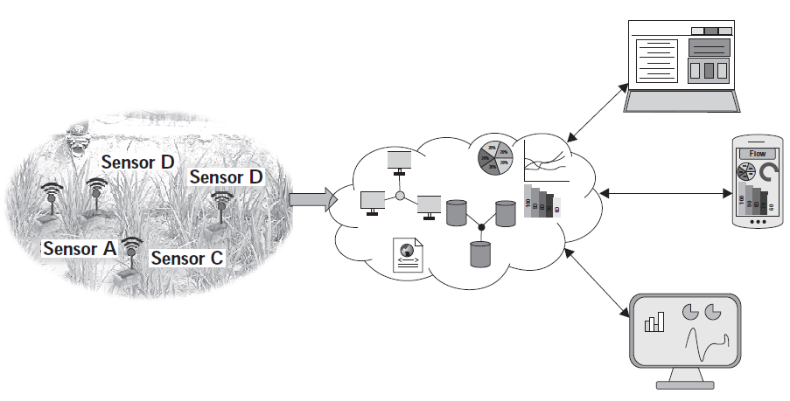
Figure 6. A basic architecture of an agricultural IoT.

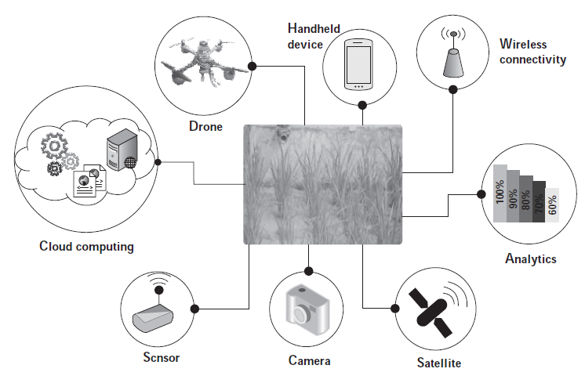
Figure 7: Components of agricultural IoT.

Different components, for example, examination, drone, distributed computing, sensors, hand-held gadgets, and remote availability empower farming IoT as portrayed in the various parts of a rural IoT are displayed in figure 6 and 7 and are talked about as follows

Cloud computing: Sensors, for example, the camera, gadgets to quantify soil dampness, soil mugginess, and soil pH-level are utilized for serving different rural applications. These sensors produce an enormous measure of horticultural information that should be dissected. Some of the time, in view of the information examination, move should be made, for example, turning on the water siphon for water system. Further, the information from the sent sensors are expected to be put away on a drawn out premise since it could be valuable for serving future applications. Consequently, for farming information examination and capacity, the cloud assumes a significant part.
Sensors: In past sections, we previously investigated various sorts of sensors and their particular prerequisites in IoT applications. We have seen that the sensors are the significant spine of any IoT application. Essentially, for agrarian IoT applications, the sensors are a crucial part. A couple of the normal sensors utilized in horticulture are sensors for soil dampness, moistness, water level, and temperature.
Cameras: Imaging is one of the primary parts of farming. Thusly, multispectral, warm, and RGB cameras are ordinarily utilized for logical horticultural IoT. These cameras are utilized for assessing the nitrogen status, warm pressure, water pressure, and harvest harm because of immersion, as well as pervasion. Video cameras are used for crop security.
Satellites: In current accuracy horticulture, satellites are broadly used to separate data from field symbolism. The satellite pictures are utilized in rural applications to screen various parts of the yields, for example, crop wellbeing observing and dry zone evaluating over a huge region.
Analytics: Investigation add to present day agribusiness greatly. As of now, with the assistance of examination, ranchers can take different horticultural choices, for example, assessing the necessary measure of compost and water in an agrarian field and assessing the kind of yields that should be developed during the impending season. Besides, examination isn't just answerable for pursuing choices locally; it is utilized to investigate information for the whole farming store network. Information examination can likewise be utilized for assessing the harvest interest on the lookout.
Wireless connectivity: One of the fundamental parts of rural IoT is remote availability. Remote network empowers the transmission of the horticultural sensor information from the field to the cloud/server. It likewise empowers ranchers to get to different application administrations over handheld gadgets, which depend on remote network for speaking with the cloud/server.
Handheld devices: Throughout recent years, e-agribusiness has become extremely well known. One of the principal parts of e-farming is a handheld gadget, for example, a cell phone. Ranchers can get to various rural data, for example, soil and harvest states of their fields and market inclination, over their cell phones. Furthermore, ranchers can likewise control different field gear, like siphons, from their telephones
Drones: Right now, the utilization of robots has become exceptionally alluring in various applications like observation, medical services, item conveyance, photography, and agribusiness. Drone imaging is a choice to satellite imaging in agribusiness. In continuation to giving improved goal land planning visuals, drones are utilized in agribusiness for crop checking, pesticide showering, and water system.

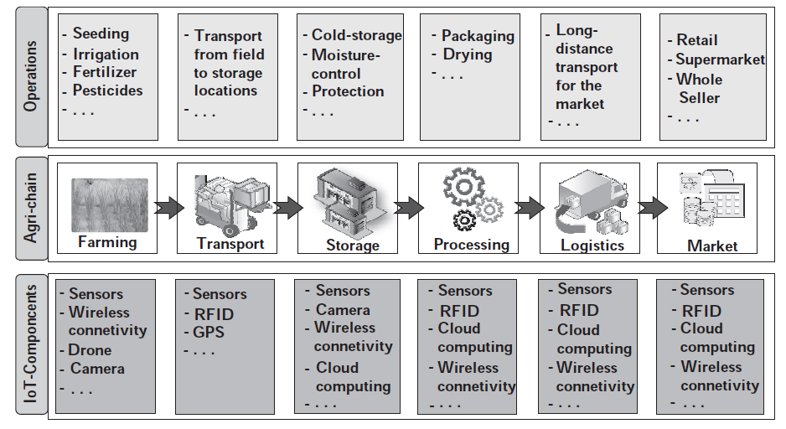
Figure 8: Use of IoT components in the agricultural chain.
A agricultural food chain (agri-chain) addresses the various stages that are associated with farming action right from the rural fields to the purchasers. a normal farming pecking order with the various tasks that are engaged with it. Moreover, figure 8 portrays the utilizations of various IoT parts expected for playing out these agrarian tasks. In the agri_chain, we think about cultivating as the main stage. In cultivating, different activities, for example, cultivating, water system, compost spreading, and pesticide showering, are involved.
For playing out these tasks, different IoT parts are utilized. For instance, for checking the dirt wellbeing, soil dampness and temperature sensors are utilized; drones are utilized for showering pesticides; and through remote network, A report on-field soil conditions is sent straightforwardly to a clients' handheld gadget or cloud. Subsequent to cultivating, the following stage in the agri-chain is transport. Transport shows the exchange of harvests from the field to the nearby stockpiling, and from that point onward, to long haul stockpiling areas. In transport, brilliant vehicles can naturally stack and dump crops.

- SUMMARY

In agriculture Modern technological advancements and the quick improvements in IoT parts have progressively expanded farming efficiency. agriculture IoT empowers the independent execution of various agrarian tasks. The particular benefits of the agriculture l IoT are as per the following:
Seeding: IoT-based horticultural frameworks are equipped for independent cultivating and establishing over the agrarian fields. These frameworks essentially diminish manual exertion, blunder likelihood, and defers in cultivating and planting.
Efficient fertilizer and pesticide distribution: Farming IoT has been utilized to foster arrangements that are equipped for applying and controlling how much manures and pesticides effectively. These arrangements depend on the investigation of yield wellbeing.
Water management: The abundance dissemination of water in the farming fields might influence the development of yields. Then again, the accessibility of worldwide water assets is limited. The requirement of restricted and frequently scant usable water assets is a powerful driving variable for the sensible and proficient circulation of rural water assets
Real-time and remote monitoring: In contrast to conventional horticulture, in IoT-based cultivating, a partner can remotely screen different farming boundaries, for example, harvest and soil conditions, plant wellbeing, and weather patterns. Besides, utilizing a shrewd handheld gadget (for example wireless), a rancher can impel on-field cultivating hardware, for example, a water siphon, valves, and different bits of hardware.
Easy yield estimation: Rural IoT arrangements can be utilized to record and total information, which might be spatially or transiently assorted, over significant stretches. These records can be utilized to concoct different evaluations connected with cultivating and ranch the executives. The most noticeable among these appraisals is crop yield, which is done in light of laid out crop models and verifiable patterns.
Production overview: The point-by-point investigation of harvest creation, market rates, and market request are fundamental elements for a rancher to gauge enhanced crop yields and choose the fundamental stages for future trimming rehearses.

Reference:

- Akshi Kumar, Danda B. Rawat, Neeli Rashmi Prasad and Sumarga Kumar Sah Tyagi, “AI-Integrated Wireless Communications and Computing Trends for Next-Generation IoT”, Wireless Communications and Mobile Computing-Hindawi, 2023.
- Rajesh Kumar Kaushal, Rajat Bhardwaj, Naveen Kumar, Abeer A. Aljohani, Shashi Kant Gupta, Prabhdeep Singh and Nitin Purohit,
“Using Mobile Computing to Provide a Smart and Secure Internet of Things (IoT) Framework for Medical Applications”, Wireless Communications and Mobile Computing-Hindawi, Volume 2022 | Article ID 8741357 | https://doi.org/10.1155/2022/8741357, 2023.
- https://www.cogniteq.com/blog/top-5-applications-iot-agriculture.
- Rajesh Kumar Kaushal, Rajat Bhardwaj, Naveen Kumar, Abeer A. Aljohani , Shashi Kant Gupta, Prabhdeep Singh and Nitin Purohit, “Using Mobile Computing to Provide a Smart and Secure Internet of Things (IoT) Framework for Medical Applications”, Hindawi- Wireless Communications and Mobile Computing Volume 2022, Article ID 8741357, pp.13-22, https://doi.org/10.1155/2022/8741357, 2022.
- https://stl.tech/blog/what-are-the-applications-of-iot/
- Ebenezer Esenogho, Karim Djouani and Anish M. Kurien , “Integrating Artificial Intelligence Internet of Things and 5G for Next-Generation Smartgrid: A Survey of Trends Challenges and Prospect”, IEEE Access, DoI 10.1109/ACCESS.2022.3140595, Volume- 10, 2022.
- P. P. Raya and N. Kumar, ‘‘SDN/NFV architectures for edge-cloud oriented IoT: A systematic review,’’ Comput. Commun., vol. 169, pp. 129–153, Jan. 2021.
- Amir Masoud Rahmani, Suleyman Bayramov & Behnam Kiani Kalejahi, “Internet of Things Applications: Opportunities and Threats”, Wireless Personal Communications, Springer Publication, 122, pages451–476 (2022), 2022.
- https://www.manxtechgroup.com/internet-of-things-iot-applications-smart-agriculture/ .
- Sachin Kumar, Prayag Tiwari and Mikhail Zymbler, “Internet of Things is a revolutionary approach for future technology enhancement: a review”, Journal of Big Data, volume 6, Article number: 111 (2021), 2021.
- K. Shafique, B. A. Khawaja, F. Sabir, S. Qazi, and M. Mustaqim, ‘‘Internet of Things (IoT) for next-generation smart systems: A review of current challenges, future trends and prospects for emerging 5G-IoT scenarios,’’ IEEE Access, vol. 8, pp. 23022–23040, 2020.
- Z. Wang, Y. Liu, Z. Ma, X. Liu, and J. Ma, ‘‘LiPSG: Lightweight privacypreserving Q-learning-based energy management for the IoT-enabled smart grid,’’ IEEE Internet Things J., vol. 7, no. 5, pp. 3935–3947, Jan. 2020.

