CAUDAL ANAESTHESIA

AUTHOR
Sankamithra S, Department of Anaesthesia Technology
School Of Allied Health Sciences, Vinayaga Mission Research Foundation-Du
AVMC&H Campus, Puducherry, India
mithrasankar7@gmail.Com

ABSTRACT
Caudal block is a form of central neuraxial block that is most frequently used in pediatrics to give analgesia for procedures up to the umbilicus and in adults to treat chronic low back pain. Caudal blocks may be administered blindly or more accurately under ultrasound or fluoroscopic supervision. This exercise highlights the role of the healthcare team in strengthening care for patients who get caudal anesthesia and covers the anatomy, indications, contraindications, and strategy to performing caudal anesthesia.
KEYWORDS: Pediatrics, Caudal
I.INTRODUCTION
A frequent method of localized anaesthetic called caudal anesthesia could be helpful in delivering peri operative analgesia.[4] Caudal anesthesia can act as a general anesthetic adjuvant and also as the only anesthetic. Caudal anesthesia is most useful for treating chronic low back pain in adults and children undergoing subumbilical procedures. In a retrospective analysis of 750 caudal blocks performed on young patients, Dalens et al. reported a 96% success rate. It is now possible to lower block failure rates even more with proper needle placement thanks to the development of fluoroscopy and ultrasound-guided caudal epidural insertion.
II.ANATOMY
Clinicians reach the epidural area through the sacral hiatus to execute caudal epidural methods. (Fig 1.1). The dural sac and spinal cord in adulthood both come to an end at L1-2. With cephalad progression over the first year of life, the spinal cord in children stops at L3-4 and the dural sac at S3-4 (Fig. 1.2). It is possible to penetrate the dural sac in young newborns while doing a caudal epidural block. The landmark-based technique is the most often used method for executing a caudal epidural block. They are most typically utilized as single-shot treatments in adults since it is challenging to thread a catheter at this location. Although it is simpler to place a catheter in children than in adults, they are more likely to undergo single-shot operations. Studies have shown that caudal catheters can be safely implanted for a short time—less than three days—without increasing the risk of a systemic infection like meningitis, an epidural abscess, systemic sepsis, or even a local infection.
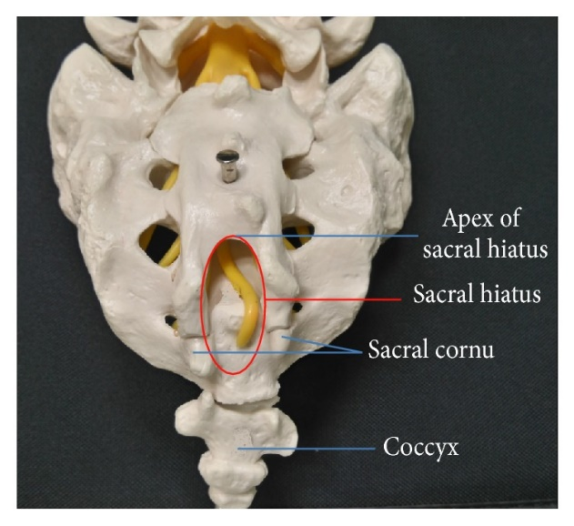

Fig1.1 Posterior view of sacrum

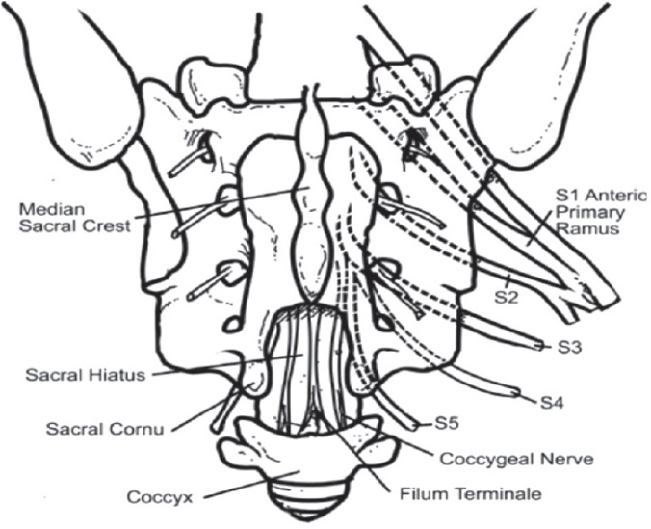

Fig1.2 Landmarks for caudal block

III.INDICATIONS
For sub-umbilical treatments caudal anesthesia can be helpful in the juvenile population. [5] For these procedures, caudal anesthesia can be used alone or in conjunction with general anesthesia. Injections into the caudal epidural space can also assist manage chronic low back pain that does not improve with conservative medical treatment.
IV.EQUIPMENTS
The following equipments are needed to complete a caudal epidural block.
- The right-sized syringe
- catheter for IV access or a needle
- Medication
- Typically used skin-cleansing.
- Personal safety gear (sterile gloves, a mask, and a hat)
- In either pediatric or adult patients, ultrasound can help in caudal epidural placement. According to a research by Shin et al., ultrasonography imaging of the sacral hiatus made it easier to complete the caudal epidural implant.
V.TECHNIQUES
V.I Blind caudal epidural block
For a blind caudal epidural block, the patient may be positioned prone or lateral decubitus. The sacral hiatus should then be roughly located by drawing a line connecting the bilateral posterior superior iliac crests and using it as one half of an equilateral triangle. The sacral hiatus can be felt as a dimple between the sacral cornua, which can be felt as two bony prominences. If the posterior surface of the sacral bone is touched, the needle is redirected and placed at a 45-degree angle to the sacrum.[1] Even in the hands of skilled practitioners, piercing the SCL is suggested by a subjective feeling of "give" or loss of resistance, but this is also linked to a miss rate of up to 26%. In adults, the "whoosh test," which involves injecting 2 mL of air while using a stethoscope to auscultate the thoracolumbar region has a sensitivity of 80% and a specificity of 60%. With a fast injection of 5 mL of air or saline, palpating for subcutaneous bulging yielded a positive predictive value of 83% and a negative predictive value of 44%. Even after numerous studies, it is obvious that utilizing a blind approach for caudal epidural injection in adults is inaccurate.
V.II Fluoroscopy-Guided Caudal Epidural Block
Some authors have advised caudal epidural injection be carried out under fluoroscopic supervision since blind technique is inaccurate. For a caudal epidural block that is guided by fluoroscopy, the patient is often lying on his or her back. The sacral hiatus was visible as an abrupt drop off at the end of the S4 lamina in the lateral view of fluoroscopy. It is possible to see the block needle trajectory and navigate it into the sacral canal appropriately. The positioning of the needle tip within the sacral epidural space can be confirmed by administering contrast agent while using fluoroscopy (Fig.1.3), and the intravascular or intrathecal needle tip placement can be identified. Even after a negative aspiration, intravascular injection during caudal epidural injection was observed by conventional fluoroscopy in 3–14% of patients. The success rate of caudal epidural blocks has significantly increased under the direction of fluoroscopy and this technique is now thought to be the best available. However, radiation risk, cost, and the need for specialized space restrict the frequent use of fluoroscopy for caudal epidural block.
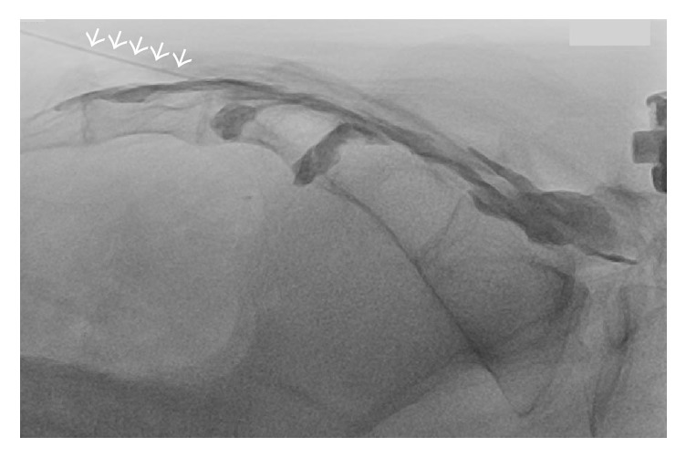

Fig.1.3 Fluoroscopy guided caudal block

V.III Ultrasound-Guided Caudal Epidural Block
Klocke and colleagues first described the ultrasound-guided caudal block in 2003, and its use has grown steadily ever then. Very high success rates (96.9–100%) of ultrasound-guided caudal injection have been reported by a number of investigations from various ethnic communities. The patient may be positioned prone or in lateral decubitus. For the majority of caudal epidural injections, a 7–13 MHz liner transducer will be sufficient; however, patients who are obese may require a 2–5 MHz curved transducer. To get a transverse picture of the sacral hiatus (Fig.1.4), the ultrasound transducer was first positioned at the midline. [2] Two hyperechoic structures are seen to represent the two sacral cornua. The SCL and the dorsal surface of the sacral bone are the two band-like hyperechoic structures that are located between the sacral cornua. The sacral gap was the hypoechoic space between the two hyperechoic structures that resembled bands. To provide a longitudinal picture of the sacral hiatus at this level, the ultrasound transducer is turned 90 degrees. The "in-plane" approach is used to insert the block needle in longitudinal perspective. The block needle can be seen piercing the SCL and entering the sacral hiatus in real time, however it is invisible after that point. Because the distance between the apex of the sacral hiatus and dural sac termination can be as small as less than 6 mm, it is advised that advancement of the needle tip beyond the apex of the sacral hiatus be limited to 5 mm without knowledge of dural sac termination from image study beforehand.
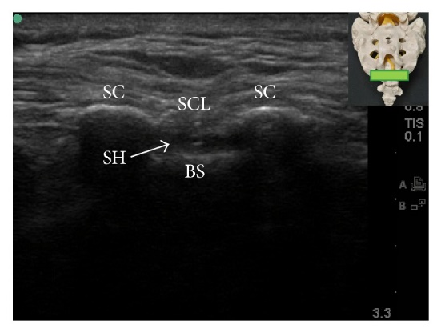

Fig1.4 Transverse ultrasound view of the sacral hiatus
VI. CONTRAINDICATIONS
Patient or guardian refusal, a localized infection over the insertion site, a severe coagulopathy, an increase in intracranial pressure, and an allergy to the anesthetics used for the surgery are all absolute contraindications to caudal anesthesia. By raising intracranial pressure even more after receiving an epidural injection, elevated intracranial pressure may be a risk factor for herniation.
The range of relative contraindications is greater. Following a neuraxial procedure, spinal stenosis increases the risk of neurologic sequelae. Due to the neuraxial technique's vasodilatory effects, hypovolemic individuals are more likely to experience hypotensive reactions. Less severe coagulopathies require further discussion even though severe coagulopathy is an unequivocal contraindication to neuraxial methods.[3] The American Society of Regional Anesthesia can be consulted for the most recent recommendations for neuraxial procedures in the context of thromboprophylaxis or anticoagulation.
VII.COMPLICATIONS
The following are typical side effects of caudal anesthesia:
- intraosseous, intravascular, or subarachnoid injection
- Infection
- Hypotension
- nerve roots are harmed.
- Antesacral Injection with Rectal Perforation
- Hematoma development
- toxicity of local anesthetics
- Respiratory depression that is delayed
- urinary incontinence
- Osteomyelitis of the sac.

REFERENCES

[1]Dalens B, Hasnaoui A. Caudal anesthesia in pediatric surgery: success rate and adverse effects in 750 consecutive patients. Anesth Analg. 1989 Feb;68(2):83-9. [PubMed]

[2]Chen CP, Tang SF, Hsu TC, Tsai WC, Liu HP, Chen MJ, Date E, Lew HL. Ultrasound guidance in caudal epidural needle placement. Anesthesiology. 2004 Jul;101(1):181-4. [PubMed]

[3]Kao SC, Lin CS. Caudal Epidural Block: An Updated Review of Anatomy and Techniques. Biomed Res Int. 2017;2017:9217145. [PMC free article] [PubMed]

[4]Aggarwal A., Kaur H., Batra Y. K., Aggarwal A. K., Rajeev S., Sahni D. Anatomic consideration of caudal epidural space: A Cadaver Study. Clinical Anatomy. 2009;22(6):730–737. doi: 10.1002/ca.20832. [PubMed] [CrossRef] [Google Scholar]

[5] Lewis M. P. N., Thomas P., Wilson L. F., Mulholland R. C. The “whoosh” test: a Clinical test to confirm correct needle placement in caudal epidural injections. Anaesthesia. 1992;47(1):57–58. doi: 10.1111/j.1365-2044.1992.tb01957.x. [PubMed] [CrossRef] [Google Scholar]

[6] Chen CP, Tang SF, Hsu TC, Tsai WC, Liu HP, Chen MJ, Date E, Lew HL. Ultrasound guidance in caudal epidural needle placement. Anesthesiology. 2004 Jul;101(1):181-4. [PubMed]

