Cultural Heirlooms, Literary Treasures: Historical Buildings in the Tapestry of English Literature
Dr. Vinodhini Chinnaswamy
Associate Professor
Department of Languages
Presidency University
Bangalore
Mob:9940212718
Email: drcvinodhini@gmail.com

Abstract:
Historical buildings, as cultural artifacts standing at the intersection of the past and the present, have consistently woven their majestic threads into the intricate fabric of English literature. This study undertakes a comprehensive investigation into the multifaceted significance of these buildings, illuminating their roles as both tangible symbols of heritage and intangible sources of literary inspiration. The symbiotic relationship between historical buildings and literature is profound. These buildings, with their imposing architecture and storied histories, become much more than physical structures; they evolve into literary muses. Authors harness the visual and emotional potency of these edifices to imbue their works with authenticity and depth. Be it the haunting ruins of a medieval castle, the soaring arches of a cathedral, or the humble charm of a village church, historical buildings provide writers with a canvas on which to paint the backdrop of their narratives. They assume roles that extend beyond the mere setting, acting as silent witnesses to the unfolding stories, catalysts for character development, and mirrors reflecting societal values and shifts. These buildings often embody the cultural memory of a nation, embodying a heritage that shapes characters' perceptions and decisions. In this way, they serve as conduits through which authors explore themes of identity, belonging, and the passage of time. This study unveils how historical buildings become repositories of meaning, transcending their physical form to become potent literary symbols. It not only deepens our appreciation for the architectural wonders that have shaped civilizations but also underscores their indispensable role in shaping the narratives that continue to inspire and resonate within the realm of English literature.
Keywords: Cultural Artifacts, Repositories, Heritage, Literary Muses and Identity.

Introduction:
Historical buildings rise from the soil of experience, and in literature, they are resurrected through words that breathe life into the stories of yesteryears.
-Unknown
In the vast tapestry of English literature, there exist invaluable treasures that transcend mere words on a page – these treasures are the cultural heirlooms and literary buildings that have played a pivotal role in shaping the literary landscape over the centuries. These artifacts, ranging from ancient manuscripts to iconic novels, stand as living testaments to the evolution of language, thought, and society.
Cultural heirlooms within English literature are the tangible and intangible relics passed down through generations, each carrying the weight of history, tradition, and identity. They encapsulate the essence of different eras, offering glimpses into the beliefs, values, and aspirations of the people who created and engaged with them. These heirlooms are more than artifacts; they are windows into the past, allowing us to connect with our predecessors and gain a deeper understanding of our collective journey.
Literary treasures, on the other hand, are the masterpieces of writing that have transcended time and space to become touchstones of human expression. From Chaucer's Canterbury Tales to Shakespeare's plays, from Dickens' sprawling narratives to Austen's incisive social commentary, these treasures have not only entertained but have also challenged, enlightened, and provoked thought. They provide insights into the human condition, reflecting the intricacies of human emotions, relationships, and societal dynamics across different epochs.
Historical buildings in the context of English literature encompass both the physical landmarks that have inspired literary works and the metaphorical landmarks that mark pivotal shifts in the literary landscape. The physical landmarks might include places like the moors of Emily Bronte's Wuthering Heights, which are inseparable from the novel's atmosphere and mood, or the streets of Charles Dickens' London, which vividly come to life through his descriptive prose. Metaphorical landmarks could be the advent of Romanticism with the works of poets like William Wordsworth and Samuel Taylor Coleridge, or the emergence of the modern novel with the contributions of James Joyce and Virginia Woolf.
As we explore the cultural heirlooms and literary treasures within English literature, we embark on a journey through time, encountering the voices and visions that have defined and redefined our understanding of the world. These buildings invite us to engage in conversations with the past and contemplate the threads that connect us to our literary heritage. Through them, we acknowledge the enduring power of stories to bridge gaps between generations, cultures, and perspectives, weaving a rich and complex tapestry that continues to unfold with each new word written and read.
Tower of London:
The Tower of London (Fig.1), with its rich history and iconic presence, has played a Crucial role in English literature as both a physical setting and a powerful symbol.
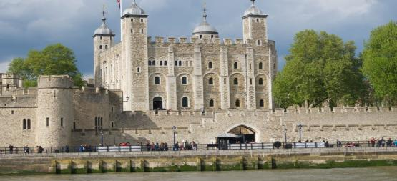
Fig.1 The Tower of London
The Tower's historical significance, its associations with royalty, imprisonment, and intrigue, as well as its architectural splendour, have made it a source of inspiration for writers across centuries. The cultural and historical importance of the Tower underwent a distinct transformation when Thomas More penned the Dialogue, establishing the groundwork for an early modern practice of portraying the Tower in literary and cultural terms as contrasting with the authority of the Crown, as indicated by the cultural geographer. Tim Cresswell explains, “the meanings ascribed to places evolve as historical contexts change, and these meanings are significant for oping and maintaining ideologies.” (15)
The Tower of London has featured prominently in historical dramas, novels, and fictional works. Its role as a site of political intrigue, power struggles, and royal drama makes it an ideal setting for stories centred around monarchs, nobility, and court life. Writers have explored the lives of prisoners, monarchs, and commoners within the Tower's walls, capturing the tension between personal struggles and the weight of history. In Deiter’s view:
“All twenty-four extant English history plays that represented the Tower from 1579 to ca.1634 destabilized, contradicted, and/or resisted the received image of the Tower as a symbol of royal power, portraying it in ways that challenged royal oppression.” (23)

William Shakespeare, the quintessential English playwright, frequently referenced the Tower of London in his works. The Tower serves as a backdrop for scenes of political turmoil, imprisonment, and regal ambition. In plays like Richard III and Henry VI, the Tower becomes a symbol of power and a stage for pivotal events in English history. In Richard III, for example, the actual historical Tower of London becomes a pivotal setting where King Richard III's victims are imprisoned and murdered. The Tower symbolizes both the political power struggles and the fragility of human life in that era. Similarly, in Henry V, the monument to King Henry V's father evokes a sense of duty and honour, anchoring the young king's actions and highlighting the weight of his legacy.
Construction of the Tower of London:
The Tower of London, officially known as Her Majesty's Royal Palace and Fortress of the Tower of London, is a historic castle located on the north bank of the River Thames in central London, England. It was founded towards the end of 1066 as part of the Norman Conquest of England. The tower complex consists of several buildings and structures (Fig.2), and the materials used for its construction have evolved over centuries due to renovations, additions, and repairs.
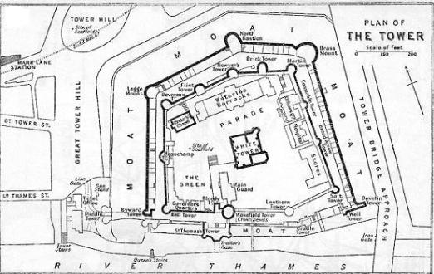
Fig.2 Tower of London, Architectural Design and Construction

The primary construction material used in the early phases of the Tower of London's development was stone, specifically Caen stone, which was imported from Normandy, France. The White Tower, the central and oldest part of the complex, was built using this type of limestone. Caen stone was chosen for its durability and strength, making it suitable for fortifications. Over time, as the Tower underwent various modifications and expansions, different materials were used. In addition to stone, bricks were also used in construction and repairs. The medieval expansion of the Tower complex during the reign of King Richard the Lionheart and subsequent kings involved the use of both stone and brick. In later centuries, as architectural styles changed and the Tower of London saw more utilitarian functions, additional materials like timber and metal were incorporated into the structures. For example, wooden structures, including houses and offices, were built within the Tower's walls.
The Tower of London has been subject to numerous renovations, repairs, and changes throughout its history. The materials used in its construction and maintenance have varied depending on the specific time period and purpose of the structures. The Tower remains a living historical site, and efforts continue to preserve and maintain its unique architecture and heritage.
Elsinore Castle, Denmark:
Elsinore Castle (Fig.3), also known as Kronborg Castle, is a literary benchmark that holds a prominent place in English literature due to its association with William Shakespeare's play Hamlet.
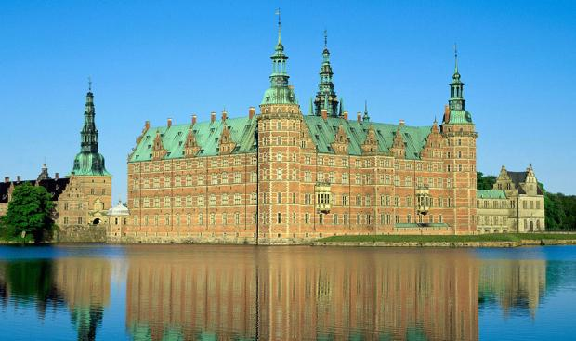
Fig. 3 The Elsinore Castle, Denmark
This iconic castle's role is intertwined with the themes of tragedy, revenge, uncertainty, and the complexities of the human psyche. The Castle serves as a microcosm of human nature's multifaceted aspects. The characters' interactions within its walls illustrate themes of betrayal, revenge, madness, and mortality. The castle's chambers become stages for power dynamics and moral dilemmas, allowing Shakespeare to delve into the intricacies of human behaviour and the consequences of unchecked ambition. Elsinore Castle's significance in English literature is primarily rooted in its portrayal in William Shakespeare's Hamlet. The play commences with Horatio, a companion of Hamlet, who is at the royal castle, Elsinore. Horatio ventures onto the battlements after hearing that the ghost of the recently murdered king, Hamlet's father, has been sighted by the guards on duty. While on the battlements, the ghost materializes; however, when the guards challenge it, the ghost remains silent and eventually departs. Horatio recounts this to Hamlet, who then ventures onto the battlements himself. Upon encountering the ghost, Hamlet is beckoned by it and decides to follow. Despite the protests of others urging him not to go, Hamlet is determined and even resorts to threats of violence if anyone tries to impede him. In Hamlet's absence, Marcellus, one of the officers, reflects on the potential implications of the ghost's appearance, stating, "Something is amiss in the state of Denmark." (I.iv.95)
As a setting that encapsulates themes of tragedy, psychological depth, moral decay, and human complexity, the castle has become a symbol of the play's timeless exploration of human nature and the intricate interplay of fate and choice.
Construction of the Elsinore Castle:
The construction of Kronborg Castle started in the late 16th century (Fig. 4 Plan of The Elsinore Castle), and the primary construction material used was sandstone.
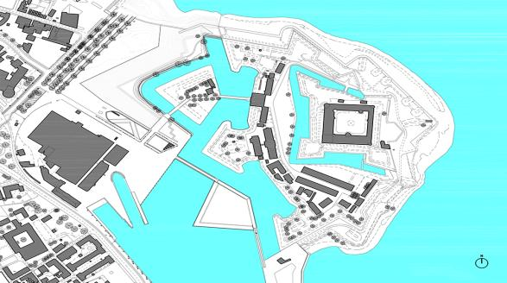
Fig.4 Plan of The Elsinore Castle
The castle's exterior and most of its architectural elements were built using sandstone from the nearby island of Hven and other local sources. Sandstone was a commonly used material in Northern European Renaissance architecture due to its availability and durability. The warm, golden hue of the sandstone gives Kronborg Castle its distinct appearance. The use of sandstone is particularly evident in the ornate facades, decorative sculptures, and intricate details that characterize the castle's architecture. The combination of sandstone and the castle's strategic location on the coast of the Øresund Strait made Kronborg a significant stronghold for controlling maritime trade routes and collecting tolls from passing ships. Kronborg Castle has undergone renovations and restoration work over the centuries to maintain its historical significance and structural integrity. The use of sandstone in its construction has contributed to its lasting beauty and cultural importance as a UNESCO World Heritage Site.
London Bridge:
London Bridge (Fig.5) has been a prominent and symbolic landmark that has found its way into various works of literature over the years, serving as a backdrop, a metaphor, and even a character in its own right. One of the most famous literary references to London Bridge can be found in the nursery rhyme London Bridge Is Falling Down.
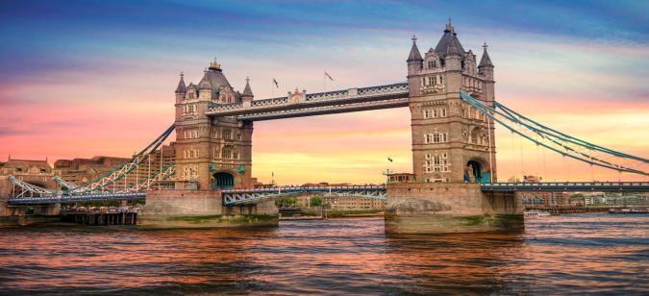
Fig. 5 London Bridge
The nursery rhyme London Bridge Is Falling Down standing as one of the earliest and most renowned allusions to London Bridge in literature. While the precise origin and historical context of the rhyme remain subjects of debate, it mirrors the adversities and necessary renovations that the bridge encountered throughout its history. Some interpretations suggest that the verse relates to King Olaf II of Norway, a Viking conqueror purportedly responsible for damaging London Bridge in the 10th century.
Construction materials used in building London Bridge:
The medieval London Bridge was primarily constructed using stone and timber. The bridge consisted of 19 arches and a drawbridge at the Southwark end (Fig. 6).
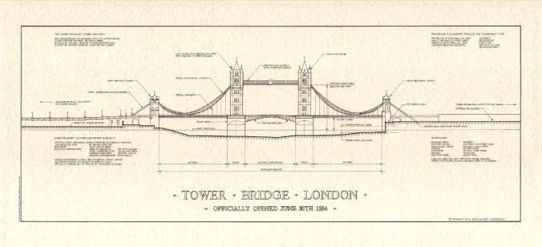
Fig.6 Medieval London Bridge Plan
The main construction material for the arches was a type of limestone called Kentish Ragstone. This durable stone was sourced from quarries in Kent, southeast of London. The piers and arches of the bridge were made of Kentish Ragstone, while the gaps between the piers were filled with wooden structures. The wooden structures provided support for the roadway and allowed for pedestrian walkways, shops, and houses to be built on the bridge. These buildings were constructed using timber and various other materials. Throughout its history, the medieval London Bridge underwent several modifications, repairs, and reconstructions. The bridge was a vital transportation route and an iconic structure in London. It served as a critical connection between the northern and southern parts of the city and played a significant role in trade and commerce. In the centuries following its initial construction, London Bridge was rebuilt and replaced multiple times. The materials used in later versions of London Bridge, including the 19th-century granite-faced bridge designed by John Rennie, changed to reflect the evolving engineering and architectural practices of the time.
The most famous nursery rhyme, "London Bridge is Falling Down," is associated with the various issues and challenges faced by the medieval London Bridge, as it required constant maintenance and repairs due to the harsh conditions of the river and the heavy traffic it carried.

Kenilworth Castle:
Kenilworth Castle (Fig.7) holds a significant part in literature due to its historical prominence, architectural grandeur, and association with key historical events and figures. This iconic castle, located in Warwickshire, England, has inspired writers and poets for centuries, finding its way into various literary works.
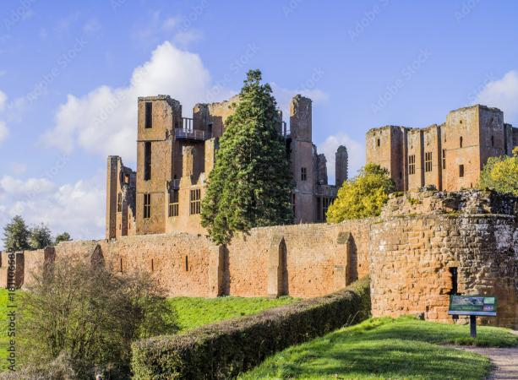
Fig. 7 Kenilworth Castle, Warwickshire, London
The most notable literary association with Kenilworth Castle is Sir Walter Scott's historical novel Kenilworth, published in 1821, the novel is set during the reign of Queen Elizabeth I and centres around the elaborate festivities organized by Robert Dudley, Earl of Leicester, at Kenilworth Castle in an attempt to win the queen's favour. Scott's vivid descriptions of the castle and its surroundings bring the setting to life, making the castle itself almost a character in the story. The novel showcases the castle's historical significance and its role as a backdrop for political manoeuvring and romantic intrigue.
In John Milton's masque Comus, Kenilworth Castle is referenced as a location of enchantment and beauty. The masque, known for its lyrical and poetic qualities, uses the castle as a symbol of grandeur and the idealized English countryside.
Beyond specific literary works, Kenilworth Castle has also been used symbolically to represent themes like historical memory, the passing of eras, and the endurance of structures through time. Its imposing presence and historical significance make it a potent symbol for various literary purposes. In literature, Kenilworth Castle serves as a touchstone of history, romance, and intrigue. Its enduring presence and the stories woven around it make it a canvas on which writers can paint tales of the past, present, and future, enriching the castle's legacy through the power of words.
Materials used in the construction of Kenilworth Castle:
The castle has a complex history with different phases of construction (Fig.8), so the materials used evolved over time. The primary building material for Kenilworth Castle was limestone.
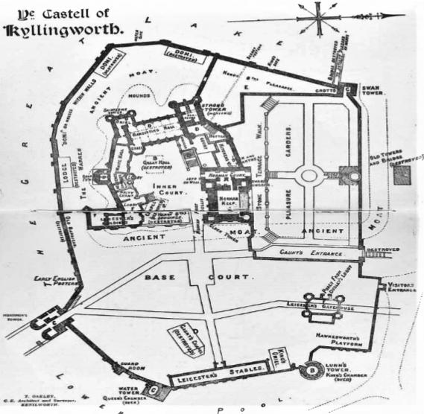
Fig. 8 Architectural Design of Kenilworth Castle

The castle's walls, towers, and other major structures were built using locally sourced limestone. The stone was quarried nearby and then shaped and assembled by skilled craftsmen. Timber was used for various purposes within the castle, including roofing, floors, doors, and internal structures. Wooden beams, joists, and supports were essential for constructing the interior spaces of the castle. Over time, brickwork was incorporated into the castle's architecture. During the later phases of construction and renovations, bricks were used for some walls and features. Bricks were more commonly used in later additions and modifications to the castle. Lead was used for roofing and as a waterproofing material. It was commonly used in medieval buildings to create durable and effective roofing solutions. Iron was used for hinges, locks, and other metalworks. It played a crucial role in constructing functional elements of the castle, such as doors and gates. Glass was used for windows, albeit sparingly in medieval times. Glass windows were often a sign of wealth and were incorporated into more important and decorative parts of the castle. Mortar, made from a mixture of lime, sand, and water, was used to bond stones and bricks together. It provided stability and strength to the castle's structures. Various materials, including thatch and wooden shingles, were used for roofing in different periods of the castle's history. Later renovations might have included more advanced roofing materials like slate.

Shrine of St. Thomas Beckett, Canterbury:
The Shrine of St. Thomas Beckett (Fig.9), also known as the Shrine of St. Thomas of Canterbury, played a pivotal role in English literature primarily due to its association with the martyrdom of Thomas Beckett and its subsequent influence on religious, political, and cultural developments.
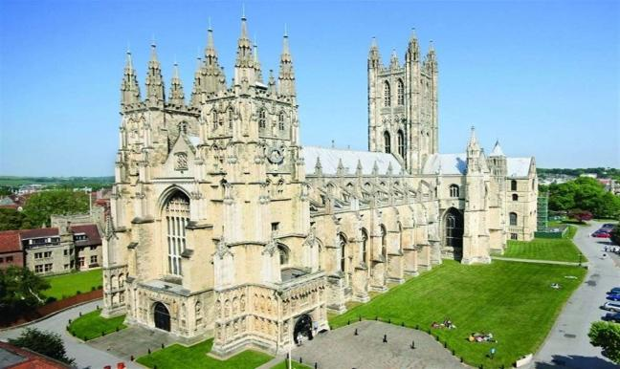
Fig. 9 Shrine of St. Thomas Beckett, Canterbury

Thomas Beckett was the Archbishop of Canterbury during the 12th century, and his tumultuous relationship with King Henry II ultimately led to his murder in Canterbury Cathedral in 1170.
The Shrine of St. Thomas Beckett became a major pilgrimage site in medieval England, drawing pilgrims from different parts of the country and even from other countries. This religious fervour and the stories associated with the shrine often found their way into medieval literature and chronicles, reflecting the significance of the shrine in the cultural and spiritual life of the time. The Shrine of St. Thomas Beckett served as a symbol of religious devotion, martyrdom, and resistance against secular authority. These themes were often incorporated into literature, serving as metaphors for broader societal concerns. The shrine's aura of sanctity and the belief in the miraculous powers associated with it added a mystical element to many literary works.
One of the most notable works is Geoffrey Chaucer's The Canterbury Tales. In this collection of stories, a diverse group of pilgrims is depicted traveling to the shrine of St. Thomas Beckett in Canterbury. Each pilgrim tells a tale, providing insights into their personalities and worldviews. Chaucer's work showcases the religious devotion of the pilgrims while also offering a social commentary on medieval English society.
Writers such as T.S. Eliot drew inspiration from Thomas Beckett's story and the Canterbury pilgrimage in their own works. Eliot's play Murder in the Cathedral explores Beckett's inner turmoil and the ethical dilemmas he faced.
The Shrine of St. Thomas Beckett played a multifaceted role in English literature by providing inspiration for diverse literary works, symbolizing religious and political themes, and influencing the portrayal of pilgrimage, devotion, and power dynamics in various texts across different time periods.
Materials used to construct Shrine of St. Thomas Beckett:
The shrine was a masterpiece of medieval craftsmanship and devotion, attracting pilgrims from all over Europe. Unfortunately, the shrine was destroyed during the English Reformation in the 16th century, so much of the information about its construction is based on historical records and archaeological findings. The shrine was known for its opulent design (Fig. 10) and lavish use of precious materials.
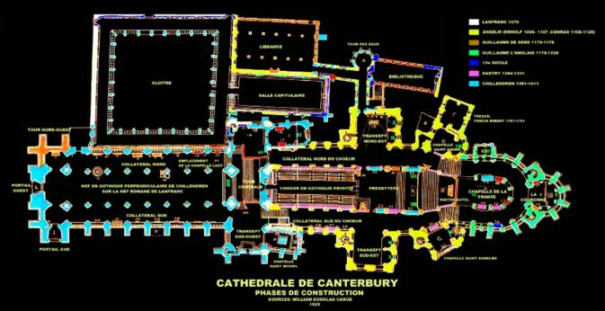
Fig. 10 St. Thomas Beckett construction plan
The shrine's base and some architectural elements were likely made of marble. Marble was a prized material in medieval architecture, associated with grandeur and luxury. The shrine was adorned with elaborate metalwork, often gilded with gold leaf. This included intricate filigree, embossed designs, and sculpted figures. Precious metals like gold and silver were used to create stunning visual effects. It was embellished with a multitude of precious gemstones and jewels. These were likely used to decorate the metalwork and create a dazzling display that reflected the spiritual significance of the relic. Enamel, a technique involving the fusion of powdered glass onto metal, was used to create colourful and detailed decorations on the shrine. Enamel added vibrant hues and intricate designs to the shrine's overall appearance. Skilled woodcarvers created intricate sculptures and reliefs that adorned the shrine. Wooden panels, possibly painted or gilded, would have depicted scenes from the life of Thomas Becket and other religious themes. Luxurious textiles, such as silk and velvet, were used to drape the shrine and create a sumptuous backdrop. Embroidery with gold and silver threads could have further enhanced the shrine's appearance. The shrine was likely a complex architectural structure that incorporated multiple materials. It might have featured architectural details such as columns, arches, and decorative elements made from various materials. The shrine's construction has been lost to history due to its destruction during the English Reformation. However, historical records, descriptions, and archaeological findings provide valuable insights into the materials and techniques used to create this magnificent religious monument.
Banqueting House, Whitehall, London:
The Banqueting House (Fig. 11) in Whitehall, London, has a notable place in English literature due to its historical significance, architectural beauty, and associations with pivotal events in English history.
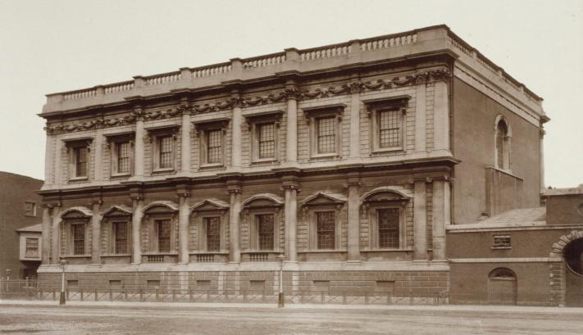
Fig. 11 Banqueting House, London

It is particularly remembered for its connection to the execution of King Charles I and the subsequent upheavals during the English Civil War, which have been explored and depicted in various literary works. Additionally, the Banqueting House's distinctive architecture and place within the English royal complex have made it a subject of artistic and literary inspiration. Its associations with monarchy, rebellion, and change make it a rich source of inspiration for writers exploring themes of power, governance, and the human experience during times of upheaval. The Banqueting House's architectural beauty and historical importance have inspired poets to incorporate it into their verses. Poems might explore themes of power, tragedy, and the passage of time, drawing on the events that unfolded within its walls.
Construction materials used in building the Banqueting House:
Inigo Jones was heavily influenced by the Italian Renaissance architectural style, particularly the works of Andrea Palladio. The Banqueting House's design (Fig 12) reflects classical proportions, symmetry, and a sense of grandeur.
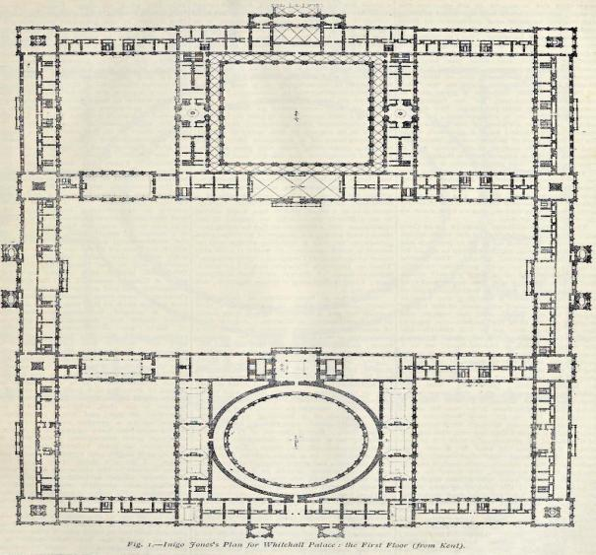
Fig.12 Banqueting House Design
The building is characterized by its use of classical orders, clean lines, and a monumental facade. The construction of the Banqueting House involved the use of various materials commonly employed in Renaissance architecture The primary building material for the Banqueting House was Portland stone. This type of limestone was quarried on the Isle of Portland in Dorset and was known for its durability and fine grain. The building's facade features a series of columns and pilasters executed in the classical orders of architecture—Doric on the ground floor and Ionic on the upper floor (Fig 13).
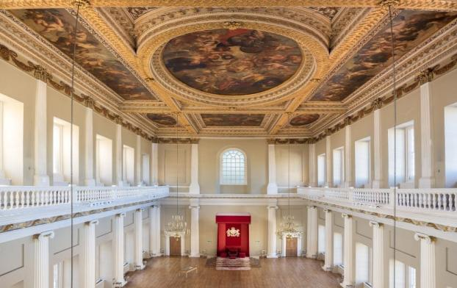
Fig. 13 Banqueting House (Interior), Whitehall, London
These were likely carved from the same Portland stone. The Banqueting House's windows and decorative elements, such as cornices and friezes, were also crafted from stone. The intricate carving and detailing were typical of the Renaissance style.
Globe Theatre, London:
The Globe Theatre in London is one of the most iconic landmarks in English literature and theatre history. It's closely associated with the works of William Shakespeare and the vibrant theatrical scene of the Elizabethan era. The original Globe Theatre (Fig. 14) was built in 1599 by the Lord Chamberlain's Men, a company of actors that included William Shakespeare.
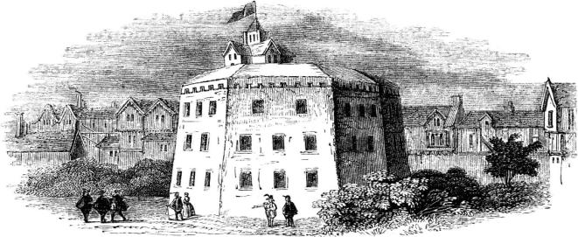
Fig. 14 Original Globe Theatre

It was situated on the south bank of the river Thames in London's Bankside district. The theatre was a central hub for entertainment during the Elizabethan era and the early Jacobean era.
The Globe Theatre is perhaps most famous for being the venue where many of William Shakespeare's plays were performed. These include timeless works like Romeo and Juliet, Hamlet, Macbeth, Othello, and many more. The theatre’s circular design and open-air setting influenced the staging, performance, and audience interaction of these plays. Shakespeare's plays often relied on the dynamic relationship between actors and the "groundlings" (lower-class, standing-room-only audience members) who stood in the yard.
The original Globe Theatre was destroyed by fire in 1613 but was rebuilt the following year. It was eventually closed down in 1642 due to the Puritan government's ban on theatres. In recent years, a reconstruction of the Globe, known as "Shakespeare's Globe," has been built near the original site in London. This modern reconstruction aims to replicate the experience of Elizabethan theatre and hosts performances of Shakespeare's plays and other classical works. The Globe Theatre's historical and cultural significance lies in its association with Shakespeare's plays, its unique open-air design, and its influence on the development of English drama and literature.
Materials used in the construction of the Globe Theatre:
Just like the original construction, the rebuilt Globe Theatre (Fig. 15) also used timber as its primary structural material.
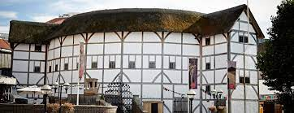
Fig. 15 Shakespeare's Globe
Oak was the most common wood used due to its strength and durability. Thatch remained the chosen roofing material for the Globe Theatre's distinctive circular roof (Fig.16).
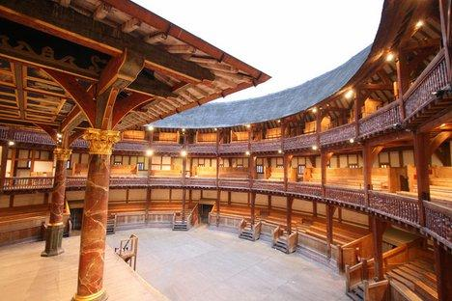
Fig. 16 Interior of Shakespeare’s Globe
Thatch provided a traditional and cost-effective way to cover the building. Bricks and clay were used for the foundation and the base of the building. They provided stability and support for the wooden superstructure. Lime plaster was used for finishing the exterior and interior surfaces of the building. Lime was mixed with sand and water to create a durable and visually appealing surface. While glass windows were not common in the Globe Theatre due to its open-air design, small glass panes might have been incorporated in certain areas. Lead was used for waterproofing and flashing, particularly for the roof. Iron fittings, including nails, hinges, and other hardware, were used to connect and secure the wooden components of the building. Canvas and fabric were likely used for creating temporary structures, partitions, and canopies for certain areas of the theatre. Similar to the original construction, paints and pigments were used for both decorative and practical purposes. Elaborate designs and colours were painted on the exterior and interior surfaces. The reconstruction of the Globe Theatre after the fire aimed to replicate the original design and layout as closely as possible (Fig. 17).
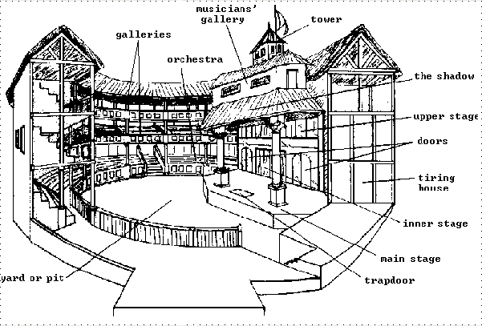
Fig. 17 Globe Theatre Plan
The use of traditional materials helped maintain the historical authenticity and aesthetic of the theatre, allowing it to continue hosting Shakespearean plays and other performances for many years.
Colosseum, Rome:
The Colosseum (Fig.18), also known as the Flavian Amphitheatre, is an ancient Roman amphitheatre located in Rome, Italy.
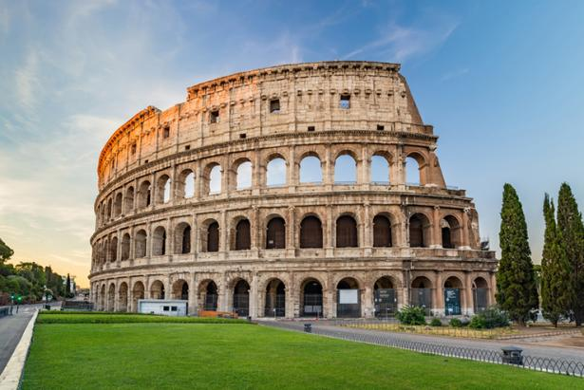
Fig. 18 Colosseum, Rome
While it is not directly associated with English literature, its historical and cultural significance has made it a prominent symbol that has been referenced and alluded to in literature, particularly in works that explore themes of power, spectacle, and the human experience. The Colosseum was a grand structure built for the purpose of hosting various forms of entertainment, including gladiator contests, animal hunts, and mock naval battles. Its scale and architectural splendour have made it a symbol of imperial power, excess, and the spectacle of the ancient Roman world. In literature, the Colosseum might be used as a symbol to represent grandiosity, opulence, and the display of authority.
The Colosseum's history of hosting brutal and often deadly spectacles can serve as a backdrop for exploring themes related to human nature, morality, and the ethics of entertainment. Literature might explore into questions about the value of life, the role of violence in society, and the ways in which individuals and societies respond to and justify such forms of entertainment.
The Colosseum's focus on spectacle, drama, and the engagement of the audience can resonate with themes found in dramatic literature. Works that explore the nature of performance, the relationship between actors and audiences, and the emotional impact of staged events might draw inspiration from the Colosseum's history. The Colosseum's history, including notable events that occurred there, can serve as inspiration for historical novels, plays, or poems that aim to bring ancient Roman society to life. The amphitheatre’s storied past can provide rich material for exploring characters, conflicts, and narratives. While the Colosseum is not a central focus in English literature, its historical legacy, architectural significance, and symbolic importance have led it to be referenced in various ways. It serves as a reminder of the intersection of human creativity, power, and the enduring impact of monumental structures on culture and imagination.
Construction materials used in building Colosseum:
The Colosseum was constructed using a variety of materials typical of Roman architecture (Fig. 19) at the time.
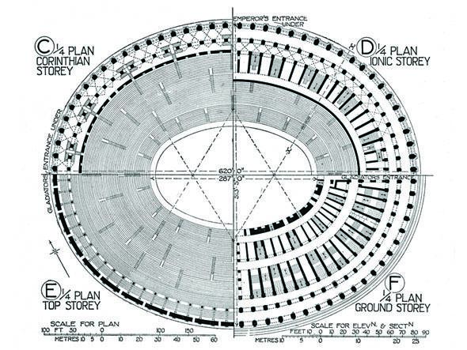
Fig. 19 Architectural plan of colosseum
The primary building material used in the Colosseum's construction was concrete. Roman concrete, known as opus caementicium, was a mixture of lime, volcanic ash, water, and small stones or aggregate. This concrete was used to create the various levels and structural components of the amphitheatre. The outer facade of the Colosseum was faced with travertine limestone, which gave the building its distinctive appearance. The use of stone provided durability and contributed to the Colosseum's grandeur. In addition to the travertine facade, other types of stone were used in the construction, including tufa, a porous rock. Bricks were also used, especially in areas not visible from the exterior. The combination of brick and stone helped create a strong and stable structure. Iron clamps and dowels were used to hold the massive stone blocks together. These clamps reinforced the structural integrity of the building. Timber was used for the flooring of the various levels and for temporary structures like ramps and platforms used during the construction process. The use of wood was limited in the Colosseum's construction due to the risk of fire. Sand and mortar were used to fill gaps between stone blocks and create a smooth surface. Mortar was also used to bond the stone blocks and create a solid structure. Lead was used for waterproofing and sealing joints, especially in areas where water infiltration was a concern. Metal clamps and fixtures were used for reinforcement and to secure architectural elements.
The Colosseum's construction methods were innovative for its time, and its design (Fig. 20) allowed for efficient crowd management and various types of events, including gladiatorial contests and public spectacles.
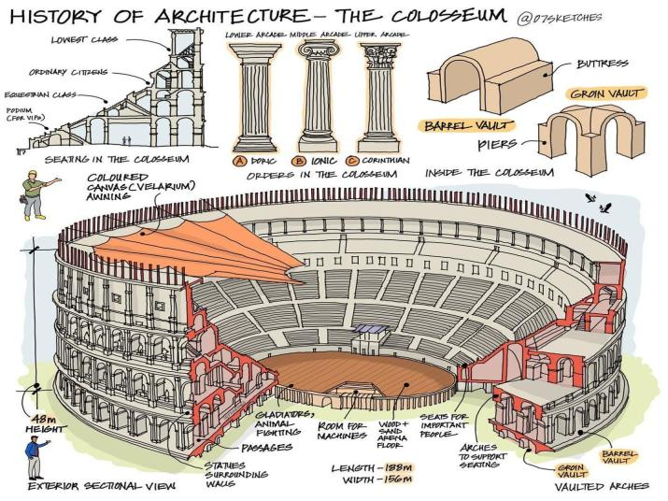
Fig. 20 Colosseum's construction methods and design
The combination of concrete and durable stone facing contributed to the Colosseum's longevity, as well as its enduring status as a symbol of ancient Roman engineering and architecture.

Conclusion:
In the intricate tapestry of English literature, historical buildings stand as cultural heirlooms and literary treasures, weaving threads of the past into the vibrant fabric of storytelling. These buildings transcend mere physical structures, becoming the embodiment of time, memory, and the human experience. The intertwining of historical buildings with the fabric of English literature adds a profound dimension to storytelling. As readers, we traverse the pages of literary works, journeying not only through the narrative but also through the corridors of history. As ink flows into narratives, the essence of these buildings’ seeps into the narratives themselves, enriching tales with layers of authenticity and depth. These buildings, standing as silent sentinels of the past, implore us to engage with history, culture, and the intricacies of the human condition. Their significance is not confined to a single era; rather, it extends an invitation to explore the narratives that have shaped our collective identity, as well as the stories that continue to echo through time. The legacy of these historical buildings transcends geographical boundaries, cultural differences, and temporal barriers, becoming a testament to the power of literature to transcend the limitations of its pages. These cultural heirlooms and literary treasures, through their permanence and evocative presence, remind us that literature is not only a means of storytelling but also a conduit that bridges the realms of imagination and reality, past and present. Just as historical buildings stand as living echoes of eras long gone, the tales they inspire continue to resonate, affirming the enduring power of words to shape our understanding of the world and our place within it.
In a world where architectural marvels continue to rise, historical buildings stand as testaments to the exceptional craftsmanship and engineering ingenuity of their eras. The enduring strength of these structures, built in times when technology was limited and resources were scarce, is a profound testament to the brilliance of human creativity. Even in the face of modern construction techniques and materials, these historical buildings remain standing as symbols of resilience and longevity.

References:
Boyes Georgina. Alice Bertha Gomme (1852-1938): A Reassessment of the Work of a
Folklorist. < https://www.jstor.org/stable/1260323>.

Cresswel, Tim. In Place / Out of Place: Geography, Ideology, and Transgression.

Minneapolis: University of Minnesota Press. 1996. 15.

Deiter, Kristen. The Tower of London in English Renaissance Drama. London: Taylor

&amp; Francis.2014.

Dimes, F.G. Conservation of Building & DecorativeStone. In J. Asthurst & F.G. Dimes (eds).

ButterworthHeinemman Publishers. 1998.

Ghedini, N., Sabbioni, C., Bonazza, A., Gobbi, G. & Zappia,G. A quantitative methodology for

carbon speciationin black crusts on monuments. In C. Saiz-Jimenez (ed), AirPollution

and Cultural Heritage: this volume. Lisse: Bal-kem. 2004.

Leary, E. The Building Limestones of the British Isles. Building Research Establishment Report. Department of Environment. 1983.

Homer. The Iliad. Tr. by Robert Fagles. New York: Penguin, 1990.
Jenkins, John. Modelling the Cult of Thomas Becket in Canterbury Cathedral. Journal
British Archaeological Association 173. 2020.
<https://doi.org/10.1080/00681288.2020.1771897>

Shakespeare, William. Hamlet. Ed. Robert S. Miola. New York: Norton, 2010.

Masson, Victoria. The Origins & Causes of the English Civil War.
< https://www.historic-uk.com/HistoryUK/HistoryofEngland/Origins-of-the-English-Civil-War/>

