Copper Deficiency Affects On Morphology And Reproductive Biology Of Blackgram

Abstract-Black gram(Vigna mungo L)CV T-9plants were grown till maturity i. e. 74days at 0.0065, 0.013(deficient) and0.065(adequate)mg cu l⁻¹ of cu in refined sand. Cu deficiency i. e. 0.0065,0.013 cu l⁻¹ caused phenotypes are that Compared to control 0.065mg cul⁻¹ cu supply the plants were stunted ,leaves were discoloured and old leaves became.Necrotic and withered and the number of flowers, pods and seeds are highly reduced. The size and number of pods were significantly reduced in cu deficiency. The seed weight marginally decreased at both the cu deficient levels. All the stages of determinations(day 24,60,74)the decrease in total dry weight was 29-30% at 0.0065mg cu l⁻¹and14-17% at 0.013 mg cu l⁻¹as compared to that of control. The concentration of cu in both leaves and seeds increased with an increase in cu supply, the cu concentration in deficient cu was higher in younger leaves than that of older leaves. Cu deficiency reduces growth , male and female fertility and this effectsthe seed quality of a plant.The cu deficiency also effect the economy of the crops .The delayed flowering,senescence and entirely abolished gynoecium fertility were also seen in cu deficient (o.o65ml cu l⁻¹ blackgram plants).The cu deficiency affects the pollen producing capacity when the pollen grains were germinated in an artificial medium the observation showed that 30-35%pollen grains were viable in deficiency as compared to 61% at normal cu and the tube length was also decreased at deficient cu .The pollen grains sticked to stigma surface also showed esterase activity and the esterase activity was studied in stigma under control condition was much higher than that of deficient cu supply.After clearing with NAOH and staining with aniline blue the whole mount of ovule showed that phenolic compounds were localized more in micropylar region of the outer integument on the placental side in cu deficient material ,whereas in control this type of deposition was not observed ,cell division in this region of integument is more frequent in the control(0.065mgl⁻¹)cu supply.As compared to deficient(0.0065mg cul⁻¹),on the protein basis the activities of peroxidase ,acid phosphatase and alkaline phosphatase decreased in both male and female parts i. e. stamen, ovaries, stigma and style.While on the fresh weight basis the activity of peroxidase increased in cu deficient supply. The activity of acid phosphatase and alkaline phosphatase increased in ovary stigma style and stamen. In the stamen the acid phosphatase activity decreased in cu deficient level.Compared to control the concentration of sugars both reducing and non-reducing in leaves (source)as well as developing pods(sink)decreased at deficient cu at 0.0065mgl⁻¹ this indicates of lower synthesis and lesser incorporation of sugars in biosynthesis of starch at deficient cu.The decrease in starch content was 43-49% from that of
1
the control cu supply both leaves (source) and pods (sink). The concentration of soluble nitrogen compounds (non-protein nitrogen) lowered as compared to control cu supply while the decrease in total and protein nitrogen in seeds ranged from 30-32% in both deficient levels of cu .The decreased pod : leaf ratio of non-protein nitrogen and increased that of protein nitrogen at deficient cu indicates hampered translocation of soluble nitrogenous compounds from source to sink.The ovaries of mature buds showed accumulation of sugars and phenols was more pronounced at the lower cu level i.e (0.065 mg cu l⁻¹)In mature seeds the decrease in protein content in cu deficient blackgram seeds ws maximum in albumins and vicilins and minimum in legumins . The sulphur containing amino acid i.e lysine , methionine and cysteine : increased with an increase in cu supply from 0.0065 to 0.065 mg cu l⁻¹
Keywords:Black gram; Copper; Pollen grains; Peroxidase; Protiens; Seed quality; Seed reserves
INTRODUCTION

Adequate amounts of protein fiber carbohydrates, bioactive, phytochemicals,, unsaturated fats, dietary fiber and micronutrients are found in black gram. Hence it is known as a protein source in the world market. Copper is of special importance as a micronutrient for plant growth. It participates in several metabolic activities. Copper plays an important role in photosynthesis and respiration (electron transport chain). Therefore, copper deficiency affects important metabolic functions of plants.Infact, copper is a micronutrient, so it is needed by plants in very small amounts. Copper deficiency affects the internal and external activities of plants. It ,also affects the plant growth, reduced flowering,,infertility and also the protein concentration and the activity of enzymes. The effect of copper deficiency is seen in both leguminous and non-leguminous plants. Effects of copper deficiency on the reproductive biology of leguminous plants also are observed experimentally. Deficiency of copper supply can be clearly seen on male and female reproductive organs of leguminous and non-leguminous plants both . Therefore, this deficiency affects the economic yield of plants. The effect of copper deficiency can be seen in the length of the plumule and radical. Copper deficiency as well as the toxicity of copper results in inhibition not only of vegetative growth but also of reproductive biology of plants. The effect of copper deficiency in plants has been observed in premature germination of grains. The effect of copper deficiency in the seed was first seen in the sprouting of grains. Thus, the effect of copper deficiency in the seed is that it affects the stress growth, nitrogen exchange, biomass, grain production and the bulk of the grain. This chapter focuses on plant reproductive physiology and seed quality, especially this study shared the knowledge of morphology and reproductive biology of plants and tried to grow the flowers of black gram on various amounts of copper in the refined sand.

2

BLACK GRAM

Origin-Black gram has been cultivated in South Asia since ancient times.Black gram is a prized pulse grown in both Kharif and Rabi seasons in India. Black Gram is commonly
known as whole urad pod and split bean (white/ dhuli urad).Infact , black gram is an important pulse crop grown in India .70% of the world's black gram is produced in India and mainly Uttar Pradesh, Madhya Pradesh, Andhra Pradesh, etc. are the black gram-producing states of India. Being a leguminous plant, Urad bean has the ability to fix atmospheric nitrogen in the soil. Black gram is known by different names in different states of India.
Morphological characters of black bean- Vigna mungo(Black gram) is a leguminous annual, dry, perennial dicotyledonous legume, which is a 4-7cm long, cylindrical, hairy pod, which gets established after 60-70 days from germination. Each pod contains 6-20 grains of black-brown colour. The flowers of urad are yellow in color, the fruits are cylindrical and the seeds are elliptical and oval shaped.
Suitable conditions for cultivation of black gram –Black gram (Vigna mungo) is grown as a pure or mixed crop in Kharif season.It is usually grown at a temperature between 25-35 degree Celsius. At that time (Kharif Season) the weather is hot and humid due to summer and rain.
Sowing time –Warm and humid environment is best for black gram, And the month of July is suitable for Sowing, black gram. If Sowing of black gram is done early, the pods are almost non-existent with very few flowers. Similarly, the right time for sowing in the summer season is from the month of February to the month of april.Late sowing should be avoided as extreme temperature is not suitable for black gram. Apart from this when all the pods turn yellow and turn black, that means 70-80% of leaves should be harvested after ripening and it is also important that 20-30% moisture should be visible in the grain at the time of harvesting
Benefits of black gram – Due to the presence of many micronutrients like potassium , magnesium , phosphorus , calcium , iron , copper etc. in black gram,it strengthens the bones and reduces the chance of osteoporosis. Being a source of protein , it is very important for vegans.
Role of copper – Plant require very small amount of copper for their healthy growth and development, but its deficiency affects plant growth hence copper is micronutrient as well as a fundamental mineral. Copper plays an important role in agriculture. It has been observed that the concentration of copper in soil is not uniform throughout the world , and in many places copper levels are sufficient in the soil . Copper deficiency in soil affects the productivity and quality of grains . Copper deficiency also affects the production of flowers

3
and beans . And the crop failures occur due to low production of flowers and pods. Hence copper deficiency is a major issue in global food production . Inorganic fertilizers such as urea, etc. also affect the supply of copper in the soil. Apart from this , the most important crops in the world market such as wheat , rice , maize , etc. are also sensitive to copper deficiency. Apart from this , other nutrient rich food crops like carrots , spinach , citrus fruits , jai , etc. are also sensitive to copper deficiency . Hence the supply of copper can be met in the form of copper sulphate in the soil. Sewage sludge is also used in some areas to replant agricultural land for the application of organic matter and metals including copper.
Role of copper in reproduction of plants -Copper affects the development of anthers and ovules and the growth of an embryo and endosperm. Inadequate copper, the legumes have delayed flowering and reduced the number of the number of mature flowers. Therefore , apart from the formation of fruits ,sufficient amount of copper is also required for the formation of endosperm pollen and ovaries.There should be a sufficient amount of copper for the fertilization and final seed yield. Accumulation of phenolic compounds in low copper condition , one of the cause of inhibition of the flowering. The effect of sugars and starch concentration is clearly visible in copper deficient seeds,due to which the grain filling length is reduced and light weight seeds are formed. This deformed seed is caused by poor development of degenerative organs . Copper deficiency affects plant development as well as physiological processes.

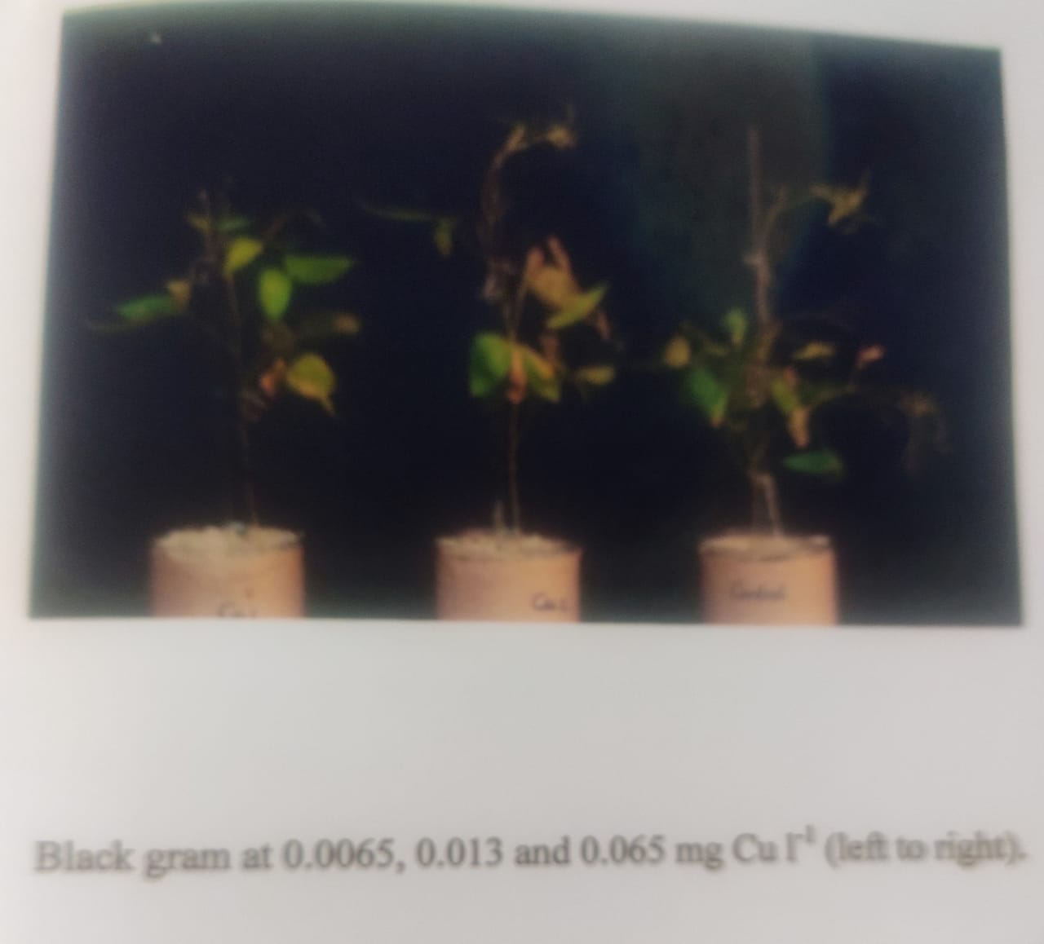

4
RESULT AND DISCUSSION
Growth and Visible Symptoms-Compared to the control the height of black gram plants decreased in copper deficiency . Owing to copper deficiency the plants were stunted, leaves were discoloured and old leaves became necrotic and withered . The number of flowers ,seeds, pods are highly reduced at deficient copper supply.

Pods and Seed yield-The size and number of pods were significantly reduced in copper deficiency. The total weight of seeds increased with increase in copper levels. Compared to that of control the 100 seed weight was marginally decreased at both the copper deficient levels

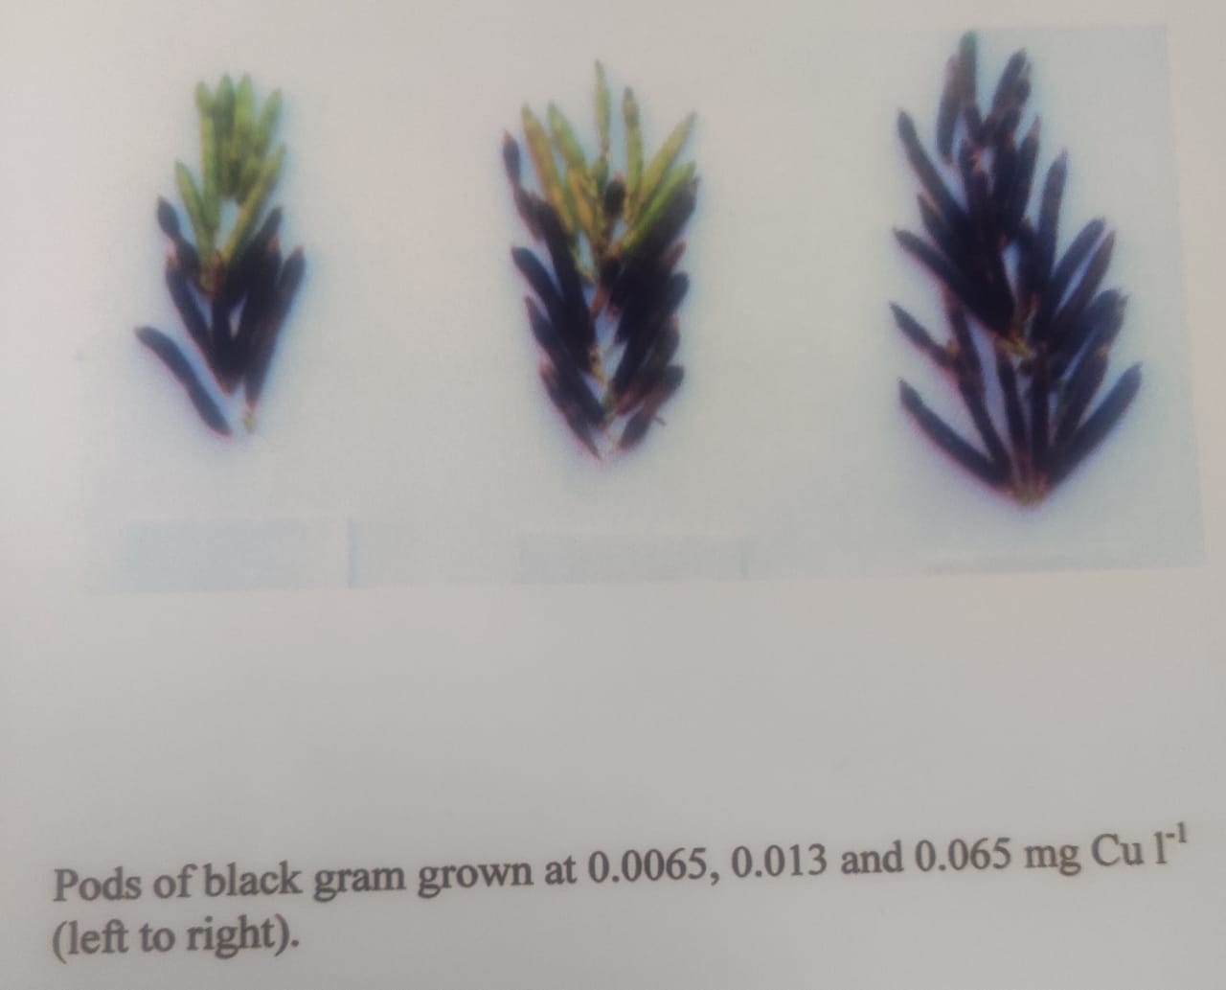
Total Dry Weight-At all stages of determinations (day 24. 60. 74), the decrease in total dry weight was 29-30 percent at 0.0065mg cul⁻¹ and 14-17 percent at 0.013mg cul⁻¹ as compared to that of control.

5
Copper Concentration-The concentration of copper in both leaves and seeds increased with increase in copper supply from 0.0065 to 0.065mg l⁻¹.The copper concentration in leaf was highest at day 24 than that of day 60 and 74. At day 60 , the copper concentration at deficient copper was higher in younger leaves than that of older leaves .
Morphological Changes-The pollen producing capacity of anthers was maximum at 0.065mg cul⁻¹and compared to this it decreased in copper deficiency more at 0.0065 than 0.013mg cul⁻¹. When the mature pollens were germinated in artificial medium the tube length was also decreased at deficient copper.

Pollen Grains- The pollen grains obtained from control(0.065mg cul⁻¹showed comparatively much higher viability than that of cu deficient (0.0065mg cul⁻¹) flowers. Pollens were dimorphic, the smaller ones were vacuolated, less stained and non-viable, whereas larger ones were viable. The pollen grains from both copper deficient and control were grown in artificial medium and it was found that germination occurred in both the conditions. However, the non-viable pollens formed in copper deficiency failed to germinate. The observation showed that 30-35 percent pollen grains were viable in copper deficiency as compared to 61 percent at normal.
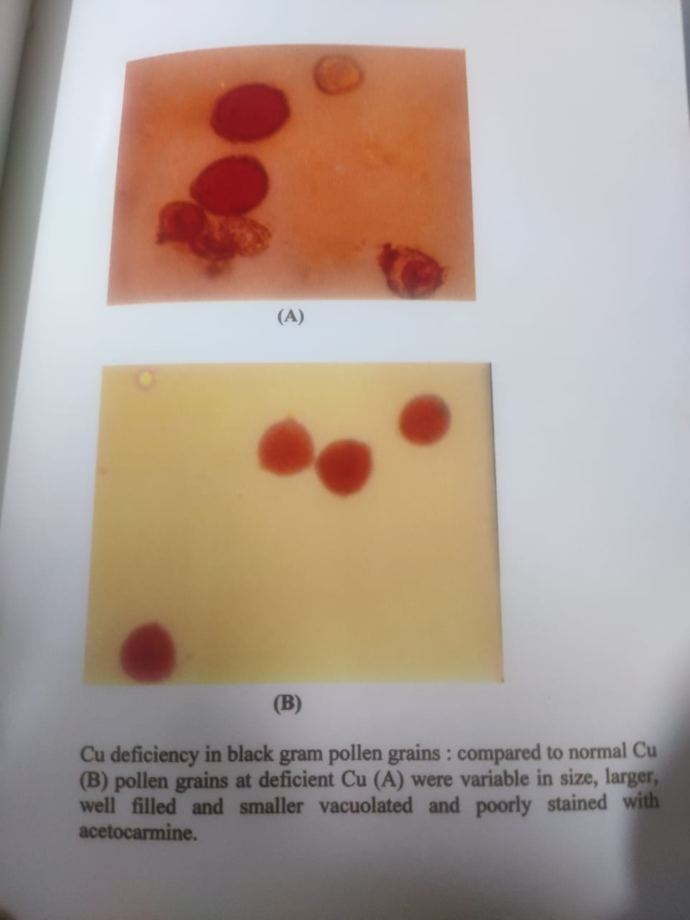
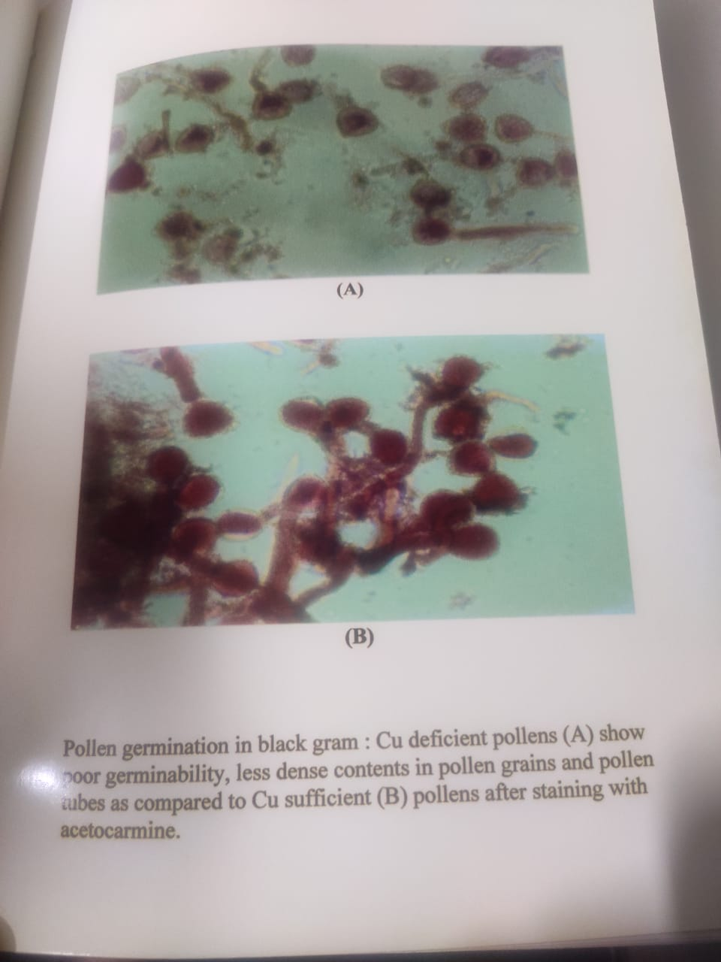
6
Stigma and Style-The esterase activity was studied in stigma under control as well as in copper deficient condition. It was found that esterase activity was much higher in stigma of control(0.065mg cul⁻¹) flower as compared to that of copper deficient (0.0065mg cul⁻¹) flower. The pollen grains sticked to stigma surface also showed esterase activity.The whole mount of ovule after clearing with NaOH and staining with aniline blue , showed that phenolic compounds were localized more in micropylar region of the outer integument on the placental side in copper deficient material, whereas in control this type of deposition was not observed . In this region of integument the cell division was more frequent in control (0.065mg cul⁻¹) as compared to deficient(0.0065mg cul⁻¹) copper.
BIOCHEMICAL CHANGES
Stamens-Compared to the control the activities of peroxidase acid phosphatase and alkaline phosphatases decreased in copper deficiency on protein basis . The decrease in enzyme activity was more pronounced at 0.0065 than 0.013mg cul⁻¹. On the basis of fresh weight the activity of peroxidase and alkaline phosphatase increased , whereas the activity of acid phosphatase was decreased at deficient copper(0.0065-0.013mg cul⁻¹)levels.
Stigma and Style-The specific activity of peroxidase , alkaline phosphatase and acid phosphatases decreased in copper deficient stigma and style as compared to control plants. The activity of these enzymes were depressed more at 0.0065 than 0.013mg cul⁻¹on protein basis. On fresh weight basis the activity of peroxidase increased ,whereas the activity of acid phosphatase and alkaline phosphatases decreased.
Ovary-The activity of acid phosphatase and peroxidase increased in cu deficient ovaries . Compared to that of control on fresh weight basis ,whereas on protein basis the activity of these enzymes was markedly decreased .
SOURCE AND SINK RELATIONSHIP
Carbohydrates and Nitrogen Fractions
Sugars-Compared to control, the concentration of sugars both reducing and non-reducing in leaves (source) as well as developing pods(sink) decreased at deficient copper at 0.0065mg cul^{-l} but remained almost unchanged or increased at 0.013mg cul^{-l}. A gradual decrease in ratio of reducing sugars in pods (sink) and leaves(source) with an increase in copper supply is indicative of lower synthesis and lesser incorporation of sugars in biosynthesis of starch at deficient copper.In mature bud the concentration of sugars and phenols were increased with increase in copper levels i. e. from 0.0065-0.065mg cul⁻¹.
Starch-The decreased in starch concentration due to low copper was higher (82-85%) at 0,0065mg cul⁻¹ than 0.013mg cul⁻¹ (41-78%)in leaves and pods . In copper deficient seeds the decrease in starch content was 43-49% from that of the control.
7
Nitrogen-The concentration of soluble nitrogen compound(non-protein nitrogen)was decreased as compared to the control copper (0.065mg cul⁻¹) , it was less at 0.0065 than 0.013mg cul⁻¹ in both leaves(source) and developing pods (sink). At 0.0065mg cul⁻¹the total protein nitrogen was 66-79% while at 0.013mg cul⁻¹it was 40-42%. In copper deficient seeds non-protein content showed a decline from that of control. The decrease in total and protein nitrogen in seeds ranged from 30-32%at both deficient levels of copper.The decreased pod leaf ratio of non-protein nitrogen and increased that of protein nitrogen at deficient copper indicates hampered translocation of soluble nitrogenous compounds from source to sink.
Phenols-The phenol concentration also showed a decrease in copper deficient levels and developing pods more at 0.013(39-48%) than 0.0065(30-44%)mg cul⁻¹. The decrease in total phenols of copper deficient seeds was 40-42% from that of the control.
Ovaries-Compared to control plants supplied with 0.065mg cul⁻¹, ovaries of mature buds at deficient copper(<0.065mg l⁻¹) showed accumulation of sugars and phenols was more pronounced at the lower copper level i. e. 0.0065mg l⁻¹than 0.013mg cu l⁻¹.
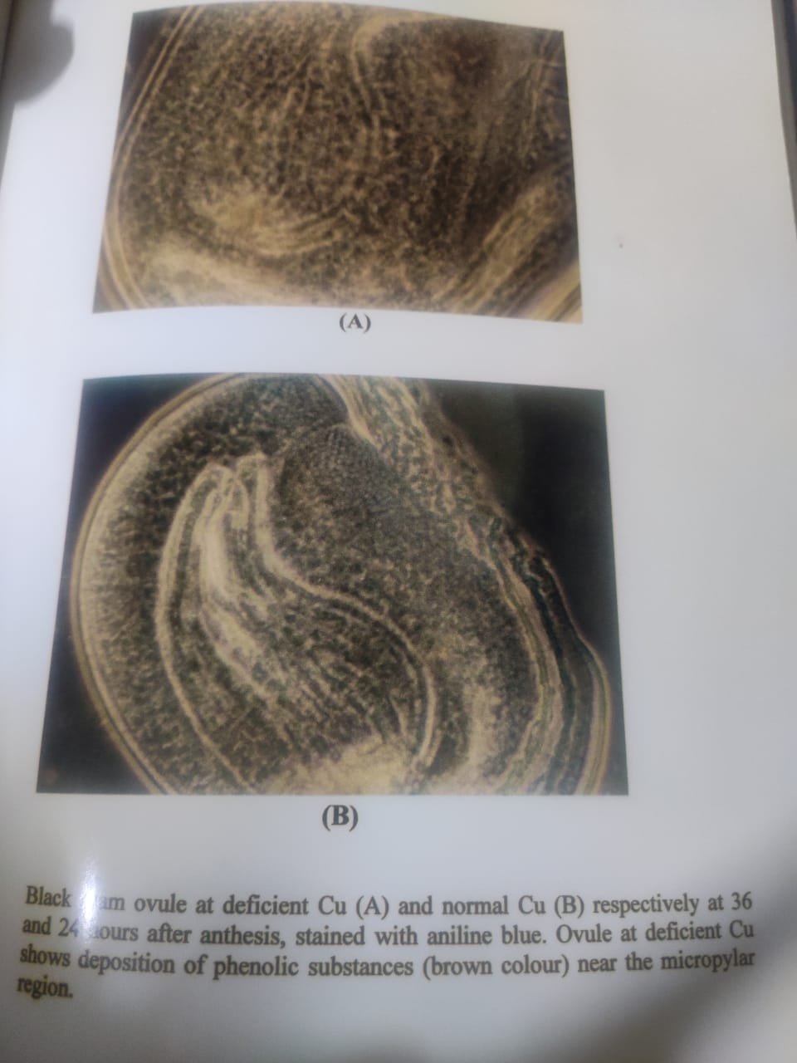

8
SEED RESERVES
Seeds- In mature seeds total protein content decreased by 52-54% at deficient copper. The decrease in protein content in copper deficient black gram seeds was maximum in albumins and vicilins and minimum in legumins.
Amino Acids-The concentration of lysine, methionine and cysteine with an increase in copper supply from 0.0065 to 0.065mg cul⁻¹.
CONCLUSION AND ANTICIPATION AHEAD
To see the effects of copper deficiency on vegetative characteristics as well as reproductive phases of black gram plant, they were grown in refined sand . The black gram showed , that young leaves subjected to severe copper deficiency became discoloured and bleached , part of lamina failed to unrolled and turned necrotic.The effect of copper deficiency is first visible on the young leaves of plant . Due to severe copper deficiency the resistance to spreading of the leaves increases as well as the water holding capacity also increases , which affects the dry weight of plants , pod number , pod weight , seed number , seed weight decreases and as a result the grain yield reduces.Defciency of copper reduces the number of buds and flower in plants . Therefore , copper is essential for the formation of fruits . Adequate amounts of copper are needed before and during fertilization of pollen and ovary of flowers.Therefore copper is important fr grain production. In copper deficient black gram , (lower pod and seed yield might be the result of poor fertilization due to impaired development of generative organsThe decline in biomass in low copper in legumes might reflect sink limitations and which in turn might be responsible for poor development of reproductive parts . The depression in growth, biomass and economic yield in copper deficient legumes is due to disturbed carbohydrate and protein metabolism in such conditions . The reduction in seed number and weight in low copper might be due to less lignifications of tapetum resulting in lower supply of nutrients and reduced formation of starch. As a consequence of which deformed and under developed seeds were finally produced In copper deficient seeds, the concentrations of total sugars, starch and protein decreased significantly . Lowered synthesis of soluble carbohydrates and low proteins in copper deficiency are responsible for lower economic yield and poor quality of its seeds. A gradual decrease in ratio of reducing sugars and increase in non-reducing sugars in pods(sink) and leaves(source) with an increase in copper supply is indicative of lower synthesis and lesser incorporation of sugars in biosynthesis of starch . This might be due to high acid invertase activity in the apoplasm , the phloem loading of sucrose is drastically decreased and sucrose and other carbohydrates accumulate in the leaves as has been observed in black gram under low copper conditions.The decreased pod /leaf ratio of non-protein nitrogen and increased that of protein nitrogen at deficient copper indicates hampered translocation of soluble nitrogenous compounds from source to sink, has been observed in the legume(black gram) here. The biomas and economic yield of black gram was reduced by low copper . Reduced pod and
9
seed production in the plants might be the consequence of copper deficiency and is probably associated with depressed floral initiation and diminished production of viable pollens as has been reported in various plant species . Accumulation of phenolic compounds in low copper condition as observed in black gram has also been suggested as one of the cause of inhibition of flowering . Also the accumulation of phenols might be due to decreased phenolase activity as has been reported earlier. The decrease in pod and seed formation in the legumes corroborate the finding of Nautiyal et al. and might be attributed to the lower sink activity as a result of aborted flowers in addition to male sterility . The reduced seed weight in copper deficiency might be due to decline in polyphenol oxidase activity , indirectly responsible for delay in flowering. Low copper in black gram resulted in poor seed quality , Under stress condition pod and seed number , their size and weight , sugars(reducing and non-reducing), starch protein , methionine, lysine and cystiene and protein nitrogen were lowered and that of non-protein nitrogen and phenols increased in seeds. The lower content of reserves (sugars and starch) reflects the poor quality of seeds, which may account for increased activity of proteinase and decrease in that of invertase and starch phosphorylase at the time of filling as has been observed in legume. The decrease in concentration of proteins might be the consequence of the accumulation of non-protein nitrogen in seeds of the legumes under cu stress conditions. These results also substantiate the disturbed protein metabolism in copper deficiency.The quality of black gram seeds deteriorated in copper
deficiency as the seed proteins were low in lysine and methionine and thereafter not good for human consumption.
REFERENCES
Agarwala,S.C.,B.D.Nautiyal,and C.Chatterjee.1986 Manganese,copper and molybdenum nutrition of papaya ,Journal of Horticultural Science.
Agarwal, S.C,Sharma,P.N, Chatterjee,C.,and Sharma, C.P 1980. Copper deficiency induced changes in wheat anther. Proc.Indian.Nat.Sci.Acad., part B, 466:172-176.
Agarwal, S.C,Sharma,C.P.1976.Pot and sand culture techniquefor the study of mineral nutrient element deficiencies underIndian condition. Geophytology 6:356-367
Agarwal, S.C,Sharma,C.P.1980, Chatterjee,C.,and Sharma, C.P 1980. Copper deficiency induced changes in wheat anther. Proc.Indian.Nat.Sci.Acad., part B, 46:172-176.
Agarwal, S.C, Chatterjee,C.,and Sharma, C.P and Nautiyal,N 1985. Copper nutrition of sugarbeet.J.Exp.Bot.36:881-888.

10
Agarwal, S.C,., Nautiyal,N, and Sharma, C.P and Chatterjee,C 1993.Studies on copper deficiency in mango,guava and jackfruit.Indian J.Hort.48:192-200.
Baranov,V.I 1980.Combined effects of the trace elements –copper and iron,phenols,amino acids and their oxidation products on the decomposition indoleacetic acid and growth processes.Mikroleum Okruzhayushchei Srede,107-111.
Brown,J.C. and Clark ,R.B.1977.Copper as essential to wheat production.Plant.Soil,48:509-523.
Bruce,D.and Bewley,J.D.2000 Soluble sugar content of white spruce (Picea glauca) seeds during and after germination.Physiol.Plant.110:1-12
Bhakuni,G.,Dube , B.K, Sinha ,P.,chatterjee, c.,2009.Copper Stress Affects Metabolism and Reproductive Yeild of Chickpea, Journal of Plant Nutrition.32(4):703-711 DOI:10.1080/01904160902743258.
Chesire,M.V.,Bick,w.,Dekock,P.C and Inkson,R.H.E 1982.The effect of copper and nitrogen on the amino acid composition of cat straw.Plant Soil,66:139-147.
Dell,B.1981.Male sterility and anther wall structure in copper-deficient plants.Ann.Bot.48:599-608
Fathi, A.A. andEI-Shahed, A.A. 2000. Response of tolerant and wild strains of Scenedesmus biguja to copper, Biol. Plant. 43:99-103.
Graham, R.D. 1980. The distribution of copper and soluble carbohydrates in wheat plants grown at high and low levels of copper supply. Z.Pflanzenernahr Bodenk. 143:161-169’
Geaham,R.D.1986. Induction of male sterility in wheat using organic ligands with high specificity for binding copper. Euphytica35:621-629.
Graham, R.D. and Nambiar, E.K.S. 1981. Advances in research on copper deficiency in cereals. Aust. J.Agric.Res. 32:1009-1037.
Graves, C. J., Adams, P. and Winsor, G. W. 1979. Some effects of copper deficiency on the flowering copper status and phenolase activity of different cultivars of Chrysanthemum morifolium. J. Sci. Food Agric.30:751-758.
Hewitt, E. J. 1966. Sand and Water culture method used in the study of plant nutrition. Rev. 2nded. Common W. Agric. Bureaux, England.
Hussain, S, Noor, .R,and Iqbal, J. 2001. Studies on the inactivation of soluble and immobilized papain by the ascorbic acid –cu²⁺system :Amodel to propose the effect of free radicals on membrane bound enzymes in vivo. Biotech. Appl. Biochem. 34:205-209.
11
Isave,B.M. and Rustamov,K.1975.Effects of the trace element copperon some physiological and biochemical processes and productivity of cotton.ab.Biol.Zh.19:27-30

Jewell,,A.W.,alloway,B.J. and Murray,B.G. 1985.The effect of copper deficiency o pollen formation and yield in cereals.J.Sci.Food Agric.36:53-538
J,Sci Food Agric 85:860-864 DOI:10.1002/jsfa.1929.
Khurana,N.,Singh,M.V.,Chatterjee,C.2006.Copper Stress Alters Physiology and Deteriorates Seed Quality of Rapeseed,Journal of Plant Nutrition.
Lidon,F.C. and Henriques,F.S.1993.Copper mediated inhibition of protein synthesis in rice rice shoots.J.Plant.Nutr.169:1619-1630
Marschner,H. 1995.Mineral Nutrition of Higher Plants(2nd edn.),Academic Press Limited, London
Nautiyal,N.,Chaterjee,C. and Sharma,C.P.1999a. Copper stress affects grain filling in rice.Commun.Soil Sci.Plant anal.30:1625-1632
Nautiyal,N, and Sharma, C.P and Chatterjee,C. 1999a. Role of copper in improving the seed quality of sunflower (Helianthus annuus). Ind.J.Agric Sci.69:210-213.
Nautiyal,N.,Singh,S.,chatterjee,C.2005.Seed reserves of chickpea in relation to molybdenum supply.
Sommer,A.L.1931. Copper as an essential for plant growth. Plant Physiol. 6:339-345.
www,agrifarming.in (Internet source)
www.sciencegate.app (Internet source)

12

Name-Dr. Soni Singh
Affiliation -B.S.N.V.P.G.College
Charbagh, Lucknow(Department of Botany)
Address-Shri, Infratech And Associates, Kanpur Road,
Gauri Bazar , Sarojini Nagar
Kanpur Road, Lucknow, Uttar Pradesh(226008)
Email id-0522soni4444@gmail. Com
Contact-no.-6386370378

THANK YOU

13

