EFFET OF THICKNESS OF DIFFERENT SHAPE MEMORY POLYMER LAYERS ON DAMPING PERFORMANCE
Betha Hemanth, M.Prasanth Kumar
^{a*} Asst.Professor, Department of Mechanical Engineering, Chaitanya Engineering college, Visakhapatnam, India-530048
^{b}Assoc.Professor, Department of Mechanical Engineering, ANITS, Visakhapatnam, India-531162
Abstract
Unconstrained layer damping, also known as extensional damping, is a surface damping treatment used for vibration suppression. It can be applied on one side or both sides of surface. This investigation used UTM and DMA tests, different analytical studies were carried out using polyurethane, silicone, and butyl rubbers as damping materials for symmetrical and unsymmetrical configurations with damping layer thicknesses of 30 mm, 40 mm and 50 mm under different cavities to evaluate and compare the damping performance of unconstrained layer damped specimens. The feasibility studies showed that butyl rubber as a layer provided better results in reducing vibration amplitude when considering rectangular and cylindrical cavities. The extensional damped samples were modeled using Solid Works, and modal analysis was conducted on the ANSYS R19 workbench.

Keywords: Damping, Unconstrained layer damping, Python programming, symmetrical and unsymmetrical configuration;
- Introduction:
Damping is the energy dissipation property of a material, converting mechanical energy into thermal energy. It is caused by friction and is determined by the loading and unloading phases of a process. Surface damping treatments are passive methods of reducing vibration, typically associated with sheet metal structure vibration. Damping treatments are configurations of mechanical or material elements designed to dissipate sufficient vibrational energy to control vibrations or noise. There are two types of damping treatments: Free Layer Damping (FLD) treatment and Constrained Layer Damping (CLD) treatment. Unconstrained Layer Damping is a type of free-layer damping treatment, where a coating of a damping material is applied to one or both sides of a structure. The dominant component of strain is tensile, and the material is subjected to tension-compression deformation when the structure is subjected to cyclic bending. Shape memory alloys like Polyurethane rubber, Silicone rubber, and Butyl rubber were used as damping materials in this study, as they have the ability to return from a deformed shape to its original shape when induced by a temperature change. The Ross-Kerwin-Ungar (RKU) equations can be applied to predict the performance of unconstrained-layer damping treatments. To use the RKU analysis, consider the special case for which the constrained-layer thickness, H, is zero. The performance of the constrained-layer damping treatment depends on the geometry and type of the constraining layer. The maximum amount of shear strain is usually achieved when the constraining layer is of the same type and geometry as the structure to be damped, which is known as the "sandwich damping treatment."
- Modal Analysis:
The FLD structure in this study is made up of a base metal (AA 6063) bonded to a damping substance utilising Epoxy Adhesive. Polyurethane, Silicone and Butyl rubbers of 75 shore A hardness are the damping materials considered [1].

The FLD samples are made by using modelling software tool i.e. SOLIDWORKS according to the ASTM-E756 standards. The FLD samples made of Polychloroprene rubber with cavities under different configurations were modelled by the software mentioned above. The base plate was made of AA6063 and layer is made of Polychloroprene rubber. The dimensions and configurations of the specimens are shown in Table 1. The layer material is glued to the base plate using epoxy resin. Since the thickness of the adhesive was very small which around 3 micron meter is the damping effect from the adhesive could be ignored [2][3].

Table 1: Configuration of the Specimen
Specimen | Materials | Length (mm) | Thickness (mm) | Width (mm)
Base plate | AA6063 | L₁ = 300 | h₁ = 3 | 25.4
Layer | Polyurethane, Silicone and Butyl Rubbers | L₂ = 250 | h₂ = 30, 40, 50  (symmetric and asymmetric) | 25.4

Fig.1 Basic Configuration of FLD without cavities

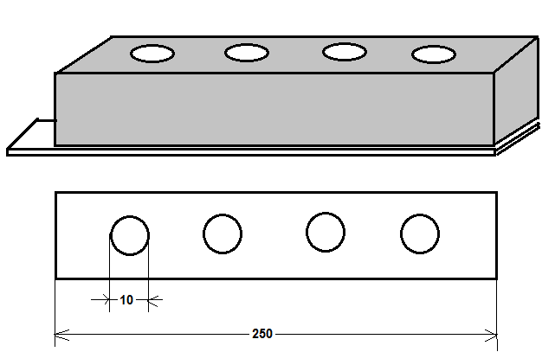

Fig.2 FLD beam having cylindrical cavities with
10mm diameter Configuration

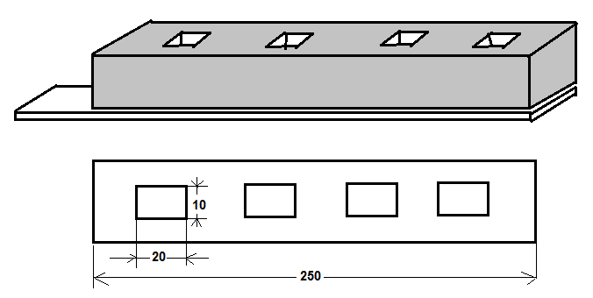

Fig.3 FLD beam having rectangular cavities with
10mm X 20mm Configuration

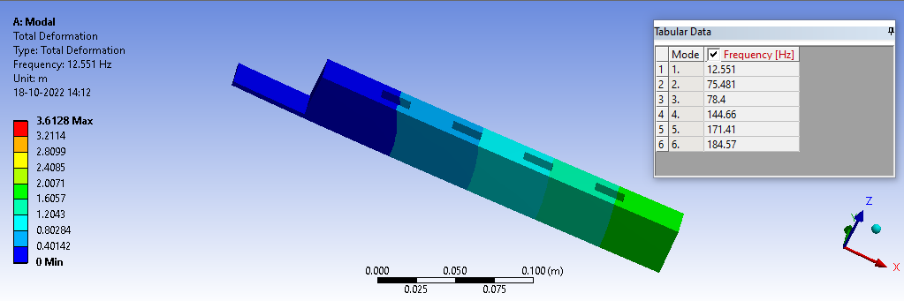
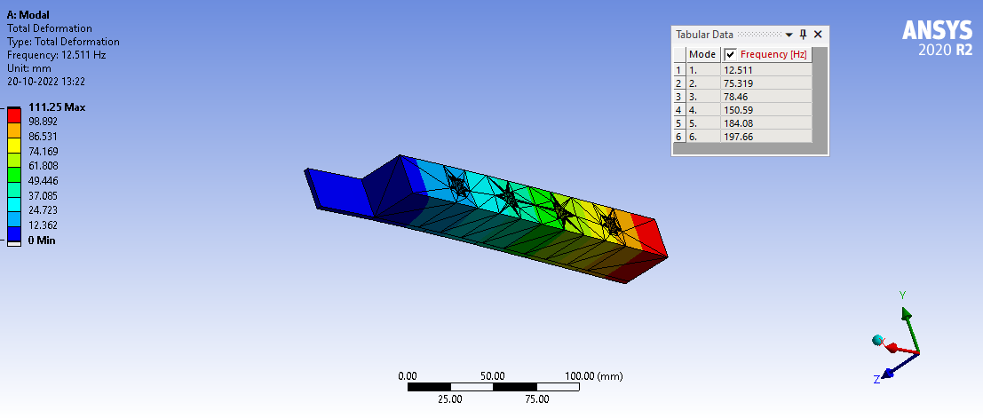

Fig.4(b) Unsymmetrical FLD beam- 30mm thick Polyurethane rubber layer with cylindrical cavities
Fig.4(a) Unsymmetrical FLD beam- 30mm thick Polyurethane rubber layer with Rectangular cavities
.

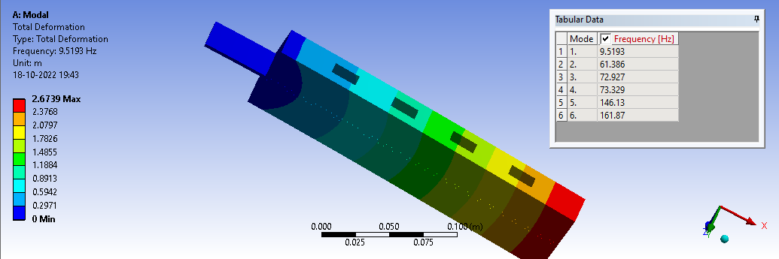
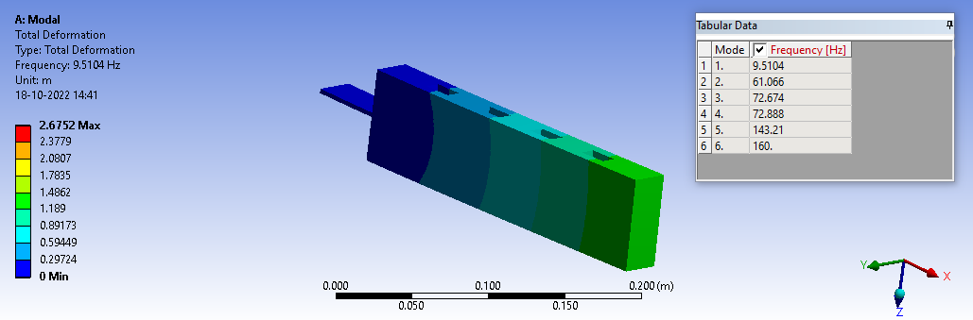

Fig.4(d) Symmetrical FLD beam- 30mm thick Polyurethane rubber layer with cylindrical cavities
Fig.4(c) Symmetrical FLD beam- 30mm thick Polyurethane rubber layer with Rectangular cavities

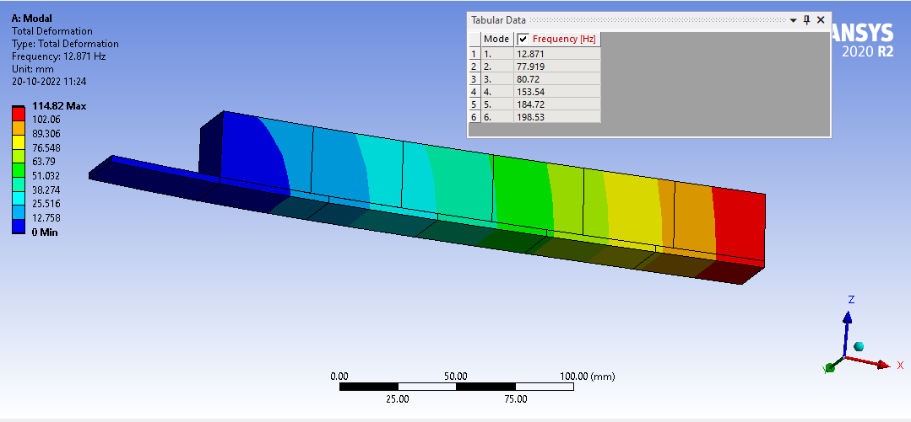
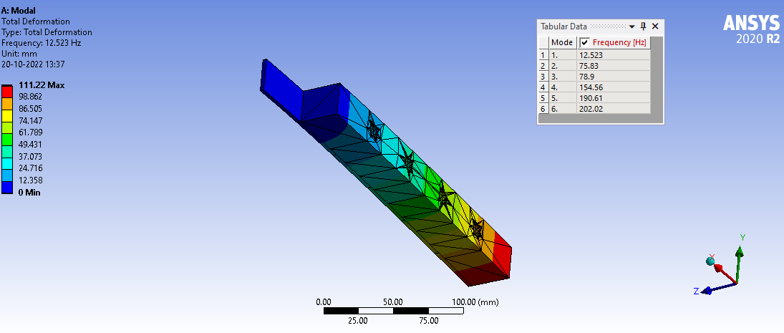

Fig.4(f) Unsymmetrical FLD beam- 30mm thick Silicone rubber layer with cylindrical cavities

Fig.4(e) Unsymmetrical FLD beam- 30mm thick Silicone rubber layer with rectangular cavities

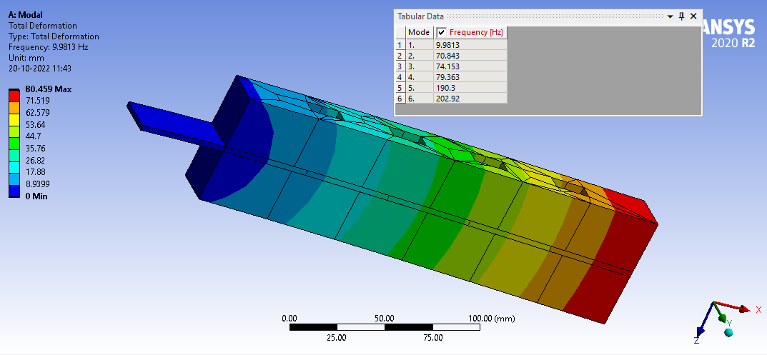
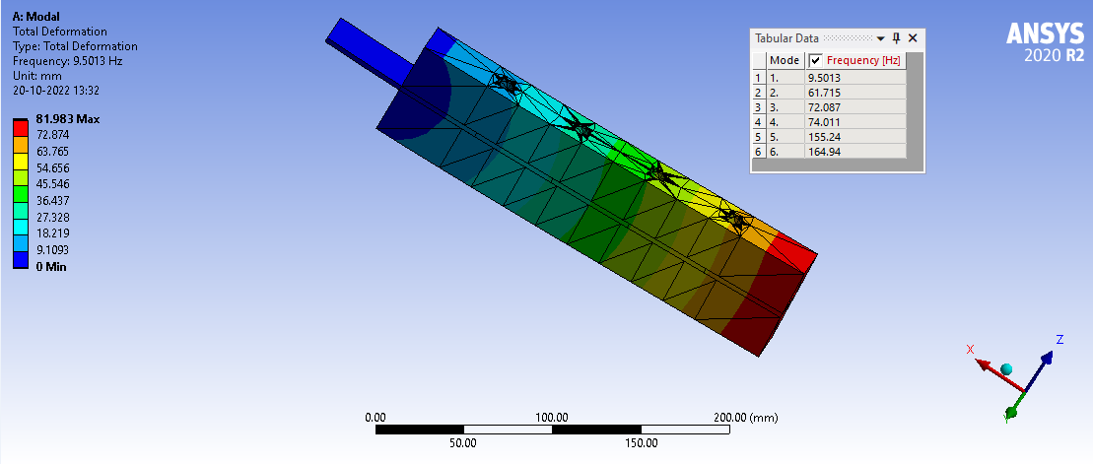

Fig.4(h) Symmetrical FLD beam- 30mm thick Silicone rubber layer with cylindrical cavities
Fig.4(g) Symmetrical FLD beam- 30mm thick Butyl rubber layer with rectangular cavities

Fig.4(j) Unsymmetrical FLD beam- 30mm thick Butyl rubber layer with rectangular cavities
Fig.4(i) Unsymmetrical FLD beam- 30mm thick silicone rubber layer with rectangular cavities

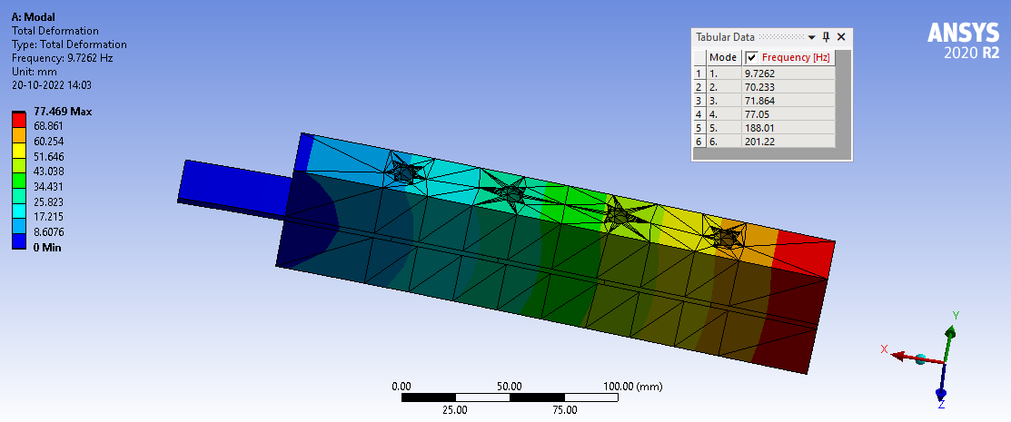

Fig.4(l) Symmetrical FLD beam- 30mm thick Butyl rubber layer with rectangular cavities
Fig.4(k) Symmetrical FLD beam- 30mm thick Butyl rubber layer with cylindrical cavities

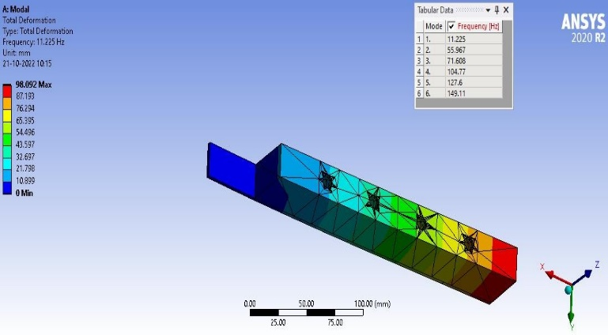
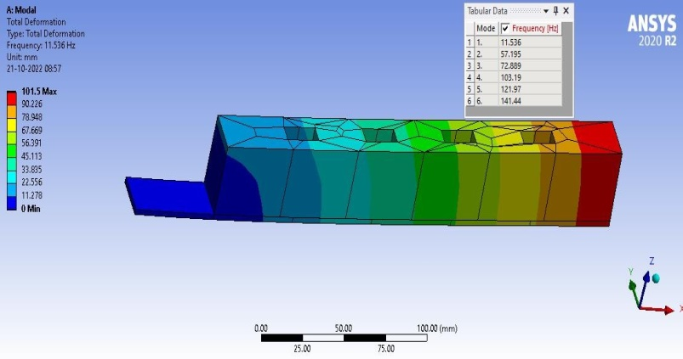
Fig.5(a) Unsymmetrical FLD beam- 40mm thick PU Fig.5(b) Unsymmetrical FLD beam-40mm PU
rubber layer rubber layer with Rectangular cavities with cylindrical cavity

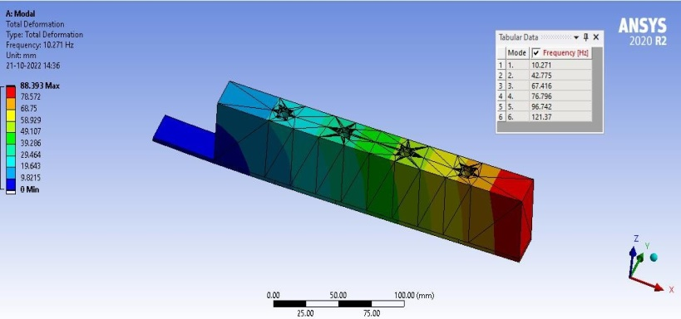
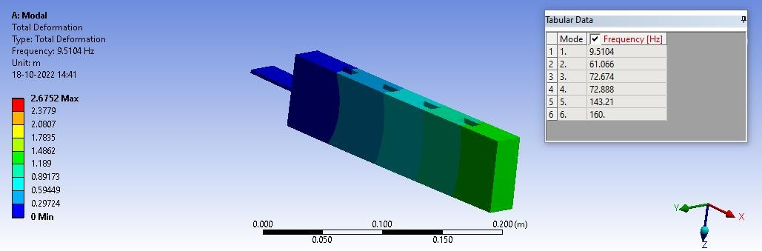

Fig.5(c) Symmetrical FLD beam 40mm thick PU rubber layer Fig.5(d) Symmetrical FLD beam 40mm thick PU rubber layer with rectangular cavity with cylindrical cavity

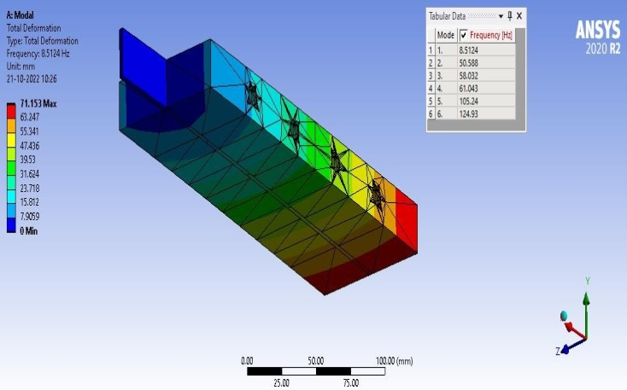
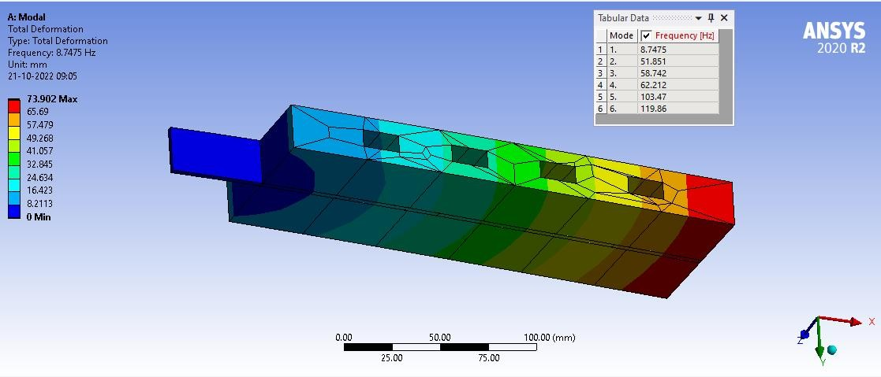

Fig.5(e) Symmetrical FLD beam 40mm thick silicone rubber with Fig.5(f) Symmetrical FLD beam 40mm thick Rectangular cavity silicone rubber with cylindrical cavity

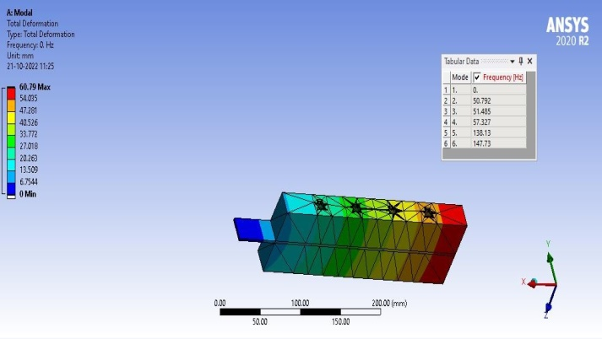
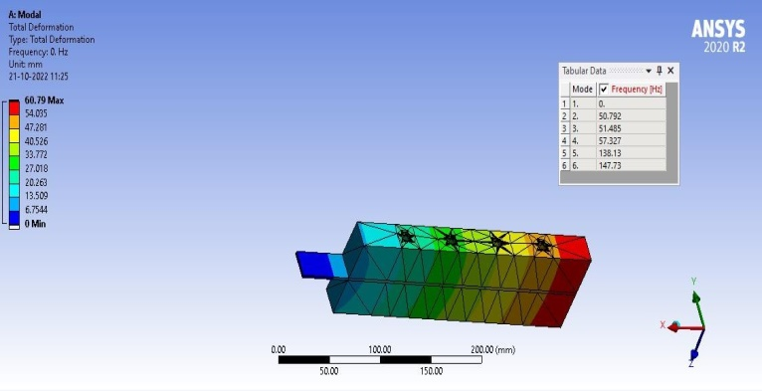

Fig.5(g) Symmetrical FLD beam 40mm thick butyl rubber with Fig.5(h) Symmetrical FLD beam 40mm thick butyl Cylindrical cavity rubber with cylindrical cavity

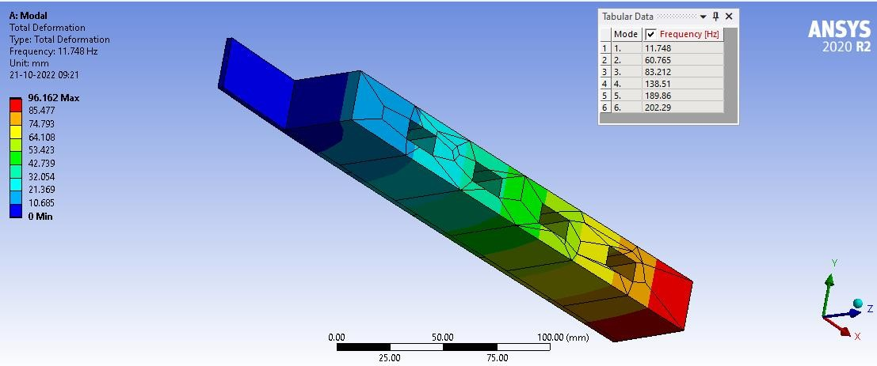
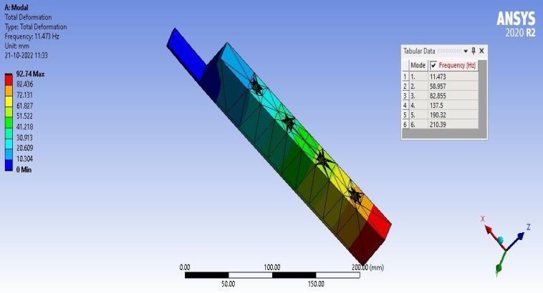

Fig.5(i) Unsymmetrical FLD beam 40mm thick butyl Fig.5(j) Unsymmetrical FLD beam 40mm thick butyl rubber with Rectangular cavity rubber with cylindrical cavity

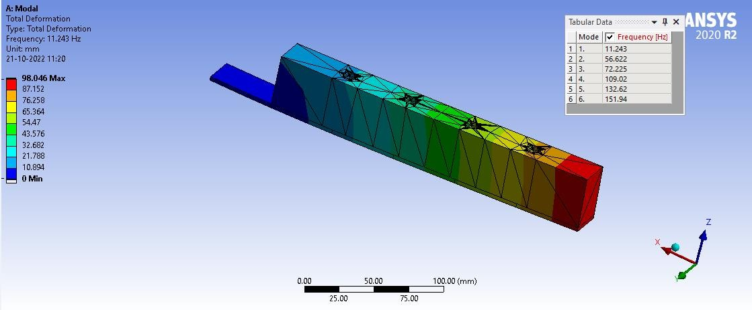
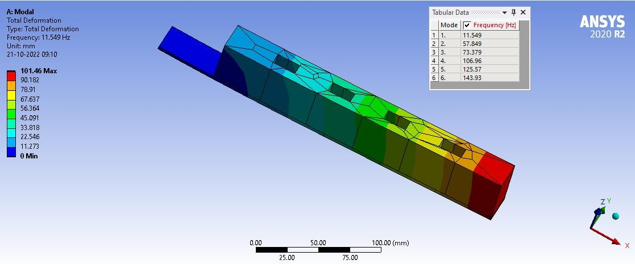
Fig.5(k) Unsymmetrical FLD beam 40mm silicone rubber with Fig.5(l) Unsymmetrical FLD beam 40mm silicone Rectangular cavity with cylindrical cavity

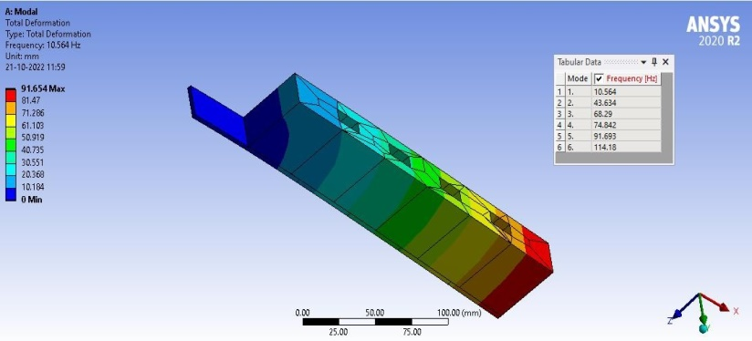
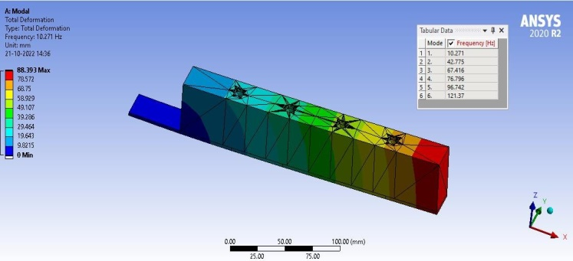
Fig.6(a) Unsymmetrical FLD beam 50mm thick polyurethane Fig.6(b) Unsymmetrical FLD beam 50mm thick
Rubber with rectangular cavity polyurethane rubber with cylindrical cavity

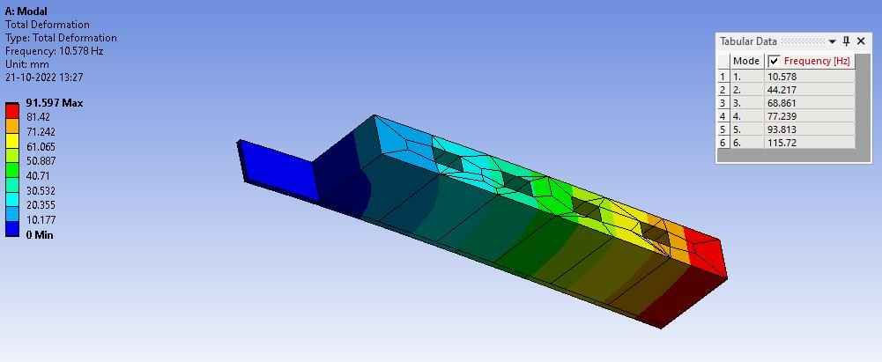
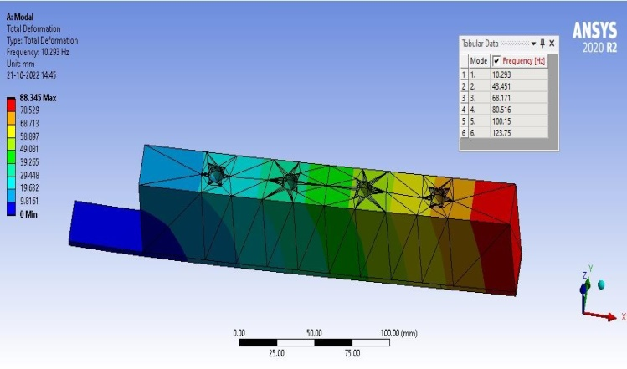

Fig.6(c) Unsymmetrical FLD beam 50 mm thick silicone Fig.6(d) Unsymmetrical FLD beam 50mm thick
Rubber with rectangular cavity silicone rubber with cylindrical cavity

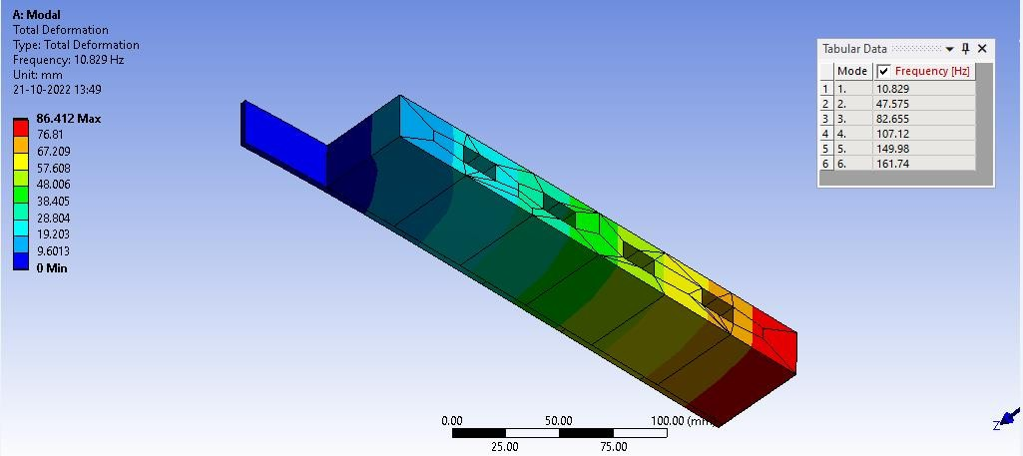
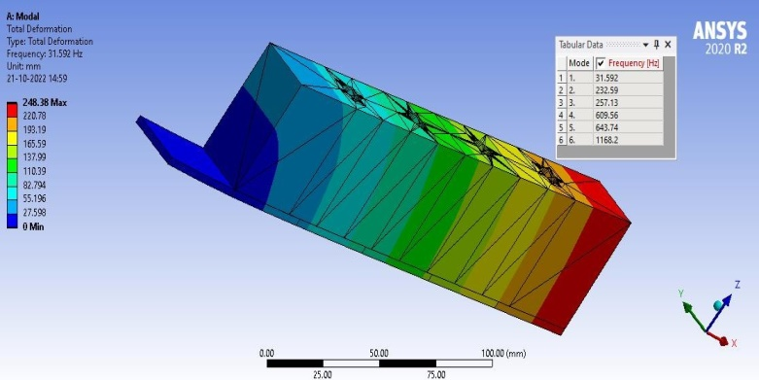

Fig.6(e) Unsymmetrical FLD 50mm thick beam butyl rubber Fig.6(f) Unsymmetrical FLD beam butyl rubber with Rectangular cavity with cylindrical cavity

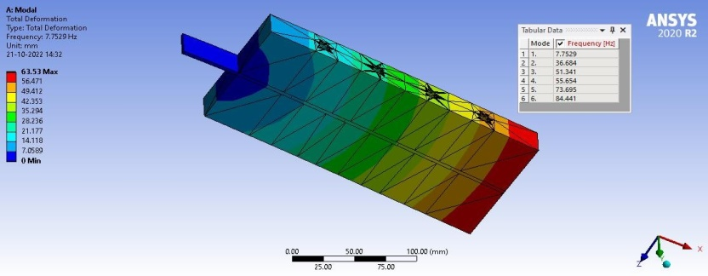
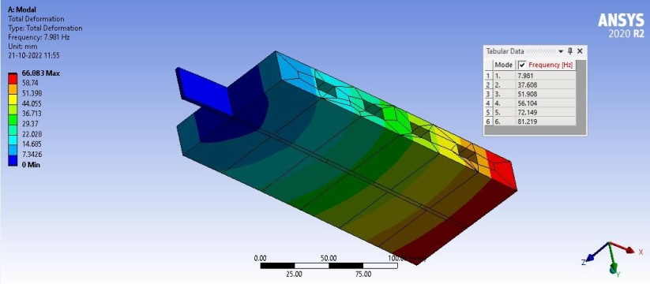

Fig.6(g) Symmetrical FLD beam of 50mm polyurethane Fig.6(h) Symmetrical FLD beam of 50mm thick
rubber with rectangular cavity polyurethane rubber with cylindrical cavity

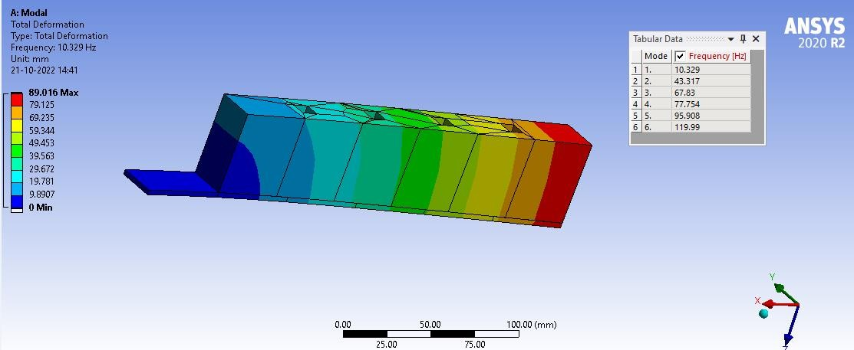
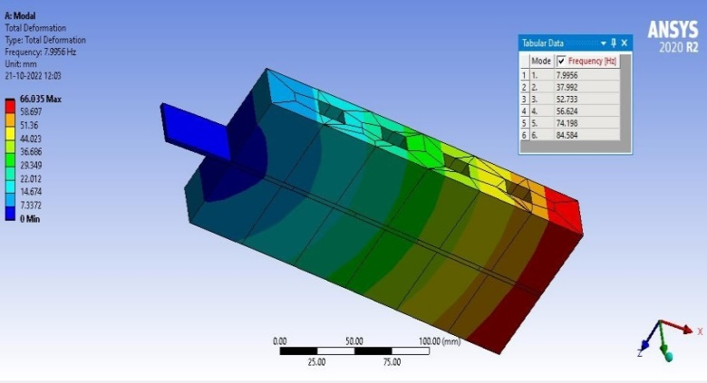

Fig.6(i) Symmetrical FLD beam of 50mm silicone rubber Fig.6(j) Symmetrical FLD beam of 50mm silicone
With rectangular cavity rubber with cylindrical cavity

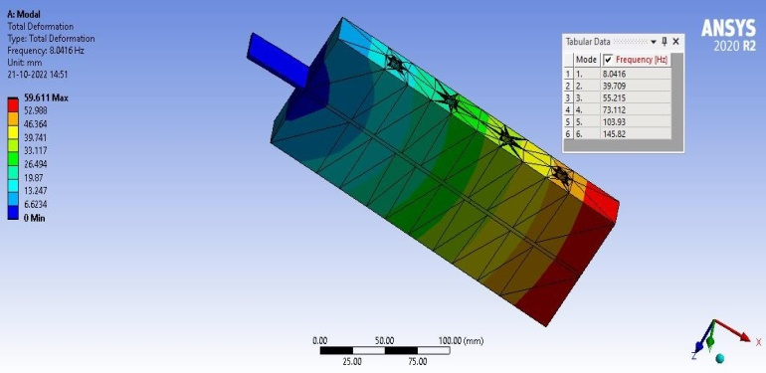
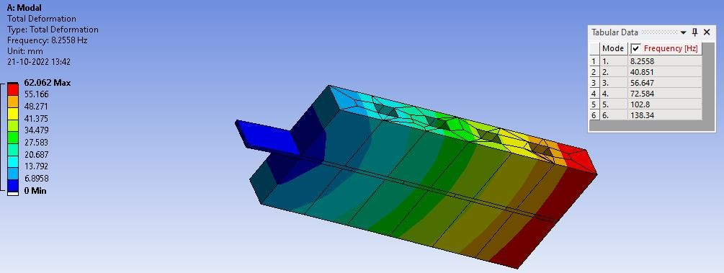
Fig.6(k) Symmetrical FLD beam of 50 mm butyl rubber
With rectangular cavity Fig.6(l) Symmetrical FLD beam of 50mm butyl
rubber with cylindrical cavity
The natural frequency values obtained from the modal analysis of Polyurethane rubber, Silicone rubber, Butyl rubber on symmetrical and unsymmetrical damping of 30, 40, 50 mm thickness [4 to 7] are listed in the Table 2.

Table 2: Natural frequencies of FLD beams with symmetrical and unsymmetrical configurations
S.No. | Type of Shape Memory Polymer | Thickness  (mm) | Shape of Cavities provided in the layer | Natural Frequency with Symmetrical configuration  (Hz) | Natural Frequency with Unsymmetrical configuration  (Hz)
1 | Polyurethane rubber | 30 | Rectangular | 61.01 | 75.48
 |  | 30 | cylindrical | 62.11 | 75.32
 |  | 40 | Rectangular | 52.73 | 57.19
 |  | 40 | cylindrical | 50.08 | 55.97
 |  | 50 | Rectangular | 37.61 | 43.63
 |  | 50 | cylindrical | 36.68 | 42.78
2 | Silicone rubber | 30 | Rectangular | 61.39 | 77.92
 |  | 30 | cylindrical | 61.72 | 75.83
 |  | 40 | Rectangular | 51.85 | 57.85
 |  | 40 | cylindrical | 50.59 | 56.62
 |  | 50 | Rectangular | 37.99 | 44.22
 |  | 50 | cylindrical | 43.32 | 43.45
3 | Butyl rubber | 30 | Rectangular | 70.84 | 79.62
 |  | 30 | cylindrical | 70.23 | 77.12
 |  | 40 | Rectangular | 54.98 | 60.77
 |  | 40 | cylindrical | 50.79 | 58.96
 |  | 50 | Rectangular | 40.85 | 47.58
 |  | 50 | cylindrical | 39.71 | 44.59

From the above results, it can be studied that by increasing the mass or lowering the stiffness will lower the natural frequency while reducing the mass or increasing the stiffness will increase natural frequency [8 to 10]. As higher is usually better, the unsymmetrical configurations can be used or operate up to a higher speed without encountering a reason that might cause noise or wear or metal fatigue or erratic performance. From the modal analysis it is understood that, under an unsymmetrical configuration has given better response in resonant frequency [11 to 13].

CONCLUSIONS

In this work the different shape memory polymers such as Polyurethane, Silicone and Butyl rubbers have been considered for damping performance (Damping factor). The DMA test and modal analysis is carried for knowing the performance of FLD treatment on cantilevered beam using the rubber has been analyzed by ANSYS R19 software. The optimum values are also determined using Python programming for the best damping property of the materials. The conclusions can be derived from the results obtained from the analysis. From the modal analysis the unsymmetrical configuration of butyl rubber with rectangular cavity with 79.62Hz has shown better results for natural frequency.
REFERENCES
[1] Prasanth Kumar M, Mamatha B, Bhaskara Raju VVS, N.Ramanaiah, (2017) “Effect of thickness on asymmetric Extensional Damping Treatment using Viscoelastic Materials”. International Journal of Engineering Trends and Technology (IJETT)
[2] N.Ramanaiah, Prasanth Kumar Mallipudi, VVS. Bhaskara Raju, et al. (2017) “Effectiveness of Extensional Damping using Rubber as Layer”. Trends in Mechanical Engineering &Technology (TMET).

[3] C.V.Ramachandrareddy, N.Ganesn, Narayanan.B.V “The response of plates with unconstrained layer damping treatment to random acoustic excitation” (1979).
[4] A.D.Roberts and C.A. Brackley, “Surface treatment of rubber to reduce friction”, Journal of Natural Rubber Research, Volume 4, Number 1, pp. 1-21, March (1989).
[5] H.H.Law, P.L.Rossiter, G.P.Simon, L.L.Koss, “Characterization of mechanical vibration damping by piezoelectric materials”, Journal of Sound and VibrationVolume 197, Issue4, Pages 489-513, October (1996).
[6] Roynganesan, “The theoretical and experimental investigations on the damping effectiveness of partially applied unconstrained layer damping treatments on rectangular plates having central rectangular cutouts” (2003).
[7] Doo-holee,Woo-Seok Hwang, “Optimization of length for unconstrained viscoelastic damping layer of beams” (2004).
[8] Ramji Koona, Ganesh, Kumar PVS and M.Lavanya “Optimization of surface damping treatments for random vibration control of structures Dynamic excitation results in vibration of machinery and supports of the structures”(2005).
[9] Laurent hazard, “Design of viscoelastic damping for vibration and noise control, modeling, experiments and optimization” (2006).
[10] H.H.Hilton, and Sung Yi, M. Fouad Ahmad “Dynamic Responses of Plates with Viscoelastic Free Layer Damping Treatment” journal of vibration and acoustics 362/vol.118, (2008).
[11] Craig A.Gallimore, Dr. Kevin B.Kochersberger “Passive Viscoelastic Constrained Layer Damping Application for a Small Aircraft Landing Gear System” (2008).
[12] Francesca Cura, Andrea Mura1 and Fabrizio Scarpa, “Modal strain energy based methods for the analysis of complex patterned free layer damped plates”, Journal of Vibration and Control,18(9) pp.1291–1302, (2011).
[13] Ashish M. Dharme, Pravin P. Hujare and Sinhgad “Analysis of performance of FLD and CLD technique”, International Journal of Engineering Sciences &Research Technology, pp.340-343, ISSN: 2277-9655, (2015).

