Trajectory Tracking of Track Belt Robot with its Comparative Analysis on Different Types of Surfaces
Rashmi Arora^{[1]} and Sunil Kumar Maurya
¹ Mechanical Engineering Department, Punjab Agricultural University, Ludhiana, India
rashmimech.cu@gmail.com

Abstract: Robotics being a major community in the upcoming progressive terminology of modern era, it plays an important role in cutting down manpower in certain areas. Nowadays robotics is being utilized in numerous areas and is playing effective and beneficial role in the respective. In this paper such kind of walking robots are being discussed whose presence makes things easy for humans specially certain jobs where manpower is excessively needed. Manpower being utilized to uplift things or transport things from one place to other can be minimized with the help of these walking robots which are meant to carry loads and transport them from one place to other. In this paper comparison of different models and working terminologies of robots are introduced in order to find the best amongst them and work further on their development and further processing to enhance their characteristics. Modern Robotic era plays with the signs and sight of work load reduction and enhancing work as well outcome efficiency for better results. In this paper comparison of legged, wheeled and track robots are shown according to their performance with respect to the working conditions and specifications of robot.
Keywords: Crawler, Track Belt Robot, Trajectory tracking, System
- Introduction
Transportation of things from one place to another is the most attractive part of any robotic set. Walking robots performing these tasks are the most awaited robots in industries where robots have total control over things and chances of mistakes being reduced. Terminology walking robot terms to the bots which are specially programmed or controlled to transport things from one place to other which may be in plane, rugged surface, uneven terrains or slope and stairs. Working conditions and circumstances may affect the performance of a robot as some are meant for better planes and some are for slopes and stairs.

- Methodology
  - Legged Robots
Ceccarelli and Figliolini [1] presented the system robot EP-WAR2 which use electro-pneumatic actuators and suction cups for movement. In order to climb the stairs, robot relies on an open-loop control algorithm implemented as a finite state machine. Here the system relies on predefined, sensed and calculated motions where terms like height of stairs and steps to be taken at angle are preprogrammed or sensed with the sensors to actuate the movement [2]. Main limitation of this approach is while operating in a different staircase, it necessitates manual recalibration. These robots are sensor based system where sensors act as primary sensing elements which inhibit the distance and altitude the robotic leg has to move. Systems related to this methodology are preprogrammed and are assessed with general configurational data which is taken as elementary basic on which the whole system works. Engineers working on these kind of robots generally configure the system with either six leg or eight legs which helps in attaining the mobility as well maintaining the balance of system in ultimate working plane.

  - Wheeled Robots
Wheeled robots usually have way out to mechanic extension to overcome steep stairs. One application of such technique is patient remedy where stair climbing could greatly improve mobility and thus quality of life of people restrained to wheelchairs. Wheeled Robotic scenario play very crucial role in the current perspective of loading and unloading, transportation from one place to another and lifting goods from lower to higher ends. Wheeled system attains stability in planes and have are less complicated compared to other two systems in terms of design, manufacturing and controlling by user end. These systems are controlled from user ends and are moreover wired as well wireless systems which enhance the working capability of the system. Wheeled robots work on certain set of wheels that may be either combination of wheels or set of single dimension wheels which is totally dependent upon the working circumstances and the purpose of system as well user desire [1]. Wheels with proportionate dimensions are most famous in the working scenario of wheeled robots as it provides better contact as well work ratio and enables the system to work under required working ratios and maintains the desirable sustainability of system. Set of Wheels with distinguish wheel ration are taken in concept when special purpose robots are designed regardless of their working as well operating scenarios. These machines are capable of working in different terrains with better efficiency and enhanced programmed systems which enhances the working quality as well specification of work according to the requirement. These are termed to be the most basic and effective robot in the robotic system as its working configuration and system ability is moreover simpler and easier to configurate than other systems. These systems can work efficiently in planes, slopes and hinged areas, as they move towards stairs and uneven terrains these system need more functionality and time and are more complicated to design, function and control as wheels need to be configured according to the terrain and ration of working circumstances and wheels changes hence it becomes more complicated to handle these systems in such terrains and are moreover costly and hassled working system.

  - Track belt Robots
Tracked robots have a larger ground contact surface than wheeled and legged robots as they cover whole surface with track belts they are much more in contact with working surface and produces better frictional effects while driving robot in uneven and steep stair terrains. They are more stable than bipeds due to their low center of gravity and more suitable than wheeled robots due to their stability to attain the position in which they are working. Liu-et-al [3] derived the fundamental dynamics of the stair-climbing string for a tracked robotic factor analyzing the various states of robot climbing and working in various states and terrains, nose crossing, nose line climbing and the effects of grouser bars or cleats. The analysis is limited to certain model and slippage of track belt, vibrations in belt during movement and edge retention and intermittent loss of track-surface contact phenomena that are commonly encountered during stair climbing are neglected. Track belt robots are the future of moving robots because of its functional diversity and easy working dimensions and parameters as well. These systems are easy to handle and actuate as these consist single tracked set of movers which are better and easy when it comes to working scenario as well functionality and controls from user end. These inhibit set of track belts which are responsible for the motion of robot. These set of track belts provide better frictional grip to the system and inhibits the property of easy slope as well stair climbing scenario for the system. Belts provide better surface contact to the system which enables stability and sustainability of robot and allows it to move in different terrains with better surface contact and less slippage as well diverting the system away from the tack or path. Variety of Track belts increase the functionality of system according to the path or terrain it is operating in. These belts are moreover responsive for attaining better motion of system in distinguished terrains.

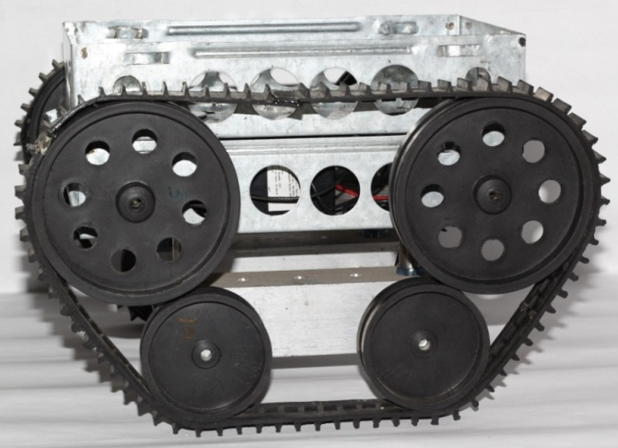
Fig. 1. Track belt Robot
- Comparison of the working robots on the basis of certain criteria
  - Even Surface
An even surface means the surface is totally smooth with no bumps or obstacles on the surface. In this comparison it is shown how different robots walk on even surface when a predefined path is provided to them and they have to track the trajectory with specific amount of load and within a certain time period [4].
Providing a predefined trajectory with points 1(1,5), 2(2,5), 3(3,3) and 4(4,3) we have tested the listed robots for even surface trajectory tracking and found the results as shown below:
Table 1 Coordinates for Different Robots for even surface trajectory tracking
Predefined Path |  | Legged robot |  | Wheeled robot |  | Track belt robot
X | Y | X | Y | X | Y | X | Y
1 | 5 | 1 | 5 | 1 | 5 | 1 | 5
2 | 5 | 2 | 4.7 | 2 | 4.8 | 2 | 4.9
3 | 3 | 3 | 3.4 | 3 | 3.2 | 3 | 2.9
4 | 3 | 4 | 2.5 | 4 | 2.7 | 4 | 2.9

The trajectory motion of various robots is listed in table 1 which clearly shows there is no deflection in X axis and major deflections are noted in Y axis. It can be seen from the table that track belt robot follows the predefined path in a very close manner. Fig. 2 shows the movement of different kind of robots on even surface descending upon the step movement and time period as operated on a fixed static plane.

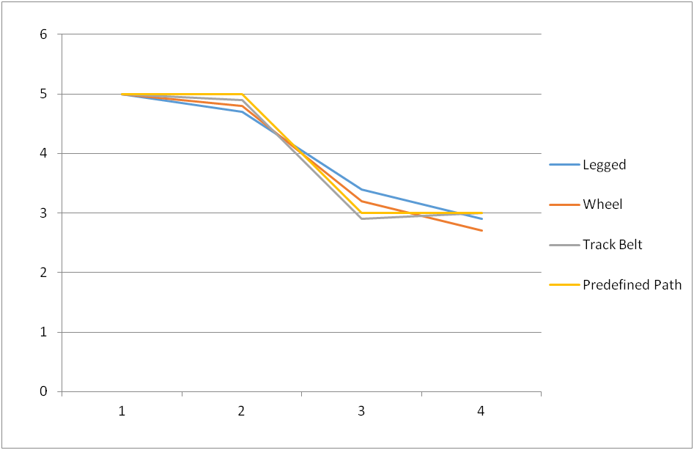
4
3
1
2
Displacement in X Axis (m)

Displacement in Y Axis (m)
Fig.2. Comparative analysis of different robots in even surface following a pre defined static path.
Table 2 shows the absolute and percentage errors for different robots on even surface. From this table, it is clearly shown that absolute error and percentage error of track belt robot is comparatively less i.e. absolute error is 0.1 m and percentage error is 3.44% which is very less and negligible as compared to the other systems in even terrain. This analysis shows track belt robot plays vital role in even terrains as it track the predefined path with utter accuracy and better efficiency within stipulated time period with load and is effective and better as compared to other systems opting the same terrain of movement. Hence track belt robots are found to be the best in even surface trajectory tracking.

Table 2 Absolute and percentage errors for different robots on even surface
Errors | Absolute Error (m) | Percentage Error(%)
Legged robot | 0.5 | 16.66
Wheeled robot | 0.3 | 10
Track belt robot | 0.1 | 3.44

  - Uneven Surface
An uneven surface contains bumps and obstacles on the surface. These surfaces can contain small pebbles or stones as obstacles or can be naturally occurred with ups and downs in the surface. This kind of surface plays an important role for any kind of robot performance analysis as the environmental conditions will differ according to the working condition [5].
Providing a predefined trajectory with co-ordinates 1(1,5), 2(2,5), 3(3,3) and 4(4,3) we have tested the listed robots for uneven surface trajectory tracking and found the results as shown below:
Table. 3. Coordinates for Different Robots for uneven surface trajectory tracking
Predefined Path |  | Legged robot |  | Wheeled robot |  | Track belt robot
X | Y | X | Y | X | Y | X | Y
1 | 5 | 1 | 5 | 1 | 5 | 1 | 5
2 | 5 | 2 | 5 | 2 | 4.9 | 2 | 5.2
3 | 3 | 3 | 3.5 | 3 | 3.2 | 3 | 2.9
4 | 3 | 4 | 2.7 | 4 | 3.3 | 4 | 2.8

The trajectory motion of various robots is listed in table 3 which clearly shows there is no deflection in X axis and major deflections are noted in Y axis. It can be seen from the table that track belt robot follows the predefined path in a very close manner. Fig. 3 shows the movement of different kind of robots on uneven surface descending upon the step movement and time period as operated on a fixed static plane.

4
3
2
1
Fig.3. Comparative analysis of different robots in uneven surface following a pre defined static path.
Table 4 shows the absolute and percentage errors for different robots on uneven surface. From this table, it is clearly shown that absolute error and percentage error of track belt robot is comparatively less i.e. absolute error is 0.2 m and percentage error is 7.14% which is very less and negligible as compared to the other systems in uneven terrain. This analysis shows track belt robot plays vital role in uneven terrains as it track the predefined path with utter accuracy and better efficiency within stipulated time period with load and is effective and better as compared to other systems opting the same terrain of movement. Hence track belt robots are found to be the best in uneven surface trajectory tracking.
Table 4 Absolute and percentage errors for different robots on uneven surface
Errors | Absolute Error (m) | Percentage Error(%)
Legged robot | 0.3 | 11.11
Wheeled robot | 0.3 | 9.09
Track belt robot | 0.2 | 7.14

  - Stair climbing
A stair surface is generally said to be a surface occurring to attain load from a particular height to a distant height containing stairs on the path. This kind of surface also plays an important role in any kind of robot performance analysis. This comparison shows the performance of different robots walking on stair surfaces and they have to track the trajectory with specific amount of load and within a certain time period [6].

4
3
2
1
Fig.4 Points of different stairs

Climbing a stair basically deals with points of contact with the stair surface of the robot. These points of contacts are shown in Fig. 4. Here we have defined stair in 4 points which are the major point of contact for the robot while crawling over the stair. Point 1 is the initiative point for the robot from where the system starts to climb the first step. A distance from 0 to 1 is kept in order to provide the system a stable working area before coming in contact with the stair. Point 1 is called as the initiative point of climbing for stairs. Point 2 is the edge point that is the next point of contact for the system which deals with efficient slipping and roll back factor induced and is a critical point of movement for the system. Point 3 in the stair system is centre point of the second stair as the robot climbs up next point of contact is point 3 and it plays an important role in keeping the pace of the system up and helping it to climb up the stair. Point 3 is known to be the crucial point in stair climbing as most of the roll backs of system occurs during overcoming the point 3. At destination i.e. point 4, legged robot shows the most deflected path as compared to the two other systems as it creates humps and joint movement which creates a deflection in the command and response of the system. As compared to legged robot, wheel robots show less deflection at point 4 and creates better outcome of system and approaches a nearby response to the command [7].
Fig. 5 Comparative analysis of different robots on stair surface

Deflection shown in the above figure clearly implies there is less deflection in wheel system as compared to the legged robot. Track belt robot shows the least deflection while climbing a stair as it is geared with rubber track belt and initiates better and effective gripping as to sustain the edge and other points and to accomplish the destination within given command system.
The above comparison clearly shows that track belt robots are more effective and efficient in climbing the stairs within stipulated time period with specific load as compared to the other systems as the gripping efficiency of track belt is much more effective and helpful for the system to attain a better grip on stairs and make it climb easily and effectively.

  - Slope climbing
Slopes are the basic operational area of any working environment. Slope can be formed or can be a part of the track which a robot needs to conquer. Slopes generally causes slipping back or flipping back due to excess load carried by the system [8].
Hence in slope gripping, friction is the key which should be kept in mind while choosing the system. Basically wheeled or track belt robots are preferred on slopes which avoids slipping and skidding back and in these conditions. Track belt robot is more efficient and effective as track belt gives better friction and gripping than the other systems. In comparison it’s clearly shown that track belt robots are better and effective for slopes rather than the other systems due to its gripping efficiency and better movement on the predefined path. Fig.6 shows the movement of different kind of robots on slope surface descending upon the slope movement and time period as operated on a fixed static plane [9].
The predefined slope provides coordinates as point 1(1, 0) and point 2(4, 3) which is the initial and final points of the slope on which testing of robots is to be carried out. The initial and final points provides an easy and better outcome for the system as its tracking the path as per the user ends requirement or not, hence testing on slope is carried out and the best tracked path is defined.
2
1
Fig. 6. Comparative analysis of different robots on slope surface

Tracking down a slope with coordinates, initial coordinates of each system remains the same as the starting point is same. Final coordinates of Legged robot is (4, 3.9), the same for wheeled robot is (4, 3.4) and for track belt robot is (4, 2.9). This shows no deflection in X axis hence the deflected area comes under Y axis and the absolute and percentage error will be calculated corresponding to this data. Table shows the absolute and percent error of each system and will conclude the best system amongst the three.
Table 5 shows the absolute and percentage errors for different robots for slope surface. From this table, it is clearly shown that absolute error and percentage error of track belt robot is comparatively less i.e. absolute error is 0.1 m and percentage error is 3.44% which is very less and negligible as compared to the other systems in slope. This analysis shows track belt robot plays vital role in descending slopes as it track the predefined path with utter accuracy and better efficiency within stipulated time period with load and is effective and better as compared to other systems opting the same terrain of movement. Hence track belt robots are found to be the best for slope surface trajectory tracking.

Table 5 Absolute and percentage errors for different robots on even surface
Errors | Absolute Error (m) | Percentage Error(%)
Legged robot | 0.9 | 23.07
Wheeled robot | 0.4 | 11.76
Track belt robot | 0.1 | 3.44

  - Cost Analysis
The below graph represent cost analysis, i.e. Maintenance cost, Controlling cost and Manufacturing cost on the basis of which a particular set of tread robot is selected for a particular work set. Figure.6. represents a comparative analysis of robots present in market for various operations.
In the below comparison it is shown that track belt robot deals with low controlling and manufacturing cost as compared to other systems but due to much wear and tear of track belt the maintenance cost is quiet high respective to others. This system inhibits better costing than the other systems. As compared to track belt robots, wheeled robots have high controlling and manufacturing cost and are costly than the track belt robots. Comparing legged robots with other two systems, it is clearly seen that its controlling and manufacturing cost is quiet high than the other two systems and is much expensive than others. After full cost analysis, track belt robots are found to be the nominal one as compared to the other systems and are effective and efficient for industry work [10].
Cost in Rupees (Thousand)

Fig.4.6. Cost Analysis of Robots
This comparison clearly indicates that track belt robots are better and efficient in working with effective cost in industry and is cost friendly. Track belt robots are budget friendly and are less effective in the related work space where other systems will cause much breakdowns and cause more expenditures to the user.
Listing the factors of costing the overall costs of the system is defined in the below table:

Table.6 Cost Estimation of Robots
Robot | Legged | Wheel | Track belt
Manufacturing Cost | 92,000 | 83,000 | 45,000
Controlling Cost | 80,000 | 70,000 | 62,000
Maintenance Cost | 62,000 | 52,000 | 80,000
Total Cost | 2,34,000 | 2,05,000 | 1,87,000

From the above table it can be clearly seen that track belt robot is much more economical that the other systems as its overall cost is less as compared to the other systems.

Fig. 7. Overall cost comparison of robots
The above figure clearly implies that the overall cost of track belt robot is less as compared to the other two systems and hence the system is economical and effective as compared to the other systems.

  - Factors affecting system
Many different aspects affect the performance of a system hence these aspects must be kept in mind while comparing systems and analyzing the comparative results. The below figure shows a comparative review of different walking robots under few common factors such as time lag, response time and actuating time. Figure.8 shows a basic comparison of different robots under some basic criteria of working [11].
It is shown here how different aspects affect the system; time lapse in which the system should reach the destination plays an important role. Within permitted time if the system reaches the destination it is said to be effective and beneficial than the other systems.
In this comparison it is clearly shown how track belt robots are better and effective with time to reach its destination in a particular time period. Compared to this, legged robot and wheeled robot lags a bit to achieve the destination in the provided time period. Time lag deals with the time delay occurred during the processing if signal from the user end to the microcontrollers. This time lag plays vital role in sustaining the effectiveness of system operation. Less the time lag more is the effective work time for the system. Comparing the systems it is found that track belt system attains fewer time lags as compared to the other systems and hence is effective and better in approaching the destination within stipulated time period [12].
Another factor is response time, which plays vital role in selection of a particular robot. Response time deals with the time a robot takes to attain the system signal and to operate the system. Response time generally deals with the bound that is provided to the system from controlling unit. This system is effective when the response is high from end user. Comparing all the systems, it is clearly observed that track belt robots form better and effective connectivity with response time to the user end than other systems.
The third most important factor of comparison is actuating time, this deal with the time gap which is formed when the signal is transmitted from the microcontroller to the motors and the motors come in play. This factor is responsive in actuating the motor and turning the system in real play. The play time is a major factor which contributes the diminished delay in the actuating time. This can be rectified with the help of proper selection of the motors and effectively placing the motors in system. Actuating time also helps in nullifying the other delays caused and is helpful in distinguishing the best outcome from the given systems [13].

Performance factor

Fig.8. Performance affecting Factors

Fig. 8 Performance affecting Factors

The above comparison clearly shows how time lag, response time and actuating time of a system affects its user end value and increases its bulky nature. These factors are real time factors which will affect the system in run time and is caused due to multiple factors. The above result clearly shows that track belt robots are better and effective than the other systems. Track belt robots consume less time to attain the destination with load and reached the end point with more accuracy. Connectivity issues for a track belt robot are less as compared to the two systems and specifications are relevant and suitable according to the working situations hence it provides the best results in any of the working environment suited to the work space.
Track belt system performs best and can be utilized without any failure in the system during real time run. Track belt robots can be inhibited in any situation and circumstance to build up a work zone and extract the maximum from these robots.

  - 2 Dimensional Trajectory tracking
Trajectory tracking is considered as one of the most important and essential part of any robotic system. If the system is unable to track the path, the system is said to be either faulty or not efficient for use. In this work a predefined path is concurred by the system where the robot is tracked down the path and shows a result which is efficient and is considered as the best in industry to use [14]. Tracking the trajectory is done by manual handling and is considered to be better for manual use. Fig. 9 clearly shows how efficiently track belt robot has tracked the predefined path for operation.
This system is effective in alternate terrains hence a predefined path shows better outcome for plane surface which is occurred here. Response is same as the command and hence the system is effective in the given surface for the given path. Response of the system is tracked and found to be close to the command given to the system in start hence it’s effectively tracking the path given by user end.
Fig. 9 2-D Simulation results while displacement in Y direction
The initial and final coordinates of command are (2,0) and (16,1.9) respectively and displayed in fig. 9. It was observed that the initial and final coordinates of response are (2,0) and (16,2) respectively as shown in fig. 9. The calculated absolute error is 0.1 m and percentage error is 5.26% which is very less and negligible.
In fig.10, the tracking of path in X direction is shown as its movement is fixed. Much deflection is not shown in the system while moving in X direction. The command and response is tracking well and stabilizes on the same record which is sign of efficient and effective output from the system.
Fig. 10. 2-D Simulation result while displacement in X direction
The initial and final coordinates of command are (2, 4.7) and (16, 3.9) and that of response are (2, 4.6) and (16, 4) respectively. The calculated absolute error is 0.1 m and percentage error is 2.56% which is very less and negligible.
Fig.11 shows the X-Y path of system. Tracking of trajectory is shown here, i.e. the command and the response of the system. The path tracked by the system is almost approaching the command or the predefined path in the results. It’s efficient and working well in different terrains detaining the track. This graph relates the accuracy of track belt robots to attain the end point or destination of trajectory within stipulated time period with less error at the source end. Measuring the initial difference it can be clearly reported as the error between command and response is 0.3 m, which is a minor error occurred in such big scale term. This error is close to the actual value or command hence is neglected and taken as the response and command to be same, with such accuracy track belt robot can work in any of the working environment and is effective and beneficial for work with affective work load capacity and time simulation [15].
Fig.11. 2-D Simulation result in X-Y direction
Fig. 11 shows the X-Y path of system. The initial and final coordinates of command (2,5) and (8,3) is displayed and the respectively, so does the initial and final coordinated of response (2,5.2) and (8,2.9) respectively in fig.11. The calculated absolute error is 0.1 m and percentage error is 3.44% which is very less and negligible. Tracking of trajectory is shown here, i.e. the command and the response of the system. The path tracked by the system is almost approaching the command or the predefined path in the results.

- Results and Conclusion
The reason for the range in techniques and technologies for robot mobility is obvious: Each technique of giving a robot its mobility, whether it is with wheels, legs or track belt, statically or dynamically stable etc. has its own set of merits and demerits. Since the number of possible application and uses of mobile robots is so vast, no single way can be ever termed as the overall best. However, some conclusions can be drawn.
In general, wheels are more energy proficient than legs on at surfaces with high-quality traction. Wheels are also often a cheaper substitute to legs, since they are simpler to design and have far less moving parts. This ease makes low level tasks such as simply affecting forward and steering minor, the same is not always the case when legs are used.
The Robot presented in this paper demonstrate that legs have advantage of enabling the robot to choose where to put its feet which is very helpful in rough terrain, as opposed to a wheels that simply roll over whatsoever that comes in front of them and get jammed if they can’t roll over the barrier. In some types of terrain there are often only a few sections of the ground that provide a stable grip with the rest of the ground being either too unstable such as loose rocks or too soft and slimy such as mud. This means that a legged robot can often only navigate through this type of terrain if it can select where to put each of its legs as conflicting to legged robots that move their legs according to a fixed outline. The ability to do this, as well as deciding where to put each foot, is though a difficult task.
Track Belt robots are the most affective machines when it comes to uneven terrains and surfaces like slopes and steeps or stairs, as they posses more contact with ground and inhibit better frictional forces, gripping efficiency of these robots are higher than other two and are profound to sustain better ability to climb and move around uneven terrains with high efficiency and with easy working factors and less wear ratio than other. These kinds of track robots are useful in areas where stability of other is less and they are not found suitable for the area. Track Robots provide better enhanced working circumstances and ability to tackle the obstructions in the path.
Enhanced Robotic System nowadays provides better working and operating conditions for the system as well increases the functionality of these systems with better outcome and easy way to control them. Inter disciplinary act robots are trending because of easy controls with better communication and working efficiency and are found to be more user friendly and economic than the previous ones.

References
- G. Figliolini and M. Ceccarelli, “Climbing stairs with EP-WAR2 biped robot,” in Proc. IEEE International Conference on Robotics and Automation (ICRA), vol. 4, Seoul, Korea, 2001.
- K. Narendra Kumar, A. Gopichand, M. Gopala Anjaneyulu and B. Gopi Krishna, “Design and Developement of Adjustable Stair Climbing Robot” in Proc. IJRET International Conference on Robotics and Properties of Modern Community. ISSN: 2319-1163 Volume: 02, no. 09, pp 232-267, Apr-2013.
- T. Shiatsu and M. Lawn, “Modeling of a stair-climbing mechanism with high single-step potential,” IEEE Transactions on Neural Systems and Rehabilitation Engineering, vol. 11, no. 3, pp. 323–332, Sept. 2003.
- J. Liu, Y. Wang, S. Ma, and B. Li, “Analysis of stairs-climbing ability for a tracked reconfigurable modular robot,” in Proc. IEEE International Workshop on Safety, Security and Rescue Robotics, pp. 53–33, Kobe, Japan, June2005.
- Nils Brynedal Ignell, Niclas Rasmusson and Johan Matsson, “An overview of legged and wheel robotic locomotion” in Proc. IRSCE 12 International Conference on Advancement of Robotics and its Mechanism of Interfacing Sources vol. 08, pp. 23-34, California, May 2012.
- Kan Yoneda, Yusuke Ota and Shigeo Hirose, “Stair Climbing Robots and High-grip Crawler” Scorpus Robotics and the Terminology for Stair Climbing, pp. 74-96, Tokyo, Japan, June 2002.
- H. A. Toliyat and S. G. Campbell, DSP-based electromechanical motion control: CRC press, 2003.
- W. J. Siembieda, "Walls and gates: a Latin perspective," Landscape Journal, vol. 15, pp. 113-122, 1996.
- F. S. Chai, "Design of automatic gate mechanism," UNIVERSITY MALAYSIA PAHANG, 2009.
- C. Butler, "Gate support and operating mechanism," ed: Google Patents, 1991.
- W. Parsadayan, "Safety gate operator which prevents entrapment, and method of its operation," ed: Google Patents, 2000.
- J. R. O'brien, "Fence and method of producing such," ed: Google Patents, 2006.
- S. P. Patil, J. R. Dhabuwala, and L. A. Patel, "Automatic Sliding Window."
- S. Garvin, "Automatic door and window controls," Building Services Journal, vol. 19, pp. 37-42, 1997.
- S. Garvin, Domestic automatic doors and windows for use by elderly and disabled people: a guide for specifiers: Construction Research Communications, 1997.

