De Novo drug designing for Influenza A virus H11N9, lead for neuraminidase inhibitors,

Archana Tomer^{1a}*, VishnuVats^{2b}, Pravita Kumar^{3c}, Yogendra Kumar^{3d}, Anjana Sarkar^{1e}
¹Dept. of Chemistry, Netaji Subhas University of Technology (N.S.U.T), erstwhile N.S.I.T, Azad Hind Fauj Marg, Dwarka, Delhi-110078
²G.B Pant DSEU Okhla-1 Campus, Delhi-110020
³Sri Aurobindo College Delhi (Delhi University)-110062
ªArchana.organic17@gmail.com, ^{b}Vishnu.vats@dseu.ac.in, ^{c}dr_yogendrak@yahoo.com, ^{d}Pravita.kumar@gmail.com, ^{e}anjisarkar@gmail.com
*Corresponding author

ABSTRACT
The study highlights the effectiveness of computer-aided de novo drug design in swiftly and reliably generating novel, target-specific drugs or lead-like molecules through in silico techniques. Utilizing the e-Lea3D de novo design platform, a set of 20 distinct stereoisomers, exhibiting drug/lead-like attributes, were meticulously crafted within the protein's core. Notably, emphasis was directed toward the de novo-generated molecules showcasing superior plant scores relative to their corresponding stereoisomers. Subsequent docking analyses, guided by the e-Lea3D website outputs, further underscored the significance of these findings. These results hold immense promise for the advancement of potential neuraminidase inhibitors, presenting a pathway towards developing compounds with enhanced therapeutic potential. The integration of computational methodologies, such as de novo design opens doors for accelerating drug discovery and design processes, ultimately contributing to the field of drug development and targeted treatment strategies.

INTRODUCTION
Influenza viruses exhibit genetic diversity due to mutations or gene reassortments, leading to drift or shift. (1)(2)They are classified inside the family Orthomyxoviridae. Seasonal outbreaks of acute respiratory diseases are attributed to Influenza A and B viruses.

, resulting in a significant annual death toll ranging from 290,000 to 650,000 people. Additionally, over the past 150 years, there have been a minimum of five instances of influenza A virus pandemics, encompassing the Spanish flu (1918–1920), Asian flu (1957–1958), Hong Kong flu (1968–1969), Russian flu (1977–1979), and swine flu (2009–2010). These pandemics have caused the loss of millions of lives worldwide.(3) According to the data from FluNet, as of January 2021, the majority of tested specimens were positive for type B influenza viruses instead of type A influenza, conducted by the World Health Organization (WHO), this takes place within the framework of the Global Influenza Surveillance and Response System (GISRS). Within these viruses, there exist 11 neuraminidase (NA) variants and 18 hemagglutinin (HA) variants. ³(H1–H3, H5–H7, H9, N1–N2, and N6–N9) Several of these variants have been identified in diverse hosts, including poultry, swine, and humans, Neuraminidase (NA) plays a crucial role in modern anti-influenza drug discovery efforts as it is a significant target. It serves as a key enzyme in the lifecycle of the influenza virus, aiding in viral release and transmission. The primary function of NA is catalyzing the hydrolysis of sialic acid from glycoprotein receptors on cellular entity, enabling the virus to spread and infect new cells.(4)
Neuraminidase (NA) is one of the pair surface glycoproteins found in influenza type viruses. Its primary role involves severing terminal sialic acid from cell surfaces linked to glycol conjugated surfaces, which act as receptors for hemagglutinin. Blockage of NA slows the discharge of new viral particles, reducing viral transmission and allowing the immune system to eliminate the viruses effectively. NA is composed of four identical monomers, forming a tetramer. Founded on sequence analysis NAs can be categorized into two phylogenetic clusters,(N1, N4, N5, and N8) Group 1 neuraminidases exhibit an open conformation 150-loop active site, while (N2, N3, N6, N7, and N9) group 2 neuraminidases have a closed conformation 150-loop active site.(5)
The CDC recommends four FDA-approved drugs for treating influenza viruses: Oseltamivir, Zanamivir, Peramivir, and Baloxavir marboxil. The effects of the H11N9 strain on avians and humans are currently unknown. However, it is worth mentioning that the H7N9 strain, which caused severe illness and deaths in humans, is suspected to have originated from either the H11N9 or H2N9 strains, specifically regarding the NA component.(6) Neuraminidase inhibitors are commonly used as antiviral medications to treat patients increased susceptibility to influenza-related complications. The well-known neuraminidase inhibitors include, zanamivir, oseltamivir, peramivir, and laninamivir,.(7) (8)(9)(10)These drugs have been effective in combating influenza; however, there have been reports of emerging resistance, highlighting the requirement for improved treatment options Baloxavir marboxil, a Cap-binding endonuclease blocker , is a recently approved drug that offers an alternative treatment option.(11) It's worth noting that laninamivir is currently approved only in Japan.(12)(13)

2. MATERIAL AND METHODOLOGY

2.1 3D structure of a target
The Protein Data Bank (PDB) database was explored to locate the 3D crystal structure of N9 neuraminidase originating from the Influenza A (strain A/Tern/Australia/G70C/1975(H11N9)). The search criteria included the X-ray crystallography method, the best resolution, and the best global validation metrics for protein retrieval. Among the available X-ray crystallography structures, the one with PDB ID: 6HCX, at a resolution of 1.30 Å and the best global validation metrics, was selected for further analysis. This structure represented a monomer with chain A and was complexed with Zanamivir (ZMR). Chain A consisted of 388 amino acids (AA) spanning from ARG83 to LEU470. Other neuraminidase structures were excluded due to reasons such as poor resolution, mutant protein structure, artificial re-assortment, missing residues, or lower global validation metrics, as per the PDB X-ray structure validation criteria.(14)(14)

2.2 Active site
In all NA subtypes, there are pivotal role in enabling the catalytic function of the NA enzyme is carried out by the amino acid residues situated within the active site. These amino acid residues include ARG118, ARG152,ARG224 ARG292, ARG371, ASP151, GLU276, and TYR406.The active site's three-dimensional structure comprises ARG156, ASP198,ASP293, GLU227, GLU425, GLU119, ILE222, , SER179, , and TRP178 .Interactions between the target 6HCX and the ligand Zanamivir (ZMR) at the active site, including both hydrogen and non-hydrogen bond interactions, were examined using LIGPLOT. The LIGPLOT interactions, which represent the active pocket of the target 6HCX with ZMR, were obtained from PDBsum. (Figure1b)

.

2.3. Protein preparation
To prepare the protein for docking, specific components of the PDB structure 6HCX, including heteroatoms, water molecules, and ligand groups, were cleaned utilizing Discovery Studio Visualizer. (Figure1a and 1b)

Figure 1(a-b) : 3D structure of 6HCX chain A, b LIGPLOT of interactions involving ligand ZMR with 6HCX amino acid residues
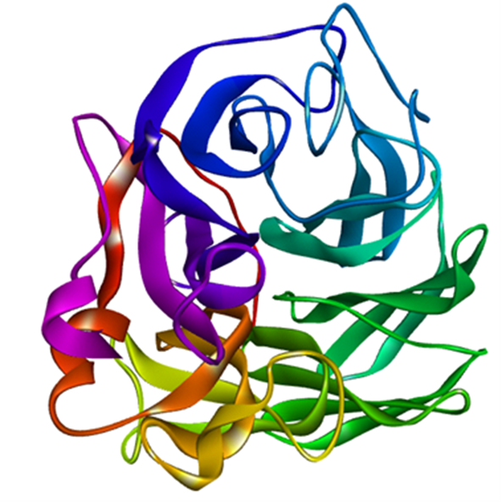a | b

2.4. ADME prediction
The Swiss ADME web server was employed to evaluate ADME properties (absorption, distribution, metabolism, and excretion). This assessment offered valuable information on their physicochemical properties, lipophilicity, bioavailability, and pharmacokinetics. Additionally, Swiss ADME was used to predict drug-likeness and potential interactions of the drugs with cytochrome P450 enzymes.(15)(16)
.

2.5. De novo designing using e-LEA3D

Researchers utilized the e-LEA3D web server to conduct computer-aided de novo drug design. This tool generates fresh compounds either by starting from square one or using a tailored scaffold featuring optimized substituents as defined by the user. The approach is fragment-based and utilizing a genetic algorithm for the enhancement of fragment combinations. The protein structure was uploaded onto the e-LEA3D web server, and the binding site coordinates were adjusted to match the predicted activity (X= 17.89466812, Y = 20.99328986, Z= 55.71566522). The parameters for the radius binding site (10A) and weight in the final score (1) were personalized. However, the genetic algorithm parameters, like the number of generations, population size, and other molecular properties, were adjusted to their default values.(17) The visualization of the acquired results was carried out using Discovery Studio software.

2.6 SWISS ADME Studies
ADME studies are crucial for assessing the drug-likeness of potential ligands, involving (absorption, distribution, metabolism, and excretion) properties. The Swiss ADME system is utilized to predict various physicochemical attributes, such as lipophilicity, water solubility, pharmacokinetics, and adherence to key drug-likeness rules (like Lipinski, Ghose, Veber, Egan, Mugge, and Bioavailability score). Among these, the widely cited Lipinski rule offers valuable insights into a ligand's potential as a drug candidate, stipulating the below criteria:
Molecular weight under 500.
Octanol-water coefficient (logP) less than 5.
A maximum of 5 hydrogen bond donors and no more than 10 hydrogen bond acceptors.

Built upon Lipinski's rule, compounds have progressed to the stage of pre-filtration for identifying promising drug candidates. This preliminary filtering of drug candidates serves to secure their pharmacological relevance and potential.

3. RESULT & DISCUSSION

3.1 ADME Properties
De novo drug design is an automated computational process that constructs molecules targeting specific biological targets using atoms or fragments. The goal is to create molecular structures that meet the criteria for in silico drug/lead likeness. In our study, we successfully designed novel molecules within the active pockets using the de novo technique with a new version of the LEA3D engine.
From the e-LEA3D output, we obtained 20 molecules, but only three were taken into account. (Table 1 and Figure 2(a-c))The others were excluded based on score, and constraint applied during in ADMET screening and silico drug/lead likeness which included the evaluation of Lipinski's rule of 5. According to the rule, for a molecule to be a potential orally active drug candidate, it must not breach more than one of the specified criteria defined within the rule.
Figure 2 :(a-c)) de novo drug design top score results
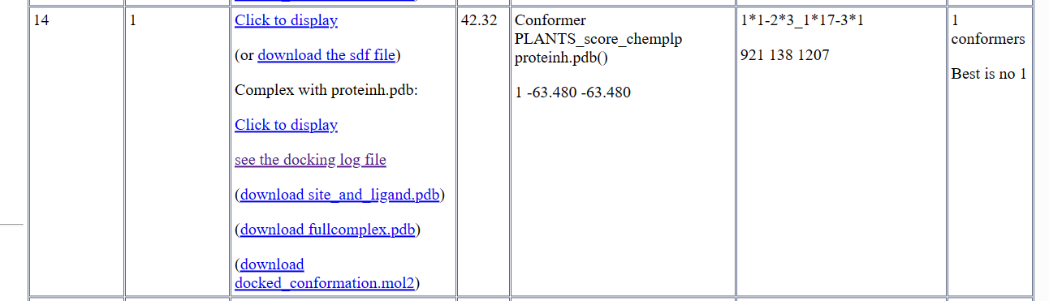
a
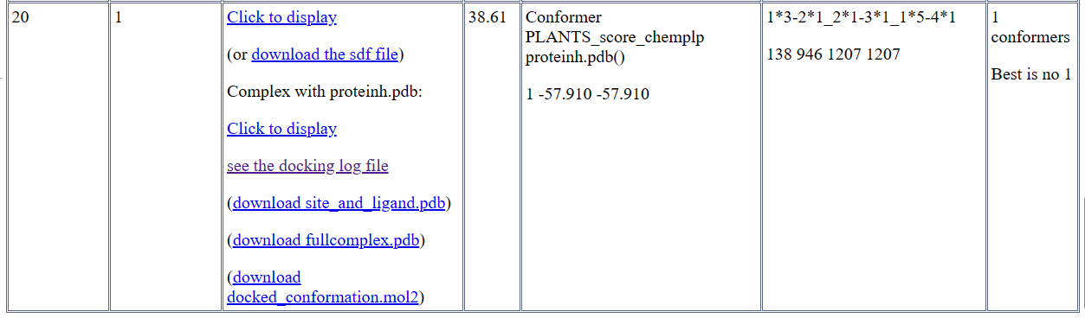
b
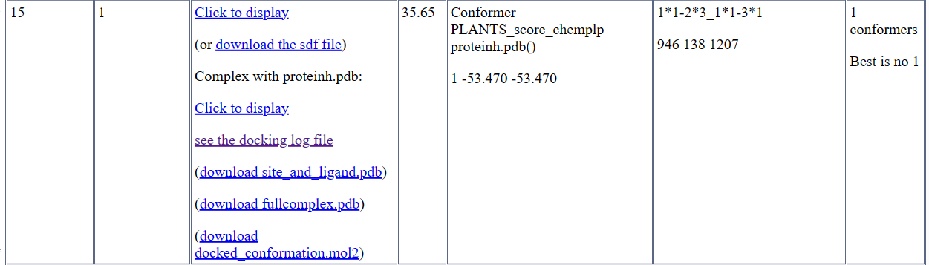
c

Table1: Generated compounds
S.no | Potential Ligands
1
2
3 | 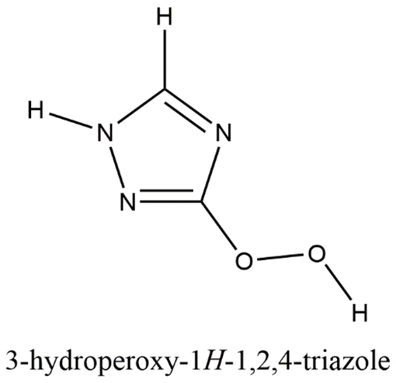

The initial screening process for potential life-saving drug candidates involved the application of Lipinski's Rule of Five. This rule examines key parameters like Hydrogen Bond Donor (HBD) count Molecular Weight (M.wt), Hydrogen Bond Acceptor (HBA) count,Octanol-Water Partition Coefficient (logP), and molar refractivity index. The evaluation of all three compounds against these criteria was detailed in Table2. Notably, these Schiff bases not only met the stringent criteria of the first assessment but also conformed to Veber's law, which gauges the bioavailability score of drug candidates. The calculated bioavailability score for these was 0.55.

Furthermore, the Synthetic Accessibility (SA) of the compound was determined to be within the favorable range of greater than one and less than ten. This range signifies the ease of synthesizing these compounds in a laboratory setting. The consideration of Synthetic Accessibility is pivotal in the selection process of drug design, and its integration into computer-aided design (CAD) workflows can significantly enhance the efficiency and success rates of drug development endeavors. In essence, these findings collectively underscore the promising potential of these designed compounds as viable candidates for further drug design and development.

Table2: Druglikeness Parameter Versus Compound
Drug likeness property Parameter | Compounds
 | 1 | 2 | 3
M.Wt <500 | 186 | 117 | 101
HBA <5 | 3 | 5 | 4
HBD<10 | 5 | 2 | 2
logP <5 | 1.10 | 0.54 | 0.06
Lipinski Rule | Yes | Yes | Yes
Bioavailability score | 0.55 | 0.55 | 0.55
Veber’s Rule | Yes | Yes | Yes
Synthetic accessibility | 3.04 | 3.05 | 2.56

3.1Moleculardocking Analysis
In the process of de novo drug design, an assessment was conducted on a total of 420 molecules. Subsequently, the software generated results for the top 20 molecules. From this subset, focused attention was directed toward the investigation of the top 3 molecules, which were selected based on their highest scores. Compound 1 exhibited the most elevated score of 42.32, while compound 2 achieved a score of 38.61, and compound 3 obtained a score of 35.65. These results establish their superior performance compared to the other compounds within the designed molecule set. Furthermore, among all the designed molecules, compounds 1, 2, and 3 maintained their leading positions.
The docking results obtained from e-LEA3D output of compounds (1-3) with the target protein 6HCX are summarized in Table3. The 2D and 3D structures of the docked compound (1-3) are illustrated in Figure 3(a-c) and Figure 4 (a-c) respectively.
Additionally, it is of significance that compound 1 exhibited interactions involving 5 hydrogen bonds, compound 2 displayed 6 hydrogen bonds, and compound 3 demonstrated 4 hydrogen bonds. These observations further underline the substantial affinity between these compounds and the protein complex.
This high score is a positive indicator of the strong connection between the target protein and compound the. The comprehensive details provided in Table 3 shed light on the distinct binding characteristics of these compounds and their potential as promising candidates for further exploration in protein-ligand interactions

Table 3: 2D interaction of 6HCX and Compounds (1-3)
Target Protein (PDB ID) | Generated Compound | Interacting amino acid at the active site | Interaction type | H-bond | Score
6HCX | 1 | GLU120,ASP152,THR227,GLU229,GLU279,TYR406 | H-bond  Vander Waals  Pi-anion | 5 | 42.32
 | 2 | THR325,ARG302,VAL350, ARG365,THR366,TYR375,GLY405,SER407, | H-bond  Vander Waals  Pi-alkyl  Pi-Cation  Pi-Sigma  Pi- Pi T-shaped | 6 | 38.61
 | 3 | ARG302,THR325,VAL350, ARG365,THR366,TYR375  GLY405,SER407 | H-bond  Vander Waals  Pi-alkyl  Pi-Cation  Pi-Sigma  Pi- Pi T-shaped | 4 | 35.65

Figure 3 :(a-c) 2D Interaction between targeted protein ,PDB ID: 3T88 with generated compounds (1-3 respectively)
a  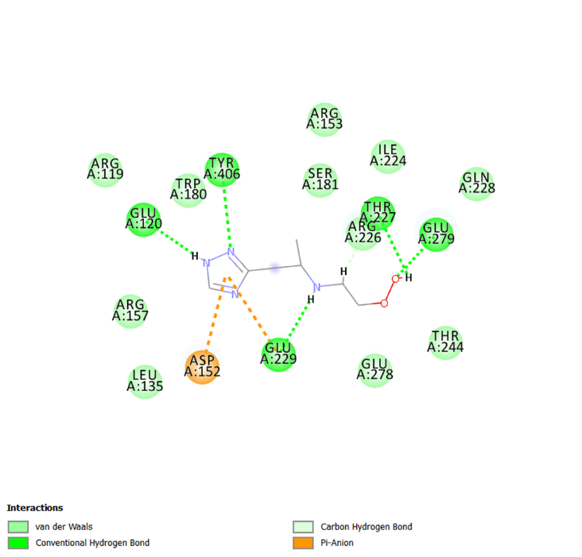 |  | b  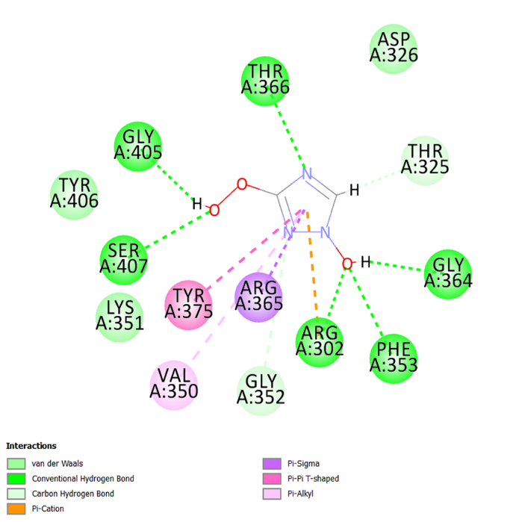
c

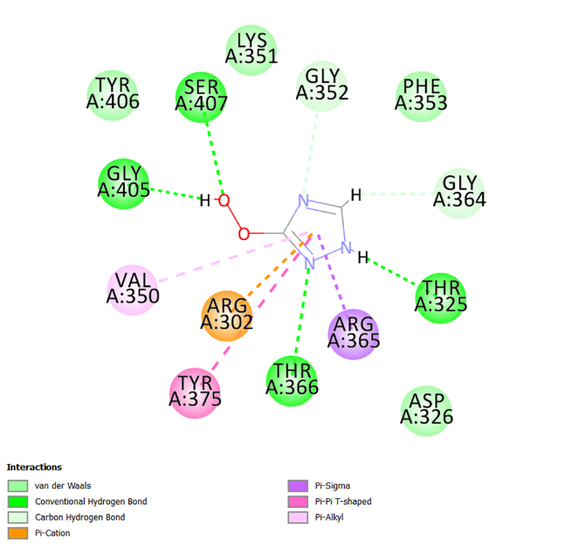

Figure 4:(a-c) 3D Interaction between targeted protein PDB ID :3T88 with generated compounds (1-3 respectively)

a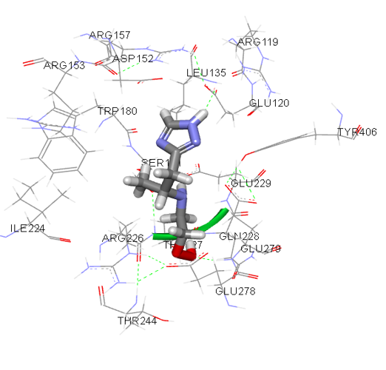 |  | b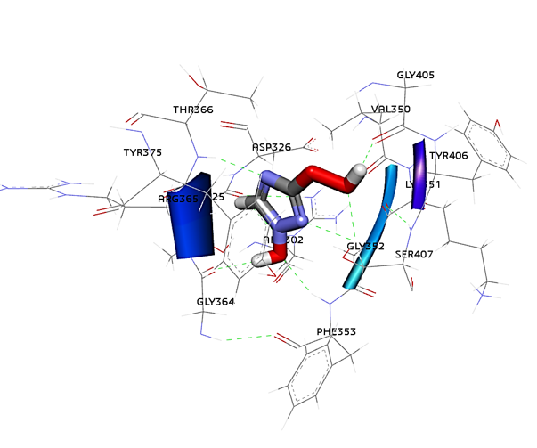
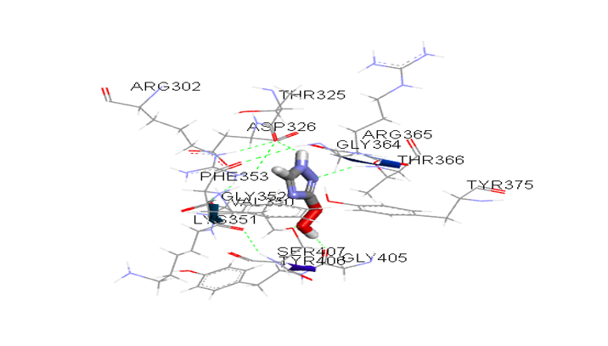
c

- Conclusion
Computer-aided de novo drug formulated represents a rapid and dependable in silico approach for creating new target-specific drugs or molecules with lead-like properties. In this study, the e-Lea3D de novo design platform was employed to generate 20 distinct stereoisomers with drug/lead-like properties within the protein's core. Specifically, the focus was placed on the de novo-generated molecules that displayed the highest plant scores among their respective stereoisomers. These molecules were subsequently subjected to docking analyses, utilizing the outcomes provided by the e-Lea3D website. These results possess the potential to contribute significantly to the advancement of promising neuraminidase inhibitors.

REFERENCES

1. Ziegler T, Mamahit A, Cox NJ. 65 years of influenza surveillance by a World Health Organization-coordinated global network. Influenza Other Respi Viruses. 2018;12(5):558–65.
2. Hofer U. Viral evolution: Past, present and future of influenza viruses. Nat Rev Microbiol. 2014;12(4):237.
3. Adlhoch C, Delgado-Sanz C, Carnahan AS, Larrauri A, Popovici O, Bossuyt N, et al. Effect of neuraminidase inhibitor (oseltamivir) treatment on outcome of hospitalised influenza patients, surveillance data from 11 EU countries, 2010 to 2020. Euro Surveill [Internet]. 2023;28(4). Available from: http://dx.doi.org/10.2807/1560-7917.ES.2023.28.4.2200340
4. Smith BJ. Analysis of inhibitor binding in influenza virus neuraminidase. Protein Sci. 2001;10(4):689–96.
5. Li Q, Qi J, Zhang W, Vavricka CJ, Shi Y, Wei J, et al. The 2009 pandemic H1N1 neuraminidase N1 lacks the 150-cavity in its active site. Nat Struct Mol Biol [Internet]. 2010;17(10):1266–8. Available from: http://dx.doi.org/10.1038/nsmb.1909
6. Tuong HT, Nguyen NM, Sung HW, Park H, Yeo SJ. Genetic characterization of avian influenza A (H11N9) virus isolated from Mandarin ducks in South Korea in 2018. Viruses. 2020;12(2).
7. Jefferson T, Jones M, Doshi P, Spencer EA, Onakpoya I, Heneghan CJ. Oseltamivir for influenza in adults and children: Systematic review of clinical study reports and summary of regulatory comments. BMJ. 2014;348(April):1–18.
8. Heneghan CJ, Onakpoya I, Thompson M, Spencer EA, Jones M, Jefferson T. Zanamivir for influenza in adults and children: Systematic review of clinical study reports and summary of regulatory comments. BMJ. 2014;348(April):1–16.
9. Ishizuka H, Yoshiba S, Okabe H, Yoshihara K. Clinical pharmacokinetics of laninamivir, a novel long-acting neuraminidase inhibitor, after single and multiple inhaled doses of its prodrug, CS-8958, in healthy male volunteers. J Clin Pharmacol. 2010;50(11):1319–29.
10. Mclaughlin MM, Skoglund EW, Ison MG. Peramivir: An intravenous neuraminidase inhibitor. Expert Opin Pharmacother. 2015;16(12):1889–900.
11. Kumar D, Ison MG, Mira J-P, Welte T, Hwan Ha J, Hui DS, et al. Combining baloxavir marboxil with standard-of-care neuraminidase inhibitor in patients hospitalised with severe influenza (FLAGSTONE): a randomised, parallel-group, double-blind, placebo-controlled, superiority trial. Lancet Infect Dis [Internet]. 2022 May 1;22(5):718–30. Available from: https://doi.org/10.1016/S1473-3099(21)00469-2
12. Sunagawa S, Higa F, Cash HL, Tateyama M, Uno T, Fujita J. Single-dose inhaled laninamivir: Registered in Japan and its potential role in control of influenza epidemics. Influenza Other Respi Viruses. 2013;7(1):1–3.
13. Lackenby A, Besselaar TG, Daniels RS, Fry A, Gregory V, Gubareva L V., et al. Global update on the susceptibility of human influenza viruses to neuraminidase inhibitors and status of novel antivirals, 2016–2017. Antiviral Res [Internet]. 2018;157:38–46. Available from: https://doi.org/10.1016/j.antiviral.2018.07.001
14. Burley SK, Berman HM, Bhikadiya C, Bi C, Chen L, Di Costanzo L, et al. Protein Data Bank: The single global archive for 3D macromolecular structure data. Nucleic Acids Res. 2019;47(D1):D520–8.
15. Daina A, Michielin O, Zoete V. SwissADME: A free web tool to evaluate pharmacokinetics, drug-likeness and medicinal chemistry friendliness of small molecules. Sci Rep. 2017;7(January):1–13.
16. Kesh M, Goel S. Target-Based Screening for Lead Discovery. 2023. 141–173 p.
17. Douguet D. e-LEA3D: a computational-aided drug design web server. Nucleic Acids Res [Internet]. 2010 Jul 1;38(suppl_2):W615–21. Available from: https://doi.org/10.1093/nar/gkq322

