Application of Normal Distribution
Dr. Kiran Singh Sisodiya (Bais)
kiransinghbais@gmail.com
Chandigarh University, UIS
ABSTRACT
The continuous random variable is used in this article along with other mathematical properties. The traits of the phenomenon we anticipate have an effect on how probability behaves. There is a certain probability distribution based on the characteristics of phenomena (which we also describe as variables). The probability for categorical (or discrete) variables may typically be explained by a binomial or Poisson distribution. Continuous probability distributions are commonly used to mathematically characterize random processes in the physical sciences and engineering. We provide a method for formalizing any continuous random variable in this paper. The probability distribution is briefly explained along with a few examples of potential applications. It is also referred to as the bell-shaped curve and the Gaussian distribution.
Keywords-Random variable, Discrete, Continuous, Mean, Normal curve

- INTRODUCTION

Random Variable- Random variable refers to a real valued function that is defined across the sample space of a random experiment.
Random Variable is assigning a number to the experiment.
Random Variable is defined from sample space to the real numbers
$$f\left(X\right)=S→R$$
where the random variable is f(X).
Real number (R) is the range of the random variable and sample space (S) is its domain.
The value of a random variable is based on the potential results of a random experiment, which might be discrete or continuous.

- Discrete Random Variable
It is a random variable that can have a limited number of distinct values, such as 0, 1, 2, and so forth.
E.g. – Heights of students, Weights of students etc.

- Continuous Random Variable
It is random variable which take values between a range and it is variable that can
have Infinite or uncountable set of values.
E.g. – Number of students who fails in a test, Number of accidents per month etc.

Area under the Probability density function's curve is used to define probabilities of continuous random variables.
The graph of discrete and continuous data looks like this:

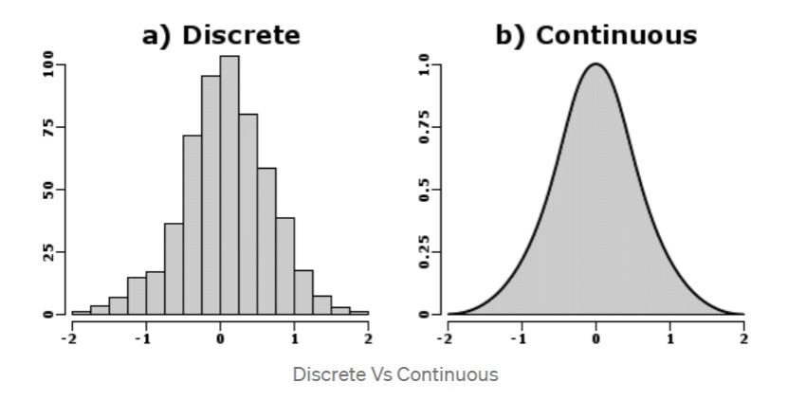
https://miro.medium.com/max/994/1*c2ylMCItL1XG6O3mGhjzng.png
Figure-1

- TYPES OF DISCRETE PROBABILITY DISTRIBUTION

A. Bernoulli Distribution
B. Binomial Distribution
C. Multinomial Distribution
D. Poisson Distribution
E. Hypergeometric Distribution
F. Negative Binomial Distribution
G. Geometric Distribution

Now we will discuss about some Discrete Probability Distribution

- Bernoulli Distribution-When an experiment is conducted just once and there are just two possible outcomes—success or failure—we utilize the Bernoulli distribution. These trails are known as Bernoulli trails.
- If we do an experiment, then let p represent the likelihood of success and 1-p represent the likelihood of failure.
- P.M.F is provided as
- $P.M.F=\left\{\begin{matrix}p , Success \\ 1-p , Failure\end{matrix}\right\}$
$$Mean=p$$
$$Variance=p(1-p)$$

E.g.- Guessing a simple True/False Question, Tossing a coin once, etc.

- Binomial Distribution- It is an identical Bernoulli distribution sequence. When there are just two possible outcomes for a random variable, the binomial distribution is created. Let 'p' stand for the likelihood that an event will succeed, and 'q' for the likelihood that any given trail will fail. Finding the likelihood of attaining 'r' successes in 'n' separate trials is necessary because the remaining 'n-r' trials will fail. After that, we repeat the experiment and plot the probability for each run, producing a binomial distribution.
The P.M.F is given as
$$P.M.F=n_{C_{r}}p^{r}q^{1-r}$$

Where p is the probability of success,
q is the probability of failure,
n is the number of trails, and
r is the number of times we obtain success.
E.g.- Tossing a coin ‘n’ time and calculating the probability of getting some number of heads.

Important Results of Binomial Distribution-
Prove that the sum of probability mass function for Binomial distribution is 1.
Proof: - $P\left(x,r\right)=n_{C_{r}}p^{r}q^{n-r}$
$P\left(x,r\right)=\sum_{n=0}^{∞}{n_{C_{r}}}p^{r}q^{n-r} ;r=0,1,2…n$
$$P\left(x,r\right)=n_{C_{0}}p^{0}q^{n}+n_{C_{1}}p^{1}q^{n-1}+…+n_{C_{n}}p^{n}q^{n-n}$$
$=q^{n}+n_{C_{1}}p^{1}q^{n-1}+…+p^{n}$
$={(q+p)}^{n}$
$=1$
Hence Proved

Mean of Binomial Distribution
Suppose $x_{1},x_{2},x_{3},… x_{n}$ are the variate values with corresponding probabilities $P_{1},P_{2},P_{3},…P_{n }$,then
$$μ=E\left(x\right)=\sum_{r=0}^{n}{rP(x=r)}$$
$=\sum_{r=0}^{n}{r n_{C_{r}}p^{r}q^{n-r}}$
$=0+n_{C_{1}}p^{1}q^{n-1}+2n_{C_{2}}p^{2}q^{n-2}+3n_{C_{3}}p^{3}q^{n-3}$
$+… +nn_{C_{n}}p^{n}q^{0}$
$=npq^{n-1}+n\left(n-1\right)p^{2}q^{n-2}+ \frac{n(n-1)(n-2)}{2!}p^{3}q^{n-3}+…+np^{n}$
$=np\left[q^{n-1}+n_{C_{1}}pq^{n-2}+{n-1}_{C_{2}}p^{2}q^{n-3}+…+{ p}^{n-1}\right]$
$=np\left[{(p+q)}^{n-1}\right]$
$μ=np$

Variance of Binomial Distribution-

$$Variance\left(σ^{2}\right)=E\left(x^{2}\right)-{(E\left(x\right))}^{2}$$
$=E\left(x^{2}\right)-{\left(np\right)}^{2} …(A)$

$$E\left(x^{2}\right)=\sum_{r=0}^{n}{r^{2}n_{C_{r}}p^{r}q^{n-r}}$$
$=\sum_{r=0}^{n}{\left[r\left(r-1\right)+r\right]}n_{C_{r}}p^{r}$
$=\sum_{r=0}^{n}{r\left(r-1\right)n_{C_{r}}p^{r}q^{n-r}+\sum_{r=0}^{n}{rn_{C_{r}}p^{r}q^{n-r}}}$
$=\left[2.1 n_{C_{2}}p^{2}q^{n-2}+3.2 n_{C_{3}}p^{3}q^{n-3}+…+ n(n-1)p^{n}\right]+np$
$=\left[n\left(n-1\right)p^{2}q^{n-2}+n\left(n-1\right)\left(n-2\right)p^{3}q^{n-3}+ …+n(n-1)p^{n}\right]+np$
$=n\left(n-1\right)p^{2}\left[q^{n-2}+\left(n-2\right)pq^{n-3}+…+ p^{n-2}\right]+np$
$=n\left(n-1\right)p^{2}{\left(p+q\right)}^{n-2}+np$
$=n\left(n-1\right)p^{2}+np$
$=np(n-1)(p+1)$
Put value of $E\left(x^{2}\right)$in equation (A)

$$Variance=np\left(n-1\right)\left(p+1\right)-n^{2}p^{2}$$
$=n^{2}p^{2}-np^{2}+np-n^{2}p^{2}$
$=np\left(1-p\right)$
$=npq$

$$Standard Deviation\left(σ\right)=\sqrt{Variance}$$
$$σ=\sqrt{npq}$$

- Multinomial Distribution
The random variable with numerous alternative outcomes is described by a multinomial distribution. Think about playing a game n times. So Multinomial Distribution helps us to determine combined probability that Player 1 will win${ x}_{1}$ times, Player 2 will win $x_{2}$ times, and Player k will win $x_{k}$ times.

The P.M.F is given as
$$P\left(X=x_{1},X=x_{2}…X=x_{k}\right)=\frac{n!}{x_{1}!x_{2}!⋯x_{k}!}{P_{1}}^{x^{1}}{P_{2}}^{x^{2}}…{P_{k}}^{x^{k}}$$

Where ‘n’ is the number of trails
$P_{1},P_{2}…P_{k}$ denote the probabilities of outcome $x_{1},x_{2}…x_{k}$ respectively.

- Poisson’s Distribution- Under the following circumstances, it is a limiting case of the binomial distribution: -
When the number of trails ‘n’ is very large i.e., $n→∞$
Probability of success ‘p’ is very small i.e., $p→0$
Poisson’s Distribution describes the event that occurs in a fixed interval of time or space.

DEFINATION- If X has the probability mass function (P.M.F.) listed below, then it will follow Poisson's distribution.
$$P\left(X=r\right)=\frac{ⅇ^{-λ}λ^{r}}{r!}$$

Where $λ=$ average number of occurrences of an event over a specific period of time,
$r=$ Desired outcome
$e=$ Euler’s Number

Types of Continuous Probability Distribution
- Rectangular/Uniform Distribution
- Exponential Distribution
- T-Distribution
- Normal Distribution
- Chi-square Distribution
- Rayleigh Distribution
Now we will discuss about some Continuous Probability Distribution

- Rectangular/Uniform Distribution
A uniformly distributed Random Variable X in interval $\left[a,b\right]$ if P.D.F is given by-

$$f\left(x\right)=\left\{\begin{aligned}\frac{1}{b-a} , a<x<b \\ 0 , elsewhere\end{aligned}\right\}$$

$$Mean=\frac{a+b}{2}$$
$$Variance=\frac{b-a}{\sqrt{3}}$$
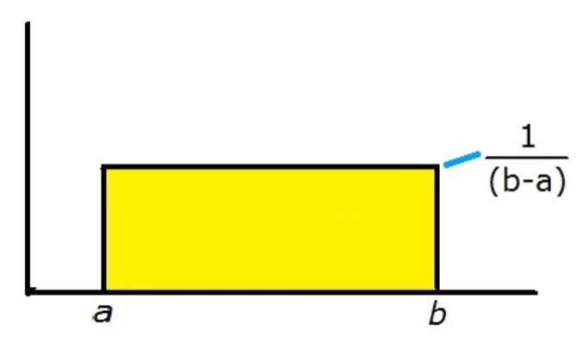
https://th.bing.com/th/id/Ra51c721e7f9b820af206667b87ba4456?rik=5cvzUE%2bTyf0V7Q&riu=http%3a%2f%2fwww.mhnederlof.nl%2fimages%2frectangularpdf.jpg&ehk=8p%2fNfYANrFsiuYZ1qDvQTkIXaiIxPfX4aX%2fULdBQ%2fUw%3d&risl=&pid=ImgRaw
Figure-2

- Exponential Distribution
It is argued that a random variable X has an exponential distribution of its P.D.F.
$$f\left(x\right)=\left\{\begin{aligned}λⅇ^{-λx} ; x≥0 \\ 0 ; elsewhere\end{aligned}\right\}$$

$$Mean=\frac{1}{λ}$$
$$Variance=\frac{1}{λ^{2}}$$

- T-Distribution
When sample size is limited and population variation is unknown, this is utilized. Degree of freedom (p), which defines this distribution, is determined as sample size minus one (n-1).
PDF is provided by
$$f\left(t\right)=\frac{Γ\frac{p+1}{2}}{\sqrt{pπ}Γ\frac{p}{2}}{\left(1+\frac{t^{2}}{p}\right)}^{-\frac{p+1}{2}}$$
Where p is degree of freedom,
$Γ$is gamma function,
And $t=\frac{\overline{x}-μ}{s/{\sqrt{n}}}$ where $\overline{x}$ is sample mean, $μ$is population mean, s is sample variance

- RESULTS AND DISCUSSIONS

- NORMAL DISTRIBUTION
The Normal Distribution, sometimes referred to as the Gaussian Distribution in statistics and probability theory, is the most important Continuous Probability Distribution. The Binomial Distribution's limiting case is one in which p and q are unrestricted and the number of trails 'n' tends to.
DEFINATION –
If a continuous random variable, X, has a probability density function that is given by

$f\left(x\right)=\frac{1}{σ\sqrt{2π}}e^{-\frac{{(x-μ)}^{2}}{2σ^{2}}}$ , $-∞<x<∞$

Where x is the Variable
$μ$ is the Mean and
$σ$ is the Standard Deviation
Mean and Standard Deviation are the parameters of Distribution.
$f\left(x\right)≥0$ ; $-∞<x<∞$ ,$σ>0$

The Normal Distribution is 1 i.e., the total probability of distribution is 1.
$$\int_{-∞}^{∞}{f\left(x\right)dx=1}$$

Important Results-
Prove that normal distribution is 1 i.e., the total probability of distribution is 1.
Proof-Let $I=\int_{-∞}^{∞}{\frac{1}{σ\sqrt{2π}}e^{\frac{{(x-μ)}^{2}}{2σ^{2}}}dx}$ … (C)
Let $z=\frac{x-μ}{σ}$
$dz=\frac{1}{σ}ⅆx$

Then equation ‘C’ becomes
$I=\int_{-∞}^{∞}{\frac{1}{σ\sqrt{2π}}ⅇ^{-\frac{z^{2}}{2}}σdz}$
$=\frac{1}{\sqrt{2π}}\int_{-∞}^{∞}{e^{-\frac{z^{2}}{2}}dz}$
$=\frac{1}{\sqrt{2π}}2\int_{0}^{∞}{e^{-\frac{z^{2}}{2}}}dz \left\{e^{-\frac{z^{2}}{2}} is an even function of z\right\}$
$=\frac{2}{\sqrt{2π}}*\sqrt{\frac{π}{2}}=1$
$\left\{\int_{0}^{∞}{e^{-\frac{z^{2}}{2}}dz=\sqrt{\frac{π}{2}}}\right\}$

Standard Normal Distribution
The mean value in a conventional normal distribution is 0, and the standard deviation is 1.
$$z=\frac{X-μ}{σ}$$

To convert Normal Variate to Standard Normal Variate

X is a normal variate having following p.d.f.
$f\left(x\right)=\frac{1}{σ\sqrt{2π}}e^{-\frac{{(x-μ)}^{2}}{2σ^{2}}}$ , $-∞<x<∞$ … (1)

For different values of µ and 𝞼, we get different normal curves.
To find the area under normal curves, we standardized the normal variate X by the following transformation
$z=\frac{X-μ}{σ}$ … (2)

From (1) and (2)

$f\left(z\right)=\frac{1}{σ\sqrt{2π}}e^{-\frac{z^{2}}{2}}$ ; $-∞<x<∞$

We know that
$f\left(z\right)≥0 ; -∞<z<∞$

Since $e^{-\frac{z^{2}}{2}}$ is an even function of z and $\int_{-∞}^{∞}{f\left(z\right)dz}=1$

- CENTRAL LIMIT THEOREM

According to the central limit theorem, the distribution of the sums of many independent random variables selected from any distribution will always converge to the Normal Distribution. The sample size has a direct relationship with how well the normal distribution is approximated.
Let $X_{1},X_{2},X_{3}, …X_{n}$ are ‘n’ independent identically distributed random variables with
$E\left(X_{1}\right)=μ$ and $Var\left(X_{1}\right)=σ^{2}$ and if $\overline{X}=\frac{1}{n}\sum_{i=1}^{n}{X_{i}}$ , then the variate $Z=\frac{X-μ}{σ/\sqrt{n}}$ has a distribution that approaches the standard normal distribution as $n→∞$ provided the moment generating function exists.

C. CENTRAL LIMIT THEOREM APPLICATIONS
- 1. It offers an easy way to calculate the approximations of the probabilities of the sums of independent random variables.
- 2. It informs us of the fact that empirical frequencies of a large number of natural "Populations" show a bell-shaped curve.
.

Area under Standard Probability Curve

Since $\frac{1}{σ\sqrt{2π}}\int_{-∞}^{∞}{e^{-\frac{{(x-μ)}^{2}}{2σ^{2}}}dx=1=P(-∞<x<∞)}$

Clearly for Standard normal variate

$$\int_{-∞}^{∞}{f\left(z\right)dz=1=P(-∞<x<∞)}$$

So $P\left(-∞<x<0\right)=0.5$
and $P\left(0<x<∞\right)=0.5$

Working Procedure to find $P\left(x_{1}<X<x_{2}\right)$

- $P(μ_{X}-σ<X<μ_{X}+σ)$

Here $z=\frac{X-μ}{σ}$
At $x=μ-σ , z=\frac{μ-σ-μ}{σ} ; z=-1$ , and
At $x=μ+σ , z=\frac{μ+σ-μ}{σ} ; z=1$
So, $P\left(-1<z<1\right)=2P\left(0≤z≤1\right)$
$=2*0.34135$ [By normal table $P\left(0≤z≤1\right)=0.34135]$
$=0.6827$

Here 68% area lies within $μ±σ$

- $P(μ_{X}-2σ<X<μ_{X}+2σ)$

At $x=μ-2σ , z=-2$
At $x=μ+2σ , z=2$
So, $P\left(-2<z<2\right)=2P(0≤z<2)$
$=2*0.4774$ [By normal table $P\left(0≤z<2\right)=0.4774]$
$=0.9545$

Here 95% of area lies within $μ±2σ$

- $P(μ_{X}-3σ<X<μ_{X}+3σ)$

At $x=μ-3σ , z=-3$
At $x=μ+3σ , z=3$
So,$P\left(-3<z<3\right)=2P\left(0≤z≤3\right)$
$=2*0.4986$ [By normal table $P\left(0≤z≤3\right)=0.4986]$
$=0.9973$

Here 99% of area lies within $μ±3σ$
Now the graph for area within $μ±σ , μ±2σ , μ±3σ$is as follows-

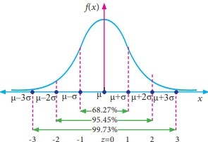
https://www.brainkart.com/media/extra3/8eVa07s.jpg
Figure-4

- Curve of Normal Distribution

We are aware that the mean contributes to the determination of the graph's line of symmetry, while the standard deviation tells us how widely distributed the data are.
The data are more closely clustered if the standard deviation is smaller, while the graph becomes wider if the standard deviation is bigger.

The scale parameter is Standard Deviation, while the location parameter is Mean.

The mean establishes where the curve's apex will be. Curves are moved right by increasing mean and left by lowering mean.
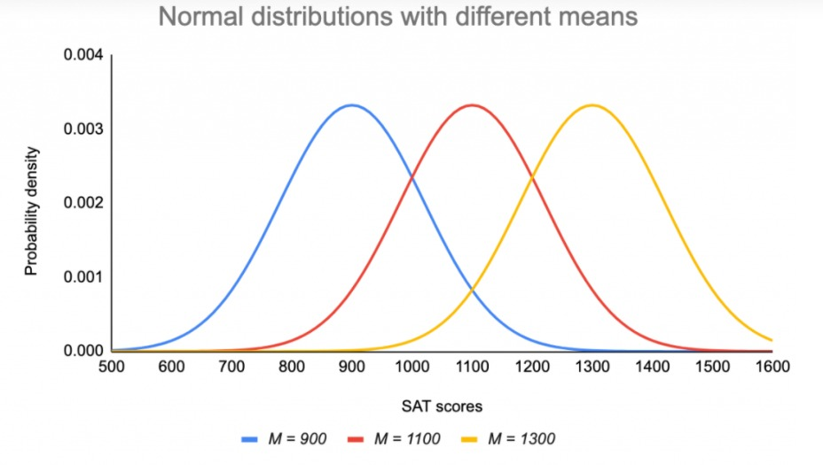
https://cdn.scribbr.com/wp-content/uploads/2020/10/normal-distributions- with-different-means-1024x633.png
Figure-5

- Standard Deviation stretches or squeezes the curve. A small standard deviation results in narrow curve while a large standard deviation leads to wide curve.

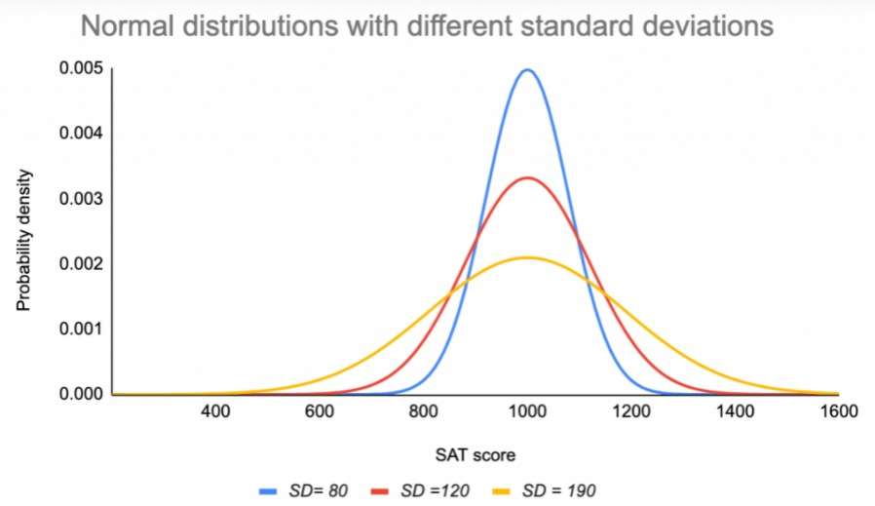
https://cdn.scribbr.com/wp-content/uploads/2020/10/normal-distributions-with-different-sds-1024x633.png
Figure-6

- Empirical Rule

Empirical formula is also known as 68-95-99.7 rule. It tells us where most of values lies in normal Distribution.

- Around 68% of data falls within one standard deviation of means.
- Around 95% of data falls within two standard deviations of mean.
- Around 99.7% of data lies within three standard deviations of mean.

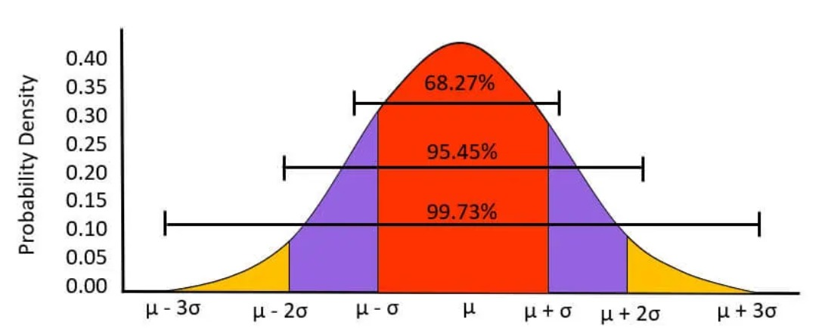
https://cdn.wallstreetmojo.com/wp-content/uploads/2020/03/Normal-Distribution-Graph1.jpg.webp
Figure-7

Properties of Normal Probability Curve

- It is a bell-shaped curve
- It is symmetric about $z=0$ i.e., $x=μ$ .
- In this distribution Mean = Mode = Median.
- Area lying under the normal probability curve is 1 because $\int_{-∞}^{∞}{f\left(x\right)dx=1}$.
- There are exactly half values which are to the left of center and exactly half of the values which are to the right of center.
- Normal curve must have only one peak.
- As $x$ increases numerically, $f(x)$ decreases rapidly. The maximum probability attains its maximum value at $x=μ$ and given by$P_{max}=\frac{1}{σ\sqrt{2π}}$ .
- Since f(x) being the probability, can never be negative, no portion of curve lies below $x$-axis.
- $x$-axis is an asymptote of normal probability curve.
- The Points of inflexion of the curve are given by $μ±σ$ .

Mean of Normal Distribution

By definition of mean

$$μ=\overline{X}=E\left(X\right)=\int_{-∞}^{∞}{xf\left(x\right)dx}$$

In normal distribution $f\left(x\right)=\frac{1}{σ\sqrt{2π}}e^{-\frac{{(x-μ)}^{2}}{2σ^{2}}}$ ; $-∞<x<∞$

$$Mean=\int_{-∞}^{∞}{x\frac{1}{σ\sqrt{2π}}e^{-\frac{{(x-μ)}^{2}}{2σ^{2}}}dx}$$

$$Mean=\frac{1}{σ\sqrt{2π}}\int_{-∞}^{∞}{xe^{-\frac{{(x-μ_{X})}^{2}}{2σ^{2}}}}dx$$

Let $z=\frac{x-μ_{X}}{σ}$
$$dz=\frac{1}{σ}dx$$
$σdz=dx$

Put $x=σz+μ_{X}$ in Mean formula

$$Mean=\frac{1}{σ\sqrt{2π}}\int_{-∞}^{∞}{\left(μ_{X}+σz\right)e^{-\frac{z^{2}}{2}}σdz}$$
$=\frac{1}{\sqrt{2π}} \int_{-∞}^{∞}{(μ_{X}}+σz)e^{-\frac{z^{2}}{2}}dz$
$$=\frac{2}{\sqrt{2π}}\left[\int_{0}^{∞}{μ_{X}e^{-\frac{z^{2}}{2}}dz+\int_{0}^{∞}{σze^{-\frac{z^{2}}{2}}dz}}\right]$$
$$=\frac{2}{\sqrt{2π}}\left[μ_{X}\int_{0}^{∞}{e^{-\frac{z^{2}}{2}}dz+σ}\int_{0}^{∞}{ze^{-\frac{z^{2}}{2}}dz}\right]$$
$$=\frac{2}{\sqrt{2π}}\left[μ^{X}\sqrt{\frac{π}{2}}+σ\int_{0}^{∞}{ze^{-\frac{z^{2}}{2}}dz}\right]$$
$$=\frac{2μ_{X}}{\sqrt{2π}}*\sqrt{\frac{π}{2}}+σ\left(0\right) \left\{ze^{-\frac{z^{2}}{2}} is an odd function\right\}$$

$$Mean=μ_{X}$$
Variance of Normal Distribution

$σ^{2}$ = Second Moment about Mean

By definition, we have $σ^{2}=\int_{-∞}^{∞}{{\left(x-μ\right)}^{2}f\left(x\right)dx}$

$$σ^{2}=\int_{-∞}^{∞}{{(x-μ)}^{2}}\frac{1}{σ\sqrt{2π}}e^{-\frac{{(x-μ)}^{2}}{2σ^{2}}}dx$$

Let $z=\frac{x-μ^{X}}{σ}=≫x=μ_{X}+σ_{z} ;dx=σdz$

$$σ^{2}=\int_{-∞}^{∞}{σ^{2}}z^{2}.\frac{1}{σ\sqrt{2π}}e^{-\frac{z^{2}}{2}}σdz$$
$$=\frac{σ^{2}}{\sqrt{2π}}\int_{-∞}^{∞}{z^{2}}e^{-\frac{z^{2}}{2}}dz \left(Since z^{2}e^{-\frac{z^{2}}{2}} is an even function\right)$$
$$=\frac{σ^{2}}{\sqrt{2π}}.2\int_{0}^{∞}{z^{2}e^{-\frac{z^{2}}{2}}}dz$$

Let $\frac{z^{2}}{2}=y=≫z^{2}=2y$
$z=\sqrt{2y}$
$2zdz=2dy ;2dz=dy$

$$=\frac{σ^{2}}{\sqrt{2π}}.2\sqrt{2}\int_{0}^{∞}{e^{-y}}.y^{\frac{1}{2}}dy$$
$$=\frac{σ^{2}}{\sqrt{2π}}.2\sqrt{2}Γ\frac{3}{2} \left\{By Gamma function \int_{0}^{∞}{μ^{n-1}e^{-μ}du=Γn}\right\}$$

Variance=$σ^{2}$

- APPLICATIONS OF NORMAL DISTRIBUTION IN DEFENSE RECRUITMENT PROCESS-

Following is the data for defense recruitment process-

Heights in Inches  (X) | Number of Candidates  (f)
60 | 0
61 | 4
62 | 20
63 | 23
64 | 75
65 | 114
66 | 186
67 | 212
68 | 252
69 | 218
70 | 175
71 | 149
72 | 46
73 | 18
74 | 8
75 | 0
Table-1

Now, as we know,
The Normal distribution's probability density function is given by-
$$f\left(x\right)=\frac{1}{σ\sqrt{2π}}e^{-\frac{z^{2}}{2}}dz$$

And $z=\frac{x-μ}{σ}$

We will now create a table using the aforementioned data and determine its mean and standard deviation.

Heigts in  Inches ($x)$ | Number of  Candidates (f) | $${x_{i}}^{2}$$ | $$x_{i}f_{i}$$ | $$f_{i}{x_{i}}^{2}$$
60 | 0 | 3600 | 0 | 0
61 | 4 | 3721 | 244 | 14884
62 | 20 | 3844 | 1240 | 76880
63 | 23 | 3969 | 1449 | 91287
64 | 75 | 4096 | 4800 | 307200
65 | 114 | 4225 | 7410 | 481650
66 | 186 | 4356 | 12276 | 810216
67 | 212 | 4489 | 14204 | 951668
68 | 152 | 4624 | 17136 | 1165248
69 | 218 | 4761 | 15042 | 1037898
70 | 175 | 4900 | 12250 | 857500
71 | 149 | 5041 | 10579 | 751109
72 | 46 | 5184 | 3312 | 238464
73 | 18 | 5329 | 1314 | 959322
74 | 8 | 5476 | 595 | 43808
75 | 0 | 5625 | 0 | 0
 | $$\sum{f_{i}=1500}$$ |  | $$\sum{f_{i}x_{i}=101848}$$ | $$\sum{f_{i}}{x_{i}}^{2}=6923734$$
Table-2

From above table 2-

$$Mean,μ=\frac{\sum{f_{i}x_{i}}}{\sum{f_{i}}}$$

$=\frac{101848}{1500}$

$μ=67.898$6

$$Standard Deviation,σ=\sqrt{\frac{∑f_{i}x_{i}^{2}}{∑f_{i}}-{\left(\frac{∑f_{i}x_{i}}{∑f_{i}}\right)}^{2}}$$
$=\sqrt{\frac{6923734}{1500}-{\left(67.898\right)}^{2}}$
$=\sqrt{4615.8226-4610.2289}$
$=\sqrt{5.6836}$

$σ=2.365$

Now we draw a table and find z and probability density function of normal distribution for all data ‘x’ i.e., the heights of the candidates.

Heights in Inches  (x) | $$z=\frac{x-μ}{σ}$$ | $$f\left(x\right)=\frac{1}{σ\sqrt{2π}}e^{-\frac{z^{2}}{2}}$$
60 | -3.3397 | 0.000633
61 | -2.8934 | 0.00254
62 | -2.4739 | 0.00769
63 | -2.0545 | 0.02
64 | -1.6350 | 0.0439
65 | -1.2156 | 0.0799
66 | -0.7961 | 0.1218
67 | -0.3766 | 0.1558
68 | 0.0427 | 0.16719
69 | 0.4622 | 0.1503
70 | 0.8817 | 0.1134
71 | 1.30117 | 0.0717
71 | 1.7206 | 0.0385
73 | 2.1401 | 0.0169
74 | 2.5595 | 0.006308
75 | 3.0027 | 0.00184
Table-3

Now from above table 3, we get the values of z and the probability density function of Normal distribution i.e., $f(x)$

Now we will draw a graph between heights of candidates and probability density function i.e.,$f(x)$
x-axis represents the heights of candidates, and
y-axis represents the Probability density function

Graph-1

Now an enlarged picture of graph of normal distribution of above data-

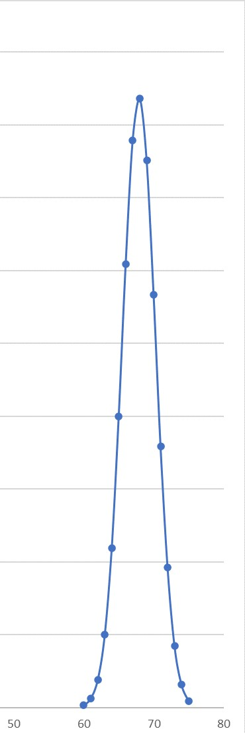

Graph-2

CONCLUSION

The likelihood of an event may often be described and possibly predicted using the probability distributions. The key is to use probability, either discrete or continuous, to characterize the nature of the variables whose behavior we are attempting to describe. The proper application of a model, such as the standardized normal distribution, which may be used to estimate the likelihood of an occurrence, is made possible by the selection of the appropriate category. We discussed how to apply normal distribution to the defense hiring procedure in this dissertation.

REFERENCES
- Altman, D., Bland, M., “Normal Distribution”, BMJ, 238-310, 1995.
- Batanero, C., Tauber, L., & Meyer, R., “A Research Project on the teaching of Normal Distribution”, Data Analysis of Interface, 52th Edition of ISI, 1999.
- Beasley, P.D., Springer, S.G., “The Percentage Points of Normal Distribution”, Applied Statistics. 26, 118-121, 1977.
- Brereton, R.G., “Normal Distribution”, Journal of Chemometrics, Vol.28, 789-792, 2014.
- Fisher, R.A., “Statistical Methods for Research Workers”, Biological Monographs and Manuals, 365p, 1958.
- Johnson, N., Kotz, S., Balakrishnan, N., “Continuous Univariate Distribution”, Wiley, Vol.1, 761p, 1994.
- Krithikadatta, J., “Normal Distribution”, Journal of Conservative Dentistry, Vol.17, 96-97, 2014.
- Krithikadatta, J., Valarmathi, S., “Research Methodology in Dentistry”, Journal of Conservative Dentistry, Journal of Conservative Dentistry, Vol.15, 206-213, 2012.

